CE100 Algorithms and Programming II

Introduction to Analysis of Algorithms

Author: Asst. Prof. Dr. Uğur CORUH

## CE100 Algorithms and Programming II

## Week-1 (Introduction to Analysis of Algorithms)

#### Spring Semester, 2021-2022

Download [DOC-PDF](ce100-week-1-intro.tr.md_doc.pdf), [DOC-DOCX](ce100-week-1-intro.tr.md_word.docx), [SLIDE](ce100-week-1-intro.tr.md_slide.pdf), [PPTX](ce100-week-1-intro.tr.md_slide.pptx)

## Brief Description of Course and Rules

We will first talk about,

1. Course Plan and Communication
2. Grading System, Homeworks, and Exams

please read the syllabus carefully.

## Outline (1)

* Introduction to Analysis of Algorithms
  + Algorithm Basics
  + Flowgorithm
  + Pseudocode

## Outline (2)

* RAM (Random Access Machine Model)
* Sorting Problem
* Insertion Sort Analysis
* Algorithm Cost Calculation for Time Complexity
* Worst, Average, and Best Case Summary
* Merge Sort Analysis

## Outline (3)

* Asymptotic Notation
  + Big O Notation
  + Big Teta Notation
  + Big Omega Notation
  + Small o Notation
  + Small omega Notation

## We Need Mathematical Proofs (1)

* Direct proof
* Proof by mathematical induction
* Proof by contraposition
* Proof by contradiction
* Proof by construction
* Proof by exhaustion

## We Need Mathematical Proofs (2)

* Probabilistic proof
* Combinatorial proof
* Nonconstructive proof
  + Statistical proofs in pure mathematics
  + Computer-assisted proofs

[Mathematical proof - Wikipedia](https://tr.wikipedia.org/wiki/Mathematical_proof)

## Introduction to Analysis of Algorithms

* Study two sorting algorithms as examples
  + Insertion sort: Incremental algorithm
  + Merge sort: Divide-and-conquer
* Introduction to runtime analysis
  + Best vs. worst vs. average case
  + Asymptotic analysis

## What is Algorithm

**Algorithm**: A sequence of computational steps that transform the input to the desired output

**Procedure vs. algorithm** An algorithm must halt within finite time with the right output

**We Need to Measure Performance Metrics**

* Processing Time
* Allocated Memory
* Network Congestion
* Power Usage etc.

**Example Sorting Algorithms**

**Input**: a sequence of n numbers

**Algorithm**: Sorting / Permutation

**Output**: sorted permutation of the input sequence

## Pseudo-code notation (1)

* Objective: Express algorithms to humans in a clear and concise way
* Liberal use of English
* Indentation for block structures
* Omission of error handling and other details (needed in real programs)

You can use [Flowgorithm](http://www.flowgorithm.org/) application to understand concept easily.

## Pseudo-code notation (2)

### Links and Examples

[Wikipedia](https://tr.wikipedia.org/wiki/Pseudocode)

[CS50](https://cs50.harvard.edu/ap/2021/problems/algorithms/)

[University of North Florida](https://www.unf.edu/~broggio/cop2221/2221pseu.htm)

[GeeksforGeeks](https://www.geeksforgeeks.org/how-to-write-a-pseudo-code/)

## Correctness (1)

We often use a **loop invariant** to help us to understand why an algorithm gives the correct answer.

**Example:** (Insertion Sort) at the start of each iteration of the “outer” for loop - the loop indexed by - the subarray consist of the elements originally in but in sorted order.

## Correctness (2)

To use a loop invariant to prove correctness, we must show 3 things about it.

* **Initialization:** It is true to the first iteration of the loop.
* **Maintaince:** If it is true before an iteration of the loop, it remains true before the next iteration.
* **Termination:** When the loop terminates, the invariant - usually along with the reason that the loop terminated - gives us a usefull property that helps show that the algorithm is correct.

## RAM (Random Access Machine Model) (1)

* Operations
  + Single Step
  + Sequential
  + No Concurrent
  + Arithmetic
    - add, subtract, multiply, divide, remainder, floor, ceiling,
    - shift left/shift right (good by multiply/dividing )

## RAM (Random Access Machine Model) (2)

* Data Movement
  + load, store, copy
* Control
  + conditional / unconditional branch
  + subroutine calls
  + returns

## RAM (Random Access Machine Model) (3)

* Each instruction take a constant amount of time
* Integer will be represented by
* the running time of the algorithm:

## What is the processing time ?

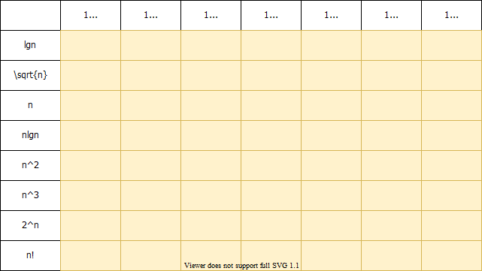

alt:“processing time map” height:500px center

## Insertion Sort Algorithm (1)

Insertion sort is a simple sorting algorithm that works similar to the way you sort playing cards in your hands

The array is virtually split into a sorted and an unsorted part

Values from the unsorted part are picked and placed at the correct position in the sorted part.

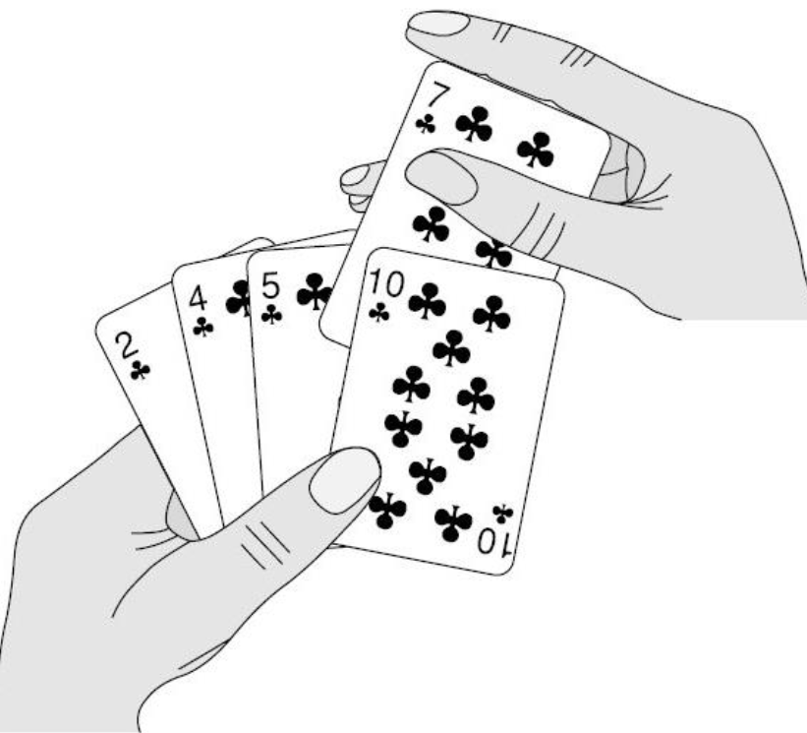

alt:“playing cards” height:300px center

* Assume input array :
* Iterate from to

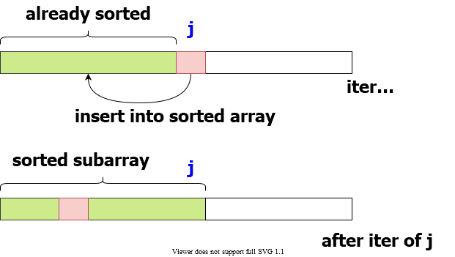

alt:“insertion sort movement” height:450px center

## Insertion Sort Algorithm (2)

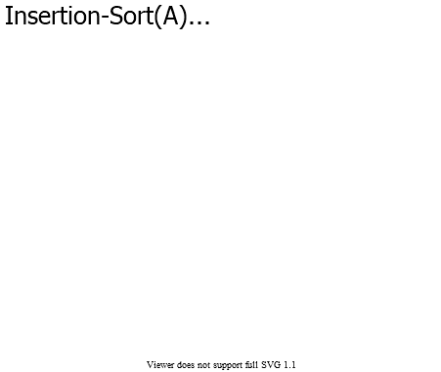

alt:“insertion sort algorithm” height:500px center

## Insertion Sort Algorithm (Pseudo-Code) (3)

Insertion-Sort(A)  
1. for j=2 to A.length  
2. key = A[j]  
3. //insert A[j] into the sorted sequence A[1...j-1]  
4. i = j - 1  
5. while i>0 and A[i]>key  
6. A[i+1] = A[i]  
7. i = i - 1  
8. A[i+1] = key

## Insertion Sort Step-By-Step Description (1)

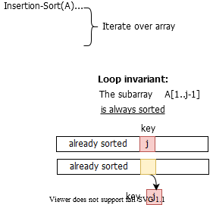

alt:“insertion sort description-1” height:500px center

## Insertion Sort Step-By-Step Description (2)

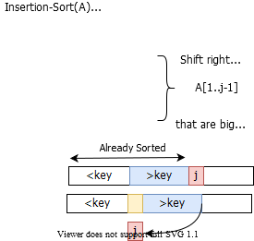

alt:“insertion sort description-2” height:500px center

## Insertion Sort Step-By-Step Description (3)

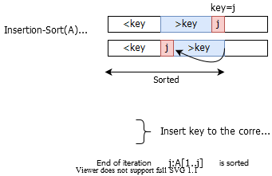

alt:“insertion sort description-3” height:500px center

## Insertion Sort Example

### Insertion Sort Step-1 (initial)

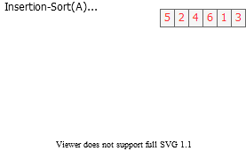

alt:“insertion sort step-1” height:450px center

### Insertion Sort Step-2 (j=2)

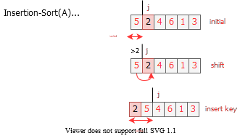

alt:“insertion sort step-2” height:450px center

### Insertion Sort Step-3 (j=3)

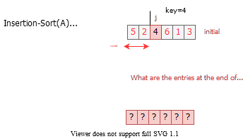

alt:“insertion sort step-3” height:450px center

### Insertion Sort Step-4 (j=3)

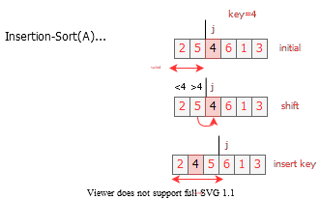

alt:“insertion sort step-4” height:450px center

### Insertion Sort Step-5 (j=4)

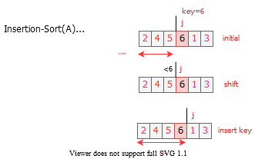

alt:“insertion sort step-5” height:450px center

### Insertion Sort Step-6 (j=5)

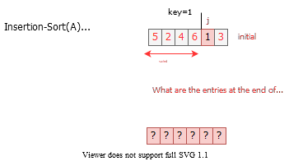

alt:“insertion sort step-6” height:450px center

### Insertion Sort Step-7 (j=5)

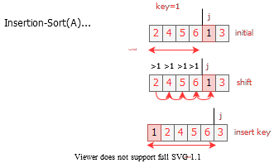

alt:“insertion sort step-7” height:450px center

### Insertion Sort Step-8 (j=6)

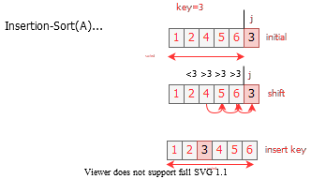

alt:“insertion sort step-8” height:450px center

## Insertion Sort Review (1)

* Items sorted in-place
  + Elements are rearranged within the array.
  + At a most constant number of items stored outside the array at any time (e.,g. the variable key)
  + Input array contains a sorted output sequence when the algorithm ends

## Insertion Sort Review (2)

* Incremental approach
  + Having sorted , place correctly so that is sorted
* Running Time
  + It depends on Input Size (5 elements or 5 billion elements) and Input Itself (partially sorted)
* Algorithm approach to *upper bound* of overall performance analysis

## Visualization of Insertion Sort

[Sorting (Bubble, Selection, Insertion, Merge, Quick, Counting, Radix) - VisuAlgo](https://visualgo.net/en/sorting)

https://www.cs.usfca.edu/~galles/visualization/ComparisonSort.html

https://algorithm-visualizer.org/

[HMvHTs - Online C++ Compiler & Debugging Tool - Ideone.com](https://ideone.com/HMvHTs)

## Kinds of Running Time Analysis (Time Complexity)

* **Worst Case (Big-O Notation)**
  + = maximum processing time of any input
  + Presentation of Big-O :
* **Average Case (Teta Notation)**
  + = average time over all inputs of size , inputs can have a uniform distribution
  + Presentation of Big-Theta :
* **Best Case (Omega Notation)**
  + = min time on any input of size , for example sorted array
  + Presentation of Big-Omega :

## Array Sorting Algorithms Time and Space Complexity

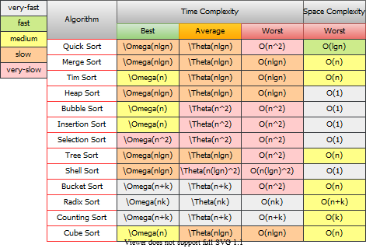

alt:“array sorting algorithms” height:550px center

## Comparison of Time Analysis Cases

For insertion sort, worst-case time depends on the speed of primitive operations such as

* **Relative Speed** (on the same machine)
* **Absolute Speed** (on different machines)
* Asymptotic Analysis
  + Ignore machine-dependent constants
  + Look at the growth of

## Asymptotic Analysis (1)

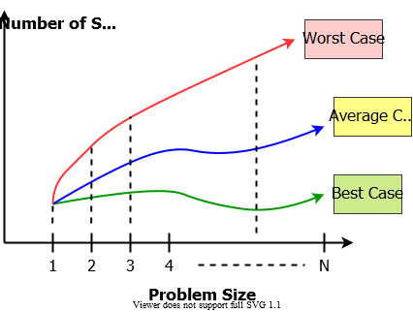

alt:“algorithm analysis comparisons” height:450px center

## Asymptotic Analysis (2)

## Theta-Notation (Average-Case)

* Drop low order terms
* Ignore leading constants

e.g

* As gets large, a algorithm runs faster than a algorithm

## Asymptotic Analysis (3)

For both algorithms, we can see a minimum item size in the following chart. After this point, we can see performance differences. Some algorithms for small item size can be run faster than others but if you increase item size you will see a reference point that notation proof performance metrics.

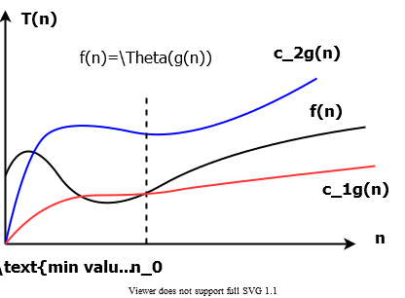

alt:“T(n) and n change graph” height:350px center

## Insertion Sort - Runtime Analysis (1)

Cost Times Insertion-Sort(A)  
---- ----- ---------------------  
c1 n 1. for j=2 to A.length  
c2 n-1 2. key = A[j]  
c3 n-1 3. //insert A[j] into the sorted sequence A[1...j-1]  
c4 n-1 4. i = j - 1  
c5 k5 5. while i>0 and A[i]>key do   
c6 k6 6. A[i+1] = A[i]  
c7 k6 7. i = i - 1  
c8 n-1 8. A[i+1] = key

we have two loops here, if we sum up costs as follow we can see big-O worst case notation.

and

for operation counts

## Insertion Sort - Runtime Analysis (2)

cost function can be evaluated as follow;

## Insertion Sort - Runtime Analysis (3)

## Insertion Sort - Runtime Analysis (4)

## Insertion Sort - Runtime Analysis (5)

## Best-Case Scenario (Sorted Array) (1)

Problem-1, If is already sorted, what will be



alt:“Insertion Sort Best-Case Scenario (Sorted Array)” height:400px center

## Best-Case Scenario (Sorted Array) (2)

*Parameters are taken from image*

for all

## Worst-Case Scenario (Reversed Array) (1)

Problem-2 If is smaller than every entry in , what will be



alt:“Insertion Sort Worst-Case Scenario (Reversed Array)” height:400px center

## Worst-Case Scenario (Reversed Array) (2)

The input array is reverse sorted for all after calculation worst case runtime will be

## Asymptotic Runtime Analysis of Insertion-Sort

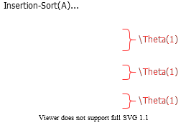

alt:“Asymptotic Runtime Analysis of Insertion-Sort” height:450px center

### Insertion-Sort Worst-case (input reverse sorted)

Inner Loop is

### Insertion-Sort Average-case (all permutations uniformly distributed)

Inner Loop is

## Array Sorting Algorithms Time/Space Complexities

To compare this sorting algorithm please check the following map again.



alt:“array sorting algorithms” height:450px center

## Merge Sort : Divide / Conquer / Combine (1)

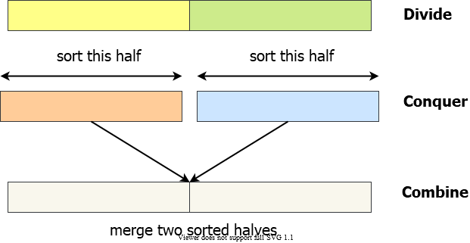

alt:“Merge Sort : Divide / Conquer / Combine” height:450px center

## Merge Sort : Divide / Conquer / Combine (2)

**Divide**: we divide the problem into a number of subproblems

**Conquer**: We solve the subproblems recursively

**Base-Case**: Solve by Brute-Force

**Combine**: Subproblem solutions to the original problem

## Merge Sort Example

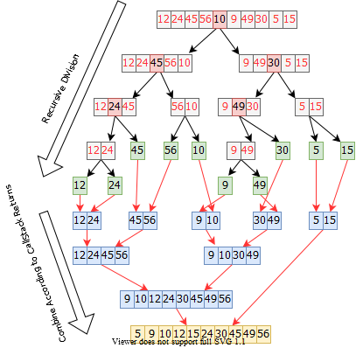

alt:“Merge Sort Example” height:550px center

## Merge Sort Algorithm (initial setup)

Merge Sort is a recursive sorting algorithm, for initial case we need to call Merge-Sort(A,1,n) for sorting

initial case

A : Array  
p : 1 (offset)  
r : n (length)  
Merge-Sort(A,1,n)

## Merge Sort Algorithm (internal iterations)

internal iterations

A : Array  
p : offset  
r : length  
Merge-Sort(A,p,r)  
 if p=r then (CHECK FOR BASE-CASE)  
 return  
 else  
 q = floor((p+r)/2) (DIVIDE)  
 Merge-Sort(A,p,q) (CONQUER)  
 Merge-Sort(A,q+1,r) (CONQUER)  
 Merge(A,p,q,r) (COMBINE)  
 endif

## Merge Sort Algorithm (Combine-1)

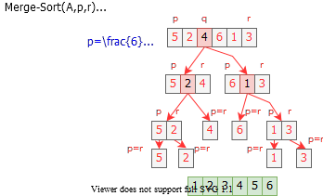

alt:“Merge Sort Algorithm (Combine-1)” height:450px center

## Merge Sort Algorithm (Combine-2)

brute-force task, merging two sorted subarrays

The pseudo-code in the textbook (Sec. 2.3.1)

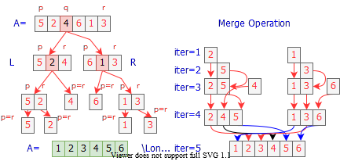

alt:“Merge Sort Algorithm (Combine-2)” height:350px center

## Merge Sort Combine Algorithm (1)

Merge(A,p,q,r)  
 n1 = q-p+1  
 n2 = r-q  
  
 //allocate left and right arrays   
 //increment will be from left to right   
 //left part will be bigger than right part  
  
 L[1...n1+1] //left array  
 R[1...n2+1] //right array  
  
 //copy left part of array  
 for i=1 to n1  
 L[i]=A[p+i-1]  
  
 //copy right part of array  
 for j=1 to n2  
 R[j]=A[q+j]  
  
 //put end items maximum values for termination  
 L[n1+1]=inf  
 R[n2+1]=inf  
  
 i=1,j=1  
 for k=p to r  
 if L[i]<=R[j]  
 A[k]=L[i]  
 i=i+1  
 else  
 A[k]=R[j]  
 j=j+1

## What is the complexity of merge operation?

You can find by counting loops will provide you base constant nested level will provide you exponent of this constant, if you drop constants you will have complexity

we have 3 for loops

it will look like and will be merge complexity

## Merge Sort Correctness

* **Base case**
  + (Trivially correct)
* **Inductive hypothesis**
  + MERGE-SORT is correct for any subarray that is a strict (smaller) subset of .
* **General Case**
  + MERGE-SORT is correct for . From inductive hypothesis and correctness of Merge.

## Merge Sort Algorithm (Pseudo-Code)

A : Array  
p : offset  
r : length  
Merge-Sort(A,p,r)  
 if p=r then (CHECK FOR BASE-CASE)  
 return  
 else  
 q = floor((p+r)/2) (DIVIDE)  
 Merge-Sort(A,p,q) (CONQUER)  
 Merge-Sort(A,q+1,r) (CONQUER)  
 Merge(A,p,q,r) (COMBINE)  
 endif

## Merge Sort Algorithm Complexity

A : Array  
p : offset  
r : length  
Merge-Sort(A,p,r)-------------> T(n)  
 if p=r then--------------->Theta(1)   
 return  
 else  
 q = floor((p+r)/2)---->Theta(1)  
 Merge-Sort(A,p,q)-----> T(n/2)  
 Merge-Sort(A,q+1,r)---> T(n/2)  
 Merge(A,p,q,r)-------->Theta(n)  
 endif

## Merge Sort Algorithm Recurrence

We can describe a function recursively in terms of itself, to analyze the performance of recursive algorithms

## How To Solve Recurrence (1)

## How To Solve Recurrence (2)

We will assume for sufficiently small to rewrite equation as

Solution for this equation will be with following recursion tree.

## How To Solve Recurrence (3)

Multiply by height with each level cost we can found

## How To Solve Recurrence (4)

This tree is binary-tree and binary-tree height is related with item size.

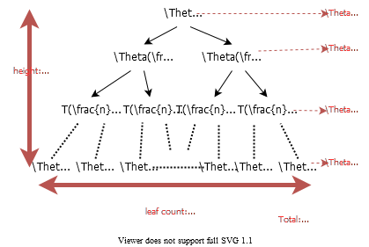

alt:“Merge Sort Recursive Tree” height:500px center

## How Height of a Binary Tree is Equal to ? (1)

Merge-Sort recursion tree is a perfect binary tree, a binary tree is a tree which every node has at most two children, A perfect binary tree is binary tree in which all internal nodes have exactly two children and all leaves are at the same level.

## How Height of a Binary Tree is Equal to ? (2)

Let be the number of nodes in the tree and let denote the number of nodes on level k. According to this;

* i.e. each level has exactly twice as many nodes as the previous level
* , i.e. on the first level we have only one node (the root node)
* The leaves are at the last level, where is the height of the tree.

## How Height of a Binary Tree is Equal to ? (3)

**The total number of nodes** in the tree is equal to the sum of the nodes on all the levels: nodes

## How Height of a Binary Tree is Equal to ? (3)

If we write it as asymptotic approach, we will have the following result

also

nearly half of the nodes are at the leaves

## Review

grows more slowly than

Therefore Merge-Sort beats Insertion-Sort in the worst case

In practice Merge-Sort beats Insertion-Sort for or so

## Asymptotic Notations

### Big-O / - Notation : Asymptotic Upper Bound (Worst-Case) (1)

if positive constants , such that

### Big-O / - Notation : Asymptotic Upper Bound (Worst-Case) (2)

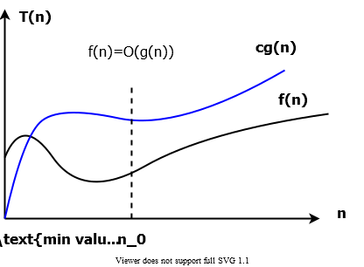

alt:“Big-O Function-1” height:450px center

### Big-O / - Notation : Asymptotic Upper Bound (Worst-Case) (3)

Asymptotic running times of algorithms are usually defined by functions whose domain are (natural numbers)

### Big-O / - Notation : Asymptotic Upper Bound (Worst-Case) (4)

#### Example-1

Show that

we need to find two positive constant and such that:

Choose and

Or, choose and

### Big-O / - Notation : Asymptotic Upper Bound (Worst-Case) (5)

#### Example-2

Show that

We need to find two positive constant and such that:

Choose and

### Big-O / - Notation : Asymptotic Upper Bound (Worst-Case) (6)

We can say the followings about equation

The notation is a little sloppy

One-way equation, e.q. but we cannot say

### Big-O / - Notation : Asymptotic Upper Bound (Worst-Case) (7)

is in fact a set of functions as follow

### Big-O / - Notation : Asymptotic Upper Bound (Worst-Case) (8)

In other words is in fact, the set of functions that have asymptotic upper bound

e.q means

### Big-O / - Notation : Asymptotic Upper Bound (Worst-Case) (9)

#### Example-1

choose and

**CORRECT**

### Big-O / - Notation : Asymptotic Upper Bound (Worst-Case) (10)

#### Example-2

choose and

**CORRECT**

### Big-O / - Notation : Asymptotic Upper Bound (Worst-Case) (11)

#### Example-3

**INCORRECT** (Contradiction)

### Big-O / - Notation : Asymptotic Upper Bound (Worst-Case) (12)

If we analysis case, -notation is an upper bound notation and the runtime of algorithm A is **at least** .

: The set of functions with asymptotic **upper bound**

means for some

function is also in . Hence : , runtime must be nonnegative.

### Big-Omega / -Notation : Asymptotic Lower Bound (Best-Case) (1)

if positive constants such that

### Big-Omega / -Notation : Asymptotic Lower Bound (Best-Case) (2)

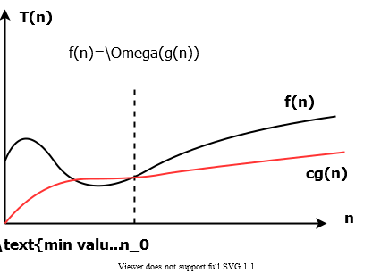

alt:“Big-Omega Function-1” height:450px center

### Big-Omega / -Notation : Asymptotic Lower Bound (Best-Case) (3)

#### Example-1

Show that

We need to find two positive constants and such that:

Choose and

### Big-Omega / -Notation : Asymptotic Lower Bound (Best-Case) (4)

#### Example-4

Show that

We need to find two positive constants and such that:

Choose and

### Big-Omega / -Notation : Asymptotic Lower Bound (Best-Case) (5)

is the set of functions that have asymptotic lower bound

### Big-Omega / -Notation : Asymptotic Lower Bound (Best-Case) (6)

#### Example-1

Choose and

**CORRECT**

### Big-Omega / -Notation : Asymptotic Lower Bound (Best-Case) (7)

#### Example-2

**INCORRECT**(Contradiction)

### Big-Omega / -Notation : Asymptotic Lower Bound (Best-Case) (8)

#### Example-3

Choose and

**CORRECT**

### Comparison of Notations (1)

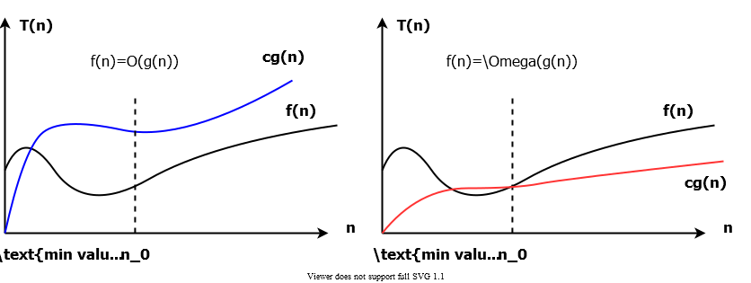

alt:“Big-Omega Function for Comparison” height:500px center

### Comparison of Notations (2)

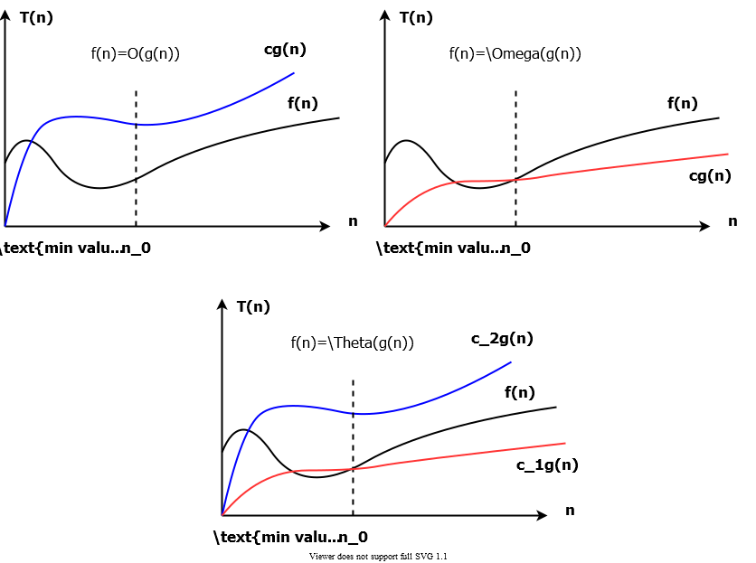

alt:“Comparison of Notations” height:550px center

### Big-Theta /-Notation : Asymptotically tight bound (Average Case) (1)

### Big-Theta /-Notation : Asymptotically tight bound (Average Case) (2)



alt:“Big-Theta Function” height:450px center

### Big-Theta /-Notation : Asymptotically tight bound (Average Case) (3)

#### Example-1

Show that

We need to find 3 positive constants and such that:

for all

for all

Choose and

for all

### Big-Theta /-Notation : Asymptotically tight bound (Average Case) (4)

#### Example-2.1

Show that

We need to find 3 positive constants and such that:

Choose 3 positive constants that satisfy for all

### Big-Theta /-Notation : Asymptotically tight bound (Average Case) (5)

#### Example-2.2

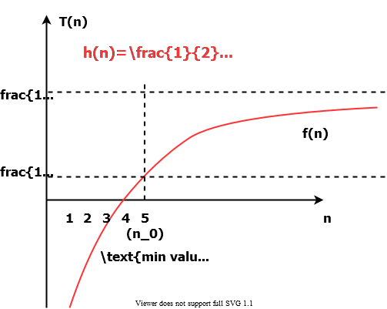

alt:“Big-Theta Example” height:500px center

### Big-Theta /-Notation : Asymptotically tight bound (Average Case) (6)

#### Example-2.3

Therefore we can choose

### Big-Theta /-Notation : Asymptotically tight bound (Average Case) (7)

**Theorem**: leading constants & low-order terms don’t matter

**Justification**: can choose the leading constant large enough to make high-order term dominate other terms

### Big-Theta /-Notation : Asymptotically tight bound (Average Case) (8)

#### Example-1

**CORRECT**

**INCORRECT**

**INCORRECT**

### Big-Theta /-Notation : Asymptotically tight bound (Average Case) (9)

is the set of functions that have asymptotically tight bound

positive constants such that

### Big-Theta /-Notation : Asymptotically tight bound (Average Case) (10)

**Theorem**:

if and only if and

is stronger than both and

### Big-Theta /-Notation : Asymptotically tight bound (Average Case) (11)

#### Example-1.1

Prove that

We can check that and

Proof by contradiction for notation

### Big-Theta /-Notation : Asymptotically tight bound (Average Case) (12)

#### Example-1.2

Suppose positive constants and exist such that:

**Contradiction**: is a constant

### Summary of and notations (1)

: The set of functions with asymptotic upper bound

: The set of functions with asymptotic lower bound

: The set of functions with asymptotically tight bound

### Summary of and notations (2)



alt:“Summary Asymptotic Analysis” height:500px center

### Small-o / -Notation : Asymptotic upper bound that is not tight (1)

Remember, upper bound provided by big- notation can be tight or not tight

Tight mean values are close the original function

e.g. followings are true

is asymptotically tight

is not asymptotically tight

According to this small- notation is an upper bound that is not asymptotically tight

### Small-o / -Notation : Asymptotic upper bound that is not tight (2)

**Note that in equations equality is removed in small notations**

e.g any positive satisfies but does not satisfy

### Small-omega / -Notation: Asymptotic lower bound that is not tight (1)

e.g. , any positive satisfies but , does not satisfy

### (Important) Analogy to compare of two real numbers (1)

### (Important) Analogy to compare of two real numbers (2)

### (Important) Trichotomy property for real numbers

For any two real numbers and , we have either

, or , or

Trichotomy property does not hold for asymptotic notation, for two functions and , it may be the case that neither nor holds.

e.g.  and cannot be compared asymptotically

### Examples

|  | TRUE |  | FALSE |
| --- | --- | --- | --- |
|  | **TRUE** |  | TRUE |
|  | **TRUE** |  | FALSE |
|  | FALSE |  | FALSE |
|  | FALSE |  | TRUE |
|  | **TRUE** |  |  |
|  | FALSE |  | TRUE |
|  | FALSE |  | FALSE |

### Asymptotic Function Properties

**Transitivity**: holds for all

e.g.

**Reflexivity**: holds for

e.g.

**Symmetry**: hold only for

e.g.

**Transpose Symmetry**: holds for and

e.g.

### Using -Notation to Describe Running Times (1)

Used to bound worst-case running times, Implies an upper bound runtime for arbitrary inputs as well

**Example:**

Insertion sort has worst-case runtime of

**Note:**

* This upper bound also applies to its running time on every input
  + Abuse to say “running time of insertion sort is ”
* For a given , the actual running time depends on the particular input of size
  + i.e., running time is not only a function of
* However, **worst-case** running time is only a function of

### Using -Notation to Describe Running Times (2)

* When we say:
  + Running time of insertion sort is
* What we really mean is
  + Worst-case running time of insertion sort is
* or equivalently
  + No matter what particular input of size n is chosen, the running time on that set of inputs is

### Using -Notation to Describe Running Times (1)

Used to bound best-case running times, Implies a lower bound runtime for arbitrary inputs as well

**Example:**

Insertion sort has best-case runtime of

**Note**:

* This lower bound also applies to its running time on every input

### Using -Notation to Describe Running Times (2)

* When we say
  + Running time of algorithm A is
* What we mean is
  + For any input of size , the runtime of A is *at least* a constant times for sufficiently large
* It’s not contradictory to say
  + **worst-case** running time of insertion sort is
  + Because there exists an input that causes the algorithm to take

### Using -Notation to Describe Running Times (1)

Consider 2 cases about the runtime of an algorithm

* **Case 1:** Worst-case and best-case not asymptotically equal
  + Use -notation to bound worst-case and best-case runtimes separately
* **Case 2:** Worst-case and best-case asymptotically equal
  + Use -notation to bound the runtime for any input

### Using -Notation to Describe Running Times (2)

* **Case 1:** Worst-case and best-case not asymptotically equal
  + Use -notation to bound the worst-case and best-case runtimes separately
  + We can say:
    - “The worst-case runtime of insertion sort is ”
    - “The best-case runtime of insertion sort is ”
  + But, we can’t say:
    - “The runtime of insertion sort is for every input”
  + A -bound on worst/best-case running time does not apply to its running time on arbitrary inputs

### Worst-Case and Best-Case Equation for Merge-Sort

e.g. for merge-sort, we have:

### Using Asymptotic Notation to Describe Runtimes Summary (1)

* “The worst case runtime of Insertion Sort is ”
  + Also implies: “The runtime of Insertion Sort is ”
* “The best-case runtime of Insertion Sort is ”
  + Also implies: “The runtime of Insertion Sort is ”

### Using Asymptotic Notation to Describe Runtimes Summary (2)

* “The worst case runtime of Insertion Sort is ”
  + But: “The runtime of Insertion Sort is not ”
* “The best case runtime of Insertion Sort is ”
  + But: “The runtime of Insertion Sort is not ”

### Using Asymptotic Notation to Describe Runtimes Summary (3)

#### Which one is true?

* **FALSE** “The worst case runtime of Merge Sort is ”
* **FALSE** “The best case runtime of Merge Sort is ”
* **TRUE** “The runtime of Merge Sort is ”
  + This is true, because the best and worst case runtimes have asymptotically the same tight bound

### Asymptotic Notation in Equations (RHS)

* Asymptotic notation appears alone on the **RHS** of an equation:
  + implies set membership
    - e.g., means

Asymptotic notation appears on the **RHS** of an equation stands for some anonymous function in the set

* e.g., means:
* , for some
  + i.e.,

### Asymptotic Notation in Equations (LHS)

* Asymptotic notation appears on the **LHS** of an equation:
  + stands for any anonymous function in the set
    - e.g., means:
  + for any function
  + some function
    - such that
* **RHS** provides coarser level of detail than **LHS**

## References

* [Introduction to Algorithms, Third Edition | The MIT Press](https://mitpress.mit.edu/books/introduction-algorithms-third-edition)
* [Bilkent CS473 Course Notes (new)](http://nabil.abubaker.bilkent.edu.tr/473/)
* [Bilkent CS473 Course Notes (old)](http://cs.bilkent.edu.tr/~ugur/teaching/cs473/)
* [Insertion Sort - GeeksforGeeks](https://www.geeksforgeeks.org/insertion-sort/)
* [NIST Dictionary of Algorithms and Data Structures](https://xlinux.nist.gov/dads/)
* [NIST - Dictionary of Algorithms and Data Structures](https://xlinux.nist.gov/dads/)
* [NIST - big-O notation](https://xlinux.nist.gov/dads/HTML/bigOnotation.html)
* [NIST - big-Omega notation](https://xlinux.nist.gov/dads/HTML/omegaCapital.html)