CE100 Algorithms and Programming II

Dynamic Programming

Author: Asst. Prof. Dr. Uğur CORUH

## CE100 Algorithms and Programming II

## Week-5 (Dynamic Programming)

#### Spring Semester, 2021-2022

Download [DOC](ce100-week-5-dp.md_doc.pdf), [SLIDE](ce100-week-5-dp.md_slide.pdf), [PPTX](ce100-week-5-dp.md_slide.pptx)

## Quicksort Sort

## Outline

* Convex Hull (Divide & Conquer)
* Dynamic Programming
  + Introduction
  + Divide-and-Conquer (DAC) vs Dynamic Programming (DP)
* Fibonacci Numbers
  + Recursive Solution
  + Bottom-Up Solution
* Optimization Problems
* Development of a DP Algorithms
* Matrix-Chain Multiplication
  + Matrix Multiplication and Row Columns Definitions
  + Cost of Multiplication Operations (pxqxr)
  + Counting the Number of Parenthesizations
* The Structure of Optimal Parenthesization
  + Characterize the structure of an optimal solution
  + A Recursive Solution
    - Direct Recursion Inefficiency.
  + Computing the optimal Cost of Matrix-Chain Multiplication
  + Bottom-up Computation
* Algorithm for Computing the Optimal Costs
  + MATRIX-CHAIN-ORDER
* Construction and Optimal Solution
  + MATRIX-CHAIN-MULTIPLY
* Summary

## Dynamic Programming - **Introduction**

* An algorithm design paradigm like divide-and-conquer
* **Programming:** A tabular method (not writing computer code)
  + Older sense of planning or scheduling, typically by filling in a table
* **Divide-and-Conquer (DAC):** subproblems are independent
* **Dynamic Programming (DP):** subproblems are not independent
* Overlapping subproblems: subproblems share sub-subproblems
  + In solving problems with overlapping subproblems
    - A DAC algorithm **does redundant** work
      * Repeatedly solves common subproblems
    - A DP algorithm solves each problem just once
      * **Saves** its result **in a table**

## Problem 1: **Fibonacci Numbers** Recursive Solution

* **Reminder:**
* Overlapping subproblems in different recursive calls. Repeated work!

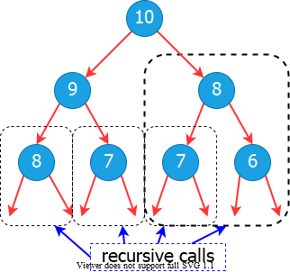

bg right:40% w:500px

## Problem 1: **Fibonacci Numbers** Recursive Solution

* **Recurrence:**
  + *exponential runtime*
$$T\left(n\right)=T\left(n−1\right)+T\left(n−2\right)+1$$

* Recursive algorithm inefficient because it recomputes the same $F\left(i\right)$ repeatedly in different branches of the recursion tree.

## Problem 1: **Fibonacci Numbers** Bottom-up Computation

* **Reminder:**
* **Runtime $Θ\left(n\right)$**

ITER-FIBO(n)  
 F[0] = 0  
 F[1] = 1  
 for i = 2 to n do  
 F[i] = F[i-1] + F[i-2]  
 return F[n]

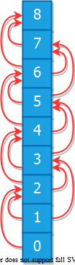

bg right:40% w:150px

## Optimization Problems

* **DP** typically applied to optimization problems
* In an optimization problem
  + There are many possible solutions (feasible solutions)
  + Each solution has a value
  + Want to find an optimal solution to the problem
    - *A solution with the optimal value (min or max value)*
  + Wrong to say **the** optimal solution to the problem
    - *There may be several solutions with the same optimal value*

## Development of a DP Algorithm

**Step-1**. Characterize the structure of an optimal solution **Step-2**. Recursively define the value of an optimal solution **Step-3**. Compute the value of an optimal solution in a bottom-up fashion **Step-4**. Construct an optimal solution from the information computed in **Step 3**

## Problem 2: **Matric Chain Multiplication**

* **Input:** a sequence (chain) $⟨A_{1},A_{2},…,A_{n}⟩$ of $n$ matrices
* **Aim:** compute the product $A_{1}⋅A_{2}⋅…A_{n}$
* A **product of matrices** is **fully parenthesized** if
  + It is either a **single matrix**
  + Or, the **product** of **two fully parenthesized matrix products** surrounded by a pair of parentheses. $(A_{i}\left(A_{i+1}A_{i+2}…A_{j}\right))$ $(\left(A_{i}A_{i+1}A_{i+2}…A_{j−1}\right)A_{j})$ $(\left(A_{i}A_{i+1}A_{i+2}…A_{k}\right)\left(A_{k+1}A_{k+2}…A_{j}\right))$ for $i≤k<j$
* All parenthesizations yield the same product; matrix product is associative

## Matrix-chain Multiplication: **An Example Parenthesization**

* **Input: $⟨A_{1},A_{2},A_{3},A_{4}⟩$** ( $5$ distinct ways of full parenthesization)
$$\begin{matrix} & (A_{1}(A_{2}\left(A_{3}A_{4}\right))) \\ & (A_{1}(\left(A_{2}A_{3}\right)A_{4})) \\ & (\left(A_{1}A_{2}\right)\left(A_{3}A_{4}\right)) \\ & ((A_{1}\left(A_{2}A_{3}\right)A_{4})) \\ & ((\left(A_{1}A_{2}\right)A_{3})A_{4})\end{matrix}$$

* The way we parenthesize a chain of matrices can have a dramatic effect on the cost of computing the product

## Matrix-chain Multiplication: **Reminder**

MATRIX-MULTIPLY(A, B)  
 if cols[A]!=rows[B] then   
 error(“incompatible dimensions”)  
 for i=1 to rows[A] do  
 for j=1 to cols[B] do   
 C[i,j]=0  
 for k=1 to cols[A] do   
 C[i,j]=C[i,j]+A[i,k]·B[k,j]  
 return C

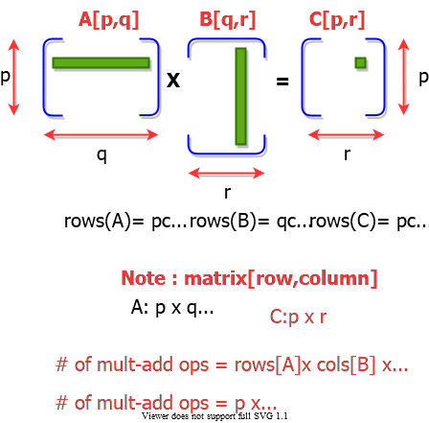

bg right:50% w:500px

## Matrix Chain Multiplication: **Example**

* $A1:10\text{x}100$, $A2:100\text{x}5$, $A3:5\text{x}50$
  + Which paranthesization is better? $\left(A1A2\right)A3$ or $A1\left(A2A3\right)$?
* 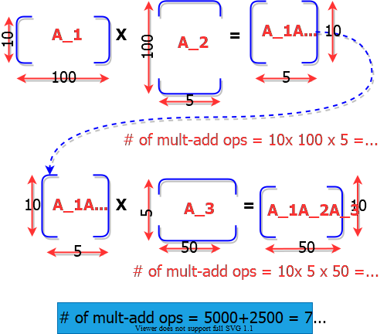
* bg right:50% w:650px

## Matrix Chain Multiplication: **Example**

* $A1:10×100$, $A2:100×5$, $A3:5×50$
  + Which paranthesization is better? $\left(A1A2\right)A3$ or $A1\left(A2A3\right)$?
* 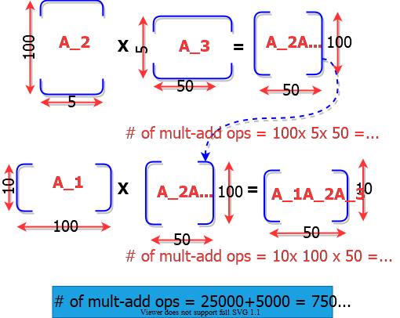
* bg right:50% w:650px

## Matrix Chain Multiplication: **Example**

* $A1:10×100$, $A2:100×5$, $A3:5×50$
  + Which paranthesization is better? $\left(A1A2\right)A3$ or $A1\left(A2A3\right)$?

**In summary:**

* $\left(A1A2\right)A3$ = $\#$ of multiply-add ops: $7500$
* $A1\left(A2A3\right)$ = $\#$ of multiple-add ops: $75000$

First parenthesization yields **10x faster** computation

## Matrix-chain Multiplication Problem

* **Input:** A chain $⟨A_{1},A_{2},…,A_{n}⟩$ of $n$ matrices,
  + where $A_{i}$ is a $p_{i−1}×p_{i}$ matrix
* **Objective:** Fully parenthesize the product
  + - such that the number of **scalar mult-adds** is minimized.

## Counting the Number of Parenthesizations

* **Brute force approach:** exhaustively check all parenthesizations
* $P\left(n\right)$: $\#$ of parenthesizations of a sequence of n matrices
* We can split sequence between $k^{th}$ and ${\left(k+1\right)}^{st}$ matrices for any $k=1,2,…,n−1$, then parenthesize the two resulting sequences independently, i.e.,
$$\left(A_{1}A_{2}A_{3}…A_{k}\overset{break−point}{\overbrace{)(}}A_{k+1}A_{k+2}…A_{n}\right)$$

* We obtain the recurrence

$$P\left(1\right)=1\text{ and }P\left(n\right)=\sum_{k=1}^{n−1}{P}\left(k\right)P\left(n−k\right)$$

## Number of Parenthesizations:

* $P\left(1\right)=1$ and $P\left(n\right)=\sum_{k=1}^{n−1}{P}\left(k\right)P\left(n−k\right)$
* The recurrence generates the sequence of **Catalan Numbers** Solution is $P\left(n\right)=C\left(n−1\right)$ where
$$C\left(n\right)=\frac{1}{n+1}\left({2n \atop n}\right)=Ω\left(4^{n}/n^{3/2}\right)$$

* The number of solutions is **exponential** in $n$
* Therefore, brute force approach is a poor strategy

## The Structure of Optimal Parenthesization

* **Notation: $A_{i..j}$** : The matrix that results from evaluation of the product: $A_{i}A_{i+1}A_{i+2}…A_{j}$
* **Observation:** Consider the last multiplication operation in any parenthesization: $\left(A_{1}A_{2}…A_{k}\right)⋅\left(A_{k+1}A_{k+2}…A_{n}\right)$
  + There is a $k$ value $\left(1≤k<n\right)$ such that:
    - First, the product $A_{1}…k$ is computed
    - Then, the product $A_{k+1…n}$ is computed
    - Finally, the matrices $A_{1…k}$ and $A_{k+1…n}$ are multiplied

## **Step 1:** Characterize the Structure of an Optimal Solution

* An optimal parenthesization of product $A_{1}A_{2}…A_{n}$ will be: $\left(A_{1}A_{2}…A_{k}\right)⋅\left(A_{k+1}A_{k+2}…A_{n}\right)$ for some $k$ value
* The **cost of this optimal parenthesization** will be: $=$ Cost of computing $A_{1…k}$ $+$ Cost of computing $A_{k+1…n}$ $+$ Cost of multiplying $A_{1…k}⋅A_{k+1…n}$

## **Step 1:** Characterize the Structure of an Optimal Solution

* **Key observation:** Given optimal parenthesization
$\left(A_{1}A_{2}A_{3}…A_{k}\right)⋅\left(A_{k+1}A_{k+2}…A_{n}\right)$

* Parenthesization of the subchain $A_{1}A_{2}A_{3}…A_{k}$
* Parenthesization of the subchain $A_{k+1}A_{k+2}…A_{n}$

should both be optimal

* Thus, optimal solution to an instance of the problem contains optimal solutions to subproblem instances
  + **i.e.**, optimal substructure within an optimal solution exists.

## **Step 2:** A Recursive Solution

* **Step 2:** Define the value of an optimal solution recursively in terms of optimal solutions to the subproblems
* Assume we are trying to determine the min cost of computing $A_{i…j}$
* $m_{i,j}$: min $\#$ of scalar multiply-add opns needed to compute $A_{i…j}$
  + **Note:** *The optimal cost of the original problem: $m_{1,n}$*
* How to compute $m_{i,j}$ recursively?

## **Step 2:** A Recursive Solution

* Base case: $m_{i,i}=0$ (single matrix, no multiplication)
* Let the size of matrix $A_{i}$ be $\left(p_{i−1}×p_{i}\right)$
* Consider an optimal parenthesization of chain
$A_{i}…A_{j}:\left(A_{i}…A_{k}\right)⋅\left(A_{k+1}…A_{j}\right)$

* The optimal cost: $m_{i,j}=m_{i,k}+m_{k+1,j}+p_{i−1}×p_{k}×p_{j}$
* **where:**
  + $m_{i,k}$: Optimal cost of computing $A_{i…k}$
  + $m_{k+1,j}$: Optimal cost of computing $A_{k+1…j}$
  + $p_{i−1}×p_{k}×p_{j}$: Cost of multiplying $A_{i…k}$ and $A_{k+1…j}$

## **Step 2:** A Recursive Solution

* In an optimal parenthesization: $k$ must be chosen to minimize $m_{ij}$
* The recursive formulation for $m_{ij}$:

$$\begin{matrix}m_{ij}=\left\{\begin{matrix}0 & if & i=j \\ \underset{i≤k<j}{MIN}\{m_{ik}+m_{k+1,j}+p_{i−1}p_{k}p_{j}\} & if & i<j\end{matrix}\right.\end{matrix}$$

## **Step 2:** A Recursive Solution

* The $m_{ij}$ values give the **costs of optimal solutions** to subproblems
* In order to keep track of how to construct an optimal solution
  + Define $s_{ij}$ to be the value of $k$ which yields the optimal split of the subchain $A_{i…j}$
    - That is, $s_{ij}=k$ such that
      * $m_{ij}=m_{ik}+m_{k+1,j}+p_{i−1}p_{k}p_{j}$ holds

## Direct Recursion: **Inefficient!**

* Recursive Matrix-Chain (**RMC**) Order

RMC(p,i,j)  
   
 if (i == j) then   
 return 0  
   
 m[i, j] = INF   
   
 for k=i to j-1 do  
   
 q = RMC(p, i, k) + RMC(p, k+1, j) + p_{i-1} p_k p_j  
   
 if q < m[i, j] then  
 m[i, j] = q  
   
 endfor  
  
 return m[i, j]

## Direct Recursion: **Inefficient!**

* Recursion tree for $RMC\left(p,1,4\right)$
* Nodes are labeled with $i$ and $j$ values
* 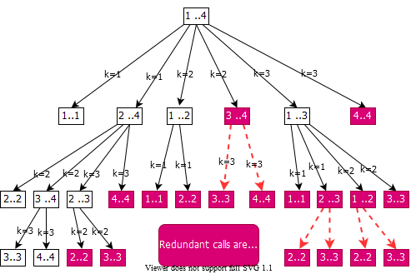
* bg right:60% w:650px

## Computing the Optimal Cost (**Matrix-Chain Multiplication**)

**An important observation:** - We have **relatively few subproblems** - one problem for each choice of $i$ and $j$ satisfying $1≤i≤j≤n$- total $n+\left(n−1\right)+…+2+1=\frac{1}{2}n\left(n+1\right)=Θ\left(n2\right)$ subproblems - We can write a **recursive** algorithm based on recurrence. - However, a recursive algorithm may encounter each subproblem many times in different branches of the recursion tree - This property, **overlapping subproblems**, is the **second important feature** for applicability of **dynamic programming**

## Computing the Optimal Cost (**Matrix-Chain Multiplication**)

* Compute the value of an optimal solution in a **bottom-up** fashion
  + matrix $A_{i}$ has dimensions $p_{i−1}×p_{i}$ for $i=1,2,…,n$
  + the input is a sequence $⟨p_{0},p_{1},…,p_{n}⟩$ where $length\left[p\right]=n+1$
* Procedure uses the following auxiliary tables:
  + $m\left[1…n,1…n\right]$: for storing the $m\left[i,j\right]$ costs
  + $s\left[1…n,1…n\right]$: records which index of $k$ achieved the optimal cost in computing $m\left[i,j\right]$

## **Bottom-Up** Computation

* How to choose the order in which we process $m_{ij}$ values?
* Before computing $m_{ij}$, we have to make sure that the values for $m_{ik}$ and $m_{k+1,j}$ have been computed for all $k$.

$$m_{ij}=\underset{i≤k<j}{MIN}\{m_{ik}+m_{k+1,j}+p_{i−1}p_{k}p_{j}\}$$

## **Bottom-Up** Computation

$$m_{ij}=\underset{i≤k<j}{MIN}\{m_{ik}+m_{k+1,j}+p_{i−1}p_{k}p_{j}\}$$

* $m_{ij}$ must be processed after $m_{ik}$ and $m_{j,k+1}$
* **Reminder: $m_{ij}$** computed only for $j>i$

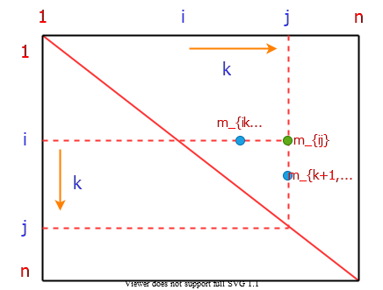

bg right:50% h:500px

## **Bottom-Up** Computation

$$m_{ij}=\underset{i≤k<j}{MIN}\{m_{ik}+m_{k+1,j}+p_{i−1}p_{k}p_{j}\}$$

* $m_{ij}$ must be processed after $m_{ik}$ and $m_{j,k+1}$
* How to set up the iterations over $i$ and $j$ to compute $m_{ij}$?

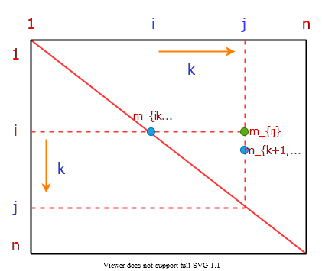

bg right:50% h:500px

## **Bottom-Up** Computation

$$m_{ij}=\underset{i≤k<j}{MIN}\{m_{ik}+m_{k+1,j}+p_{i−1}p_{k}p_{j}\}$$

* If the entries $m_{ij}$ are computed in the shown order, then $m_{ik}$ and $m_{k+1,j}$ values are guaranteed to be computed before $m_{ij}$.

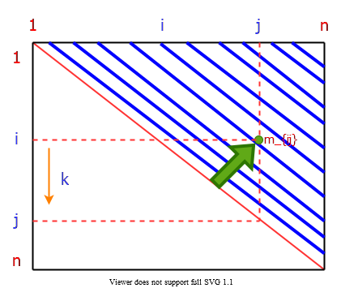

bg right:50% h:500px

## **Bottom-Up** Computation

$$m_{ij}=\underset{i≤k<j}{MIN}\{m_{ik}+m_{k+1,j}+p_{i−1}p_{k}p_{j}\}$$

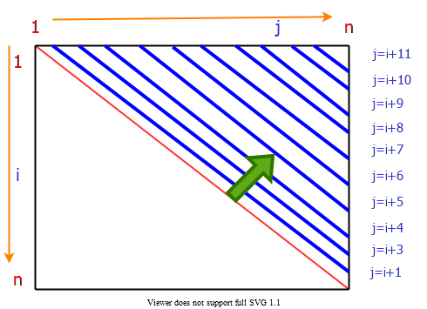

bg right:50% h:450px

## **Bottom-Up** Computation

$$m_{ij}=\underset{i≤k<j}{MIN}\{m_{ik}+m_{k+1,j}+p_{i−1}p_{k}p_{j}\}$$

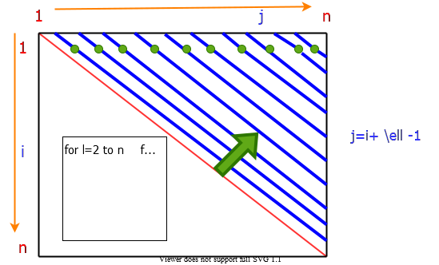

bg right:65% h:500px

## Algorithm for Computing the Optimal Costs

* *Note*: l $=ℓ$ and p_{i-1} p_k p_j $=p_{i−1}p_{k}p_{j}$

MATRIX-CHAIN-ORDER(p)  
 n = length[p]-1  
 for i=1 to n do  
 m[i, i]=0  
 endfor  
 for l=2 to n do  
 for i=1 to n n-l+1 do  
 j=i+l-1  
 m[i, j]=INF  
 for k=i to j-1 do  
 q=m[i,k]+m[k+1, j]+p_{i-1} p_k p_j  
 if q < m[i,j] then  
 m[i,j]=q  
 s[i,j]=k  
 endfor  
 endfor  
 endfor  
 return m and s

## Algorithm for Computing the Optimal Costs

* The algorithm first computes
  + $m\left[i,i\right]←0$ for $i=1,2,…,n$ min costs for all chains of length 1
* **Then**, for $ℓ=2,3,…,n$ computes
  + $m\left[i,i+ℓ−1\right]$ for $i=1,…,n−ℓ+1$ min costs for all chains of length $ℓ$
* For each value of $ℓ=2,3,…,n$,
  + $m\left[i,i+ℓ−1\right]$ depends only on table entries $m\left[i,k\right]\&m\left[k+1,i+ℓ−1\right]$ for $i≤k<i+ℓ−1$, which are already computed

## Algorithm for Computing the Optimal Costs

## **Table access pattern** in computing s for

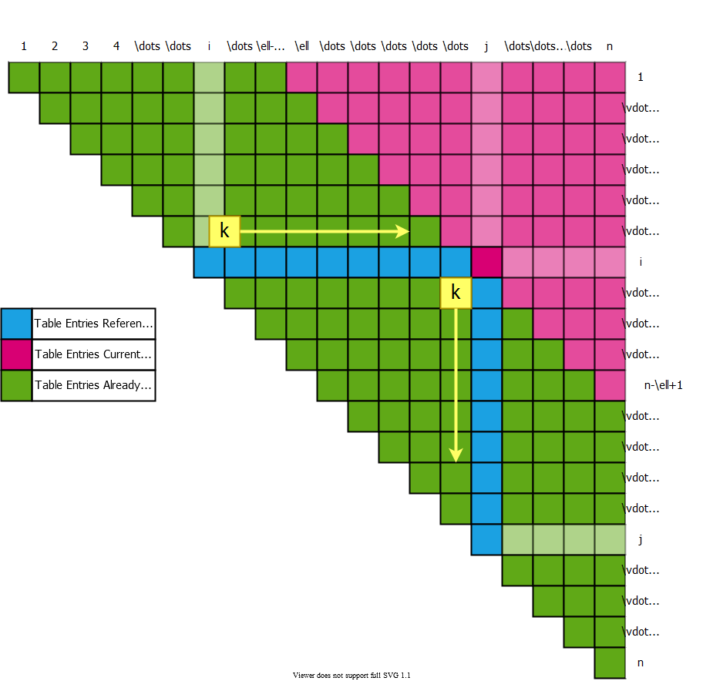

bg right:50% h:600px

## **Table access pattern** in computing s for

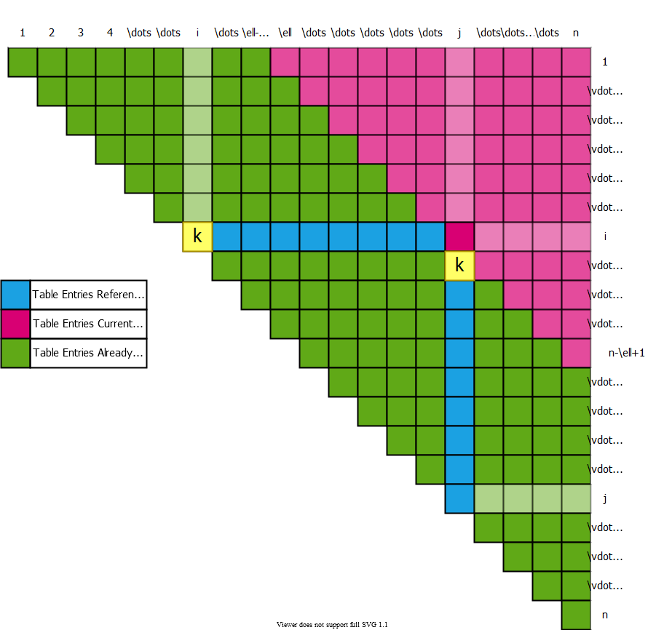

bg right:50% h:600px

## **Table access pattern** in computing $m\left[i,j\right]$ s for $ℓ=j−i+1$

$$\begin{matrix}\left(\left(A_{i}A_{i+1}\right)\overset{mult.}{\overbrace{⋮}}\left(A_{i+2}…A_{j}\right)\right)\end{matrix}$$

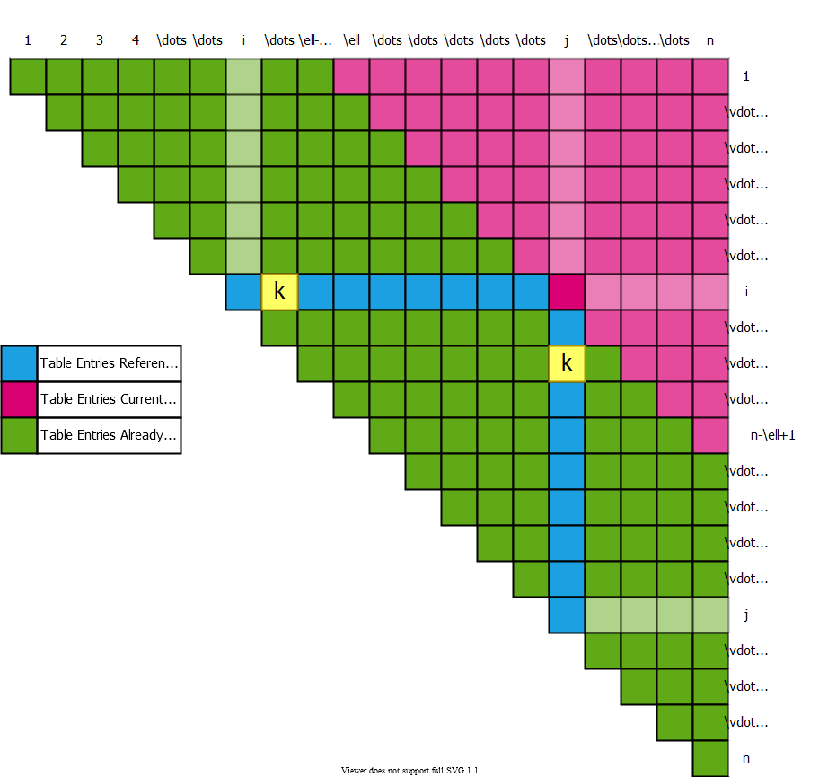

bg right:50% h:600px

## **Table access pattern** in computing s for

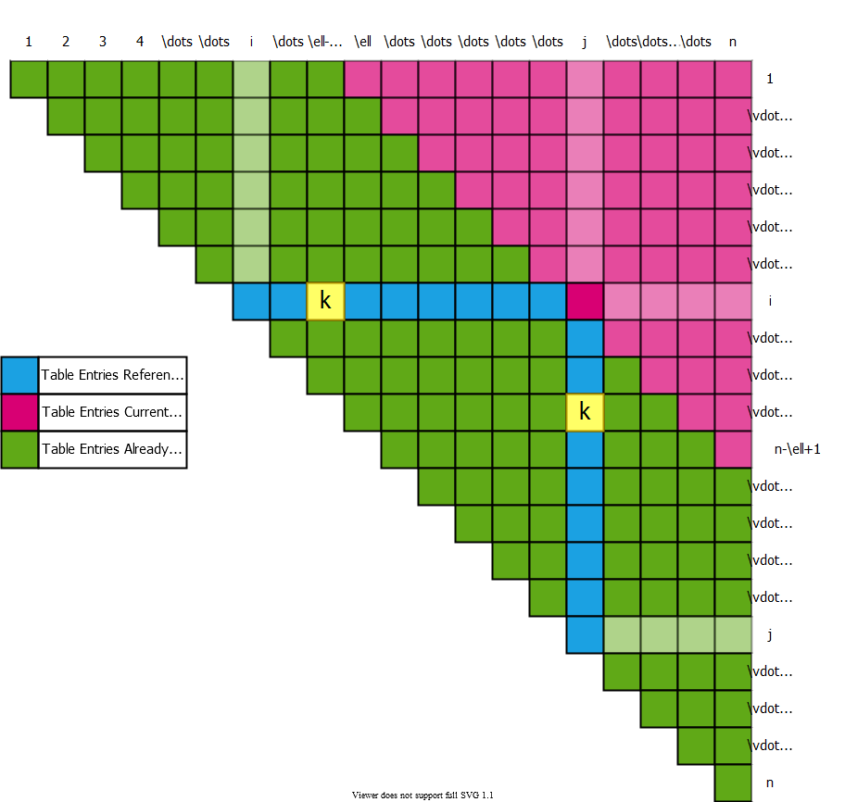

bg right:50% h:600px

## **Table access pattern** in computing s for

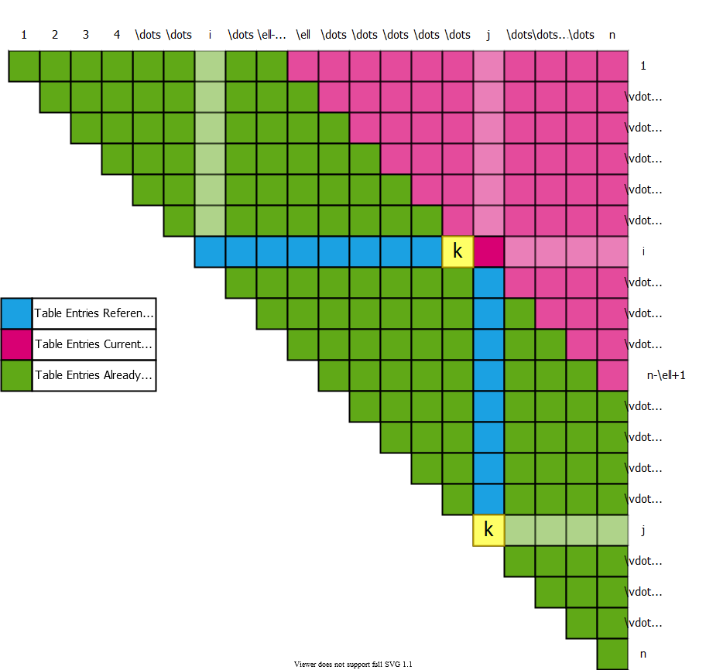

bg right:50% h:600px

## **Table access pattern** Example

* Compute
* Choose the value that leads to **min cost**

$$
m_{ij}=\underset{i \leq k < j}{MIN} \{ m_{ik} + m_{k+1,j} + p_{i-1} p_k p_j \} \\[10pt]
\begin{align*}
\begin{aligned}
A_1 &: (30 \times 35) \\
A_2 &: (35 \times 15) \\
A_3 &: (15 \times 5) \\
A_4 &: (5 \times 10) \\
A_5 &: (10 \times 20) \\
A_6 &: (20 \times 25)
\end{aligned}
\begin{aligned}
& ((A_2) \overbrace{\vdots}^{ (k=2) } (A_3 A_4 A_5)) \\[10 pt]
\quad cost &= m_{22} + m_{35} + p_1p_2p_5 \\
&= 0 + 2500 + 35 \times 15 \times 20 \\
&= 13000
\end{aligned}
\end{align*}
$$

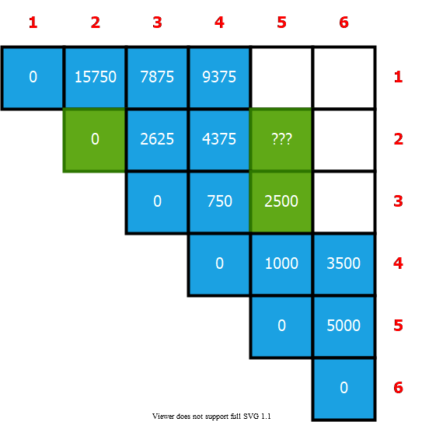

bg right:40% h:500px

## **Table access pattern** Example

* Compute
* Choose the value that leads to **min cost**

$$
m_{ij}=\underset{i \leq k < j}{MIN} \{ m_{ik} + m_{k+1,j} + p_{i-1} p_k p_j \} \\[10pt]
\begin{align*}
\begin{aligned}
A_1 &: (30 \times 35) \\
A_2 &: (35 \times 15) \\
A_3 &: (15 \times 5) \\
A_4 &: (5 \times 10) \\
A_5 &: (10 \times 20) \\
A_6 &: (20 \times 25)
\end{aligned}
\begin{aligned}
& ((A_2 A_3) \overbrace{\vdots}^{ (k=3) } (A_4 A_5)) \\[10 pt]
\quad cost &= m_{23} + m_{45} + p_1p_3p_5 \\
&= 2625 + 1000 + 35 \times 5 \times 20 \\
&= 7125
\end{aligned}
\end{align*}
$$

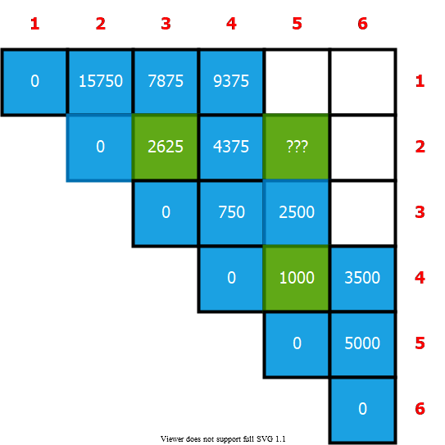

bg right:40% h:500px

## **Table access pattern** Example

* Compute
* Choose the value that leads to **min cost**

$$
m_{ij}=\underset{i \leq k < j}{MIN} \{ m_{ik} + m_{k+1,j} + p_{i-1} p_k p_j \} \\[10pt]
\begin{align*}
\begin{aligned}
A_1 &: (30 \times 35) \\
A_2 &: (35 \times 15) \\
A_3 &: (15 \times 5) \\
A_4 &: (5 \times 10) \\
A_5 &: (10 \times 20) \\
A_6 &: (20 \times 25)
\end{aligned}
\begin{aligned}
& ((A_2 A_3 A_4)\overbrace{\vdots}^{ (k=4) }(A_5)) \\[10 pt]
\quad cost &= m_{24} + m_{55} + p_1p_4p_5 \\
&= 4375 + 0 + 35 \times 10 \times 20 \\
&= 11375
\end{aligned}
\end{align*}
$$

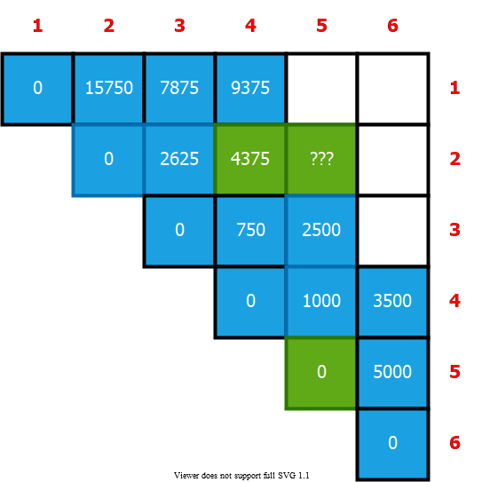

bg right:40% h:500px

## **Table access pattern** Example

* Compute
* Choose the value that leads to **min cost**

$$
m_{ij}=\underset{i \leq k < j}{MIN} \{ m_{ik} + m_{k+1,j} + p_{i-1} p_k p_j \} \\[10pt]
\begin{align*}
\begin{aligned}
A_1 &: (30 \times 35) \\
A_2 &: (35 \times 15) \\
A_3 &: (15 \times 5) \\
A_4 &: (5 \times 10) \\
A_5 &: (10 \times 20) \\
A_6 &: (20 \times 25)
\end{aligned} \quad
\begin{aligned}
& ((A_2)\overbrace{\vdots}^{ (k=2) } (A_3 A_4 A_5)) \rightarrow m_{22} + m_{35} + p_1p_2p_5 = 13000 \\
& ((A_2 A_3) \overbrace{\vdots}^{ (k=3) } (A_4 A_5)) \rightarrow m_{23} + m_{45} + p_1p_3p_5 = \overbrace{ \boldsymbol{7125}}^{selected} \Leftarrow \text{min} \\
& ((A_2 A_3 A_4)\overbrace{\vdots}^{ (k=4) }(A_5)) \rightarrow m_{24} + m_{55} + p_1p_4p_5 = 11375 \\[20 pt]
& m_{25} = 7125 \\
& s_{25} = 3
\end{aligned}
\end{align*}
$$

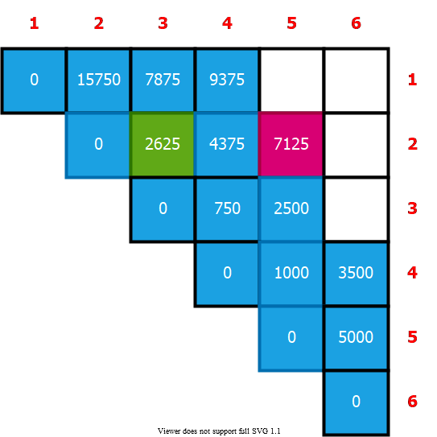

bg right:40% h:500px

## Constructing an Optimal Solution

* **MATRIX-CHAIN-ORDER** determines the optimal of scalar **mults/adds**
  + needed to compute a matrix-chain product
  + it does not directly show how to multiply the matrices
* That is,
  + it determines the cost of the optimal solution(s)
  + it does not show how to obtain an optimal solution
* Each entry records the value of such that optimal parenthesization of splits the product between &
* We know that the final matrix multiplication in computing optimally is

## **Example:** Constructing an Optimal Solution

* **Reminder:** is the optimal top-level split of
* What is the optimal top-level split for:

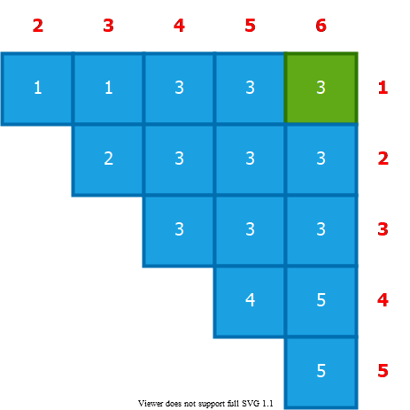

bg right:30% h:400px

## **Example:** Constructing an Optimal Solution

* **Reminder:** is the optimal top-level split of
  + What is the optimal split for ? ( )
  + What is the optimal split for ? ( )

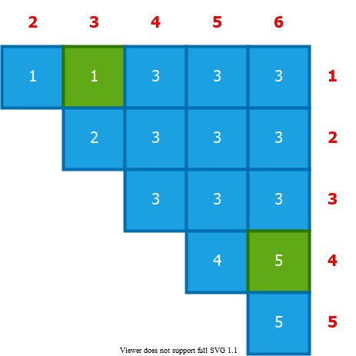

bg right:30% h:400px

## **Example:** Constructing an Optimal Solution

* **Reminder:** is the optimal top-level split of
  + What is the optimal split for ? ( )
  + What is the optimal split for ? ( )



bg right:30% h:400px

## **Example:** Constructing an Optimal Solution

* **Reminder:** is the optimal top-level split of
  + What is the optimal split for ? ( )
  + What is the optimal split for ? ( )

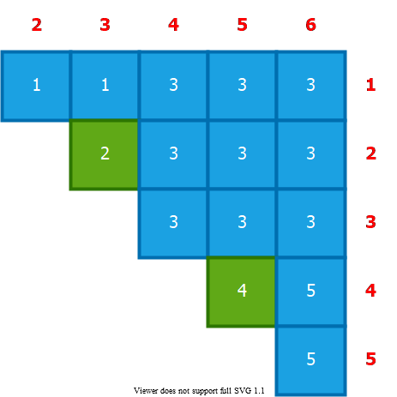

bg right:30% h:400px

## **Example:** Constructing an Optimal Solution

* **Reminder:** is the optimal top-level split of
  + What is the optimal split for ? ( )
  + What is the optimal split for ? ( )



bg right:30% h:390px

## Constructing an **Optimal Solution**

* Earlier optimal matrix multiplications can be computed recursively
* **Given:**
  + the chain of matrices the s table computed by
  + The following recursive procedure computes the **matrix-chain product**
* **Invocation:**

## Example: Recursive Construction of an Optimal Solution

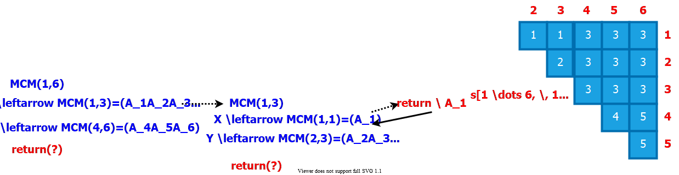

center

## Example: Recursive Construction of an Optimal Solution

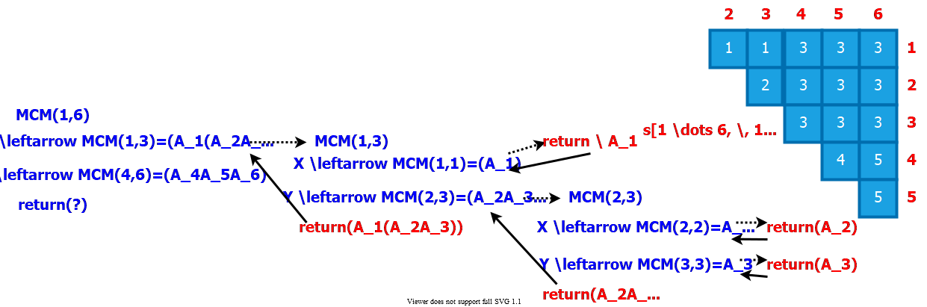

center

## Example: Recursive Construction of an Optimal Solution

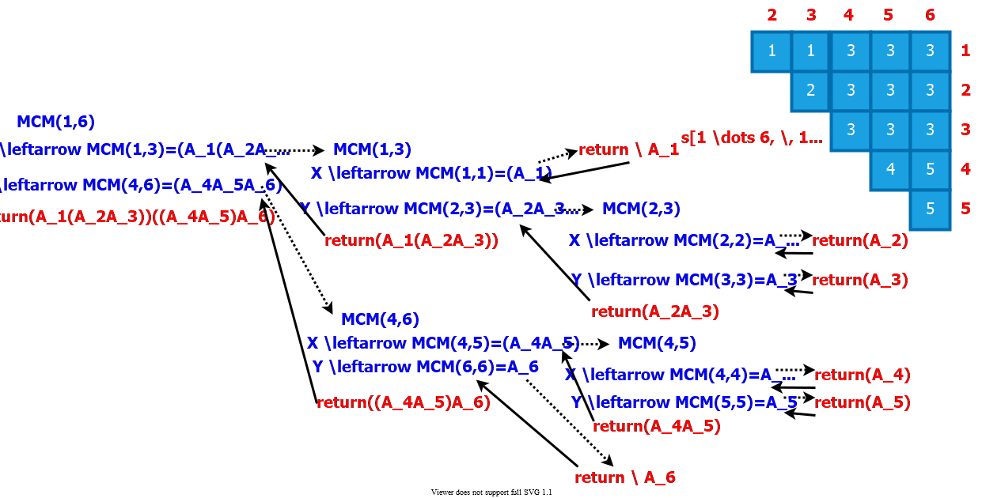

center

## Table reference pattern for

* is referenced for the computation of
  + times
  + times

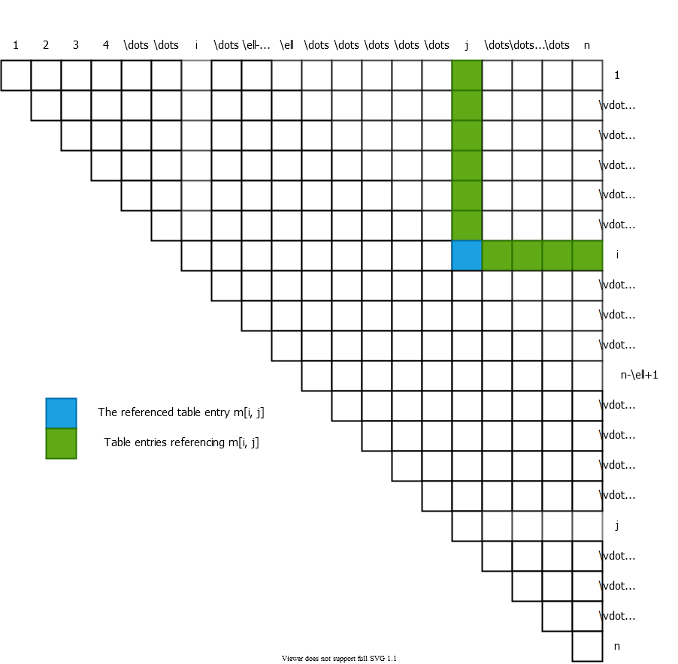

bg right:60% h:700px

## Table reference pattern for

* = of times that is referenced in computing other entries
* The total of references for the entire table is:

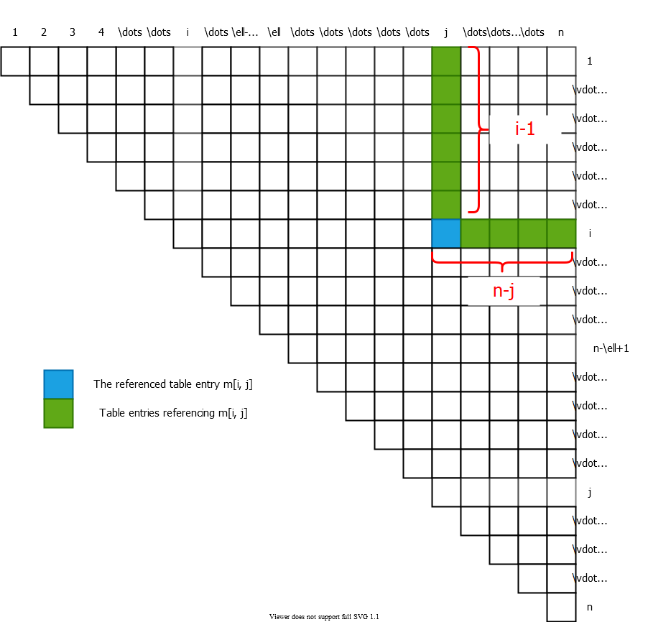

bg right:40% h:490px

## Summary

* Identification of the optimal substructure property
* Recursive formulation to compute the cost of the optimal solution
* Bottom-up computation of the table entries
* Constructing the optimal solution by backtracing the table entries

## References

* [Introduction to Algorithms, Third Edition | The MIT Press](https://mitpress.mit.edu/books/introduction-algorithms-third-edition)
* [Bilkent CS473 Course Notes (new)](http://nabil.abubaker.bilkent.edu.tr/473/)
* [Bilkent CS473 Course Notes (old)](http://cs.bilkent.edu.tr/~ugur/teaching/cs473/)