CE103 Algorithms and Programming I
Development Environments and Algorithm Basics
Author: Asst. Prof. Dr. Uğur CORUH

CE103 Algorithms and Programming I

Week-2

Fall Semester, 2021-2022
Download DOC, SLIDE, PPTX

Algorithm Basics

Flowgorithm
http://www.flowgorithm.org/

Pseudocode
Pseudocode - Wikipedia
Pseudocode Examples
How to write a Pseudo Code? - GeeksforGeeks

Introduction to Analysis of Algorithms
In this course we will learn how to code with several development environments and next term we will see analysis of algorithms in details.
This topic is covered in the following link : CE100 Introduction to Analysis of Algorithms

Programming Environment Setup and Configuration
Programming life is not about only learning how to code. Mostly you need to use several code development environments and you need to learn how to use them efficiently.

C / C++ Environment and Development

DevCpp (Install / Compile / Run / Debug) (1)
Download DevC++ IDE from following link
https://www.bloodshed.net/

DevCpp (Install / Compile / Run / Debug) (2)
Open DevC++ IDE for C Project Generation
Open File->New->Project
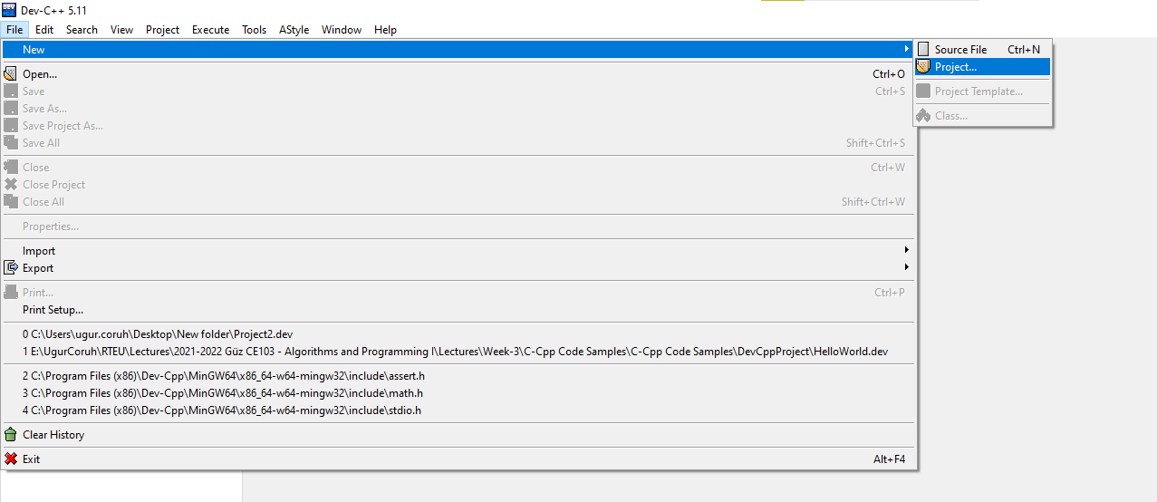
alt:“alt” height:400px center

DevCpp (Install / Compile / Run / Debug) (3)
Select Console Application from Basic tab and with C Project Option and write a project name such as “Hello” then press OK
Select a folder and save Hello.dev project file.

DevCpp (Install / Compile / Run / Debug) (4)
You will see a sample main with empty body
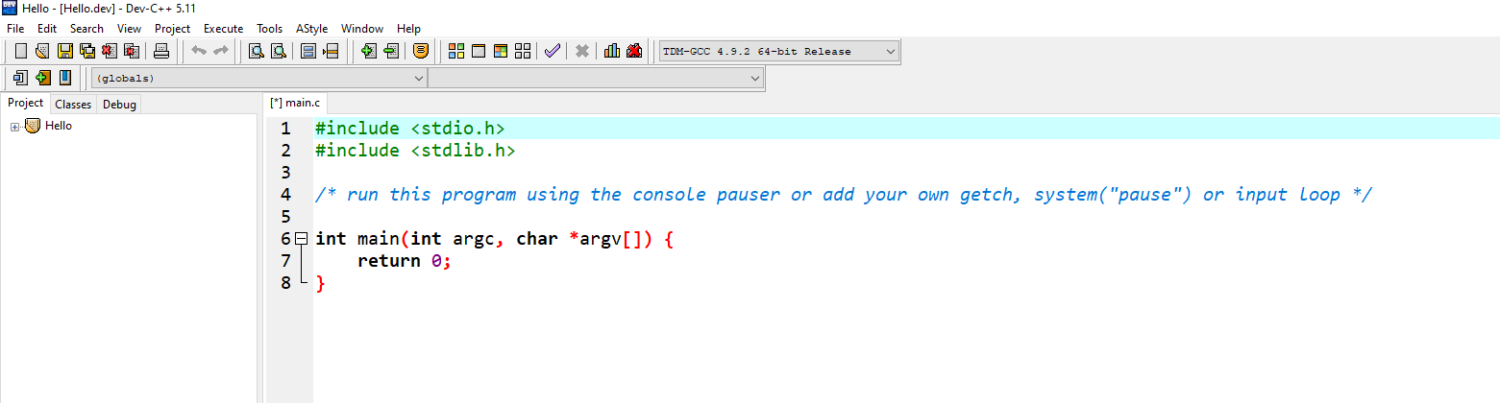
alt:“alt” height:450px center

DevCpp (Install / Compile / Run / Debug) (5)
#include <stdio.h>
#include <stdlib.h>
/* run this program using the console pauser or add your own getch, s,ystem("pause") or input loop */
int main(int argc, char *argv[]) {
retAdd 0;
}

DevCpp (Install / Compile / Run / Debug) (6)
add the following line in main function. This will write “Hello, World!” on the screen and then wait a keypress to exit from application
#include <stdio.h>
#include <stdlib.h>
/* run this program using the console pauser or add your own getch, system("pause") or input loop */
int main(int argc, char *argv[]) {
printf("Hello, World!");
getchar();
return 0;
}

DevCpp (Install / Compile / Run / Debug) (7)
Then save the file
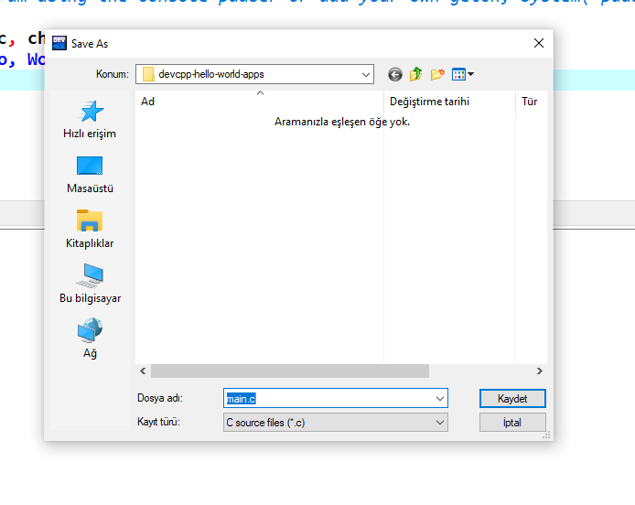
alt:“alt” height:450px center

DevCpp (Install / Compile / Run / Debug) (8)
Use from menu Execute->Compile F5 to generate Hello.exe
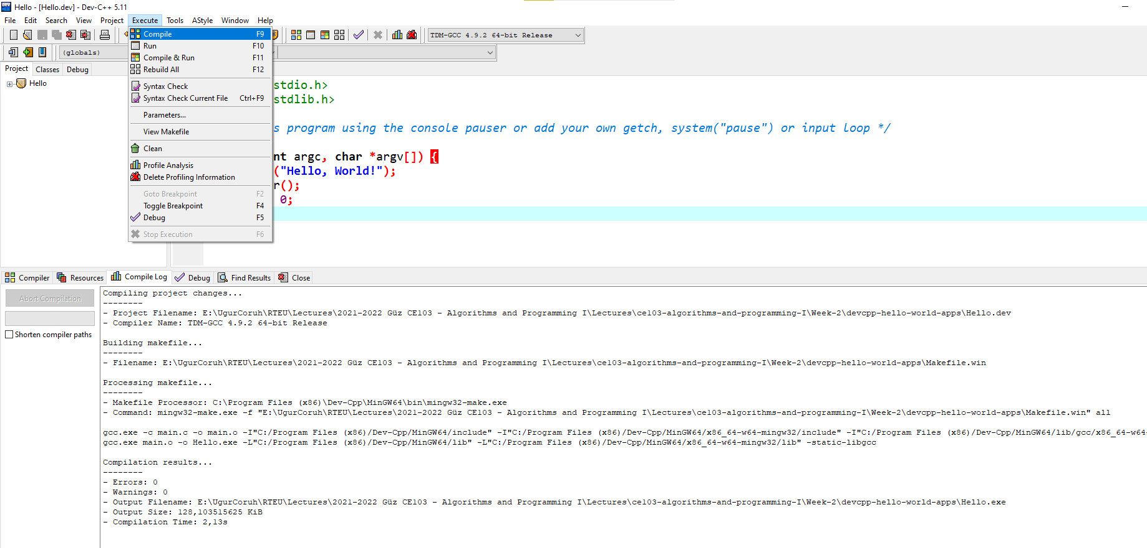
alt:“alt” height:450px center

DevCpp (Install / Compile / Run / Debug) (9)
You can find the generated Hello.exe path from Compile.log as follow. Check the Output Filename
Compiling project changes...
--------
- Project Filename: E:\UgurCoruh\RTEU\Lectures\2021-2022 Güz CE103 - Algorithms and Programming I\Lectures\ce103-algorithms-and-programming-I\Week-2\devcpp-hello-world-apps\Hello.dev
- Compiler Name: TDM-GCC 4.9.2 64-bit Release
Building makefile...
--------
- Filename: E:\UgurCoruh\RTEU\Lectures\2021-2022 Güz CE103 - Algorithms and Programming I\Lectures\ce103-algorithms-and-programming-I\Week-2\devcpp-hello-world-apps\Makefile.win
Processing makefile...
--------
- Makefile Processor: C:\Program Files (x86)\Dev-Cpp\MinGW64\bin\mingw32-make.exe
- Command: mingw32-make.exe -f "E:\UgurCoruh\RTEU\Lectures\2021-2022 Güz CE103 - Algorithms and Programming I\Lectures\ce103-algorithms-and-programming-I\Week-2\devcpp-hello-world-apps\Makefile.win" all
gcc.exe -c main.c -o main.o -I"C:/Program Files (x86)/Dev-Cpp/MinGW64/include" -I"C:/Program Files (x86)/Dev-Cpp/MinGW64/x86_64-w64-mingw32/include" -I"C:/Program Files (x86)/Dev-Cpp/MinGW64/lib/gcc/x86_64-w64-mingw32/4.9.2/include"
gcc.exe main.o -o Hello.exe -L"C:/Program Files (x86)/Dev-Cpp/MinGW64/lib" -L"C:/Program Files (x86)/Dev-Cpp/MinGW64/x86_64-w64-mingw32/lib" -static-libgcc
Compilation results...
--------
- Errors: 0
- Warnings: 0
- Output Filename: E:\UgurCoruh\RTEU\Lectures\2021-2022 Güz CE103 - Algorithms and Programming I\Lectures\ce103-algorithms-and-programming-I\Week-2\devcpp-hello-world-apps\Hello.exe
- Output Size: 128,103515625 KiB
- Compilation Time: 2,13s

DevCpp (Install / Compile / Run / Debug) (10)
Then you can run with Execute->Run F10 or Directly Compile&Run F11
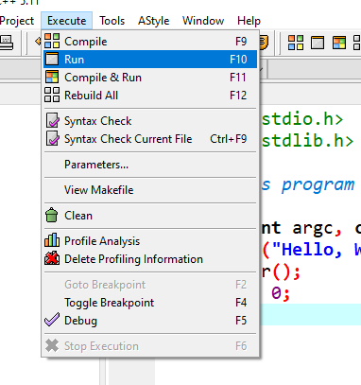
alt:“alt” height:450px center

DevCpp (Install / Compile / Run / Debug) (11)
for debugging operations, just change the code and add more statements as follow
#include <stdio.h>
#include <stdlib.h>
/* run this program using the console pauser or add your getch, system(",pause") or input loop */
int main(int argc, char *argv[]) {
printf("Hello, World! Step-1\n");
printf("Hello, World! Step-2\n");
printf("Hello, World! Step-3\n");
printf("Hello, World! Step-4\n");
printf("Hello, World! Step-5\n");
printf("Hello, World! Step-6\n");
getchar();
return 0;
}

DevCpp (Install / Compile / Run / Debug) (12)
Click on line numbers and add breakpoints for debugger. This red point will be debugger stop points
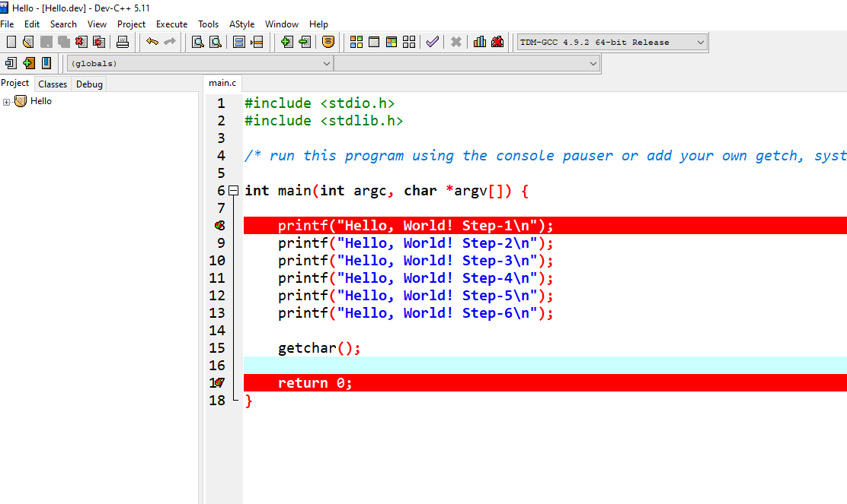
alt:“alt” height:450px center

DevCpp (Install / Compile / Run / Debug) (13)
In the ,menu section select compiler with debug option
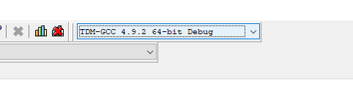
alt:“alt” height:450px center

DevCpp (Install / Compile / Run / Debug) (14)
Compile application with debug setting and in Execute Section use Debug F5 to start debugging
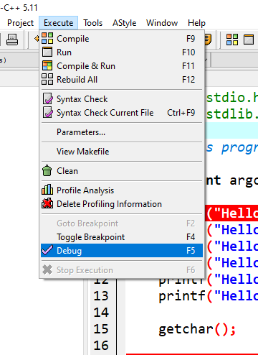
alt:“alt” height:450px center

DevCpp (Install / Compile / Run / Debug) (15)
Debugger will stop at breakpoint at the debug point (blue line)
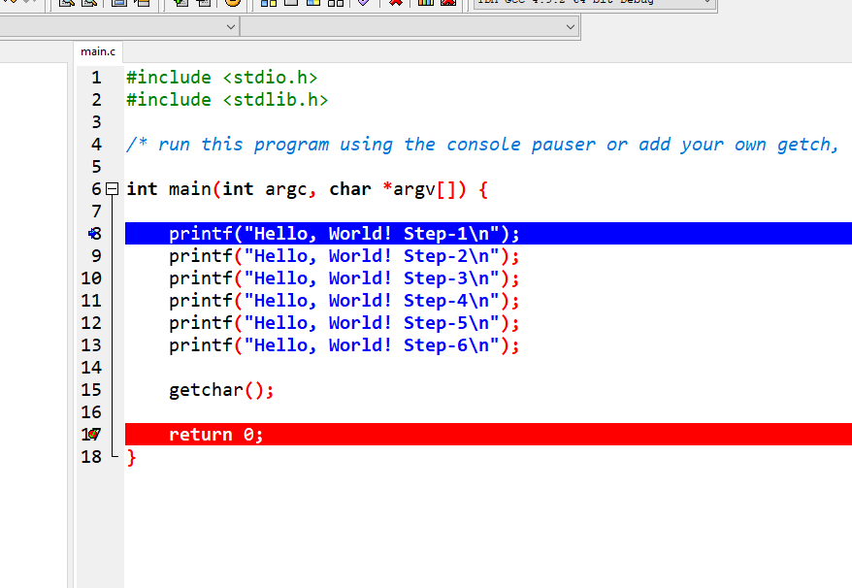
alt:“alt” height:450px center

DevCpp (Install / Compile / Run / Debug) (16)
Moving to next statement can be done via control buttons or shortcuts
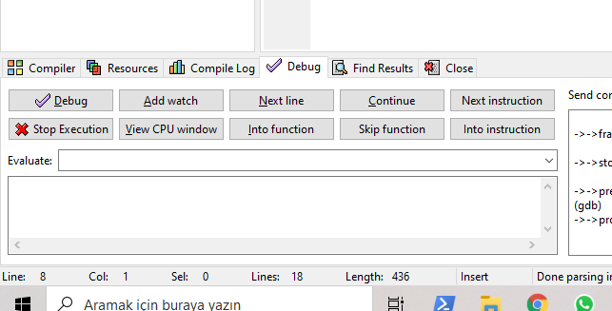
alt:“alt” height:450px center

DevCpp (Install / Compile / Run / Debug) (17)
Press F8 to step-by-step continue
Then go to Project Options - Compiler - Linker and set Generate debugging information to “yes”, and make sure you are not using any optimization options (they’re not good for debug mode). Also check the Parameters tab, make sure you don’t have any optimization options (like -O2 or -O3, but -O0 is ok because it means no optimization) or strip option (-s).

DevCpp (Install / Compile / Run / Debug) (18)
After that, do a full rebuild (Ctrl-F11), then set breakpoint(s) where you want the debugger to stop (otherwise it will just run the program). To set a breakpoint on a line, just click on the gutter (the gray band on the left), or press Ctrl-F5.

DevCpp (Install / Compile / Run / Debug) (19)
Now you are ready to launch the debugger, by pressing F8 or clicking the debug button. If everything goes well, the program will start, and then stop at the first breakpoint. Then you can step through the code, entering function calls, by pressing Shift-F7 or the “step into” button, or stepping over the function calls, by pressing F7 or the “next step” button. You can press Ctrl-F7 or the “continue” button to continue execution till the next breakpoint. At any time, you can add or remove breakpoints.

DevCpp (Install / Compile / Run / Debug) (20)
When the program stopped at a breakpoint and you are stepping through the code, you can display the values of various variables in your program by putting your mouse over them, or you can display variables and expressions by pressing F4 or the “add watch” button and typing the expression.

DevCpp (Install / Compile / Run / Debug) (21)
How do I debug using Dev-C++

Code Blocks (Install / Compile / Run / Debug) (1)
Download Code Blocks from the following link
Binary releases - Code::Blocks

Code Blocks (Install / Compile / Run / Debug) (2)
Open Code Blocks and
Select File->New->Project
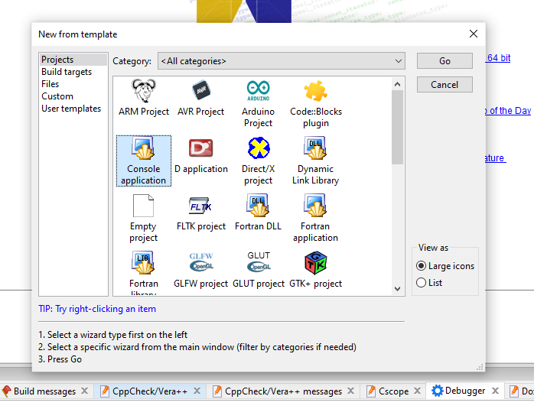
alt:“alt” height:450px center

Code Blocks (Install / Compile / Run / Debug) (3)
Select Console Application
Click Next from Opening Window
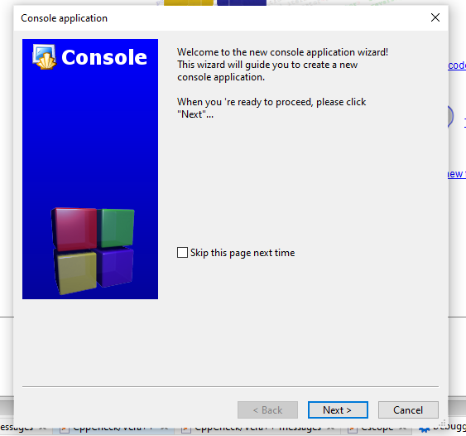
alt:“alt” height:450px center

Code Blocks (Install / Compile / Run / Debug) (4)
Select C for Sample Project
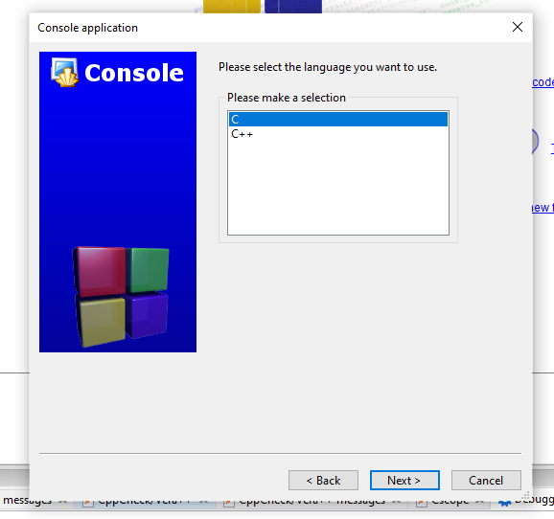
alt:“alt” height:450px center

Code Blocks (Install / Compile / Run / Debug) (5)
Write a project name and title also set a project folder
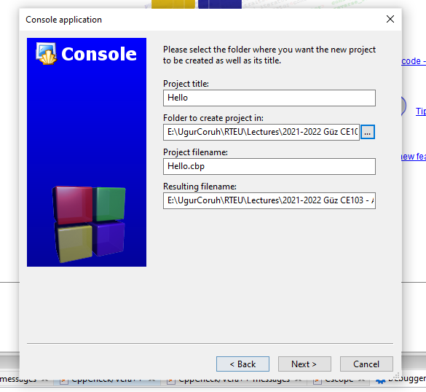
alt:“alt” height:450px center

Code Blocks (Install / Compile / Run / Debug) (6)
Select complier for this project we selected GCC but you can select C compliers from list. Set Debug and Release executable output folders.
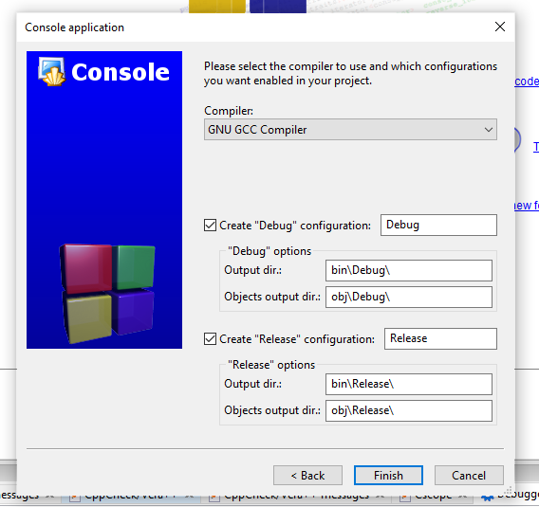
alt:“alt” height:450px center

Code Blocks (Install / Compile / Run / Debug) (7)
After this wizard you will have the following code
#include <stdio.h>
#include <stdlib.h>
int main()
{
printf("Hello world!\n");
return 0;
}

Code Blocks (Install / Compile / Run / Debug) (8)
Select Debug Build from menu
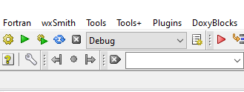
alt:“alt” height:450px center

Code Blocks (Install / Compile / Run / Debug) (9)
Run with Build and Run F9
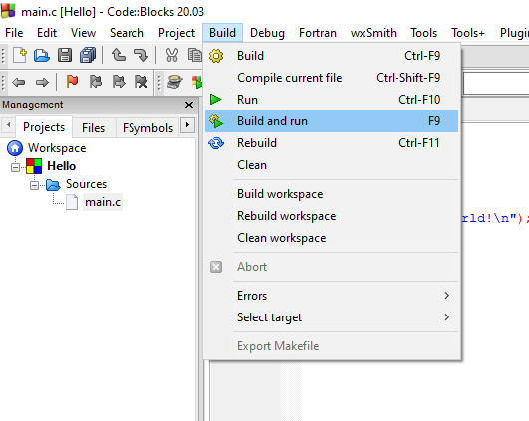
alt:“alt” height:450px center

Code Blocks (Install / Compile / Run / Debug) (10)
You should see the following output
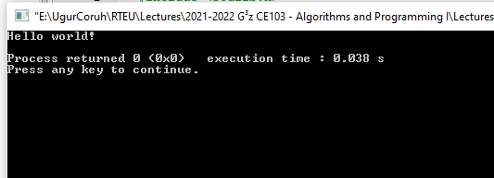
alt:“alt” height:450px center

Code Blocks (Install / Compile / Run / Debug) (11)
Add the following lines to your source code for debugging
#include <stdio.h>
#include <stdlib.h>
int main()
{
printf("Hello world! Step-1\n");
printf("Hello world! Step-2\n");
printf("Hello world! Step-3\n");
printf("Hello world! Step-4\n");
printf("Hello world! Step-5\n");
printf("Hello world! Step-6\n");
return 0;
}

Code Blocks (Install / Compile / Run / Debug) (12)
and add break points with F5 or mouse click
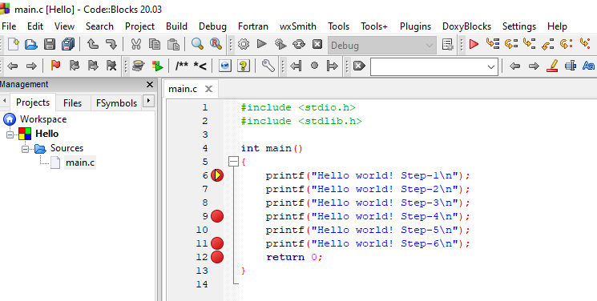
alt:“alt” height:450px center

Code Blocks (Install / Compile / Run / Debug) (13)
select Debug->Start/Continue to start debugger
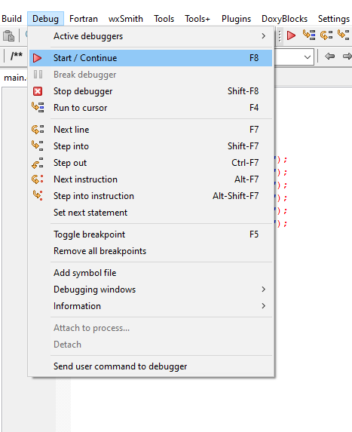
alt:“alt” height:450px center

Code Blocks (Install / Compile / Run / Debug) (14)
If you see the following error this is related with long or turkish character including path. Just move project to a shorter path and try again
Setting breakpoints
Debugger name and version: GNU gdb (GDB) 8.1
Starting the debuggee failed: No executable specified, use `target exec'.
Debugger finished with status 0

Code Blocks (Install / Compile / Run / Debug) (15)
You will see the following yellow pointer for debugger
alt:“alt” height:450px center

Code Blocks (Install / Compile / Run / Debug) (16)
You can use the following menu or shortcuts for step-by-step debugging.
alt:“alt” height:100px center

GCC/G++ Complier (MinGW) / Clang-cl (LLVM) (1)
Download and install MinGW or LLVM compiler (if you downloded then skip this step)
MinGW installer (clang)
Download MinGW-w64 - for 32 and 64 bit Windows from SourceForge.net
LLVM installer (gcc / g++)
Download LLVM releases
Also use the following notes
https://llvm.org/devmtg/2014-04/PDFs/Talks/clang-cl.pdf

GCC/G++ Complier (MinGW) / Clang-cl (LLVM) (2)
Open a console with “cmd” and test the following commands if commands are not recognized then set the system environment variable add gcc and g++ exe paths to path variable (add to both system and user path variable)
gcc --version
g++ --version
C:\Users\ugur.coruh>gcc --version
gcc (x86_64-win32-seh-rev0, Built by MinGW-W64 project) 8.1.0
Copyright (C) 2018 Free Software Foundation, Inc.
This is free software; see the source for copying conditions. There is NO
warranty; not even for MERCHANTABILITY or FITNESS FOR A PARTICULAR PURPOSE.
clang --version

GCC/G++ Complier (MinGW) / Clang-cl (LLVM) (3)
for gcc.exe, g++.exe and gdb.exe
C:\Program Files\mingw-w64\x86_64-8.1.0-win32-seh-rt_v6-rev0\mingw64\bin
for clang.exe , lldb.exe
C:\Program Files\LLVM\bin
This folder paths changes according to your setup

VSCode (Install / Compile / Run / Debug) (1)
Download Visual Studio Code from the following link
Download Visual Studio Code - Mac, Linux, Windows

VSCode (Install / Compile / Run / Debug) (2)
In this sample you will find MinGW and LLVM compiler combinations for C and C++
Create a folder and enter this folder then open this folder with vscode by right click
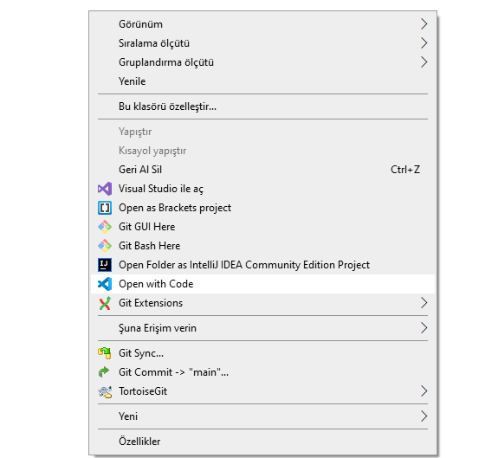
alt:“alt” height:450px center

VSCode (Install / Compile / Run / Debug) (3)
or enter the folder via console
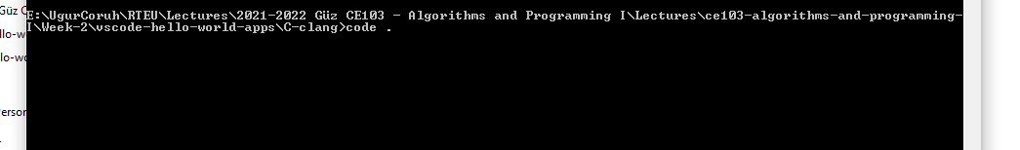
alt:“alt” height:300px center
write
code .

VSCode (Install / Compile / Run / Debug) (4)
This will open vscode for current folder . dot present current folder.
You will see a empty folder in the right window
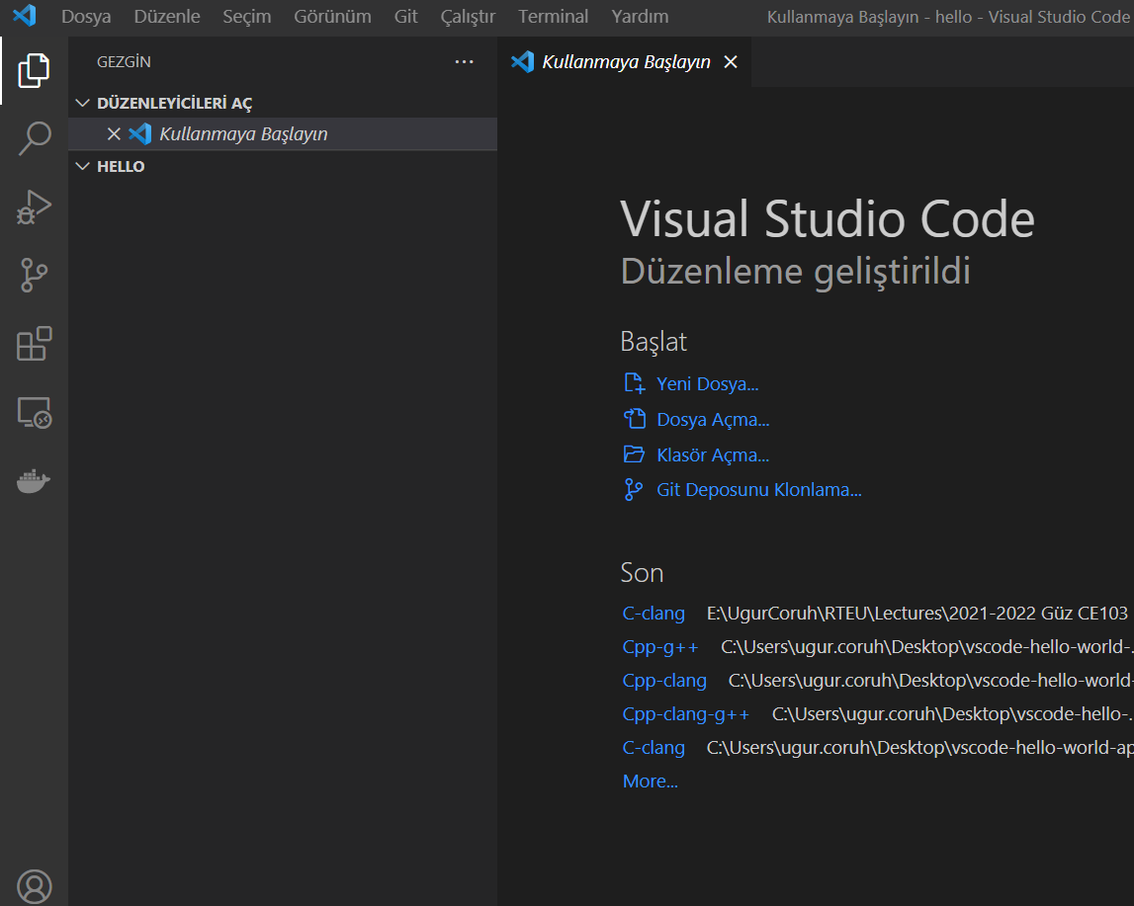
alt:“alt” height:400px center

VSCode (Install / Compile / Run / Debug) (5)
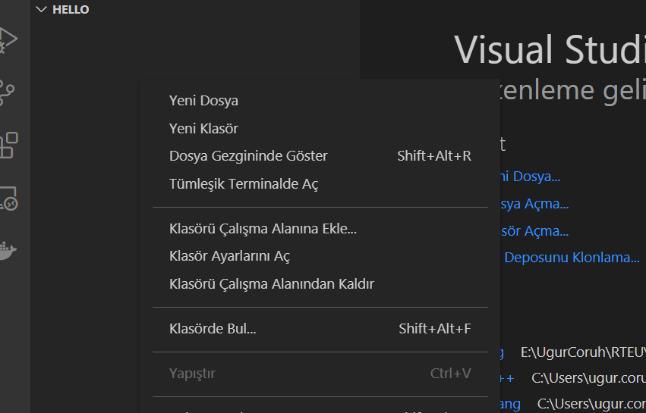
alt:“alt” height:400px center

VSCode (Install / Compile / Run / Debug) (6)
Create a hello.c file and write following content
#include <stdio.h>
int main() {
// printf() displays the string inside quotation
printf("Hello, World!");
return 0;
}

VSCode (Install / Compile / Run / Debug) (7)
use CTRL+SHIFT+B (you should be on source code section) to build file
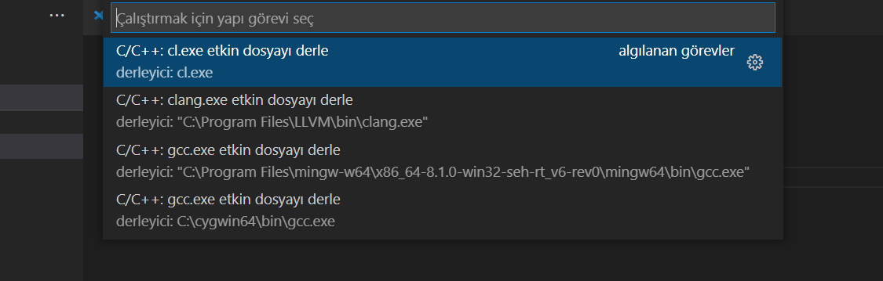
alt:“alt” height:400px center

VSCode (Install / Compile / Run / Debug) (8)
Select GCC or CLANG for this sample we can use GCC
You will see output generated Hello.exe
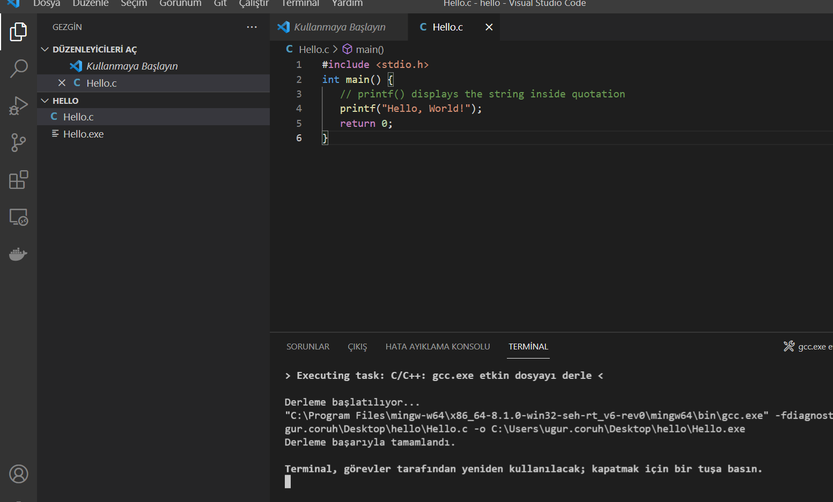
alt:“alt” height:450px center

VSCode (Install / Compile / Run / Debug) (9)
for debugging just put breakpoint and build again
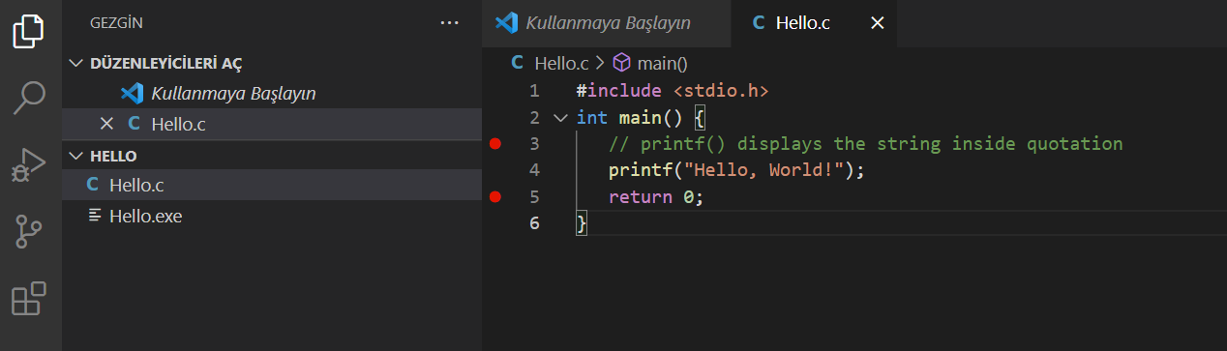
alt:“alt” height:450px center

VSCode (Install / Compile / Run / Debug) (10)
after build for debug press CTRL+SHIFT+D (you should be on source code section)and in the right window select create launch.json
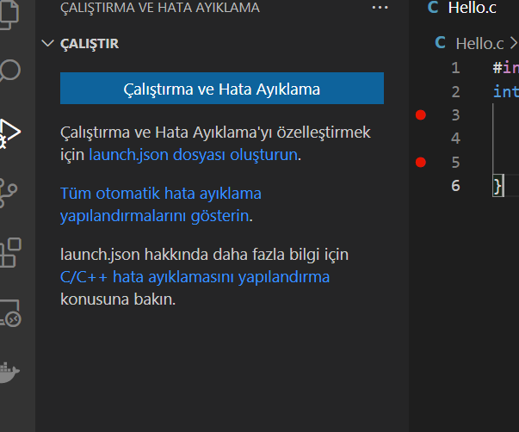
alt:“alt” height:450px center

VSCode (Install / Compile / Run / Debug) (11)
from opening window select C++ GDB/LLDB
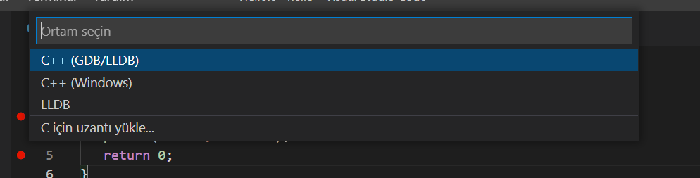
alt:“alt” height:300px center

VSCode (Install / Compile / Run / Debug) (12)
from next opening menu select mingw-w64 gcc.exe
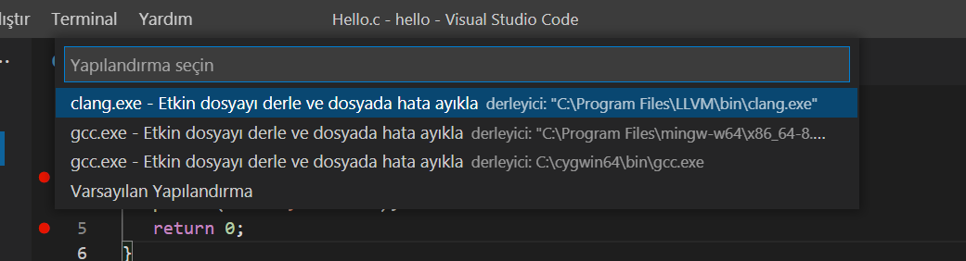
alt:“alt” height:350px center

VSCode (Install / Compile / Run / Debug) (13)
this will run debugger and you will see debug points activated
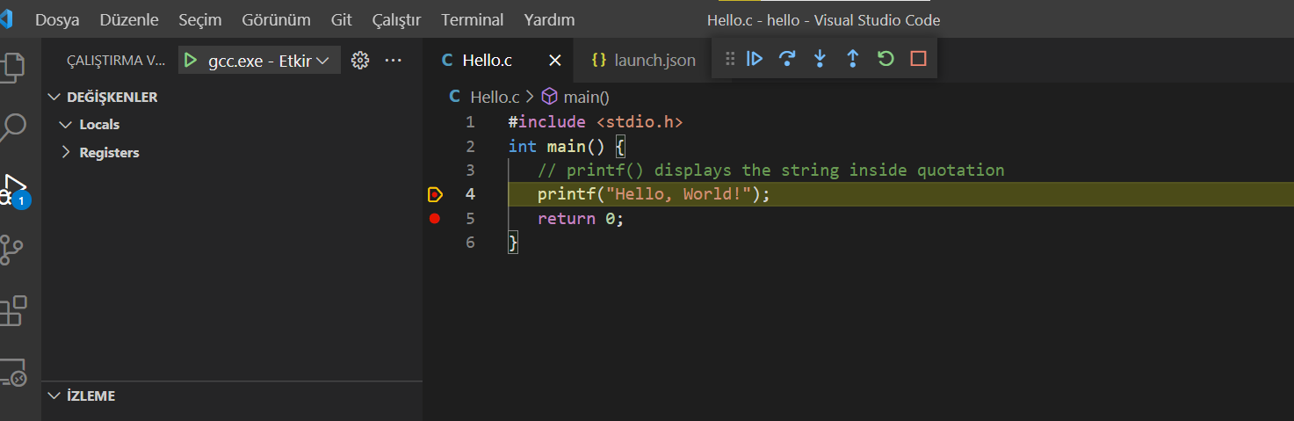
alt:“alt” height:400px center

VSCode (Install / Compile / Run / Debug) (14)
then you can step-by-step debug your code.
the following task.json and launch.json automatically generated with your selections
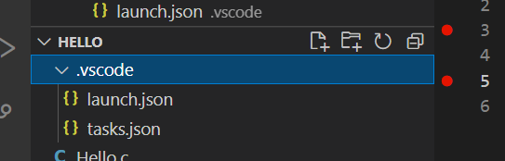
alt:“alt” height:250px center

VSCode (Install / Compile / Run / Debug) (15)
launch.json
{
// Olası öznitelikler hakkında bilgi edinmek için IntelliSense kullanın.
// Mevcut özniteliklerin açıklamalarını görüntülemek için üzerine gelin.
// Daha fazla bilgi için şu adresi ziyaret edin: https://go.microsoft.com/fwlink/?linkid=830387
"version": "0.2.0",
"configurations": [
{
"name": "gcc.exe - Etkin dosyayı derle ve dosyada hata ayıkla",
"type": "cppdbg",
"request": "launch",
"program": "${fileDirname}\\${fileBasenameNoExtension}.exe",
"args": [],
"stopAtEntry": false,
"cwd": "${fileDirname}",
"environment": [],
"externalConsole": false,
"MIMode": "gdb",
"miDebuggerPath": "C:\\Program Files\\mingw-w64\\x86_64-8.1.0-win32-seh-rt_v6-rev0\\mingw64\\bin\\gdb.exe",
"setupCommands": [
{
"description": "gdb için düzgün yazdırmayı etkinleştir",
"text": "-enable-pretty-printing",
"ignoreFailures": true
}
],
"preLaunchTask": "C/C++: gcc.exe etkin dosyayı derle"
}
]
}

VSCode (Install / Compile / Run / Debug) (16)
task.json
{
"tasks": [
{
"type": "cppbuild",
"label": "C/C++: gcc.exe etkin dosyayı derle",
"command": "C:\\Program Files\\mingw-w64\\x86_64-8.1.0-win32-seh-rt_v6-rev0\\mingw64\\bin\\gcc.exe",
"args": [
"-fdiagnostics-color=always",
"-g",
"${file}",
"-o",
"${fileDirname}\\${fileBasenameNoExtension}.exe"
],
"options": {
"cwd": "${fileDirname}"
},
"problemMatcher": [
"$gcc"
],
"group": {
"kind": "build",
"isDefault": true
},
"detail": "Hata Ayıklayıcısı tarafından oluşturulan görev."
}
],
"version": "2.0.0"
}

VSCode (Install / Compile / Run / Debug) (17)
you can do the same thing for other compilers and c++ source codes. LLVM do not support debug on vscode now.
for C++ VsCode you can check the following links
for Windows
https://code.visualstudio.com/docs/cpp/config-mingw
for Linux
https://code.visualstudio.com/docs/cpp/config-linux
for WSL
https://code.visualstudio.com/docs/cpp/config-wsl

VSCode (Install / Compile / Run / Debug) (18)
in the launch file if you start debugging with F5
(you can select debugger with CTRL+SHIFT+P and then writing Debug and Selecting Configure Debugger Option)

VSCode (Install / Compile / Run / Debug) (19)
following line will be your debugging application path
if you start debugging with F5 in Hello.c file this will set <Hello.c base path>/Hello.exe

VSCode (Install / Compile / Run / Debug) (20)
You should set this correct for both LLVM and GCC configuration in launch.json
"program": "${fileDirname}\\${fileBasenameNoExtension}.exe",
Also you should set your installed debugger paths
for GCC
"miDebuggerPath": "C:\\Program Files\\mingw-w64\\x86_64-8.1.0-win32-seh-rt_v6-rev0\\mingw64\\bin\\gdb.exe",
for LLVM
"miDebuggerPath": "C:\\Program Files\\LLVM\\bin\\lldb.exe",
for more details please check the sample source codes.

Visual Studio Community Edition (Install / Compile / Run / Debug)
//TODO//

alt:“alt” height:200px center

Notepad++ (Install / Compile ) (1)
Please download Notepad++ from the following link
Downloads | Notepad++

Notepad++ (Install / Compile ) (2)
Download and install MinGW or LLVM compiler (if you downloded then skip this step)
MinGW installer (clang)
Download MinGW-w64 - for 32 and 64 bit Windows from SourceForge.net
LLVM installer (gcc / g++)
Download LLVM releases
Also use the following notes
https://llvm.org/devmtg/2014-04/PDFs/Talks/clang-cl.pdf

Notepad++ (Install / Compile ) (3)
Open a console with “cmd” and test the following commands if commands are not recognized then set the system environment variable add gcc and g++ exe paths to path variable (add to both system and user path variable)
gcc --version
g++ --version
C:\Users\ugur.coruh>gcc --version
gcc (x86_64-win32-seh-rev0, Built by MinGW-W64 project) 8.1.0
Copyright (C) 2018 Free Software Foundation, Inc.
This is free software; see the source for copying conditions. There is NO
warranty; not even for MERCHANTABILITY or FITNESS FOR A PARTICULAR PURPOSE.

Notepad++ (Install / Compile ) (4)
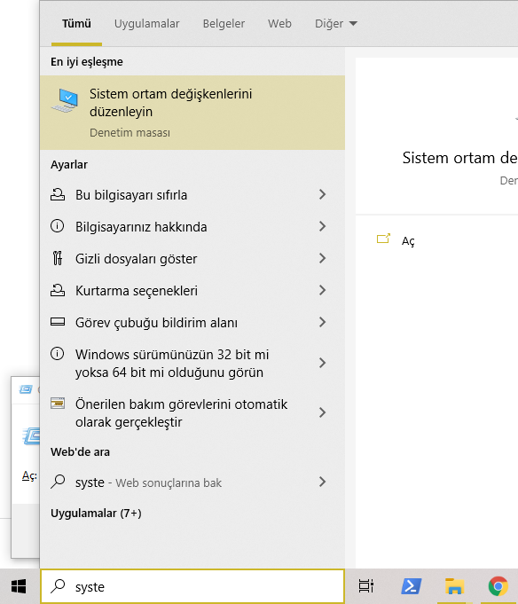
alt:“alt” height:450px center

Notepad++ (Install / Compile ) (5)
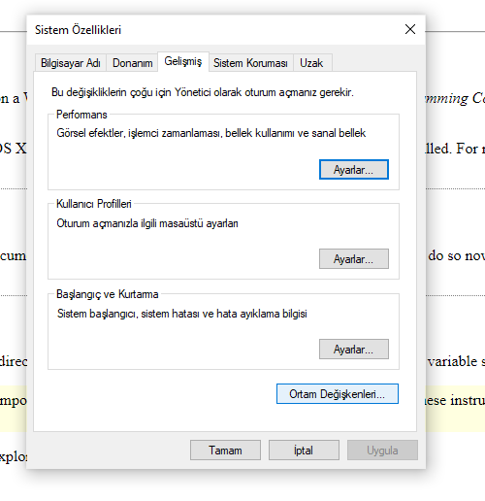
alt:“alt” height:450px center

Notepad++ (Install / Compile ) (6)
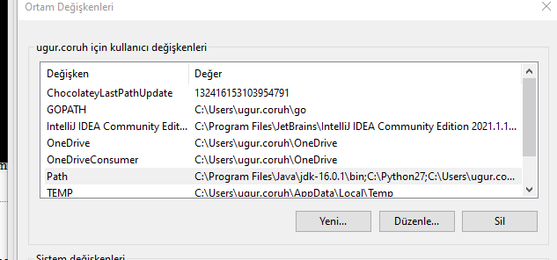
alt:“alt” height:450px center

Notepad++ (Install / Compile ) (7)
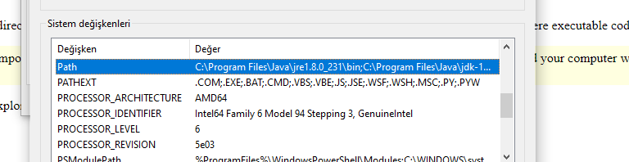
alt:“alt” height:450px center

Notepad++ (Install / Compile ) (8)
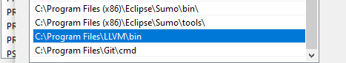
alt:“alt” height:450px center

Notepad++ (Install / Compile ) (9)
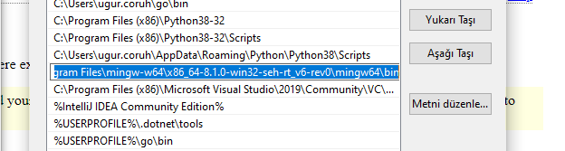
alt:“alt” height:450px center

Notepad++ (Install / Compile ) (10)
for gcc.exe, g++.exe and gdb.exe
C:\Program Files\mingw-w64\x86_64-8.1.0-win32-seh-rt_v6-rev0\mingw64\bin

Notepad++ (Install / Compile ) (11)
for clang.exe , lldb.exe
C:\Program Files\LLVM\bin

Notepad++ (Install / Compile ) (12)
This folder paths changes according to your setup
Open NppExec extension (install from extension manager if not exist)
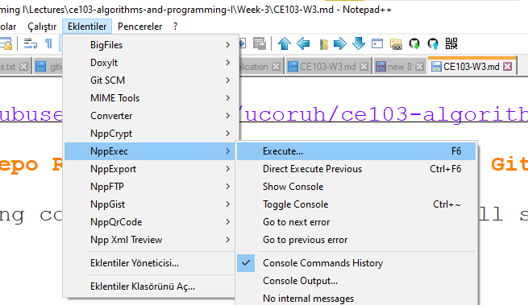
alt:“alt” height:450px center

Notepad++ (Install / Compile ) (13)
write the following commands in box
NPP_SAVE // save current file
cd $(CURRENT_DIRECTORY) // go to directory of the current file
gcc -Wall -Wextra -Wpedantic -std=c++11 -o "$(NAME_PART)" "$(FILE_NAME)"
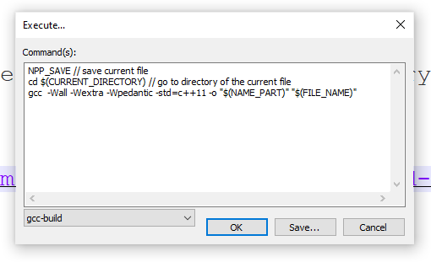
alt:“alt” height:300px center

Notepad++ (Install / Compile ) (14)
save script as gcc-build and for more information check the following link
How To Setup Notepad for Writing C++ Programs
You can modify or add multiple scripts for another tasks.

Vi/Vim (C/C++)
//TODO//
alt:“alt” height:200px center

Eclipse (C/C++)
//TODO//
alt:“alt” height:200px center

Netbeans (C/C++)
//TODO//
alt:“alt” height:200px center

Turbo C++/C
//TODO//
alt:“alt” height:200px center

Cmake (C++/C) (1)
CMake (http://www.cmake.org/) is a program which generates the Makefiles used by Make.

Cmake (C++/C) (2)
Why use CMake ?
- Eases Make use
  - but the same way of thinking
  - generate the Makefile
- Separate the compilation from the sources
- Multi-platfoms
- Very flexible

Cmake (C++/C) (3)
- Check if the libraries/programs are available on your system
- File generator (configure_file)
- Calling programs or scripts (doxygen)
- One of the new standards

Cmake (C++/C) (4) (Download and Install)
use the following link for download
Download | CMake

Cmake (C++/C) (5) (WSL and Linux Environment)
Hello world with CMake

Cmake (C++/C) (6) (Windows Environment)
main.c
#include <stdio.h>
int main()
{
char name[20];
printf("Enter name: ");
scanf("%s", name);
printf("Your name is %s.", name);
return 0;
}
CMakeLists.txt
cmake_minimum_required(VERSION 3.7.2)
project(scanf-sample)
add_executable(scanf-sample main.c)

Cmake (C++/C) (7) (Windows Environment)
put main.c and CMakeLists.txt file in sample-scanf folder and from command line
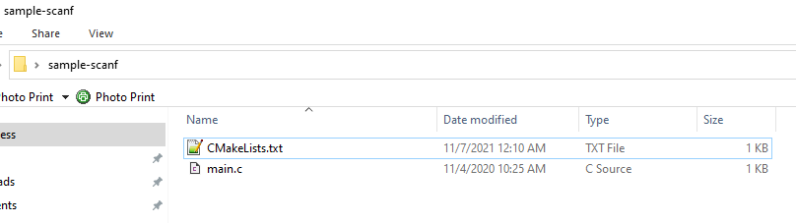
alt:“alt” height:450px center
run the following cmake command with dot (.) to create solution file for c project
C:\Users\ugur.coruh\Desktop\sample-scanf>cmake .

Cmake (C++/C) (8) (Windows Environment)
I have Visual Studio 2022 Community Edition Installed on My Computer, for these reason build tools are selected for visual studio environment and the following outputs are generated
C:\Users\ugur.coruh\Desktop\sample-scanf>cmake .
-- Building for: Visual Studio 17 2022
-- Selecting Windows SDK version 10.0.22000.0 to target Windows 10.0.19043.
-- The C compiler identification is MSVC 19.30.30704.0
-- The CXX compiler identification is MSVC 19.30.30704.0
-- Detecting C compiler ABI info
-- Detecting C compiler ABI info - done
-- Check for working C compiler: C:/Program Files/Microsoft Visual Studio/2022/Community/VC/Tools/MSVC/14.30.30704/bin/Hostx64/x64/cl.exe - skipped
-- Detecting C compile features
-- Detecting C compile features - done
-- Detecting CXX compiler ABI info
-- Detecting CXX compiler ABI info - done
-- Check for working CXX compiler: C:/Program Files/Microsoft Visual Studio/2022/Community/VC/Tools/MSVC/14.30.30704/bin/Hostx64/x64/cl.exe - skipped
-- Detecting CXX compile features
-- Detecting CXX compile features - done
-- Configuring done
-- Generating done
-- Build files have been written to: C:/Users/ugur.coruh/Desktop/sample-scanf
C:\Users\ugur.coruh\Desktop\sample-scanf>

Cmake (C++/C) (9) (Windows Environment)
also following files are generated
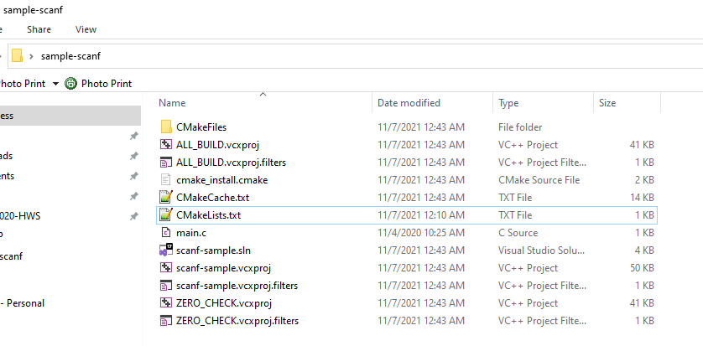
alt:“alt” height:450px center

Cmake (C++/C) (10) (Windows Environment)
if we open scanf-sample.sln file we will have automated generated project files
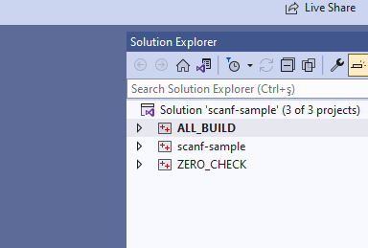
alt:“alt” height:450px center

Cmake (C++/C) (11) (Windows Environment)
you can make scanf-sample with startup project with right click and then run on visual studio.
if you want to configure for another build tool you can use Cmake-GUI installed with setup on your computer
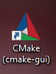
alt:“alt” height:150px center

Cmake (C++/C) (12) (Windows Environment)
Open GUI and Select File-> Delete Cache
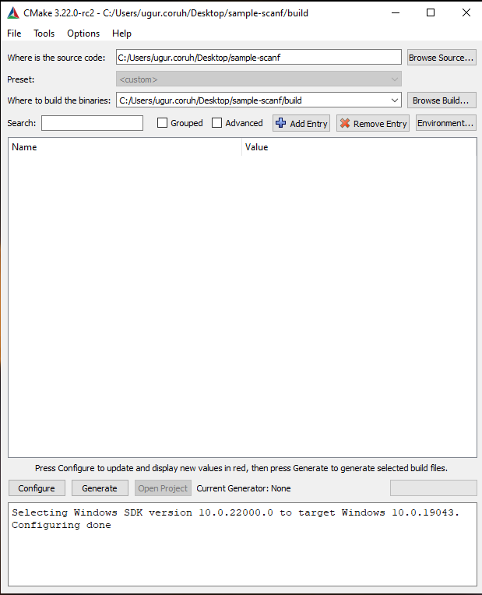
alt:“alt” height:450px center

Cmake (C++/C) (13) (Windows Environment)
then you can click “Configure” to select build tool
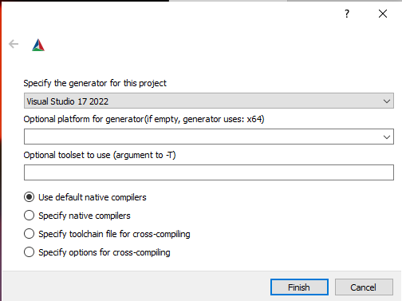
alt:“alt” height:450px center

Cmake (C++/C) (14) (Windows Environment)
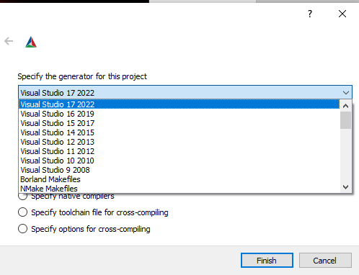
alt:“alt” height:400px center

Cmake (C++/C) (15) (Windows Environment)
if you click “Configure” twice it will generate the visual studio solution in build folder
for more detailed examples that include also docker and travis-ci sample you can check the following repo
GitHub - ttroy50/cmake-examples: Useful CMake Examples

Make (1)
Sample
hello.c
#include <stdio.h>
int main(void)
{
printf("hello, world\n");
}

Make (2)
Makefile
# This is the default target, which will be built when
# you invoke make
.PHONY: all
all: hello
# This rule tells make how to build hello from hello.cpp
hello: hello.c
g++ -o hello hello.c
# This rule tells make to copy hello to the binaries subdirectory,
# creating it if necessary
.PHONY: install
install:
mkdir -p binaries
cp -p hello binaries
# This rule tells make to delete hello and hello.o
.PHONY: clean
clean:
rm -f hello

Make (3)
compile.bat
make all .
will create hello.exe
check hello-make sample

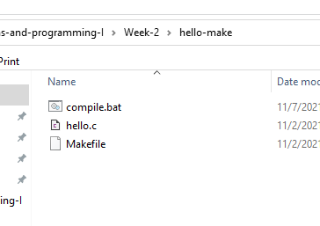
alt:“alt” height:450px center

JAVA Environment and Development
//TODO//
alt:“alt” height:200px center

JDK and JRE Setup
//TODO//
alt:“alt” height:200px center

System Environments and Paths for Java
//TODO//
alt:“alt” height:200px center

Netbeans (Java)
//TODO//
alt:“alt” height:200px center

Eclipse (Java)
//TODO//
alt:“alt” height:200px center

Intellij Idea (Jet Brains) (Java)
//TODO//
alt:“alt” height:200px center

VSCode (Java)
//TODO//
alt:“alt” height:200px center

Notepad++ (Java)
//TODO//
alt:“alt” height:200px center

Cmake (Java)
ASTERICS_HPC

C# Environment and Development

Visual Studio Community Edition (C#)
//TODO//
alt:“alt” height:200px center

Notepad++ (C#)
//TODO//
alt:“alt” height:200px center

Cmake (C#)
Outline

Common Tools and Platforms

Fatih Kalem

https://cdnvideo.eba.gov.tr/fatihkalem/fatihkalem_portable.zip
https://cdnvideo.eba.gov.tr/fatihkalem/fatihkalem_setup.exe
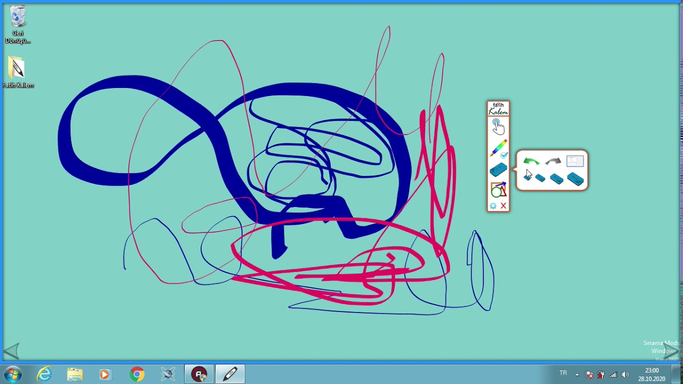
Fatih Kalem indir - Akıllı Tahta için

Notepad++ (Notepad for Source Code)

Downloads | Notepad++
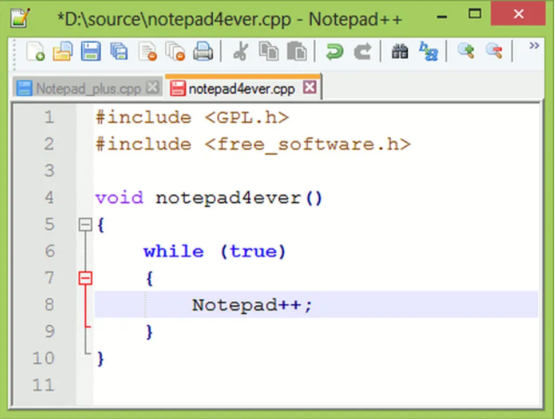

HxD (Hex Editor)

HxD - Freeware Hex Editor and Disk Editor | mh-nexus
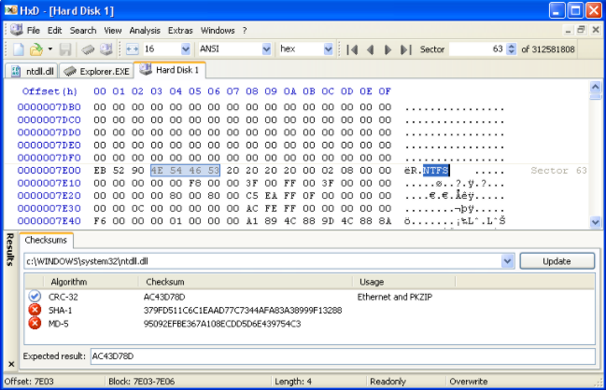

Marktext (Markdown Syntax Editor)

https://marktext.app/
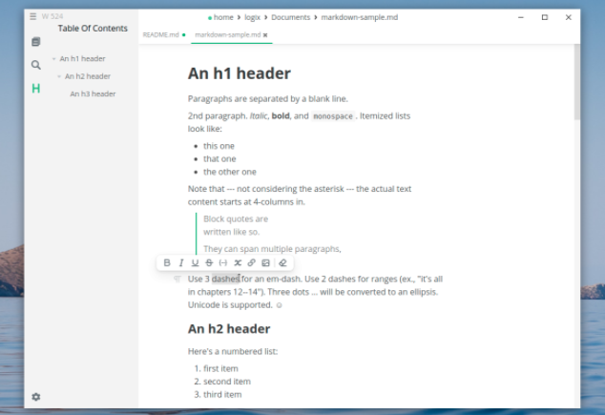

Cygwin (Linux environment for Windows)

https://www.cygwin.com/
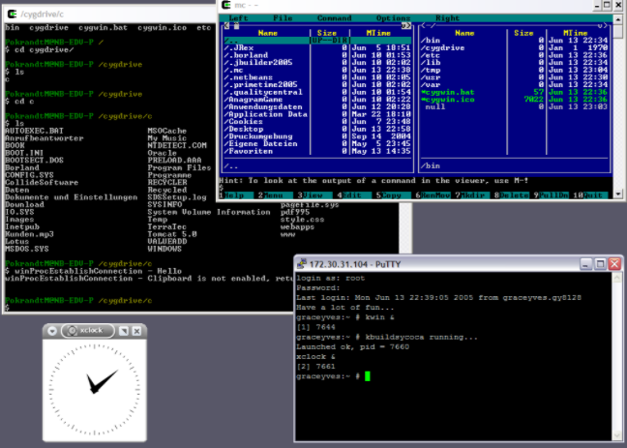

Dependency Walker (32-bit or 64-bit Windows module dependency checker)

https://www.dependencywalker.com/
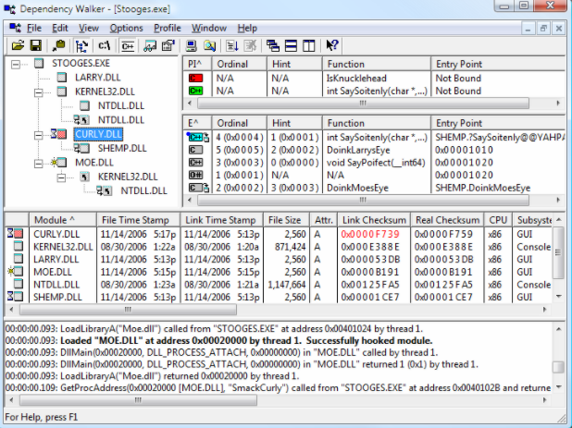

Doxygen (Code Documentation)

Doxygen: Doxygen
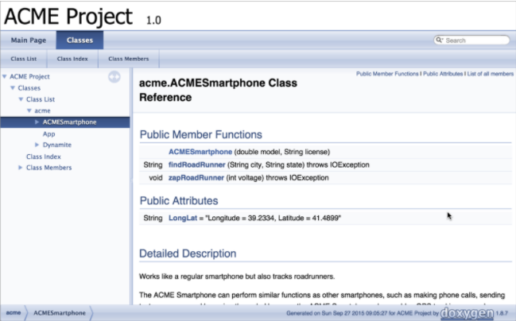

Sonarlint (Code Quality and Code Security Extension)

https://www.sonarlint.org/

Codepen.io (online code sharing)

https://codepen.io/
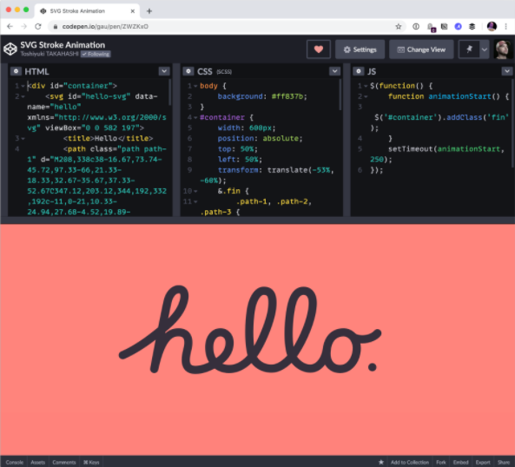

Credit Card Sample
https://codepen.io/quinlo/pen/YONMEa

Codeshare.io (real time code sharing)
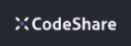
https://codeshare.io/
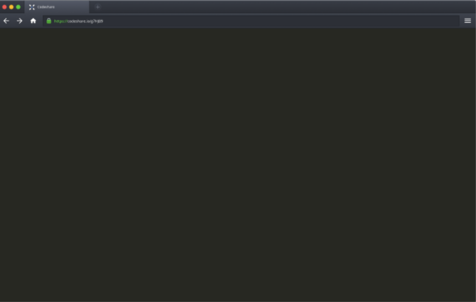

Codebeautify.org (online data conversion tools)

https://codebeautify.org/

AsciiFlow.com (ASCII drawing tool)
//TODO//
alt:“alt” height:200px center

Freemind (opensource mindmap application)
//TODO//
alt:“alt” height:200px center

Wireflow (user flow designer)
//TODO//
alt:“alt” height:200px center

PlantUML (software designer)
//TODO//
alt:“alt” height:200px center

Drawio (drawing tool)
//TODO//
alt:“alt” height:200px center

Putty (Remote Connection)
//TODO//
alt:“alt” height:200px center

MobaXterm (Remote Connection)
//TODO//
alt:“alt” height:200px center

Teamviewer (Remote Connection)
//TODO//
alt:“alt” height:200px center

Paletton.com (Color Chooser)
//TODO//

Understand (Static Code Analysis)
//TODO//
alt:“alt” height:200px center

JD Project (Java Decompiler)
//TODO//
alt:“alt” height:200px center

Cutter (Multi-Platform Reverse Engineering Tool)
//TODO//
alt:“alt” height:200px center

IDA Pro / Freeware (Native Reverse Engineering Tool)
//TODO//
alt:“alt” height:200px center

Code Visualization (Python, C , C++ , Java)
https://pythontutor.com/
//TODO//
alt:“alt” height:200px center

Assembly of C Code
https://godbolt.org/
//TODO//
alt:“alt” height:200px center

Mobile Device Screen Sharing for Demo
GitHub - Genymobile/scrcpy: Display and control your Android device

Travis-CI
- Travis.yml
//TODO//
alt:“alt” height:200px center

Jenkins
//TODO//
alt:“alt” height:200px center

Valgrind
//TODO//
alt:“alt” height:200px center

Docker
- https://www.youtube.com/watch?v=nBwJm0onzeo&ab_channel=GaryExplains Dockerfile
- DockerHub
- Docker Compose Yaml
- Dockerrun.aws.json (AWS)
//TODO//
alt:“alt” height:200px center

Nuget Packages
//TODO//
alt:“alt” height:200px center

Vim for Windows
- vim/vim-wim32-installer (windows vim installer)
//TODO//
alt:“alt” height:200px center

SCV Cryptomanager
//TODO//
alt:“alt” height:200px center

Addario CryptoBench
//TODO//
alt:“alt” height:200px center

Raymond’s MD5 & SHA Checksum Utility
//TODO//
alt:“alt” height:200px center

SlavaSoft HashCalc
//TODO//
alt:“alt” height:200px center

Portable PGP
//TODO//
alt:“alt” height:200px center

Online Programming Envoriments
- Hackerrank
- CS50 Sandbox
- Programiz C Online Complier
//TODO//
alt:“alt” height:200px center

