CE103 Algorithms and Programming I

C++ Functional Console Programming

Author: Asst. Prof. Dr. Uğur CORUH

## CE103 Algorithms and Programming I

### Week-6

#### C++ Functional Console Programming

Download [DOC](ce103-week-6-cpp.en.md_doc.pdf), [SLIDE](ce103-week-6-cpp.en.md_slide.pdf), [PPTX](ce103-week-6-cpp.en.md_slide.pptx)

#### C++ Functional Console Programming

### Books and Resources

[free-programming-books/free-programming-books-langs.md at master · EbookFoundation/free-programming-books · GitHub](https://github.com/EbookFoundation/free-programming-books/blob/master/books/free-programming-books-langs.md#c-1)

### C++ Functional Console Programming

### C++ Introduction

# C++ Variables, Literals and Constants

In this tutorial, we will learn about variables, literals, and constants in C++ with the help of examples.

## C++ Variables

In programming, a variable is a container (storage area) to hold data.

To indicate the storage area, each variable should be given a unique name (identifier). For example,

int age = 14;

Here, age is a variable of the int data type, and we have assigned an integer value 14 to it.

**Note:** The int data type suggests that the variable can only hold integers. Similarly, we can use the double data type if we have to store decimals and exponentials.

We will learn about all the data types in detail in the next tutorial.

The value of a variable can be changed, hence the name **variable**.

int age = 14; // age is 14  
age = 17; // age is 17

### Rules for naming a variable

* A variable name can only have alphabets, numbers, and the underscore _.
* A variable name cannot begin with a number.
* It is a preferred practice to begin variable names with a lowercase character. For example, name is preferable to Name.
* A variable name cannot be a [keyword](https://www.programiz.com/cpp-programming/keywords-identifiers). For example, int is a keyword that is used to denote integers.
* A variable name can start with an underscore. However, it’s not considered a good practice.

**Note:** We should try to give meaningful names to variables. For example, first_name is a better variable name than fn.

## C++ Literals

Literals are data used for representing fixed values. They can be used directly in the code. For example: 1, 2.5, 'c' etc.

Here, 1, 2.5 and 'c' are literals. Why? You cannot assign different values to these terms.

Here’s a list of different literals in C++ programming.

### 1. Integers

An integer is a numeric literal(associated with numbers) without any fractional or exponential part. There are three types of integer literals in C programming:

* decimal (base 10)
* octal (base 8)
* hexadecimal (base 16)

For example:

Decimal: 0, -9, 22 etc  
Octal: 021, 077, 033 etc  
Hexadecimal: 0x7f, 0x2a, 0x521 etc

In C++ programming, octal starts with a 0, and hexadecimal starts with a 0x.

### 2. Floating-point Literals

A floating-point literal is a numeric literal that has either a fractional form or an exponent form. For example:

-2.0

0.0000234

-0.22E-5

**Note:** E-5 = 10-5

### 3. Characters

A character literal is created by enclosing a single character inside single quotation marks. For example: 'a', 'm', 'F', '2', '}' etc.

### 4. Escape Sequences

Sometimes, it is necessary to use characters that cannot be typed or has special meaning in C++ programming. For example, newline (enter), tab, question mark, etc.

In order to use these characters, escape sequences are used.

| Escape Sequences | Characters |
| --- | --- |
| \b | Backspace |
| \f | Form feed |
| \n | Newline |
| \r | Return |
| \t | Horizontal tab |
| \v | Vertical tab |
| \\ | Backslash |
| \' | Single quotation mark |
| \" | Double quotation mark |
| \? | Question mark |
| \0 | Null Character |

### 5. String Literals

A string literal is a sequence of characters enclosed in double-quote marks. For example:

| "good" | string constant |
| --- | --- |
| "" | null string constant |
| " " | string constant of six white space |
| "x" | string constant having a single character |
| "Earth is round\n" | prints string with a newline |

We will learn about strings in detail in the C++ string tutorial.

## C++ Constants

In C++, we can create variables whose value cannot be changed. For that, we use the const keyword. Here’s an example:

const int LIGHT_SPEED = 299792458;  
LIGHT_SPEED = 2500 // Error! LIGHT_SPEED is a constant.

Here, we have used the keyword const to declare a constant named LIGHT_SPEED. If we try to change the value of LIGHT_SPEED, we will get an error.

A constant can also be created using the #define preprocessor directive. We will learn about it in detail in the C++ Macros tutorial.

# C++ Data Types

In this tutorial, we will learn about basic data types such as int, float, char, etc. in C++ programming with the help of examples.

In C++, data types are declarations for variables. This determines the type and size of data associated with variables. For example,

int age = 13;

Here, age is a variable of type int. Meaning, the variable can only store integers of either 2 or 4 bytes.

## C++ Fundamental Data Types

The table below shows the fundamental data types, their meaning, and their sizes (in bytes):

| Data Type | Meaning | Size (in Bytes) |
| --- | --- | --- |
| int | Integer | 2 or 4 |
| float | Floating-point | 4 |
| double | Double Floating-point | 8 |
| char | Character | 1 |
| wchar_t | Wide Character | 2 |
| bool | Boolean | 1 |
| void | Empty | 0 |

Now, let us discuss these fundamental data types in more detail.

### 1. C++ int

* The int keyword is used to indicate integers.
* Its size is usually 4 bytes. Meaning, it can store values from **-2147483648 to 2147483647**.
* For example,

int salary = 85000;

### 2. C++ float and double

* float and double are used to store floating-point numbers (decimals and exponentials).
* The size of float is 4 bytes and the size of double is 8 bytes. Hence, double has two times the precision of float. To learn more, visit C++ float and double.
* For example,

float area = 64.74;  
double volume = 134.64534;

As mentioned above, these two data types are also used for exponentials. For example,

double distance = 45E12 // 45E12 is equal to 45*10^12

### 3. C++ char

* Keyword char is used for characters.
* Its size is 1 byte.
* Characters in C++ are enclosed inside single quotes ' '.
* For example,

char test = 'h';

**Note:** In C++, an integer value is stored in a char variable rather than the character itself. To learn more, visit [C++ characters](https://www.programiz.com/cpp-programming/char-type).

### 4. C++ wchar_t

* Wide character wchar_t is similar to the char data type, except its size is 2 bytes instead of 1.
* It is used to represent characters that require more memory to represent them than a single char.
* For example,

wchar_t test = L'ם' // storing Hebrew character;

Notice the letter L before the quotation marks.

**Note:** There are also two other fixed-size character types char16_t and char32_t introduced in C++11.

### 5. C++ bool

* The bool data type has one of two possible values: true or false.
* Booleans are used in conditional statements and loops (which we will learn in later chapters).
* For example,

bool cond = false;

### 6. C++ void

* The void keyword indicates an absence of data. It means “nothing” or “no value”.
* We will use void when we learn about functions and pointers.

**Note:** We cannot declare variables of the void type.

## C++ Type Modifiers

We can further modify some of the fundamental data types by using type modifiers. There are 4 type modifiers in C++. They are:

1. signed
2. unsigned
3. short
4. long

We can modify the following data types with the above modifiers:

* int
* double
* char

### C++ Modified Data Types List

| Data Type | Size (in Bytes) | Meaning |
| --- | --- | --- |
| signed int | 4 | used for integers (equivalent to int) |
| unsigned int | 4 | can only store positive integers |
| short | 2 | used for small integers (range **-32768 to 32767**) |
| unsigned short | 2 | used for small positive integers (range **0 to 65,535**) |
| long | at least 4 | used for large integers (equivalent to long int) |
| unsigned long | 4 | used for large positive integers or 0 (equivalent to unsigned long int) |
| long long | 8 | used for very large integers (equivalent to long long int). |
| unsigned long long | 8 | used for very large positive integers or 0 (equivalent to unsigned long long int) |
| long double | 12 | used for large floating-point numbers |
| signed char | 1 | used for characters (guaranteed range **-127 to 127**) |
| unsigned char | 1 | used for characters (range **0 to 255**) |

Let’s see a few examples.

long b = 4523232;  
long int c = 2345342;  
long double d = 233434.56343;  
short d = 3434233; // Error! out of range  
unsigned int a = -5; // Error! can only store positive numbers or 0

## Derived Data Types

Data types that are derived from fundamental data types are derived types. For example: arrays, pointers, function types, structures, etc.

We will learn about these derived data types in later tutorials.

# C++ Basic Input/Output

In this tutorial, we will learn to use the cin object to take input from the user, and the cout object to display output to the user with the help of examples.

## C++ Output

In C++, cout sends formatted output to standard output devices, such as the screen. We use the cout object along with the << operator for displaying output.

### Example 1: String Output

#include <iostream>  
using namespace std;  
  
int main() {  
 // prints the string enclosed in double quotes  
 cout << "This is C++ Programming";  
 return 0;  
}

[Run Code](https://www.programiz.com/cpp-programming/online-compiler)

**Output**

This is C++ Programming

**How does this program work?**

* We first include the iostream header file that allows us to display output.
* The cout object is defined inside the std namespace. To use the std namespace, we used the using namespace std; statement.
* Every C++ program starts with the main() function. The code execution begins from the start of the main() function.
* cout is an object that prints the string inside quotation marks " ". It is followed by the << operator.
* return 0; is the “exit status” of the main() function. The program ends with this statement, however, this statement is not mandatory.

**Note:** If we don’t include the using namespace std; statement, we need to use std::cout instead of cout.

This is the preferred method as using the std namespace can create potential problems.

However, we have used the std namespace in our tutorials in order to make the codes more readable.

#include <iostream>  
  
int main() {  
 // prints the string enclosed in double quotes  
 std::cout << "This is C++ Programming";  
 return 0;  
}

[Run Code](https://www.programiz.com/cpp-programming/online-compiler)

### Example 2: Numbers and Characters Output

To print the numbers and character variables, we use the same cout object but without using quotation marks.

#include <iostream>  
using namespace std;  
  
int main() {  
 int num1 = 70;  
 double num2 = 256.783;  
 char ch = 'A';  
  
 cout << num1 << endl; // print integer  
 cout << num2 << endl; // print double  
 cout << "character: " << ch << endl; // print char  
 return 0;  
}

[Run Code](https://www.programiz.com/cpp-programming/online-compiler)

**Output**

70  
256.783  
character: A

**Notes:**

* The endl manipulator is used to insert a new line. That’s why each output is displayed in a new line.
* The << operator can be used more than once if we want to print different variables, strings and so on in a single statement. For example:

cout << "character: " << ch << endl;

## C++ Input

In C++, cin takes formatted input from standard input devices such as the keyboard. We use the cin object along with the >> operator for taking input.

### Example 3: Integer Input/Output

#include <iostream>  
using namespace std;  
  
int main() {  
 int num;  
 cout << "Enter an integer: ";  
 cin >> num; // Taking input  
 cout << "The number is: " << num;  
 return 0;  
}

[Run Code](https://www.programiz.com/cpp-programming/online-compiler)

**Output**

Enter an integer: 70  
The number is: 70

In the program, we used

cin >> num;

to take input from the user. The input is stored in the variable num. We use the >> operator with cin to take input.

**Note:** If we don’t include the using namespace std; statement, we need to use std::cin instead of cin.

## C++ Taking Multiple Inputs

#include <iostream>  
using namespace std;  
  
int main() {  
 char a;  
 int num;  
  
 cout << "Enter a character and an integer: ";  
 cin >> a >> num;  
  
 cout << "Character: " << a << endl;  
 cout << "Number: " << num;  
  
 return 0;  
}

[Run Code](https://www.programiz.com/cpp-programming/online-compiler)

**Output**

Enter a character and an integer: F  
23  
Character: F  
Number: 23

# C++ Type Conversion

In this tutorial, we will learn about the basics of C++ type conversion with the help of examples.

C++ allows us to convert data of one type to that of another. This is known as type conversion.

There are two types of type conversion in C++.

1. Implicit Conversion
2. Explicit Conversion (also known as Type Casting)

## Implicit Type Conversion

The type conversion that is done automatically done by the compiler is known as implicit type conversion. This type of conversion is also known as automatic conversion.

Let us look at two examples of implicit type conversion.

### Example 1: Conversion From int to double

// Working of implicit type-conversion  
  
#include <iostream>  
using namespace std;  
  
int main() {  
 // assigning an int value to num_int  
 int num_int = 9;  
  
 // declaring a double type variable  
 double num_double;  
  
 // implicit conversion  
 // assigning int value to a double variable  
 num_double = num_int;  
  
 cout << "num_int = " << num_int << endl;  
 cout << "num_double = " << num_double << endl;  
  
 return 0;  
}

[Run Code](https://www.programiz.com/cpp-programming/online-compiler)

**Output**

num_int = 9  
num_double = 9

In the program, we have assigned an int data to a double variable.

num_double = num_int;

Here, the int value is automatically converted to double by the compiler before it is assigned to the num_double variable. This is an example of implicit type conversion.

### Example 2: Automatic Conversion from double to int

//Working of Implicit type-conversion  
  
#include <iostream>  
using namespace std;  
  
int main() {  
  
 int num_int;  
 double num_double = 9.99;  
  
 // implicit conversion  
 // assigning a double value to an int variable  
 num_int = num_double;  
  
 cout << "num_int = " << num_int << endl;  
 cout << "num_double = " << num_double << endl;  
  
 return 0;  
}

[Run Code](https://www.programiz.com/cpp-programming/online-compiler)

**Output**

num_int = 9  
num_double = 9.99

In the program, we have assigned a double data to an int variable.

num_int = num_double;

Here, the double value is automatically converted to int by the compiler before it is assigned to the num_int variable. This is also an example of implicit type conversion.

**Note:** Since int cannot have a decimal part, the digits after the decimal point are truncated in the above example.

### Data Loss During Conversion (Narrowing Conversion)

As we have seen from the above example, conversion from one data type to another is prone to data loss. This happens when data of a larger type is converted to data of a smaller type.

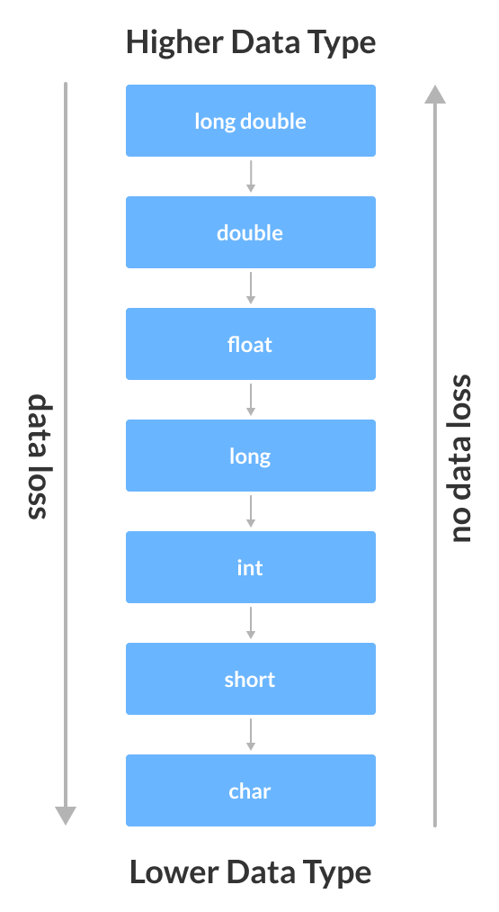

center h:400

Possible Data Loss During Type Conversion

## C++ Explicit Conversion

When the user manually changes data from one type to another, this is known as **explicit conversion**. This type of conversion is also known as **type casting**.

There are three major ways in which we can use explicit conversion in C++. They are:

1. C-style type casting (also known as **cast notation**)
2. Function notation (also known as **old C++ style type casting**)
3. Type conversion operators

### C-style Type Casting

As the name suggests, this type of casting is favored by the **C programming language**. It is also known as **cast notation**.

The syntax for this style is:

(data_type)expression;

For example,

// initializing int variable  
int num_int = 26;  
  
// declaring double variable  
double num_double;  
  
// converting from int to double  
num_double = (double)num_int;

### Function-style Casting

We can also use the function like notation to cast data from one type to another.

The syntax for this style is:

data_type(expression);

For example,

// initializing int variable  
int num_int = 26;  
  
// declaring double variable  
double num_double;  
  
// converting from int to double  
num_double = double(num_int);

### Example 3: Type Casting

#include <iostream>  
  
using namespace std;  
  
int main() {  
 // initializing a double variable  
 double num_double = 3.56;  
 cout << "num_double = " << num_double << endl;  
  
 // C-style conversion from double to int  
 int num_int1 = (int)num_double;  
 cout << "num_int1 = " << num_int1 << endl;  
  
 // function-style conversion from double to int  
 int num_int2 = int(num_double);  
 cout << "num_int2 = " << num_int2 << endl;  
  
 return 0;  
}

[Run Code](https://www.programiz.com/cpp-programming/online-compiler)

**Output**

num_double = 3.56  
num_int1 = 3  
num_int2 = 3

We used both the **C style type conversion** and the **function-style casting for type conversion** and displayed the results. Since they perform the same task, both give us the same output.

### Type Conversion Operators

Besides these two type castings, C++ also has four operators for type conversion. They are known as **type conversion operators**. They are:

* static_cast
* dynamic_cast
* const_cast
* reinterpret_cast

We will learn about these casts in later tutorials.

**Recommended Tutorials:**

* [*C++ string to int and Vice-versa*](https://www.programiz.com/cpp-programming/string-int-conversion)
* [*C++ string to float, double and Vice-versa*](https://www.programiz.com/cpp-programming/string-float-conversion)

# C++ Operators

In this tutorial, we will learn about the different types of operators in C++ with the help of examples. In programming, an operator is a symbol that operates on a value or a variable.

Operators are symbols that perform operations on variables and values. For example, + is an operator used for addition, while - is an operator used for subtraction.

Operators in C++ can be classified into 6 types:

1. [Arithmetic Operators](https://www.programiz.com/cpp-programming/operators#arithmetic)
2. [Assignment Operators](https://www.programiz.com/cpp-programming/operators#assignment)
3. [Relational Operators](https://www.programiz.com/cpp-programming/operators#relational)
4. [Logical Operators](https://www.programiz.com/cpp-programming/operators#logical)
5. [Bitwise Operators](https://www.programiz.com/cpp-programming/operators#bitwise)
6. [Other Operators](https://www.programiz.com/cpp-programming/operators#other-operators)

## 1. C++ Arithmetic Operators

Arithmetic operators are used to perform arithmetic operations on variables and data. For example,

a + b;

Here, the + operator is used to add two variables a and b. Similarly there are various other arithmetic operators in C++.

| Operator | Operation |
| --- | --- |
| + | Addition |
| - | Subtraction |
| * | Multiplication |
| / | Division |
| % | Modulo Operation (Remainder after division) |

### Example 1: Arithmetic Operators

#include <iostream>  
using namespace std;  
  
int main() {  
 int a, b;  
 a = 7;  
 b = 2;  
  
 // printing the sum of a and b  
 cout << "a + b = " << (a + b) << endl;  
  
 // printing the difference of a and b  
 cout << "a - b = " << (a - b) << endl;  
  
 // printing the product of a and b  
 cout << "a * b = " << (a * b) << endl;  
  
 // printing the division of a by b  
 cout << "a / b = " << (a / b) << endl;  
  
 // printing the modulo of a by b  
 cout << "a % b = " << (a % b) << endl;  
  
 return 0;  
}

[Run Code](https://www.programiz.com/cpp-programming/online-compiler)

**Output**

a + b = 9  
a - b = 5  
a * b = 14  
a / b = 3  
a % b = 1

Here, the operators +, - and * compute addition, subtraction, and multiplication respectively as we might have expected.

**/ Division Operator**

Note the operation (a / b) in our program. The / operator is the division operator.

As we can see from the above example, if an integer is divided by another integer, we will get the quotient. However, if either divisor or dividend is a floating-point number, we will get the result in decimals.

In C++,

7/2 is 3  
7.0 / 2 is 3.5  
7 / 2.0 is 3.5  
7.0 / 2.0 is 3.5

**% Modulo Operator**

The modulo operator % computes the remainder. When a = 9 is divided by b = 4, the remainder is **1**.

**Note:** The % operator can only be used with integers.

### Increment and Decrement Operators

C++ also provides increment and decrement operators: ++ and -- respectively.

* ++ increases the value of the operand by **1**
* -- decreases it by **1**

For example,

int num = 5;  
  
// increment operator  
++num; // 6

Here, the code ++num; increases the value of num by **1**.

### Example 2: Increment and Decrement Operators

// Working of increment and decrement operators  
  
#include <iostream>  
using namespace std;  
  
int main() {  
 int a = 10, b = 100, result_a, result_b;  
  
 // incrementing a by 1 and storing the result in result_a  
 result_a = ++a;  
 cout << "result_a = " << result_a << endl;  
  
  
 // decrementing b by 1 and storing the result in result_b   
 result_b = --b;  
 cout << "result_b = " << result_b << endl;  
  
 return 0;  
}

[Run Code](https://www.programiz.com/cpp-programming/online-compiler)

**Output**

result_a = 11  
result_b = 99

In the above program, we have used the ++ and -- operators as **prefixes (++a and –b)**. However, we can also use these operators as **postfix (a++ and b–)**.

To learn more, visit [increment and decrement operators](https://www.programiz.com/article/increment-decrement-operator-difference-prefix-postfix).

## 2. C++ Assignment Operators

In C++, assignment operators are used to assign values to variables. For example,

// assign 5 to a  
a = 5;

Here, we have assigned a value of 5 to the variable a.

| Operator | Example | Equivalent to |
| --- | --- | --- |
| = | a = b; | a = b; |
| += | a += b; | a = a + b; |
| -= | a -= b; | a = a - b; |
| *= | a *= b; | a = a * b; |
| /= | a /= b; | a = a / b; |
| %= | a %= b; | a = a % b; |

### Example 3: Assignment Operators

#include <iostream>  
using namespace std;  
  
int main() {  
 int a, b;  
  
 // 2 is assigned to a  
 a = 2;  
  
 // 7 is assigned to b  
 b = 7;  
  
 cout << "a = " << a << endl;  
 cout << "b = " << b << endl;  
 cout << "\nAfter a += b;" << endl;  
  
 // assigning the sum of a and b to a  
 a += b; // a = a +b  
 cout << "a = " << a << endl;  
  
 return 0;  
}

[Run Code](https://www.programiz.com/cpp-programming/online-compiler)

**Output**

a = 2  
b = 7  
After a += b;  
a = 9

## 3. C++ Relational Operators

A relational operator is used to check the relationship between two operands. For example,

// checks if a is greater than b  
a > b;

Here, > is a relational operator. It checks if a is greater than b or not.

If the relation is **true**, it returns **1** whereas if the relation is **false**, it returns **0**.

| Operator | Meaning | Example |
| --- | --- | --- |
| == | Is Equal To | 3 == 5 gives us **false** |
| != | Not Equal To | 3 != 5 gives us **true** |
| > | Greater Than | 3 > 5 gives us **false** |
| < | Less Than | 3 < 5 gives us **true** |
| >= | Greater Than or Equal To | 3 >= 5 give us **false** |
| <= | Less Than or Equal To | 3 <= 5 gives us **true** |

### Example 4: Relational Operators

#include <iostream>  
using namespace std;  
  
int main() {  
 int a, b;  
 a = 3;  
 b = 5;  
 bool result;  
  
 result = (a == b); // false  
 cout << "3 == 5 is " << result << endl;  
  
 result = (a != b); // true  
 cout << "3 != 5 is " << result << endl;  
  
 result = a > b; // false  
 cout << "3 > 5 is " << result << endl;  
  
 result = a < b; // true  
 cout << "3 < 5 is " << result << endl;  
  
 result = a >= b; // false  
 cout << "3 >= 5 is " << result << endl;  
  
 result = a <= b; // true  
 cout << "3 <= 5 is " << result << endl;  
  
 return 0;  
}

[Run Code](https://www.programiz.com/cpp-programming/online-compiler)

**Output**

3 == 5 is 0  
3 != 5 is 1  
3 > 5 is 0  
3 < 5 is 1  
3 >= 5 is 0  
3 <= 5 is 1

**Note**: Relational operators are used in decision-making and loops.

## 4. C++ Logical Operators

Logical operators are used to check whether an expression is **true** or **false**. If the expression is **true**, it returns **1** whereas if the expression is **false**, it returns **0**.

| Operator | Example | Meaning |
| --- | --- | --- |
| && | expression1 **&&** expression2 | Logical AND.True only if all the operands are true. |
| \| | expression1 **|** expression2 | Logical OR.True if at least one of the operands is true. |
| ! | **!**expression | Logical NOT.True only if the operand is false. |

In C++, logical operators are commonly used in decision making. To further understand the logical operators, let’s see the following examples,

Suppose,  
a = 5  
b = 8  
  
Then,  
  
(a > 3) && (b > 5) evaluates to true  
(a > 3) && (b < 5) evaluates to false  
  
(a > 3) || (b > 5) evaluates to true  
(a > 3) || (b < 5) evaluates to true  
(a < 3) || (b < 5) evaluates to false  
  
!(a < 3) evaluates to true  
!(a > 3) evaluates to false

### Example 5: Logical Operators

#include <iostream>  
using namespace std;  
  
int main() {  
 bool result;  
  
 result = (3 != 5) && (3 < 5); // true  
 cout << "(3 != 5) && (3 < 5) is " << result << endl;  
  
 result = (3 == 5) && (3 < 5); // false  
 cout << "(3 == 5) && (3 < 5) is " << result << endl;  
  
 result = (3 == 5) && (3 > 5); // false  
 cout << "(3 == 5) && (3 > 5) is " << result << endl;  
  
 result = (3 != 5) || (3 < 5); // true  
 cout << "(3 != 5) || (3 < 5) is " << result << endl;  
  
 result = (3 != 5) || (3 > 5); // true  
 cout << "(3 != 5) || (3 > 5) is " << result << endl;  
  
 result = (3 == 5) || (3 > 5); // false  
 cout << "(3 == 5) || (3 > 5) is " << result << endl;  
  
 result = !(5 == 2); // true  
 cout << "!(5 == 2) is " << result << endl;  
  
 result = !(5 == 5); // false  
 cout << "!(5 == 5) is " << result << endl;  
  
 return 0;  
}

[Run Code](https://www.programiz.com/cpp-programming/online-compiler)

**Output**

(3 != 5) && (3 < 5) is 1  
(3 == 5) && (3 < 5) is 0  
(3 == 5) && (3 > 5) is 0  
(3 != 5) || (3 < 5) is 1  
(3 != 5) || (3 > 5) is 1  
(3 == 5) || (3 > 5) is 0  
!(5 == 2) is 1  
!(5 == 5) is 0

**Explanation of logical operator program**

* (3 != 5) && (3 < 5) evaluates to **1** because both operands (3 != 5) and (3 < 5) are **1** (true).
* (3 == 5) && (3 < 5) evaluates to **0** because the operand (3 == 5) is **0** (false).
* (3 == 5) && (3 > 5) evaluates to **0** because both operands (3 == 5) and (3 > 5) are **0** (false).
* (3 != 5) || (3 < 5) evaluates to **1** because both operands (3 != 5) and (3 < 5) are **1** (true).
* (3 != 5) || (3 > 5) evaluates to **1** because the operand (3 != 5) is **1** (true).
* (3 == 5) || (3 > 5) evaluates to **0** because both operands (3 == 5) and (3 > 5) are **0** (false).
* !(5 == 2) evaluates to **1** because the operand (5 == 2) is **0** (false).
* !(5 == 5) evaluates to **0** because the operand (5 == 5) is **1** (true).

## 5. C++ Bitwise Operators

In C++, bitwise operators are used to perform operations on individual bits. They can only be used alongside char and int data types.

| Operator | Description |
| --- | --- |
| & | Binary AND |
| \| | Binary OR |
| ^ | Binary XOR |
| ~ | Binary One’s Complement |
| << | Binary Shift Left |
| >> | Binary Shift Right |

To learn more, visit [C++ bitwise operators](https://www.programiz.com/cpp-programming/bitwise-operators).

## 6. Other C++ Operators

Here’s a list of some other common operators available in C++. We will learn about them in later tutorials.

| Operator | Description | Example |
| --- | --- | --- |
| sizeof | returns the size of data type | sizeof(int); // 4 |
| ?: | returns value based on the condition | string result = (5 > 0) ? "even" : "odd"; // "even" |
| & | represents memory address of the operand | &num; // address of num |
| . | accesses members of struct variables or class objects | s1.marks = 92; |
| -> | used with pointers to access the class or struct variables | ptr->marks = 92; |
| << | prints the output value | cout << 5; |
| >> | gets the input value | cin >> num; |

# C++ Comments

In this tutorial, we will learn about C++ comments, why we use them, and how to use them with the help of examples.

C++ comments are hints that a programmer can add to make their code easier to read and understand. They are completely ignored by C++ compilers.

There are two ways to add comments to code:

// - Single Line Comments

/* */ -Multi-line Comments

## Single Line Comments

In C++, any line that starts with // is a comment. For example,

// declaring a variable  
int a;  
  
// initializing the variable 'a' with the value 2  
a = 2;

Here, we have used two single-line comments:

* // declaring a variable
* // initializing the variable 'a' with the value 2

We can also use single line comment like this:

int a; // declaring a variable

## Multi-line comments

In C++, any line between /* and */ is also a comment. For example,

/* declaring a variableto store salary to employees*/  
int salary = 2000;

This syntax can be used to write both single-line and multi-line comments.

## Using Comments for Debugging

Comments can also be used to disable code to prevent it from being executed. For example,

#include <iostream>  
using namespace std;  
int main() {  
 cout << "some code";  
 cout << ''error code; cout << "some other code"; return 0;}

[Run Code](https://www.programiz.com/cpp-programming/online-compiler)

If we get an error while running the program, instead of removing the error-prone code, we can use comments to disable it from being executed; this can be a valuable debugging tool.

#include <iostream>  
using namespace std;  
int main() {  
 cout << "some code";  
 // cout << ''error code;  
 cout << "some other code";  
  
 return 0;  
}

[Run Code](https://www.programiz.com/cpp-programming/online-compiler)

**Pro Tip:** Remember the shortcut for using comments; it can be really helpful. For most code editors, it’s Ctrl + / for Windows and Cmd + / for Mac.

## Why use Comments?

If we write comments on our code, it will be easier for us to understand the code in the future. Also, it will be easier for your fellow developers to understand the code.

**Note:** Comments shouldn’t be the substitute for a way to explain poorly written code in English. We should always write well-structured and self-explanatory code. And, then use comments.

As a general rule of thumb, use comments to explain **Why** you did something rather than **How** you did something, and you are good.

### C++ Flow Control

# C++ if, if…else and Nested if…else

In this tutorial, we will learn about the if…else statement to create decision making programs with the help of examples.

In computer programming, we use the if...else statement to run one block of code under certain conditions and another block of code under different conditions.

For example, assigning grades (A, B, C) based on marks obtained by a student.

* if the percentage is above **90**, assign grade **A**
* if the percentage is above **75**, assign grade **B**
* if the percentage is above **65**, assign grade **C**

There are three forms of if...else statements in C++.

1. if statement
2. if...else statement
3. if...else if...else statement

## C++ if Statement

The syntax of the if statement is:

if (condition) {  
 // body of if statement  
}

The if statement evaluates the condition inside the parentheses ( ).

* If the condition evaluates to true, the code inside the body of if is executed.
* If the condition evaluates to false, the code inside the body of if is skipped.

**Note:** The code inside { } is the body of the if statement.

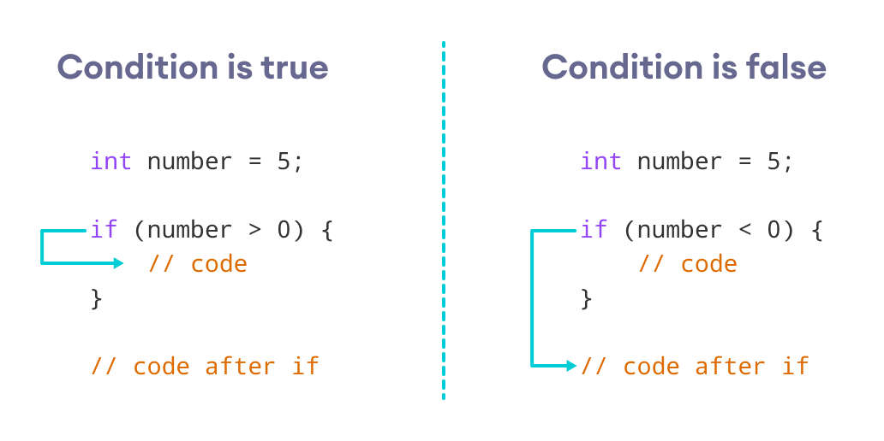

Working of if Statement

How if Statement Works

### Example 1: C++ if Statement

// Program to print positive number entered by the user  
// If the user enters a negative number, it is skipped  
  
#include <iostream>  
using namespace std;  
  
int main() {  
  
 int number;  
  
 cout << "Enter an integer: ";  
 cin >> number;  
  
 // checks if the number is positive  
 if (number > 0) {  
 cout << "You entered a positive integer: " << number << endl;  
 }  
  
 cout << "This statement is always executed.";  
  
 return 0;  
}

[Run Code](https://www.programiz.com/cpp-programming/online-compiler)

**Output 1**

Enter an integer: 5  
You entered a positive number: 5  
This statement is always executed.

When the user enters 5, the condition number > 0 is evaluated to true and the statement inside the body of if is executed.

**Output 2**

Enter a number: -5  
This statement is always executed.

When the user enters -5, the condition number > 0 is evaluated to false and the statement inside the body of if is not executed.

## C++ if…else

The if statement can have an optional else clause. Its syntax is:

if (condition) {  
 // block of code if condition is true  
}  
else {  
 // block of code if condition is false  
}

The if..else statement evaluates the condition inside the parenthesis.

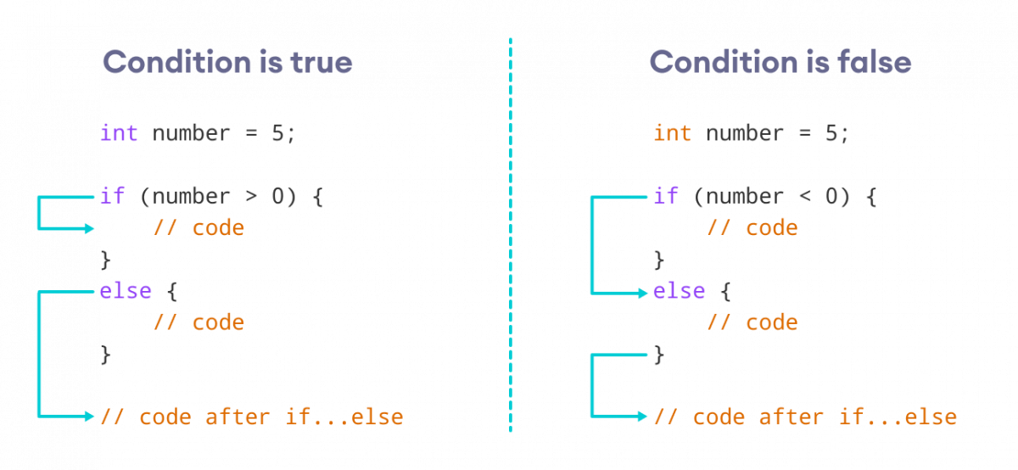

center h:400

How if…else Statement Works

If the condition evaluates true,

* the code inside the body of if is executed
* the code inside the body of else is skipped from execution

If the condition evaluates false,

* the code inside the body of else is executed
* the code inside the body of if is skipped from execution

### Example 2: C++ if…else Statement

// Program to check whether an integer is positive or negative  
// This program considers 0 as a positive number  
  
#include <iostream>  
using namespace std;  
  
int main() {  
  
 int number;  
  
 cout << "Enter an integer: ";  
 cin >> number;  
  
 if (number >= 0) {  
 cout << "You entered a positive integer: " << number << endl;  
 }  
 else {  
 cout << "You entered a negative integer: " << number << endl;  
 }  
  
 cout << "This line is always printed.";  
  
 return 0;  
}

[Run Code](https://www.programiz.com/cpp-programming/online-compiler)

**Output 1**

Enter an integer: 4  
You entered a positive integer: 4.  
This line is always printed.

In the above program, we have the condition number >= 0. If we enter the number greater or equal to 0, then the condition evaluates true.

Here, we enter 4. So, the condition is true. Hence, the statement inside the body of if is executed.

**Output 2**

Enter an integer: -4  
You entered a negative integer: -4.  
This line is always printed.

Here, we enter -4. So, the condition is false. Hence, the statement inside the body of else is executed.

## C++ if…else…else if statement

The if...else statement is used to execute a block of code among two alternatives. However, if we need to make a choice between more than two alternatives, we use the if...else if...else statement.

The syntax of the if...else if...else statement is:

if (condition1) {  
 // code block 1  
}  
else if (condition2){  
 // code block 2  
}  
else {  
 // code block 3  
}

Here,

* If condition1 evaluates to true, the code block 1 is executed.
* If condition1 evaluates to false, then condition2 is evaluated.
* If condition2 is true, the code block 2 is executed.
* If condition2 is false, the code block 3 is executed.

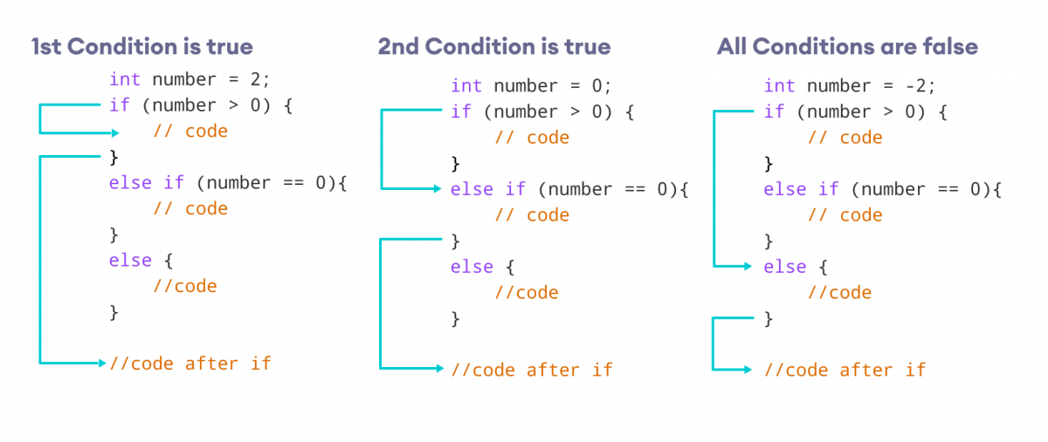

center h:400

How if…else if…else Statement Works

**Note:** There can be more than one else if statement but only one if and else statements.

### Example 3: C++ if…else…else if

// Program to check whether an integer is positive, negative or zero  
  
#include <iostream>  
using namespace std;  
  
int main() {  
  
 int number;  
  
 cout << "Enter an integer: ";  
 cin >> number;  
  
 if (number > 0) {  
 cout << "You entered a positive integer: " << number << endl;  
 }   
 else if (number < 0) {  
 cout << "You entered a negative integer: " << number << endl;  
 }   
 else {  
 cout << "You entered 0." << endl;  
 }  
  
 cout << "This line is always printed.";  
  
 return 0;  
}

[Run Code](https://www.programiz.com/cpp-programming/online-compiler)

**Output 1**

Enter an integer: 1  
You entered a positive integer: 1.  
This line is always printed.

**Output 2**

Enter an integer: -2  
You entered a negative integer: -2.  
This line is always printed.

**Output 3**

Enter an integer: 0  
You entered 0.  
This line is always printed.

In this program, we take a number from the user. We then use the if...else if...else ladder to check whether the number is positive, negative, or zero.

If the number is greater than 0, the code inside the if block is executed. If the number is less than 0, the code inside the else if block is executed. Otherwise, the code inside the else block is executed.

## C++ Nested if…else

Sometimes, we need to use an if statement inside another if statement. This is known as nested if statement.

Think of it as multiple layers of if statements. There is a first, outer if statement, and inside it is another, inner if statement. Its syntax is:

// outer if statement  
if (condition1) {  
  
 // statements  
  
 // inner if statement  
 if (condition2) {  
 // statements  
 }  
}

**Notes:**

* We can add else and else if statements to the inner if statement as required.
* The inner if statement can also be inserted inside the outer else or else if statements (if they exist).
* We can nest multiple layers of if statements.

### Example 4: C++ Nested if

// C++ program to find if an integer is positive, negative or zero  
// using nested if statements  
  
#include <iostream>  
using namespace std;  
  
int main() {  
  
 int num;  
  
 cout << "Enter an integer: ";   
 cin >> num;   
  
 // outer if condition  
 if (num != 0) {  
  
 // inner if condition  
 if (num > 0) {  
 cout << "The number is positive." << endl;  
 }  
 // inner else condition  
 else {  
 cout << "The number is negative." << endl;  
 }   
 }  
 // outer else condition  
 else {  
 cout << "The number is 0 and it is neither positive nor negative." << endl;  
 }  
  
 cout << "This line is always printed." << endl;  
  
 return 0;  
}

[Run Code](https://www.programiz.com/cpp-programming/online-compiler)

**Output 1**

Enter an integer: 35  
The number is positive.  
This line is always printed.

**Output 2**

Enter an integer: -35  
The number is negative.  
This line is always printed.

**Output 3**

Enter an integer: 0  
The number is 0 and it is neither positive nor negative.  
This line is always printed.

In the above example,

* We take an integer as an input from the user and store it in the variable num.
* We then use an if...else statement to check whether num is not equal to 0.
  + If true, then the **inner** if...else statement is executed.
  + If false, the code inside the **outer** else condition is executed, which prints "The number is 0 and it is neither positive nor negative."
* The **inner** if...else statement checks whether the input number is positive i.e. if num is greater than **0**.
  + If true, then we print a statement saying that the number is positive.
  + If false, we print that the number is negative.

**Note:** As you can see, nested if...else makes your logic complicated. If possible, you should always try to avoid nested if...else.

## Body of if…else With Only One Statement

If the body of if...else has only one statement, you can omit { } in the program. For example, you can replace

int number = 5;  
  
if (number > 0) {  
 cout << "The number is positive." << endl;  
}  
else {  
 cout << "The number is negative." << endl;  
}

with

int number = 5;  
  
if (number > 0)  
 cout << "The number is positive." << endl;  
else  
 cout << "The number is negative." << endl;

The output of both programs will be the same.

**Note:** Although it’s not necessary to use { } if the body of if...else has only one statement, using { } makes your code more readable.

## More on Decision Making

In certain situations, a **ternary operator** can replace an if...else statement. To learn more, visit [C++ Ternary Operator](https://www.programiz.com/cpp-programming//cpp-programming/ternary-operator/).

If we need to make a choice between more than one alternatives based on a given test condition, the switch statement can be used. To learn more, visit [C++ switch](https://www.programiz.com/cpp-programming/switch-case).

Check out these examples to learn more:

[C++ Program to Check Whether Number is Even or Odd](https://www.programiz.com/cpp-programming/examples/even-odd)

[C++ Program to Check Whether a character is Vowel or Consonant.](https://www.programiz.com/cpp-programming/examples/vowel-consonant)

[C++ Program to Find Largest Number Among Three Numbers](https://www.programiz.com/cpp-programming/examples/largest-number-among-three)

# C++ for Loop

In this tutorial, we will learn about the C++ for loop and its working with the help of some examples.

In computer programming, loops are used to repeat a block of code.

For example, let’s say we want to show a message 100 times. Then instead of writing the print statement 100 times, we can use a loop.

That was just a simple example; we can achieve much more efficiency and sophistication in our programs by making effective use of loops.

There are 3 types of loops in C++.

* for loop
* while loop
* do...while loop

This tutorial focuses on C++ for loop. We will learn about the other type of loops in the upcoming tutorials.

## C++ for loop

The syntax of for-loop is:

for (initialization; condition; update) {  
 // body of-loop   
}

Here,

* initialization - initializes variables and is executed only once
* condition - if true, the body of for loop is executed  
  if false, the for loop is terminated
* update - updates the value of initialized variables and again checks the condition

To learn more about conditions, check out our tutorial on [C++ Relational and Logical Operators](https://www.programiz.com/cpp-programming/relational-logical-operators).

## Flowchart of for Loop in C++

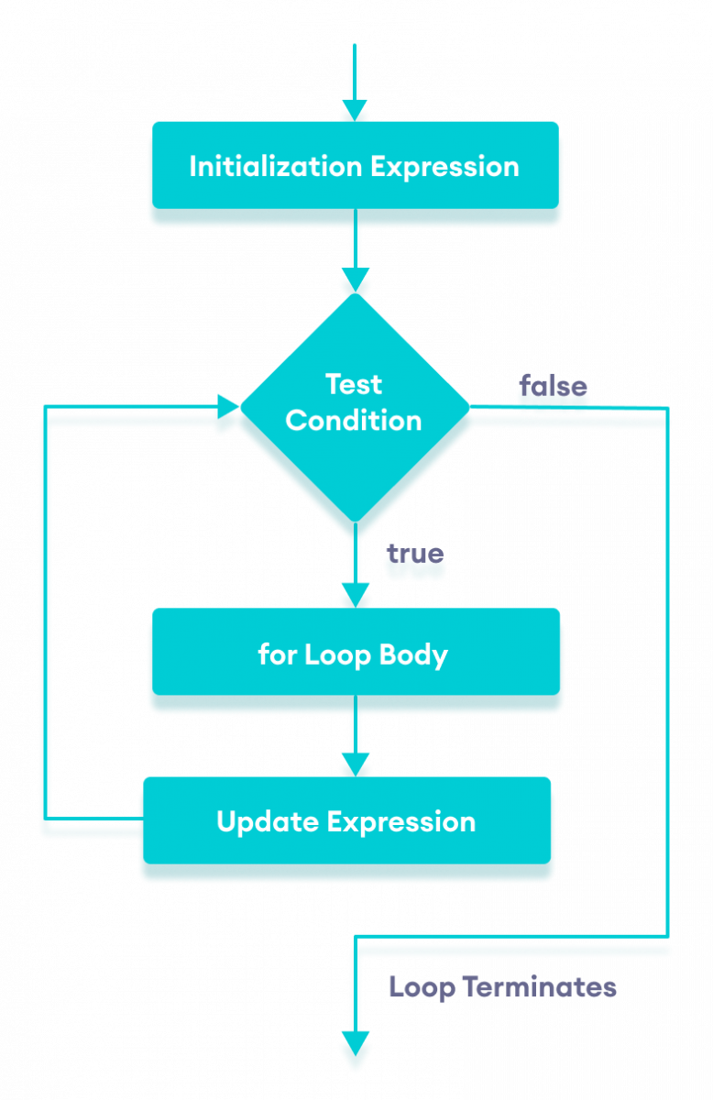

center h:400

Flowchart of for loop in C++

### Example 1: Printing Numbers From 1 to 5

#include <iostream>  
  
using namespace std;  
  
int main() {  
 for (int i = 1; i <= 5; ++i) {  
 cout << i << " ";  
 }  
 return 0;  
}

[Run Code](https://www.programiz.com/cpp-programming/online-compiler)

**Output**

1 2 3 4 5

Here is how this program works

| Iteration | Variable | i <= 5 | Action |
| --- | --- | --- | --- |
| 1st | i = 1 | true | 1 is printed. i is increased to 2. |
| 2nd | i = 2 | true | 2 is printed. i is increased to 3. |
| 3rd | i = 3 | true | 3 is printed. i is increased to 4. |
| 4th | i = 4 | true | 4 is printed. i is increased to 5. |
| 5th | i = 5 | true | 5 is printed. i is increased to 6. |
| 6th | i = 6 | false | The loop is terminated |

### Example 2: Display a text 5 times

// C++ Program to display a text 5 times  
  
#include <iostream>  
  
using namespace std;  
  
int main() {  
 for (int i = 1; i <= 5; ++i) {  
 cout << "Hello World! " << endl;  
 }  
 return 0;  
}

[Run Code](https://www.programiz.com/cpp-programming/online-compiler)

**Output**

Hello World!  
Hello World!  
Hello World!  
Hello World!  
Hello World!

Here is how this program works

| Iteration | Variable | i <= 5 | Action |
| --- | --- | --- | --- |
| 1st | i = 1 | true | Hello World! is printed and i is increased to 2. |
| 2nd | i = 2 | true | Hello World! is printed and i is increased to 3. |
| 3rd | i = 3 | true | Hello World! is printed and i is increased to 4. |
| 4th | i = 4 | true | Hello World! is printed and i is increased to 5. |
| 5th | i = 5 | true | Hello World! is printed and i is increased to 6. |
| 6th | i = 6 | false | The loop is terminated |

### Example 3: Find the sum of first n Natural Numbers

// C++ program to find the sum of first n natural numbers  
// positive integers such as 1,2,3,...n are known as natural numbers  
  
#include <iostream>  
  
using namespace std;  
  
int main() {  
 int num, sum;  
 sum = 0;  
  
 cout << "Enter a positive integer: ";  
 cin >> num;  
  
 for (int i = 1; i <= num; ++i) {  
 sum += i;  
 }  
  
 cout << "Sum = " << sum << endl;  
  
 return 0;  
}

[Run Code](https://www.programiz.com/cpp-programming/online-compiler)

**Output**

Enter a positive integer: 10  
Sum = 55

In the above example, we have two variables num and sum. The sum variable is assigned with 0 and the num variable is assigned with the value provided by the user.

Note that we have used a for loop.

for(int i = 1; i <= num; ++i)

Here,

* int i = 1: initializes the i variable
* i <= num: runs the loop as long as i is less than or equal to num
* ++i: increases the i variable by 1 in each iteration

When i becomes 11, the condition is false and sum will be equal to 0 + 1 + 2 + ... + 10.

## Ranged Based for Loop

In C++11, a new range-based for loop was introduced to work with collections such as **arrays** and **vectors**. Its syntax is:

for (variable : collection) {  
 // body of loop  
}

Here, for every value in the collection, the for loop is executed and the value is assigned to the variable.

### Example 4: Range Based for Loop

#include <iostream>  
  
using namespace std;  
  
int main() {  
  
 int num_array[] = {1, 2, 3, 4, 5, 6, 7, 8, 9, 10};  
  
 for (int n : num_array) {  
 cout << n << " ";  
 }  
  
 return 0;  
}

[Run Code](https://www.programiz.com/cpp-programming/online-compiler)

**Output**

1 2 3 4 5 6 7 8 9 10

In the above program, we have declared and initialized an int array named num_array. It has 10 items.

Here, we have used a range-based for loop to access all the items in the array.

### C++ Infinite for loop

If the condition in a for loop is always true, it runs forever (until memory is full). For example,

// infinite for loop  
for(int i = 1; i > 0; i++) {  
 // block of code  
}

In the above program, the condition is always true which will then run the code for infinite times.

Check out these examples to learn more:

* [C++ Program to Calculate Sum of Natural Numbers](https://www.programiz.com/cpp-programming/examples/sum-natural-number)
* [C++ Program to Find Factorial](https://www.programiz.com/cpp-programming/examples/factorial)
* [C++ Program to Generate Multiplication Table](https://www.programiz.com/cpp-programming/examples/multiplication-table)

In the next tutorial, we will learn about while and do...while loop.

# C++ while and do…while Loop

In this tutorial, we will learn the use of while and do…while loops in C++ programming with the help of some examples.

In computer programming, loops are used to repeat a block of code.

For example, let’s say we want to show a message 100 times. Then instead of writing the print statement 100 times, we can use a loop.

That was just a simple example; we can achieve much more efficiency and sophistication in our programs by making effective use of loops.

There are **3** types of loops in C++.

1. for loop
2. while loop
3. do...while loop

In the previous tutorial, we learned about the [C++ for loop](https://www.programiz.com/cpp-programming/for-loop). Here, we are going to learn about while and do...while loops.

## C++ while Loop

The syntax of the while loop is:

while (condition) {  
 // body of the loop  
}

Here,

* A while loop evaluates the condition
* If the condition evaluates to true, the code inside the while loop is executed.
* The condition is evaluated again.
* This process continues until the condition is false.
* When the condition evaluates to false, the loop terminates.

To learn more about the conditions, visit [C++ Relational and Logical Operators](https://www.programiz.com/cpp-programming/relational-logical-operators).

### Flowchart of while Loop

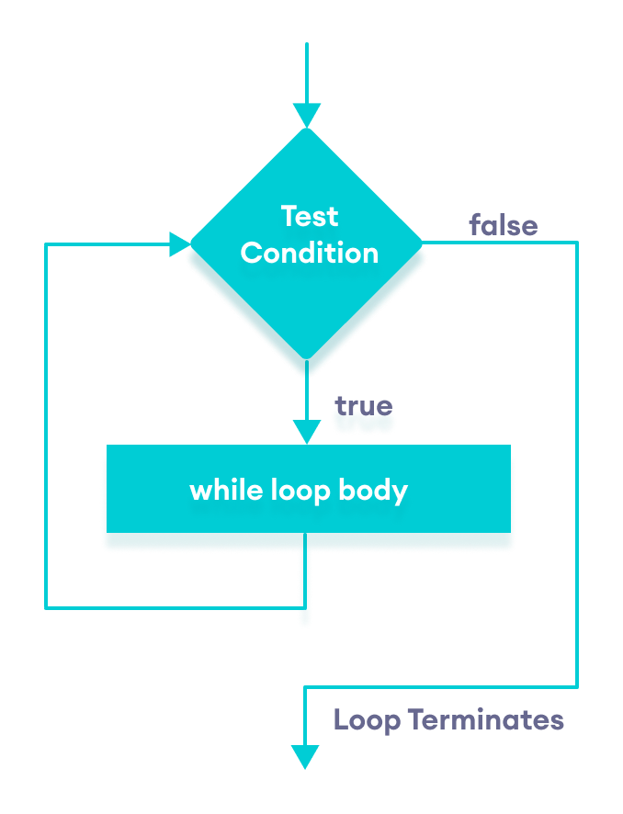

center h:400

Flowchart of C++ while loop

### Example 1: Display Numbers from 1 to 5

// C++ Program to print numbers from 1 to 5  
  
#include <iostream>  
  
using namespace std;  
  
int main() {  
 int i = 1;   
  
 // while loop from 1 to 5  
 while (i <= 5) {  
 cout << i << " ";  
 ++i;  
 }  
  
 return 0;  
}

[Run Code](https://www.programiz.com/cpp-programming/online-compiler)

**Output**

1 2 3 4 5

Here is how the program works.

| Iteration | Variable | i <= 5 | Action |
| --- | --- | --- | --- |
| 1st | i = 1 | true | 1 is printed and i is increased to 2. |
| 2nd | i = 2 | true | 2 is printed and i is increased to 3. |
| 3rd | i = 3 | true | 3 is printed and i is increased to 4 |
| 4th | i = 4 | true | 4 is printed and i is increased to 5. |
| 5th | i = 5 | true | 5 is printed and i is increased to 6. |
| 6th | i = 6 | false | The loop is terminated |

### Example 2: Sum of Positive Numbers Only

// program to find the sum of positive numbers  
// if the user enters a negative number, the loop ends  
// the negative number entered is not added to the sum  
  
#include <iostream>  
using namespace std;  
  
int main() {  
 int number;  
 int sum = 0;  
  
 // take input from the user  
 cout << "Enter a number: ";  
 cin >> number;  
  
 while (number >= 0) {  
 // add all positive numbers  
 sum += number;  
  
 // take input again if the number is positive  
 cout << "Enter a number: ";  
 cin >> number;  
 }  
  
 // display the sum  
 cout << "\nThe sum is " << sum << endl;  
  
 return 0;  
}

[Run Code](https://www.programiz.com/cpp-programming/online-compiler)

**Output**

Enter a number: 6  
Enter a number: 12  
Enter a number: 7  
Enter a number: 0  
Enter a number: -2  
The sum is 25

In this program, the user is prompted to enter a number, which is stored in the variable number.

In order to store the sum of the numbers, we declare a variable sum and initialize it to the value of 0.

The while loop continues until the user enters a negative number. During each iteration, the number entered by the user is added to the sum variable.

When the user enters a negative number, the loop terminates. Finally, the total sum is displayed.

## C++ do…while Loop

The do...while loop is a variant of the while loop with one important difference: the body of do...while loop is executed once before the condition is checked.

Its syntax is:

do {  
 // body of loop;  
}  
while (condition);

Here,

* The body of the loop is executed at first. Then the condition is evaluated.
* If the condition evaluates to true, the body of the loop inside the do statement is executed again.
* The condition is evaluated once again.
* If the condition evaluates to true, the body of the loop inside the do statement is executed again.
* This process continues until the condition evaluates to false. Then the loop stops.

### Flowchart of do…while Loop

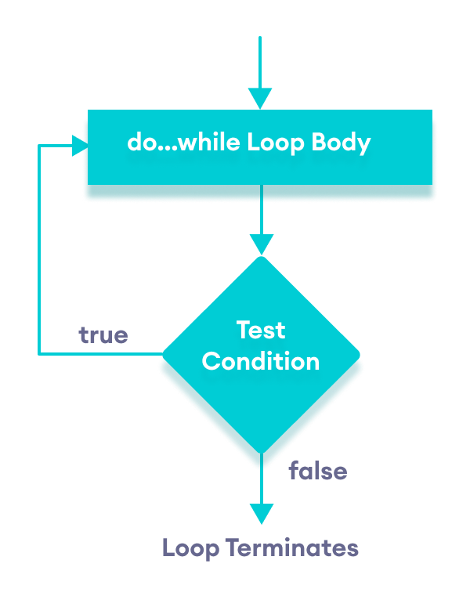

center h:400

Flowchart of C++ do…while loop

### Example 3: Display Numbers from 1 to 5

// C++ Program to print numbers from 1 to 5  
  
#include <iostream>  
  
using namespace std;  
  
int main() {  
 int i = 1;   
  
 // do...while loop from 1 to 5  
 do {  
 cout << i << " ";  
 ++i;  
 }  
 while (i <= 5);  
  
 return 0;  
}

[Run Code](https://www.programiz.com/cpp-programming/online-compiler)

**Output**

1 2 3 4 5

Here is how the program works.

| Iteration | Variable | i <= 5 | Action |
| --- | --- | --- | --- |
|  | i = 1 | not checked | 1 is printed and i is increased to 2 |
| 1st | i = 2 | true | 2 is printed and i is increased to 3 |
| 2nd | i = 3 | true | 3 is printed and i is increased to 4 |
| 3rd | i = 4 | true | 4 is printed and i is increased to 5 |
| 4th | i = 5 | true | 5 is printed and i is increased to **6** |
| 5th | i = 6 | false | The loop is terminated |

### Example 4: Sum of Positive Numbers Only

// program to find the sum of positive numbers  
// If the user enters a negative number, the loop ends  
// the negative number entered is not added to the sum  
  
#include <iostream>  
using namespace std;  
  
int main() {  
 int number = 0;  
 int sum = 0;  
  
 do {  
 sum += number;  
  
 // take input from the user  
 cout << "Enter a number: ";  
 cin >> number;  
 }  
 while (number >= 0);  
  
 // display the sum  
 cout << "\nThe sum is " << sum << endl;  
  
 return 0;  
}

[Run Code](https://www.programiz.com/cpp-programming/online-compiler)

**Output 1**

Enter a number: 6  
Enter a number: 12  
Enter a number: 7  
Enter a number: 0  
Enter a number: -2  
The sum is 25

Here, the do...while loop continues until the user enters a negative number. When the number is negative, the loop terminates; the negative number is not added to the sum variable.

**Output 2**

Enter a number: -6  
The sum is 0.

The body of the do...while loop runs only once if the user enters a negative number.

## Infinite while loop

If the condition of a loop is always true, the loop runs for infinite times (until the memory is full). For example,

// infinite while loop  
while(true) {  
 // body of the loop  
}

Here is an example of an infinite do...while loop.

// infinite do...while loop  
  
int count = 1;  
  
do {  
 // body of loop  
}   
while(count == 1);

In the above programs, the condition is always true. Hence, the loop body will run for infinite times.

## for vs while loops

A for loop is usually used when the number of iterations is known. For example,

// This loop is iterated 5 times  
for (int i = 1; i <=5; ++i) {  
 // body of the loop  
}

Here, we know that the for-loop will be executed 5 times.

However, while and do...while loops are usually used when the number of iterations is unknown. For example,

while (condition) {  
 // body of the loop  
}

Check out these examples to learn more:

* [C++ Program to Display Fibonacci Series](https://www.programiz.com/cpp-programming/examples/fibonacci-series)
* [C++ Program to Find GCD](https://www.programiz.com/cpp-programming/examples/hcf-gcd)
* [C++ Program to Find LCM](https://www.programiz.com/cpp-programming/examples/lcm)

# C++ break Statement

In this tutorial, we will learn about the break statement and its working in loops with the help of examples.

In C++, the break statement terminates the loop when it is encountered.

The syntax of the break statement is:

break;

Before you learn about the break statement, make sure you know about:

* [C++ for loop](https://www.programiz.com/cpp-programming/for-loop)
* [C++ if…else](https://www.programiz.com/cpp-programming/for-loop)
* [C++ while loop](https://www.programiz.com/cpp-programming/do-while-loop)

## Working of C++ break Statement

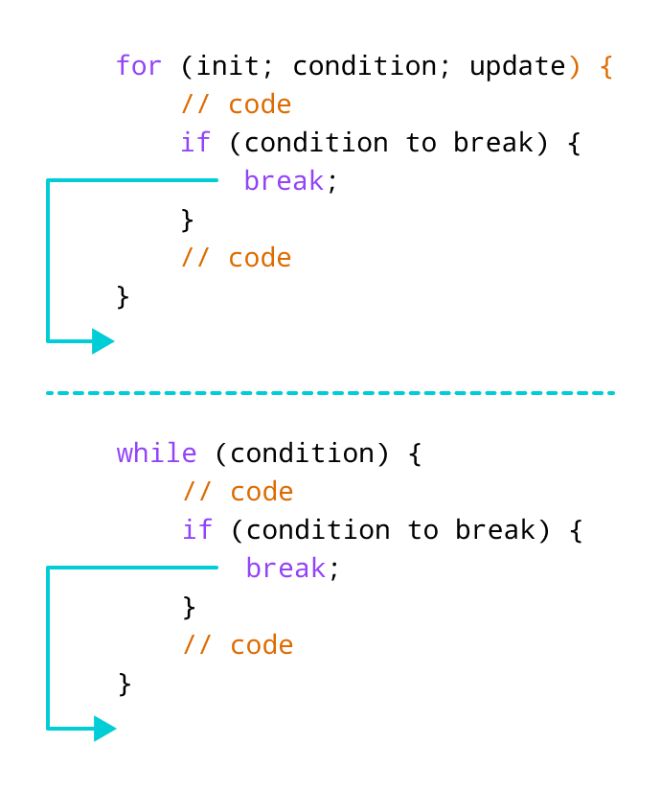

center h:400

Working of break statement in C++

## Example 1: break with for loop

// program to print the value of i  
  
#include <iostream>  
using namespace std;  
  
int main() {  
 for (int i = 1; i <= 5; i++) {  
 // break condition   
 if (i == 3) {  
 break;  
 }  
 cout << i << endl;  
 }  
  
return 0;  
}

[Run Code](https://www.programiz.com/cpp-programming/online-compiler)

**Output**

1  
2

In the above program, the for loop is used to print the value of i in each iteration. Here, notice the code:

if (i == 3) {  
 break;  
}

This means, when i is equal to **3**, the break statement terminates the loop. Hence, the output doesn’t include values greater than or equal to 3.

**Note:** The break statement is usually used with decision-making statements.

## Example 2: break with while loop

// program to find the sum of positive numbers  
// if the user enters a negative numbers, break ends the loop  
// the negative number entered is not added to sum  
  
#include <iostream>  
using namespace std;  
  
int main() {  
 int number;  
 int sum = 0;  
  
 while (true) {  
 // take input from the user  
 cout << "Enter a number: ";  
 cin >> number;  
  
 // break condition  
 if (number < 0) {  
 break;  
 }  
  
 // add all positive numbers  
 sum += number;  
 }  
  
 // display the sum  
 cout << "The sum is " << sum << endl;  
  
 return 0;  
}

[Run Code](https://www.programiz.com/cpp-programming/online-compiler)

**Output**

Enter a number: 1  
Enter a number: 2  
Enter a number: 3  
Enter a number: -5  
The sum is 6.

In the above program, the user enters a number. The while loop is used to print the total sum of numbers entered by the user. Here, notice the code,

if(number < 0) {  
 break;  
}

This means, when the user enters a negative number, the break statement terminates the loop and codes outside the loop are executed.

The while loop continues until the user enters a negative number.

## break with Nested loop

When break is used with nested loops, break terminates the inner loop. For example,

// using break statement inside  
// nested for loop  
  
#include <iostream>  
using namespace std;  
  
int main() {  
 int number;  
 int sum = 0;  
  
 // nested for loops  
  
 // first loop  
 for (int i = 1; i <= 3; i++) {  
 // second loop  
 for (int j = 1; j <= 3; j++) {  
 if (i == 2) {  
 break;  
 }  
 cout << "i = " << i << ", j = " << j << endl;  
 }  
 }  
  
 return 0;  
}

[Run Code](https://www.programiz.com/cpp-programming/online-compiler)

**Output**

i = 1, j = 1  
i = 1, j = 2  
i = 1, j = 3  
i = 3, j = 1  
i = 3, j = 2  
i = 3, j = 3

In the above program, the break statement is executed when i == 2. It terminates the inner loop, and the control flow of the program moves to the outer loop.

Hence, the value of i = 2 is never displayed in the output.

The break statement is also used with the switch statement. To learn more, visit [C++ switch statement](https://www.programiz.com/cpp-programming/switch-case).

# C++ continue Statement

In this tutorial, we will learn about the continue statement and its working with loops with the help of examples.

In computer programming, the continue statement is used to skip the current iteration of the loop and the control of the program goes to the next iteration.

The syntax of the continue statement is:

continue;

Before you learn about the continue statement, make sure you know about,

* [C++ for loop](https://www.programiz.com/cpp-programming/for-loop)
* [C++ if…else](https://www.programiz.com/cpp-programming/for-loop)
* [C++ while loop](https://www.programiz.com/cpp-programming/do-while-loop)

## Working of C++ continue Statement

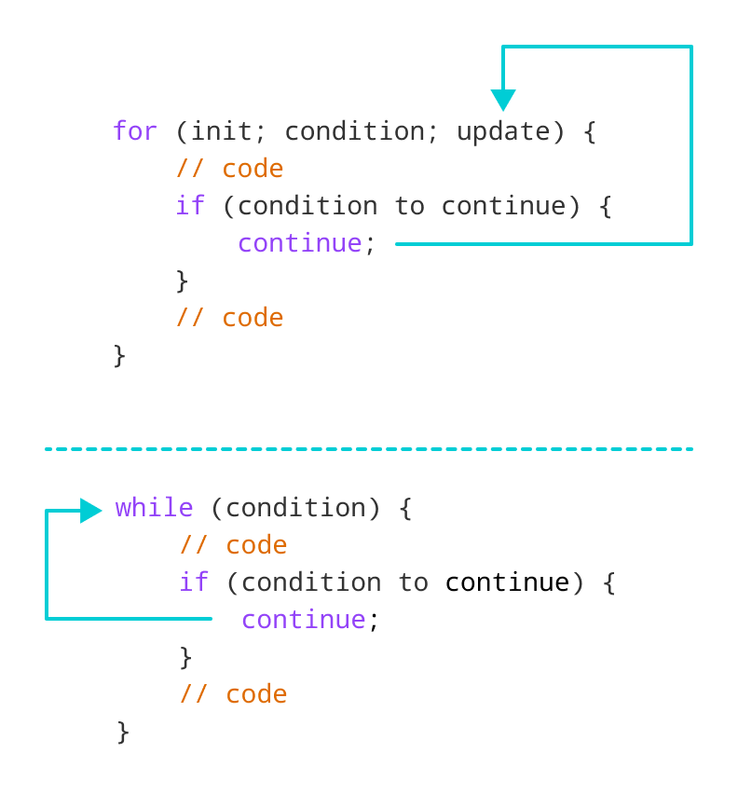

center h:400

Working of continue statement in C++

## Example 1: continue with for loop

In a for loop, continue skips the current iteration and the control flow jumps to the update expression.

// program to print the value of i  
  
#include <iostream>  
using namespace std;  
  
int main() {  
 for (int i = 1; i <= 5; i++) {  
 // condition to continue  
 if (i == 3) {  
 continue;  
 }  
  
 cout << i << endl;  
 }  
  
 return 0;  
}

[Run Code](https://www.programiz.com/cpp-programming/online-compiler)

**Output**

1  
2  
4  
5

In the above program, we have used the the for loop to print the value of i in each iteration. Here, notice the code,

if (i == 3) {  
 continue;  
}

This means

* When i is equal to 3, the continue statement skips the current iteration and starts the next iteration
* Then, i becomes 4**,** and the condition is evaluated again.
* Hence, 4 and 5 are printed in the next two iterations.

**Note**: The continue statement is almost always used with decision-making statements.

## Example 2: continue with while loop

In a while loop, continue skips the current iteration and control flow of the program jumps back to the while condition.

// program to calculate positive numbers till 50 only  
// if the user enters a negative number,  
// that number is skipped from the calculation  
  
// negative number -> loop terminate  
// numbers above 50 -> skip iteration  
  
#include <iostream>  
using namespace std;  
  
int main() {  
 int sum = 0;  
 int number = 0;  
  
 while (number >= 0) {  
 // add all positive numbers  
 sum += number;  
  
 // take input from the user  
 cout << "Enter a number: ";  
 cin >> number;  
  
 // continue condition  
 if (number > 50) {  
 cout << "The number is greater than 50 and won't be calculated." << endl;  
 number = 0; // the value of number is made 0 again  
 continue;  
 }  
 }  
  
 // display the sum  
 cout << "The sum is " << sum << endl;  
  
 return 0;  
}

[Run Code](https://www.programiz.com/cpp-programming/online-compiler)

**Output**

Enter a number: 12  
Enter a number: 0  
Enter a number: 2  
Enter a number: 30  
Enter a number: 50  
Enter a number: 56  
The number is greater than 50 and won't be calculated.  
Enter a number: 5  
Enter a number: -3  
The sum is 99

In the above program, the user enters a number. The while loop is used to print the total sum of positive numbers entered by the user, as long as the numbers entered are not greater than 50.

Notice the use of the continue statement.

if (number > 50){  
 continue;  
}

* When the user enters a number greater than 50, the continue statement skips the current iteration. Then the control flow of the program goes to the condition of while loop.
* When the user enters a number less than 0, the loop terminates.

**Note**: The continue statement works in the same way for the do...while loops.

## continue with Nested loop

When continue is used with nested loops, it skips the current iteration of the inner loop. For example,

// using continue statement inside  
// nested for loop  
  
#include <iostream>  
using namespace std;  
  
int main() {  
 int number;  
 int sum = 0;  
  
 // nested for loops  
  
 // first loop  
 for (int i = 1; i <= 3; i++) {  
 // second loop  
 for (int j = 1; j <= 3; j++) {  
 if (j == 2) {  
 continue;  
 }  
 cout << "i = " << i << ", j = " << j << endl;  
 }  
 }  
  
 return 0;  
}

[Run Code](https://www.programiz.com/cpp-programming/online-compiler)

**Output**

i = 1, j = 1  
i = 1, j = 3  
i = 2, j = 1  
i = 2, j = 3  
i = 3, j = 1  
i = 3, j = 3

In the above program, when the continue statement executes, it skips the current iteration in the inner loop. And the control of the program moves to the **update expression** of the inner loop.

Hence, the value of j = 2 is never displayed in the output.

**Note**: The [break statement](https://www.programiz.com/cpp-programming/break-statement) terminates the loop entirely. However, the continue statement only skips the current iteration.

# C++ switch..case Statement

In this tutorial, we will learn about switch statement and its working in C++ programming with the help of some examples.

The switch statement allows us to execute a block of code among many alternatives.

The syntax of the switch statement in C++ is:

switch (expression) {  
 case constant1:  
 // code to be executed if   
 // expression is equal to constant1;  
 break;  
  
 case constant2:  
 // code to be executed if  
 // expression is equal to constant2;  
 break;  
 .  
 .  
 .  
 default:  
 // code to be executed if  
 // expression doesn't match any constant  
}

**How does the switch statement work?**

The expression is evaluated once and compared with the values of each case label.

* If there is a match, the corresponding code after the matching label is executed. For example, if the value of the variable is equal to constant2, the code after case constant2: is executed until the [break statement](https://www.programiz.com/cpp-programming/break-statement) is encountered.
* If there is no match, the code after default: is executed.

**Note**: We can do the same thing with the if...else..if ladder. However, the syntax of the switch statement is cleaner and much easier to read and write.

## Flowchart of switch Statement

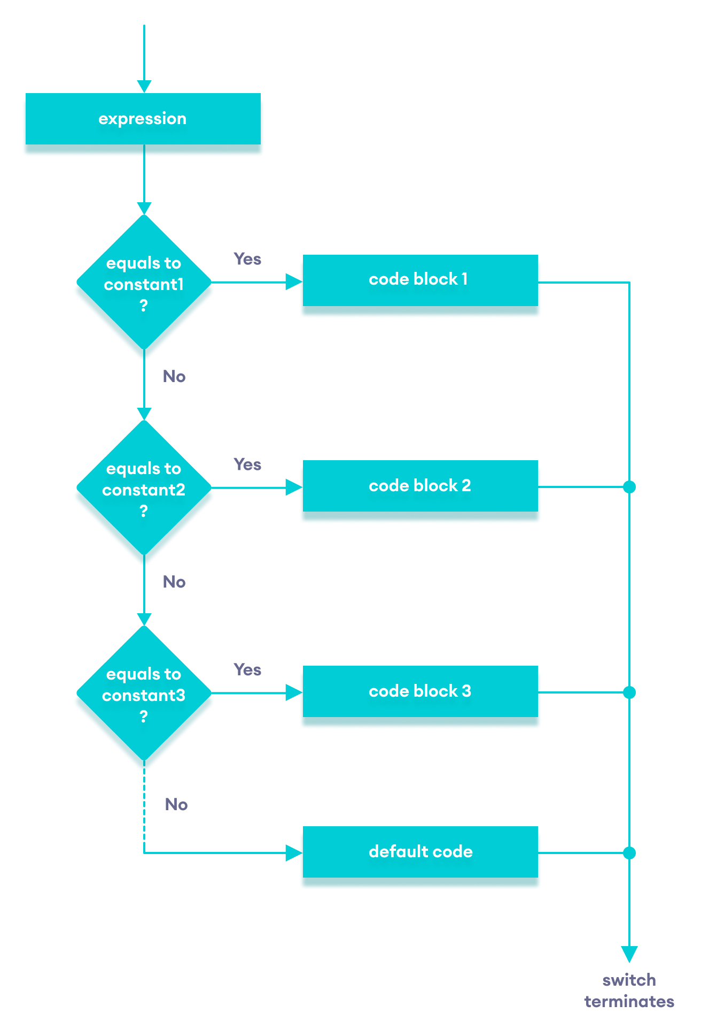

center h:400

Flowchart of C++ switch…case statement

### Example: Create a Calculator using the switch Statement

// Program to build a simple calculator using switch Statement  
#include <iostream>  
using namespace std;  
  
int main() {  
 char oper;  
 float num1, num2;  
 cout << "Enter an operator (+, -, *, /): ";  
 cin >> oper;  
 cout << "Enter two numbers: " << endl;  
 cin >> num1 >> num2;  
  
 switch (oper) {  
 case '+':  
 cout << num1 << " + " << num2 << " = " << num1 + num2;  
 break;  
 case '-':  
 cout << num1 << " - " << num2 << " = " << num1 - num2;  
 break;  
 case '*':  
 cout << num1 << " * " << num2 << " = " << num1 * num2;  
 break;  
 case '/':  
 cout << num1 << " / " << num2 << " = " << num1 / num2;  
 break;  
 default:  
 // operator is doesn't match any case constant (+, -, *, /)  
 cout << "Error! The operator is not correct";  
 break;  
 }  
  
 return 0;  
}

[Run Code](https://www.programiz.com/cpp-programming/online-compiler)

**Output 1**

Enter an operator (+, -, *, /): +  
Enter two numbers:   
2.3  
4.5  
2.3 + 4.5 = 6.8

**Output 2**

Enter an operator (+, -, *, /): -  
Enter two numbers:   
2.3  
4.5  
2.3 - 4.5 = -2.2

**Output 3**

Enter an operator (+, -, *, /): *  
Enter two numbers:   
2.3  
4.5  
2.3 * 4.5 = 10.35

**Output 4**

Enter an operator (+, -, *, /): /  
Enter two numbers:   
2.3  
4.5  
2.3 / 4.5 = 0.511111

**Output 5**

Enter an operator (+, -, *, /): ?  
Enter two numbers:   
2.3  
4.5  
Error! The operator is not correct.

In the above program, we are using the switch...case statement to perform addition, subtraction, multiplication, and division.

**How This Program Works**

1. We first prompt the user to enter the desired operator. This input is then stored in the char variable named oper.
2. We then prompt the user to enter two numbers, which are stored in the float variables num1 and num2.
3. The switch statement is then used to check the operator entered by the user:
   * If the user enters +, addition is performed on the numbers.
   * If the user enters -, subtraction is performed on the numbers.
   * If the user enters *, multiplication is performed on the numbers.
   * If the user enters /, division is performed on the numbers.
   * If the user enters any other character, the default code is printed.

Notice that the break statement is used inside each case block. This terminates the switch statement.

If the break statement is not used, all cases after the correct case are executed.

# C++ goto Statement

In this article, you’ll learn about goto statment, how it works and why should it be avoided.

In C++ programming, the goto statement is used for altering the normal sequence of program execution by transferring control to some other part of the program.

## Syntax of goto Statement

goto label;  
... .. ...  
... .. ...  
... .. ...  
label:   
statement;  
... .. ...

In the syntax above, label is an identifier. When goto label; is encountered, the control of program jumps to label: and executes the code below it.

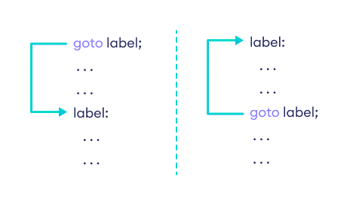

center h:400

Working of goto in C++

### Example: goto Statement

// This program calculates the average of numbers entered by the user.  
// If the user enters a negative number, it ignores the number and   
// calculates the average number entered before it.  
  
# include <iostream>  
using namespace std;  
  
int main()  
{  
 float num, average, sum = 0.0;  
 int i, n;  
  
 cout << "Maximum number of inputs: ";  
 cin >> n;  
  
 for(i = 1; i <= n; ++i)  
 {  
 cout << "Enter n" << i << ": ";  
 cin >> num;  
  
 if(num < 0.0)  
 {  
 // Control of the program move to jump:  
 goto jump;  
 }   
 sum += num;  
 }  
  
jump:  
 average = sum / (i - 1);  
 cout << "\nAverage = " << average;  
 return 0;  
}

**Output**

Maximum number of inputs: 10  
Enter n1: 2.3  
Enter n2: 5.6  
Enter n3: -5.6  
Average = 3.95

You can write any C++ program without the use of goto statement and is generally considered a good idea not to use them.

### Reason to Avoid goto Statement

The goto statement gives the power to jump to any part of a program but, makes the logic of the program complex and tangled.

In modern programming, the goto statement is considered a harmful construct and a bad programming practice.

The goto statement can be replaced in most of C++ program with the use of [break](https://www.programiz.com/cpp-programming/break-statement) and [continue](https://www.programiz.com/cpp-programming/continue-statement) statements.

### C++ Functions

# C++ Functions

In this tutorial, we will learn about the C++ function and function expressions with the help of examples.

A function is a block of code that performs a specific task.

Suppose we need to create a program to create a circle and color it. We can create two functions to solve this problem:

* a function to draw the circle
* a function to color the circle

Dividing a complex problem into smaller chunks makes our program easy to understand and reusable.

There are two types of function:

1. **Standard Library Functions:** Predefined in C++
2. **User-defined Function:** Created by users

In this tutorial, we will focus mostly on user-defined functions.

## C++ User-defined Function

C++ allows the programmer to define their own function.

A user-defined function groups code to perform a specific task and that group of code is given a name (identifier).

When the function is invoked from any part of the program, it all executes the codes defined in the body of the function.

### C++ Function Declaration

The syntax to declare a function is:

returnType functionName (parameter1, parameter2,...) {  
 // function body   
}

Here’s an example of a function declaration.

// function declaration  
void greet() {  
 cout << "Hello World";  
}

Here,

* the name of the function is greet()
* the return type of the function is void
* the empty parentheses mean it doesn’t have any parameters
* the function body is written inside {}

**Note:** We will learn about returnType and parameters later in this tutorial.

### Calling a Function

In the above program, we have declared a function named greet(). To use the greet() function, we need to call it.

Here’s how we can call the above greet() function.

int main() {  
  
 // calling a function   
 greet();   
  
}

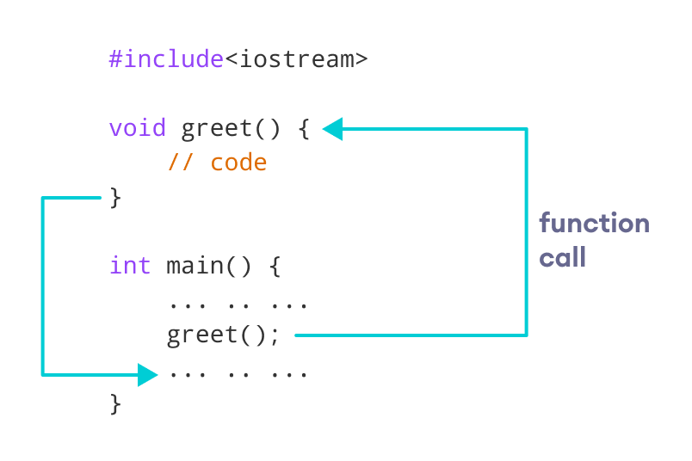

center h:400

How Function works in C++

### Example 1: Display a Text

#include <iostream>  
using namespace std;  
  
// declaring a function  
void greet() {  
 cout << "Hello there!";  
}  
  
int main() {  
  
 // calling the function  
 greet();  
  
 return 0;  
}

[Run Code](https://www.programiz.com/cpp-programming/online-compiler)

**Output**

Hello there!

### Function Parameters

As mentioned above, a function can be declared with parameters (arguments). A parameter is a value that is passed when declaring a function.

For example, let us consider the function below:

void printNum(int num) {  
 cout << num;  
}

Here, the int variable num is the function parameter.

We pass a value to the function parameter while calling the function.

int main() {  
 int n = 7;  
  
 // calling the function  
 // n is passed to the function as argument  
 printNum(n);  
  
 return 0;  
}

### Example 2: Function with Parameters

// program to print a text  
  
#include <iostream>  
using namespace std;  
  
// display a number  
void displayNum(int n1, float n2) {  
 cout << "The int number is " << n1;  
 cout << "The double number is " << n2;  
}  
  
int main() {  
  
 int num1 = 5;  
 double num2 = 5.5;  
  
 // calling the function  
 displayNum(num1, num2);  
  
 return 0;  
}

[Run Code](https://www.programiz.com/cpp-programming/online-compiler)

**Output**

The int number is 5  
The double number is 5.5

In the above program, we have used a function that has one int parameter and one double parameter.

We then pass num1 and num2 as arguments. These values are stored by the function parameters n1 and n2 respectively.

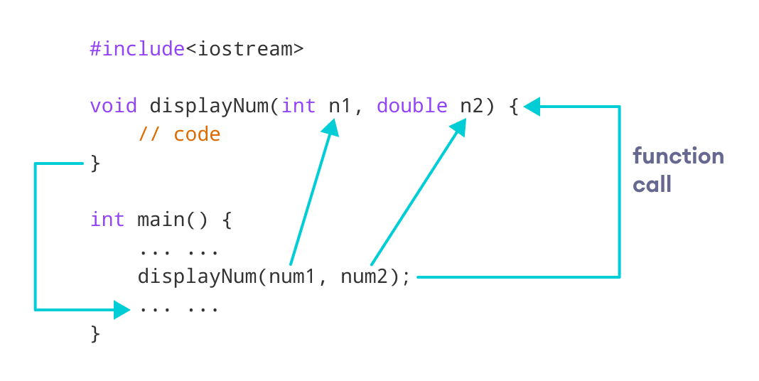

center h:400

C++ function with parameters

**Note:** The type of the arguments passed while calling the function must match with the corresponding parameters defined in the function declaration.

### Return Statement

In the above programs, we have used void in the function declaration. For example,

void displayNumber() {  
 // code  
}

This means the function is not returning any value.

It’s also possible to return a value from a function. For this, we need to specify the returnType of the function during function declaration.

Then, the return statement can be used to return a value from a function.

For example,

int add (int a, int b) {  
 return (a + b);  
}

Here, we have the data type int instead of void. This means that the function returns an int value.

The code return (a + b); returns the sum of the two parameters as the function value.

The return statement denotes that the function has ended. Any code after return inside the function is not executed.

### Example 3: Add Two Numbers

// program to add two numbers using a function  
  
#include <iostream>  
  
using namespace std;  
  
// declaring a function  
int add(int a, int b) {  
 return (a + b);  
}  
  
int main() {  
  
 int sum;  
  
 // calling the function and storing  
 // the returned value in sum  
 sum = add(100, 78);  
  
 cout << "100 + 78 = " << sum << endl;  
  
 return 0;  
}

[Run Code](https://www.programiz.com/cpp-programming/online-compiler)

**Output**

100 + 78 = 178

In the above program, the add() function is used to find the sum of two numbers.

We pass two int literals 100 and 78 while calling the function.

We store the returned value of the function in the variable sum, and then we print it.

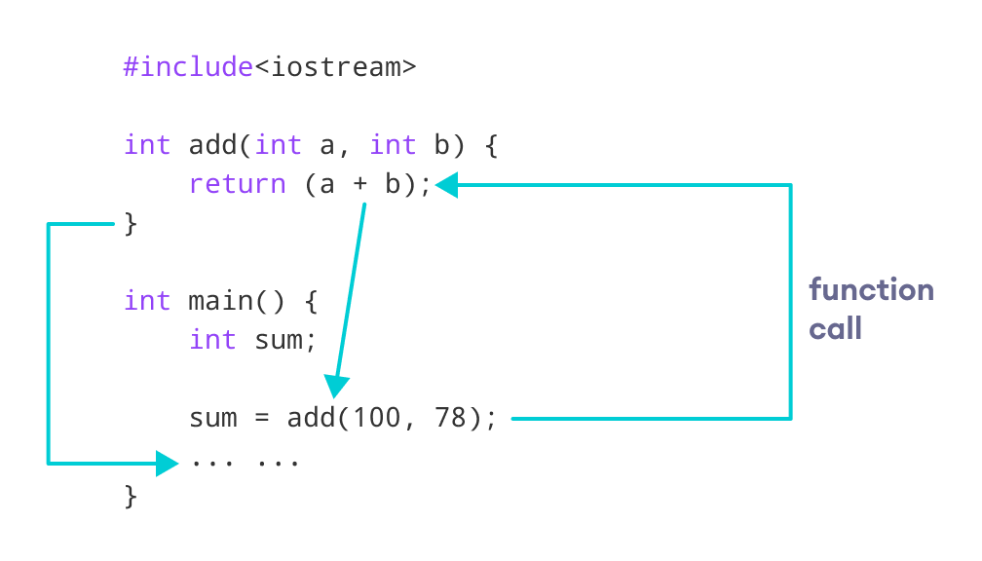

center h:400

Working of C++ Function with return statement

Notice that sum is a variable of int type. This is because the return value of add() is of int type.

### Function Prototype

In C++, the code of function declaration should be before the function call. However, if we want to define a function after the function call, we need to use the function prototype. For example,

// function prototype  
void add(int, int);  
  
int main() {  
 // calling the function before declaration.  
 add(5, 3);  
 return 0;  
}  
  
// function definition  
void add(int a, int b) {  
 cout << (a + b);  
}

In the above code, the function prototype is:

void add(int, int);

This provides the compiler with information about the function name and its parameters. That’s why we can use the code to call a function before the function has been defined.

The syntax of a function prototype is:

returnType functionName(dataType1, dataType2, ...);

### Example 4: C++ Function Prototype

// using function definition after main() function  
// function prototype is declared before main()  
  
#include <iostream>  
  
using namespace std;  
  
// function prototype  
int add(int, int);  
  
int main() {  
 int sum;  
  
 // calling the function and storing  
 // the returned value in sum  
 sum = add(100, 78);  
  
 cout << "100 + 78 = " << sum << endl;  
  
 return 0;  
}  
  
// function definition  
int add(int a, int b) {  
 return (a + b);  
}

[Run Code](https://www.programiz.com/cpp-programming/online-compiler)

**Output**

100 + 78 = 178

The above program is nearly identical to **Example 3**. The only difference is that here, the function is defined **after** the function call.

That’s why we have used a function prototype in this example.

### Benefits of Using User-Defined Functions

* Functions make the code reusable. We can declare them once and use them multiple times.
* Functions make the program easier as each small task is divided into a function.
* Functions increase readability.

## C++ Library Functions

Library functions are the built-in functions in C++ programming.

Programmers can use library functions by invoking the functions directly; they don’t need to write the functions themselves.

Some common library functions in C++ are sqrt(), abs(), isdigit(), etc.

In order to use library functions, we usually need to include the header file in which these library functions are defined.

For instance, in order to use mathematical functions such as sqrt() and abs(), we need to include the header file cmath.

### Example 5: C++ Program to Find the Square Root of a Number

#include <iostream>  
#include <cmath>  
using namespace std;  
  
int main() {  
 double number, squareRoot;  
  
 number = 25.0;  
  
 // sqrt() is a library function to calculate the square root  
 squareRoot = sqrt(number);  
  
 cout << "Square root of " << number << " = " << squareRoot;  
  
 return 0;  
}

[Run Code](https://www.programiz.com/cpp-programming/online-compiler)

**Output**

Square root of 25 = 5

In this program, the sqrt() library function is used to calculate the square root of a number.

The function declaration of sqrt() is defined in the cmath header file. That’s why we need to use the code #include <cmath> to use the sqrt() function.

To learn more, visit [C++ Standard Library functions](https://www.programiz.com/cpp-programming/library-function).

# C++ User-defined Function Types

In this tutorial, you will learn about different approaches you can take to solve a single problem using functions.

For better understanding of arguments and return in functions, user-defined functions can be categorised as:

* [Function with no argument and no return value](https://www.programiz.com/cpp-programming/user-defined-function-types#no_argument_no_return)
* [Function with no argument but return value](https://www.programiz.com/cpp-programming/user-defined-function-types#no_argument_yes_return)
* [Function with argument but no return value](https://www.programiz.com/cpp-programming/user-defined-function-types#yes_argument_no_return)
* [Function with argument and return value](https://www.programiz.com/cpp-programming/user-defined-function-types#yes_argument_yes_return)

Consider a situation in which you have to check prime number. This problem is solved below by making user-defined function in 4 different ways as mentioned above.

## Example 1: No arguments passed and no return value

# include <iostream>  
using namespace std;  
  
void prime();  
  
int main()  
{  
 // No argument is passed to prime()  
 prime();  
 return 0;  
}  
  
  
// Return type of function is void because value is not returned.  
void prime()  
{  
  
 int num, i, flag = 0;  
  
 cout << "Enter a positive integer enter to check: ";  
 cin >> num;  
  
 for(i = 2; i <= num/2; ++i)  
 {  
 if(num % i == 0)  
 {  
 flag = 1;   
 break;  
 }  
 }  
  
 if (flag == 1)  
 {  
 cout << num << " is not a prime number.";  
 }  
 else  
 {  
 cout << num << " is a prime number.";  
 }  
}

In the above program, prime() is called from the main() with no arguments.

prime() takes the positive number from the user and checks whether the number is a prime number or not.

Since, return type of prime() is void, no value is returned from the function.

## Example 2: No arguments passed but a return value

#include <iostream>  
using namespace std;  
  
int prime();  
  
int main()  
{  
 int num, i, flag = 0;  
  
 // No argument is passed to prime()  
 num = prime();  
 for (i = 2; i <= num/2; ++i)  
 {  
 if (num%i == 0)  
 {  
 flag = 1;  
 break;  
 }  
 }  
  
 if (flag == 1)  
 {  
 cout<<num<<" is not a prime number.";  
 }  
 else  
 {  
 cout<<num<<" is a prime number.";  
 }  
 return 0;  
}  
  
// Return type of function is int  
int prime()  
{  
 int n;  
  
 printf("Enter a positive integer to check: ");  
 cin >> n;  
  
 return n;  
}

In the above program, prime() function is called from the main() with no arguments.

prime() takes a positive integer from the user. Since, return type of the function is an int, it returns the inputted number from the user back to the calling main() function.

Then, whether the number is prime or not is checked in the main() itself and printed onto the screen.

## Example 3: Arguments passed but no return value

#include <iostream>  
using namespace std;  
  
void prime(int n);  
  
int main()  
{  
 int num;  
 cout << "Enter a positive integer to check: ";  
 cin >> num;  
  
 // Argument num is passed to the function prime()  
 prime(num);  
 return 0;  
}  
  
// There is no return value to calling function. Hence, return type of function is void. */  
void prime(int n)  
{  
 int i, flag = 0;  
 for (i = 2; i <= n/2; ++i)  
 {  
 if (n%i == 0)  
 {  
 flag = 1;  
 break;  
 }  
 }  
  
 if (flag == 1)  
 {  
 cout << n << " is not a prime number.";  
 }  
 else {  
 cout << n << " is a prime number.";  
 }  
}

In the above program, positive number is first asked from the user which is stored in the variable num.

Then, num is passed to the prime() function where, whether the number is prime or not is checked and printed.

Since, the return type of prime() is a void, no value is returned from the function.

## Example 4: Arguments passed and a return value.

#include <iostream>  
using namespace std;  
  
int prime(int n);  
  
int main()  
{  
 int num, flag = 0;  
 cout << "Enter positive integer to check: ";  
 cin >> num;  
  
 // Argument num is passed to check() function  
 flag = prime(num);  
  
 if(flag == 1)  
 cout << num << " is not a prime number.";  
 else  
 cout<< num << " is a prime number.";  
 return 0;  
}  
  
/* This function returns integer value. */  
int prime(int n)  
{  
 int i;  
 for(i = 2; i <= n/2; ++i)  
 {  
 if(n % i == 0)  
 return 1;  
 }  
  
 return 0;  
}

In the above program, a positive integer is asked from the user and stored in the variable num.

Then, num is passed to the function prime() where, whether the number is prime or not is checked.

Since, the return type of prime() is an int, 1 or 0 is returned to the main() calling function. If the number is a prime number, 1 is returned. If not, 0 is returned.

Back in the main() function, the returned 1 or 0 is stored in the variable flag, and the corresponding text is printed onto the screen.

## Which method is better?

All four programs above gives the same output and all are technically correct program.

There is no hard and fast rule on which method should be chosen.

The particular method is chosen depending upon the situation and how you want to solve a problem.

# C++ Function Overloading

In this tutorial, we will learn about the function overloading in C++ with examples.

In C++, two functions can have the same name if the number and/or type of arguments passed is different.

These functions having the same name but different arguments are known as overloaded functions. For example:

// same name different arguments  
int test() { }  
int test(int a) { }  
float test(double a) { }  
int test(int a, double b) { }

Here, all 4 functions are overloaded functions.

Notice that the return types of all these 4 functions are not the same. Overloaded functions may or may not have different return types but they must have different arguments. For example,

// Error code  
int test(int a) { }  
double test(int b){ }

Here, both functions have the same name, the same type, and the same number of arguments. Hence, the compiler will throw an error.

## Example 1: Overloading Using Different Types of Parameter

// Program to compute absolute value  
// Works for both int and float  
  
#include <iostream>  
using namespace std;  
  
// function with float type parameter  
float absolute(float var){  
 if (var < 0.0)  
 var = -var;  
 return var;  
}  
  
// function with int type parameter  
int absolute(int var) {  
 if (var < 0)  
 var = -var;  
 return var;  
}  
  
int main() {  
  
 // call function with int type parameter  
 cout << "Absolute value of -5 = " << absolute(-5) << endl;  
  
 // call function with float type parameter  
 cout << "Absolute value of 5.5 = " << absolute(5.5f) << endl;  
 return 0;  
}

[Run Code](https://www.programiz.com/cpp-programming/online-compiler)

**Output**

Absolute value of -5 = 5  
Absolute value of 5.5 = 5.5

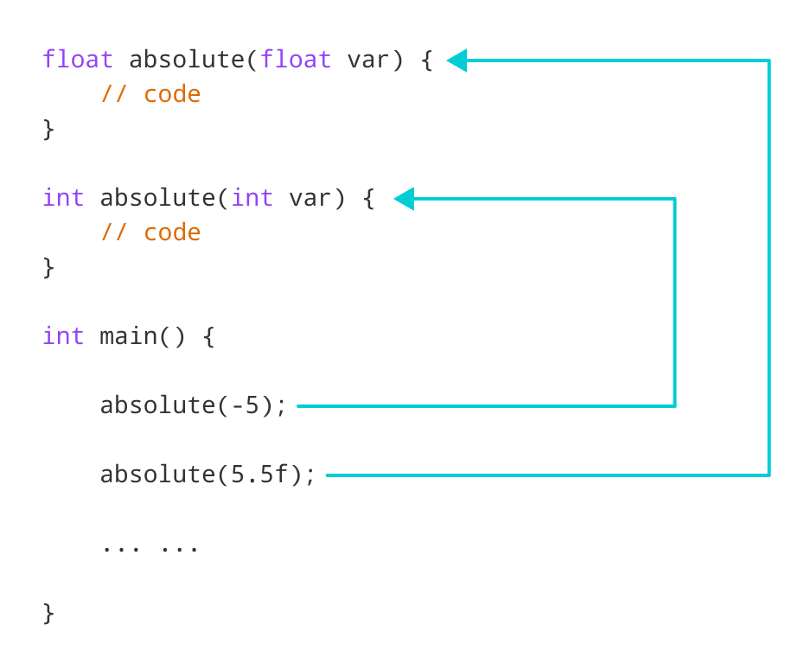

center h:400

Working of overloading for the absolute() function

In this program, we overload the absolute() function. Based on the type of parameter passed during the function call, the corresponding function is called.

## Example 2: Overloading Using Different Number of Parameters

#include <iostream>  
using namespace std;  
  
// function with 2 parameters  
void display(int var1, double var2) {  
 cout << "Integer number: " << var1;  
 cout << " and double number: " << var2 << endl;  
}  
  
// function with double type single parameter  
void display(double var) {  
 cout << "Double number: " << var << endl;  
}  
  
// function with int type single parameter  
void display(int var) {  
 cout << "Integer number: " << var << endl;  
}  
  
int main() {  
  
 int a = 5;  
 double b = 5.5;  
  
 // call function with int type parameter  
 display(a);  
  
 // call function with double type parameter  
 display(b);  
  
 // call function with 2 parameters  
 display(a, b);  
  
 return 0;  
}

[Run Code](https://www.programiz.com/cpp-programming/online-compiler)

**Output**

Integer number: 5  
Float number: 5.5  
Integer number: 5 and double number: 5.5

Here, the display() function is called three times with different arguments. Depending on the number and type of arguments passed, the corresponding display() function is called.

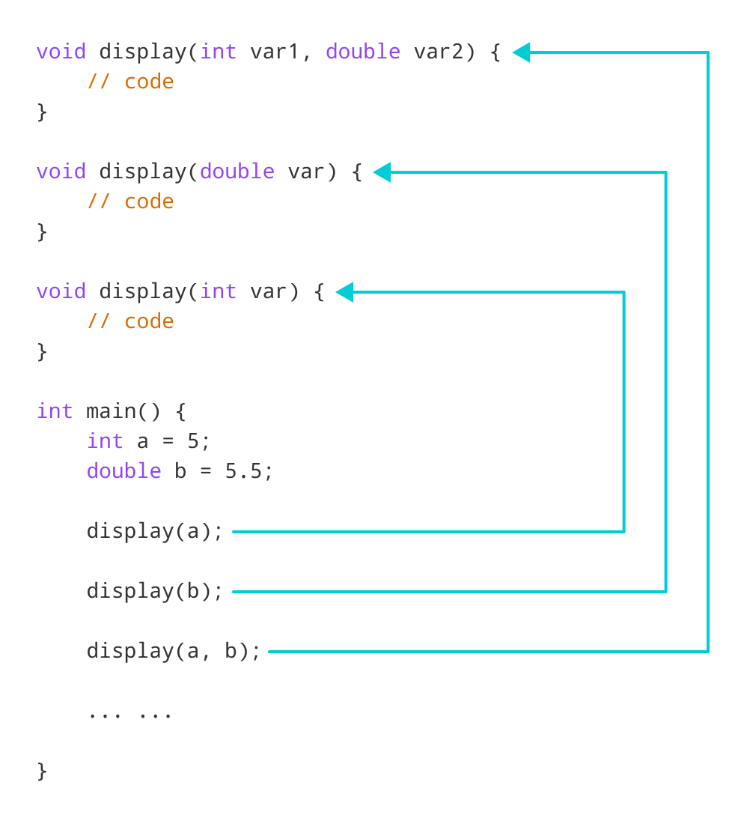

center h:400

Working of overloading for the display() function

The return type of all these functions is the same but that need not be the case for function overloading.

**Note:** In C++, many standard library functions are overloaded. For example, the sqrt() function can take double, float, int, etc. as parameters. This is possible because the sqrt() function is overloaded in C++.

# C++ Programming Default Arguments (Parameters)

In this tutorial, we will learn C++ default arguments and their working with the help of examples.

In C++ programming, we can provide default values for [function](https://www.programiz.com/cpp-programming/function) parameters.

If a function with default arguments is called without passing arguments, then the default parameters are used.

However, if arguments are passed while calling the function, the default arguments are ignored.

## Working of default arguments

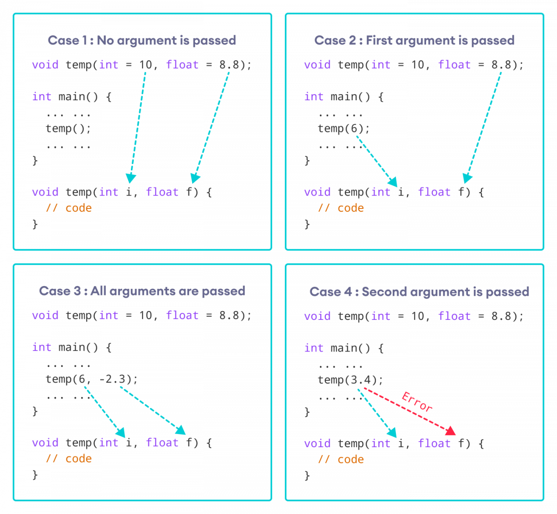

center h:400

How default arguments work in C++

We can understand the working of default arguments from the image above:

1. When temp() is called, both the default parameters are used by the function.
2. When temp(6) is called, the first argument becomes 6 while the default value is used for the second parameter.
3. When temp(6, -2.3) is called, both the default parameters are overridden, resulting in i = 6 and f = -2.3.
4. When temp(3.4) is passed, the function behaves in an undesired way because the second argument cannot be passed without passing the first argument.

* Therefore, 3.4 is passed as the first argument. Since the first argument has been defined as int, the value that is actually passed is 3.

## Example: Default Argument

#include <iostream>  
using namespace std;  
  
// defining the default arguments  
void display(char = '*', int = 3);  
  
int main() {  
 int count = 5;  
  
 cout << "No argument passed: ";  
 // *, 3 will be parameters  
 display();   
  
 cout << "First argument passed: ";  
 // #, 3 will be parameters  
 display('#');   
  
 cout << "Both arguments passed: ";  
 // $, 5 will be parameters  
 display('$', count);   
  
 return 0;  
}  
  
void display(char c, int count) {  
 for(int i = 1; i <= count; ++i)  
 {  
 cout << c;  
 }  
 cout << endl;  
}

[Run Code](https://www.programiz.com/cpp-programming/online-compiler)

**Output**

No argument passed: ***  
First argument passed: ###  
Both arguments passed: $$$$$

Here is how this program works:

1. display() is called without passing any arguments. In this case, display() uses both the default parameters c = '*' and n = 1.
2. display('#') is called with only one argument. In this case, the first becomes '#'. The second default parameter n = 1 is retained.
3. display('#', count) is called with both arguments. In this case, default arguments are not used.

We can also define the default parameters in the function definition itself. The program below is equivalent to the one above.

#include <iostream>  
using namespace std;  
  
// defining the default arguments  
void display(char c = '*', int count = 3) {  
 for(int i = 1; i <= count; ++i) {  
 cout << c;  
 }  
 cout << endl;  
}  
  
int main() {  
 int count = 5;  
  
 cout << "No argument passed: ";  
 // *, 3 will be parameters  
 display();   
  
 cout << "First argument passed: ";  
 // #, 3 will be parameters  
 display('#');   
  
 cout << "Both argument passed: ";  
 // $, 5 will be parameters  
 display('$', count);   
  
 return 0;  
}

[Run Code](https://www.programiz.com/cpp-programming/online-compiler)

## Things to Remember

1. Once we provide a default value for a parameter, all subsequent parameters must also have default values. For example,

* // Invalid  
  void add(int a, int b = 3, int c, int d);  
    
  // Invalid  
  void add(int a, int b = 3, int c, int d = 4);  
    
  // Valid  
  void add(int a, int c, int b = 3, int d = 4);

1. If we are defining the default arguments in the function definition instead of the function prototype, then the function must be defined before the function call.

* // Invalid code  
    
  int main() {  
   // function call  
   display();  
  }  
    
  void display(char c = '*', int count = 5) {  
   // code  
  }

# C++ Storage Class

In this article, you’ll learn about different storage classes in C++. Namely: local, global, static local, register and thread local.

Every variable in C++ has two features: type and storage class.

Type specifies the type of data that can be stored in a variable. For example: int, float, char etc.

And, storage class controls two different properties of a variable: lifetime (determines how long a variable can exist) and scope (determines which part of the program can access it).

Depending upon the storage class of a variable, it can be divided into 4 major types:

* [Local variable](https://www.programiz.com/cpp-programming/storage-class#local_variable)
* [Global variable](https://www.programiz.com/cpp-programming/storage-class#global_variable)
* [Static local variable](https://www.programiz.com/cpp-programming/storage-class#static_variable)
* [Register Variable](https://www.programiz.com/cpp-programming/storage-class#register%20variable)
* [Thread Local Storage](https://www.programiz.com/cpp-programming/storage-class#thread_local_storage)

## Local Variable

A variable defined inside a function (defined inside [function](https://www.programiz.com/cpp-programming/function) body between braces) is called a local variable or automatic variable.

Its scope is only limited to the function where it is defined. In simple terms, local variable exists and can be accessed only inside a function.

The life of a local variable ends (It is destroyed) when the function exits.

### Example 1: Local variable

#include <iostream>  
using namespace std;  
  
void test();  
  
int main()   
{  
 // local variable to main()  
 int var = 5;  
  
 test();  
  
 // illegal: var1 not declared inside main()  
 var1 = 9;  
}  
  
void test()  
{  
 // local variable to test()  
 int var1;  
 var1 = 6;  
  
 // illegal: var not declared inside test()  
 cout << var;  
}

The variable var cannot be used inside test() and var1 cannot be used inside main() function.

Keyword auto was also used for defining local variables before as: auto int var;

But, after [C++11 auto](http://en.cppreference.com/w/cpp/language/auto) has a different meaning and should not be used for defining local variables.

## Global Variable

If a variable is defined outside all functions, then it is called a global variable.

The scope of a global variable is the whole program. This means, It can be used and changed at any part of the program after its declaration.

Likewise, its life ends only when the program ends.

### Example 2: Global variable

#include <iostream>  
using namespace std;  
  
// Global variable declaration  
int c = 12;  
  
void test();  
  
int main()  
{  
 ++c;  
  
 // Outputs 13  
 cout << c <<endl;  
 test();  
  
 return 0;  
}  
  
void test()  
{  
 ++c;  
  
 // Outputs 14  
 cout << c;  
}

**Output**

13  
14

In the above program, c is a global variable.

This variable is visible to both functions main() and test() in the above program.

### Static Local variable

Keyword static is used for specifying a static variable. For example:

... .. ...  
int main()  
{  
 static float a;  
 ... .. ...  
}

A static local variable exists only inside a function where it is declared (similar to a local variable) but its lifetime starts when the function is called and ends only when the program ends.

The main difference between local variable and static variable is that, the value of static variable persists the end of the program.

### Example 3: Static local variable

#include <iostream>  
using namespace std;  
  
void test()  
{  
 // var is a static variable  
 static int var = 0;  
 ++var;  
  
 cout << var << endl;  
}  
  
int main()  
{  
  
 test();  
 test();  
  
 return 0;  
}

**Output**

1  
2

In the above program, test() function is invoked 2 times.

During the first call, variable var is declared as static variable and initialized to 0. Then 1 is added to var which is displayed in the screen.

When the function test() returns, variable var still exists because it is a static variable.

During second function call, no new variable var is created. The same var is increased by 1 and then displayed to the screen.

**Output of above program if var was not specified as static variable**

1  
1

## Register Variable (Deprecated in C++11)

Keyword register is used for specifying register variables.

Register variables are similar to automatic variables and exists inside a particular function only. It is supposed to be faster than the local variables.

If a program encounters a register variable, it stores the variable in processor’s register rather than memory if available. This makes it faster than the local variables.

However, this keyword was deprecated in C++11 and should not be used.

## Thread Local Storage

Thread-local storage is a mechanism by which variables are allocated such that there is one instance of the variable per extant thread.

Keyword thread_local is used for this purpose.

Learn more about [thread local storage](http://www.codeproject.com/Articles/8113/Thread-Local-Storage-The-C-Way).

# C++ Recursion

In this tutorial, we will learn about recursive function in C++ and its working with the help of examples.

A [function](https://www.programiz.com/cpp-programming/function) that calls itself is known as a recursive function. And, this technique is known as recursion.

## Working of Recursion in C++

void recurse()  
{  
 ... .. ...  
 recurse();  
 ... .. ...  
}  
  
int main()  
{  
 ... .. ...  
 recurse();  
 ... .. ...  
}

The figure below shows how recursion works by calling itself over and over again.

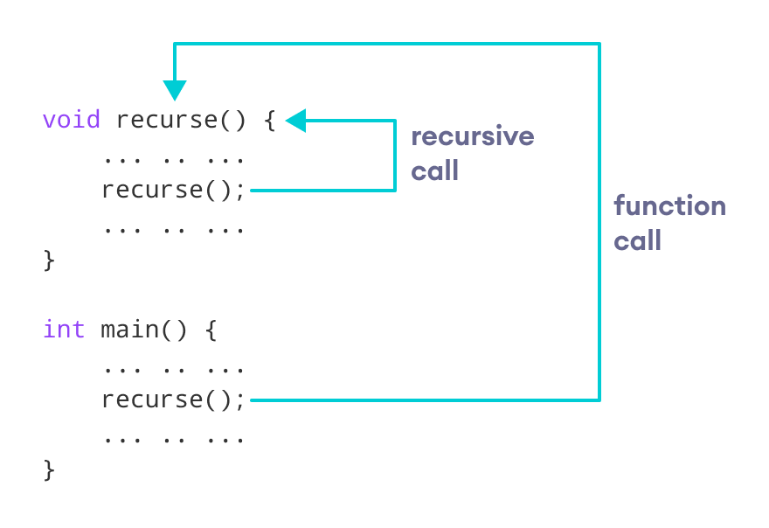

center h:400

How recursion works in C++ programming

The recursion continues until some condition is met.

To prevent infinite recursion, [if…else statement](https://www.programiz.com/cpp-programming/if-else) (or similar approach) can be used where one branch makes the recursive call and the other doesn’t.

## Example 1: Factorial of a Number Using Recursion

// Factorial of n = 1*2*3*...*n  
  
#include <iostream>  
using namespace std;  
  
int factorial(int);  
  
int main() {  
 int n, result;  
  
 cout << "Enter a non-negative number: ";  
 cin >> n;  
  
 result = factorial(n);  
 cout << "Factorial of " << n << " = " << result;  
 return 0;  
}  
  
int factorial(int n) {  
 if (n > 1) {  
 return n * factorial(n - 1);  
 } else {  
 return 1;  
 }  
}

[Run Code](https://www.programiz.com/cpp-programming/online-compiler)

**Output**

Enter a non-negative number: 4  
Factorial of 4 = 24

### Working of Factorial Program

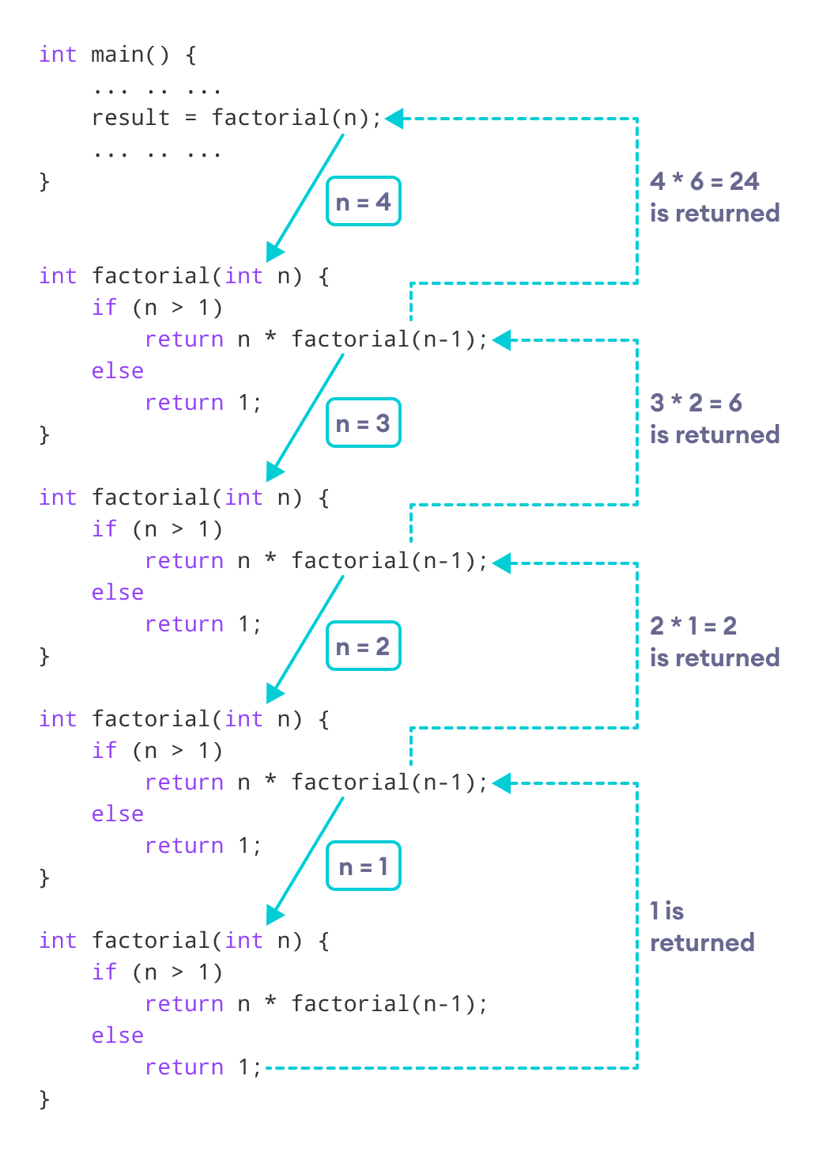

center h:400

How this C++ recursion program works

As we can see, the factorial() function is calling itself. However, during each call, we have decreased the value of n by 1. When n is less than 1, the factorial() function ultimately returns the output.

## Advantages and Disadvantages of Recursion

Below are the pros and cons of using recursion in C++.

### Advantages of C++ Recursion

* It makes our code shorter and cleaner.
* Recursion is required in problems concerning data structures and advanced algorithms, such as Graph and Tree Traversal.

### Disadvantages of C++ Recursion

* It takes a lot of stack space compared to an iterative program.
* It uses more processor time.
* It can be more difficult to debug compared to an equivalent iterative program.

# C++ Return by Reference

In this article, you’ll learn how to return a value by reference in a function and use it efficiently in your program.

In C++ Programming, not only can you pass values by reference to a [function](https://www.programiz.com/cpp-programming/function) but you can also return a value by reference.

To understand this feature, you should have the knowledge of:

* [Global variables](https://www.programiz.com/cpp-programming/storage-class#global_variable)

## Example: Return by Reference

#include <iostream>  
using namespace std;  
  
// global variable  
int num;  
  
// function declaration  
int& test();  
  
int main() {  
  
  // assign 5 to num variable  
  // equivalent to num = 5;  
 test() = 5;  
  
 cout << num;  
  
 return 0;  
}  
  
// function definition  
// returns the address of num variable  
int& test() {  
 return num;  
}

**Output**

5

In program above, the return type of function test() is int&. Hence, this function returns a reference of the variable num.

The return statement is return num;. Unlike return by value, this statement doesn’t return value of num, instead it returns the variable itself (address).

So, when the **variable** is returned, it can be assigned a value as done in test() = 5;

This stores **5** to the variable num, which is displayed onto the screen.

### Important Things to Remember When Returning by Reference.

* Ordinary function returns value but this function doesn’t. Hence, you cannot return a constant from the function.
* int& test() {  
    
   return 2;  
    
  }
* You cannot return a local variable from this function.
* int& test() {  
    
   int n = 2;   
   return n;   
    
  }

### C++ Arrays & String

# C++ Arrays

In this tutorial, we will learn to work with arrays. We will learn to declare, initialize, and access array elements in C++ programming with the help of examples.

In C++, an array is a variable that can store multiple values of the same type. For example,

Suppose a class has 27 students, and we need to store the grades of all of them. Instead of creating 27 separate variables, we can simply create an array:

double grade[27];

Here, grade is an array that can hold a maximum of 27 elements of double type.

In C++, the size and type of arrays cannot be changed after its declaration.

## C++ Array Declaration

dataType arrayName[arraySize];

For example,

int x[6];

Here,

* int - type of element to be stored
* x - name of the array
* 6 - size of the array

## Access Elements in C++ Array

In C++, each element in an array is associated with a number. The number is known as an array index. We can access elements of an array by using those indices.

// syntax to access array elements  
array[index];

Consider the array x we have seen above.

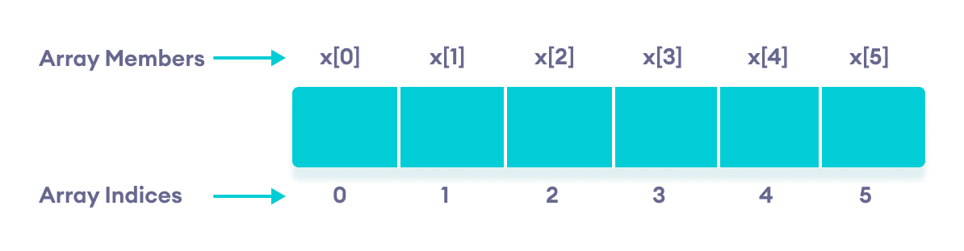

center h:400

Elements of an array in C++

### Few Things to Remember:

* The array indices start with 0. Meaning x[0] is the first element stored at index 0.
* If the size of an array is n, the last element is stored at index (n-1). In this example, x[5] is the last element.
* Elements of an array have consecutive addresses. For example, suppose the starting address of x[0] is **2120**.
* Then, the address of the next element x[1] will be **2124**, the address of x[2] will be **2128**, and so on.
* Here, the size of each element is increased by **4**. This is because the size of int is 4 bytes.

## C++ Array Initialization

In C++, it’s possible to initialize an array during declaration. For example,

// declare and initialize and array  
int x[6] = {19, 10, 8, 17, 9, 15};

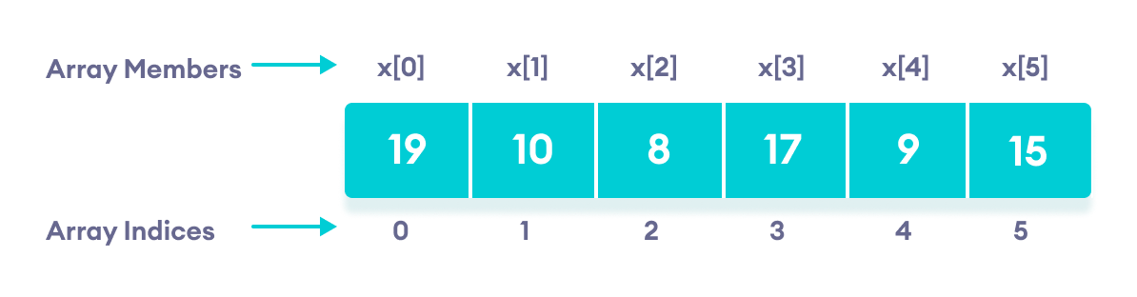

center h:400

C++ Array elements and their data

Another method to initialize array during declaration:

// declare and initialize an array  
int x[] = {19, 10, 8, 17, 9, 15};

Here, we have not mentioned the size of the array. In such cases, the compiler automatically computes the size.

### C++ Array With Empty Members

In C++, if an array has a size n, we can store upto n number of elements in the array. However, what will happen if we store less than n number of elements.

For example,

// store only 3 elements in the array  
int x[6] = {19, 10, 8};

Here, the array x has a size of 6. However, we have initialized it with only 3 elements.

In such cases, the compiler assigns random values to the remaining places. Oftentimes, this random value is simply 0.

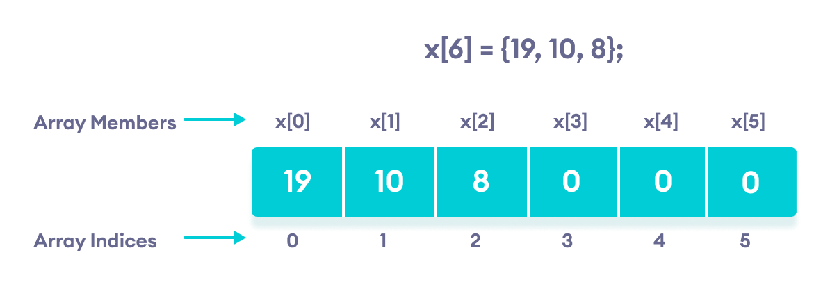

center h:400

Empty array members are automatically assigned the value 0

## How to insert and print array elements?

int mark[5] = {19, 10, 8, 17, 9}  
  
// change 4th element to 9  
mark[3] = 9;  
  
// take input from the user  
// store the value at third position  
cin >> mark[2];  
  
  
// take input from the user  
// insert at ith position  
cin >> mark[i-1];  
  
// print first element of the array  
cout << mark[0];  
  
// print ith element of the array  
cout >> mark[i-1];

## Example 1: Displaying Array Elements

#include <iostream>  
using namespace std;  
  
int main() {  
  
 int numbers[5] = {7, 5, 6, 12, 35};  
  
 cout << "The numbers are: ";  
  
 // Printing array elements  
 // using range based for loop  
 for (const int &n : numbers) {  
 cout << n << " ";  
 }  
  
 cout << "\nThe numbers are: ";  
  
 // Printing array elements  
 // using traditional for loop  
 for (int i = 0; i < 5; ++i) {  
 cout << numbers[i] << " ";  
 }  
  
 return 0;  
}

[Run Code](https://www.programiz.com/cpp-programming/online-compiler)

**Output**

The numbers are: 7 5 6 12 35  
The numbers are: 7 5 6 12 35

Here, we have used a for loop to iterate from i = 0 to i = 4. In each iteration, we have printed numbers[i].

We again used a range-based for loop to print out the elements of the array. To learn more about this loop, check [C++ Ranged for Loop](https://www.programiz.com/cpp-programming/ranged-for-loop).

**Note:** In our range-based loop, we have used the code const int &n instead of int n as the range declaration. However, the const int &n is more preferred because:

1. Using int n simply copies the array elements to the variable n during each iteration. This is not memory-efficient.

* &n, however, uses the memory address of the array elements to access their data without copying them to a new variable. This is memory-efficient.

1. We are simply printing the array elements, not modifying them. Therefore, we use const so as not to accidentally change the values of the array.

## Example 2: Take Inputs from User and Store Them in an Array

#include <iostream>  
using namespace std;  
  
int main() {  
  
 int numbers[5];  
  
 cout << "Enter 5 numbers: " << endl;  
  
 // store input from user to array  
 for (int i = 0; i < 5; ++i) {  
 cin >> numbers[i];  
 }  
  
 cout << "The numbers are: ";  
  
 // print array elements  
 for (int n = 0; n < 5; ++n) {  
 cout << numbers[n] << " ";  
 }  
  
 return 0;  
}

[Run Code](https://www.programiz.com/cpp-programming/online-compiler)

**Output**

Enter 5 numbers:   
11  
12  
13  
14  
15  
The numbers are: 11 12 13 14 15

Once again, we have used a for loop to iterate from i = 0 to i = 4. In each iteration, we took an input from the user and stored it in numbers[i].

Then, we used another for loop to print all the array elements.

## Example 3: Display Sum and Average of Array Elements Using for Loop

#include <iostream>  
using namespace std;  
  
int main() {  
  
 // initialize an array without specifying size  
 double numbers[] = {7, 5, 6, 12, 35, 27};  
  
 double sum = 0;  
 double count = 0;  
 double average;  
  
 cout << "The numbers are: ";  
  
 // print array elements  
 // use of range-based for loop  
 for (const double &n : numbers) {  
 cout << n << " ";  
  
 // calculate the sum  
 sum += n;  
  
 // count the no. of array elements  
 ++count;  
 }  
  
 // print the sum  
 cout << "\nTheir Sum = " << sum << endl;  
  
 // find the average  
 average = sum / count;  
 cout << "Their Average = " << average << endl;  
  
 return 0;  
}

[Run Code](https://www.programiz.com/cpp-programming/online-compiler)

**Output**

The numbers are: 7 5 6 12 35 27  
Their Sum = 92  
Their Average = 15.3333

In this program:

1. We have initialized a double array named numbers but without specifying its size. We also declared three double variables sum, count, and average.

* Here, sum =0 and count = 0.

1. Then we used a range-based for loop to print the array elements. In each iteration of the loop, we add the current array element to sum.
2. We also increase the value of count by 1 in each iteration, so that we can get the size of the array by the end of the for loop.
3. After printing all the elements, we print the sum and the average of all the numbers. The average of the numbers is given by average = sum / count;

**Note:** We used a ranged for loop instead of a normal for loop.

A normal for loop requires us to specify the number of iterations, which is given by the size of the array.

But a ranged for loop does not require such specifications.

## C++ Array Out of Bounds

If we declare an array of size **10**, then the array will contain elements from index **0** to **9**.

However, if we try to access the element at index **10** or more than **10**, it will result in Undefined Behaviour.

# C++ Multidimensional Arrays

In this tutorial, we’ll learn about multi-dimensional arrays in C++. More specifically, how to declare them, access them, and use them efficiently in our program.

In C++, we can create an [array](https://www.programiz.com/cpp-programming/arrays) of an array, known as a multidimensional array. For example:

int x[3][4];

Here, x is a two-dimensional array. It can hold a maximum of 12 elements.

We can think of this array as a table with 3 rows and each row has 4 columns as shown below.

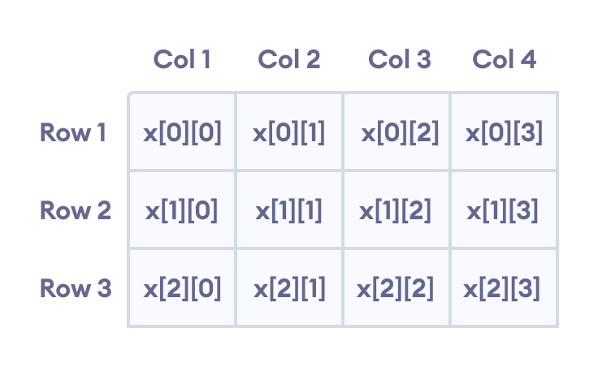

center h:400

Elements in two-dimensional array in C++ Programming

Three-dimensional arrays also work in a similar way. For example:

float x[2][4][3];

This array x can hold a maximum of 24 elements.

We can find out the total number of elements in the array simply by multiplying its dimensions:

2 x 4 x 3 = 24

## Multidimensional Array Initialization

Like a normal array, we can initialize a multidimensional array in more than one way.

### 1. Initialization of two-dimensional array

int test[2][3] = {2, 4, 5, 9, 0, 19};

The above method is not preferred. A better way to initialize this array with the same array elements is given below:

int test[2][3] = { {2, 4, 5}, {9, 0, 19}};

This array has 2 rows and 3 columns, which is why we have two rows of elements with 3 elements each.

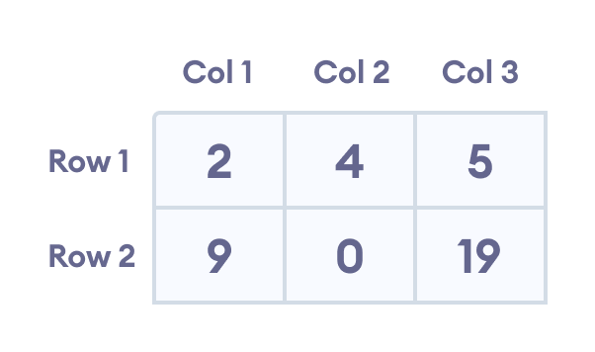

center h:400

Initializing a two-dimensional array in C++

### 2. Initialization of three-dimensional array

int test[2][3][4] = {3, 4, 2, 3, 0, -3, 9, 11, 23, 12, 23,   
 2, 13, 4, 56, 3, 5, 9, 3, 5, 5, 1, 4, 9};

This is not a good way of initializing a three-dimensional array. A better way to initialize this array is:

int test[2][3][4] = {   
 { {3, 4, 2, 3}, {0, -3, 9, 11}, {23, 12, 23, 2} },  
 { {13, 4, 56, 3}, {5, 9, 3, 5}, {5, 1, 4, 9} }  
 };

Notice the dimensions of this three-dimensional array.

The first dimension has the value 2. So, the two elements comprising the first dimension are:

Element 1 = { {3, 4, 2, 3}, {0, -3, 9, 11}, {23, 12, 23, 2} }  
Element 2 = { {13, 4, 56, 3}, {5, 9, 3, 5}, {5, 1, 4, 9} }

The second dimension has the value 3. Notice that each of the elements of the first dimension has three elements each:

{3, 4, 2, 3}, {0, -3, 9, 11} and {23, 12, 23, 2} for Element 1.  
{13, 4, 56, 3}, {5, 9, 3, 5} and {5, 1, 4, 9} for Element 2.

Finally, there are four int numbers inside each of the elements of the second dimension:

{3, 4, 2, 3}  
{0, -3, 9, 11}  
... .. ...  
... .. ...

## Example 1: Two Dimensional Array

// C++ Program to display all elements  
// of an initialised two dimensional array  
  
#include <iostream>  
using namespace std;  
  
int main() {  
 int test[3][2] = {{2, -5},  
 {4, 0},  
 {9, 1}};  
  
 // use of nested for loop  
 // access rows of the array  
 for (int i = 0; i < 3; ++i) {  
  
 // access columns of the array  
 for (int j = 0; j < 2; ++j) {  
 cout << "test[" << i << "][" << j << "] = " << test[i][j] << endl;  
 }  
 }  
  
 return 0;  
}

[Run Code](https://www.programiz.com/cpp-programming/online-compiler)

**Output**

test[0][0] = 2  
test[0][1] = -5  
test[1][0] = 4  
test[1][1] = 0  
test[2][0] = 9  
test[2][1] = 1

In the above example, we have initialized a two-dimensional int array named test that has 3 “rows” and 2 “columns”.

Here, we have used the nested for loop to display the array elements.

* the outer loop from i == 0 to i == 2 access the rows of the array
* the inner loop from j == 0 to j == 1 access the columns of the array

Finally, we print the array elements in each iteration.

## Example 2: Taking Input for Two Dimensional Array

#include <iostream>  
using namespace std;  
  
int main() {  
 int numbers[2][3];  
  
 cout << "Enter 6 numbers: " << endl;  
  
 // Storing user input in the array  
 for (int i = 0; i < 2; ++i) {  
 for (int j = 0; j < 3; ++j) {  
 cin >> numbers[i][j];  
 }  
 }  
  
 cout << "The numbers are: " << endl;  
  
 // Printing array elements  
 for (int i = 0; i < 2; ++i) {  
 for (int j = 0; j < 3; ++j) {  
 cout << "numbers[" << i << "][" << j << "]: " << numbers[i][j] << endl;  
 }  
 }  
  
 return 0;  
}

[Run Code](https://www.programiz.com/cpp-programming/online-compiler)

**Output**

Enter 6 numbers:   
1  
2  
3  
4  
5  
6  
The numbers are:  
numbers[0][0]: 1  
numbers[0][1]: 2  
numbers[0][2]: 3  
numbers[1][0]: 4  
numbers[1][1]: 5  
numbers[1][2]: 6

Here, we have used a nested for loop to take the input of the 2d array. Once all the input has been taken, we have used another nested for loop to print the array members.

## Example 3: Three Dimensional Array

// C++ Program to Store value entered by user in  
// three dimensional array and display it.  
  
#include <iostream>  
using namespace std;  
  
int main() {  
 // This array can store upto 12 elements (2x3x2)  
 int test[2][3][2] = {  
 {  
 {1, 2},  
 {3, 4},  
 {5, 6}  
 },   
 {  
 {7, 8},   
 {9, 10},   
 {11, 12}  
 }  
 };  
  
 // Displaying the values with proper index.  
 for (int i = 0; i < 2; ++i) {  
 for (int j = 0; j < 3; ++j) {  
 for (int k = 0; k < 2; ++k) {  
 cout << "test[" << i << "][" << j << "][" << k << "] = " << test[i][j][k] << endl;  
 }  
 }  
 }  
  
 return 0;  
}

[Run Code](https://www.programiz.com/cpp-programming/online-compiler)

**Output**

test[0][0][0] = 1  
test[0][0][1] = 2  
test[0][1][0] = 3  
test[0][1][1] = 4  
test[0][2][0] = 5  
test[0][2][1] = 6  
test[1][0][0] = 7  
test[1][0][1] = 8  
test[1][1][0] = 9  
test[1][1][1] = 10  
test[1][2][0] = 11  
test[1][2][1] = 12

The basic concept of printing elements of a 3d array is similar to that of a 2d array.

However, since we are manipulating 3 dimensions, we use a nested for loop with 3 total loops instead of just 2:

* the outer loop from i == 0 to i == 1 accesses the first dimension of the array
* the middle loop from j == 0 to j == 2 accesses the second dimension of the array
* the innermost loop from k == 0 to k == 1 accesses the third dimension of the array

As we can see, the complexity of the array increases exponentially with the increase in dimensions.

# Passing Array to a Function in C++ Programming

In this tutorial, we will learn how to pass a single-dimensional and multidimensional array as a function parameter in C++ with the help of examples.

In C++, we can pass arrays as an argument to a function. And, also we can return arrays from a function.

Before you learn about passing arrays as a function argument, make sure you know about [C++ Arrays](https://www.programiz.com/cpp-programming/arrays) and [C++ Functions](https://www.programiz.com/cpp-programming/function).

## Syntax for Passing Arrays as Function Parameters

The syntax for passing an array to a function is:

returnType functionName(dataType arrayName[arraySize]) {  
 // code  
}

Let’s see an example,

int total(int marks[5]) {  
 // code  
}

Here, we have passed an int type array named marks to the function total(). The size of the array is 5.

### Example 1: Passing One-dimensional Array to a Function

// C++ Program to display marks of 5 students  
  
#include <iostream>  
using namespace std;  
  
// declare function to display marks  
// take a 1d array as parameter  
void display(int m[5]) {  
 cout << "Displaying marks: " << endl;  
  
 // display array elements   
 for (int i = 0; i < 5; ++i) {  
 cout << "Student " << i + 1 << ": " << m[i] << endl;  
 }  
}  
  
int main() {  
  
 // declare and initialize an array  
 int marks[5] = {88, 76, 90, 61, 69};  
  
 // call display function  
 // pass array as argument  
 display(marks);  
  
 return 0;  
}

[Run Code](https://www.programiz.com/cpp-programming/online-compiler)

**Output**

Displaying marks:   
Student 1: 88  
Student 2: 76  
Student 3: 90  
Student 4: 61  
Student 5: 69

Here,

1. When we call a function by passing an array as the argument, only the name of the array is used.

* display(marks);
* Here, the argument marks represent the memory address of the first element of array marks[5].

1. However, notice the parameter of the display() function.

* void display(int m[5])
* Here, we use the full declaration of the array in the function parameter, including the square braces [].

1. The function parameter int m[5] converts to int* m;. This points to the same address pointed by the array marks. This means that when we manipulate m[5] in the function body, we are actually manipulating the original array marks.

* C++ handles passing an array to a function in this way to save memory and time.

### Passing Multidimensional Array to a Function

We can also pass [Multidimensional arrays](https://www.programiz.com/cpp-programming/multidimensional-arrays) as an argument to the function. For example,

### Example 2: Passing Multidimensional Array to a Function

// C++ Program to display the elements of two  
// dimensional array by passing it to a function  
  
#include <iostream>  
using namespace std;  
  
// define a function   
// pass a 2d array as a parameter  
void display(int n[][2]) {  
 cout << "Displaying Values: " << endl;  
 for (int i = 0; i < 3; ++i) {  
 for (int j = 0; j < 2; ++j) {  
 cout << "num[" << i << "][" << j << "]: " << n[i][j] << endl;  
 }  
 }  
}  
  
int main() {  
  
 // initialize 2d array  
 int num[3][2] = {  
 {3, 4},  
 {9, 5},  
 {7, 1}  
 };  
  
 // call the function  
 // pass a 2d array as an argument  
 display(num);  
  
 return 0;  
}

[Run Code](https://www.programiz.com/cpp-programming/online-compiler)

**Output**

Displaying Values:   
num[0][0]: 3  
num[0][1]: 4  
num[1][0]: 9  
num[1][1]: 5  
num[2][0]: 7  
num[2][1]: 1

In the above program, we have defined a function named display(). The function takes a two dimensional array, int n[][2] as its argument and prints the elements of the array.

While calling the function, we only pass the name of the two dimensional array as the function argument display(num).

**Note**: It is not mandatory to specify the number of rows in the array. However, the number of columns should always be specified. This is why we have used int n[][2].

We can also pass arrays with more than 2 dimensions as a function argument.

## C++ Returning an Array From a Function

We can also return an array from the function. However, the actual array is not returned. Instead the address of the first element of the array is returned with the help of [pointers](https://www.programiz.com/cpp-programming/pointers).

We will learn about returning arrays from a function in the coming tutorials.

# C++ Strings

In this tutorial, you’ll learn to handle strings in C++. You’ll learn to declare them, initialize them and use them for various input/output operations.

String is a collection of characters. There are two types of strings commonly used in C++ programming language:

* Strings that are objects of string class (The Standard C++ Library string class)
* C-strings (C-style Strings)

## C-strings

In C programming, the collection of characters is stored in the form of arrays. This is also supported in C++ programming. Hence it’s called C-strings.

C-strings are arrays of type char terminated with null character, that is, \0 (ASCII value of null character is 0).

### How to define a C-string?

char str[] = "C++";

In the above code, str is a string and it holds 4 characters.

Although, “C++” has 3 character, the null character \0 is added to the end of the string automatically.

### Alternative ways of defining a string

char str[4] = "C++";  
  
char str[] = {'C','+','+','\0'};  
char str[4] = {'C','+','+','\0'};

Like arrays, it is not necessary to use all the space allocated for the string. For example:

char str[100] = "C++";

### Example 1: C++ String to read a word

**C++ program to display a string entered by user.**

#include <iostream>  
using namespace std;  
  
int main()  
{  
 char str[100];  
  
 cout << "Enter a string: ";  
 cin >> str;  
 cout << "You entered: " << str << endl;  
  
 cout << "\nEnter another string: ";  
 cin >> str;  
 cout << "You entered: "<<str<<endl;  
  
 return 0;  
}

**Output**

Enter a string: C++  
You entered: C++  
Enter another string: Programming is fun.  
You entered: Programming

Notice that, in the second example only “Programming” is displayed instead of “Programming is fun”.

This is because the extraction operator >> works as scanf() in C and considers a space ” ” has a terminating character.

### Example 2: C++ String to read a line of text

**C++ program to read and display an entire line entered by user.**

#include <iostream>  
using namespace std;  
  
int main()  
{  
 char str[100];  
 cout << "Enter a string: ";  
 cin.get(str, 100);  
  
 cout << "You entered: " << str << endl;  
 return 0;  
}

**Output**

Enter a string: Programming is fun.  
You entered: Programming is fun.

To read the text containing blank space, cin.get function can be used. This function takes two arguments.

First argument is the name of the string (address of first element of string) and second argument is the maximum size of the array.

In the above program, str is the name of the string and 100 is the maximum size of the array.

## string Object

In C++, you can also create a string object for holding strings.

Unlike using char arrays, string objects has no fixed length, and can be extended as per your requirement.

### Example 3: C++ string using string data type

#include <iostream>  
using namespace std;  
  
int main()  
{  
 // Declaring a string object  
 string str;  
 cout << "Enter a string: ";  
 getline(cin, str);  
  
 cout << "You entered: " << str << endl;  
 return 0;  
}

**Output**

Enter a string: Programming is fun.  
You entered: Programming is fun.

In this program, a string str is declared. Then the string is asked from the user.

Instead of using cin>> or cin.get() function, you can get the entered line of text using getline().

getline() function takes the input stream as the first parameter which is cin and str as the location of the line to be stored.

## Passing String to a Function

Strings are passed to a function in a similar way [arrays are passed to a function](https://www.programiz.com/cpp-programming/passing-arrays-function).

#include <iostream>  
  
using namespace std;  
  
void display(char *);  
void display(string);  
  
int main()  
{  
 string str1;  
 char str[100];  
  
 cout << "Enter a string: ";  
 getline(cin, str1);  
  
 cout << "Enter another string: ";  
 cin.get(str, 100, '\n');  
  
 display(str1);  
 display(str);  
 return 0;  
}  
  
void display(char s[])  
{  
 cout << "Entered char array is: " << s << endl;  
}  
  
void display(string s)  
{  
 cout << "Entered string is: " << s << endl;  
}

**Output**

Enter a string: Programming is fun.  
Enter another string: Really?  
Entered string is: Programming is fun.  
Entered char array is: Really?

|  |
| --- |
| In the above program, two strings are asked to enter. These are stored in str and str1 respectively, where str is a char array and str1 is a string object. |
| Then, we have two functions display() that outputs the string onto the string. |
| The only difference between the two functions is the parameter. The first display() function takes char array as a parameter, while the second takes string as a parameter. |
| This process is known as function overloading. Learn more about [Function Overloading](https://www.programiz.com/cpp-programming/function-overloading). |

### C++ Structures

# C++ Structures

In this article, you’ll learn about structures in C++ programming; what is it, how to define it and use it in your program.

Structure is a collection of variables of different data types under a single name. It is similar to a [class](https://www.programiz.com/cpp-programming/object-class) in that, both holds a collecion of data of different data types.

**For example:** You want to store some information about a person: his/her name, citizenship number and salary. You can easily create different variables name, citNo, salary to store these information separately.

However, in the future, you would want to store information about multiple persons. Now, you’d need to create different variables for each information per person: name1, citNo1, salary1, name2, citNo2, salary2

You can easily visualize how big and messy the code would look. Also, since no relation between the variables (information) would exist, it’s going to be a daunting task.

A better approach will be to have a collection of all related information under a single name Person, and use it for every person. Now, the code looks much cleaner, readable and efficient as well.

This collection of all related information under a single name Person is a structure.

## How to declare a structure in C++ programming?

The struct keyword defines a structure type followed by an identifier (name of the structure).

Then inside the curly braces, you can declare one or more members (declare variables inside curly braces) of that structure. For example:

struct Person  
{  
 char name[50];  
 int age;  
 float salary;  
};

Here a structure person is defined which has three members: name, age and salary.

When a structure is created, no memory is allocated.

The structure definition is only the blueprint for the creating of variables. You can imagine it as a datatype. When you define an integer as below:

int foo;

The int specifies that, variable foo can hold integer element only. Similarly, structure definition only specifies that, what property a structure variable holds when it is defined.

**Note:** Remember to end the declaration with a semicolon **(;)**

## How to define a structure variable?

Once you declare a structure person as above. You can define a structure variable as:

Person bill;

Here, a structure variable bill is defined which is of type structure Person.

When structure variable is defined, only then the required memory is allocated by the compiler.

Considering you have either 32-bit or 64-bit system, the memory of float is 4 bytes, memory of int is 4 bytes and memory of char is 1 byte.

Hence, 58 bytes of memory is allocated for structure variable bill.

## How to access members of a structure?

The members of structure variable is accessed using a **dot (.)** operator.

Suppose, you want to access age of structure variable bill and assign it 50 to it. You can perform this task by using following code below:

bill.age = 50;

## Example: C++ Structure

C++ Program to assign data to members of a structure variable and display it.

#include <iostream>  
using namespace std;  
  
struct Person  
{  
 char name[50];  
 int age;  
 float salary;  
};  
  
int main()  
{  
 Person p1;  
  
 cout << "Enter Full name: ";  
 cin.get(p1.name, 50);  
 cout << "Enter age: ";  
 cin >> p1.age;  
 cout << "Enter salary: ";  
 cin >> p1.salary;  
  
 cout << "\nDisplaying Information." << endl;  
 cout << "Name: " << p1.name << endl;  
 cout <<"Age: " << p1.age << endl;  
 cout << "Salary: " << p1.salary;  
  
 return 0;  
}

**Output**

Enter Full name: Magdalena Dankova  
Enter age: 27  
Enter salary: 1024.4  
Displaying Information.  
Name: Magdalena Dankova  
Age: 27  
Salary: 1024.4

Here a structure Person is declared which has three members name, age and salary.

Inside main() [function](https://www.programiz.com/cpp-programming/function), a structure variable p1 is defined. Then, the user is asked to enter information and data entered by user is displayed.

You should also check out these structure related tutorials:

* [How to pass structures to functions?](https://www.programiz.com/cpp-programming/structure-function)
* [How to use pointers with structures?](https://www.programiz.com/cpp-programming/structure-pointer)

# C++ Structure and Function

In this article, you’ll find relevant examples to pass structures as an argument to a function, and use them in your program.

[Structure](https://www.programiz.com/cpp-programming/structure) variables can be passed to a [function](https://www.programiz.com/cpp-programming/function) and returned in a similar way as normal arguments.

## Passing structure to function in C++

A structure variable can be passed to a function in similar way as normal argument. Consider this example:

### Example 1: C++ Structure and Function

#include <iostream>  
using namespace std;  
  
struct Person {  
 char name[50];  
 int age;  
 float salary;  
};  
  
void displayData(Person); // Function declaration  
  
int main() {  
 Person p;  
  
 cout << "Enter Full name: ";  
 cin.get(p.name, 50);  
 cout << "Enter age: ";  
 cin >> p.age;  
 cout << "Enter salary: ";  
 cin >> p.salary;  
  
 // Function call with structure variable as an argument  
 displayData(p);  
  
 return 0;  
}  
  
void displayData(Person p) {  
 cout << "\nDisplaying Information." << endl;  
 cout << "Name: " << p.name << endl;  
 cout <<"Age: " << p.age << endl;  
 cout << "Salary: " << p.salary;  
}

**Output**

Enter Full name: Bill Jobs  
Enter age: 55  
Enter salary: 34233.4  
Displaying Information.  
Name: Bill Jobs  
Age: 55  
Salary: 34233.4

In this program, user is asked to enter the name, age and salary of a Person inside main() function.

Then, the structure variable p is to passed to a function using.

displayData(p);

The return type of displayData() is void and a single argument of type structure Person is passed.

Then the members of structure p is displayed from this function.

### Example 2: Returning structure from function in C++

#include <iostream>  
using namespace std;  
  
struct Person {  
 char name[50];  
 int age;  
 float salary;  
};  
  
Person getData(Person);   
void displayData(Person);   
  
int main() {  
  
 Person p, temp;  
  
 temp = getData(p);  
  p = temp;  
 displayData(p);  
  
 return 0;  
}  
  
Person getData(Person p) {  
  
 cout << "Enter Full name: ";  
 cin.get(p.name, 50);  
  
 cout << "Enter age: ";  
 cin >> p.age;  
  
 cout << "Enter salary: ";  
 cin >> p.salary;  
  
 return p;  
}  
  
void displayData(Person p) {  
 cout << "\nDisplaying Information." << endl;  
 cout << "Name: " << p.name << endl;  
 cout <<"Age: " << p.age << endl;  
 cout << "Salary: " << p.salary;  
}

The output of this program is the same as the program above.

In this program, we have created two structure variables p and temp of type Person under the main() function.

The structure variable p is passed to getData() function which takes input from the user which is then stored in the temp variable.

temp = getData(p);

We then assign the value of temp to p.

p = temp;

Then the structure variable p is passed to displayData() function, which displays the information.

**Note:** We don’t really need to use the temp variable for most compilers and C++ versions. Instead, we can simply use the following code:

p = getData(p);

# C++ Pointers to Structure

In this article, you’ll find relevant examples that will help you to work with pointers to access data within a structure.

A [pointer](https://www.programiz.com/cpp-programming/pointers) variable can be created not only for native types like (int, float, double etc.) but they can also be created for user defined types like [structure](https://www.programiz.com/cpp-programming/structure).

If you do not know what pointers are, visit [C++ pointers](https://www.programiz.com/cpp-programming/pointers).

Here is how you can create pointer for structures:

#include <iostream>  
using namespace std;  
  
struct temp {  
 int i;  
 float f;  
};  
  
int main() {  
 temp *ptr;  
 return 0;  
}

This program creates a pointer ptr of type structure temp.

## Example: Pointers to Structure

#include <iostream>  
using namespace std;  
  
struct Distance {  
 int feet;  
 float inch;  
};  
  
int main() {  
 Distance *ptr, d;  
  
 ptr = &d;  
  
 cout << "Enter feet: ";  
 cin >> (*ptr).feet;  
 cout << "Enter inch: ";  
 cin >> (*ptr).inch;  
  
 cout << "Displaying information." << endl;  
 cout << "Distance = " << (*ptr).feet << " feet " << (*ptr).inch << " inches";  
  
 return 0;  
}

**Output**

Enter feet: 4  
Enter inch: 3.5  
Displaying information.  
Distance = 4 feet 3.5 inches

In this program, a pointer variable ptr and normal variable d of type structure Distance is defined.

The address of variable d is stored to pointer variable, that is, ptr is pointing to variable d. Then, the member function of variable d is accessed using pointer.

**Notes:**

* Since pointer ptr is pointing to variable d in this program, (*ptr).inch and d.inch are equivalent. Similarly, (*ptr).feet and d.feet are equivalent.
* However, if we are using pointers, it is far more preferable to access struct members using the -> operator, since the . operator has a higher precedence than the * operator.
* Hence, we enclose *ptr in brackets when using (*ptr).inch. Because of this, it is easier to make mistakes if both operators are used together in a single code.
* ptr->feet is same as (*ptr).feet  
  ptr->inch is same as (*ptr).inc

# C++ Enumeration

In this article, you will learn to work with enumeration (enum). Also, you will learn where enums are commonly used in C++ programming.

An enumeration is a user-defined data type that consists of integral constants. To define an enumeration, keyword **enum** is used.

enum season { spring, summer, autumn, winter };

Here, the name of the enumeration is season.

And, spring, summer and winter are values of type season.

By default, spring is 0, summer is 1 and so on. You can change the default value of an enum element during declaration (if necessary).

enum season   
{ spring = 0,   
 summer = 4,   
 autumn = 8,  
 winter = 12  
};

## Enumerated Type Declaration

When you create an enumerated type, only blueprint for the variable is created. Here’s how you can create variables of enum type.

enum boolean { false, true };  
// inside function  
enum boolean check;

Here, a variable check of type **enum boolean** is created.

Here is another way to declare same check variable using different syntax.

enum boolean   
{   
 false, true  
} check;

### Example 1: Enumeration Type

#include <iostream>  
using namespace std;  
  
enum week { Sunday, Monday, Tuesday, Wednesday, Thursday, Friday, Saturday };  
  
int main()  
{  
 week today;  
 today = Wednesday;  
 cout << "Day " << today+1;  
 return 0;  
}

**Output**

Day 4

### Example2: Changing Default Value of Enums

#include <iostream>  
using namespace std;  
  
enum seasons { spring = 34, summer = 4, autumn = 9, winter = 32};  
  
int main() {  
  
 seasons s;  
  
 s = summer;  
 cout << "Summer = " << s << endl;  
  
 return 0;  
}

**Output**

Summer = 4

## Why enums are used in C++ programming?

An enum variable takes only one value out of many possible values. Example to demonstrate it,

#include <iostream>  
using namespace std;  
  
enum suit {  
 club = 0,  
 diamonds = 10,  
 hearts = 20,  
 spades = 3  
} card;  
  
int main()   
{  
 card = club;  
 cout << "Size of enum variable " << sizeof(card) << " bytes.";   
 return 0;  
}

**Output**

Size of enum variable 4 bytes.

It’s because the size of an integer is 4 bytes.;

This makes enum a good choice to work with flags.

You can accomplish the same task using [C++ structures](https://www.programiz.com/cpp-programming/structure). However, working with enums gives you efficiency along with flexibility.

### How to use enums for flags?

Let us take an example,

enum designFlags {  
 ITALICS = 1,  
 BOLD = 2,  
 UNDERLINE = 4  
} button;

Suppose you are designing a button for Windows application. You can set flags ITALICS, BOLD and UNDERLINE to work with text.

There is a reason why all the integral constants are power of 2 in above pseudocode.

// In binary  
ITALICS = 00000001  
BOLD = 00000010  
UNDERLINE = 00000100

Since, the integral constants are power of 2, you can combine two or more flags at once without overlapping using bitwise OR **|** operator. This allows you to choose two or more flags at once. For example,

#include <iostream>  
using namespace std;  
  
enum designFlags {  
 BOLD = 1,  
 ITALICS = 2,  
 UNDERLINE = 4  
};  
  
int main()   
{  
 int myDesign = BOLD | UNDERLINE;   
  
 // 00000001  
 // | 00000100  
 // ___________  
 // 00000101  
  
 cout << myDesign;  
  
 return 0;  
}

**Output**

5

When the output is 5, you always know that bold and underline is used.

Also, you can add flag to your requirements.

if (myDesign & ITALICS) {  
 // code for italics  
}

Here, we have added italics to our design. Note, only code for italics is written inside the [if statement](https://www.programiz.com/cpp-programming/if-else).

You can accomplish almost anything in C++ programming without using enumerations. However, they can be pretty handy in certain situations. That’s what differentiates good programmers from great programmers.

# C++ Classes and Objects

In this tutorial, we will learn about objects and classes and how to use them in C++ with the help of examples.

In previous tutorials, we learned about functions and variables. Sometimes it’s desirable to put related functions and data in one place so that it’s logical and easier to work with.

Suppose, we need to store the length, breadth, and height of a rectangular room and calculate its area and volume.

To handle this task, we can create three variables, say, length, breadth, and height along with the functions calculateArea() and calculateVolume().

However, in C++, rather than creating separate variables and functions, we can also wrap these related data and functions in a single place (by creating **objects**). This programming paradigm is known as object-oriented programming.

But before we can create **objects** and use them in C++, we first need to learn about **classes**.

## C++ Class

A class is a blueprint for the object.

We can think of a class as a sketch (prototype) of a house. It contains all the details about the floors, doors, windows, etc. Based on these descriptions we build the house. House is the object.

### Create a Class

A class is defined in C++ using keyword class followed by the name of the class.

The body of the class is defined inside the curly brackets and terminated by a semicolon at the end.

class className {  
 // some data  
 // some functions  
};

For example,

class Room {  
 public:  
 double length;  
 double breadth;  
 double height;   
  
 double calculateArea(){   
 return length * breadth;  
 }  
  
 double calculateVolume(){   
 return length * breadth * height;  
 }  
  
};

Here, we defined a class named Room.

The variables length, breadth, and height declared inside the class are known as **data members**. And, the functions calculateArea() and calculateVolume() are known as **member functions** of a class.

## C++ Objects

When a class is defined, only the specification for the object is defined; no memory or storage is allocated.

To use the data and access functions defined in the class, we need to create objects.

### Syntax to Define Object in C++

className objectVariableName;

We can create objects of Room class (defined in the above example) as follows:

// sample function  
void sampleFunction() {  
 // create objects  
 Room room1, room2;  
}  
  
int main(){  
 // create objects   
 Room room3, room4;  
}

Here, two objects room1 and room2 of the Room class are created in sampleFunction(). Similarly, the objects room3 and room4 are created in main().

As we can see, we can create objects of a class in any function of the program. We can also create objects of a class within the class itself, or in other classes.

Also, we can create as many objects as we want from a single class.

### C++ Access Data Members and Member Functions

We can access the data members and member functions of a class by using a . (dot) operator. For example,

room2.calculateArea();

This will call the calculateArea() function inside the Room class for object room2.

Similarly, the data members can be accessed as:

room1.length = 5.5;

In this case, it initializes the length variable of room1 to 5.5.

### Example 1: Object and Class in C++ Programming

// Program to illustrate the working of  
// objects and class in C++ Programming  
  
#include <iostream>  
using namespace std;  
  
// create a class  
class Room {  
  
 public:  
 double length;  
 double breadth;  
 double height;  
  
 double calculateArea() {  
 return length * breadth;  
 }  
  
 double calculateVolume() {  
 return length * breadth * height;  
 }  
};  
  
int main() {  
  
 // create object of Room class  
 Room room1;  
  
 // assign values to data members  
 room1.length = 42.5;  
 room1.breadth = 30.8;  
 room1.height = 19.2;  
  
 // calculate and display the area and volume of the room  
 cout << "Area of Room = " << room1.calculateArea() << endl;  
 cout << "Volume of Room = " << room1.calculateVolume() << endl;  
  
 return 0;  
}

[Run Code](https://www.programiz.com/cpp-programming/online-compiler)

**Output**

Area of Room = 1309  
Volume of Room = 25132.8

In this program, we have used the Room class and its object room1 to calculate the area and volume of a room.

In main(), we assigned the values of length, breadth, and height with the code:

room1.length = 42.5;  
room1.breadth = 30.8;  
room1.height = 19.2;

We then called the functions calculateArea() and calculateVolume() to perform the necessary calculations.

Note the use of the keyword public in the program. This means the members are public and can be accessed anywhere from the program.

As per our needs, we can also create private members using the private keyword. The private members of a class can only be accessed from within the class. For example,

class Test {  
  
private:  
 int a;  
 void function1() { }  
  
public:  
 int b;  
 void function2() { }  
}

Here, a and function1() are private. Thus they cannot be accessed from outside the class.

On the other hand, b and function2() are accessible from everywhere in the program.

To learn more about public and private keywords, please visit our [C++ Class Access Modifiers](https://www.programiz.com/cpp-programming/access-modifiers) tutorial.

### Example 2: Using public and private in C++ Class

// Program to illustrate the working of  
// public and private in C++ Class  
  
#include <iostream>  
using namespace std;  
  
class Room {  
  
 private:  
 double length;  
 double breadth;  
 double height;  
  
 public:  
  
 // function to initialize private variables  
 void initData(double len, double brth, double hgt) {  
 length = len;  
 breadth = brth;  
 height = hgt;  
 }  
  
 double calculateArea() {  
 return length * breadth;  
 }  
  
 double calculateVolume() {  
 return length * breadth * height;  
 }  
};  
  
int main() {  
  
 // create object of Room class  
 Room room1;  
  
 // pass the values of private variables as arguments  
 room1.initData(42.5, 30.8, 19.2);  
  
 cout << "Area of Room = " << room1.calculateArea() << endl;  
 cout << "Volume of Room = " << room1.calculateVolume() << endl;  
  
 return 0;  
}

[Run Code](https://www.programiz.com/cpp-programming/online-compiler)

**Output**

Area of Room = 1309  
Volume of Room = 25132.8

The above example is nearly identical to the first example, except that the class variables are now private.

Since the variables are now private, we cannot access them directly from main(). Hence, using the following code would be invalid:

// invalid code  
obj.length = 42.5;  
obj.breadth = 30.8;  
obj.height = 19.2;

Instead, we use the public function initData() to initialize the private variables via the function parameters double len, double brth, and double hgt.

To learn more on objects and classes, visit these topics:

* [C++ Constructors](https://www.programiz.com/cpp-programming/constructors)
* [How to pass and return an object from a function?](https://www.programiz.com/cpp-programming/pass-return-object-function)

# C++ Constructors

In this tutorial, we will learn about the C++ constructor and its type with the help examples.

A constructor is a special type of member function that is called automatically when an object is created.

In C++, a constructor has the same name as that of the class and it does not have a return type. For example,

class Wall {  
 public:  
 // create a constructor  
 Wall() {  
 // code  
 }  
};

Here, the function Wall() is a constructor of the class Wall. Notice that the constructor

* has the same name as the class,
* does not have a return type, and
* is public

## C++ Default Constructor

A constructor with no parameters is known as a **default constructor**. In the example above, Wall() is a default constructor.

### Example 1: C++ Default Constructor

// C++ program to demonstrate the use of default constructor  
  
#include <iostream>  
using namespace std;  
  
// declare a class  
class Wall {  
 private:  
 double length;  
  
 public:  
 // default constructor to initialize variable  
 Wall() {  
 length = 5.5;  
 cout << "Creating a wall." << endl;  
 cout << "Length = " << length << endl;  
 }  
};  
  
int main() {  
 Wall wall1;  
 return 0;  
}

[Run Code](https://www.programiz.com/cpp-programming/online-compiler)

**Output**

Creating a Wall  
Length = 5.5

Here, when the wall1 object is created, the Wall() constructor is called. This sets the length variable of the object to 5.5.

**Note:** If we have not defined a constructor in our class, then the C++ compiler will automatically create a default constructor with an empty code and no parameters.

## C++ Parameterized Constructor

In C++, a constructor with parameters is known as a parameterized constructor. This is the preferred method to initialize member data.

### Example 2: C++ Parameterized Constructor

// C++ program to calculate the area of a wall  
  
#include <iostream>  
using namespace std;  
  
// declare a class  
class Wall {  
 private:  
 double length;  
 double height;  
  
 public:  
 // parameterized constructor to initialize variables  
 Wall(double len, double hgt) {  
 length = len;  
 height = hgt;  
 }  
  
 double calculateArea() {  
 return length * height;  
 }  
};  
  
int main() {  
 // create object and initialize data members  
 Wall wall1(10.5, 8.6);  
 Wall wall2(8.5, 6.3);  
  
 cout << "Area of Wall 1: " << wall1.calculateArea() << endl;  
 cout << "Area of Wall 2: " << wall2.calculateArea();  
  
 return 0;  
}

[Run Code](https://www.programiz.com/cpp-programming/online-compiler)

**Output**

Area of Wall 1: 90.3  
Area of Wall 2: 53.55

Here, we have created a parameterized constructor Wall() that has 2 parameters: double len and double hgt. The values contained in these parameters are used to initialize the member variables length and height.

When we create an object of the Wall class, we pass the values for the member variables as arguments. The code for this is:

Wall wall1(10.5, 8.6);  
Wall wall2(8.5, 6.3);

With the member variables thus initialized, we can now calculate the area of the wall with the calculateArea() function.

## C++ Copy Constructor

The copy constructor in C++ is used to copy data of one object to another.

### Example 3: C++ Copy Constructor

#include <iostream>  
using namespace std;  
  
// declare a class  
class Wall {  
 private:  
 double length;  
 double height;  
  
 public:  
  
 // initialize variables with parameterized constructor  
 Wall(double len, double hgt) {  
 length = len;  
 height = hgt;  
 }  
  
 // copy constructor with a Wall object as parameter  
 // copies data of the obj parameter  
 Wall(Wall &obj) {  
 length = obj.length;  
 height = obj.height;  
 }  
  
 double calculateArea() {  
 return length * height;  
 }  
};  
  
int main() {  
 // create an object of Wall class  
 Wall wall1(10.5, 8.6);  
  
 // copy contents of wall1 to wall2  
 Wall wall2 = wall1;  
  
 // print areas of wall1 and wall2  
 cout << "Area of Wall 1: " << wall1.calculateArea() << endl;  
 cout << "Area of Wall 2: " << wall2.calculateArea();  
  
 return 0;  
}

[Run Code](https://www.programiz.com/cpp-programming/online-compiler)

**Output**

Area of Wall 1: 90.3  
Area of Wall 2: 90.3

In this program, we have used a copy constructor to copy the contents of one object of the Wall class to another. The code of the copy constructor is:

Wall(Wall &obj) {  
 length = obj.length;  
 height = obj.height;  
}

Notice that the parameter of this constructor has the address of an object of the Wall class.

We then assign the values of the variables of the obj object to the corresponding variables of the object calling the copy constructor. This is how the contents of the object are copied.

In main(), we then create two objects wall1 and wall2 and then copy the contents of wall1 to wall2:

// copy contents of wall1 to wall2  
Wall wall2 = wall1;

Here, the wall2 object calls its copy constructor by passing the address of the wall1 object as its argument i.e. &obj = &wall1.

**Note**: A constructor is primarily used to initialize objects. They are also used to run a default code when an object is created.

# How to pass and return object from C++ Functions?

In this tutorial, we will learn to pass objects to a function and return an object from a function in C++ programming.

In C++ programming, we can pass objects to a function in a similar manner as passing regular arguments.

## Example 1: C++ Pass Objects to Function

// C++ program to calculate the average marks of two students  
  
#include <iostream>  
using namespace std;  
  
class Student {  
  
 public:  
 double marks;  
  
 // constructor to initialize marks  
 Student(double m) {  
 marks = m;  
 }  
};  
  
// function that has objects as parameters  
void calculateAverage(Student s1, Student s2) {  
  
 // calculate the average of marks of s1 and s2   
 double average = (s1.marks + s2.marks) / 2;  
  
 cout << "Average Marks = " << average << endl;  
  
}  
  
int main() {  
 Student student1(88.0), student2(56.0);  
  
 // pass the objects as arguments  
 calculateAverage(student1, student2);  
  
 return 0;  
}

[Run Code](https://www.programiz.com/cpp-programming/online-compiler)

**Output**

Average Marks = 72

Here, we have passed two Student objects student1 and student2 as arguments to the calculateAverage() function.

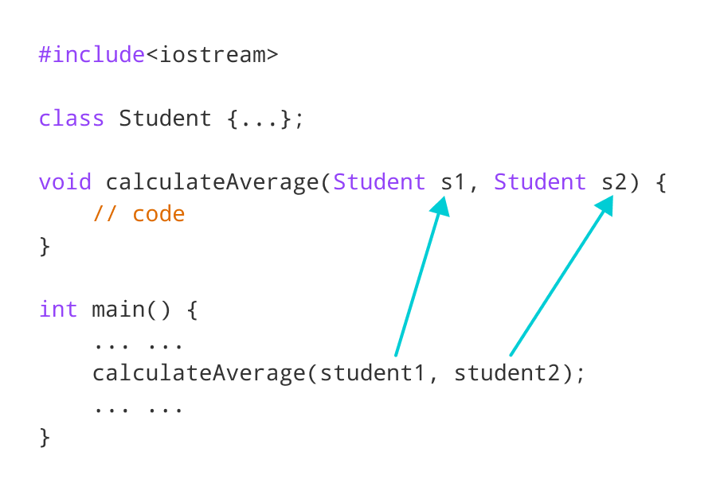

center h:400

Pass objects to function in C++

## Example 2: C++ Return Object from a Function

#include <iostream>  
using namespace std;  
  
class Student {  
 public:  
 double marks1, marks2;  
};  
  
// function that returns object of Student  
Student createStudent() {  
 Student student;  
  
 // Initialize member variables of Student  
 student.marks1 = 96.5;  
 student.marks2 = 75.0;  
  
 // print member variables of Student  
 cout << "Marks 1 = " << student.marks1 << endl;  
 cout << "Marks 2 = " << student.marks2 << endl;  
  
 return student;  
}  
  
int main() {  
 Student student1;  
  
 // Call function  
 student1 = createStudent();  
  
 return 0;  
}

[Run Code](https://www.programiz.com/cpp-programming/online-compiler)

**Output**

Marks1 = 96.5  
Marks2 = 75

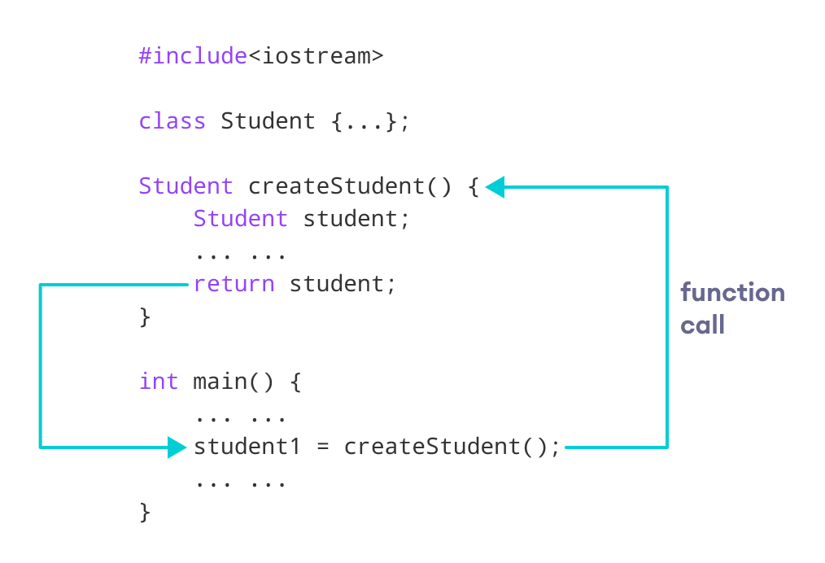

center h:400

Return object from function in C++

In this program, we have created a function createStudent() that returns an object of Student class.

We have called createStudent() from the main() method.

// Call function  
student1 = createStudent();

Here, we are storing the object returned by the createStudent() method in the student1.

# C++ Operator Overloading

In this tutorial, we will learn about operator overloading with the help of examples.

In C++, we can change the way operators work for user-defined types like objects and structures. This is known as **operator overloading**. For example,

Suppose we have created three objects c1, c2 and result from a class named Complex that represents complex numbers.

Since operator overloading allows us to change how operators work, we can redefine how the + operator works and use it to add the complex numbers of c1 and c2 by writing the following code:

result = c1 + c2;

instead of something like

result = c1.addNumbers(c2);

This makes our code intuitive and easy to understand.

**Note:** We cannot use operator overloading for fundamental data types like int, float, char and so on.

## Syntax for C++ Operator Overloading

To overload an operator, we use a special operator function. We define the function inside the class or structure whose objects/variables we want the overloaded operator to work with.

class className {  
 ... .. ...  
 public  
 returnType operator symbol (arguments) {  
 ... .. ...  
 }   
 ... .. ...  
};

Here,

* returnType is the return type of the function.
* operator is a keyword.
* symbol is the operator we want to overload. Like: +, <, -, ++, etc.
* arguments is the arguments passed to the function.

## Operator Overloading in Unary Operators

Unary operators operate on only one operand. The increment operator ++ and decrement operator -- are examples of unary operators.

### Example1: ++ Operator (Unary Operator) Overloading

// Overload ++ when used as prefix  
  
#include <iostream>  
using namespace std;  
  
class Count {  
 private:  
 int value;  
  
 public:  
  
 // Constructor to initialize count to 5  
 Count() : value(5) {}  
  
 // Overload ++ when used as prefix  
 void operator ++ () {  
 ++value;  
 }  
  
 void display() {  
 cout << "Count: " << value << endl;  
 }  
};  
  
int main() {  
 Count count1;  
  
 // Call the "void operator ++ ()" function  
 ++count1;  
  
 count1.display();  
 return 0;  
}

[Run Code](https://www.programiz.com/cpp-programming/online-compiler)

**Output**

Count: 6

Here, when we use ++count1;, the void operator ++ () is called. This increases the value attribute for the object count1 by 1.

**Note:** When we overload operators, we can use it to work in any way we like. For example, we could have used ++ to increase value by 100.

However, this makes our code confusing and difficult to understand. It’s our job as a programmer to use operator overloading properly and in a consistent and intuitive way.

The above example works only when ++ is used as a prefix. To make ++ work as a postfix we use this syntax.

void operator ++ (int) {  
 // code  
}

Notice the int inside the parentheses. It’s the syntax used for using unary operators as postfix; it’s not a function parameter.

### Example 2: ++ Operator (Unary Operator) Overloading

// Overload ++ when used as prefix and postfix  
  
#include <iostream>  
using namespace std;  
  
class Count {  
 private:  
 int value;  
  
 public:  
  
 // Constructor to initialize count to 5  
 Count() : value(5) {}  
  
  
 // Overload ++ when used as prefix  
 void operator ++ () {  
 ++value;  
 }  
  
  
 // Overload ++ when used as postfix  
 void operator ++ (int) {  
 value++;  
 }  
  
 void display() {  
 cout << "Count: " << value << endl;  
 }  
};  
  
int main() {  
 Count count1;  
  
 // Call the "void operator ++ (int)" function  
 count1++;  
 count1.display();  
  
 // Call the "void operator ++ ()" function  
 ++count1;  
  
 count1.display();  
 return 0;  
}

[Run Code](https://www.programiz.com/cpp-programming/online-compiler)

**Output**

Count: 6  
Count: 7

The **Example 2** works when ++ is used as both prefix and postfix. However, it doesn’t work if we try to do something like this:

Count count1, result;  
  
// Error  
result = ++count1;

This is because the return type of our operator function is void. We can solve this problem by making Count as the return type of the operator function.

// return Count when ++ used as prefix  
  
Count operator ++ () {  
 // code  
}  
  
// return Count when ++ used as postfix  
  
Count operator ++ (int) {  
 // code  
}

### Example 3: Return Value from Operator Function (++ Operator)

#include <iostream>  
using namespace std;  
  
class Count {  
 private:  
 int value;  
  
 public  
 :  
 // Constructor to initialize count to 5  
 Count() : value(5) {}  
  
 // Overload ++ when used as prefix  
 Count operator ++ () {  
 Count temp;  
  
 // Here, value is the value attribute of the calling object  
 temp.value = ++value;  
  
 return temp;  
 }  
  
 // Overload ++ when used as postfix  
 Count operator ++ (int) {  
 Count temp;  
  
 // Here, value is the value attribute of the calling object  
 temp.value = value++;  
  
 return temp;  
 }  
  
 void display() {  
 cout << "Count: " << value << endl;  
 }  
};  
  
int main() {  
 Count count1, result;  
  
 // Call the "Count operator ++ ()" function  
 result = ++count1;  
 result.display();  
  
 // Call the "Count operator ++ (int)" function  
 result = count1++;  
 result.display();  
  
 return 0;  
}

[Run Code](https://www.programiz.com/cpp-programming/online-compiler)

**Output**

Count: 6  
Count: 6

Here, we have used the following code for prefix operator overloading:

// Overload ++ when used as prefix  
Count operator ++ () {  
 Count temp;  
  
 // Here, value is the value attribute of the calling object  
 temp.value = ++value;  
  
 return temp;  
}

The code for the postfix operator overloading is also similar. Notice that we have created an object temp and returned its value to the operator function.

Also, notice the code

temp.value = ++value;

The variable value belongs to the count1 object in main() because count1 is calling the function, while temp.value belongs to the temp object.

## Operator Overloading in Binary Operators

Binary operators work on two operands. For example,

result = num + 9;

Here, + is a binary operator that works on the operands num and 9.

When we overload the binary operator for user-defined types by using the code:

obj3 = obj1 + obj2;

The operator function is called using the obj1 object and obj2 is passed as an argument to the function.

### Example 4: C++ Binary Operator Overloading

// C++ program to overload the binary operator +  
// This program adds two complex numbers  
  
#include <iostream>  
using namespace std;  
  
class Complex {  
 private:  
 float real;  
 float imag;  
  
 public:  
 // Constructor to initialize real and imag to 0  
 Complex() : real(0), imag(0) {}  
  
 void input() {  
 cout << "Enter real and imaginary parts respectively: ";  
 cin >> real;  
 cin >> imag;  
 }  
  
 // Overload the + operator  
 Complex operator + (const Complex& obj) {  
 Complex temp;  
 temp.real = real + obj.real;  
 temp.imag = imag + obj.imag;  
 return temp;  
 }  
  
 void output() {  
 if (imag < 0)  
 cout << "Output Complex number: " << real << imag << "i";  
 else  
 cout << "Output Complex number: " << real << "+" << imag << "i";  
 }  
};  
  
int main() {  
 Complex complex1, complex2, result;  
  
 cout << "Enter first complex number:\n";  
 complex1.input();  
  
 cout << "Enter second complex number:\n";  
 complex2.input();  
  
 // complex1 calls the operator function  
 // complex2 is passed as an argument to the function  
 result = complex1 + complex2;  
 result.output();  
  
 return 0;  
}

[Run Code](https://www.programiz.com/cpp-programming/online-compiler)

**Output**

Enter first complex number:  
Enter real and imaginary parts respectively: 9 5  
Enter second complex number:  
Enter real and imaginary parts respectively: 7 6  
Output Complex number: 16+11i

In this program, the operator function is:

Complex operator + (const Complex& obj) {  
 // code  
}

Instead of this, we also could have written this function like:

Complex operator + (Complex obj) {  
 // code  
}

However,

* using & makes our code efficient by referencing the complex2 object instead of making a duplicate object inside the operator function.
* using const is considered a good practice because it prevents the operator function from modifying complex2.

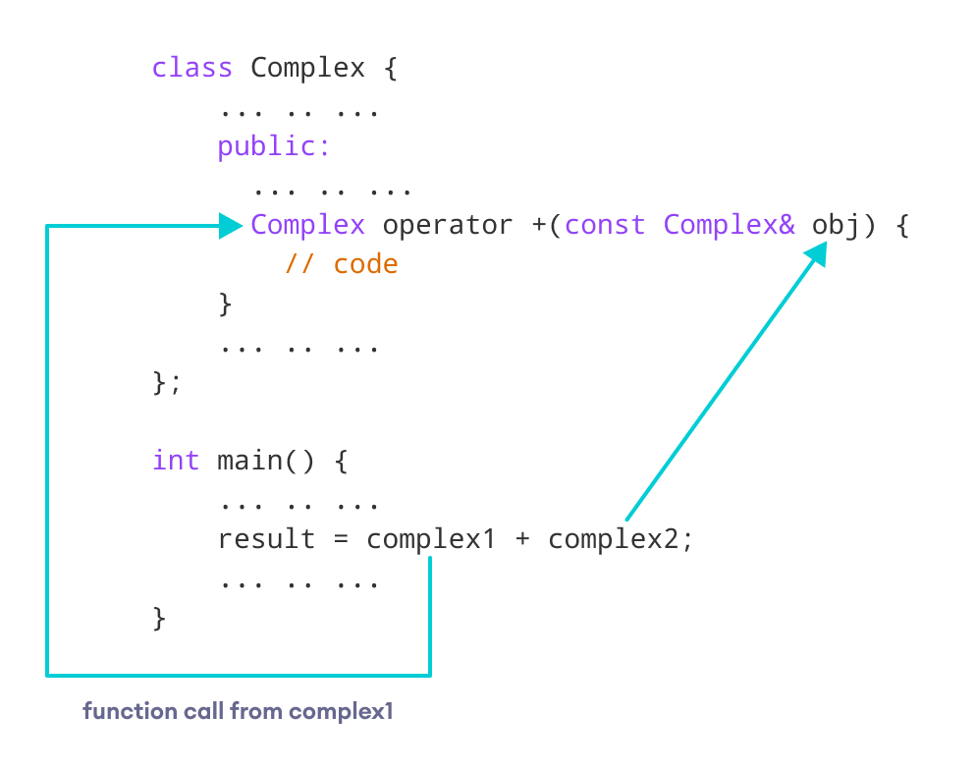

center h:400

Overloading binary operators in C++

## Things to Remember in C++ Operator Overloading

1. Two operators = and & are already overloaded by default in C++. For example, to [copy objects of the same class](https://www.programiz.com/cpp-programming/constructors#copy-constructor), we can directly use the = operator. We do not need to create an operator function.
2. Operator overloading cannot change the [precedence and associativity of operators](https://www.programiz.com/cpp-programming/operators-precedence-associativity). However, if we want to change the order of evaluation, parentheses should be used.
3. There are 4 operators that cannot be overloaded in C++. They are:
   1. :: (scope resolution)
   2. . (member selection)
   3. .* (member selection through pointer to function)
   4. ?: (ternary operator)

Visit these pages to learn more on:

* [How to overload increment operator in right way?](https://www.programiz.com/cpp-programming/increment-decrement-operator-overloading)
* [How to overload binary operator - to subtract complex numbers?](https://www.programiz.com/cpp-programming/operator-overloading/binary-operator-overloading)

# C++ Pointers

# C++ Pointers

In this tutorial, we will learn about pointers in C++ and their working with the help of examples.

In C++, pointers are variables that store the memory addresses of other variables.

## Address in C++

If we have a variable var in our program, &var will give us its address in the memory. For example,

### Example 1: Printing Variable Addresses in C++

#include <iostream>  
using namespace std;  
  
int main()  
{  
 // declare variables  
 int var1 = 3;  
 int var2 = 24;  
 int var3 = 17;  
  
 // print address of var1  
 cout << "Address of var1: "<< &var1 << endl;  
  
 // print address of var2  
 cout << "Address of var2: " << &var2 << endl;  
  
 // print address of var3  
 cout << "Address of var3: " << &var3 << endl;  
}

[Run Code](https://www.programiz.com/cpp-programming/online-compiler)

**Output**

Address of var1: 0x7fff5fbff8ac  
Address of var2: 0x7fff5fbff8a8  
Address of var3: 0x7fff5fbff8a4

Here, 0x at the beginning represents the address is in the hexadecimal form.

Notice that the first address differs from the second by 4 bytes and the second address differs from the third by 4 bytes.

This is because the size of an int variable is 4 bytes in a 64-bit system.

**Note:** You may not get the same results when you run the program.

## C++ Pointers

As mentioned above, pointers are used to store addresses rather than values.

Here is how we can declare pointers.

int *pointVar;

Here, we have declared a pointer pointVar of the int type.

We can also declare pointers in the following way.

int* pointVar; // preferred syntax

Let’s take another example of declaring pointers.

int* pointVar, p;

Here, we have declared a pointer pointVar and a normal variable p.

**Note:** The * operator is used after the data type to declare pointers.

### Assigning Addresses to Pointers

Here is how we can assign addresses to pointers:

int* pointVar, var;  
var = 5;  
  
// assign address of var to pointVar pointer  
pointVar = &var;

Here, 5 is assigned to the variable var. And, the address of var is assigned to the pointVar pointer with the code pointVar = &var.

### Get the Value from the Address Using Pointers

To get the value pointed by a pointer, we use the * operator. For example:

int* pointVar, var;  
var = 5;  
  
// assign address of var to pointVar  
pointVar = &var;  
  
// access value pointed by pointVar  
cout << *pointVar << endl; // Output: 5

In the above code, the address of var is assigned to pointVar. We have used the *pointVar to get the value stored in that address.

When * is used with pointers, it’s called the **dereference operator**. It operates on a pointer and gives the value pointed by the address stored in the pointer. That is, *pointVar = var.

**Note: In C++,** pointVar and *pointVar is completely different. We cannot do something like *pointVar = &var;

### Example 2: Working of C++ Pointers

#include <iostream>  
using namespace std;  
int main() {  
 int var = 5;  
  
 // declare pointer variable  
 int* pointVar;  
  
 // store address of var  
 pointVar = &var;  
  
 // print value of var  
 cout << "var = " << var << endl;  
  
 // print address of var  
 cout << "Address of var (&var) = " << &var << endl  
 << endl;  
  
 // print pointer pointVar  
 cout << "pointVar = " << pointVar << endl;  
  
 // print the content of the address pointVar points to  
 cout << "Content of the address pointed to by pointVar (*pointVar) = " << *pointVar << endl;  
  
 return 0;  
}

[Run Code](https://www.programiz.com/cpp-programming/online-compiler)

**Output**

var = 5  
Address of var (&var) = 0x61ff08  
pointVar = 0x61ff08  
Content of the address pointed to by pointVar (*pointVar) = 5

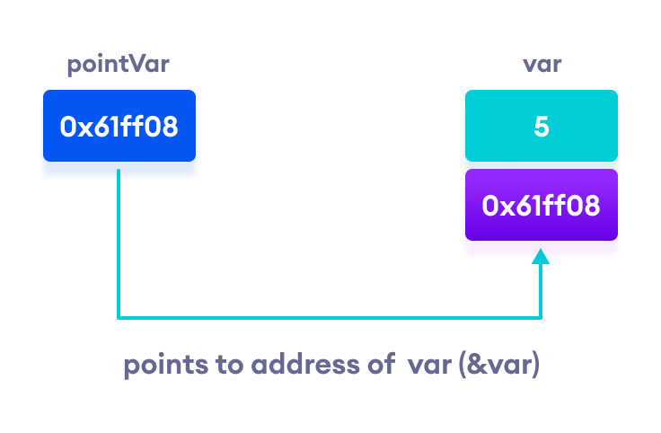

center h:400

Working of C++ pointers

### Changing Value Pointed by Pointers

If pointVar points to the address of var, we can change the value of var by using *pointVar.

For example,

int var = 5;  
int* pointVar;  
  
// assign address of var  
pointVar = &var;  
  
// change value at address pointVar  
*pointVar = 1;  
  
cout << var << endl; // Output: 1

Here, pointVar and &var have the same address, the value of var will also be changed when *pointVar is changed.

### Example 3: Changing Value Pointed by Pointers

#include <iostream>  
using namespace std;  
int main() {  
 int var = 5;  
 int* pointVar;  
  
 // store address of var  
 pointVar = &var;  
  
 // print var  
 cout << "var = " << var << endl;  
  
 // print *pointVar  
 cout << "*pointVar = " << *pointVar << endl  
 << endl;  
  
 cout << "Changing value of var to 7:" << endl;  
  
 // change value of var to 7  
 var = 7;  
  
 // print var  
 cout << "var = " << var << endl;  
  
 // print *pointVar  
 cout << "*pointVar = " << *pointVar << endl  
 << endl;  
  
 cout << "Changing value of *pointVar to 16:" << endl;  
  
 // change value of var to 16  
 *pointVar = 16;  
  
 // print var  
 cout << "var = " << var << endl;  
  
 // print *pointVar  
 cout << "*pointVar = " << *pointVar << endl;  
 return 0;  
}

[Run Code](https://www.programiz.com/cpp-programming/online-compiler)

**Output**

var = 5  
*pointVar = 5  
Changing value of var to 7:  
var = 7  
*pointVar = 7  
Changing value of *pointVar to 16:  
var = 16  
*pointVar = 16

## Common mistakes when working with pointers

Suppose, we want a pointer varPoint to point to the address of var. Then,

int var, *varPoint;  
  
// Wrong!   
// varPoint is an address but var is not  
varPoint = var;  
  
// Wrong!  
// &var is an address  
// *varPoint is the value stored in &var  
*varPoint = &var;  
  
// Correct!   
// varPoint is an address and so is &var  
varPoint = &var;  
  
 // Correct!  
// both *varPoint and var are values  
*varPoint = var;

**Recommended Readings**:

* [How to use generic data type pointers using a void pointer?](https://www.programiz.com/cpp-programming/pointer-void)
* [How to represent an array using a pointer?](https://www.programiz.com/cpp-programming/pointers-arrays)
* [How to use pointers with functions?](https://www.programiz.com/cpp-programming/pointers-function)
* [How to use pointers with structures?](https://www.programiz.com/cpp-programming/structure-pointer)

# C++ Pointers and Arrays

In this tutorial, we will learn about the relation between arrays and pointers with the help of examples.

In C++, [Pointers](https://www.programiz.com/cpp-programming/pointers) are variables that hold addresses of other variables. Not only can a pointer store the address of a single variable, it can also store the address of cells of an [array](https://www.programiz.com/cpp-programming/arrays).

Consider this example:

int *ptr;  
int arr[5];  
  
// store the address of the first  
// element of arr in ptr  
ptr = arr;

Here, ptr is a pointer variable while arr is an int array. The code ptr = arr; stores the address of the first element of the array in variable ptr.

Notice that we have used arr instead of &arr[0]. This is because both are the same. So, the code below is the same as the code above.

int *ptr;  
int arr[5];  
ptr = &arr[0];

The addresses for the rest of the array elements are given by &arr[1], &arr[2], &arr[3], and &arr[4].

## Point to Every Array Elements

Suppose we need to point to the fourth element of the array using the same pointer ptr.

Here, if ptr points to the first element in the above example then ptr + 3 will point to the fourth element. For example,

int *ptr;  
int arr[5];  
ptr = arr;  
  
ptr + 1 is equivalent to &arr[1];  
ptr + 2 is equivalent to &arr[2];  
ptr + 3 is equivalent to &arr[3];  
ptr + 4 is equivalent to &arr[4];

Similarly, we can access the elements using the single pointer. For example,

// use dereference operator  
*ptr == arr[0];  
*(ptr + 1) is equivalent to arr[1];  
*(ptr + 2) is equivalent to arr[2];  
*(ptr + 3) is equivalent to arr[3];  
*(ptr + 4) is equivalent to arr[4];

Suppose if we have initialized ptr = &arr[2]; then

ptr - 2 is equivalent to &arr[0];  
ptr - 1 is equivalent to &arr[1];   
ptr + 1 is equivalent to &arr[3];  
ptr + 2 is equivalent to &arr[4];

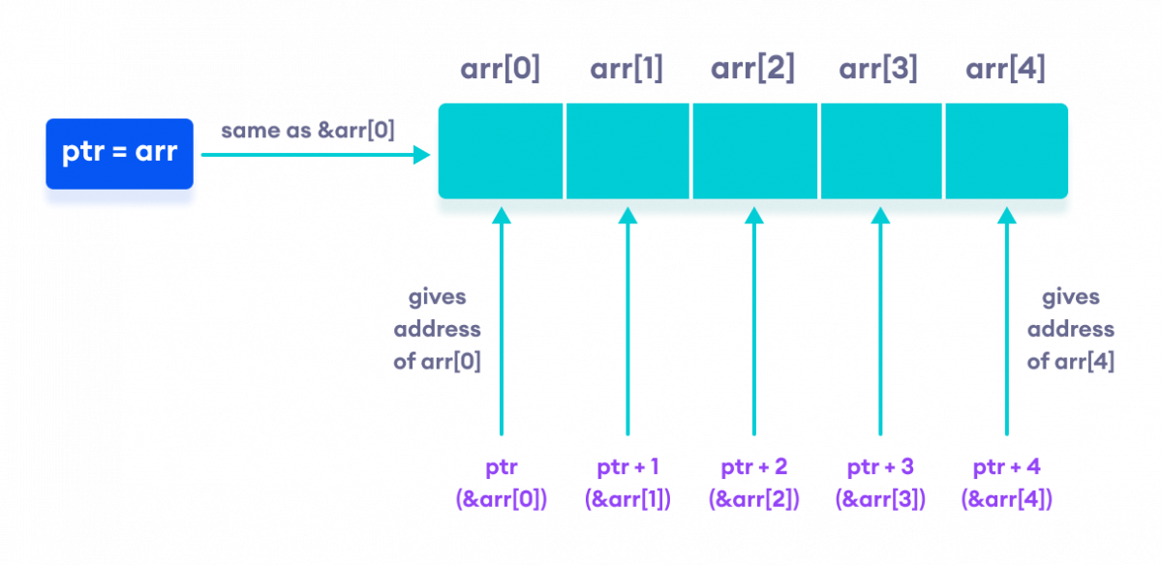

center h:400

Working of C++ Pointers with Arrays

**Note:** The address between ptr and ptr + 1 differs by 4 bytes. It is because ptr is a pointer to an int data. And, the size of int is 4 bytes in a 64-bit operating system.

Similarly, if pointer ptr is pointing to char type data, then the address between ptr and ptr + 1 is 1 byte. It is because the size of a character is 1 byte.

## Example 1: C++ Pointers and Arrays

// C++ Program to display address of each element of an array   
  
#include <iostream>  
using namespace std;  
  
int main()  
{  
 float arr[3];  
  
 // declare pointer variable  
 float *ptr;  
  
 cout << "Displaying address using arrays: " << endl;  
  
 // use for loop to print addresses of all array elements  
 for (int i = 0; i < 3; ++i)  
 {  
 cout << "&arr[" << i << "] = " << &arr[i] << endl;  
 }  
  
 // ptr = &arr[0]  
 ptr = arr;  
  
 cout<<"\nDisplaying address using pointers: "<< endl;  
  
 // use for loop to print addresses of all array elements  
 // using pointer notation  
 for (int i = 0; i < 3; ++i)  
 {  
 cout << "ptr + " << i << " = "<< ptr + i << endl;  
 }  
  
 return 0;  
}

[Run Code](https://www.programiz.com/cpp-programming/online-compiler)

**Output**

Displaying address using arrays:   
&arr[0] = 0x61fef0  
&arr[1] = 0x61fef4  
&arr[2] = 0x61fef8  
Displaying address using pointers:   
ptr + 0 = 0x61fef0  
ptr + 1 = 0x61fef4  
ptr + 2 = 0x61fef8

In the above program, we first simply printed the addresses of the array elements without using the pointer variable ptr.

Then, we used the pointer ptr to point to the address of a[0], ptr + 1 to point to the address of a[1], and so on.

In most contexts, array names decay to pointers. In simple words, array names are converted to pointers. That’s the reason why we can use pointers to access elements of arrays.

However, we should remember that pointers and arrays are not the same.

There are a few cases where array names don’t decay to pointers. To learn more, visit: [When does array name doesn’t decay into a pointer?](https://stackoverflow.com/questions/17752978/exceptions-to-array-decaying-into-a-pointer)

## Example 2: Array name used as pointer

// C++ Program to insert and display data entered by using pointer notation.  
  
#include <iostream>  
using namespace std;  
  
int main() {  
 float arr[5];  
  
 // Insert data using pointer notation  
 cout << "Enter 5 numbers: ";  
 for (int i = 0; i < 5; ++i) {  
  
 // store input number in arr[i]  
 cin >> *(arr + i) ;  
  
 }  
  
 // Display data using pointer notation  
 cout << "Displaying data: " << endl;  
 for (int i = 0; i < 5; ++i) {  
  
 // display value of arr[i]  
 cout << *(arr + i) << endl ;  
  
 }  
  
 return 0;  
}

[Run Code](https://www.programiz.com/cpp-programming/online-compiler)

**Output**

Enter 5 numbers: 2.5  
3.5  
4.5  
5  
2  
Displaying data:   
2.5  
3.5  
4.5  
5  
2

Here,

1. We first used the pointer notation to store the numbers entered by the user into the array arr.

* cin >> *(arr + i) ;
* This code is equivalent to the code below:
* cin >> arr[i];
* Notice that we haven’t declared a separate pointer variable, but rather we are using the array name arr for the pointer notation.
* As we already know, the array name arr points to the first element of the array. So, we can think of arr as acting like a pointer.

1. Similarly, we then used for loop to display the values of arr using pointer notation.

* cout << *(arr + i) << endl ;
* This code is equivalent to
* cout << arr[i] << endl ;

# C++ Call by Reference: Using pointers

In this tutorial, we will learn about C++ call by reference to pass pointers as an argument to the function with the help of examples.

In the [C++ Functions](https://www.programiz.com/cpp-programming/function) tutorial, we learned about passing arguments to a function. This method used is called passing by value because the actual value is passed.

However, there is another way of passing arguments to a function where the actual values of arguments are not passed. Instead, the reference to values is passed.

For example,

// function that takes value as parameter  
  
void func1(int numVal) {  
 // code  
}  
  
// function that takes reference as parameter  
// notice the & before the parameter  
void func2(int &numRef) {  
 // code  
}  
  
int main() {  
 int num = 5;  
  
 // pass by value  
 func1(num);  
  
 // pass by reference  
 func2(num);  
  
 return 0;  
}

[Run Code](https://www.programiz.com/cpp-programming/online-compiler)

Notice the & in void func2(int &numRef). This denotes that we are using the address of the variable as our parameter.

So, when we call the func2() function in main() by passing the variable num as an argument, we are actually passing the address of num variable instead of the value **5**.

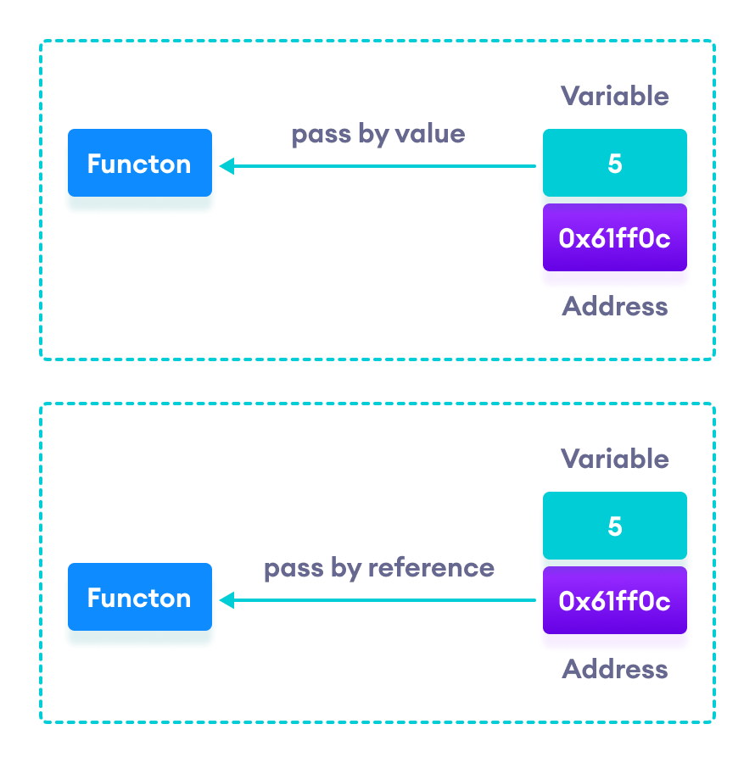

center h:400

C++ Pass by Value vs. Pass by Reference

## Example 1: Passing by reference without pointers

#include <iostream>  
using namespace std;  
  
// function definition to swap values  
void swap(int &n1, int &n2) {  
 int temp;  
 temp = n1;  
 n1 = n2;  
 n2 = temp;  
}  
  
int main()  
{  
  
 // initialize variables  
 int a = 1, b = 2;  
  
 cout << "Before swapping" << endl;  
 cout << "a = " << a << endl;  
 cout << "b = " << b << endl;  
  
 // call function to swap numbers  
 swap(a, b);  
  
 cout << "\nAfter swapping" << endl;  
 cout << "a = " << a << endl;  
 cout << "b = " << b << endl;  
  
 return 0;  
}

[Run Code](https://www.programiz.com/cpp-programming/online-compiler)

**Output**

Before swapping  
a = 1  
b = 2  
After swapping  
a = 2  
b = 1

In this program, we passed the variables a and b to the swap() function. Notice the function definition,

void swap(int &n1, int &n2)

Here, we are using & to denote that the function will accept addresses as its parameters.

Hence, the compiler can identify that instead of actual values, the reference of the variables is passed to function parameters.

In the swap() function, the function parameters n1 and n2 are pointing to the same value as the variables a and b respectively. Hence the swapping takes place on actual value.

The same task can be done using the pointers. To learn about pointers, visit [C++ Pointers](https://www.programiz.com/cpp-programming/pointers).

## Example 2: Passing by reference using pointers

#include <iostream>  
using namespace std;  
  
// function prototype with pointer as parameters  
void swap(int*, int*);  
  
int main()  
{  
  
 // initialize variables  
 int a = 1, b = 2;  
  
 cout << "Before swapping" << endl;  
 cout << "a = " << a << endl;  
 cout << "b = " << b << endl;  
  
 // call function by passing variable addresses  
 swap(&a, &b);  
  
 cout << "\nAfter swapping" << endl;  
 cout << "a = " << a << endl;  
 cout << "b = " << b << endl;  
 return 0;  
}  
  
// function definition to swap numbers  
void swap(int* n1, int* n2) {  
 int temp;  
 temp = *n1;  
 *n1 = *n2;  
 *n2 = temp;  
}

[Run Code](https://www.programiz.com/cpp-programming/online-compiler)

**Output**

Before swapping  
a = 1  
b = 2  
After swapping  
a = 2  
b = 1

Here, we can see the output is the same as the previous example. Notice the line,

// &a is address of a  
// &b is address of b  
swap(&a, &b);

Here, the address of the variable is passed during the function call rather than the variable.

Since the address is passed instead of value, a dereference operator * must be used to access the value stored in that address.

temp = *n1;  
*n1 = *n2;  
*n2 = temp;

*n1 and *n2 gives the value stored at address n1 and n2 respectively.

Since n1 and n2 contain the addresses of a and b, anything is done to *n1 and *n2 will change the actual values of a and b.

Hence, when we print the values of a and b in the main() function, the values are changed.

# C++ Memory Management: new and delete

In this tutorial, we will learn to manage memory effectively in C++ using new and delete operations with the help of examples.

C++ allows us to allocate the memory of a variable or an array in run time. This is known as dynamic memory allocation.

In other programming languages such as Java and Python, the compiler automatically manages the memories allocated to variables. But this is not the case in C++.

In C++, we need to deallocate the dynamically allocated memory manually after we have no use for the variable.

We can allocate and then deallocate memory dynamically using the new and delete operators respectively.

## C++ new Operator

The new operator allocates memory to a variable. For example,

// declare an int pointer  
int* pointVar;  
  
// dynamically allocate memory  
// using the new keyword   
pointVar = new int;  
  
// assign value to allocated memory  
*pointVar = 45;

Here, we have dynamically allocated memory for an int variable using the new operator.

Notice that we have used the pointer pointVar to allocate the memory dynamically. This is because the new operator returns the address of the memory location.

In the case of an array, the new operator returns the address of the first element of the array.

From the example above, we can see that the syntax for using the new operator is

pointerVariable = new dataType;

## delete Operator

Once we no longer need to use a variable that we have declared dynamically, we can deallocate the memory occupied by the variable.

For this, the delete operator is used. It returns the memory to the operating system. This is known as **memory deallocation**.

The syntax for this operator is

delete pointerVariable;

Consider the code:

// declare an int pointer  
int* pointVar;  
  
// dynamically allocate memory  
// for an int variable   
pointVar = new int;  
  
// assign value to the variable memory  
*pointVar = 45;  
  
// print the value stored in memory  
cout << *pointVar; // Output: 45  
  
// deallocate the memory  
delete pointVar;

Here, we have dynamically allocated memory for an int variable using the pointer pointVar.

After printing the contents of pointVar, we deallocated the memory using delete.

**Note**: If the program uses a large amount of unwanted memory using new, the system may crash because there will be no memory available for the operating system. In this case, the delete operator can help the system from crash.

## Example 1: C++ Dynamic Memory Allocation

#include <iostream>  
using namespace std;  
  
int main() {  
  
 // declare an int pointer  
 int* pointInt;  
  
 // declare a float pointer  
 float* pointFloat;  
  
 // dynamically allocate memory  
 pointInt = new int;  
 pointFloat = new float;  
  
 // assigning value to the memory  
 *pointInt = 45;  
 *pointFloat = 45.45f;  
  
 cout << *pointInt << endl;  
 cout << *pointFloat << endl;  
  
 // deallocate the memory  
 delete pointInt;  
 delete pointFloat;  
  
 return 0;  
}

[Run Code](https://www.programiz.com/cpp-programming/online-compiler)

**Output**

45  
45.45

In this program, we dynamically allocated memory to two variables of int and float types. After assigning values to them and printing them, we finally deallocate the memories using the code

delete pointInt;  
delete pointFloat;

**Note:** Dynamic memory allocation can make memory management more efficient.

Especially for arrays, where a lot of the times we don’t know the size of the array until the run time.

## Example 2: C++ new and delete Operator for Arrays

// C++ Program to store GPA of n number of students and display it  
// where n is the number of students entered by the user  
  
#include <iostream>  
using namespace std;  
  
int main() {  
  
 int num;  
 cout << "Enter total number of students: ";  
 cin >> num;  
 float* ptr;  
  
 // memory allocation of num number of floats  
 ptr = new float[num];  
  
 cout << "Enter GPA of students." << endl;  
 for (int i = 0; i < num; ++i) {  
 cout << "Student" << i + 1 << ": ";  
 cin >> *(ptr + i);  
 }  
  
 cout << "\nDisplaying GPA of students." << endl;  
 for (int i = 0; i < num; ++i) {  
 cout << "Student" << i + 1 << ": " << *(ptr + i) << endl;  
 }  
  
 // ptr memory is released  
 delete[] ptr;  
  
 return 0;  
}

[Run Code](https://www.programiz.com/cpp-programming/online-compiler)

**Output**

Enter total number of students: 4  
Enter GPA of students.  
Student1: 3.6  
Student2: 3.1  
Student3: 3.9  
Student4: 2.9  
Displaying GPA of students.  
Student1: 3.6  
Student2: 3.1  
Student3: 3.9  
Student4: 2.9

In this program, we have asked the user to enter the number of students and store it in the num variable.

Then, we have allocated the memory dynamically for the float array using new.

We enter data into the array (and later print them) using pointer notation.

After we no longer need the array, we deallocate the array memory using the code delete[] ptr;.

Notice the use of [] after delete. We use the square brackets [] in order to denote that the memory deallocation is that of an array.

## Example 3: C++ new and delete Operator for Objects

#include <iostream>  
using namespace std;  
  
class Student {  
 private:  
 int age;  
  
 public:  
  
 // constructor initializes age to 12  
 Student() : age(12) {}  
  
 void getAge() {  
 cout << "Age = " << age << endl;  
 }  
};  
  
int main() {  
  
 // dynamically declare Student object  
 Student* ptr = new Student();  
  
 // call getAge() function  
 ptr->getAge();  
  
 // ptr memory is released  
 delete ptr;  
  
 return 0;  
}

[Run Code](https://www.programiz.com/cpp-programming/online-compiler)

**Output**

Age = 12

In this program, we have created a Student class that has a private variable age.

We have initialized age to 12 in the default constructor Student() and print its value with the function getAge().

In main(), we have created a Student object using the new operator and use the pointer ptr to point to its address.

The moment the object is created, the Student() constructor initializes age to 12.

We then call the getAge() function using the code:

ptr->getAge();

Notice the arrow operator ->. This operator is used to access class members using pointers.

# C++ Inheritance

In this tutorial, we will learn about inheritance in C++ with the help of examples.

Inheritance is one of the key features of Object-oriented programming in C++. It allows us to create a new [class](https://www.programiz.com/cpp-programming/object-class) (derived class) from an existing class (base class).

**The derived class inherits the features from the base class** and can have additional features of its own. For example,

class Animal {  
 // eat() function  
 // sleep() function  
};  
  
class Dog : public Animal {  
 // bark() function  
};

Here, the Dog class is derived from the Animal class. Since Dog is derived from Animal, members of Animal are accessible to Dog.

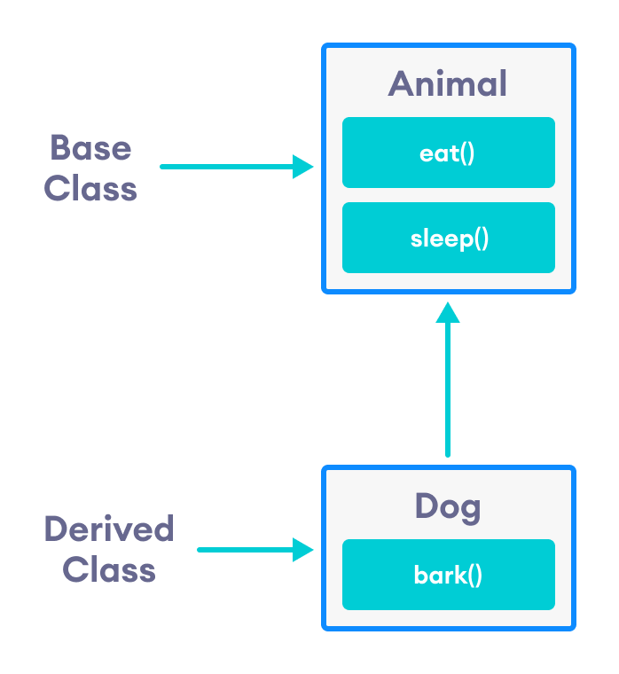

center h:400

Inheritance in C++

Notice the use of the keyword public while inheriting Dog from Animal.

class Dog : public Animal {...};

We can also use the keywords private and protected instead of public. We will learn about the differences between using private, public and protected later in this tutorial.

## is-a relationship

Inheritance is an **is-a relationship**. We use inheritance only if an **is-a relationship** is present between the two classes.

Here are some examples:

* A car is a vehicle.
* Orange is a fruit.
* A surgeon is a doctor.
* A dog is an animal.

## Example 1: Simple Example of C++ Inheritance

// C++ program to demonstrate inheritance  
  
#include <iostream>  
using namespace std;  
  
// base class  
class Animal {  
  
 public:  
 void eat() {  
 cout << "I can eat!" << endl;  
 }  
  
 void sleep() {  
 cout << "I can sleep!" << endl;  
 }  
};  
  
// derived class  
class Dog : public Animal {  
  
 public:  
 void bark() {  
 cout << "I can bark! Woof woof!!" << endl;  
 }  
};  
  
int main() {  
 // Create object of the Dog class  
 Dog dog1;  
  
 // Calling members of the base class  
 dog1.eat();  
 dog1.sleep();  
  
 // Calling member of the derived class  
 dog1.bark();  
  
 return 0;  
}

[Run Code](https://www.programiz.com/cpp-programming/online-compiler)

**Output**

I can eat!  
I can sleep!  
I can bark! Woof woof!!

Here, dog1 (the object of derived class Dog) can access members of the base class Animal. It’s because Dog is inherited from Animal.

// Calling members of the Animal class  
dog1.eat();  
dog1.sleep();

## C++ protected Members

The access modifier protected is especially relevant when it comes to C++ inheritance.

Like private members, protected members are inaccessible outside of the class. However, they can be accessed by **derived classes** and **friend classes/functions**.

We need protected members if we want to hide the data of a class, but still want that data to be inherited by its derived classes.

To learn more about protected, refer to our [C++ Access Modifiers](https://www.programiz.com/cpp-programming/access-modifiers) tutorial.

### Example 2 : C++ protected Members

// C++ program to demonstrate protected members  
  
#include <iostream>  
#include <string>  
using namespace std;  
  
// base class  
class Animal {  
  
 private:  
 string color;  
  
 protected:  
 string type;  
  
 public:  
 void eat() {  
 cout << "I can eat!" << endl;  
 }  
  
 void sleep() {  
 cout << "I can sleep!" << endl;  
 }  
  
 void setColor(string clr) {  
 color = clr;  
 }  
  
 string getColor() {  
 return color;  
 }  
};  
  
// derived class  
class Dog : public Animal {  
  
 public:  
 void setType(string tp) {  
 type = tp;  
 }  
  
 void displayInfo(string c) {  
 cout << "I am a " << type << endl;  
 cout << "My color is " << c << endl;  
 }  
  
 void bark() {  
 cout << "I can bark! Woof woof!!" << endl;  
 }  
};  
  
int main() {  
 // Create object of the Dog class  
 Dog dog1;  
  
 // Calling members of the base class  
 dog1.eat();  
 dog1.sleep();  
 dog1.setColor("black");  
  
 // Calling member of the derived class  
 dog1.bark();  
 dog1.setType("mammal");  
  
 // Using getColor() of dog1 as argument  
 // getColor() returns string data  
 dog1.displayInfo(dog1.getColor());  
  
 return 0;  
}

[Run Code](https://www.programiz.com/cpp-programming/online-compiler)

**Output**

I can eat!  
I can sleep!  
I can bark! Woof woof!!  
I am a mammal  
My color is black

Here, the variable type is protected and is thus accessible from the derived class Dog. We can see this as we have initialized type in the Dog class using the function setType().

On the other hand, the private variable color cannot be initialized in Dog.

class Dog : public Animal {  
  
 public:  
 void setColor(string clr) {  
 // Error: member "Animal::color" is inaccessible  
 color = clr;   
 }  
};

Also, since the protected keyword hides data, we cannot access type directly from an object of Dog or Animal class.

// Error: member "Animal::type" is inaccessible  
dog1.type = "mammal";

## Access Modes in C++ Inheritance

In our previous tutorials, we have learned about C++ access specifiers such as [public, private, and protected](https://www.programiz.com/cpp-programming/public-protected-private-inheritance).

So far, we have used the public keyword in order to inherit a class from a previously-existing base class. However, we can also use the private and protected keywords to inherit classes. For example,

class Animal {  
 // code  
};  
  
class Dog : private Animal {  
 // code  
};

class Cat : protected Animal {  
 // code  
};

The various ways we can derive classes are known as **access modes**. These access modes have the following effect:

1. **public:** If a derived class is declared in public mode, then the members of the base class are inherited by the derived class just as they are.
2. **private:** In this case, all the members of the base class become private members in the derived class.
3. **protected:** The public members of the base class become protected members in the derived class.

The private members of the base class are always private in the derived class.

To learn more, visit our [C++ public, private, protected inheritance](https://www.programiz.com/cpp-programming/public-protected-private-inheritance) tutorial.

## Member Function Overriding in Inheritance

Suppose, base class and derived class have member functions with the same name and arguments.

If we create an object of the derived class and try to access that member function, the member function in the derived class is invoked instead of the one in the base class.

The member function of derived class overrides the member function of base class.

Learn more about [Function overriding in C++](https://www.programiz.com/cpp-programming/function-overriding).

# C++ Public, Protected and Private Inheritance

In this tutorial, we will learn to use public, protected and private inheritance in C++ with the help of examples.

In [C++ inheritance](https://www.programiz.com/cpp-programming/inheritance), we can derive a child class from the base class in different access modes. For example,

class Base {  
.... ... ....  
};  
  
class Derived : public Base {  
.... ... ....  
};

Notice the keyword public in the code

class Derived : public Base

This means that we have created a derived class from the base class in **public mode**. Alternatively, we can also derive classes in **protected** or **private** modes.

These 3 keywords (public, protected, and private) are known as **access specifiers** in C++ inheritance.

## public, protected and private inheritance in C++

**public**, **protected,** and **private** inheritance have the following features:

* **public inheritance** makes public members of the base class public in the derived class, and the protected members of the base class remain protected in the derived class.
* **protected inheritance** makes the public and protected members of the base class protected in the derived class.
* **private inheritance** makes the public and protected members of the base class private in the derived class.

**Note:** private members of the base class are inaccessible to the derived class.

class Base {  
 public:  
 int x;  
 protected:  
 int y;  
 private:  
 int z;  
};  
  
class PublicDerived: public Base {  
 // x is public  
 // y is protected  
 // z is not accessible from PublicDerived  
};  
  
class ProtectedDerived: protected Base {  
 // x is protected  
 // y is protected  
 // z is not accessible from ProtectedDerived  
};  
  
class PrivateDerived: private Base {  
 // x is private  
 // y is private  
 // z is not accessible from PrivateDerived  
};

## Example 1: C++ public Inheritance

// C++ program to demonstrate the working of public inheritance  
  
#include <iostream>  
using namespace std;  
  
class Base {  
 private:  
 int pvt = 1;  
  
 protected:  
 int prot = 2;  
  
 public:  
 int pub = 3;  
  
 // function to access private member  
 int getPVT() {  
 return pvt;  
 }  
};  
  
class PublicDerived : public Base {  
 public:  
 // function to access protected member from Base  
 int getProt() {  
 return prot;  
 }  
};  
  
int main() {  
 PublicDerived object1;  
 cout << "Private = " << object1.getPVT() << endl;  
 cout << "Protected = " << object1.getProt() << endl;  
 cout << "Public = " << object1.pub << endl;  
 return 0;  
}

[Run Code](https://www.programiz.com/cpp-programming/online-compiler)

**Output**

Private = 1  
Protected = 2  
Public = 3

Here, we have derived PublicDerived from Base in **public mode**.

As a result, in PublicDerived:

* prot is inherited as **protected**.
* pub and getPVT() are inherited as **public**.
* pvt is inaccessible since it is **private** in Base.

Since **private** and **protected** members are not accessible from main(), we need to create public functions getPVT() and getProt() to access them:

// Error: member "Base::pvt" is inaccessible  
cout << "Private = " << object1.pvt;  
  
// Error: member "Base::prot" is inaccessible  
cout << "Protected = " << object1.prot;

Notice that the getPVT() function has been defined inside Base. But the getProt() function has been defined inside PublicDerived.

This is because pvt, which is **private** in Base, is inaccessible to PublicDerived.

However, prot is accessible to PublicDerived due to public inheritance. So, getProt() can access the protected variable from within PublicDerived.

### Accessibility in public Inheritance

| Accessibility | private members | protected members | public members |
| --- | --- | --- | --- |
| Base Class | Yes | Yes | Yes |
| Derived Class | No | Yes | Yes |

## Example 2: C++ protected Inheritance

// C++ program to demonstrate the working of protected inheritance  
  
#include <iostream>  
using namespace std;  
  
class Base {  
 private:  
 int pvt = 1;  
  
 protected:  
 int prot = 2;  
  
 public:  
 int pub = 3;  
  
 // function to access private member  
 int getPVT() {  
 return pvt;  
 }  
};  
  
class ProtectedDerived : protected Base {  
 public:  
 // function to access protected member from Base  
 int getProt() {  
 return prot;  
 }  
  
 // function to access public member from Base  
 int getPub() {  
 return pub;  
 }  
};  
  
int main() {  
 ProtectedDerived object1;  
 cout << "Private cannot be accessed." << endl;  
 cout << "Protected = " << object1.getProt() << endl;  
 cout << "Public = " << object1.getPub() << endl;  
 return 0;  
}

[Run Code](https://www.programiz.com/cpp-programming/online-compiler)

**Output**

Private cannot be accessed.  
Protected = 2  
Public = 3

Here, we have derived ProtectedDerived from Base in **protected mode**.

As a result, in ProtectedDerived:

* prot, pub and getPVT() are inherited as **protected**.
* pvt is inaccessible since it is **private** in Base.

As we know, **protected** members cannot be directly accessed from outside the class. As a result, we cannot use getPVT() from ProtectedDerived.

That is also why we need to create the getPub() function in ProtectedDerived in order to access the pub variable.

// Error: member "Base::getPVT()" is inaccessible  
cout << "Private = " << object1.getPVT();  
  
// Error: member "Base::pub" is inaccessible  
cout << "Public = " << object1.pub;

### Accessibility in protected Inheritance

| Accessibility | private members | protected members | public members |
| --- | --- | --- | --- |
| Base Class | Yes | Yes | Yes |
| Derived Class | No | Yes | Yes (inherited as protected variables) |

## Example 3: C++ private Inheritance

// C++ program to demonstrate the working of private inheritance  
  
#include <iostream>  
using namespace std;  
  
class Base {  
 private:  
 int pvt = 1;  
  
 protected:  
 int prot = 2;  
  
 public:  
 int pub = 3;  
  
 // function to access private member  
 int getPVT() {  
 return pvt;  
 }  
};  
  
class PrivateDerived : private Base {  
 public:  
 // function to access protected member from Base  
 int getProt() {  
 return prot;  
 }  
  
 // function to access private member  
 int getPub() {  
 return pub;  
 }  
};  
  
int main() {  
 PrivateDerived object1;  
 cout << "Private cannot be accessed." << endl;  
 cout << "Protected = " << object1.getProt() << endl;  
 cout << "Public = " << object1.getPub() << endl;  
 return 0;  
}

[Run Code](https://www.programiz.com/cpp-programming/online-compiler)

**Output**

Private cannot be accessed.  
Protected = 2  
Public = 3

Here, we have derived PrivateDerived from Base in **private mode**.

As a result, in PrivateDerived:

* prot, pub and getPVT() are inherited as **private**.
* pvt is inaccessible since it is **private** in Base.

As we know, private members cannot be directly accessed from outside the class. As a result, we cannot use getPVT() from PrivateDerived.

That is also why we need to create the getPub() function in PrivateDerived in order to access the pub variable.

// Error: member "Base::getPVT()" is inaccessible  
cout << "Private = " << object1.getPVT();  
  
// Error: member "Base::pub" is inaccessible  
cout << "Public = " << object1.pub;

### Accessibility in private Inheritance

| Accessibility | private members | protected members | public members |
| --- | --- | --- | --- |
| Base Class | Yes | Yes | Yes |
| Derived Class | No | Yes (inherited as private variables) | Yes (inherited as private variables) |

# C++ Function Overriding

In this tutorial, we will learn about function overriding in C++ with the help of examples.

As we know, [inheritance](https://www.programiz.com/cpp-programming/inheritance) is a feature of OOP that allows us to create derived classes from a base class. The derived classes inherit features of the base class.

Suppose, the same function is defined in both the derived class and the based class. Now if we call this function using the object of the derived class, the function of the derived class is executed.

This is known as **function overriding** in C++. The function in derived class overrides the function in base class.

## Example 1: C++ Function Overriding

// C++ program to demonstrate function overriding  
  
#include <iostream>  
using namespace std;  
  
class Base {  
 public:  
 void print() {  
 cout << "Base Function" << endl;  
 }  
};  
  
class Derived : public Base {  
 public:  
 void print() {  
 cout << "Derived Function" << endl;  
 }  
};  
  
int main() {  
 Derived derived1;  
 derived1.print();  
 return 0;  
}

**Output**

Derived Function

Here, the same function print() is defined in both Base and Derived classes.

So, when we call print() from the Derived object derived1, the print() from Derived is executed by overriding the function in Base.

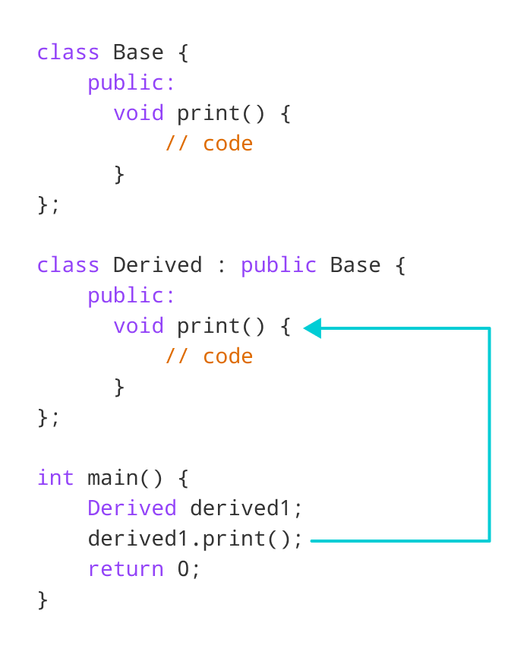

center h:400

Working of function overriding in C++

As we can see, the function was overridden because we called the function from an object of the Derived class.

Had we called the print() function from an object of the Base class, the function would not have been overridden.

// Call function of Base class  
Base base1;  
base1.print(); // Output: Base Function

## Access Overridden Function in C++

To access the overridden function of the base class, we use the scope resolution operator ::.

We can also access the overridden function by using a pointer of the base class to point to an object of the derived class and then calling the function from that pointer.

### Example 2: C++ Access Overridden Function to the Base Class

// C++ program to access overridden function  
// in main() using the scope resolution operator ::  
  
#include <iostream>  
using namespace std;  
  
class Base {  
 public:  
 void print() {  
 cout << "Base Function" << endl;  
 }  
};  
  
class Derived : public Base {  
 public:  
 void print() {  
 cout << "Derived Function" << endl;  
 }  
};  
  
int main() {  
 Derived derived1, derived2;  
 derived1.print();  
  
 // access print() function of the Base class  
 derived2.Base::print();  
  
 return 0;  
}

**Output**

Derived Function  
Base Function

Here, this statement

derived2.Base::print();

accesses the print() function of the Base class.

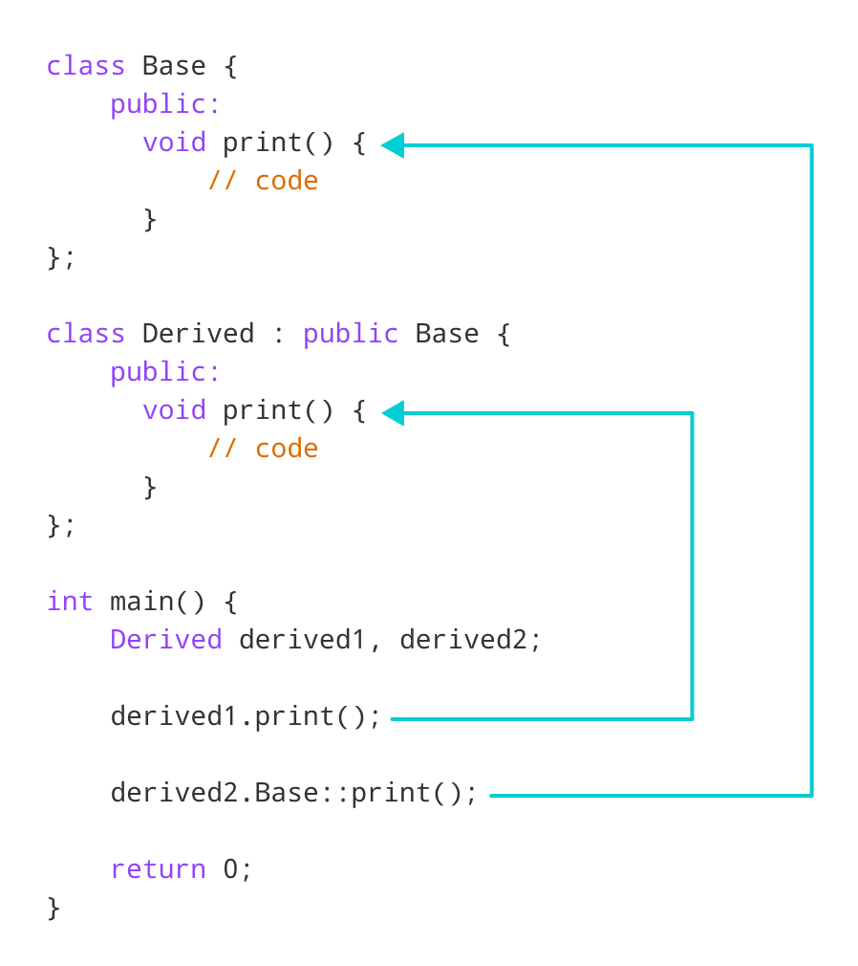

center h:400

Access overridden function using object of derived class in C++

### Example 3: C++ Call Overridden Function From Derived Class

// C++ program to call the overridden function  
// from a member function of the derived class  
  
#include <iostream>  
using namespace std;  
  
class Base {  
 public:  
 void print() {  
 cout << "Base Function" << endl;  
 }  
};  
  
class Derived : public Base {  
 public:  
 void print() {  
 cout << "Derived Function" << endl;  
  
 // call overridden function  
 Base::print();  
 }  
};  
  
int main() {  
 Derived derived1;  
 derived1.print();  
 return 0;  
}

**Output**

Derived Function  
Base Function

In this program, we have called the overridden function inside the Derived class itself.

class Derived : public Base {  
 public:  
 void print() {  
 cout << "Derived Function" << endl;  
 Base::print();  
 }  
};

Notice the code Base::print();, which calls the overridden function inside the Derived class.

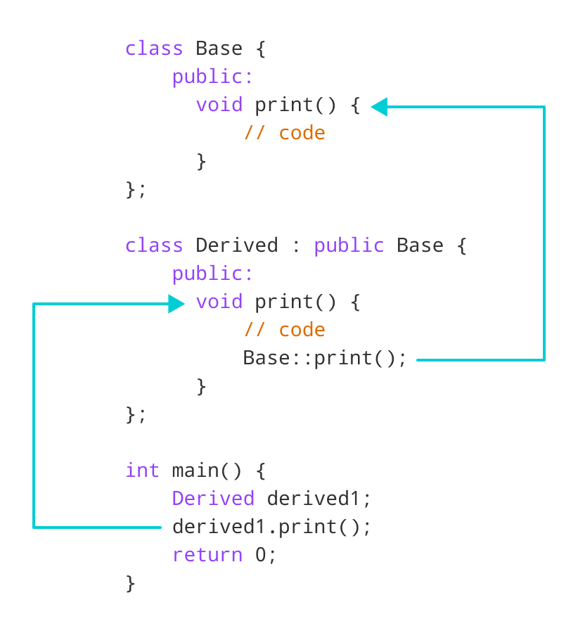

center h:400

Access overridden function inside derived class in C++

### Example 4: C++ Call Overridden Function Using Pointer

// C++ program to access overridden function using pointer  
// of Base type that points to an object of Derived class  
  
#include <iostream>  
using namespace std;  
  
class Base {  
 public:  
 void print() {  
 cout << "Base Function" << endl;  
 }  
};  
  
class Derived : public Base {  
 public:  
 void print() {  
 cout << "Derived Function" << endl;  
 }  
};  
  
int main() {  
 Derived derived1;  
  
 // pointer of Base type that points to derived1  
 Base* ptr = &derived1;  
  
 // call function of Base class using ptr  
 ptr->print();  
  
 return 0;  
}

**Output**

Base Function

In this program, we have created a pointer of Base type named ptr. This pointer points to the Derived object derived1.

// pointer of Base type that points to derived1  
Base* ptr = &derived1;

When we call the print() function using ptr, it calls the overridden function from Base.

// call function of Base class using ptr  
ptr->print();

This is because even though ptr points to a Derived object, it is actually of Base type. So, it calls the member function of Base.

In order to override the Base function instead of accessing it, we need to use [virtual functions](https://www.programiz.com/cpp-programming/virtual-functions) in the Base class.

# C++ Multiple, Multilevel and Hierarchical Inheritance

In this tutorial, we will learn about different models of inheritance in C++ programming: Multiple, Multilevel and Hierarchical inheritance with examples.

[Inheritance](https://www.programiz.com/cpp-programming/inheritance) is one of the core feature of an object-oriented programming language. It allows software developers to derive a new class from the existing class. The derived class inherits the features of the base class (existing class).

There are various models of inheritance in C++ programming.

## C++ Multilevel Inheritance

In C++ programming, not only you can derive a class from the base class but you can also derive a class from the derived class. This form of inheritance is known as multilevel inheritance.

class A {   
... .. ...   
};  
class B: public A {  
... .. ...  
};  
class C: public B {  
... ... ...  
};

Here, class B is derived from the base class A and the class C is derived from the derived class B.

### Example 1: C++ Multilevel Inheritance

#include <iostream>  
using namespace std;  
  
class A {  
 public:  
 void display() {  
 cout<<"Base class content.";  
 }  
};  
  
class B : public A {};  
  
class C : public B {};  
  
int main() {  
 C obj;  
 obj.display();  
 return 0;  
}

**Output**

Base class content.

In this program, class C is derived from class B (which is derived from base class A).

The obj object of class C is defined in the main() function.

When the display() function is called, display() in class A is executed. It’s because there is no display() function in class C and class B.

The compiler first looks for the display() function in class C. Since the function doesn’t exist there, it looks for the function in class B (as C is derived from B).

The function also doesn’t exist in class B, so the compiler looks for it in class A (as B is derived from A).

If display() function exists in C, the compiler overrides display() of class A (because of [member function overriding](https://www.programiz.com/cpp-programming/function-overriding)).

## C++ Multiple Inheritance

In C++ programming, a class can be derived from more than one parent. For example, A class Bat is derived from base classes Mammal and WingedAnimal. It makes sense because bat is a mammal as well as a winged animal.

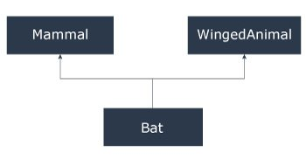

center h:400

Multiple Inheritance

### Example 2: Multiple Inheritance in C++ Programming

#include <iostream>  
using namespace std;  
  
class Mammal {  
 public:  
 Mammal() {  
 cout << "Mammals can give direct birth." << endl;  
 }  
};  
  
class WingedAnimal {  
 public:  
 WingedAnimal() {  
 cout << "Winged animal can flap." << endl;  
 }  
};  
  
class Bat: public Mammal, public WingedAnimal {};  
  
int main() {  
 Bat b1;  
 return 0;  
}

**Output**

Mammals can give direct birth.  
Winged animal can flap.

### Ambiguity in Multiple Inheritance

The most obvious problem with multiple inheritance occurs during function overriding.

Suppose, two base classes have a same function which is not overridden in derived class.

If you try to call the function using the object of the derived class, compiler shows error. It’s because compiler doesn’t know which function to call. For example,

class base1 {  
 public:  
 void someFunction( ) {....}   
};  
class base2 {  
 void someFunction( ) {....}   
};  
class derived : public base1, public base2 {};  
  
int main() {  
 derived obj;  
 obj.someFunction() // Error!   
}

This problem can be solved using the scope resolution function to specify which function to class either base1or base2

int main() {  
 obj.base1::someFunction( ); // Function of base1 class is called  
 obj.base2::someFunction(); // Function of base2 class is called.  
}

## C++ Hierarchical Inheritance

If more than one class is inherited from the base class, it’s known as [hierarchical inheritance](http://www.programtopia.net/cplusplus/docs/hierarchical-inheritance-c-programming?utm_source=programiz&utm_campaign=display). In hierarchical inheritance, all features that are common in child classes are included in the base class.

For example, Physics, Chemistry, Biology are derived from Science class. Similarly, Dog, Cat, Horse are derived from Animal class.

### Syntax of Hierarchical Inheritance

class base_class {  
 ... .. ...  
}  
class first_derived_class: public base_class {  
 ... .. ...  
}  
class second_derived_class: public base_class {  
 ... .. ...  
}  
class third_derived_class: public base_class {  
 ... .. ...  
}

### Example 3: Hierarchical Inheritance in C++ Programming

// C++ program to demonstrate hierarchical inheritance  
  
#include <iostream>  
using namespace std;  
  
// base class  
class Animal {  
 public:  
 void info() {  
 cout << "I am an animal." << endl;  
 }  
};  
  
// derived class 1  
class Dog : public Animal {  
 public:  
 void bark() {  
 cout << "I am a Dog. Woof woof." << endl;  
 }  
};  
  
// derived class 2  
class Cat : public Animal {  
 public:  
 void meow() {  
 cout << "I am a Cat. Meow." << endl;  
 }  
};  
  
int main() {  
 // Create object of Dog class  
 Dog dog1;  
 cout << "Dog Class:" << endl;  
 dog1.info(); // Parent Class function  
 dog1.bark();  
  
 // Create object of Cat class  
 Cat cat1;  
 cout << "\nCat Class:" << endl;  
 cat1.info(); // Parent Class function  
 cat1.meow();  
  
 return 0;  
}

[Run Code](https://www.programiz.com/cpp-programming/online-compiler)

**Output**

Dog Class:  
I am an animal.  
I am a Dog. Woof woof.  
Cat Class:  
I am an animal.  
I am a Cat. Meow.

Here, both the Dog and Cat classes are derived from the Animal class. As such, both the derived classes can access the info() function belonging to the Animal class.

# C++ friend Function and friend Classes

In this tutorial, we will learn to create friend functions and friend classes in C++ with the help of examples.

Data hiding is a fundamental concept of object-oriented programming. It restricts the access of private members from outside of the class.

Similarly, protected members can only be accessed by derived classes and are inaccessible from outside. For example,

class MyClass {  
 private:  
 int member1;  
}  
  
int main() {  
 MyClass obj;  
  
 // Error! Cannot access private members from here.  
 obj.member1 = 5;  
}

However, there is a feature in C++ called **friend functions** that break this rule and allow us to access member functions from outside the class.

Similarly, there is a **friend class** as well, which we will learn later in this tutorial.

## friend Function in C++

A **friend function** can access the **private** and **protected** data of a class. We declare a friend function using the friend keyword inside the body of the class.

class className {  
 ... .. ...  
 friend returnType functionName(arguments);  
 ... .. ...  
}

### Example 1: Working of friend Function

// C++ program to demonstrate the working of friend function  
  
#include <iostream>  
using namespace std;  
  
class Distance {  
 private:  
 int meter;  
  
 // friend function  
 friend int addFive(Distance);  
  
 public:  
 Distance() : meter(0) {}  
  
};  
  
// friend function definition  
int addFive(Distance d) {  
  
 //accessing private members from the friend function  
 d.meter += 5;  
 return d.meter;  
}  
  
int main() {  
 Distance D;  
 cout << "Distance: " << addFive(D);  
 return 0;  
}

[Run Code](https://www.programiz.com/cpp-programming/online-compiler)

**Output**

Distance: 5

Here, addFive() is a friend function that can access both **private** and **public** data members.

Though this example gives us an idea about the concept of a friend function, it doesn’t show any meaningful use.

A more meaningful use would be operating on objects of two different classes. That’s when the friend function can be very helpful.

### Example 2: Add Members of Two Different Classes

// Add members of two different classes using friend functions  
  
#include <iostream>  
using namespace std;  
  
// forward declaration  
class ClassB;  
  
class ClassA {  
  
 public:  
 // constructor to initialize numA to 12  
 ClassA() : numA(12) {}  
  
 private:  
 int numA;  
  
 // friend function declaration  
 friend int add(ClassA, ClassB);  
};  
  
class ClassB {  
  
 public:  
 // constructor to initialize numB to 1  
 ClassB() : numB(1) {}  
  
 private:  
 int numB;  
  
 // friend function declaration  
 friend int add(ClassA, ClassB);  
};  
  
// access members of both classes  
int add(ClassA objectA, ClassB objectB) {  
 return (objectA.numA + objectB.numB);  
}  
  
int main() {  
 ClassA objectA;  
 ClassB objectB;  
 cout << "Sum: " << add(objectA, objectB);  
 return 0;  
}

[Run Code](https://www.programiz.com/cpp-programming/online-compiler)

**Output**

Sum: 13

In this program, ClassA and ClassB have declared add() as a friend function. Thus, this function can access **private** data of both classes.

One thing to notice here is the friend function inside ClassA is using the ClassB. However, we haven’t defined ClassB at this point.

// inside classA   
friend int add(ClassA, ClassB);

For this to work, we need a forward declaration of ClassB in our program.

// forward declaration  
class ClassB;

## friend Class in C++

We can also use a friend Class in C++ using the friend keyword. For example,

class ClassB;  
  
class ClassA {  
 // ClassB is a friend class of ClassA  
 friend class ClassB;  
 ... .. ...  
}  
  
class ClassB {  
 ... .. ...  
}

When a class is declared a friend class, all the member functions of the friend class become friend functions.

Since ClassB is a friend class, we can access all members of ClassA from inside ClassB.

However, we cannot access members of ClassB from inside ClassA. It is because friend relation in C++ is only granted, not taken.

### Example 3: C++ friend Class

// C++ program to demonstrate the working of friend class  
  
#include <iostream>  
using namespace std;  
  
// forward declaration  
class ClassB;  
  
class ClassA {  
 private:  
 int numA;  
  
 // friend class declaration  
 friend class ClassB;  
  
 public:  
 // constructor to initialize numA to 12  
 ClassA() : numA(12) {}  
};  
  
class ClassB {  
 private:  
 int numB;  
  
 public:  
 // constructor to initialize numB to 1  
 ClassB() : numB(1) {}  
  
 // member function to add numA  
 // from ClassA and numB from ClassB  
 int add() {  
 ClassA objectA;  
 return objectA.numA + numB;  
 }  
};  
  
int main() {  
 ClassB objectB;  
 cout << "Sum: " << objectB.add();  
 return 0;  
}

[Run Code](https://www.programiz.com/cpp-programming/online-compiler)

**Output**

Sum: 13

Here, ClassB is a friend class of ClassA. So, ClassB has access to the members of classA.

In ClassB, we have created a function add() that returns the sum of numA and numB.

Since ClassB is a friend class, we can create objects of ClassA inside of ClassB.

# C++ Virtual Functions

In this tutorial, we will learn about C++ virtual function and its use with the help of examples.

A virtual function is a member function in the base class that we expect to redefine in derived classes.

Basically, a virtual function is used in the base class in order to ensure that the function is **overridden**. This especially applies to cases where a pointer of base class points to an object of a derived class.

For example, consider the code below:

class Base {  
 public:  
 void print() {  
 // code  
 }  
};  
  
class Derived : public Base {  
 public:  
 void print() {  
 // code  
 }  
};

Later, if we create a pointer of Base type to point to an object of Derived class and call the print() function, it calls the print() function of the Base class.

In other words, the member function of Base is not overridden.

int main() {  
 Derived derived1;  
 Base* base1 = &derived1;  
  
 // calls function of Base class  
 base1->print();  
  
 return 0;  
}

In order to avoid this, we declare the print() function of the Base class as virtual by using the virtual keyword.

class Base {  
 public:  
 virtual void print() {  
 // code  
 }  
};

Virtual functions are an integral part of polymorphism in C++. To learn more, check our tutorial on [C++ Polymorphism](https://www.programiz.com/cpp-programming/polymorphism).

## Example 1: C++ virtual Function

#include <iostream>  
using namespace std;  
  
class Base {  
 public:  
 virtual void print() {  
 cout << "Base Function" << endl;  
 }  
};  
  
class Derived : public Base {  
 public:  
 void print() {  
 cout << "Derived Function" << endl;  
 }  
};  
  
int main() {  
 Derived derived1;  
  
 // pointer of Base type that points to derived1  
 Base* base1 = &derived1;  
  
 // calls member function of Derived class  
 base1->print();  
  
 return 0;  
}

[Run Code](https://www.programiz.com/cpp-programming/online-compiler)

**Output**

Derived Function

Here, we have declared the print() function of Base as virtual.

So, this function is overridden even when we use a pointer of Base type that points to the Derived object derived1.

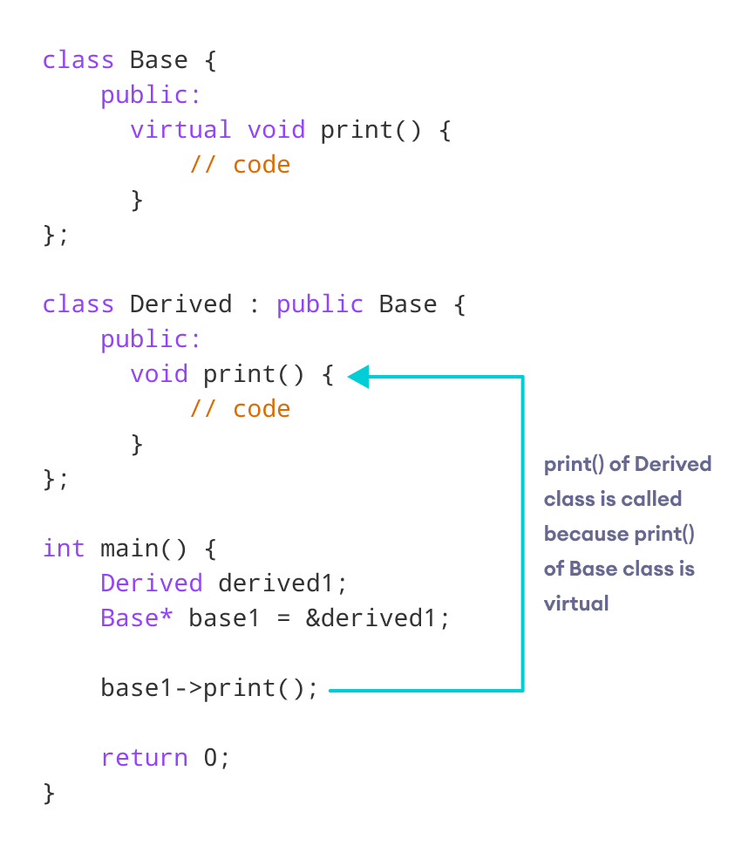

center h:400

Working of virtual functions in C++

## C++ override Identifier

C++ 11 has given us a new identifier override that is very useful to avoid bugs while using virtual functions.

This identifier specifies the member functions of the derived classes that override the member function of the base class.

For example,

class Base {  
 public:  
 virtual void print() {  
 // code  
 }  
};  
  
class Derived : public Base {  
 public:  
 void print() override {  
 // code  
 }  
};

If we use a function prototype in Derived class and define that function outside of the class, then we use the following code:

class Derived : public Base {  
 public:  
 // function prototype  
 void print() override;  
};  
  
// function definition  
void Derived::print() {  
 // code  
}

### Use of C++ override

When using virtual functions, it is possible to make mistakes while declaring the member functions of the derived classes.

Using the override identifier prompts the compiler to display error messages when these mistakes are made.

Otherwise, the program will simply compile but the virtual function will not be overridden.

Some of these possible mistakes are:

* **Functions with incorrect names:** For example, if the virtual function in the base class is named print(), but we accidentally name the overriding function in the derived class as pint().
* **Functions with different return types:** If the virtual function is, say, of void type but the function in the derived class is of int type.
* **Functions with different parameters:** If the parameters of the virtual function and the functions in the derived classes don’t match.
* No virtual function is declared in the base class.

## Use of C++ Virtual Functions

Suppose we have a base class Animal and derived classes Dog and Cat.

Suppose each class has a data member named type. Suppose these variables are initialized through their respective constructors.

class Animal {  
 private:  
 string type;  
 ... .. ...  
 public:  
 Animal(): type("Animal") {}  
 ... .. ...  
};  
  
class Dog : public Animal {  
 private:  
 string type;  
 ... .. ...  
 public:  
 Animal(): type("Dog") {}  
 ... .. ...  
};  
  
class Cat : public Animal {  
 private:  
 string type;  
 ... .. ...  
 public:  
 Animal(): type("Cat") {}  
 ... .. ...  
};

Now, let us suppose that our program requires us to create two public functions for each class:

1. getType() to return the value of type
2. print() to print the value of type

We could create both these functions in each class separately and override them, which will be long and tedious.

Or we could make getType() **virtual** in the Animal class, then create a single, separate print() function that accepts a pointer of Animal type as its argument. We can then use this single function to override the virtual function.

class Animal {  
 ... .. ...  
 public:  
 ... .. ...  
 virtual string getType {...}  
};  
  
... .. ...  
... .. ...  
  
void print(Animal* ani) {  
 cout << "Animal: " << ani->getType() << endl;  
}

This will make the code **shorter**, **cleaner**, and **less repetitive**.

## Example 2: C++ virtual Function Demonstration

// C++ program to demonstrate the use of virtual function  
  
#include <iostream>  
#include <string>  
using namespace std;  
  
class Animal {  
 private:  
 string type;  
  
 public:  
 // constructor to initialize type  
 Animal() : type("Animal") {}  
  
 // declare virtual function  
 virtual string getType() {  
 return type;  
 }  
};  
  
class Dog : public Animal {  
 private:  
 string type;  
  
 public:  
 // constructor to initialize type  
 Dog() : type("Dog") {}  
  
 string getType() override {  
 return type;  
 }  
};  
  
class Cat : public Animal {  
 private:  
 string type;  
  
 public:  
 // constructor to initialize type  
 Cat() : type("Cat") {}  
  
 string getType() override {  
 return type;  
 }  
};  
  
void print(Animal* ani) {  
 cout << "Animal: " << ani->getType() << endl;  
}  
  
int main() {  
 Animal* animal1 = new Animal();  
 Animal* dog1 = new Dog();  
 Animal* cat1 = new Cat();  
  
 print(animal1);  
 print(dog1);  
 print(cat1);  
  
 return 0;  
}

[Run Code](https://www.programiz.com/cpp-programming/online-compiler)

**Output**

Animal: Animal  
Animal: Dog  
Animal: Cat

Here, we have used the virtual function getType() and an Animal pointer ani in order to avoid repeating the print() function in every class.

void print(Animal* ani) {  
 cout << "Animal: " << ani->getType() << endl;  
}

In main(), we have created 3 Animal pointers to dynamically create objects of Animal, Dog and Cat classes.

// dynamically create objects using Animal pointers  
Animal* animal1 = new Animal();  
Animal* dog1 = new Dog();  
Animal* cat1 = new Cat();

We then call the print() function using these pointers:

1. When print(animal1) is called, the pointer points to an Animal object. So, the virtual function in Animal class is executed inside of print().
2. When print(dog1) is called, the pointer points to a Dog object. So, the virtual function is overridden and the function of Dog is executed inside of print().
3. When print(cat1) is called, the pointer points to a Cat object. So, the virtual function is overridden and the function of Cat is executed inside of print().

# C++ Class Templates

In this tutorial, we will learn about class templates in C++ with the help of examples.

Templates are powerful features of C++ which allows us to write generic programs. There are two ways we can implement templates:

* [Function Templates](https://programiz.com/cpp-programming/function-template)
* Class Templates

Similar to function templates, we can use class templates to create a single class to work with different data types.

Class templates come in handy as they can make our code shorter and more manageable.

## Class Template Declaration

A class template starts with the keyword template followed by template parameter(s) inside <> which is followed by the class declaration.

template <class T>  
class className {  
 private:  
 T var;  
 ... .. ...  
 public:  
 T functionName(T arg);  
 ... .. ...  
};

In the above declaration, T is the template argument which is a placeholder for the data type used, and class is a keyword.

Inside the class body, a member variable var and a member function functionName() are both of type T.

## Creating a Class Template Object

Once we’ve declared and defined a class template, we can create its objects in other classes or functions (such as the main() function) with the following syntax

className<dataType> classObject;

For example,

className<int> classObject;  
className<float> classObject;  
className<string> classObject;

## Example 1: C++ Class Templates

// C++ program to demonstrate the use of class templates  
  
#include <iostream>  
using namespace std;  
  
// Class template  
template <class T>  
class Number {  
 private:  
 // Variable of type T  
 T num;  
  
 public:  
 Number(T n) : num(n) {} // constructor  
  
 T getNum() {  
 return num;  
 }  
};  
  
int main() {  
  
 // create object with int type  
 Number<int> numberInt(7);  
  
 // create object with double type  
 Number<double> numberDouble(7.7);  
  
 cout << "int Number = " << numberInt.getNum() << endl;  
 cout << "double Number = " << numberDouble.getNum() << endl;  
  
 return 0;  
}

[Run Code](https://www.programiz.com/cpp-programming/online-compiler)

**Output**

int Number = 7  
double Number = 7.7

In this program. we have created a class template Number with the code

template <class T>  
class Number {  
 private:  
 T num;  
  
 public:  
 Number(T n) : num(n) {}  
 T getNum() { return num; }  
};

Notice that the variable num, the constructor argument n, and the function getNum() are of type T, or have a return type T. That means that they can be of any type.

In main(), we have implemented the class template by creating its objects

Number<int> numberInt(7);  
Number<double> numberDouble(7.7);

Notice the codes Number<int> and Number<double> in the code above.

This creates a class definition each for int and float, which are then used accordingly.

It is compulsory to specify the type when declaring objects of class templates. Otherwise, the compiler will produce an error.

//Error  
Number numberInt(7);  
Number numberDouble(7.7);

## Defining a Class Member Outside the Class Template

Suppose we need to define a function outside of the class template. We can do this with the following code:

template <class T>  
class ClassName {  
 ... .. ...  
 // Function prototype  
 returnType functionName();  
};  
  
// Function definition  
template <class T>  
returnType ClassName<T>::functionName() {  
 // code  
}

Notice that the code template <class T> is repeated while defining the function outside of the class. This is necessary and is part of the syntax.

If we look at the code in **Example 1**, we have a function getNum() that is defined inside the class template Number.

We can define getNum() outside of Number with the following code:

template <class T>  
class Number {  
 ... .. ...  
 // Function prototype  
 T getnum();  
};  
  
// Function definition  
template <class T>  
T Number<T>::getNum() {  
 return num;  
}

## Example 2: Simple Calculator Using Class Templates

This program uses a class template to perform addition, subtraction, multiplication and division of two variables num1 and num2.

The variables can be of any type, though we have only used int and float types in this example.

#include <iostream>  
using namespace std;  
  
template <class T>  
class Calculator {  
 private:  
 T num1, num2;  
  
 public:  
 Calculator(T n1, T n2) {  
 num1 = n1;  
 num2 = n2;  
 }  
  
 void displayResult() {  
 cout << "Numbers: " << num1 << " and " << num2 << "." << endl;  
 cout << num1 << " + " << num2 << " = " << add() << endl;  
 cout << num1 << " - " << num2 << " = " << subtract() << endl;  
 cout << num1 << " * " << num2 << " = " << multiply() << endl;  
 cout << num1 << " / " << num2 << " = " << divide() << endl;  
 }  
  
 T add() { return num1 + num2; }  
 T subtract() { return num1 - num2; }  
 T multiply() { return num1 * num2; }  
 T divide() { return num1 / num2; }  
};  
  
int main() {  
 Calculator<int> intCalc(2, 1);  
 Calculator<float> floatCalc(2.4, 1.2);  
  
 cout << "Int results:" << endl;  
 intCalc.displayResult();  
  
 cout << endl  
 << "Float results:" << endl;  
 floatCalc.displayResult();  
  
 return 0;  
}

[Run Code](https://www.programiz.com/cpp-programming/online-compiler)

**Output**

Int results:  
Numbers: 2 and 1.  
2 + 1 = 3  
2 - 1 = 1  
2 * 1 = 2  
2 / 1 = 2  
Float results:  
Numbers: 2.4 and 1.2.  
2.4 + 1.2 = 3.6  
2.4 - 1.2 = 1.2  
2.4 * 1.2 = 2.88  
2.4 / 1.2 = 2

In the above program, we have declared a class template Calculator.

The class contains two private members of type T: num1 & num2, and a constructor to initialize the members.

We also have add(), subtract(), multiply(), and divide() functions that have the return type T. We also have a void function displayResult() that prints out the results of the other functions.

In main(), we have created two objects of Calculator: one for int data type and another for float data type.

Calculator<int> intCalc(2, 1);  
Calculator<float> floatCalc(2.4, 1.2);

This prompts the compiler to create two class definitions for the respective data types during compilation.

## C++ Class Templates With Multiple Parameters

In C++, we can use multiple template parameters and even use default arguments for those parameters. For example,

template <class T, class U, class V = int>  
class ClassName {  
 private:  
 T member1;  
 U member2;  
 V member3;  
 ... .. ...  
 public:  
 ... .. ...  
};

### Example 3: C++ Templates With Multiple Parameters

#include <iostream>  
using namespace std;  
  
// Class template with multiple and default parameters  
template <class T, class U, class V = char>  
class ClassTemplate {  
 private:  
 T var1;  
 U var2;  
 V var3;  
  
 public:  
 ClassTemplate(T v1, U v2, V v3) : var1(v1), var2(v2), var3(v3) {} // constructor  
  
 void printVar() {  
 cout << "var1 = " << var1 << endl;  
 cout << "var2 = " << var2 << endl;  
 cout << "var3 = " << var3 << endl;  
 }  
};  
  
int main() {  
 // create object with int, double and char types  
 ClassTemplate<int, double> obj1(7, 7.7, 'c');  
 cout << "obj1 values: " << endl;  
 obj1.printVar();  
  
 // create object with int, double and bool types  
 ClassTemplate<double, char, bool> obj2(8.8, 'a', false);  
 cout << "\nobj2 values: " << endl;  
 obj2.printVar();  
  
 return 0;  
}

[Run Code](https://www.programiz.com/cpp-programming/online-compiler)

**Output**

obj1 values:   
var1 = 7  
var2 = 7.7  
var3 = c  
obj2 values:   
var1 = 8.8  
var2 = a  
var3 = 0

In this program, we have created a class template, named ClassTemplate, with three parameters, with one of them being a default parameter.

template <class T, class U, class V = char>  
class ClassTemplate {  
 // code   
};

Notice the code class V = char. This means that V is a default parameter whose default type is char.

Inside ClassTemplate, we declare 3 variables var1, var2 and var3, each corresponding to one of the template parameters.

class ClassTemplate {  
 private:  
 T var1;  
 U var2;  
 V var3;  
 ... .. ...  
 ... .. ...  
};

In main(), we create two objects of ClassTemplate with the code

// create object with int, double and char types  
ClassTemplate<int, double> obj1(7, 7.7, 'c');  
  
// create object with double, char and bool types  
ClassTemplate<double, char, bool> obj2(8, 8.8, false);

Here,

| Object | T | U | V |
| --- | --- | --- | --- |
| obj1 | int | double | char |
| obj2 | double | char | bool |

For obj1, T = int, U = double and V = char.

For obj2, T = double, U = char and V = bool.

### References

* [Learn C++ Programming](https://www.programiz.com/cpp-programming)
* [Introduction to C++ | C Plus Plus Programming Language Tutorials](http://www.btechsmartclass.com/cpp-programming/index.php)
* [The C and C++ programming tutorials, hands-on approach with program examples, code samples and tons of output images using Visual C++, C++ Builder, Linux gcc and g++ compilers and IDE](https://www.tenouk.com/cncplusplustutorials.html)