CE103 Algorithms and Programming I

C/Cpp GUI Programming

Author: Asst. Prof. Dr. Uğur CORUH

# CE103 Algorithms and Programming I

# Week-12 (C/Cpp GUI Programming)

#### Fall Semester, 2021-2022

Download [DOC](ce103-week-12-c-cpp-gui.tr.md_doc.pdf), [SLIDE](ce103-week-12-c-cpp-gui.tr.md_slide.pdf), [PPTX](ce103-week-12-c-cpp-gui.tr.md_slide.pptx)

# C/Cpp GUI Programming

The Microsoft Foundation Class

[MFC Tutorial](https://www.tutorialspoint.com/mfc/index.htm)

[Visual C++ / MFC Calculator 3 - YouTube](https://www.youtube.com/watch?v=CgLLSi9aC4I&ab_channel=PekkaK.)

[MFC C++ : My videos source code download available now to members - YouTube](https://www.youtube.com/watch?v=nmR1ZfYIZDA&t=0s&ab_channel=PekkaK.)

[The Windows GUI interface programming using Microsoft Foundation Classes (MFC) with Visual C++ and .Net hands-on approach tutorials](https://www.tenouk.com/cplusplusnmfc.html)

[Module 1: Using Visual C++ 6.0, .Net and Windows MFC Graphic User Interface (GUI) programming hands-on tutorial-Module1](https://www.tenouk.com/visualcplusmfc/visualcplusmfc1.html)

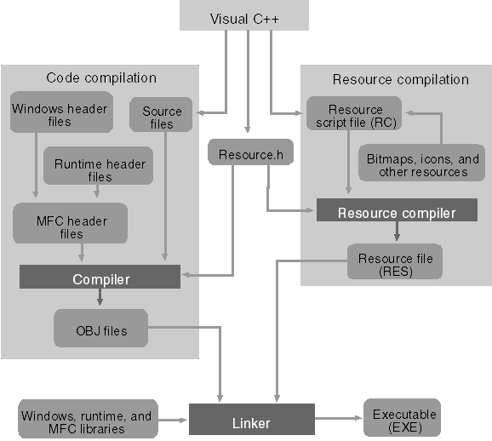

The Visual C++ application build process

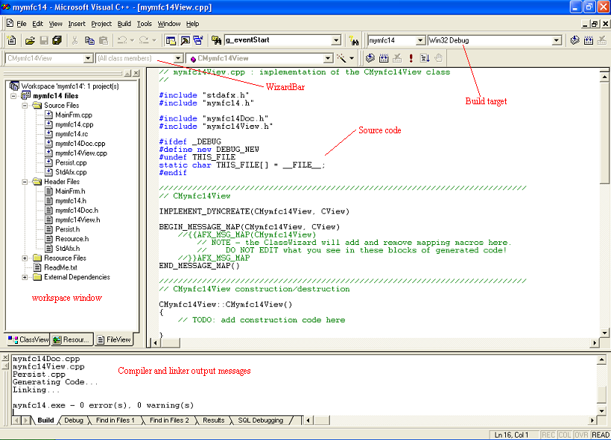

Visual C++ 6.0 windows with main components displayed

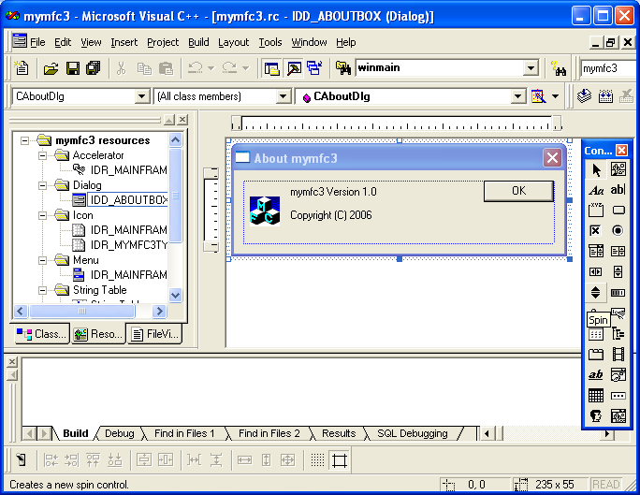

Visual C++ ResourceView

GTK 4

https://www.msys2.org/

https://www.msys2.org/

[Programming with gtkmm 4](https://developer-old.gnome.org/gtkmm-tutorial/stable/index.html)

[Build and run GTK 4 applications with Visual Studio](https://www.collabora.com/news-and-blog/blog/2021/03/18/build-and-run-gtk-4-applications-with-visual-studio/)

https://www.gtk.org/

[The Meson Build system](https://mesonbuild.com/index.html#features)

[The GTK Project - A free and open-source cross-platform widget toolkit](https://www.gtk.org/docs/architecture/)

// Include gtk  
#include <gtk/gtk.h>  
  
static void on_activate (GtkApplication *app) {  
 // Create a new window  
 GtkWidget *window = gtk_application_window_new (app);  
 // Create a new button  
 GtkWidget *button = gtk_button_new_with_label ("Hello, World!");  
 // When the button is clicked, close the window passed as an argument  
 g_signal_connect_swapped (button, "clicked", G_CALLBACK (gtk_window_close), window);  
 gtk_window_set_child (GTK_WINDOW (window), button);  
 gtk_window_present (GTK_WINDOW (window));  
}  
  
int main (int argc, char *argv[]) {  
 // Create a new application  
 GtkApplication *app = gtk_application_new ("com.example.GtkApplication",  
 G_APPLICATION_FLAGS_NONE);  
 g_signal_connect (app, "activate", G_CALLBACK (on_activate), NULL);  
 return g_application_run (G_APPLICATION (app), argc, argv);  
}

[eBooks by Tags | RIP Tutorial](https://riptutorial.com/ebook)