CEN206 Object-Oriented Programming
  - PlantUML
Author: Asst. Prof. Dr. Ugur CORUH
List of Figures

List of Tables

CEN206 Object-Oriented Programming

Week-5 (PlantUML)

Spring Semester, 2025-2026
Download DOC-PDF, DOC-DOCX, SLIDE

Module A: PlantUML Introduction

Module Outline
- PlantUML: What is it?
- PlantUML: When do you need it?

Plantuml What is it?

Plantuml What is it?
- PlantUML is an open-source tool allowing users to create diagrams from a plain text language, based on UML
- 22 April, 2009: First public release.
- Webpage PlantUML
- Wiki PlantUML
- Github PlantUML

Plantuml What is it?
- Besides various UML diagrams, PlantUML has support for various other software development related formats such as
  - Archimate,
  - Block diagram,
  - BPMN,
  - C4,
  - Computer network diagram,
  - ERD,
  - Gantt chart,
  - Mind map,
  - and WBD,
  - as well as visualisation of JSON and YAML files.
- Details in Next Slides…

Plantuml What is it?
@startuml
Bob->Alice : Hello!
@enduml
bg right h:300px
Demo Link
PlantUML Web Server

Plantuml What is it?
@startuml
skinparam style strictuml
class Façade {
doSomething()
}
Façade .> package1.Class1
Façade .> package2.Class2
Façade .> package3.Class3
Client1 .> Façade : doSomething()
Client2 .> Façade : doSomething()
note as N2
doSomething() {
Class1 c1 = newClass1();
Class2 c2 = newClass2();
Class3 c3 = newClass3();
c1.doStuff(c2)
c3.setX(c1.getX());
return c3.getY();
}
end note
Façade .. N2
@enduml
bg right w:600px
Demo Link
PlantUML Web Server

Plantuml What is it?

PlantUML Status

Plantuml What is it?

PlantUML Status

Plantuml What is it?

PlantUML Status

Plantuml What is it?

PlantUML Status

This badges are generated via
https://shields.io/

Plantuml What is it?
- Diagram As Code
  - Diagrams are defined using a simple and intuitive language. (see PlantUML Language Reference Guide).
- Easy to use
  - New users can read the quick start page. There is also a F.A.Q. page.
- Easy to integrate
  - PlantUML can be used within many other tools.
- Several outputs
  - Images can be generated in PNG, in SVG or in LaTeX format.
  - It is also possible to generate ASCII art diagrams (only for sequence diagrams).

Plantuml What is it?
PlantUML is a component that allows to quickly write:
- Sequence diagram
- Usecase diagram
- Class diagram
- Object diagram
- Activity diagram (here is the legacy syntax)
- Component diagram
- Deployment diagram
- State diagram
- Timing diagram

Plantuml What is it?
The following non-UML diagrams are also supported:
- JSON data
- YAML data
- Network diagram (nwdiag)
- Wireframe graphical interface or UI mockups (salt)
- Archimate diagram
- Specification and Description Language (SDL)
- Ditaa diagram
- Gantt diagram
- MindMap diagram
- Work Breakdown Structure diagram (WBS)
- Mathematic with AsciiMath or JLaTeXMath notation
- Entity Relationship diagram (IE/ER)

Plantuml What is it?
Furthermore:
- Hyperlinks and tooltips
- Creole: rich text, emoticons, unicode, icons
- OpenIconic icons
- Sprite icons
- AsciiMath mathematical expressions

Plantuml When do you need it?

Plantuml When do you need it?
- Integrate application source code with its UML design
- Do not worry about visual design
- If you need something platform independent and portable
- If you need something that has lightweight diagramming features.
- If you do not want to pay for licences.
- If you do not need to install applications.
- If you need fast operations for diagraming models that you need to generate and share with others.

Plantuml When do you need it?
- There are many applications that use PlantUML.
- There are many examples of PlantUML diagrams.maybe you can find your solutions. Do not forget to check the examples.

Takeaway: PlantUML Introduction
- PlantUML is an open-source tool for creating UML diagrams from plain text descriptions
- “Diagrams as Code” approach: version control friendly, automatable, and reproducible
- PlantUML supports all standard UML diagrams plus many non-UML diagram types
- Use PlantUML when you need quick, maintainable, and text-based diagram generation
- PlantUML renders diagrams as PNG, SVG, or other image formats

Module B: PlantUML Setup & Online Usage

Module Outline
- Download & Installation Options for Offline Usage
- Testing Installation and Version
- Using PlantUML Online (Web Server, Examples)

Before Start Lets Download & Install PlantUML

Download & Installation Options for Offline Usage
- Download from Direct Site and Use As *.jar File
- Install via Choco and use with Command Line

Option-1 : Download Jar File and PDF Guide
- Visit Download page
- Download Latest Version Always with GraphViz Support
  - PlantUML compiled Jar (Version 1.2022.4)
    - From GitHub releases, you can download plantuml.1.2022.4.jar
    - Version without embedded GraphViz: plantuml-nodot.1.2022.4.jar
- PlantUML Language Reference Guide
  -  English Deutsch Español Français 日本語 한국어 Русский 中文

Option-2 : Install via Choco and use with Command Line
- Choco install
  - For windows users, majkinetor introduced a way to install plantuml and its dependencies easily. Run cmd.exe as Administrator, and run two commands as follows (the first command is not needed and will fail if you already have chocolatey installed).
@"%SystemRoot%\System32\WindowsPowerShell\v1.0\powershell.exe" -NoProfile -ExecutionPolicy Bypass -Command "iex ((New-Object System.Net.WebClient).DownloadString('https://chocolatey.org/install.ps1'))" && SET "PATH=%PATH%;%ALLUSERSPROFILE%\chocolatey\bin"
choco install plantuml
- If you’ve installed java, but still prompts “java not installed”, please add java bin path to PATH environment variable.

Always Test Installation and Its Version

Plantuml How to use it online?

Plantuml How to use it online?
- From PlantUML Web Page Select “Online Server”
- Default Online Server Link
  - https://www.plantuml.com/plantuml/uml/SyfFKj2rKt3CoKnELR1Io4ZDoSa70000 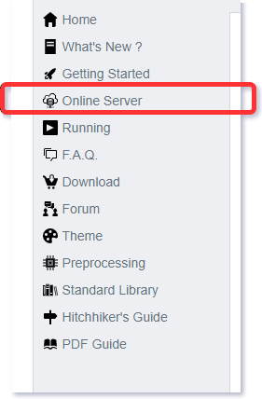

Plantuml How to use it online?
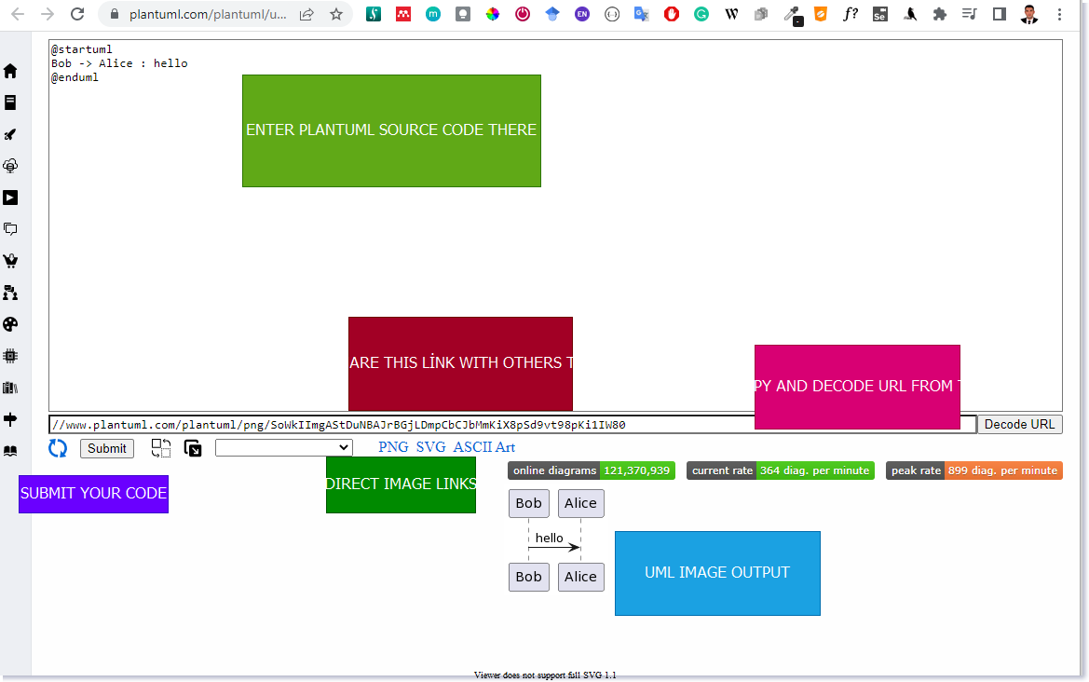
center h:550

Plantuml How to use it online?

You can download get shareable PNG, SVG links from server
- You can access directly UML diagram via browser
- You can parse links from server to get editable diagram
- You can try several built-in themes
- You can seperate diagram window from code window to make easier to edit diagram

Plantuml How to use it online?
- Everything stored on link, example
- Request URL
https://www.plantuml.com/plantuml/uml/SyfFKj2rKt3CoKnELR1Io4ZDoSa70000

Plantuml How to use it online?
- Server Base URL
https://www.plantuml.com/plantuml/uml/
- Encoded PlantUML Script
- SyfFKj2rKt3CoKnELR1Io4ZDoSa70000
- Decoded PlantUML Script
``` plantuml
@startuml
Bob -> Alice : hello
@enduml

Plantuml How to use it online?
- If you plantuml text-encoding features https://plantuml.com/text-encoding
- They use
  - https://en.wikipedia.org/wiki/Deflate (LZ77 + Huffman)
  - https://en.wikipedia.org/wiki/Brotli (LZ77)

Plantuml How to use it online?

Plantuml.jar Console-Command
You can use -encodeurl or -decodeurl in the command line flags to encode or decode the text.
@startuml
Bob -> Alice : hello
@enduml
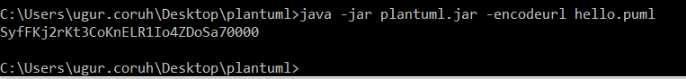
- https://www.plantuml.com/plantuml/uml/SyfFKj2rKt3CoKnELR1Io4ZDoSa70000

Plantuml How to use it online?
You will find here some implementation of this encoder:
- Code in PHP
- Code in Javascript
- Code in Python
- Code in Swift

Plantuml How to use it online?

Javascript Encoder & Decoder Library
- You can use following libraries to encode/decode URLs with you app.
  - https://github.com/markushedvall/plantuml-encoder
  - https://www.npmjs.com/package/plantuml-encoder-decoder

Plantuml How to use it online?

Javascript Encoder Example
var plantumlEncoder = require('plantuml-encoder')
var encoded = plantumlEncoder.encode('A -> B: Hello')
console.log(encoded) // SrJGjLDmibBmICt9oGS0
var url = 'http://www.plantuml.com/plantuml/img/' + encoded
var decoded = plantumlEncoder.decode(encoded)
console.log(decoded)

Plantuml How to use it online?

Javascript Decoder Example
var plantumlEncoder = require('plantuml-encoder')
var plain = plantumlEncoder.decode('UDfpLD2rKt2oKl18pSd91m0KGWDz')
console.log(plain) // A -> B: Hello

Plantuml How to use it online?

Simple HEX format
- If you find Deflate and Brotli too complex, you can try the HEX format. In that case, you just have to encode each character in hexadecimal format.
- For example :
- @startuml
Alice->Bob : I am using hex
@enduml
- will be turned into:
- 407374617274756d6c0a416c6963652d3e426f62203a204920616d207573696e67206865780a40656e64756d6c
- To indicate the use of HEX format, you must add ~h at the start of the data sent to PlantUML server.
  - http://www.plantuml.com/plantuml/uml/~h4073…
- Since there is no compression here, the URL will become very long as the diagram grows.

Plantuml How to use it online?

PNG service
To get a PNG file of a diagram, use the following URL scheme: /plantuml/png/ENCODED

Plantuml How to use it online?

SVG service
To get a SVG XML file of a diagram, use the following URL scheme: /plantuml/svg/ENCODED
Note that not all diagrams can be produced in SVG. For example, ditaa diagrams are only available in PNG format.

Plantuml How to use it online?

ASCII Art Service
To get an ASCII Art representation of a diagram, encoded in UTF-8, use the following URL scheme: /plantuml/txt/ENCODED
Note that only sequence diagrams can be produced in ASCII Art.

Plantuml How to use it online?

Image Map service
To get the client image map related to a previously generated PNG image, use the following URL scheme: /plantuml/map/ENCODED

Plantuml How to use it online?

Image Map service
The output is a list of <area> tags, each line matching a link present in the diagram description.
For example, the following diagram:
@startuml
participant Bob [[http://plantuml.com]]
Bob -> Alice : [[http://forum.plantuml.net]] hello
@enduml
produces the following output:
<map id="plantuml_map" name="plantuml_map">
<area shape="rect" id="id1" href="http://forum.plantuml.net" title="http://forum.plantuml.net" alt="" coords="38,50,199,65"/>
<area shape="rect" id="id2" href="http://plantuml.com" title="http://plantuml.com" alt="" coords="8,3,50,116"/>
</map>

Plantuml How to use it online?
Note that you need to include these <area... tags inside a <map... html tag to make the complete image map.
<!DOCTYPE html>
<html lang="en">
<head>
<title>Plantuml Image Map</title>
<meta charset="UTF-8" >
<meta name="keywords" content="Plantuml,ImageMap">
<meta name="description" content="Plantuml Image Map">
<meta name="author" content="Uğur CORUH">
</head>
<body>
<!-- -->
<h1>Sample Image</h1>
<img src="image.png" alt="Website map" usemap="#plantuml_map" />
<map id="plantuml_map" name="plantuml_map">
<area shape="rect" id="id1" href="http://forum.plantuml.net" title="http://forum.plantuml.net" alt="" coords="38,50,199,65"/>
<area shape="rect" id="id2" href="http://plantuml.com" title="http://plantuml.com" alt="" coords="8,3,50,116"/>
</map>
</body>
</html>

Plantuml How to use it online?

Proxy Service
With the proxy service, the source description of the diagram can be fetched by the PlantUML Server from a remote document.
The proxy service uses the following URL scheme: /plantuml/proxy?src=RESOURCE&idx=INDEX&fmt=FORMAT
- RESOURCE is the complete URL of the document which contains the diagram description (with the @startxxx and @endxxx tags), it could be a .html or a .txt file.
- INDEX is optional, it specifies the occurrence (starting at 0) of the diagram description that will be parsed when there are more than one diagram descriptions in the remote document. It defaults to zero.
- FORMAT is optional, it specifies the format to return. Supported values are: png, svg, eps, epstext and txt. Default is png,

Plantuml How to use it online?

Proxy Service
For example, try this link: http://www.plantuml.com/plantuml/proxy?src=https://raw.github.com/plantuml/plantuml-server/master/src/main/webapp/resource/test2diagrams.txt
Note that the address of the remote document is specified as a parameter, so it is not necessary to URL encode the URL.

Plantuml How to use it online?
- Checkout Integrations
  - https://plantuml.com/running
    - Wikis and Forums
    - Text editors and IDE
    - Programming language
    - Generated Documentation
    - Online Editors
    - Other services

Takeaway: PlantUML Setup & Online Usage
- PlantUML can be installed via JAR download or package managers (e.g., Chocolatey)
- Always verify installation with version check before starting
- Online server (plantuml.com/plantuml) allows quick diagram generation without installation
- Online usage is great for quick prototyping; offline is better for production workflows
- PlantUML requires Java Runtime Environment (JRE) to run locally

Module C: PlantUML Offline Usage

Module Outline
- PlantUML PicoWeb Server (Lightweight Local Server)
- PlantUML Server (Full JEE Web Application)
- Command Line Usage
- Local Rendering and Batch Processing

Plantuml How to use it offline?

Plantuml How to use it offline?

PlantUML PicoWeb Server
- https://plantuml.com/picoweb
- Many plugins take advantage of the online web server to generate images.
- For some reasons (security, performance…) you may need to use your own local server instead. This is possible thanks to the PlantUML Server which is available here.
- However, installing and configuring a full webserver may be too complex for some users so we have decided to integrate a tiny webserver inside plantuml.jar.
- This means that you only need a Java Runtime Environment and plantuml.jar to run this very simple web server.

Plantuml How to use it offline?

PlantUML PicoWeb Server
- https://plantuml.com/picoweb
- Running the server
  - Running the server is pretty simple. You just have to launch:
java -jar plantuml.jar -picoweb
- Attention: By default, the server listens on all interfaces on port 8080.
- To change the default behavior, you can specify a colon separated port (still listening on all interfaces) or, both, a port and a bind address:
- java -jar plantuml.jar -picoweb:8000
java -jar plantuml.jar -picoweb:8000:127.0.0.1

Plantuml How to use it offline?

PlantUML PicoWeb Server
- https://plantuml.com/picoweb
- Running the server
  - The server is really basic. It only understands GET requests with following patterns:
/plantuml/png/xyz....
/plantuml/svg/xyz....
- The server will return a PNG or SVG image.
- The server will return a 404 error if the request is not understood.
- The server will return a 500 error if the image cannot be generated.

Plantuml How to use it offline?

PlantUML PicoWeb Server
- Those GET requests are used by various PlantUML plugins. Once you have launched your server, you can simply test it. With any web browser, you just have to point to: http://127.0.0.1:8080.
- This way, you can very easily use any plugins which need some PlantUML HTTP server without the official online server.

Plantuml How to use it offline?

PlantUML Server
- You can use PlantUML using the online web service to generate images on-the-fly. A online demonstration is available at http://www.plantuml.com/plantuml, but you can also install it on your own JEE web application server.
- Full featured server is available here:
  - https://plantuml.com/server

Plantuml How to use it offline?

PlantUML Server
- To install PlantUML Server on your own JEE 5 web server,
  - download the plantuml.war file and copy it on the webapp folder of your server.
- Because of the transition from javax.* to jakarta.*, the PlantUML Server does not work on Tomcat 6/7/8/9 anymore. You have to use Tomcat 10.

Plantuml How to use it offline?
- Download and install Java Runtime Environment (JRE) or Java Development Kit (JDK) with JRE.
- Download jar file from https://plantuml.com/download
- Select Latest version plantuml.jar with graphviz support.
- Prepare a batch file to launch on your computer as follow in the same folder with plantuml.jar
- for PNG image output run run_plantuml_for_png_export.bat
- java -DPLANTUML_LIMIT_SIZE=8192 -jar "plantuml.jar" -v "./**.(puml)"
- for SVG output run run_plantuml_for_svg_export.bat
- java -DPLANTUML_LIMIT_SIZE=8192 -jar "plantuml.jar" -svg -v "./**.(puml)"
- This scripts are look for folders and find *.puml files and generate PNG or SVG images.

Plantuml How to use it offline?
- Other options
The most basic way to run it is:
java -jar plantuml.jar file1 file2 file3
This will look for @startXYZ into file1, file2 and file3. For each diagram, a .png file will be created.

Plantuml How to use it offline?
For processing a whole directory, you can use:
java -jar plantuml.jar "c:/directory1" "c:/directory2"
This command will search for @startXYZ and @endXYZ into .txt, .tex, .java, .htm, .html, .c, .h, .cpp, .apt, .pu, .puml, .hpp, .hh or .md files of the c:/directory1 and c:/directory2 directories.

Plantuml How to use it offline?

Configuration File
- You can also provide a configuration file which will be included before each diagram:
java -jar plantuml.jar -config "./config.cfg" dir1

Plantuml How to use it offline?

Configuration File
- Suppose you have the two following files:
test1.txt:
@startuml
Alice->Bob : hello
@enduml
config.txt:
skinparam handwritten true
- If you launch the following command:
java -jar plantuml.jar -config config.txt test1.txt
- File config.txt is automatically included at the very beginning of the diagram.

Plantuml How to use it offline?

Metadata
- PlantUML saves the diagram’s source code in the generated PNG Metadata in the form of encoded text.
- So it is possible to retrieve this source by using the query parameter metadata, giving it some image URL.
- For example, if you want to retrieve the diagram source of the image http://i.stack.imgur.com/HJvKF.png use the following server request:
  - http://www.plantuml.com/plantuml/?metadata=http://i.stack.imgur.com/HJvKF.png.
- Sounds like magic! No, merely clever engineering :-)

Plantuml How to use it offline?

Metadata
After all preprocessing (includes etc), PlantUML saves the diagram’s source code in the generated PNG Metadata in the form of encoded text.
- If you does not want plantuml to save the diagram’s source code in the generated PNG Metadata, you can during generation use the option -nometadata to disable this functionality (To NOT export metadata in PNG/SVG generated files).
- It is possible to retrieve this source with the -metadata option. This means that the PNG is almost “editable”: you can post it on a corporate wiki where you cannot install plugins, and someone in the future can update the diagram by getting the metadata, editing and re-uploading again. Also, the diagram is stand-alone.

Plantuml How to use it offline?

Metadata
- Conversely, the -checkmetadata option checks whether the target PNG has the same source and if there are no changes, doesn’t regenerate the PNG, thus saving all processing time. This allows you to run PlantUML on a whole folder (or tree with the -recursive option) incrementally.
Sounds like magic! No, merely clever engineering :-)
Example:
java -jar plantuml.jar -metadata diagram.png > diagram.puml
Unfortunately this option works only with local files. It doesn’t work with -pipe so you cannot fetch a URL with eg curl and feed the PNG to PlantUML.
However, the Plantuml server has a similar feature, where it can get a PNG from a URL and extract its metadata.

Plantuml How to use it offline?

Command line
You can run PlantUML using the command line. (See running for ways to run PlantUML from various other tools and workflows).The most basic way to run it is:
java -jar plantuml.jar file1 file2 file3
This will look for @startXYZ into file1, file2 and file3. For each diagram, a .png file will be created.For processing a whole directory, you can use:
java -jar plantuml.jar "c:/directory1" "c:/directory2"
This command will search for @startXYZ and @endXYZ into .txt, .tex, .java, .htm, .html, .c, .h, .cpp, .apt, .pu, .puml, .hpp, .hh or .md files of the c:/directory1 and c:/directory2 directories.

Plantuml How to use it offline?

Wildcards
You can also use wildcards :
- For a single character, use ?
- For zero or more characters, use *
- For zero or more characters, (including / or \), use a double **
So to process any .cpp files in all directories starting by dummy :
java -jar plantuml.jar "dummy*/*.cpp"
And to process any .cpp files in all directories starting by dummy, and theirs subdirectories :
java -jar plantuml.jar "dummy*/**.cpp"

Plantuml How to use it offline?

Excluded files
You can exlude some files from the process using the -x option:
java -jar plantuml.jar -x "**/common/**" -x "**/test/Test*" "dummy*/**/*.cpp"

Plantuml How to use it offline?

Output Directory
You can specify an output directory for all images using the -o switch:
java -jar plantuml.jar -o "c:/outputPng" "c:/directory2"
If you recurse into several directory, there is a slight difference if you provide an absolute or a relative path for this output directory:
- An absolute path will ensure that all images are output to a single, specific, directory.
- If you provide a relative path then the images is placed in that directory relative to the location of the input file, not the current directory (note: this applies even if the path begins with a .). When Plantuml processes files from multiple directores then the corresponding directory structure is created under the computed output directory.

Plantuml How to use it offline?

Types of Output File
Images for your diagrams can be exported in a variety of different formats. By default the format will be a PNG file but another type can be selected using the following extensions:
Example:
java -jar plantuml.jar yourdiagram.txt -ttxt

Plantuml How to use it offline?

Types of Output File
Param name | Short param name | Output format | Comment
-tpng | -png | PNG | Default
-tsvg | -svg | SVG | Further details can be found here
-teps | -eps | EPS | Further details can be found here

Plantuml How to use it offline?

Types of Output File
Param Name | Short Param Name | Output Format | Comment
-teps:text | -eps:text | EPS | This option keeps text as text
-tpdf | -pdf | PDF | Further details can be found here
-tvdx | -vdx | VDX | Microsoft Visio Document

Plantuml How to use it offline?

Types of Output File
Param Name | Short Param Name | Output Format | Comment
-txmi | -xmi | XMI | Further details can be found here
-tscxml | -scxml | SCXML
-thtml | -html | HTML | Alpha feature: do not use

Plantuml How to use it offline?

Types of Output File
Param Name | Short Param Name | Output Format | Comment
-ttxt | -txt | ATXT | ASCII art. Further details can be found here
-tutxt | -utxt | UTXT | ASCII art using Unicode characters
-tlatex | -latex | LATEX | Further details can be found here

Plantuml How to use it offline?

Types of Output File
Param Name | Short Param Name | Output Format | Comment
-tlatex:nopreamble | -latex:nopreamble | LATEX | Contains no LaTeX preamble creating a document
-tbraille | -braille | PNG | Braille image [Ref. QA-4752]

Plantuml How to use it offline?

Exit Code
- When there are some errors in diagrams the command returns an error (-1) exit code. But even if some diagrams contain some errors, all diagrams are generated, which can be time consuming for large project.
- You can use the -failfast flag to change this behavior to stop diagram generations as soon as one error occurs. In that case, some diagrams will be generated, and some will not.
- There is also a -failfast2 flag that does a first checking pass. If some error is present, no diagram will be generated at all. In case of error, -failfast2 runs even faster than -failfast, which may be useful for huge project.

Plantuml How to use it offline?

Standard report [stdrpt]
Using the -stdrpt (standard report) option, you can change the format of the error output of your PlantUML scripts.
With this option, a different error output of your diagram is possible:
- none: two lines
- -stdrpt: single line
- -stdrpt:1: verbose
- -stdrpt:2: single line
[Ref. Issue#155 and QA-11805]

Plantuml How to use it offline?

Standard report [stdrpt]
Examples, with the bad file file1.pu, where as is written aass:
@startuml
participant "Famous Bob" aass Bob
@enduml

Plantuml How to use it offline?

Standard report [stdrpt]

Without any option
java -jar plantuml.jar file1.pu
The error output is:
Error line 2 in file: file1.pu
Some diagram description contains errors

Plantuml How to use it offline?

Standard report [stdrpt]

-stdrpt option
java -jar plantuml.jar -stdrpt file1.pu
The error output is:
file1.pu:2:error:Syntax Error?

Plantuml How to use it offline?

Standard report [stdrpt]

-stdrpt:1 option
java -jar plantuml.jar -stdrpt:1 file1.pu
The error output is:
protocolVersion=1
status=ERROR
lineNumber=2
label=Syntax Error?
Error line 2 in file: file1.pu
Some diagram description contains errors

Plantuml How to use it offline?

Standard report [stdrpt]

-stdrpt:2 option (like -stdrpt)
java -jar plantuml.jar -stdrpt:2 file1.pu
The error output is:
file1.pu:2:error:Syntax Error?

Plantuml How to use it offline?

Command-Line Options and Help
You can have a help message by launching :
java -jar plantuml.jar -help

Plantuml How to use it offline?

Command-Line Options and Help
This will output:
Usage: java -jar plantuml.jar [options] -gui
(to execute the GUI)
or java -jar plantuml.jar [options] [file/dir] [file/dir] [file/dir]
(to process files or directories)
You can use the following wildcards in files/dirs:
* means any characters but '\'
? one and only one character but '\'
** means any characters (used to recurse through directories)

Plantuml How to use it offline?

Command-Line Options and Help
where options include:
-gui To run the graphical user interface
-tpng To generate images using PNG format (default)
-tsvg To generate images using SVG format
-teps To generate images using EPS format
-tpdf To generate images using PDF format
-tvdx To generate images using VDX format
-txmi To generate XMI file for class diagram
-tscxml To generate SCXML file for state diagram
-thtml To generate HTML file for class diagram

Plantuml How to use it offline?

Command-Line Options and Help
-ttxt To generate images with ASCII art
-tutxt To generate images with ASCII art using Unicode characters
-tlatex To generate images using LaTeX/Tikz format
-tlatex:nopreamble To generate images using LaTeX/Tikz format without preamble
-o[utput] "dir" To generate images in the specified directory
-DVAR1=value To set a preprocessing variable as if '!define VAR1 value' were used
-Sparam1=value To set a skin parameter as if 'skinparam param1 value' were used

Plantuml How to use it offline?

Command-Line Options and Help
-Ppragma1=value To set pragma as if '!pragma pragma1 value' were used
-I\path\to\file To include file as if '!include file' were used
-I\path\to\*.puml To include files with pattern
-theme xxx To use a specific theme
-charset xxx To use a specific charset (default is windows-1251)
-e[x]clude pattern To exclude files that match the provided pattern
-metadata To retrieve PlantUML sources from PNG images
-nometadata To NOT export metadata in PNG/SVG generated files
-checkmetadata Skip PNG files that don't need to be regenerated
-version To display information about PlantUML and Java versions
-v[erbose] To have log information

Plantuml How to use it offline?

Command-Line Options and Help
-quiet To NOT print error message into the console
-debugsvek To generate intermediate svek files
-h[elp] To display this help message
-testdot To test the installation of graphviz
-graphvizdot "exe" To specify dot executable
-p[ipe] To use stdin for PlantUML source and stdout for PNG/SVG/EPS generation
-encodesprite 4|8|16[z] "file" To encode a sprite at gray level (z for compression) from an image
-computeurl|-encodeurl To compute the encoded URL of a PlantUML source file
-decodeurl To retrieve the PlantUML source from an encoded URL

Plantuml How to use it offline?

Command-Line Options and Help
-syntax To report any syntax error from standard input without generating images
-language To print the list of PlantUML keywords
-checkonly To check the syntax of files without generating images
-failfast To stop processing as soon as a syntax error in diagram occurs
-failfast2 To do a first syntax check before processing files, to fail even faster
-noerror To skip images when error in diagrams
-duration To print the duration of complete diagrams processing
-nbthread N To use (N) threads for processing
-nbthread auto To use 4 threads for processing
-timeout N Processing timeout in (N) seconds. Defaults to 15 minutes (900 seconds).

Plantuml How to use it offline?

Command-Line Options and Help
-author[s] To print information about PlantUML authors
-overwrite To allow to overwrite read only files
-printfonts To print fonts available on your system
-enablestats To enable statistics computation
-disablestats To disable statistics computation (default)
-htmlstats To output general statistics in file plantuml-stats.html
-xmlstats To output general statistics in file plantuml-stats.xml
-realtimestats To generate statistics on the fly rather than at the end
-loopstats To continuously print statistics about usage
-splash To display a splash screen with some progress bar
-progress To display a textual progress bar in console

Plantuml How to use it offline?

Command-Line Options and Help
-pipeimageindex N To generate the Nth image with pipe option
-stdlib To print standard library info
-extractstdlib To extract PlantUML Standard Library into stdlib folder
-filedir xxx To behave as if the PlantUML source is in this dir (only affects '-pipe' and PicoWeb 'POST /render')
-filename "example.puml" To override %filename% variable
-preproc To output preprocessor text of diagrams
-cypher To cypher texts of diagrams so that you can share them
-picoweb To start internal HTTP Server. See https://plantuml.com/picoweb
- If needed, you can setup the environment variable GRAPHVIZ_DOT

Takeaway: PlantUML Offline Usage
- PicoWeb Server: lightweight local server built into plantuml.jar (java -jar plantuml.jar -picoweb)
- Full PlantUML Server: JEE web application for team/enterprise use
- Command line: generate diagrams directly from .puml files with various output formats
- Offline usage ensures security, performance, and no dependency on external services
- Can process multiple files in batch for large projects

Module D: PlantUML Integrations

Module Outline
- Wikis and Forums (GitHub, GitLab, Confluence, MediaWiki, etc.)
- Text Editors and IDEs (Eclipse, IntelliJ, VS Code, Visual Studio, etc.)
- Documentation Tools (Doxygen, Javadoc, Sphinx, etc.)
- Build and CI Tools

Plantuml Integrations with other tools

Plantuml Integrations with other tools
- PlantUML is integrated in a variety of external tools. See command-line for options to run it from the command line.
  - Running PlantUML from Other Tools
  - Plugins for PlantUML

Plantuml Integrations with other tools

Wikis and Forums
Make PlantUML diagrams easily accessible from markdown, GitHub flavored
Marketplace on GitHub
GitLab or GitHub integration with Markdown
Integrate it with MoinMoin
Integrate it with WordPress
Integrate it with Discourse Forum

Plantuml Integrations with other tools

Wikis and Forums
Integrate it with NodeBB Forum
Integrate it with MediaWiki
Integrate it with Redmine
Integrate it with Confluence
Integrate it with Confluence Cloud
Integrate it with Trac

Plantuml Integrations with other tools

Wikis and Forums
Integrate it with DokuWiki (see Weatherwax issue solved)
Integrate it with XWiki
Integrate it with PmWiki
Integrate it with TiddlyWiki
Integrate it with Ikiwiki
Integrate it with Jekyll

Plantuml Integrations with other tools

Wikis and Forums
Integrate it with Publet
Integrate it with Zim
Integrate it with Fitnesse
Integrate it with Slack

Plantuml Integrations with other tools

Text editors and IDE
Render PlantUML Diagrams for QOwnNotes editor
Connecting Astah and PlantUML
Integrate it with TinyMCE Editor
Integrate it with CKeditor
Use the Eclipse Plugin
Use a NetBeans Plugin

Plantuml Integrations with other tools

Text editors and IDE
Use it with NetBeans
Use it with Intellij idea
Run it directly from Word
Use Gizmo to render PlantUML diagrams within Word
Run it directly from Open Office

Plantuml Integrations with other tools

Text editors and IDE
Run it from Emacs
Run it from Sublime Text Editor
Run it from VIM (And use F5 key, Syntax, or PaperColor)
Use it with LaTeX
Use it with mbeddr
Use it with GEdit

Plantuml Integrations with other tools

Text editors and IDE
Use it with Brackets
Use it with Atom
PlantUML language package for Atom
UDL for Notepad++ to support the PlantUML language syntax
Visual Studio Code plugin
Another Visual Studio Code plugin

Plantuml Integrations with other tools

Text editors and IDE
PlantUML syntax highlighter
Generates UML class diagrams from MATLAB m-code

Plantuml Integrations with other tools

Programming language
Use it with Markdown
Use it from HTML code with JQuery
JOII-based classes diagram generator
Call it from PHP
Call it from Java
Call it from Python

Plantuml Integrations with other tools

Programming language
Another python remote client interface
Integration with IPython
Python tools for PlantUML
Call it from Groovy
Use builder pattern with Groovy PlantUML builder
Use command line

Plantuml Integrations with other tools

Programming language
Write an ANT task
Use the Maven2 plugin
Use it with Gradle
Use it on Salesforce.com with Apex
A Leiningen plugin for generating UML diagrams using PlantUML
Emacs Lisp DSL for PlantUML
Generate PHP classes from your PlantUML diagram

Plantuml Integrations with other tools

Generated Documentation
Create logical and physical database diagrams and generate DDL files.
Helm chart for PlantUML.
Markdown extension for PlantUML and Nikola.
Renders PlantUML files from Nikola.
JSDoc plugin to use PlantUML inside javascript documentation.

Plantuml Integrations with other tools

Generated Documentation
Simple tool to turn a swagger api spec into a uml class diagram.
Convert OpenAPI specifications to PlantUML diagrams.
Generate UML Diagrams for Given Swagger Definition.
Use it with LyX.
Reverse Engineering with PlantUML Dependency

Plantuml Integrations with other tools

Generated Documentation
Use it with Almost Plain Text (APT) files
Generate diagrams with Javadoc
Generate diagrams with Javadoc and PlantUML Taglet
Use it with Doxygen
Integrate it with docutils
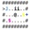Use it with AsciiDoc

Plantuml Integrations with other tools

Generated Documentation
Use it with Asciidoctor
Generate UML description from Java sources using a doclet
Use it with Pegdown
Use enhanced Doclet
Generate UML from C# sources

Plantuml Integrations with other tools

Generated Documentation
Generate UML from Scaladoc
Integrate it with Sphinx
Generate PlantUML diagrams from SqlALchemy models
Generate PlantUML diagram for Lua with LDoc
Generate PlantUML diagrams from grails project sources
Create PlantUML class diagrams from your PHP source.

Plantuml Integrations with other tools

Generated Documentation
Integrate PlantUML with ROBODoc.
Integrate PlantUML with Pandoc.
Integrate PlantUML with Sbt, the interactive build tool.
Gulp plugin for automated generation of diagrams.
Node.Js module for processing PlantUML
Another Node.js module and CLI

Plantuml Integrations with other tools

Generated Documentation
Plugin for TypeDoc for TypeScript programs
Maven plugin to inspect at compile time
Show the recursive dependencies of a Helm Chart-

Plantuml Integrations with other tools

Online Editors
Create and update UML diagrams inside of Google Docs,
Use the online servlet, (Explanation here)
Codeuml - design UML diagrams as fast as you can code
PlantText UML Editor

Plantuml Integrations with other tools

Online Editors
Seeduml
EtherPlant on Etherpad
Emacs/vim online Editor
TexWriting online Editor

Plantuml Integrations with other tools

Other
Node.js CLI tool that allows for live-reloading and exporting PlantUML.
Embed PlantUml diagrams in PowerPoint presentations.
A Chrome / Firefox extension for visualizing PlantUML descriptions.
Use the Docker repository
PlantUML with GitLab.org / GitLab Community Edition
PlantUML with Github Gist and Gitlab Support

Plantuml Integrations with other tools

Other
A GitBucket plugin renders PlantUML sources
Auto generating UML diagrams from SAP/ABAP code
Puse editor
PlantUML Chrome extension
Cloud version with Renderist on herokuapp.com
PlantUML QEditor written in Qt4

Plantuml Integrations with other tools

Other
Sketchlet : a software designer’s sketchbook
Double-click on the .jar to run it
PlantUML Editor: A fast and simple UML editor using WPF Dotnet
Install your own server
Use it with textcube
Gravizo.com

Plantuml Integrations with other tools

Plantuml How to integrate with Doxygen?
- Plantuml search for @startuml and @enduml tags in your source code and generate the diagram.
- You need to specify the output directory for the generated images in the Doxygen configuration file with the environment variable DOC_IMG_PATH_UML.
- First plantuml runs the source code through the PlantUML compiler and generates the images.
- Then doxygen runs the source code through the Doxygen preprocessor and generates the documentation.

Plantuml Integrations with other tools

Plantuml How to integrate with Doxygen?
- Folder structure should be as follow
  - app
    - src
      - main.cpp
    - doxygen
      - Resouces
      - DoxyFile
      - doxy_run.bat
      - plantuml.jar
- Example Application
  - https://github.com/ucoruh/ce103-hw2-template/tree/f3e17bc466b4b4db50625ab6c8aee884fbe4345f/doxygen

Plantuml Integrations with other tools

Plantuml How to integrate with Doxygen?
- Example Doxyfile
  - https://github.com/ucoruh/ce103-hw2-template/blob/f3e17bc466b4b4db50625ab6c8aee884fbe4345f/doxygen/Doxyfile

Plantuml Integrations with other tools

Plantuml How to integrate with Doxygen?
- Example Batch Script
- SET GRAPHVIZ_DOT="C:\Program Files\Graphviz\bin\dot.exe"
SET DOXYGEN_EXE="C:\Program Files\doxygen\bin\doxygen.exe"
SET SOURCE_DIR=..\source
SET DOCS_DIR=..\docs
SET DOC_IMG_PATH_UML=..\doxygen-plantuml\resources
SET DOC_IMG_PATH=../doxygen-plantuml/resources
:: SET STRIP_PATH="C:xx"
IF NOT EXIST plantuml.jar ( curl -o plantuml.jar “https://github.com/plantuml/plantuml/releases/download/v1.2021.14/plantuml-1.2021.14.jar” )
java -jar “plantuml.jar” -v “%DOCS_DIR%/.(puml)” java -jar ”plantuml.jar” -v -o ”%DOC_IMG_PATH_UML%” ”%SOURCE_DIR%/.(c|cpp|doc|h|cs)” doxygen Doxyfile pause
---
<style scoped>section{ font-size: 25px; }</style>
## **Plantuml Integrations with other tools**
### Plantuml How to integrate with Doxygen?
``` c
/**
@name TestFunction(fnCE103HW2Lib)
@brief \b Auto Generated Test Function
Auto Generated Test Function Has Doxygen and Plantuml Integration
Sample Web Page Link
@see https://www.cplusplus.com/reference/cstring/strcpy/
Sample Image AES Block Decryption Operation
@image html aes_enc_dec.png
@image rtf aes_enc_dec.png
@image latex aes_enc_dec.png
Sample Related Function Link
@see TestFunction (fnCE103HW2Lib)
<b> Plant UML Sample </b> <BR>
@image html fnCE103HW2Lib.png
@image rtf fnCE103HW2Lib.png
@image latex fnCE103HW2Lib.png
<!--
@startuml fnCE103HW2Lib.png
start
if (multiprocessor?) then (yes)
fork
:Treatment 1;
fork again
:Treatment 2;
end fork
else (monoproc)
:Treatment 1;
:Treatment 2;
endif
@enduml
-->
@param [in] fia [\b unsigned char*] Binary Data Input
@param [in] fib [\b int] Binary Data Input Length
@param [out] fic [\b char*] Hex String Output Array
@retval [\b int] operation result success 0 fail 1
Example Usage :
@code
#include <stdio.h>
#include <string.h>
int main (){
unsigned char data[]="\x13\x13\x13x\13";
int dataLength = 4;
char dataHex[40];
if(fnCE103HW2Lib(data,dataLength,dataHex)!=0)
{
printf("Operation Failed!");
return -1;
}
printf("Converted Data [%s]",dataHex);
return 0;
}
@endcode
**/
int fnCE103HW2Lib(unsigned char* fia, int fib, char* fic)
{
//Empty Body...
return -1;
}

Plantuml Integrations with other tools

Plantuml How to integrate with Doxygen?
...
@image html fnCE103HW2Lib.png
@image rtf fnCE103HW2Lib.png
@image latex fnCE103HW2Lib.png
<!--
@startuml fnCE103HW2Lib.png
start
if (multiprocessor?) then (yes)
fork
:Treatment 1;
fork again
:Treatment 2;
end fork
else (monoproc)
:Treatment 1;
:Treatment 2;
endif
@enduml
-->
...

Plantuml Integrations with other tools

Plantuml How to integrate with Doxygen?

Built-in Feature
- https://www.doxygen.nl/manual/commands.html#cmdstartuml

- Starts a text fragment which should contain a valid description of a PlantUML diagram.
  - See https://plantuml.com/ for examples. The text fragment ends with .

Plantuml Integrations with other tools

Plantuml How to integrate with Doxygen?

Built-in Feature
Note
- You need to install Java and the PlantUML’s jar file, if you want to use this command. When using PlantUML in you have to download some more jar files,
- for details see the PlantUML documentation. This also is valid for the <engine>s latex and math.
- The location of the PlantUML file should be specified using PLANTUML_JAR_PATH. The other jar files should also reside in this directory.

Plantuml Integrations with other tools

Plantuml How to integrate with Doxygen?

Built-in Feature
- The use of the <engine> ditaa is not possible in as PlantUML only supports the png format and doxygen requires, temporary, eps output.
- Not all diagrams can be created with the PlantUML @startuml command but need another PlantUML @start... command.
- This will look like @start<engine> where currently supported are the following <engine>s: uml, bpm, wire, dot, ditaa, salt, math, latex, gantt, mindmap, wbs, yaml, creole, json, flow, board and git. By default the <engine> is uml. The <engine> can be specified as an option.
- Also the file to write the resulting image to can be specified by means of an option, see the description of the first (optional) argument for details. Of course only one <engine> can be specified and also the filename can only be specified once.

Plantuml Integrations with other tools

Plantuml How to integrate with Doxygen?

Built-in Feature
- The first argument is optional and is for compatibility with running PlantUML as a preprocessing step before running doxygen, you can also add the name of the image file after \startuml and inside curly brackets as option, i.e.
@startuml{myimage.png} "Image Caption" width=5cm
Alice -> Bob : Hello
@enduml
- When the name of the image is specified, doxygen will generate an image with that name. Without the name doxygen will choose a name automatically.

Plantuml Integrations with other tools

Plantuml How to integrate with Doxygen?

Built-in Feature
- The second argument is optional and can be used to specify the caption that is displayed below the image. This argument has to be specified between quotes even if it does not contain any spaces. The quotes are stripped before the caption is displayed.
- The third argument is also optional and can be used to specify the width or height of the image. For a description of the possibilities see the paragraph Size indication with the command.

Plantuml Integrations with other tools

Plantuml How to integrate with Doxygen?

Built-in Feature
Note
- doxygen creates a temporary file that is automatically removed unless the DOT_CLEANUP tag is set to NO.

Plantuml Integrations with other tools

Plantuml How to integrate with Doxygen?

Built-in Feature
Here is an example of the use of the \startuml command.
/** Sender class. Can be used to send a command to the server.
* The receiver will acknowledge the command by calling Ack().
* \startuml
* Sender->Receiver : Command()
* Sender<--Receiver : Ack()
* \enduml
*/

Plantuml Integrations with other tools

Plantuml How to integrate with Doxygen?

Built-in Feature
class Sender
{
public:
/** Acknowledgment from server */
void Ack(bool ok);
};

Plantuml Integrations with other tools

Plantuml How to integrate with Doxygen?

Built-in Feature
/** Receiver class. Can be used to receive and execute commands.
* After execution of a command, the receiver will send an acknowledgment
* \startuml
* Receiver<-Sender : Command()
* Receiver-->Sender : Ack()
* \enduml
*/

Plantuml Integrations with other tools

Plantuml How to integrate with Doxygen?

Built-in Feature
class Receiver
{
public:
/** Executable a command on the server */
void Command(int commandId);
};

Plantuml Integrations with other tools

Plantuml How to integrate with Eclipse?

Information about the PlantUML Eclipse Plugin
- The Eclipse Plugin is developed and maintained by Hallvard Trætteberg (many thanks for his work!).
- Like the core library PlantUML itself, it is open source and the plugin is distributed under EPL license.
- The source code is hosted on GitHub.

Plantuml Integrations with other tools

Plantuml How to integrate with Eclipse?

How to use it?
- First, you have to display the PlantUML View (click the Window menu):
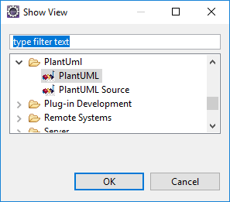
center h:350px

Plantuml Integrations with other tools

Plantuml How to integrate with Eclipse?

How to use it?
This view displays automatically the class you are working on:
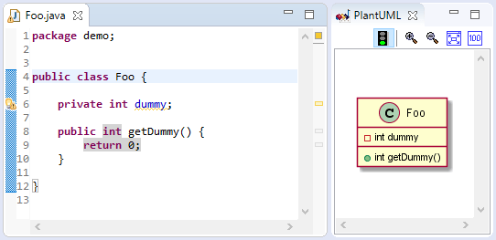
center h:350px

Plantuml Integrations with other tools

Plantuml How to integrate with Eclipse?

How to use it?
If you write some comment in PlantUML language, the corresponding diagram is automatically displayed. And if you have several comments with diagrams, it selects the one the cursor is in.
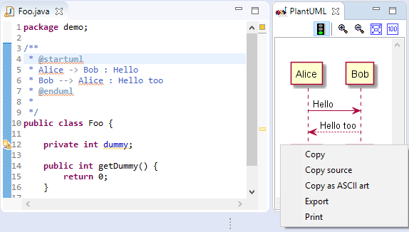
center h:350px

Plantuml Integrations with other tools

Plantuml How to integrate with Eclipse?

How to use it?
In the Preferences Windows, you can also set up GraphViz path if needed:
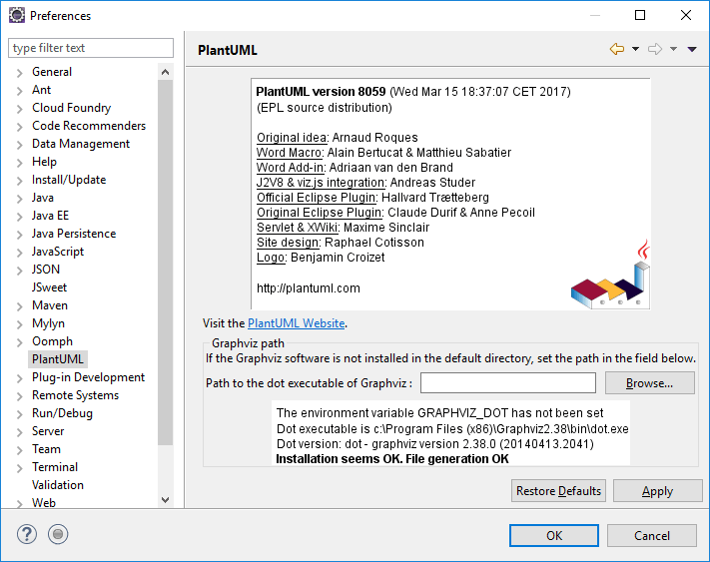
bg right:60% h:600px

Plantuml Integrations with other tools

Plantuml How to integrate with Eclipse?

How to install it?
To install the plugin, you have to:
- Go to Help/Software Update/Find and install… or Help/Install new software…
- Create (if needed) or choose the following site as update site: http://hallvard.github.io/plantuml/

Plantuml Integrations with other tools

Plantuml How to integrate with Eclipse?

How to install it?
- Add Repository http://hallvard.github.io/plantuml/ to Eclipse
- 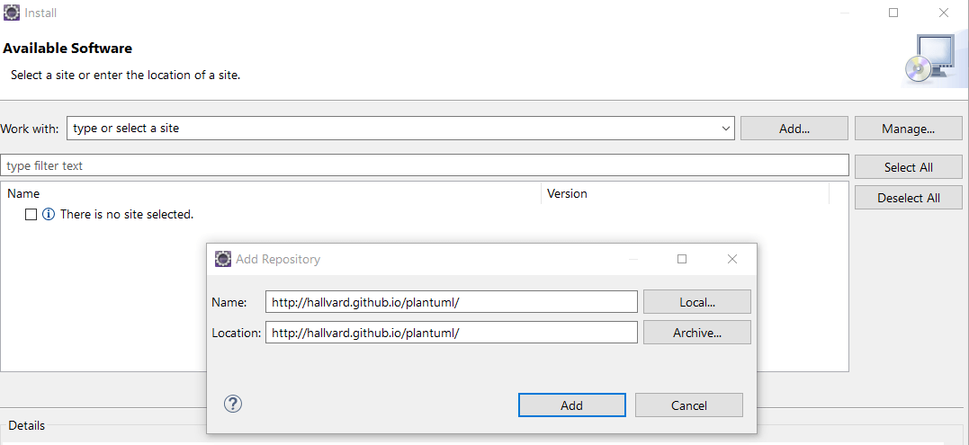
- center h:450px

Plantuml Integrations with other tools

Plantuml How to integrate with Eclipse?

How to install it?
- Select PlantUML features:
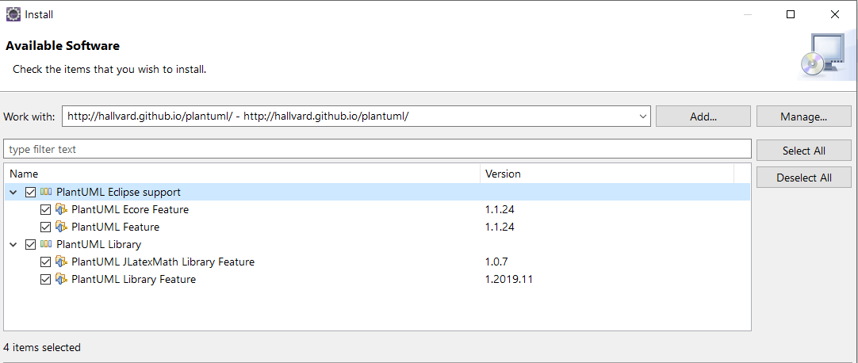
- Restart Eclipse

Plantuml Integrations with other tools

Plantuml How to integrate with Eclipse?

How to improve it?
The plugin is not limited to Java source file, it also works with *Ecore**/Xcore* files.
So that you can see the corresponding class diagram in a view side-by-side the *Ecore**/Xcore* editor :
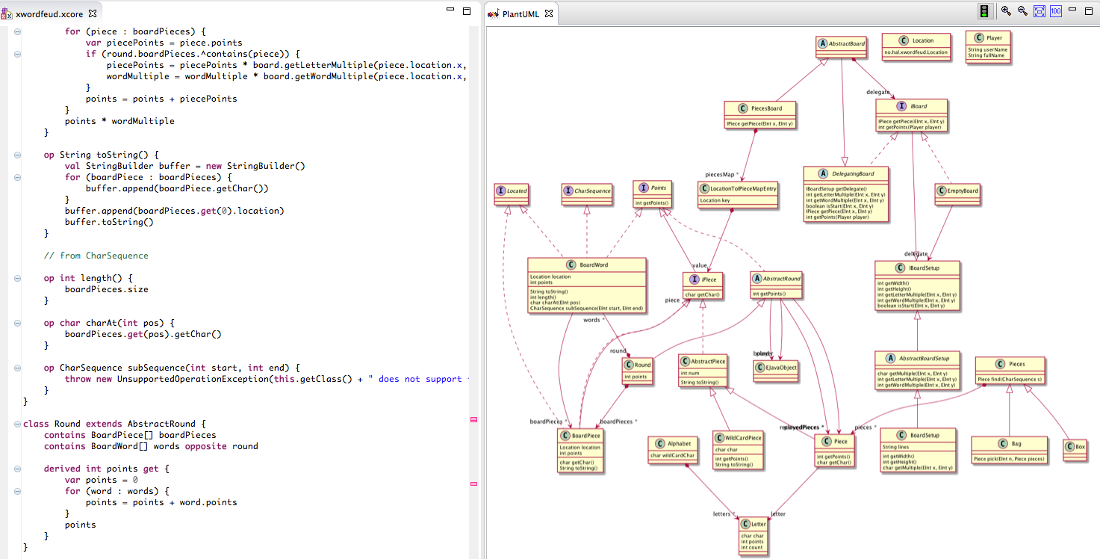
bg right:60% h:380px

Plantuml Integrations with other tools

Plantuml How to integrate with Eclipse?

How to improve it?
- If you want to support other file types, you can implement a new extension to do so. You can have a look at the current xcore implementation.

Takeaway: PlantUML Integrations
- PlantUML integrates with virtually every major wiki, forum, IDE, and documentation tool
- Key integrations: VS Code (PlantUML extension), Eclipse, IntelliJ IDEA, Doxygen
- Wiki integrations: GitHub, GitLab, Confluence, MediaWiki, DokuWiki
- Documentation tools: Sphinx, Javadoc, Markdown processors
- Integration enables “diagrams as code” workflow directly in your development environment

Module E: PlantUML Diagram Types & Advanced Features

Module Outline
- PlantUML UML Diagrams (Sequence, Use Case, Class, Object, Activity, Component, Deployment, State, Timing)
- PlantUML C4 Model Diagrams
- PlantUML Non-UML Diagrams (JSON, YAML, Network, Wireframe, Gantt, MindMap, etc.)
- PlantUML Preprocessing
- PlantUML Icon Support (Stdlib)
- Calling PlantUML from Java

Plantuml How to integrate with Visual Studio Code?

Plantuml How to integrate with Visual Studio Code?
- Install the PlantUML extension by jebbs from the VS Code Marketplace
- Extension ID: jebbs.plantuml
- Requirements: Java runtime and Graphviz installed on your system
- Features: syntax highlighting, auto-completion, preview, and export
- Use Alt+D to preview diagrams in a side panel
- Create .puml or .plantuml files and start writing PlantUML code

Plantuml How to integrate with Visual Studio?

Plantuml How to integrate with Visual Studio?
- Install the PlantUML Language Service extension from Visual Studio Marketplace
- Provides syntax highlighting and preview for .puml files
- Alternatively, use Markdown Editor extensions that support PlantUML rendering
- You can also integrate PlantUML into your build process using the plantuml.jar command line
- For .NET projects, use NuGet package PlantUml.Net to generate diagrams programmatically

Plantuml UML Diagrams

Plantuml UML Diagrams

Sequence diagram
- Models interactions between objects in time order
- Shows message exchange between participants (actors, objects, components)
- Use for: API call flows, method invocations, protocol interactions
@startuml
actor User
User -> WebApp : HTTP Request
WebApp -> AuthService : validate(token)
AuthService --> WebApp : isValid
WebApp -> Database : query(data)
Database --> WebApp : resultSet
WebApp --> User : HTTP Response
@enduml
- https://plantuml.com/sequence-diagram

Plantuml UML Diagrams

Sequence diagram - Key Elements
- Participants: actor, participant, boundary, control, entity, database
- Arrows: -> (solid), --> (dashed), ->> (async)
- Grouping: alt/else, loop, opt, par, break, group
- Activation: activate/deactivate or ++/--
@startuml
participant Client
participant Server
Client -> Server ++ : request()
Server -> Server : process()
Server --> Client -- : response()
@enduml

Plantuml UML Diagrams

Usecase diagram
- Models system functionality from the user’s perspective
- Shows actors (users/external systems) and their interactions with use cases
- Use for: requirements gathering, system scope definition
@startuml
left to right direction
actor Student as S
actor Professor as P
rectangle "University System" {
usecase "Enroll in Course" as UC1
usecase "View Grades" as UC2
usecase "Submit Assignment" as UC3
usecase "Grade Assignment" as UC4
}
S --> UC1
S --> UC2
S --> UC3
P --> UC4
P --> UC2
@enduml
- https://plantuml.com/use-case-diagram

Plantuml UML Diagrams

Usecase diagram - Key Elements
- Actors: actor "Name" or :Name:
- Use cases: usecase "Name" or (Name)
- Relationships: --> (association), .> (include/extend)
- System boundary: rectangle "System Name" { ... }
- Stereotypes: <<include>>, <<extend>>
@startuml
:User: --> (Login)
:User: --> (Place Order)
(Place Order) .> (Authenticate) : <<include>>
(Place Order) .> (Apply Discount) : <<extend>>
@enduml

Plantuml UML Diagrams

Class diagram
- Models the static structure of a system showing classes, attributes, methods, and relationships
- Use for: object-oriented design, database schema planning, API design
@startuml
class Animal {
- name : String
- age : int
+ getName() : String
+ makeSound() : void
}
class Dog extends Animal {
- breed : String
+ fetch() : void
}
class Cat extends Animal {
+ purr() : void
}
interface Trainable {
+ train() : void
}
Dog ..|> Trainable
@enduml
- https://plantuml.com/class-diagram

Plantuml UML Diagrams

Class diagram - Key Elements
- Visibility: - private, + public, # protected, ~ package
- Relationships: <|-- inheritance, *-- composition, o-- aggregation
- Interfaces: interface Name, ..|> implements
- Abstract: abstract class Name
- Notes: note left of, note right of
@startuml
class Order {
+ orderId : int
+ getTotal() : double
}
class OrderItem {
+ quantity : int
}
Order *-- "1..*" OrderItem : contains
@enduml

Plantuml UML Diagrams

Object diagram
- Shows a snapshot of objects and their relationships at a specific point in time
- Similar to class diagrams but shows instances instead of classes
- Use for: illustrating specific examples of class structures
@startuml
object "john : Student" as john {
name = "John Smith"
studentId = 12345
gpa = 3.5
}
object "cs101 : Course" as cs101 {
title = "Intro to CS"
credits = 3
}
object "cs202 : Course" as cs202 {
title = "Data Structures"
credits = 4
}
john --> cs101 : enrolled
john --> cs202 : enrolled
@enduml
- https://plantuml.com/object-diagram

Plantuml UML Diagrams

Object diagram - Key Elements
- Objects: object "name : Class" as alias { ... }
- Field values: fieldName = value inside object body
- Links: -->, --, ..> between objects
- Maps: map keyword for key-value structures
@startuml
object "app : Application" as app {
version = "2.0"
}
map "config : Map" as config {
host => localhost
port => 8080
}
app --> config : uses
@enduml

Plantuml UML Diagrams

Activity diagram (here is the legacy syntax)
- Models the workflow or business process logic
- Shows control flow from activity to activity, including decisions and parallel flows
- Use for: algorithm visualization, business process modeling, use case flows
@startuml
start
:Receive Order;
if (Payment Valid?) then (yes)
:Process Order;
fork
:Pack Items;
fork again
:Generate Invoice;
end fork
:Ship Order;
else (no)
:Reject Order;
:Notify Customer;
endif
stop
@enduml
- https://plantuml.com/activity-diagram-beta
- https://plantuml.com/activity-diagram-legacy

Plantuml UML Diagrams

Activity diagram - Key Elements
- Start/Stop: start, stop, end
- Actions: :Action name;
- Decisions: if (condition?) then (yes) ... else (no) ... endif
- Loops: while (condition?) ... endwhile
- Parallel: fork / fork again / end fork
- Swimlanes: |Swimlane Name|
@startuml
|Customer|
start
:Place Order;
|Warehouse|
:Check Stock;
|Customer|
:Receive Confirmation;
stop
@enduml

Plantuml UML Diagrams

Component diagram
- Models the physical structure of a system in terms of its components and dependencies
- Shows how components are wired together to form larger systems
- Use for: software architecture, system integration, module dependencies
@startuml
package "Frontend" {
[Web Browser] as WB
[Mobile App] as MA
}
package "Backend" {
[REST API] as API
[Auth Service] as Auth
[Business Logic] as BL
}
database "PostgreSQL" as DB
WB --> API
MA --> API
API --> Auth
API --> BL
BL --> DB
@enduml
- https://plantuml.com/component-diagram

Plantuml UML Diagrams

Component diagram - Key Elements
- Components: [Component Name] or component "Name"
- Interfaces: () "Interface" or interface "Name"
- Packages: package "Name" { ... }
- Dependencies: -->, ..>, --
- Ports: defined with interface connections
@startuml
[OrderService] as OS
[PaymentGateway] as PG
() "REST" as R
OS - R
R )-- PG
@enduml

Plantuml UML Diagrams

Deployment diagram
- Models the physical deployment of software artifacts on hardware nodes
- Shows the runtime architecture: servers, devices, and execution environments
- Use for: infrastructure planning, deployment documentation, cloud architecture
@startuml
node "Web Server" as WS {
[Apache HTTP]
[PHP Runtime]
}
node "App Server" as AS {
[Spring Boot App]
}
database "DB Server" as DB {
[MySQL]
}
cloud "CDN" as CDN
WS --> AS : HTTP
AS --> DB : JDBC
CDN --> WS : static assets
@enduml
- https://plantuml.com/deployment-diagram

Plantuml UML Diagrams

Deployment diagram - Key Elements
- Nodes: node "Name" { ... }
- Artifacts: artifact "Name", [Component]
- Cloud: cloud "Name" { ... }
- Database: database "Name" { ... }
- Connections: -->, --, ..> with optional labels
@startuml
actor User
cloud "AWS" {
node "EC2 Instance" {
[Web App]
}
database "RDS" {
[PostgreSQL]
}
}
User --> [Web App] : HTTPS
[Web App] --> [PostgreSQL] : SQL
@enduml

Plantuml UML Diagrams

State diagram
- Models the different states of an object and transitions between them
- Shows how an object responds to events throughout its lifetime
- Use for: protocol modeling, UI navigation, object lifecycle tracking
@startuml
[*] --> Idle
Idle --> Processing : submit()
Processing --> Approved : approve()
Processing --> Rejected : reject()
Approved --> Completed : finalize()
Rejected --> Idle : resubmit()
Completed --> [*]
@enduml
- https://plantuml.com/state-diagram

Plantuml UML Diagrams

State diagram - Key Elements
- Initial/Final: [*] for both start and end states
- States: state "Name" as alias
- Transitions: --> with optional event labels
- Composite states: state Name { ... }
- Concurrent regions: -- separator inside composite states
- Guards: State1 --> State2 : event [guard]
@startuml
state Active {
[*] --> Running
Running --> Paused : pause()
Paused --> Running : resume()
}
[*] --> Active
Active --> [*] : shutdown()
@enduml

Plantuml UML Diagrams

Timing diagram
- Models state changes of objects over time along a time axis
- Shows when and how long an object stays in a particular state
- Use for: hardware signal timing, protocol analysis, real-time system behavior
@startuml
robust "Web Server" as WS
concise "User Session" as US
@0
WS is Idle
US is Disconnected
@100
WS is Processing
US is Connected
@300
WS is Responding
@500
WS is Idle
US is Disconnected
@enduml
- https://plantuml.com/timing-diagram

Plantuml UML Diagrams

Timing diagram - Key Elements
- Participants: robust "Name" (thick), concise "Name" (thin), clock "Name"
- Time: @T sets absolute time, @+T sets relative offset
- States: ParticipantName is StateName
- Constraints: {duration}, {start}, {end}
- Highlights: highlight to mark time ranges
@startuml
clock "CPU Clock" as CLK with period 50
concise "Signal" as S
@0
S is Low
@50
S is High
@100
S is Low
@enduml

Plantuml C4 Model Diagrams

Plantuml C4 Model Diagrams
- Context Diagram
- Container Diagram
- Component Diagram
- Class Diagram
- https://crashedmind.github.io/PlantUMLHitchhikersGuide/C4/c4.html
- https://crashedmind.github.io/PlantUMLHitchhikersGuide/C4/C4Stdlib.html

Plantuml C4 Model Diagrams

Context Diagram
- Highest level view showing the system, its users, and external dependencies
- Uses the C4-PlantUML standard library
@startuml
!include https://raw.githubusercontent.com/plantuml-stdlib/C4-PlantUML/master/C4_Context.puml
Person(user, "Customer", "A user of the system")
System(system, "E-Commerce System", "Allows customers to buy products")
System_Ext(payment, "Payment Provider", "Handles payments")
System_Ext(email, "Email Service", "Sends emails")
Rel(user, system, "Browses and purchases")
Rel(system, payment, "Processes payments")
Rel(system, email, "Sends notifications")
@enduml

Plantuml C4 Model Diagrams

Container Diagram
- Zooms into the system to show containers (apps, databases, services)
@startuml
!include https://raw.githubusercontent.com/plantuml-stdlib/C4-PlantUML/master/C4_Container.puml
Person(user, "Customer")
System_Boundary(sys, "E-Commerce System") {
Container(web, "Web App", "React", "Frontend UI")
Container(api, "API Server", "Spring Boot", "REST API")
ContainerDb(db, "Database", "PostgreSQL", "Stores data")
}
Rel(user, web, "Uses", "HTTPS")
Rel(web, api, "Calls", "JSON/HTTPS")
Rel(api, db, "Reads/Writes", "JDBC")
@enduml

Plantuml C4 Model Diagrams

Component Diagram
- Zooms into a container to show its internal components
@startuml
!include https://raw.githubusercontent.com/plantuml-stdlib/C4-PlantUML/master/C4_Component.puml
Container_Boundary(api, "API Server") {
Component(ctrl, "OrderController", "REST Controller", "Handles HTTP requests")
Component(svc, "OrderService", "Service", "Business logic")
Component(repo, "OrderRepository", "Repository", "Data access")
}
ContainerDb(db, "Database", "PostgreSQL")
Rel(ctrl, svc, "Calls")
Rel(svc, repo, "Uses")
Rel(repo, db, "Reads/Writes")
@enduml

Plantuml C4 Model Diagrams

Class Diagram
- The lowest C4 level showing detailed class structures inside components
- At this level, you typically use standard PlantUML class diagram syntax
@startuml
class OrderController {
+ createOrder(req) : Response
+ getOrder(id) : Response
}
class OrderService {
+ processOrder(order) : Order
+ validateOrder(order) : boolean
}
interface OrderRepository {
+ save(order) : Order
+ findById(id) : Order
}
OrderController --> OrderService
OrderService --> OrderRepository
@enduml

Plantuml None-UML Diagrams

Plantuml None-UML Diagrams

JSON data
- Visualizes JSON data structures as a tree diagram
- Use for: API response documentation, configuration visualization
@startjson
{
"name": "John Smith",
"age": 30,
"address": {
"street": "123 Main St",
"city": "Anytown"
},
"courses": ["CS101", "CS202", "MATH301"]
}
@endjson
- Key: uses @startjson / @endjson instead of @startuml
- https://plantuml.com/json

Plantuml None-UML Diagrams

YAML data
- Visualizes YAML data structures as a tree diagram
- Use for: configuration file documentation, CI/CD pipeline visualization
@startyaml
server:
host: localhost
port: 8080
database:
driver: postgresql
name: myapp_db
credentials:
user: admin
password: "****"
@endyaml
- Key: uses @startyaml / @endyaml
- https://plantuml.com/yaml

Plantuml None-UML Diagrams

Network diagram (nwdiag)
- Models network topologies showing servers, devices, and connections
- Use for: network infrastructure documentation
@startuml
nwdiag {
network Internet {
web01 [address = "210.x.x.1"]
web02 [address = "210.x.x.2"]
}
network DMZ {
web01 [address = "172.x.x.1"]
web02 [address = "172.x.x.2"]
db01
}
network Internal {
db01 [address = "192.168.x.1"]
app01 [address = "192.168.x.2"]
}
}
@enduml
- https://plantuml.com/nwdiag

Plantuml None-UML Diagrams

Wireframe graphical interface or UI mockups (salt)
- Creates simple wireframe mockups of user interfaces
- Use for: quick UI prototyping and design discussions
@startsalt
{+
Login Form
==
{
"Username:" | " "
"Password:" | " "
}
[ Cancel ] | [ Login ]
}
@endsalt
- Key: uses @startsalt / @endsalt
- Elements: [Button], {Tree}, {Table}, radio buttons, checkboxes
- https://plantuml.com/salt

Plantuml None-UML Diagrams

Archimate diagram
- Models enterprise architecture using the ArchiMate standard
- Use for: enterprise architecture, IT landscape documentation
@startuml
!include <archimate/Archimate>
archimate #Technology "Server" as server <<technology-device>>
archimate #Application "Web App" as webapp <<application-component>>
archimate #Business "Customer Service" as cs <<business-process>>
cs -down-> webapp : uses
webapp -down-> server : deployed on
@enduml
- https://plantuml.com/archimate-diagram

Plantuml None-UML Diagrams

Specification and Description Language (SDL)
- Creates SDL process diagrams using activity diagram beta syntax
- Use for: telecom protocol specifications, real-time system behavior
@startuml
:Ready;
if (Message received?) then (yes)
:>Received Signal|
:Parse Message;
:Send Acknowledgment>
else (no)
:Wait;
endif
@enduml
- SDL shapes are created with special characters: |, <, >, /, \
- https://plantuml.com/activity-diagram-beta#sdl

Plantuml None-UML Diagrams

Ditaa diagram
- Converts ASCII art drawings into proper bitmap graphics
- Use for: informal diagrams, quick sketches, architecture overviews
@startditaa
+--------+ +--------+ +--------+
| Client |-->| Server |-->|Database|
| {io} | | {s} | | {s} |
+--------+ +--------+ +--------+
@endditaa
- Key: uses @startditaa / @endditaa
- Shapes: {s} storage, {io} I/O, {d} document, {o} rounded corners
- https://plantuml.com/ditaa

Plantuml None-UML Diagrams

Gantt diagram
- Creates project timeline and scheduling charts
- Use for: project planning, sprint scheduling, milestone tracking
@startgantt
Project starts 2025-03-01
[Requirements] lasts 10 days
[Design] lasts 15 days
[Design] starts at [Requirements]'s end
[Implementation] lasts 20 days
[Implementation] starts at [Design]'s end
[Testing] lasts 10 days
[Testing] starts at [Implementation]'s end
@endgantt
- Key: uses @startgantt / @endgantt
- https://plantuml.com/gantt-diagram

Plantuml None-UML Diagrams

MindMap diagram
- Creates hierarchical mind maps for brainstorming and idea organization
- Use for: feature planning, topic exploration, knowledge mapping
@startmindmap
* OOP Concepts
** Encapsulation
*** Data hiding
*** Access modifiers
** Inheritance
*** Single
*** Multiple
** Polymorphism
*** Overloading
*** Overriding
** Abstraction
*** Abstract classes
*** Interfaces
@endmindmap
- Key: uses @startmindmap / @endmindmap, * for depth level
- https://plantuml.com/mindmap-diagram

Plantuml None-UML Diagrams

Work Breakdown Structure diagram (WBS)
- Creates hierarchical decomposition of project work
- Use for: project scope definition, task breakdown
@startwbs
* Software Project
** Planning
*** Requirements Analysis
*** Feasibility Study
** Development
*** Frontend
*** Backend
*** Database
** Testing
*** Unit Testing
*** Integration Testing
** Deployment
*** Staging
*** Production
@endwbs
- Key: uses @startwbs / @endwbs, * for hierarchy levels
- https://plantuml.com/wbs-diagram

Plantuml None-UML Diagrams

Mathematic with AsciiMath or JLaTeXMath notation
- Renders mathematical formulas inside PlantUML diagrams
- Use for: algorithm documentation, mathematical specifications
@startuml
:<math>f(x) = x^2 + 2x + 1</math>;
note right
Quadratic function
<math>Delta = b^2 - 4ac</math>
end note
:<math>sum_(i=1)^n i = (n(n+1))/2</math>;
@enduml
- Key: use <math> tags with AsciiMath notation inside diagrams
- Standalone math: <latex> for JLaTeXMath notation
- https://plantuml.com/ascii-math

Plantuml None-UML Diagrams

Entity Relationship diagram (IE/ER)
- Models database entities and their relationships using IE notation
- Use for: database design, data modeling
@startuml
entity "Student" as student {
*student_id : int <<PK>>
--
*name : varchar
email : varchar
gpa : float
}
entity "Course" as course {
*course_id : int <<PK>>
--
*title : varchar
credits : int
}
entity "Enrollment" as enroll {
*enrollment_id : int <<PK>>
--
*student_id : int <<FK>>
*course_id : int <<FK>>
grade : char
}
student ||--o{ enroll
course ||--o{ enroll
@enduml
- https://plantuml.com/ie-diagram

PlantUML Preprocessing

PlantUML Preprocessing
- PlantUML includes a preprocessor for reusable and parameterized diagrams
- Supports variables, conditionals, includes, and procedures
@startuml
!define ENTITY_COLOR #LightBlue
!procedure $entity($name, $fields)
class $name ENTITY_COLOR {
$fields
}
!endprocedure
$entity("User", "id : int\nname : String\nemail : String")
$entity("Order", "id : int\ntotal : double\ndate : Date")
User --> Order : places
@enduml
- https://plantuml.com/preprocessing

PlantUML Preprocessing - Key Features
- Variables: !define NAME value, !$var = "value"
- Conditions: !if, !else, !endif
- Includes: !include filename.puml, !include <stdlib>
- Procedures: !procedure $name($param) … !endprocedure
- Functions: !function $name($param) … !endfunction
- Loops: !foreach $item in ("A", "B", "C")
These features help create reusable diagram templates and reduce duplication.
- https://plantuml.com/preprocessing

Plantuml Icon Diagrams Support (PlantUML Stdlib)

Plantuml Icon Diagrams Support (PlantUML Stdlib)
- PlantUML Standard Library provides built-in icon sets for richer diagrams
- Includes: AWS, Azure, Kubernetes, Material Design, Office, and more
@startuml
!include <awslib/AWSCommon>
!include <awslib/Compute/EC2>
!include <awslib/Storage/SimpleStorageService>
!include <awslib/Database/RDS>
EC2(server, "Web Server", "t2.micro")
SimpleStorageService(s3, "S3 Bucket", "Static Assets")
RDS(db, "Database", "PostgreSQL")
server --> s3 : reads
server --> db : queries
@enduml
- https://plantuml.com/stdlib
- https://crashedmind.github.io/PlantUMLHitchhikersGuide/NetworkUsersMachines/NetworkUsersMachines.html

Plantuml Icon Diagrams Support - Available Libraries
- AWS: !include <awslib/...> - Amazon Web Services icons
- Azure: !include <azure/...> - Microsoft Azure icons
- C4-PlantUML: !include <C4/...> - C4 model support
- Material: !include <material/...> - Material Design icons
- Office: !include <office/...> - Microsoft Office icons
- Tupadr3: !include <tupadr3/...> - DevIcons, Font Awesome
Browse all available libraries: https://github.com/plantuml/plantuml-stdlib
- https://plantuml.com/stdlib

Calling PlantUML from Java
You can easily integrate PlantUML with your own code by adding plantuml.jar in your classpath.

Calling PlantUML from Java

PNG generation from a String
If your diagram description is stored in a String, you can use the SourceStringReader class to generate some PNG file.
import net.sourceforge.plantuml.SourceStringReader;
OutputStream png = ...;
String source = "@startuml\n";
source += "Bob -> Alice : hello\n";
source += "@enduml\n";
SourceStringReader reader = new SourceStringReader(source);
// Write the first image to "png"
String desc = reader.outputImage(png).getDescription();
// Return a null string if no generation

Calling PlantUML from Java

PNG generation from a File
If your diagram description is stored in a File, you can use the SourceFileReader class to generate some PNG file.
File source = ...;
SourceFileReader reader = new SourceFileReader(source);
List<GeneratedImage> list = reader.getGeneratedImages();
// Generated files
File png = list.get(0).getPngFile();

Calling PlantUML from Java

SVG generation from a String
If your diagram description is stored in a String, you can use the SourceStringReader class to generate some SVG file.
String source = "@startuml\n";
source += "Bob -> Alice : hello\n";
source += "@enduml\n";
SourceStringReader reader = new SourceStringReader(source);
final ByteArrayOutputStream os = new ByteArrayOutputStream();
// Write the first image to "os"
String desc = reader.generateImage(os, new FileFormatOption(FileFormat.SVG));
os.close();
// The XML is stored into svg
final String svg = new String(os.toByteArray(), Charset.forName("UTF-8"));

Takeaway: PlantUML Diagram Types & Advanced Features
- PlantUML supports all 9 standard UML diagram types with simple text syntax
- C4 Model support enables architectural diagrams (Context, Container, Component, Class levels)
- Non-UML diagrams: JSON/YAML visualization, network diagrams, wireframes, Gantt charts, mind maps
- PlantUML can be called programmatically from Java using SourceStringReader and SourceFileReader
- Preprocessing and Stdlib provide reusable components and icon libraries

References
- Plantuml Official Web Site
- Plantuml Wikipedia
- Plantuml GitHub
- Plantuml Online Server

Plantuml Credits
- Original idea: Arnaud Roques
- Word Macro: Alain Bertucat & Matthieu Sabatier
- Word Add-in: Adriaan van den Brand
- J2V8 & viz.js integration: Andreas Studer
- Official Eclipse Plugin: Hallvard Trætteberg
- Original Eclipse Plugin: Claude Durif & Anne Pecoil

Plantuml Credits
- Servlet & XWiki: Maxime Sinclair
- Docker: David Ducatel
- AWS lib: Chris Passarello
- Stdlib Icons: tupadr3
- Site design: Raphael Cotisson
- Logo: Benjamin Croizet

