CEN206 Object-Oriented Programming
  - Software Engineering, Java Introduction and Fundamental Structures
Author: Asst. Prof. Dr. Ugur CORUH
List of Figures

List of Tables

CEN206 Object-Oriented Programming

Week-1 (Software Engineering, Java Introduction and Fundamental Structures)

Spring Semester, 2025-2026
Download DOC-PDF, DOC-DOCX, SLIDE

Module A: Course Introduction

Course Plan and Communication
- Introduction to the course
- Course objectives and learning outcomes
- Grading system
- Assignments and exams
- Communication channels (Microsoft Teams Code: 42ttevp)
- Office hours and consultation

Takeaway: Course Introduction
- CEN206 covers OOP concepts, UML, Design Patterns, and Java implementation
- Growth track: Java OOP -> UML -> PlantUML/UMPLE -> Design Patterns
- One semester-long project with midterm and final checkpoints
- Two quizzes (Week 7 and Week 13) to assess theoretical understanding

Module B: Software and Software Engineering

Module Outline
- Software and Software Engineering
- The Project Construction Cycle - The Tree Swing Example
- Software Quality and Metrics
- Software Engineering Projects and Life Cycle
- Unified Process (UP)

Software and Software Engineering

Software
- Computer Software is the product that software engineers design and build.
- It encompasses
  - programs that execute within a computer of any size and architecture,
  - documents that encompass hard-copy and virtual forms,
  - data that combine numbers and text but also includes representations of pictorial, video, and audio information.

The Nature of Software… (1)
- Software is intangible Hard to understand development effort
- Software is easy to reproduce
  - Cost is in its development
    - in other engineering products, manufacturing is the costly stage
- The industry is labor-intensive
  - Hard to automate
- Untrained people can hack something together
  - Quality problems are hard to notice

The Nature of Software… (2)
- Software is easy to modify
  - People make changes without fully understanding it
- Software does not “wear out”
  - It deteriorates by having its design changed:
    - erroneously, or
    - in ways that were not anticipated, thus making it complex
- Conclusions
  - Much software has poor design and is getting worse
  - We have to learn to ‘engineer’ software

Some types of Software
- Real time embedded software
  - E.g. control and monitoring systems
  - Must react immediately
  - Safety often a concern
- Data processing software
  - Used to run businesses
  - Accuracy and security of data are key
- Game software
- Mobile device software
- Web-based software
- Etc.

Single Chance
Most of the clients use applications to ease their tasks to make money. For this reason, you do not have a chance to try your application development in real system. Before this deployment you have to use
- Theory
- Experimentation
- Guesses
- Feedback

Lets talk about.

The Project Construction Cycle - The Tree Swing Example

1-How the customer explained it
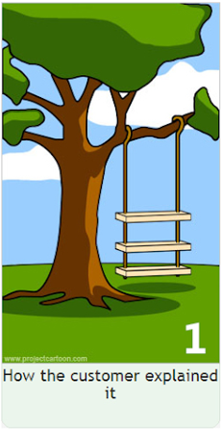
center h:500px

2-How the project leader understood it.
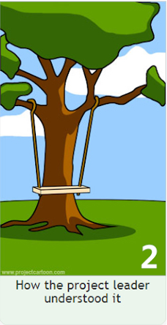
center h:500px

3- How the analyst designed it
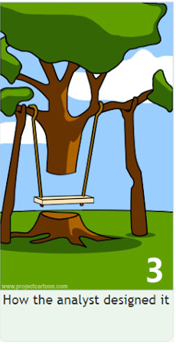
center h:500px

4-How the programmer wrote it
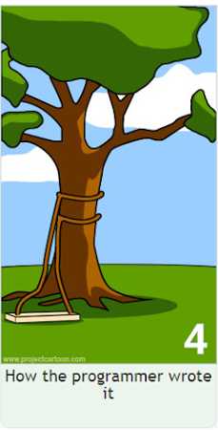
center h:500px

5-What the beta testers received
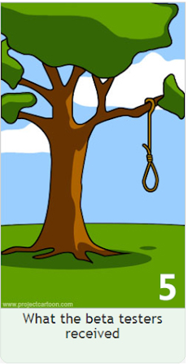
center h:500px

6-How the business consultant described it

center h:500px

7- How the project was documented
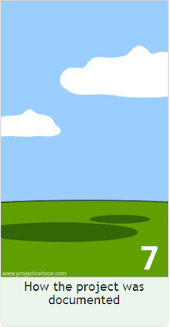
center h:500px

8-What operations installed
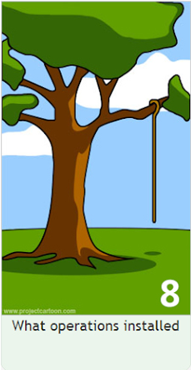
center h:500px

9-How the customer was billed
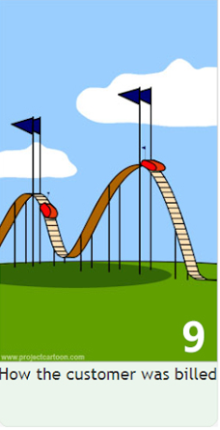
center h:500px

10-How it was supported

center h:500px

11-What marketing advertised

center h:500px

12-What the customer really needed
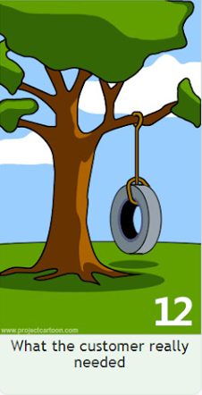
center h:500px

13-The disaster recover plan

center h:500px

14- What the digg effect can do to your site

center h:500px

15- (Finally) When it was delivered

center h:500px

Need for a good programming method
- Common problems
  - Why does it take so long?
  - Why are development costs so high?
  - Why can’t find all faults before delivery?
  - Why can’t we measure development?
NIST reported that even though 50 percent of software development budgets go to testing, flaws in software still cost the U.S. economy $59.5 billion annually.*
Updated NIST Software Uses Combination Testing to Catch Bugs Fast and Easy | NIST

What is Software Engineering? (1)
- The process of solving customers’ problems by the
  - systematic development and evolution of large,
  - high-quality software systems within
    - cost,
    - time and
    - other constraints

What is Software Engineering? (2)
- Solving customers’ problems
  - The goal
    - Sometimes the solution is to buy, not build
    - Adding unnecessary features often makes software worse
    - Software engineers must communicate effectively to identify and understand the problem

What is Software Engineering? (3)
- Systematic development and evolution
  - An engineering process involves applying well understood techniques in a organized and disciplined way
  - Many well-accepted practices have been formally standardized
    - e.g. by the IEEE or ISO
  - Most development work is evolution

What is Software Engineering? (4)
- Large, high quality software systems
  - Software engineering techniques are needed because large systems cannot be completely understood by one person
  - Teamwork and co-ordination are required
  - Key challenge: Dividing up the work and ensuring that the parts of the system work properly together
  - The end-product must be of sufficient quality

What is Software Engineering? (5)
- Cost, time and other constraints
  - Finite resources
  - The benefit must outweigh the cost
  - Others are competing to do the job cheaper and faster
  - Inaccurate estimates of cost and time have caused many project failures

The Software Engineering Profession
- The term Software Engineering was coined in 1968
  - People began to realize that the principles of engineering should be applied to software development
- Engineering is a licensed profession
  - In order to protect the public
  - Engineers design artifacts following well accepted practices which involve the application of science, mathematics and economics
  - Ethical practice is also a key tenet of the profession
- In many countries, much software engineering does not require an engineering licence, but is still engineering

Software Engineering Code of Ethics
- Software engineers shall
  - Act consistently with public interest
  - Act in the best interests of their clients
  - Develop and maintain with the highest standards possible
  - Maintain integrity and independence
  - Promote an ethical approach in management
  - Advance the integrity and reputation of the profession
  - Be fair and supportive to colleagues
  - Participate in lifelong learning

Software Quality
- Usability
  - Users can learn it and fast and get their job done easily
- Efficiency
  - It doesn’t waste resources such as CPU time and memory
- Reliability
  - It does what it is required to do without failing
- Maintainability
  - It can be easily changed
- Reusability
  - Its parts can be used in other projects, so reprogramming is not needed

Software Quality and Stakeholders
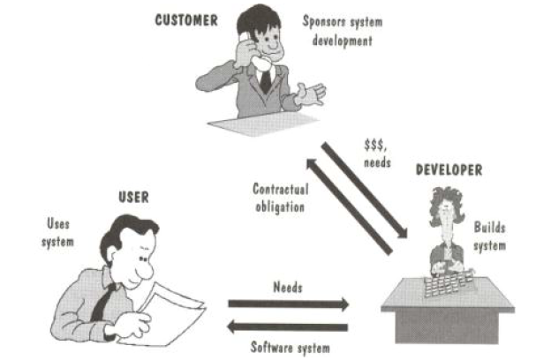
center h:500px

Software Quality and Stakeholders
- Customer (those who pay):
  - solves problems at an acceptable cost in terms of money paid and resources used
- User
  - easy to learn; efficient to use; helps get work done
- Developer
  - easy to design; easy to maintain; easy to reuse its parts
- Development manager
  - sells more and pleases customers while costing less to develop and maintain

Software Quality Metrics – User
- A program must do its job correctly. It must be useful and - usable
- A program must run as fast as necessary (Real-time constraints)
- A program must not waste system resources(processor time, - memory, disk capacity, network capacity) too much
- It must be reliable
- It must be easily updated
- A good software must have sufficient documentation (users manual)

Software Quality Metrics – SW Developer
- Source code must be readable and understandable
- It must be easy to maintain and update the program
- A program must consist of independent modules
- An error may not affect other parts of a program (Locality of errors)
- Modules of the program must be reusable in other projects
- A software project must meet its deadline
- Good software must have sufficient documentation

Software Quality Metrics - OOP
- OOP techniques ensure high-quality programs
- While designing and coding a program, these quality metrics must always be considered

Software Quality: Conflicts and Objectives
- The different qualities can conflict
  - Increasing efficiency can reduce maintainability or reusability
  - Increasing usability can reduce efficiency
- Setting objectives for quality is a key engineering activity
  - You then design to meet the objectives
  - Avoids “over-engineering” which wastes money

Software Engineering Projects
- Most projects are evolutionary or maintenance projects, involving work on legacy systems
  - Corrective projects: fixing defects
  - Adaptive projects: changing the system in response to changes in
    - Operating system
    - Database
    - Rules and regulations
  - Enhancement projects: adding new features for users
  - Reengineering or perfective projects: changing the system internally so it is more maintainable

Software Engineering Projects Start Points
Green Field Development | Brownfield Development
Start afresh | Build on existing code
Choose your technology | Technology already chosen
Use your best ideas, patterns, techniques | Understand previous developers’ code
Learn from mistakes | Live with mistakes

Software Engineering Projects Start Points
 | Requirements must be determined | Clients have produced requirements
New development, Green Field Project | A | B
Evolution of Existing System, Brown Field Project | C | D

Activities Common to Software Projects
- Requirements and specification
  - Includes
    - Domain analysis
    - Defining the problem
    - Requirements gathering
      - Obtaining input from as many sources as possible
    - Requirements analysis
      - Organizing the information
    - Requirements specification
      - Writing detailed instructions about how the software should behave

Activities Common to Software Projects
- Design
  - Deciding how the requirements should be implemented, using the available technology
  - Includes:
    - Systems engineering: Deciding what should be in hardware and what in software
    - Software architecture: Dividing the system into subsystems and deciding how the subsystems will interact
    - Detailed design of the internals of a subsystem
    - User interface design
    - Design of databases

Activities Common to Software Projects
- Modeling
  - Creating representations of the domain or the software
    - Use case modeling
    - Structural modeling
    - Dynamic and behavioural modeling
- Programming
- Quality assurance
  - Reviews and inspections
  - Testing
- Deployment
- Managing the process

Software Projects Development Team
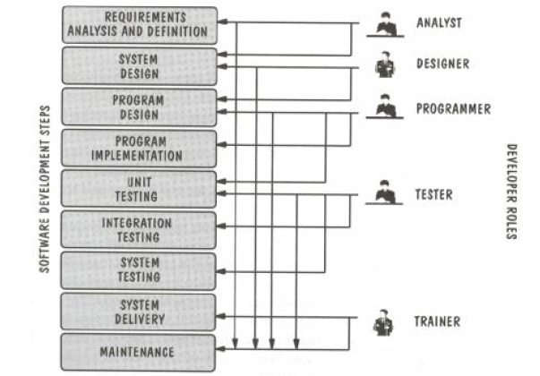
center h:500px

Software Life Cycle
- Requirements Phase
- Specification Phase
- Design Phase
- Implementation Phase
- Integration Phase
- Maintenance Phase
- Retirement Phase

Requirements Phase
- Defining constraints
  - Functions
  - Due dates
  - Costs
  - Reliability
  - Size
- Types
  - Functional
  - Non-Functional

Specification Phase
- Documentation of requirements
  - Inputs & Outputs
  - Formal
  - Understandable for user & developer
  - Usually functional requirements (what to do)
  - Base for testing & maintenance
- The contract between customer & developer

Design Phase
- Defining Internal structure (how to do)
- Has some levels (or types of docs)
  - Architectural design
  - Detailed design
- Important
  - To backtrack the aims of decisions
  - To easily maintain

Implementation and Integration Phases
- Implementation phase: Simply coding
  - Unit tests
    - For verification
- Combining modules
- System tests
  - For validation
- Quality tests

Maintenance Phase
- Corrective
- Enhancement
  - Perfective
  - Adaptive
- Usually maintainers are not the same people with developers.
- The only input is (in general) the source code of the software

Retirement Phase
- When the cost of maintenance is not effective.
  - Changes are so drastic, that the software should be redesigned.
- So many changes may have been made.
- The update frequency of docs is not enough.
- The hardware (or OS) will be changed.

Software Development Process
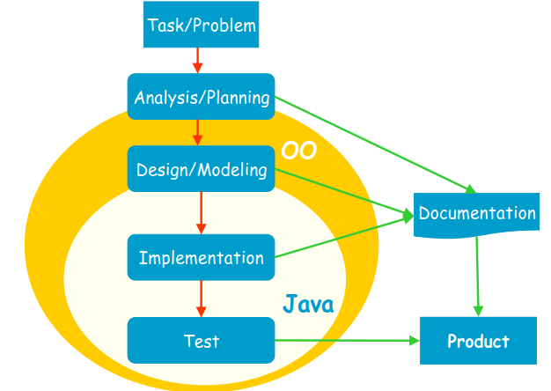
center h:500px

Software Development Process
- Analysis: Understanding requirements. They may change during (or after) development of the system! Building the programming team.
- Design: Identifying the key concepts involved in a solution and creation of the models.
  - This stage has a strong effect on the quality of the software. Therefore, before the coding, verification of the created model must be done.
  - Design process is connected with the programming scheme. Here, our design style is object-oriented.

Software Development Process
- Coding: The solution (model) is expressed in a program. In this course we will use Java.
- Documentation: Each phase of a software project must be clearly explained. A users manual should also be written.
- Test: the behavior of the program for possible inputs must be examined.
These steps are important design principles and design patterns, which help us developing high-quality software. The Unified Modeling Language (UML) is useful to express the model.

Unified Process (UP)
- The UP promotes several best practices.
  - Iterative
  - Incremental
  - Risk-driven

Unified Process (UP)
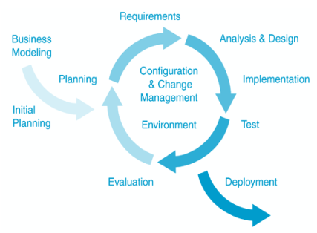
center h:500px

Unified Process (UP)
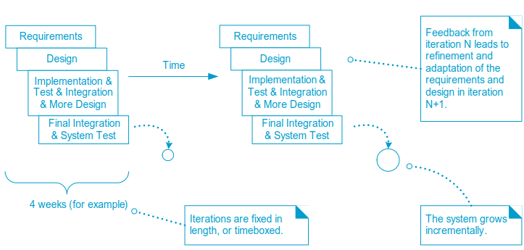
center h:500px

Takeaway: Software and Software Engineering
- Software is intangible, easy to modify but hard to engineer correctly
- The Tree Swing example shows why communication matters in SE projects
- Software quality has multiple stakeholders with potentially conflicting needs
- Software Life Cycle: Requirements -> Specification -> Design -> Implementation -> Maintenance -> Retirement
- Unified Process (UP) provides an iterative, incremental development framework

Module C: What is Object-Oriented Programming?

Module Outline
- OOP Concepts and the Four Pillars
- Procedural Programming and Its Problems
- OOP vs Procedural Programming: Side-by-Side Comparison
- Object Model and Paradigm Views
- Key Terminology

Object Orientation Part-1

OOP Concepts in Java
OOP stands for Object-Oriented Programming. OOP is a programming paradigm in which every program is follows the concept of object. In other words, OOP is a way of writing programs based on the object concept.
The object-oriented programming paradigm has the following core concepts.
- Encapsulation
- Inheritance
- Polymorphism
- Abstraction
The popular object-oriented programming languages are Smalltalk, C++, Java, PHP, C#, Python, etc.

Encapsulation
Encapsulation is the process of combining data and code into a single unit (object / class). In OOP, every object is associated with its data and code. In programming, data is defined as variables and code is defined as methods. The java programming language uses the class concept to implement encapsulation.

Encapsulation
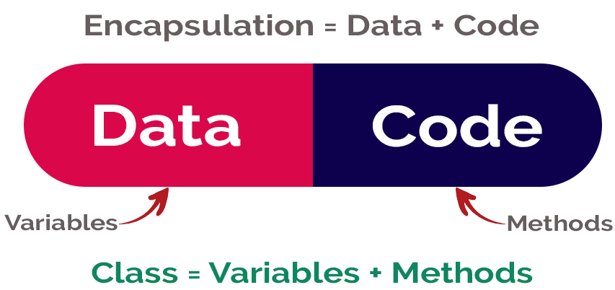
center h:400px

Inheritance
Inheritance is the process of acquiring properties and behaviors from one object to another object or one class to another class. In inheritance, we derive a new class from the existing class. Here, the new class acquires the properties and behaviors from the existing class. In the inheritance concept, the class which provides properties is called as parent class and the class which receives the properties is called as child class. The parent class is also known as base class or super class. The child class is also known as derived class or sub class.
In the inheritance, the properties and behaviors of base class extended to its derived class, but the base class never receive properties or behaviors from its derived class.
In java programming language the keyword extends is used to implement inheritance.

Inheritance
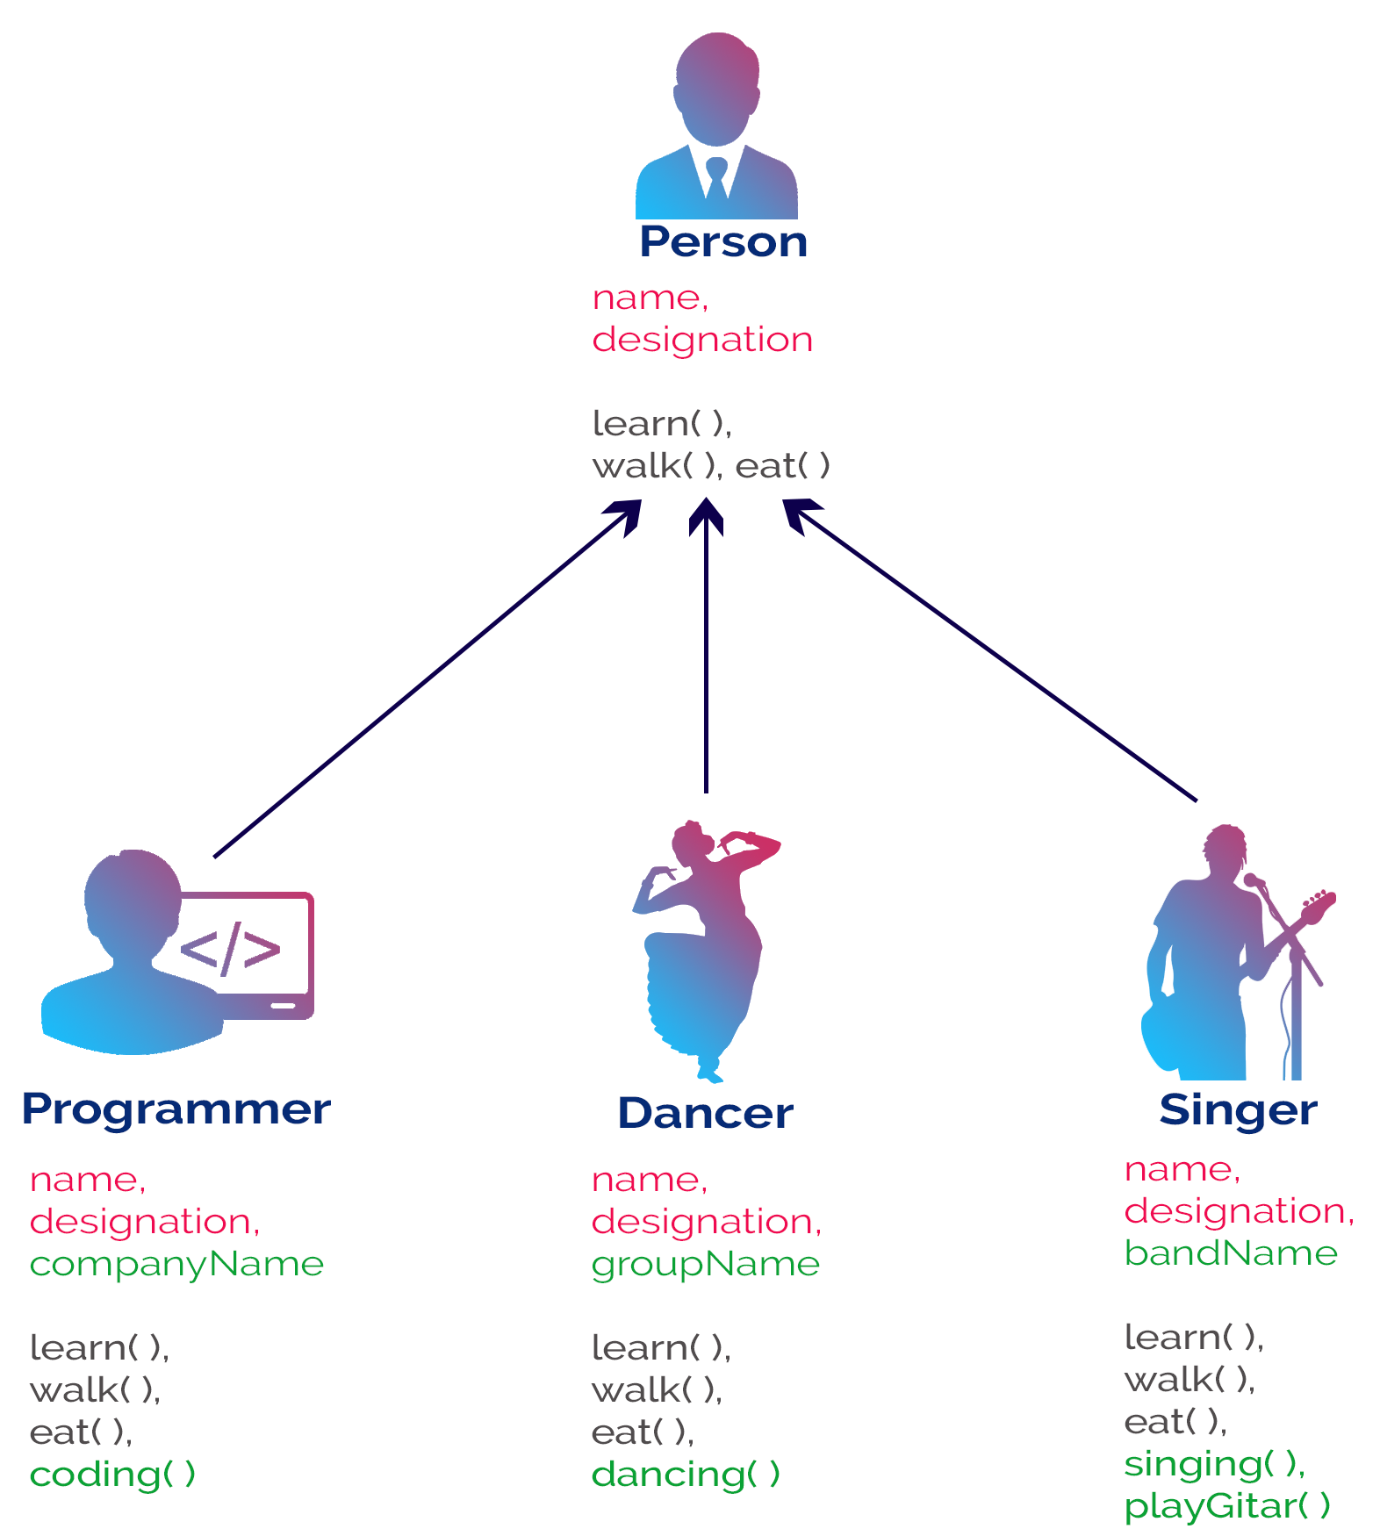
bg right:50% h:700px

Polymorphism
Polymorphism is the process of defining same method with different implementation. That means creating multiple methods with different behaviors.
The java uses method overloading and method overriding to implement polymorphism.
Method overloading - multiple methods with same name but different parameters.
Method overriding - multiple methods with same name and same parameters.

Polymorphism
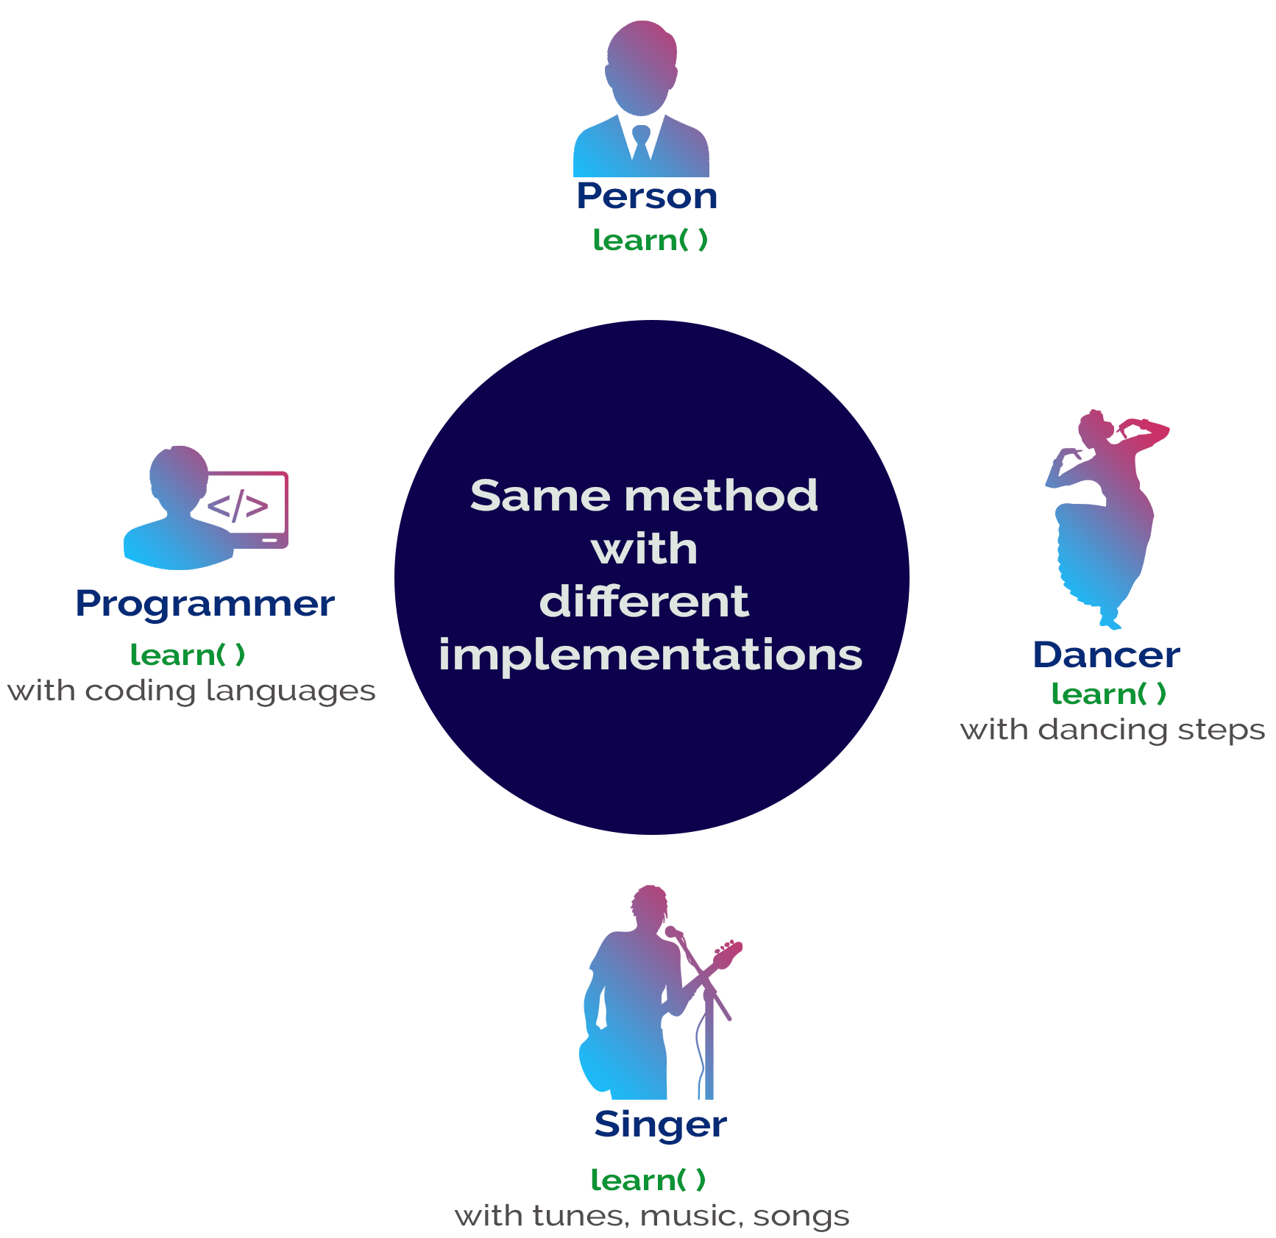
bg right:50% h:700px

Abstraction
Abstraction is hiding the internal details and showing only esential functionality. In the abstraction concept, we do not show the actual implemention to the end user, instead we provide only esential things. For example, if we want to drive a car, we does not need to know about the internal functionality like how wheel system works? how brake system works? how music system works? etc.

Abstraction
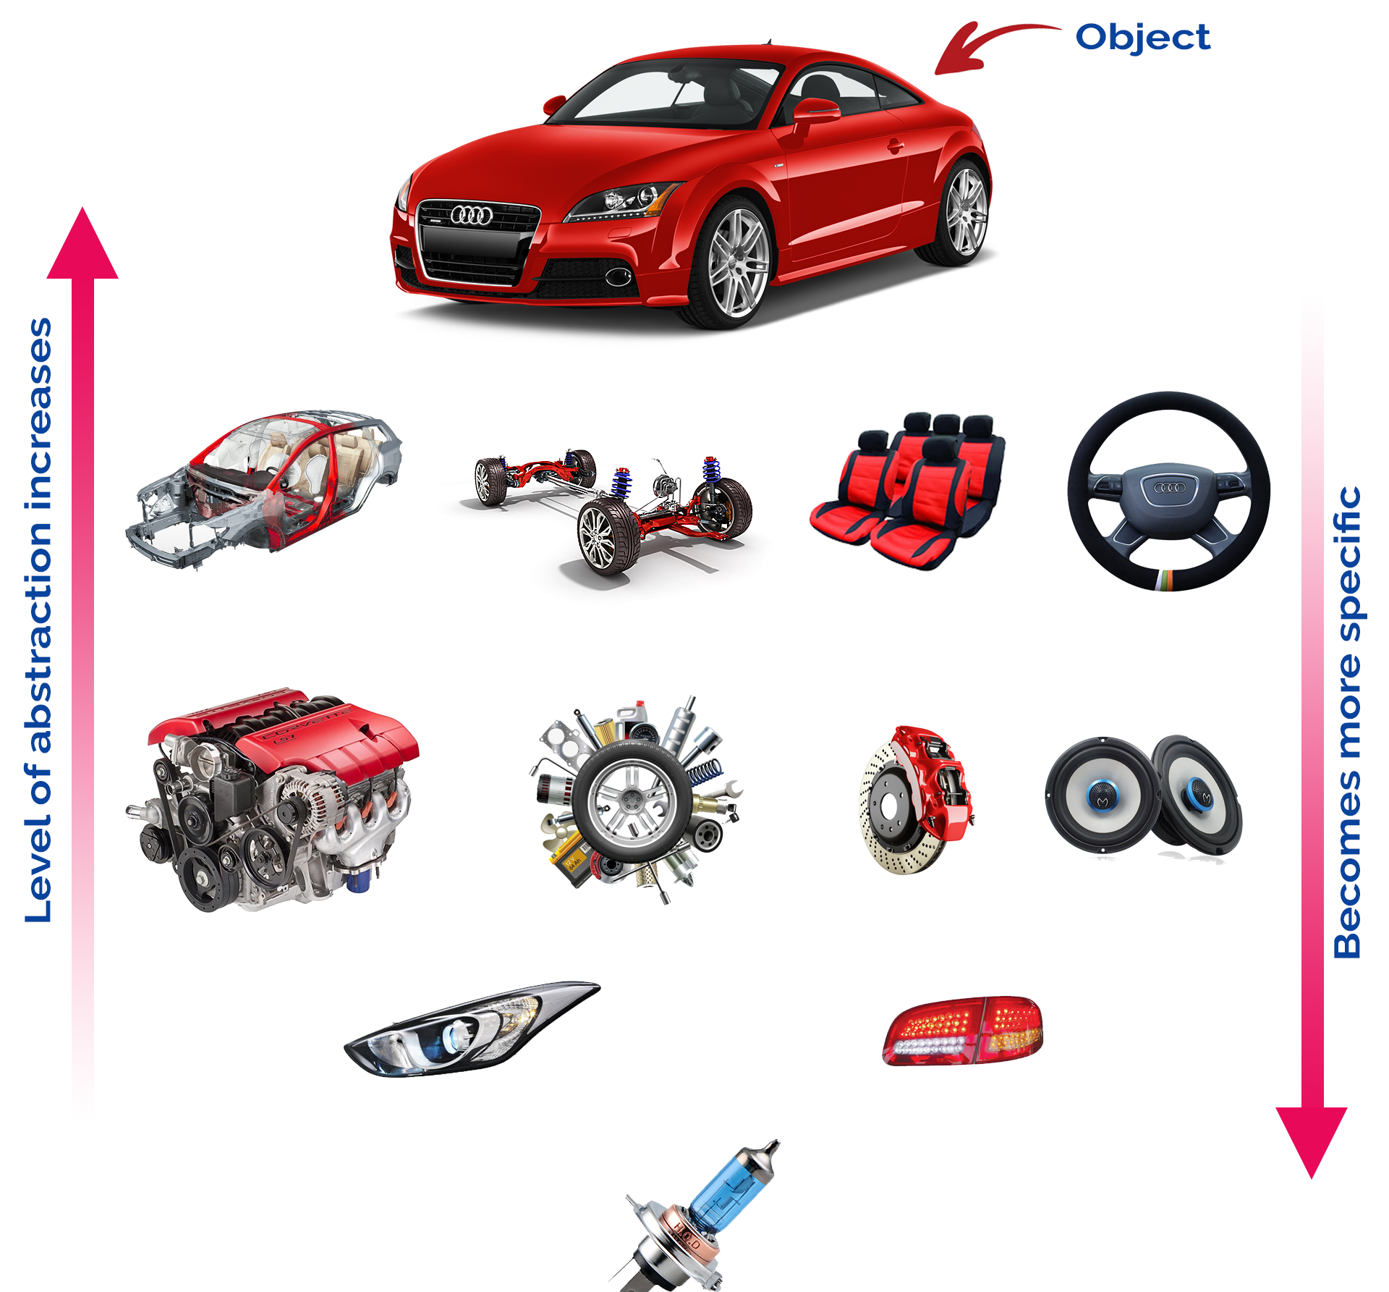
bg right:50% h:600px

Why Object Technology
- Expectations are,
- Reducing the effort, complexity, and cost of development and maintenance of software systems.
- Reducing the time to adapt an existing system (quicker reaction to changes in the business environment): Flexibility, reusability.
- Increasing the reliability of the system.

Object Orientation Part-2

Procedural Programming
- Pascal, C, Basic, Fortran and similar traditional languages are procedural
  - Each statement tells the computer to do something
- The emphasis is on doing things
  - Functions
- A program is divided into functions
  - Each function has a clearly defined purpose and interface

Procedural Programming
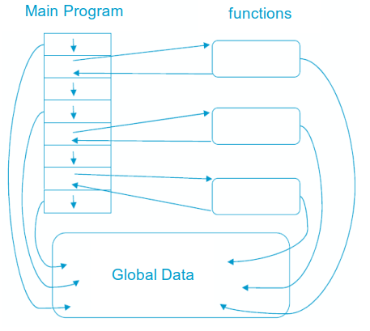
center h:500px

Problems with Procedural Programming
- Data Is undervalued
- Data is, after all, the reason for a program’s existence. The important parts of a program are not functions that display the data or functions that checks for correct input; they are data
- Procedural programs don’t model the real world very well. The real world does not consist of functions
- Global data can be corrupted by functions that have no business changing it
- To add new data items, all the functions that access data must be modified so that they can also access these new items
- Creating new data types is difficult

Besides
- It is also possible to write good programs by using procedural programming (C programs).
- But object-oriented programming offers programmers many advantages, enables them to write high-quality programs

Object-Oriented Programming
The fundamental idea behind object-oriented programming:
- The real world consists of objects. Computer programs may contain computer world representations of the things (objects) that constitute the solutions of real world problems.
- Real world objects have two parts:
  - Properties (or state: characteristics that can change),
  - Behavior (or abilities: things they can do).
- To solve a programming problem in an object-oriented language,the programmer no longer asks how the problem will be divided into functions, but how it will be divided into objects.
- The emphasis is on data

Object-Oriented Programming
- What kinds of things become objects in object-oriented programs?
  - Human entities: Employees, customers, salespeople,worker, manager
  - Graphics program: Point, line, square, circle, …
  - Mathematics: Complex numbers, matrix
  - Computer user environment: Windows, menus, buttons
  - Data-storage constructs: Customized arrays, stacks, linked lists

Object Model
A Java program typically consists of a number of objects that communicate with each other by calling one another’s member functions.
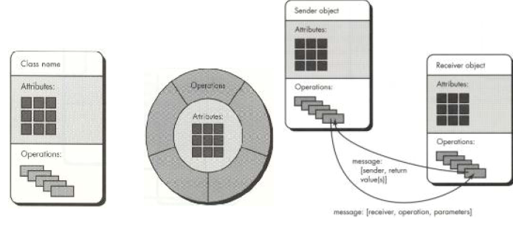
center h:400px

OOP vs. Procedural Programming
- Procedural languages still require you to think in terms of the structure of the computer rather than the structure of the problem you are trying to solve.
- The programmer must establish the association between the machine model and the model of the problem that is actually being solved.
- The effort required to perform this mapping produces programs that are difficult to write and expensive to maintain. Because the real world thing and their models on the computer are quite different

Example: Procedural Programming
- Real world thing: student
- Computer model: char *, int, float
- It is said that the C language is closer to the computer than the problem.

OOP vs. Procedural Programming
- The OO approach provides tools for the programmer to represent elements in the problem space
- Objects are both in the problem space and the solution
- The OO programs are easy to update by adding new types of objects
- OOP allows you to describe the problem in terms of the problem, rather than in terms of the computer where the solution will run.

OOP vs. Procedural Programming
Benefits of the object-oriented programming:
- Readability
- Understandability
- Low probability of errors
- Maintenance
- Reusability
- Teamwork

OOP vs. Procedural Programming
- Procedural paradigm:
  - Software is organized around the notion of procedures
  - Procedural abstraction
    - Works as long as the data is simple
- Adding data abstractions groups together the pieces of data that describe some entity
  - Helps reduce the system’s complexity.
    - Such as Records and structures
- Object oriented paradigm:
  - Organizing procedural abstractions in the context of data abstractions

Object Oriented paradigm
- All computations are performed in the context of objects.
  - The objects are instances of classes, which:
    - are data abstractions
    - contain procedural abstractions that operate on the objects
  - A running program can be seen as a collection of objects collaborating to perform a given task

A View of the Two paradigms
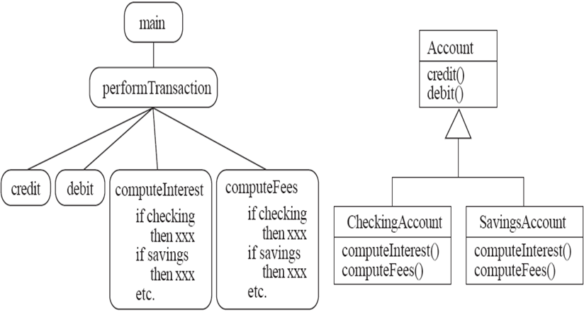
center h:400px

Key Terminology
- Abstraction
  - Object $⇒$ something in the world
  - Class $⇒$ objects
  - Superclass $⇒$ subclasses
  - Operation $⇒$ methods
  - Attributes and associations $⇒$ instance variables
- Modularity
  - Code is divided into classes, and classes into methods
- Encapsulation
  - Details can be hidden in classes
  - This gives rise to information hiding:
    - Programmers do not need to know all the details of a class

Takeaway: What is OOP?
- OOP models real-world entities as objects with state (fields) and behavior (methods)
- Four pillars: Encapsulation, Inheritance, Polymorphism, Abstraction
- Procedural programming focuses on functions; OOP focuses on objects
- OOP reduces complexity, improves reusability, and supports team development
- Key terms: Class, Object, Message, Method, Instance Variable, Generalization, Specialization

Module D: Introduction to Java

Module Outline
- What is Programming? Why Java?
- Java Buzz Words and Features
- Java Basics Overview (Types, Strings, Arrays, Casting, Exceptions)
- Programming Style Guidelines
- C++ vs Java Comparison

What is Programming?
- A programming language provides a way to express concepts.
- Program development involves creating models of real world - situations and building computer programs based on these models.
- Computer programs describe the method of implementing the model.
- Computer programs may contain computer world representations of the things that constitute the solutions of real world problems.

What is Programming?
If successful, this medium of expression (the object-oriented way) will be significantly easier, more flexible, and efficient than the alternatives as problems grow larger and more complex
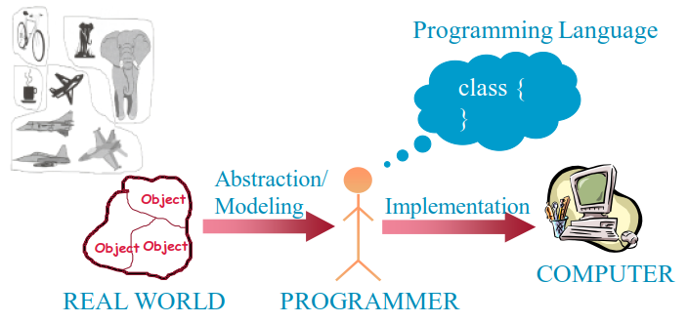
center h:400px

Why JAVA
- Java supports writing high quality programs (pure OO)
- Provides an easy-to-use language
- Provides an interpreted environment for
  - Improved development speed
  - Code portability
- Simple
- Architecture Neutral and Portable
- Robust and Secure
- High Performance

Why JAVA
- Write less code
  - can be four times smaller than the same program written in C++
- Write better code
  - encourages good coding practices, garbage collection for avoiding memory leaks, wide-ranging, easily extendible API
- Avoid platform dependencies
- Write once, run anywhere
- Gained popularity in gadgets such as
  - PDAs, cell phones etc.

Learning JAVA
- Many syntax and grammar rules
- Learning how to write “good programs”
- Focusing on concepts and not get lost in language-technical - details
- Paying attention to design techniques rather than details
- Building an effective programming scheme
- Practicing, practicing and practicing!
- Consequently, new and better ways of building systems

Java Buzz Words
- Simple
- Secure
- Portable
- Object-oriented
- Robust
- Architecture-neutral (or) Platform Independent
- Multi-threaded
- Interpreted
- High performance
- Distributed
- Dynamic

Simple
Java programming language is very simple and easy to learn, understand, and code. Most of the syntaxes in java follow basic programming language C and object-oriented programming concepts are similar to C++. In a java programming language, many complicated features like pointers, operator overloading, structures, unions, etc. have been removed. One of the most useful features is the garbage collector it makes java more simple.

Secure
Java is said to be more secure programming language because it does not have pointers concept, java provides a feature “applet” which can be embedded into a web application. The applet in java does not allow access to other parts of the computer, which keeps away from harmful programs like viruses and unauthorized access.

Portable
Portability is one of the core features of java which enables the java programs to run on any computer or operating system. For example, an applet developed using java runs on a wide variety of CPUs, operating systems, and browsers connected to the Internet.

Object-oriented
Java is said to be a pure object-oriented programming language. In java, everything is an object. It supports all the features of the object-oriented programming paradigm. The primitive data types java also implemented as objects using wrapper classes, but still, it allows primitive data types to archive high-performance.

Robust
Java is more robust because the java code can be executed on a variety of environments, java has a strong memory management mechanism (garbage collector), java is a strictly typed language, it has a strong set of exception handling mechanism, and many more.

Architecture-neutral (or) Platform Independent
Java has invented to archive “write once; run anywhere, any time, forever”. The java provides JVM (Java Virtual Machine) to to archive architectural-neutral or platform-independent. The JVM allows the java program created using one operating system can be executed on any other operating system.

Multi-threaded
Java supports multi-threading programming, which allows us to write programs that do multiple operations simultaneously.

Interpreted
Java enables the creation of cross-platform programs by compiling into an intermediate representation called Java bytecode. The byte code is interpreted to any machine code so that it runs on the native machine.

High performance
Java provides high performance with the help of features like JVM, interpretation, and its simplicity.

Distributed
Java programming language supports TCP/IP protocols which enable the java to support the distributed environment of the Internet. Java also supports Remote Method Invocation (RMI), this feature enables a program to invoke methods across a network.

Dynamic
Java is said to be dynamic because the java byte code may be dynamically updated on a running system and it has a dynamic memory allocation and deallocation (objects and garbage collector).

The Basics of Java
History
- The first object oriented programming language was Simula-67
  - designed to allow programmers to write simulation programs
- In the early 1980’s, Smalltalk was developed at Xerox PARC
  - New syntax, large open-source library of reusable code, bytecode, platform independence, garbage collection.

The Basics of Java
- late 1980’s, C++ was developed by B. Stroustrup,
  - Recognized the advantages of OO but also recognized that there were tremendous numbers of C programmers
- In 1991, engineers at Sun Microsystems started a project to design a language that could be used in consumer ‘smart devices’: Oak
  - When the Internet gained popularity, Sun saw an opportunity to exploit the technology.
  - The new language, renamed Java, was formally presented in 1995 at the SunWorld ’95 conference.

Java documentation
- Looking up classes and methods is an essential skill
  - Looking up unknown classes and methods will get you a long way towards understanding code
- Java documentation can be automatically generated by a program called Javadoc
  - Documentation is generated from the code and its comments
  - You should format your comments as shown in some of the book’s examples
    - These may include embeded html

Characters and Strings
- Character is a class representing Unicode characters
  - More than a byte each
  - Represent any world language
- char is a primitive data type containing a Unicode character
- String is a class containing collections of characters
- + is the operator used to concatenate strings

Arrays and Collections
- Arrays are of fixed size and lack methods to manipulate them
- ArrayList is the most widely used class to hold a collection of other objects
  - More powerful than arrays, but less efficient
- Iterators are used to access members of Vectors
  - Enumerations were formally used, but were more complex
Java linenums="1" hl_lines="2 3 5" a = new ArrayList(); Iterator i = a.iterator(); while(i.hasNext()) { aMethod(i.next()); }

Casting
- Java is very strict about types
  - If variable v is declared to have type X, you can only invoke operations on v that are defined in X or its superclasses
    - Even though an instance of a subclass of X may be actually stored in the variable
  - If you know an instance of a subclass is stored, then you can cast the variable to the subclass
    - E.g. if I know a Vector contains instances of String, I can get the next element of its Iterator using: (String)i.next();
    - To avoid casting you could also have used templates:: a = ArrayList<String>; i=a.iterator(); i.next()

Exceptions
- Anything that can go wrong should result in the raising of an Exception
  - Exception is a class with many subclasses for specific things that can go wrong
- Use a try - catch block to trap an exception
Java linenums="1" try { // some code } catch (ArithmeticException e) { // code to handle division by zero }

Interfaces
- Like abstract classes, but cannot have executable statements
  - Define a set of operations that make sense in several classes
  - Abstract Data Types
- A class can implement any number of interfaces
  - It must have concrete methods for the operations
- You can declare the type of a variable to be an interface
  - This is just like declaring the type to be an abstract class
- Important interfaces in Java’s library include
  - Runnable, Collection, Iterator, Comparable, Cloneable

Packages and importing
- A package combines related classes into subsystems
  - All the classes in a particular directory
- Classes in different packages can have the same name
  - Although not recommended
- Importing a package is done as follows:
  - import finance.banking.accounts.*;

Access control
- Applies to methods and variables
  - public
    - Any class can access
  - protected
    - Only code in the package, or subclasses can access
  - (blank)
    - Only code in the package can access
  - private
    - Only code written in the class can access
    - Inheritance still occurs!

Threads and concurrency
- Thread:
  - Sequence of executing statements that can be running concurrently with other threads
- To create a thread in Java:
  - Create a class implementing Runnable or extending Thread
  - Implement the run method as a loop that does something for a period of time
  - Create an instance of this class
  - Invoke the start operation, which calls run

Programming Style Guidelines
- Remember that programs are for people to read
  - Always choose the simpler alternative
  - Reject clever code that is hard to understand
  - Shorter code is not necessarily better
- Choose good names
  - Make them highly descriptive
  - Do not worry about using long names

Programming style
- Comment extensively
  - Comment whatever is non-obvious
  - Do not comment the obvious
  - Comments should be 25-50% of the code
- Organize class elements consistently
  - Variables, constructors, public methods then private methods
- Be consistent regarding layout of code

Programming style
- Avoid duplication of code
  - Do not “clone” if possible
    - Create a new method and call it
    - Cloning results in two copies that may both have bugs
      - When one copy of the bug is fixed, the other may be forgotten

Programming style
- Adhere to good object oriented principles
  - E.g. the ‘isa rule’
- Prefer private as opposed to public
- Do not mix user interface code with non-user interface code
  - Interact with the user in separate classes
    - This makes non-UI classes more reusable

Difficulties and Risks in Programming
- Language evolution and deprecated features:
  - Java is evolving, so some features are ‘deprecated’ at every release
- Efficiency can be a concern in some object oriented systems
  - Java can be less efficient than other languages
    - VM-based
    - Dynamic binding

C++ vs Java
Comparison Index | C++ | Java
Platform-independent | C++ is platform-dependent. | Java is platform-independent.
Mainly used for | C++ is mainly used for system programming. | Java is mainly used for application programming. It is widely used in Windows-based, web-based, enterprise, and mobile applications.

C++ vs Java
Comparison Index | C++ | Java
Multiple inheritance | C++ supports multiple inheritance. | Java doesn’t support multiple inheritance through class. It can be achieved by using interfaces in java.
Operator Overloading | C++ supports operator overloading. | Java doesn’t support operator overloading.

C++ vs Java
Comparison Index | C++ | Java
Goto | C++ supports the goto statement. | Java doesn’t support the goto statement.
Compiler and Interpreter | C++ uses compiler only. C++ is compiled and run using the compiler which converts source code into machine code so, C++ is platform dependent. | Java uses both compiler and interpreter. Java source code is converted into bytecode at compilation time. The interpreter executes this bytecode at runtime and produces output. Java is interpreted that is why it is platform-independent.

C++ vs Java
Comparison Index | C++ | Java
Pointers | C++ supports pointers. You can write a pointer program in C++. | Java supports pointer internally. However, you can’t write the pointer program in java. It means java has restricted pointer support in java.
Design Goal | C++ was designed for systems and applications programming. It was an extension of the C programming language. | Java was designed and created as an interpreter for printing systems but later extended as a support network computing. It was designed to be easy to use and accessible to a broader audience.

C++ vs Java
Comparison Index | C++ | Java
Structure and Union | C++ supports structures and unions. | Java doesn’t support structures and unions.
Thread Support | C++ doesn’t have built-in support for threads. It relies on third-party libraries for thread support. | Java has built-in thread support.

C++ vs Java
Comparison Index | C++ | Java
Documentation comment | C++ doesn’t support documentation comments. | Java supports documentation comment (/** … */) to create documentation for java source code.
Virtual Keyword | C++ supports virtual keyword so that we can decide whether or not to override a function. | Java has no virtual keyword. We can override all non-static methods by default. In other words, non-static methods are virtual by default.

C++ vs Java
Comparison Index | C++ | Java
unsigned right shift >>> | C++ doesn’t support >>> operator. | Java supports unsigned right shift >>> operator that fills zero at the top for the negative numbers. For positive numbers, it works same like >> operator.
Inheritance Tree | C++ always creates a new inheritance tree. | Java always uses a single inheritance tree because all classes are the child of the Object class in Java. The Object class is the root of the inheritance tree in java.

C++ vs Java
Comparison Index | C++ | Java
Hardware | C++ is nearer to hardware. | Java is not so interactive with hardware.
Object-oriented | C++ is an object-oriented language. However, in the C language, a single root hierarchy is not possible. | Java is also an object-oriented language. However, everything (except fundamental types) is an object in Java. It is a single root hierarchy as everything gets derived from java.lang.Object.

Takeaway: Introduction to Java
- Java is platform-independent, object-oriented, and strongly typed
- Key features: Simple, Secure, Portable, Robust, Multi-threaded, Dynamic
- Java vs C++: No pointers, automatic garbage collection, no multiple class inheritance
- Good programming style: meaningful names, consistent indentation, clear comments
- Java ecosystem: JDK, JRE, JVM, javadoc

Module E: Java Classes and Objects

Module Outline
- Conceptual Understanding: Classes, Objects, and Variables
- UML Instance Diagrams and Naming Conventions
- Java Class Definition and Syntax
- Creating Objects in Java
- Accessing Members and Practical Examples

Classes and Objects
Object
- A chunk of structured data in a running software system
- Has properties
  - Represent its state
- Has behaviour
  - How it acts and reacts
  - May simulate the behaviour of an object in the real world

Objects: Shown as a UML instance diagram
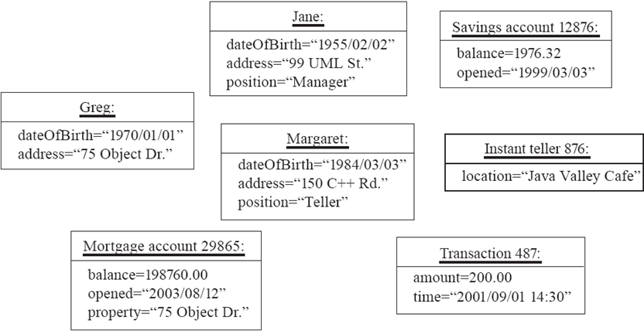
center h:400px

Classes
A class:
- A unit of abstraction in an object oriented (OO) program
- Represents similar objects
  - Its instances
- A kind of software module
  - Describes its instances’ structure (properties)
  - Contains methods to implement their behaviour

Is Something a Class or an Instance?
- Something should be a class if it could have instances
- Something should be an instance if it is clearly a single member of the set defined by a class
- Film
  - Class; instances are individual films.
- Reel of Film:
  - Class; instances are physical reels
- Film reel with serial number SW19876
  - Instance of ReelOfFilm

Is Something a Class or an Instance?
- Science Fiction
  - Instance of the class Genre.
- Science Fiction Film
  - Class; instances include ‘Star Wars’
- Showing of ‘Star Wars’ in the Phoenix Cinema at 7 p.m.:
  - Instance of ShowingOfFilm

Naming classes
- Use capital letters
  - E.g. BankAccount not bankAccount
- Use singular nouns
- Use the right level of generality
  - E.g. Municipality, not City
- Make sure the name has only one meaning
  - E.g. “bus” has several meanings

Instance Variables
- Variables defined inside a class corresponding to data present in each instance
  - Also called fields or member variables
  - Attributes
    - Simple data
    - E.g. name, dateOfBirth
  - Associations
    - Relationships to other important classes
    - E.g. supervisor, coursesTaken

Variables vs. Objects
- A variable
  - Refers to an object
  - May refer to different objects at different points in time
- An object can be referred to by several different variables at the same time
- Type of a variable
  - Determines what classes of objects it may contain

Class variables
- A class variable’s value is shared by all instances of a class.
  - Also called a static variable
  - If one instance sets the value of a class variable, then all the other instances see the same changed value.
  - Class variables are useful for:
    - Default or ‘constant’ values (e.g. PI)
    - Lookup tables and similar structures
Caution: do not over-use class variables

Java Classes and Objects

Java Classes
Java is an object-oriented programming language, so everything in java program must be based on the object concept. In a java programming language, the class concept defines the skeleton of an object.

Java Classes
The java class is a template of an object. The class defines the blueprint of an object. Every class in java forms a new data type. Once a class got created, we can generate as many objects as we want. Every class defines the properties and behaviors of an object. All the objects of a class have the same properties and behaviors that were defined in the class.

Java Classes
Every class of java programming language has the following characteristics.
- Identity - It is the name given to the class.
- State - Represents data values that are associated with an object.
- Behavior - Represents actions can be performed by an object.

Java Classes
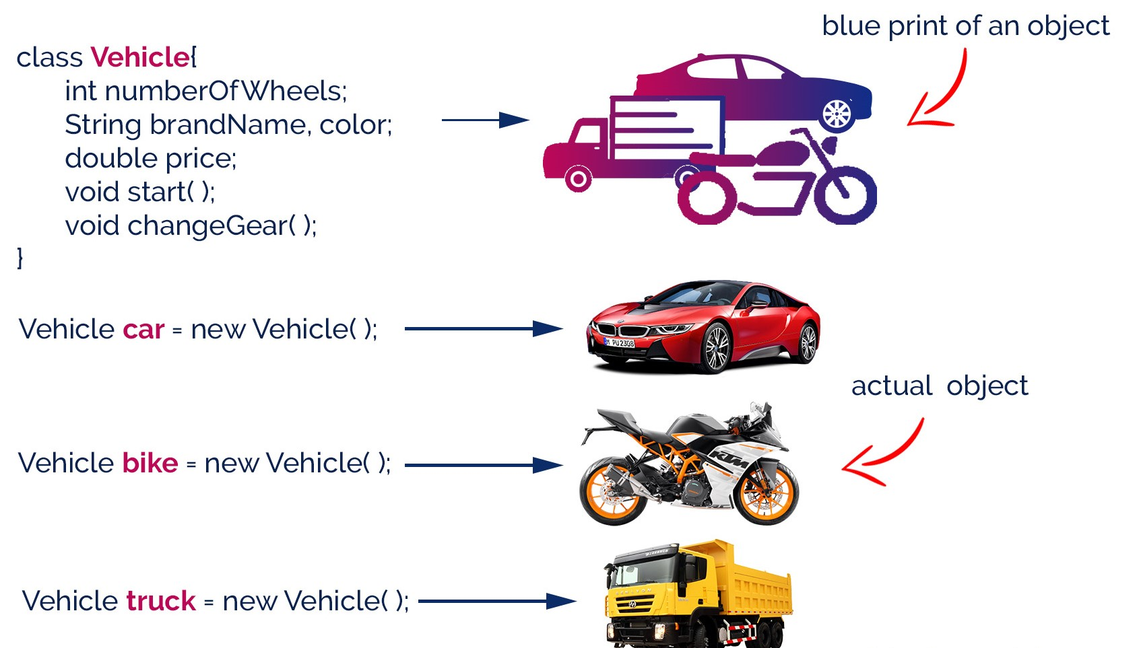
center h:500px

Creating a Class
In java, we use the keyword class to create a class. A class in java contains properties as variables and behaviors as methods. Following is the syntax of class in the java.
Java linenums="1" class <ClassName>{ data members declaration; methods defination; }
Here, fields (variables) and methods represent the state and behavior of the object respectively.
- fields are used to store data
- methods are used to perform some operations

Creating a Class
- A class is a blueprint for the object. Before we create an object, we first need to define the class.
- We can think of the class as a sketch (prototype) of a house. It contains all the details about the floors, doors, windows, etc. Based on these descriptions we build the house. House is the object.
- Since many houses can be made from the same description, we can create many objects from a class.

Creating a Class
- The ClassName must begin with an alphabet, and the Upper-case letter is preferred.
- The ClassName must follow all naming rules.

Creating a Class
``` Java linenums=“1” class Bicycle {
// state or field private int gear = 5;
// behavior or method public void braking() { System.out.println(“Working of Braking”); } }
In the above example, we have created a class named Bicycle. It contains a field named gear and a method named braking().
---
### Creating a Class
Here, Bicycle is a prototype. Now, we can create any number of bicycles using the prototype. And, all the bicycles will share the fields and methods of the prototype.
---
### Creating an Object
In java, an object is an instance of a class. When an object of a class is created, the class is said to be instantiated. All the objects that are created using a single class have the same properties and methods. But the value of properties is different for every object. Following is the syntax of class in the java.
``` Java linenums="1"
<ClassName> <objectName> = new <ClassName>( );

Creating an Object
- The objectName must begin with an alphabet, and a Lower-case letter is preferred.
- The objectName must follow all naming rules.

Creating an Object
An object is called an instance of a class. For example, suppose Bicycle is a class then MountainBicycle, SportsBicycle, TouringBicycle, etc can be considered as objects of the class.
``` Java linenums=“1” className object = new className();
// for Bicycle class Bicycle sportsBicycle = new Bicycle();
Bicycle touringBicycle = new Bicycle();
We have used the new keyword along with the constructor of the class to create an object. Constructors are similar to methods and have the same name as the class. For example, Bicycle() is the constructor of the Bicycle class.
---
### Creating an Object
Here, sportsBicycle and touringBicycle are the names of objects. We can use them to access fields and methods of the class.
---
### Access Members of a Class
sportsBicycle.gear - access the field gear
sportsBicycle.braking() - access the method braking()
``` Java linenums="1"
class Bicycle {
// field of class
int gear = 5;
// method of class
void braking() {
...
}
}
// create object
Bicycle sportsBicycle = new Bicycle();
// access field and method
sportsBicycle.gear;
sportsBicycle.braking();

Example: Java Class and Objects
``` Java linenums=“1” class Lamp {
// stores the value for light // true if light is on // false if light is off boolean isOn;
// method to turn on the light void turnOn() { isOn = true; System.out.println(“Light on?” + isOn);
}
// method to turnoff the light void turnOff() { isOn = false; System.out.println(“Light on?” + isOn); } }
---
### Example: Java Class and Objects
``` Java linenums="1"
class Main {
public static void main(String[] args) {
// create objects led and halogen
Lamp led = new Lamp();
Lamp halogen = new Lamp();
// turn on the light by
// calling method turnOn()
led.turnOn();
// turn off the light by
// calling method turnOff()
halogen.turnOff();
}
}

Example: Create objects inside the same class
Note that in the previous example, we have created objects inside another class and accessed the members from that class.
However, we can also create objects inside the same class.

Example: Create objects inside the same class
``` Java linenums=“1” class Lamp {
// stores the value for light // true if light is on // false if light is off boolean isOn;
// method to turn on the light void turnOn() { isOn = true; System.out.println(“Light on?” + isOn);
}
public static void main(String[] args) {
// create an object of Lamp
Lamp led = new Lamp();
// access method using object
led.turnOn();
} }
---
### Takeaway: Java Classes and Objects
- A class is a blueprint/template that defines properties and behaviors
- An object is a specific instance of a class, created with the 'new' keyword
- Instance variables hold per-object state; class variables (static) are shared
- UML instance diagrams visualize objects and their relationships
- Access members using the dot (.) operator: object.field, object.method()
---
## **Module F: Java Methods and Method Overloading**
---
### Module Outline
- Defining and Calling Methods
- Method Parameters, Return Types, and Variable Arguments
- Static vs Instance Methods
- Method Overloading: Same Name, Different Parameters
---
## **Java Methods**
---
### Java Methods
A method is a block of statements under a name that gets executes only when it is called. Every method is used to perform a specific task. The major advantage of methods is code re-usability (define the code once, and use it many times).
---
### Java Methods
In a java programming language, a method defined as a behavior of an object. That means, every method in java must belong to a class.
Every method in java must be declared inside a class.
---
### Java Methods
Every method declaration has the following characteristics.
- **returnType** - Specifies the data type of a return value.
- **name** - Specifies a unique name to identify it.
- **parameters** - The data values it may accept or recieve.
- **{ }** - Defienes the block belongs to the method.
---
### Creating a method
A method is created inside the class and it may be created with any access specifier. However, specifying access specifier is optional.
Following is the syntax for creating methods in java.
``` Java linenums="1"
class <ClassName>{
<accessSpecifier> <returnType> <methodName>( parameters ){
...
block of statements;
...
}
}

Creating a method
Java linenums="1" modifier static returnType nameOfMethod (parameter1, parameter2, ...) { // method body }
modifier - It defines access types whether the method is public, private, and so on. static - If we use the static keyword, it can be accessed without creating objects.

Creating a method
- The methodName must begin with an alphabet, and the Lower-case letter is preferred.
- The methodName must follow all naming rules.
- If you don’t want to pass parameters, we ignore it.
- If a method defined with return type other than void, it must contain the return statement, otherwise, it may be ignored.

Calling a method
In java, a method call precedes with the object name of the class to which it belongs and a dot operator. It may call directly if the method defined with the static modifier. Every method call must be made, as to the method name with parentheses (), and it must terminate with a semicolon.
Java linenums="1" <objectName>.<methodName>( actualArguments );

Calling a method
- The method call must pass the values to parameters if it has.
- If the method has a return type, we must provide the receiver.

Calling a Method : Example
``` Java linenums=“1” import java.util.Scanner; public class JavaMethodsExample { int sNo; String name; Scanner read = new Scanner(System.in);
void readData() {
System.out.print("Enter Serial Number: ");
sNo = read.nextInt();
System.out.print("Enter the Name: ");
name = read.next();
}
static void showData(int sNo, String name) {
System.out.println("Hello, " + name + "! your serial number is " + sNo);
}
…
---
### Calling a Method : Example
``` Java linenums="1"
...
public static void main(String[] args) {
JavaMethodsExample obj = new JavaMethodsExample();
obj.readData(); // method call using object
showData(obj.sNo, obj.name); // method call without using object
}
}

Variable arguments of a method
In java, a method can be defined with a variable number of arguments. That means creating a method that receives any number of arguments of the same data type.
Java linenums="1" <returnType> <methodName>(dataType...parameterName);

Variable arguments of a method : Example
``` Java linenums=“1” public class JavaMethodWithVariableArgs {
void display(int...list) {
System.out.println("\nNumber of arguments: " + list.length);
for(int i : list) {
System.out.print(i + "\t");
}
}
…
---
### Variable arguments of a method : Example
``` Java linenums="1"
...
public static void main(String[] args) {
JavaMethodWithVariableArgs obj = new JavaMethodWithVariableArgs();
obj.display(1, 2);
obj.display(10, 20, 30, 40, 50);
}
}

Java Normal Method Example
``` Java linenums=“1” class Main {
// create a method public int addNumbers(int a, int b) { int sum = a + b; // return value return sum; }
public static void main(String[] args) {
int num1 = 25;
int num2 = 15;
// create an object of Main
Main obj = new Main();
// calling method
int result = obj.addNumbers(num1, num2);
System.out.println("Sum is: " + result);
} }
---
### Java Static Method Example
``` Java linenums="1"
class Main {
// create a method
public static int square(int num) {
// return statement
return num * num;
}
public static void main(String[] args) {
int result;
// call the method
// store returned value to result
result = square(10);
System.out.println("Squared value of 10 is: " + result);
}
}

Java Method Parameters
``` Java linenums=“1” class Main {
// method with no parameter public void display1() { System.out.println(“Method without parameter”); }
// method with single parameter public void display2(int a) { System.out.println(“Method with a single parameter:” + a); }
public static void main(String[] args) {
// create an object of Main
Main obj = new Main();
// calling method with no parameter
obj.display1();
// calling method with the single parameter
obj.display2(24);
} }
---
## **Java Method Overloading**
---
### Java Method Overloading
two or more methods may have the same name if they differ in parameters (different number of parameters, different types of parameters, or both). These methods are called overloaded methods and this feature is called method overloading.
---
### Java Method Overloading
``` Java linenums="1"
void func() { ... }
void func(int a) { ... }
float func(double a) { ... }
float func(int a, float b) { ... }
Note: The return types of the above methods are not the same. It is because method overloading is not associated with return types. Overloaded methods may have the same or different return types, but they must differ in parameters.

Why method overloading?
Suppose, you have to perform the addition of given numbers but there can be any number of arguments (let’s say either 2 or 3 arguments for simplicity).
In order to accomplish the task, you can create two methods sum2num(int, int) and sum3num(int, int, int) for two and three parameters respectively. However, other programmers, as well as you in the future may get confused as the behavior of both methods are the same but they differ by name.
The better way to accomplish this task is by overloading methods. And, depending upon the argument passed, one of the overloaded methods is called. This helps to increase the readability of the program.

How to perform method overloading in Java?
- Overloading by changing the number of parameters
``` Java linenums=“1” class MethodOverloading { private static void display(int a){ System.out.println(“Arguments:” + a); }
private static void display(int a, int b){
System.out.println("Arguments: " + a + " and " + b);
}
public static void main(String[] args) {
display(1);
display(1, 4);
}
}
---
### How to perform method overloading in Java?
- Method Overloading by changing the data type of parameters
``` Java linenums="1"
class MethodOverloading {
// this method accepts int
private static void display(int a){
System.out.println("Got Integer data.");
}
// this method accepts String object
private static void display(String a){
System.out.println("Got String object.");
}
public static void main(String[] args) {
display(1);
display("Hello");
}
}

Java Overloading Example
``` Java linenums=“1” class HelperService {
private String formatNumber(int value) {
return String.format("%d", value);
}
private String formatNumber(double value) {
return String.format("%.3f", value);
}
private String formatNumber(String value) {
return String.format("%.2f", Double.parseDouble(value));
}
public static void main(String[] args) {
HelperService hs = new HelperService();
System.out.println(hs.formatNumber(500));
System.out.println(hs.formatNumber(89.9934));
System.out.println(hs.formatNumber("550"));
}
}
---
### Takeaway: Java Methods and Method Overloading
- Methods define the behavior of objects (access modifier + return type + name + parameters + body)
- Static methods belong to the class; instance methods belong to objects
- Varargs (Type... args) allow flexible number of parameters
- Method Overloading: same method name with different parameter lists
- Overloading is resolved at compile-time (compile-time polymorphism)
---
## **Module G: Java Constructors**
---
### Module Outline
- What are Constructors?
- No-Arg, Parameterized, and Default Constructors
- Constructor Overloading
---
## **Java Constructor**
---
### Java Constructor
A constructor is a special method of a class that has the same name as the class name. The constructor gets executes automatically on object creation. It does not require the explicit method call. A constructor may have parameters and access specifiers too. In java, if you do not provide any constructor the compiler automatically creates a default constructor.
---
### Java Constructor
A constructor can not have return value.
``` Java linenums="1"
public class ConstructorExample {
ConstructorExample() {
System.out.println("Object created!");
}
public static void main(String[] args) {
ConstructorExample obj1 = new ConstructorExample();
ConstructorExample obj2 = new ConstructorExample();
}
}

Types of Constructor
In Java, constructors can be divided into 3 types:
- No-Arg Constructor
- Parameterized Constructor
- Default Constructor

Java No-Arg Constructors
- Java private no-arg constructor
``` Java linenums=“1” class Main {
int i;
// constructor with no parameter private Main() { i = 5; System.out.println(“Constructor is called”); }
public static void main(String[] args) {
// calling the constructor without any parameter
Main obj = new Main();
System.out.println("Value of i: " + obj.i);
} }
---
### Java No-Arg Constructors
- Java public no-arg constructor
``` Java linenums="1"
class Company {
String name;
// public constructor
public Company() {
name = "My Company";
}
}
class Main {
public static void main(String[] args) {
// object is created in another class
Company obj = new Company();
System.out.println("Company name = " + obj.name);
}
}

Java Parameterized Constructor
``` Java linenums=“1” class Main {
String languages;
// constructor accepting single value Main(String lang) { languages = lang; System.out.println(languages + ” Programming Language”); }
public static void main(String[] args) {
// call constructor by passing a single value
Main obj1 = new Main("Java");
Main obj2 = new Main("Python");
Main obj3 = new Main("C");
} }
---
### Java Default Constructor
``` Java linenums="1"
class Main {
int a;
boolean b;
public static void main(String[] args) {
// A default constructor is called
Main obj = new Main();
System.out.println("Default Value:");
System.out.println("a = " + obj.a);
System.out.println("b = " + obj.b);
}
}

Java Default Values
The default constructor initializes any uninitialized instance variables with default values.
Type $⇒$ Default Value boolean $⇒$ false byte $⇒$ 0 short $⇒$ 0 int $⇒$ 0 long $⇒$ 0L char $⇒$ 000 float $⇒$ 0.0f double $⇒$ 0.0d object $⇒$ Reference null

Java Default Constructor Equivalent
``` Java linenums=“1” class Main {
int a; boolean b;
// a private constructor private Main() { a = 0; b = false; }
public static void main(String[] args) { // call the constructor Main obj = new Main();
System.out.println("Default Value:");
System.out.println("a = " + obj.a);
System.out.println("b = " + obj.b);
} }
---
### Constructors Overloading in Java
``` Java linenums="1"
class Main {
String language;
// constructor with no parameter
Main() {
this.language = "Java";
}
// constructor with a single parameter
Main(String language) {
this.language = language;
}
public void getName() {
System.out.println("Programming Langauage: " + this.language);
}
...

Constructors Overloading in Java
``` Java linenums=“1” … public static void main(String[] args) {
// call constructor with no parameter
Main obj1 = new Main();
// call constructor with a single parameter
Main obj2 = new Main("Python");
obj1.getName();
obj2.getName();
} }
---
### Takeaway: Java Constructors
- Constructors initialize objects - called automatically when 'new' is used
- No-arg constructor: no parameters, sets default values
- Parameterized constructor: accepts arguments for custom initialization
- If you define no constructor, Java provides a default no-arg constructor
- Constructor overloading: multiple constructors with different parameter lists
---
## **Module H: Java Access Modifiers**
---
### Module Outline
- Four Access Levels: public, protected, default, private
- Access Modifiers with Classes and Members
- Access Modifiers with Inheritance
- Best Practices for Access Control
---
## **Java Access Modifiers**
---
### Java Access Modifiers
- In Java, the access specifiers (also known as access modifiers) used to restrict
- the scope or
- accessibility of a
- class,
- constructor,
- variable,
- method or
- data member of class and interface.
---
### Java Access Modifiers
There are four access specifiers, and their list is below.
- default (or) no modifier
- public
- protected
- private
---
### Java Access Modifiers
- In java, we can not employ all access specifiers on everything. The following table describes where we can apply the access specifiers.
![bg right:60% h:650px](assets/java-access-specifiers.png)
---
### Java Access Modifiers
- Let's look at the following example java code,
- which generates an error
- because a class does not allow private access specifier
- unless it is an inner class.
``` Java linenums="1"
private class Sample{
...
}
```
---
### Java Access Modifiers
- In java, the accessibility of the members of a class or interface depends on its access specifiers. The following table provides information about the visibility of both data members and methods.
![bg right:60% h:370px](assets/java-access-modifiers.png)
---
### Java Access Modifiers
- The public members can be accessed everywhere.
- The private members can be accessed only inside the same class.
- The protected members are accessible to every child class (same package or other packages).
- The default members are accessible within the same package but not outside the package.
---
### Java Access Modifiers
``` Java linenums="1"
class ParentClass{
int a = 10;
public int b = 20;
protected int c = 30;
private int d = 40;
void showData() {
System.out.println("Inside ParentClass");
System.out.println("a = " + a);
System.out.println("b = " + b);
System.out.println("c = " + c);
System.out.println("d = " + d);
}
}

Java Access Modifiers
``` Java linenums=“1” class ChildClass extends ParentClass{
void accessData() {
System.out.println("Inside ChildClass");
System.out.println("a = " + a);
System.out.println("b = " + b);
System.out.println("c = " + c);
//System.out.println("d = " + d); // private member can't be accessed
}
}
---
### Java Access Modifiers
``` Java linenums="1"
public class AccessModifiersExample {
public static void main(String[] args) {
ChildClass obj = new ChildClass();
obj.showData();
obj.accessData();
}
}

Java Access Modifiers
- Default Access Modifier
  - Here, the Logger class has the default access modifier
Java linenums="1" package defaultpackage; class Logger { void message(){ System.out.println("This is a message"); } }
- the class is visible to all the classes that belong to the defaultPackage package
- However, if we try to use the Logger class in another class outside of defaultPackage, we will get a compilation error.

Java Access Modifiers
- Private Access Modifier
  - When variables and methods are declared private, they cannot be accessed outside of the class
Java linenums="1" class Data { // private variable private String name; }

Java Access Modifiers
- Private Access Modifier
``` Java linenums=“1” public class Main { public static void main(String[] main){
// create an object of Data
Data d = new Data();
// access private variable and field from another class
d.name = "My App";
}
}
---
### Java Access Modifiers
- **Private Access Modifier**
- When we run the program, we will get the following error
``` Bash
Main.java:18: error: name has private access in Data
d.name = "My App";
^

Java Access Modifiers
- Private Access Modifier
  - if we need to access those private variables
    - we can use the getters and setters method
``` Java linenums=“1” class Data { private String name;
// getter method
public String getName() {
return this.name;
}
// setter method
public void setName(String name) {
this.name= name;
}
}
---
### Java Access Modifiers
- **Private Access Modifier**
``` Java linenums="1"
public class Main {
public static void main(String[] main){
Data d = new Data();
// access the private variable using the getter and setter
d.setName("My App");
System.out.println(d.getName());
}
}

Java Access Modifiers
- Private Access Modifier
- We cannot declare classes and interfaces private in Java.
  - However, the nested classes can be declared private.

Java Access Modifiers
- Protected Access Modifier
  - When methods and data members are declared protected,
    - we can access them within the same package
    - as well as from subclasses.

Java Access Modifiers
- Protected Access Modifier
Java linenums="1" class Animal { // protected method protected void display() { System.out.println("I am an animal"); } }
``` Java linenums=“1” class Dog extends Animal { public static void main(String[] args) {
// create an object of Dog class
Dog dog = new Dog();
// access protected method
dog.display();
}
}
---
### Java Access Modifiers
- **Protected Access Modifier** (Ex-2)
``` Java linenums="1"
class Animal {
protected String name;
protected void display() {
System.out.println("I am an animal.");
}
}
``` Java linenums=“1” class Dog extends Animal {
public void getInfo() { System.out.println(“My name is” + name); } }
---
### Java Access Modifiers
- **Protected Access Modifier** (Ex-2)
``` Java linenums="1"
class Main {
public static void main(String[] args) {
// create an object of the subclass
Dog labrador = new Dog();
// access protected field and method
// using the object of subclass
labrador.name = "Rocky";
labrador.display();
labrador.getInfo();
}
}

Java Access Modifiers
- Protected Access Modifier
  - We cannot declare classes or interfaces protected in Java.

Java Access Modifiers
- Public Access Modifier
  - When methods, variables, classes, and so on are declared public,
    - then we can access them from anywhere.
``` Java linenums=“1” // Animal.java file // public class public class Animal { // public variable public int legCount;
// public method
public void display() {
System.out.println("I am an animal.");
System.out.println("I have " + legCount + " legs.");
}
}
---
### Java Access Modifiers
- **Public Access Modifier**
``` Java linenums="1"
// Main.java
public class Main {
public static void main( String[] args ) {
// accessing the public class
Animal animal = new Animal();
// accessing the public variable
animal.legCount = 4;
// accessing the public method
animal.display();
}
}

Takeaway: Java Access Modifiers
- private: accessible only within the same class (most restrictive)
- default (no modifier): accessible within the same package
- protected: same package + subclasses in other packages
- public: accessible from everywhere (least restrictive)
- Best practice: use the most restrictive access level that makes sense

Module I: Basing Software Development on Reusable Technology

Module Outline
- Building on the Experience of Others
- Frameworks: Types and Benefits
- Client-Server Architecture
- The Object Client-Server Framework (OCSF)
- SimpleChat: An Instant Messaging Application
- Risks in Reuse and Client-Server Development

Basing Software Development on Reusable Technology

Building on the Experience of Others
Software engineers should avoid re-developing software already developed
- Types of reuse:
  - Reuse of expertise
  - Reuse of standard designs and algorithms
  - Reuse of libraries of classes or procedures
  - Reuse of powerful commands built into languages and operating systems
  - Reuse of frameworks
  - Reuse of complete applications

Frameworks: Reusable Subsystems
- A framework is reusable software that implements a generic solution to a generalized problem.
  - It provides common facilities applicable to different application programs. - Principle: Applications that do different, but related, things tend to have similar designs

Frameworks to promote reuse
- A framework is intrinsically incomplete
  - Certain classes or methods are used by the framework, but are missing (slots)
  - Some functionality is optional
    - Allowance is made for developer to provide it (hooks or extension points)
  - Developers use the services that the framework provides
    - Taken together the services are called the Application Program Interface (API)

Object-oriented frameworks
- In the object oriented paradigm, a framework is composed of a library of classes.
  - The API is defined by the set of all public methods of these classes.
  - Some of the classes will normally be abstract and there are often many Interfaces
- Example:
  - A framework for payroll management
  - A framework for frequent buyer clubs
  - A framework for university registration
  - A framework for e-commerce web sites

Frameworks and product lines
- A product line (or product family) is a set of products built on a common base of technology.
  - The various products in the product line have different features to satisfy different markets
  - The software common to all products in included in a framework
  - Each product is produced by filling the available hooks and slots
    - E.g. software products offering “demo”, “lite” or “pro” versions

Types of frameworks
- A horizontal framework provides general application facilities that a large number of applications can use
- A vertical framework (application framework) is more ‘complete’ but still needs some slots to be filled to adapt it to specific application needs
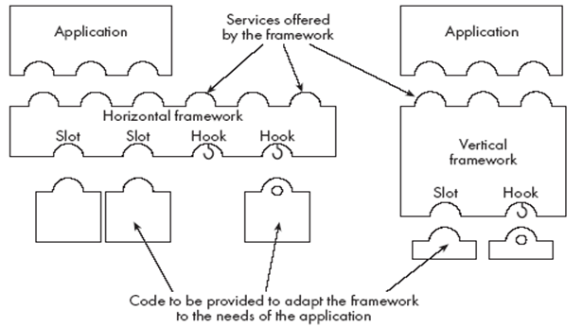
center h:300px

The Client-Server Architecture
- A distributed system is a system in which:
  - computations are performed by separate programs
  - … normally running on separate pieces of hardware
  - … that co-operate to perform the task of the system.
- Server:
  - A program that provides a service for other programs that connect to it using a communication channel
- Client
  - A program that accesses a server (or several servers) to obtain services
  - A server may be accessed by many clients simultaneously

Example of client-server systems
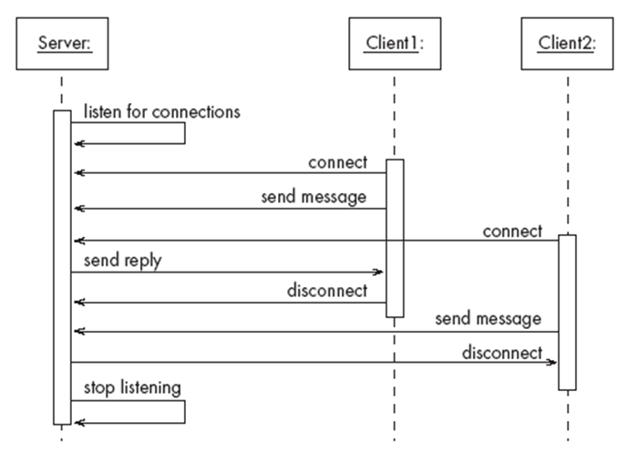
center h:500px

Activities of a server
- Initializes itself
- Starts listening for clients
- Handles the following types of events originating from clients
  - accepts connections
  - responds to messages
  - handles client disconnection
- May stop listening
- Must cleanly terminate
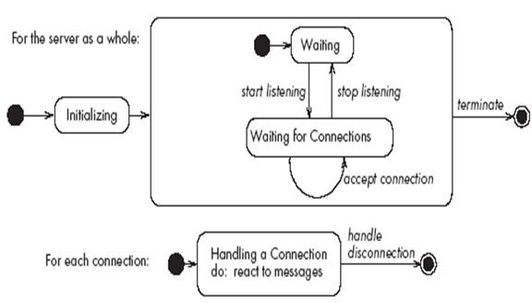
bg right:50% h:350px

Activities of a client
- Initializes itself
- Initiates a connection
- Sends messages
- Handles the following types of events originating from the server
  - responds to messages
  - handles server disconnection
- Must cleanly terminate
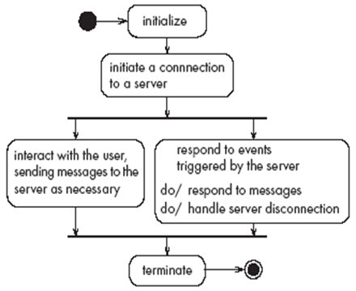
bg right:50% h:350px

Threads in a client-server system
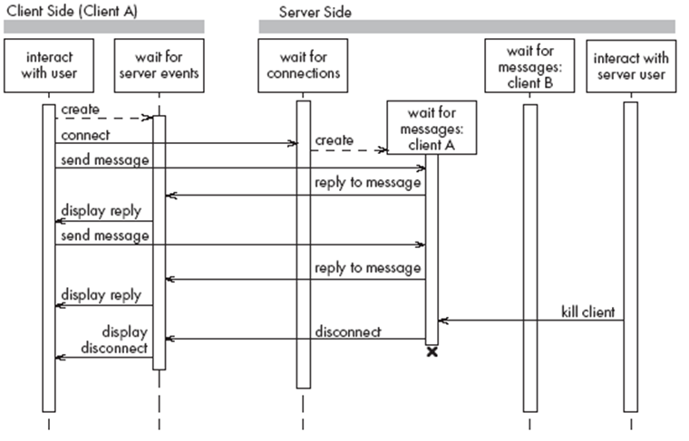
center h:550px

Thin- versus fat-client systems
- Thin-client system (a)
  - Client is made as small as possible
  - Most of the work is done in the server.
  - Client easy to download over the network
- Fat-client system (b)
  - As much work as possible is delegated to the clients.
  - Server can handle more clients
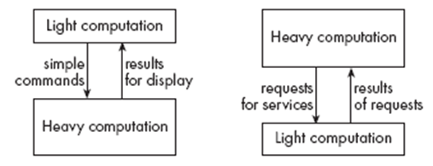
center h:230px

Communications protocols
- The messages the client sends to the server form a language.
  - The server has to be programmed to understand that language.
- The messages the server sends to the client also form a language.
  - The client has to be programmed to understand that language.
- When a client and server are communicating, they are in effect having a conversation using these two languages
- The two languages and the rules of the conversation, taken together, are called the protocol

Tasks to perform to develop client-server applications
- Design the primary work to be performed by both client and server
- Design how the work will be distributed
- Design the details of the set of messages that will be sent
- Design the mechanism for
  - Initializing
  - Handling connections
  - Sending and receiving messages
  - Terminating

Advantages of client-server systems
- The work can be distributed among different machines
- The clients can access the server’s functionality from a distance
- The client and server can be designed separately
- They can both be simpler
- There is a choice about where to keep data:
  - All the data can be kept centrally at the server
  - Data can be distributed among many different clients or servers
- The server can be accessed simultaneously by many clients
- Competing clients can be written to communicate with the same server, and vice-versa

Technology Needed to Build Client-Server Systems
- Internet Protocol (IP)
  - Route messages from one computer to another
  - Long messages are normally split up into small pieces
- Transmission Control Protocol (TCP)
  - Handles connections between two computers
  - Computers can then exchange many IP messages over a connection
  - Assures that the messages have been satisfactorily received
- A host has an IP address and a host name
  - Several servers can run on the same host.
  - Each server is identified by a port number (0 to 65535).
  - To initiate communication with a server, a client must know both the host name and the port number

Establishing a connection in Java
- The java.net package
  - Permits the creation of a TCP/IP connection between two applications
- Before a connection can be established, the server must start listening to one of the ports:
Java linenums="1" ServerSocket serverSocket = new ServerSocket(port); Socket clientSocket = serverSocket.accept();
- For a client to connect to a server:
Java linenums="1" Socket clientSocket= new Socket(host, port);

Exchanging information in Java
- Each program uses an instance of
  - InputStream to receive messages from the other program
  - OutputStream to send messages to the other program
  - These are found in package java.io
Java linenums="1" output = clientSocket.getOutputStream();
Java linenums="1" input = clientSocket.getInputStream();

Sending and receiving messages
- without any filters (raw bytes)
Java linenums="1" output.write(msg); msg = input.read();
- or using DataInputStream / DataOutputStream filters
Java linenums="1" output.writeDouble(msg); msg = input.readDouble();
- or using ObjectInputStream / ObjectOutputStream filters
Java linenums="1" output.writeObject(msg); msg = input.readObject();

The Object Client-Server Framework (OCSF)
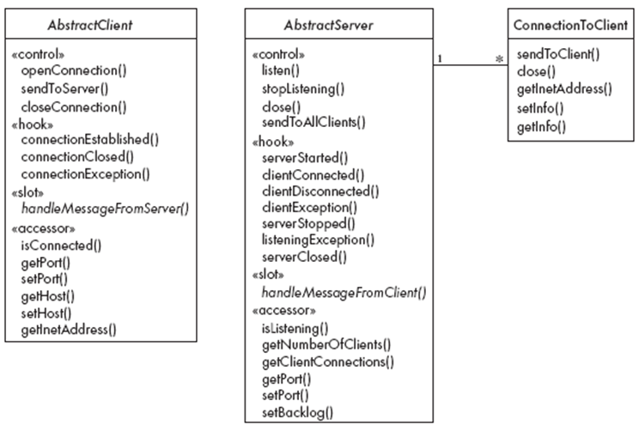
center h:550px

Using OCSF
- Software engineers using OCSF never modify its three classes
- They:
  - Create subclasses of the abstract classes in the framework
  - Call public methods that are provided by the framework
  - Override certain slot and hook methods (explicitly designed to be overridden)

The Client Side
- Consists of a single class: AbstractClient
  - Must be subclassed
    - Any subclass must provide an implementation for handleMessageFromServer
      - Takes appropriate action when a message is received from a server
- Implements the Runnable interface
  - Has a run method which
    - Contains a loop that executes for the lifetime of the thread

The public interface of AbstractClient
- Controlling methods:
  - openConnection
  - closeConnection
  - sendToServer
- Accessing methods:
  - isConnected
  - getHost
  - setHost
  - getPort
  - setPort
  - getInetAddress

The callback methods of AbstractClient
- Methods that may be overridden:
  - connectionEstablished
  - connectionClosed
- Method that must be implemented:
  - handleMessageFromServer

Using AbstractClient
- Create a subclass of AbstractClient
- Implement handleMessageFromServer slot method
- Write code that:
  - Creates an instance of the new subclass
  - Calls openConnection
  - Sends messages to the server using the sendToServer service method
- Implement the connectionClosed callback
- Implement the connectionException callback

Internals of AbstractClient
- Instance variables:
  - A Socket which keeps all the information about the connection to the server
  - Two streams, an ObjectOutputStream and an ObjectInputStream
  - A Thread that runs using AbstractClient’s run method
  - Two variables storing the host and port of the server

The Server Side
- Two classes:
  - One for the thread which listens for new connections (AbstractServer)
  - One for the threads that handle the connections to clients (ConnectionToClient)

The public interface of AbstractServer
- Controlling methods:
  - listen
  - stopListening
  - close
  - sendToAllClients
- Accessing methods:
  - isListening
  - getClientConnections
  - getPort
  - setPort
  - setBacklog

The callback methods of AbstractServer
- Methods that may be overridden:
  - serverStarted
  - clientConnected
  - clientDisconnected
  - clientException
  - serverStopped
  - listeningException
  - serverClosed
- Method that must be implemented:
  - handleMessageFromClient

The public interface of ConnectionToClient
- Controlling methods:
  - sendToClient
  - close
- Accessing methods:
  - getInetAddress
  - setInfo
  - getInfo

Using AbstractServer and ConnectionToClient
- Create a subclass of AbstractServer
- Implement the slot method handleMessageFromClient
- Write code that:
  - Creates an instance of the subclass of AbstractServer
  - Calls the listen method
  - Sends messages to clients, using:
    - the getClientConnections and sendToClient service methods
    - or sendToAllClients
- Implement one or more of the other callback methods

Internals of AbstractServer and ConnectionToClient
- The setInfo and getInfo methods make use of a Java class called HashMap
- Many methods in the server side are synchronized
- The collection of instances of ConnectionToClient is stored using a special class called ThreadGroup
- The server must pause from listening every 500ms to see if the stopListening method has been called
  - if not, then it resumes listening immediately

An Instant Messaging Application: SimpleChat
- ClientConsole can eventually be replaced by ClientGUI
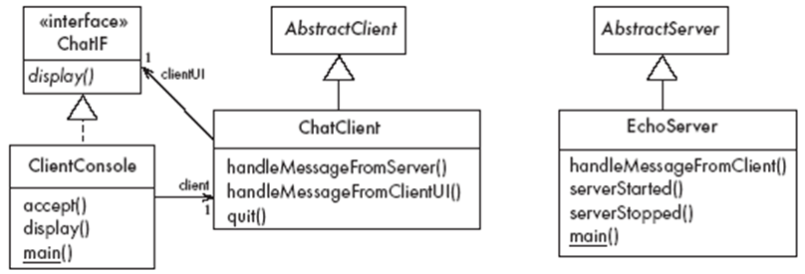
center h:450px

The server
- EchoServer is a subclass of AbstractServer
  - The main method creates a new instance and starts it
    - It listens for clients and handles connections until the server is stopped
- The three callback methods just print out a message to the user
  - handleMessageFromClient, serverStarted and serverStopped
- The slot method handleMessageFromClient calls sendToAllClients
  - This echoes any messages

Key code in EchoServer
Java linenums="1" public void handleMessageFromClient (Object msg, ConnectionToClient client) { System.out.println( "Message received: " + msg + " from " + client); this.sendToAllClients(msg); }

The client
- When the client program starts, it creates instances of two classes:
  - ChatClient
    - A subclass of AbstractClient
    - Overrides handleMessageFromServer
      - This calls the display method of the user interface
  - ClientConsole
    - User interface class that implements the interface ChatIF
      - Hence implements display which outputs to the console
    - Accepts user input by calling accept in its run method
    - Sends all user input to the ChatClient by calling its handleMessageFromClientUI
      - This, in turn, calls sendToServer

Key code in ChatClient
Java linenums="1" public void handleMessageFromClientUI( String message) { try { sendToServer(message); } catch(IOException e) { clientUI.display ( "Could not send message. " + "Terminating client."); quit(); } }

Key code in ChatClient
Java linenums="1" public void handleMessageFromServer(Object msg) { clientUI.display(msg.toString()); }

Risks when reusing technology
- Poor quality reusable components
  - Ensure that the developers of the reusable technology:
    - follow good software engineering practices
    - are willing to provide active support
- Compatibility not maintained
  - Avoid obscure features
  - Only re-use technology that others are also re-using

Risks when developing reusable technology
- Investment uncertainty
  - Plan the development of the reusable technology, just as if it was a product for a client
- The “not invented here syndrome”
  - Build confidence in the reusable technology by:
    - Guaranteeing support
    - Ensuring it is of high quality
    - Responding to the needs of its users

Risks when developing reusable technology
- Competition
  - The reusable technology must be as useful and as high quality as possible
- Divergence (tendency of various groups to change technology in different ways)
  - Design it to be general enough, test it and review it in advance

Risks when adopting a client-server approach
- Security
  - Security is a big problem with no perfect solutions: consider the use of encryption, firewalls, …
- Need for adaptive maintenance
  - Ensure that all software is forward and backward compatible with other versions of clients and servers

Takeaway: Reusable Technology
- Software reuse saves time and reduces errors - build on proven solutions
- Frameworks provide reusable subsystems with clearly defined extension points
- Client-Server architecture separates service providers from consumers
- OCSF demonstrates how OOP principles apply to real networking frameworks
- Reuse has risks: dependency, learning curve, version compatibility issues

References
- https://www.site.uottawa.ca/~tcl/seg2105/
- https://cruise.umple.org/index.shtml
- https://cruise.umple.org/umple/GettingStarted.html
- Sanem Sarıel Associate Professor, PhD BT503 Application Development with Java (Kemerburgaz University 2013-2015)
- How To Define The Project Scope The Foolproof Way

References
- BtechSmartClass Java OOP Concepts
- BtechSmartClass-Java Buzz Words
- JavatPoint-Cpp vs Java
- BtechSmartClass-Java Classes
- Programiz-Class Objects

References
- BtechSmartClass-Java-Methods-and-Classes
- Programiz-Methods
- Programiz-Method Overloading
- Programiz-Constructors
- BtechSmartClass-Java inheritance basics

References
- BtechSmartClass-Java access specifiers
- Programiz-Access Modifiers
- BtechSmartClass-java constructors in inheritance
- Programiz-Inheritance
- Programiz-this Keyword
- Programiz-instanceof

$End−Of−Week−1−Module$

