CEN206 Object-Oriented Programming
  - Final Project Progress Review & Course Summary
Author: Asst. Prof. Dr. Ugur CORUH
List of Figures

List of Tables

CEN206 Object-Oriented Programming

Week-15 (Final Project Progress Review & Course Summary)

Spring Semester, 2025-2026
Download DOC-PDF, DOC-DOCX, SLIDE

Week-15 Overview

Final Project Progress Review & Course Summary
Module | Topic
A | Course Review – OOP Fundamentals (Weeks 1-7)
B | Course Review – Design Patterns & Refactoring (Weeks 9-14)
C | Final Project Requirements & Evaluation
D | Project Demonstration Guidelines
E | Final Exam Preparation

Purpose of This Week
- Consolidate all knowledge gained throughout the semester
- Clarify final project expectations and evaluation criteria
- Provide demonstration guidelines for project presentations
- Prepare students for the final exam
- Answer remaining questions and address concerns

Module A: Course Review – OOP Fundamentals

Weeks 1-7 Recap

Module A Outline

Course Review – OOP Fundamentals (Weeks 1-7)
- Weeks 1-3: Core OOP Concepts
- Week 4: UML Diagrams
- Week 5: PlantUML
- Weeks 6-7: UMPLE
- Key Takeaways from Each Topic

Weeks 1-3: Core OOP Concepts

The Four Pillars of Object-Oriented Programming
Pillar | Description | Key Mechanism
Encapsulation | Bundling data and methods together, hiding internal state | Access modifiers (private, protected, public)
Inheritance | Creating new classes from existing ones, reusing code | extends (Java), : (C++)
Polymorphism | Same interface, different implementations | Method overriding, method overloading
Abstraction | Exposing only essential features, hiding complexity | Abstract classes, interfaces
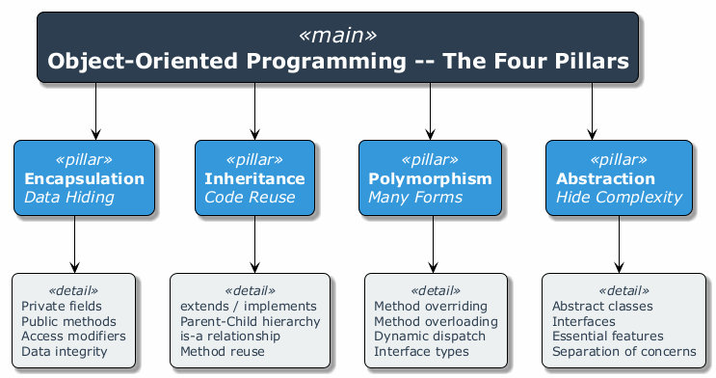
center

Weeks 1-3: Encapsulation Review
- What: Restricting direct access to an object’s internal state and requiring interaction through well-defined methods.
- Why: Protects data integrity, reduces coupling, enables implementation changes without affecting clients.
public class BankAccount {
private double balance; // hidden internal state
public double getBalance() {
return balance;
}
public void deposit(double amount) {
if (amount > 0) {
balance += amount;
}
}
public boolean withdraw(double amount) {
if (amount > 0 && amount <= balance) {
balance -= amount;
return true;
}
return false;
}
}

Weeks 1-3: Inheritance Review
- What: A mechanism where a child class inherits fields and methods from a parent class.
- Why: Code reuse, establishing is-a relationships, building class hierarchies.
public class Animal {
protected String name;
public void eat() {
System.out.println(name + " is eating.");
}
}
public class Dog extends Animal {
public Dog(String name) {
this.name = name;
}
public void bark() {
System.out.println(name + " is barking.");
}
}

Weeks 1-3: Polymorphism Review
- What: The ability of objects of different classes to respond to the same method call in different ways.
- Why: Enables flexible, extensible code that works with abstractions rather than concrete types.
public abstract class Shape {
public abstract double area();
}
public class Circle extends Shape {
private double radius;
public Circle(double r) { this.radius = r; }
public double area() { return Math.PI * radius * radius; }
}
public class Rectangle extends Shape {
private double width, height;
public Rectangle(double w, double h) { this.width = w; this.height = h; }
public double area() { return width * height; }
}
// Polymorphic usage
Shape s = new Circle(5);
System.out.println(s.area()); // calls Circle's area()

Weeks 1-3: Abstraction Review
- What: Defining essential characteristics of an object while hiding the implementation details.
- Why: Simplifies complex systems, focuses on what an object does rather than how it does it.
public interface Sortable {
void sort(int[] data);
}
public class QuickSort implements Sortable {
public void sort(int[] data) {
// Quick sort implementation hidden from clients
quickSort(data, 0, data.length - 1);
}
private void quickSort(int[] arr, int low, int high) { /* ... */ }
}
public class MergeSort implements Sortable {
public void sort(int[] data) {
// Merge sort implementation hidden from clients
mergeSort(data, 0, data.length - 1);
}
private void mergeSort(int[] arr, int low, int high) { /* ... */ }
}

Week 4: UML Diagrams Review

Unified Modeling Language
Diagram Type | Category | Purpose
Class Diagram | Structural | Shows classes, attributes, methods, and relationships
Object Diagram | Structural | Shows instances at a specific point in time
Sequence Diagram | Behavioral | Shows object interactions over time
Use Case Diagram | Behavioral | Shows system functionality from user perspective
Activity Diagram | Behavioral | Shows workflow and business processes
State Machine Diagram | Behavioral | Shows object state transitions
Component Diagram | Structural | Shows system components and dependencies

Week 4: Class Diagram Relationships Review
Relationship | Symbol | Meaning | Example
Association | solid line | “uses” or “knows about” | Student – Course
Aggregation | open diamond | “has-a” (weak ownership) | Department <>– Professor
Composition | filled diamond | “owns” (strong ownership) | House <>– Room
Inheritance | open triangle arrow | “is-a” | Dog –> Animal
Realization | dashed triangle arrow | “implements” | ArrayList ..> List
Dependency | dashed arrow | “depends on” | Client ..> Service

Week 5: PlantUML Review

Key Features
- Text-based UML diagramming tool
- Converts plain text descriptions into UML diagrams
- Supports class diagrams, sequence diagrams, use case diagrams, and more
- Integrates with IDEs, CI/CD pipelines, and documentation tools
@startuml
class Animal {
- name: String
+ eat(): void
}
class Dog extends Animal {
+ bark(): void
}
class Cat extends Animal {
+ meow(): void
}
@enduml

Weeks 6-7: UMPLE Review

Key Features
- Model-Oriented Programming language
- Adds modeling constructs directly into programming languages (Java, C++, PHP)
- Supports associations, state machines, and design patterns
- Generates executable code from models
class Student {
name;
Integer studentId;
1 -- * Course;
}
class Course {
title;
Integer courseCode;
}

Weeks 6-7: UMPLE Associations & State Machines

Associations
Multiplicity | Meaning | Example
1 -- * | One-to-many | One Student has many Courses
* -- * | Many-to-many | Students and Clubs
0..1 -- * | Optional one-to-many | Mentor and Students

State Machines
class TrafficLight {
status {
Red { timer -> Green; }
Green { timer -> Yellow; }
Yellow { timer -> Red; }
}
}

Module A – Takeaway

OOP Fundamentals: Key Points
Week | Topic | Core Skill Gained
1-3 | OOP Concepts | Understanding encapsulation, inheritance, polymorphism, abstraction
4 | UML Diagrams | Modeling software systems visually
5 | PlantUML | Automating UML diagram generation from text
6-7 | UMPLE | Model-oriented programming and code generation
Remember: OOP is not just about syntax – it is about thinking in objects, designing clean abstractions, and building maintainable systems.

Module B: Course Review – Design Patterns & Refactoring

Weeks 9-14 Recap

Module B Outline

Design Patterns & Refactoring (Weeks 9-14)
- Week 9: Creational Patterns (5 patterns)
- Week 10: Structural Patterns (7 patterns)
- Week 11: Behavioral Patterns (10 patterns)
- Week 12: Code Smells (5 categories, 22 smells)
- Week 13: Refactoring Techniques (6 categories, 66 techniques)
- Week 14: Case Studies and Best Practices
- Pattern Selection Decision Guide
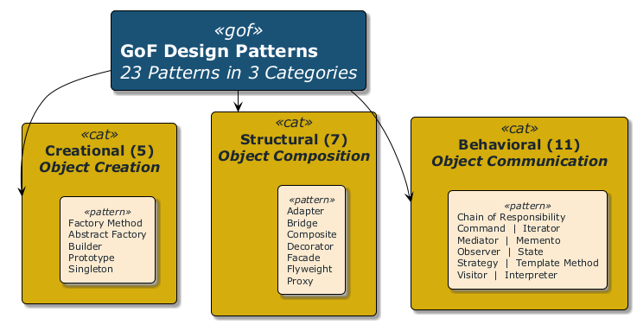
center

Week 9: Creational Design Patterns Summary

5 Patterns for Object Creation
# | Pattern | Intent | When to Use
1 | Factory Method | Define an interface for creating objects, letting subclasses decide the type | When a class cannot anticipate the type of objects it needs to create
2 | Abstract Factory | Create families of related objects without specifying concrete classes | When the system must be independent of how its products are created
3 | Builder | Separate the construction of a complex object from its representation | When creating objects with many optional parameters
4 | Prototype | Create new objects by copying existing ones | When object creation is expensive and similar objects already exist
5 | Singleton | Ensure a class has only one instance and provide global access | When exactly one instance is needed (e.g., configuration, logging)

Week 10: Structural Design Patterns Summary

7 Patterns for Class/Object Composition
# | Pattern | Intent | When to Use
1 | Adapter | Convert one interface to another that clients expect | When you need to use an existing class with an incompatible interface
2 | Bridge | Separate abstraction from implementation | When both abstraction and implementation may vary independently
3 | Composite | Compose objects into tree structures for part-whole hierarchies | When you need to treat individual objects and compositions uniformly
4 | Decorator | Attach additional responsibilities dynamically | When you need to add behavior without subclassing
5 | Facade | Provide a simplified interface to a complex subsystem | When you need a simple interface to a complex system
6 | Flyweight | Share objects to support large numbers efficiently | When many similar objects consume excessive memory
7 | Proxy | Provide a surrogate or placeholder for another object | When you need controlled access, lazy loading, or logging

Week 11: Behavioral Design Patterns Summary

10 Patterns for Object Communication
# | Pattern | Intent | When to Use
1 | Chain of Responsibility | Pass request along a chain of handlers | When multiple objects may handle a request
2 | Command | Encapsulate a request as an object | When you need undo/redo, queuing, or logging of requests
3 | Iterator | Access elements sequentially without exposing internals | When you need uniform traversal of collections
4 | Mediator | Define centralized communication between objects | When many objects communicate in complex ways
5 | Memento | Capture and restore object state | When you need undo/rollback functionality
6 | Observer | Notify dependents automatically when state changes | When one object change should update many others
7 | State | Alter behavior when internal state changes | When behavior depends on state and changes at runtime
8 | Strategy | Define interchangeable algorithms | When you need to select an algorithm at runtime
9 | Template Method | Define algorithm skeleton, letting subclasses fill in steps | When subclasses should customize parts of an algorithm
10 | Visitor | Add operations to objects without modifying them | When you need to perform operations across a class hierarchy

Week 12: Code Smells Summary

5 Categories, 22 Smells
Category | Smells | Key Indicator
Bloaters | Long Method, Large Class, Primitive Obsession, Long Parameter List, Data Clumps | Code that grows excessively large
Object-Orientation Abusers | Switch Statements, Temporary Field, Refused Bequest, Alternative Classes with Different Interfaces | Improper use of OOP principles
Change Preventers | Divergent Change, Shotgun Surgery, Parallel Inheritance Hierarchies | Changes require modifications in many places
Dispensables | Comments (excessive), Duplicate Code, Lazy Class, Data Class, Dead Code, Speculative Generality | Unnecessary code that adds complexity
Couplers | Feature Envy, Inappropriate Intimacy, Message Chains, Middle Man, Incomplete Library Class | Excessive coupling between classes

Week 13: Refactoring Techniques Summary

6 Categories, 66 Techniques
Category | Count | Purpose | Key Techniques
Composing Methods | 9 | Better method structure | Extract Method, Inline Method, Extract Variable
Moving Features | 8 | Proper feature placement | Move Method, Move Field, Extract Class
Organizing Data | 15 | Better data management | Encapsulate Field, Replace Magic Number, Replace Type Code
Simplifying Conditionals | 8 | Cleaner conditional logic | Decompose Conditional, Replace Conditional with Polymorphism
Simplifying Method Calls | 14 | Better method interfaces | Rename Method, Add/Remove Parameter, Parameterize Method
Dealing with Generalization | 12 | Better inheritance hierarchies | Pull Up Method, Push Down Method, Extract Interface

Week 14: Case Studies & Best Practices

Key Lessons
- Real-world applications of design patterns in industry projects
- Pattern combinations – how patterns work together in practice
- Anti-patterns – common mistakes and how to avoid them
- SOLID principles applied alongside design patterns
  - S – Single Responsibility Principle
  - O – Open/Closed Principle
  - L – Liskov Substitution Principle
  - I – Interface Segregation Principle
  - D – Dependency Inversion Principle
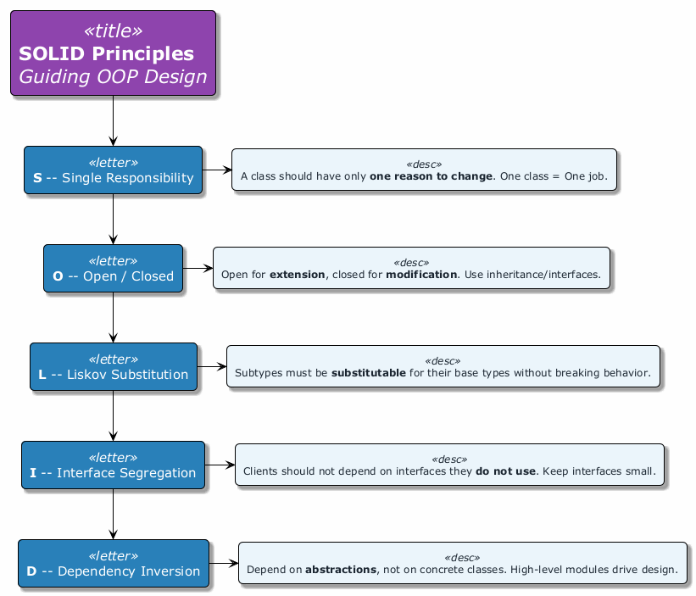
center

Pattern Selection Decision Guide

How to Choose the Right Pattern
Is your problem about...
CREATING objects?
|-- Need one instance only? --> Singleton
|-- Need families of related objects? --> Abstract Factory
|-- Need flexible object construction?--> Builder
|-- Need to copy existing objects? --> Prototype
|-- Need subclass to decide type? --> Factory Method
STRUCTURING classes?
|-- Need to adapt an interface? --> Adapter
|-- Need to add behavior dynamically? --> Decorator
|-- Need a simplified interface? --> Facade
|-- Need tree structures? --> Composite
|-- Need controlled access? --> Proxy
MANAGING behavior?
|-- Need to notify on state change? --> Observer
|-- Need interchangeable algorithms? --> Strategy
|-- Need to encapsulate requests? --> Command
|-- Need to traverse a collection? --> Iterator
|-- Need state-dependent behavior? --> State

Module B – Takeaway

Design Patterns & Refactoring: Key Points
Week | Topic | Core Skill Gained
9 | Creational Patterns | Flexible and decoupled object creation
10 | Structural Patterns | Composing classes and objects effectively
11 | Behavioral Patterns | Managing complex object interactions
12 | Code Smells | Identifying problematic code
13 | Refactoring Techniques | Systematically improving code quality
14 | Case Studies & Best Practices | Applying patterns in real-world scenarios
Remember: Design patterns are tools, not rules. Use them when they solve a real problem, not to demonstrate knowledge.

Module C: Final Project Requirements & Evaluation

Project Report Structure, Deliverables & Grading

Module C Outline

Final Project Requirements & Evaluation
- Project Report Structure (MPR2)
- Expected Deliverables
- Evaluation Criteria and Rubric
- Presentation Guidelines
- Code Quality Expectations
- Documentation Requirements

Project Report Structure (MPR2)

Required Report Sections
Section | Description
1. Title Page | Project name, team members, date, course information
2. Abstract | Brief summary of the project (150-300 words)
3. Introduction | Problem statement, motivation, objectives
4. Requirements Analysis | Functional and non-functional requirements
5. System Design | Architecture, UML diagrams (class, sequence, use case)
6. Implementation | Key implementation details, design patterns used
7. Testing | Test strategy, test cases, results
8. Conclusion | Summary, challenges faced, lessons learned
9. References | All sources cited properly
10. Appendices | Additional diagrams, full code listings (if needed)

Expected Deliverables

What You Must Submit
- Source Code
  - Complete, compilable, and runnable project
  - Hosted on a version control system (e.g., GitHub)
  - Clean commit history showing team contributions
- Project Report (MPR2)
  - Following the structure described above
  - Minimum 15 pages (excluding appendices)
  - PDF format
- UML Diagrams
  - Class diagram (mandatory)
  - Sequence diagram for at least 2 key scenarios
  - Use case diagram
- Presentation Slides
  - 10-15 slides covering key aspects
  - Demo screenshots or video
- Live Demonstration
  - Working prototype shown during project presentation

Evaluation Criteria and Rubric

Grading Breakdown
Criterion | Weight | Excellent (90-100) | Good (70-89) | Satisfactory (50-69) | Poor (0-49)
OOP Design | 25% | Proper use of all 4 pillars, clean abstractions | Good use of 3+ pillars, minor issues | Basic use of inheritance/encapsulation only | No clear OOP structure
Design Patterns | 20% | 3+ patterns used appropriately with justification | 2 patterns used correctly | 1 pattern attempted | No patterns used
Code Quality | 20% | Clean code, no smells, well-refactored | Mostly clean, minor smells | Some code smells present | Many code smells, poor structure
Documentation | 15% | Complete report, clear UML diagrams | Good report, minor diagram issues | Incomplete report or diagrams | Missing report or diagrams
Functionality | 10% | All features work as specified | Most features work | Core features work | Major features broken
Presentation | 10% | Clear, well-prepared, handles Q&A well | Good presentation, minor issues | Basic presentation | Unprepared, unclear
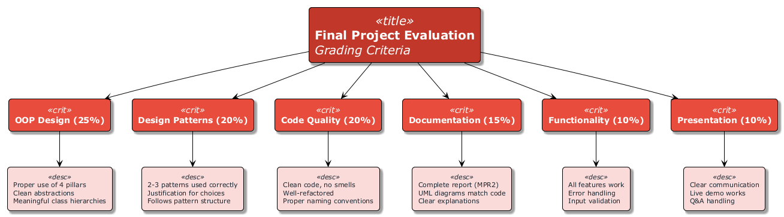
center

Presentation Guidelines

How to Structure Your Presentation
Time | Section | Content
2 min | Introduction | Problem statement, motivation, team members
3 min | Design | Architecture overview, key UML diagrams
3 min | Implementation | Design patterns used, key technical decisions
5 min | Demo | Live demonstration of working features
2 min | Conclusion | Lessons learned, future work
5 min | Q&A | Answer questions from instructor and peers
Total Time: ~20 minutes per team

Code Quality Expectations

What We Look For
- Clean Code Principles
  - Meaningful variable and method names
  - Short, focused methods (no Long Methods)
  - Proper code organization and package structure
- Design Patterns Usage
  - At least 2-3 design patterns applied appropriately
  - Justification for why each pattern was chosen
  - Correct implementation following pattern structure
- Proper OOP
  - Encapsulation: private fields with getters/setters where needed
  - Inheritance: meaningful class hierarchies (not forced)
  - Polymorphism: interfaces and abstract classes used effectively
  - Abstraction: clean separation of concerns
- No Code Smells
  - No duplicate code
  - No long parameter lists
  - No feature envy or inappropriate intimacy

Documentation Requirements

UML Diagrams Required
Diagram | Purpose | Minimum Content
Class Diagram | Show system structure | All major classes, attributes, methods, relationships
Sequence Diagram | Show key interactions | At least 2 important use case flows
Use Case Diagram | Show system functionality | All primary actors and use cases

Report Requirements
- PlantUML or UMPLE preferred for diagram generation (not hand-drawn)
- Diagrams must be consistent with actual code
- All external libraries and frameworks must be documented
- Code snippets in the report should be formatted and explained

Module C – Takeaway

Final Project Requirements: Key Points
- Your project is evaluated on design quality, not just functionality
- Use at least 2-3 design patterns with proper justification
- Submit clean, well-documented code with proper OOP structure
- UML diagrams must match your actual implementation
- The report should tell the story of your project: problem, design, implementation, testing

Module D: Project Demonstration Guidelines

How to Present Your Project Effectively

Module D Outline

Project Demonstration Guidelines
- How to Present Your Project
- Demo Flow Recommendations
- Q&A Preparation Tips
- Common Pitfalls to Avoid
- Grading Rubric for Demonstrations

How to Present Your Project

Preparation Checklist
- Test everything on the presentation machine beforehand
- Prepare a backup plan (screenshots, video recording) in case of technical issues
- Know your code – every team member should understand all parts
- Prepare talking points – do not read from slides
- Practice the demo at least 2-3 times
- Time your presentation to stay within limits
- Assign roles – who presents which section

Presentation Tips
- Start with the big picture before diving into details
- Show the architecture before showing code
- Use diagrams to explain complex interactions
- Keep slides simple – use them as visual aids, not scripts

Demo Flow Recommendations

Recommended Demo Structure
1. SETUP (1 minute)
- Show project structure briefly
- Mention technologies and tools used
2. CORE FEATURES (3-4 minutes)
- Demonstrate primary functionality
- Show the most impressive features first
- Follow a logical user workflow
3. DESIGN HIGHLIGHTS (1-2 minutes)
- Show a specific design pattern in action
- Explain WHY you chose that pattern
- Show the corresponding UML diagram
4. CODE WALKTHROUGH (1-2 minutes)
- Show one well-written class
- Highlight clean code practices
- Show how patterns are implemented
5. EDGE CASES (1 minute)
- Show error handling
- Demonstrate input validation

Q&A Preparation Tips

Common Questions to Expect
Category | Example Questions
Design Decisions | “Why did you choose the Observer pattern here instead of Mediator?”
Alternatives | “What other patterns did you consider and why did you reject them?”
Challenges | “What was the biggest technical challenge and how did you solve it?”
OOP Principles | “How does your design demonstrate the Open/Closed Principle?”
Testing | “How did you test this feature? What edge cases did you consider?”
Scalability | “How would your design handle 10x more users/data?”

Tips for Answering
- Be honest – if you do not know, say so and explain how you would find out
- Be specific – reference actual classes, methods, and patterns by name
- Be concise – answer the question directly, then elaborate if asked

Common Pitfalls to Avoid

What NOT to Do
Pitfall | Why It Is a Problem | How to Avoid
No backup plan | Technical failures happen | Record a demo video beforehand
Reading from slides | Shows lack of preparation | Use slides as visual aids only
Showing too much code | Overwhelms the audience | Show only key snippets
Skipping the design | Misses the main evaluation point | Spend at least 30% on design
Unequal participation | Shows poor teamwork | Ensure every member presents
Ignoring time limits | Disrespectful, loses points | Practice with a timer
Using patterns incorrectly | Worse than not using them | Understand each pattern fully
No error handling in demo | Crashes look unprofessional | Test all demo paths beforehand

Grading Rubric for Demonstrations

How Demos Are Evaluated
Criterion | Weight | Description
Technical Depth | 30% | Demonstrates understanding of OOP concepts, design patterns, and code quality
Functionality | 25% | Features work correctly and as described in the report
Presentation Quality | 20% | Clear communication, good structure, professional delivery
Design Justification | 15% | Can explain WHY design decisions were made, not just WHAT was done
Q&A Response | 10% | Handles questions competently and honestly

Grade Descriptors
Grade | Description
A (90-100) | Exceptional design, flawless demo, deep understanding shown in Q&A
B (80-89) | Good design, working demo with minor issues, solid Q&A
C (70-79) | Adequate design, demo works for core features, basic Q&A
D (60-69) | Minimal design effort, demo has significant issues, weak Q&A
F (<60) | Poor or missing design, demo fails, unable to answer questions

Module D – Takeaway

Project Demonstration: Key Points
- Prepare thoroughly – practice the demo multiple times
- Always have a backup – record a video of your demo
- Focus on design – the demo should showcase your OOP and pattern usage, not just features
- Every team member must be able to explain every part of the project
- Anticipate questions – prepare answers for common Q&A topics

Module E: Final Exam Preparation

Exam Format, Key Topics & Study Guide

Module E Outline

Final Exam Preparation
- Exam Format and Scope
- Key Topics to Review
- Sample Question Types
- Study Resources and Recommendations

Exam Format and Scope

Final Exam Details
Aspect | Details
Duration | 90 minutes
Format | Written exam (closed book)
Question Types | Multiple choice, code analysis, short answer, design problems
Scope | All topics from Weeks 1-14
Weight | As specified in the course syllabus

What to Bring
- Student ID
- Pen/pencil
- No electronic devices allowed

Key Topics to Review

High-Priority Topics
Priority | Topic | What to Know
High | 4 Pillars of OOP | Definitions, examples, when to use each
High | Design Patterns (all 22) | Intent, structure, when to use, code examples
High | UML Class Diagrams | Read and create class diagrams, understand relationships
High | Code Smells | Identify smells, know which refactoring to apply
Medium | Refactoring Techniques | Know the major techniques and their purposes
Medium | PlantUML | Read PlantUML syntax, understand generated diagrams
Medium | UMPLE | Understand associations, state machines, code generation
Medium | SOLID Principles | Definitions, examples, how they relate to patterns
Low | Specific pattern implementations | Detailed code for all 22 patterns
Low | All 66 refactoring techniques | Detailed steps for every technique

Sample Question Types

Type 1: Multiple Choice
Example: Which design pattern ensures a class has only one instance?
- Factory Method
- Singleton
- Prototype
- Builder
Answer: b) Singleton

Sample Question Types (continued)

Type 2: Code Analysis
Example: Identify the design pattern used in the following code:
public interface Logger {
void log(String message);
}
public class FileLogger implements Logger {
public void log(String message) { /* write to file */ }
}
public class ConsoleLogger implements Logger {
public void log(String message) { /* print to console */ }
}
public class LoggerFactory {
public static Logger getLogger(String type) {
if (type.equals("file")) return new FileLogger();
if (type.equals("console")) return new ConsoleLogger();
throw new IllegalArgumentException("Unknown type: " + type);
}
}
Answer: Factory Method (Simple Factory variant) – creates objects without exposing creation logic to the client.

Sample Question Types (continued)

Type 3: Code Smell Identification
Example: Identify the code smell(s) in the following code and suggest a refactoring:
public double calculatePrice(String type, int quantity, double unitPrice,
double discount, boolean isMember,
String couponCode, double taxRate) {
// ... complex calculation
}
Answer: - Code Smell: Long Parameter List - Refactoring: Introduce Parameter Object – create a PriceRequest class to group related parameters.

Sample Question Types (continued)

Type 4: Design Problem
Example: You are designing a notification system that needs to: - Support multiple notification channels (email, SMS, push notification) - Allow adding new channels without modifying existing code - Let users subscribe/unsubscribe from notifications
Question: Which design pattern(s) would you use? Draw a UML class diagram and explain your choice.
Expected Answer: - Observer Pattern for subscribe/unsubscribe mechanism - Strategy Pattern for interchangeable notification channels - Should include a class diagram showing NotificationService, Observer interface, NotificationChannel strategy interface, and concrete implementations

Study Resources and Recommendations

Recommended Study Plan
Day | Activity | Focus
Day 1 | Review OOP fundamentals | 4 pillars, SOLID principles
Day 2 | Review Creational & Structural patterns | 12 patterns: intent, when to use
Day 3 | Review Behavioral patterns | 10 patterns: intent, when to use
Day 4 | Review Code Smells & Refactoring | 22 smells, major refactoring techniques
Day 5 | Practice problems | Sample questions, code analysis
Day 6 | UML diagrams & PlantUML | Draw class diagrams, read PlantUML
Day 7 | Full review | Go through all week summaries

Key Resources
- Course slides (Weeks 1-14)
- RefactoringGuru: https://refactoring.guru
- Design Patterns (GoF Book): Gamma, Helm, Johnson, Vlissides
- Clean Code: Robert C. Martin

Module E – Takeaway

Final Exam Preparation: Key Points
- The exam covers all topics from Weeks 1-15
- Focus on understanding concepts, not memorizing code
- Practice identifying patterns in code snippets
- Practice identifying code smells and suggesting refactorings
- Be able to draw UML class diagrams for given scenarios
- Know when to use each pattern, not just what it is

Course Summary

What You Have Learned
CEN206 Object-Oriented Programming
|
|-- FOUNDATIONS (Weeks 1-7)
| |-- OOP Concepts: Encapsulation, Inheritance,
| | Polymorphism, Abstraction
| |-- UML Diagrams: Visual modeling of software systems
| |-- PlantUML: Text-based diagram generation
| |-- UMPLE: Model-oriented programming
|
|-- DESIGN PATTERNS (Weeks 9-11)
| |-- Creational: 5 patterns for object creation
| |-- Structural: 7 patterns for composition
| |-- Behavioral: 10 patterns for communication
|
|-- CODE QUALITY (Weeks 12-14)
| |-- Code Smells: 22 smells across 5 categories
| |-- Refactoring: 66 techniques across 6 categories
| |-- Best Practices: SOLID, Clean Code, Case Studies
|
|-- APPLICATION (Week 15)
|-- Final Project: Applying all concepts together
|-- Course Summary: Consolidating knowledge
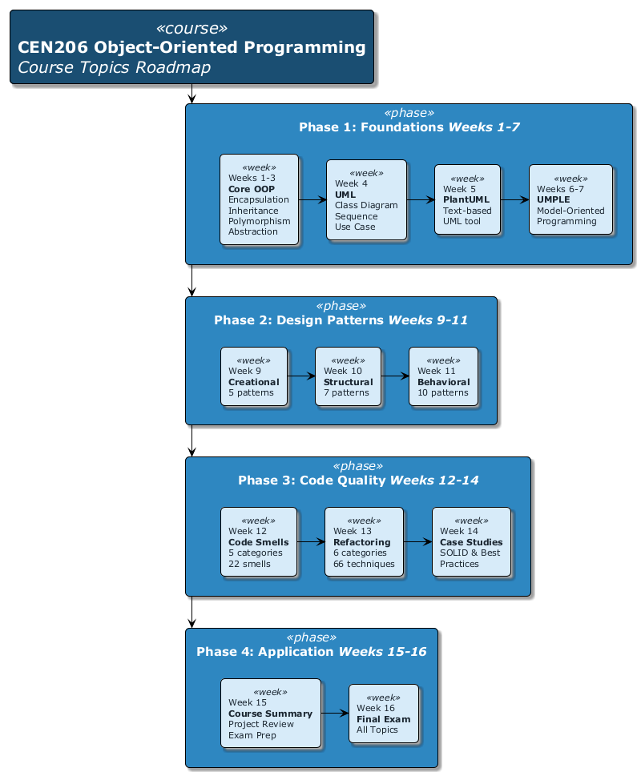
center

Final Words

Key Principles to Carry Forward
- Think in objects – model real-world entities with classes and relationships
- Design before coding – UML diagrams save debugging time
- Use patterns wisely – they are solutions to recurring problems, not goals themselves
- Keep code clean – refactor continuously, eliminate smells early
- Follow SOLID – these principles guide good OOP design
- Test your code – untested code is unreliable code
- Document your design – future you (and your team) will thank you
Good luck with your final projects and exams!

References
- Gamma, E., Helm, R., Johnson, R., & Vlissides, J. (1994). Design Patterns: Elements of Reusable Object-Oriented Software. Addison-Wesley.
- Fowler, M. (2018). Refactoring: Improving the Design of Existing Code (2nd Edition). Addison-Wesley Professional.
- Martin, R. C. (2008). Clean Code: A Handbook of Agile Software Craftsmanship. Prentice Hall.
- RefactoringGuru. Design Patterns. https://refactoring.guru/design-patterns
- RefactoringGuru. Refactoring Techniques. https://refactoring.guru/refactoring/techniques
- RefactoringGuru. Code Smells. https://refactoring.guru/refactoring/smells

References (continued)
- Lethbridge, T. C., & Laganiere, R. (2004). Object-Oriented Software Engineering: Practical Software Development using UML and Java. McGraw-Hill.
- Booch, G., Rumbaugh, J., & Jacobson, I. (2005). The Unified Modeling Language User Guide (2nd Edition). Addison-Wesley.
- PlantUML. PlantUML Documentation. https://plantuml.com
- UMPLE. UMPLE Online. https://cruise.umple.org/umpleonline
- Freeman, E., Robson, E., Sierra, K., & Bates, B. (2004). Head First Design Patterns. O’Reilly Media.

$End−Of−Week−15−Module$

