CEN206 Object-Oriented Programming
  - UMPLE - Part 1
Author: Asst. Prof. Dr. Ugur CORUH
List of Figures

List of Tables

CEN206 Object-Oriented Programming

Week-6 (UMPLE - Part 1)

Spring Semester, 2025-2026
Download DOC-PDF, DOC-DOCX, SLIDE

Module A: Introduction to UMPLE

Module Outline
- What is UMPLE?
- UMPLE Motivation and Key Innovations
- Model-Driven Development with UMPLE

Introduction to UMPLE

UMPLE: Si&mple&, A&mple&, &UM&L &P&rogramming &L&anguag&e&
- Open source textual modelling tool set for 3 platforms
  - Command line compiler
  - Web-based tool (UMPLEOnline) for demos and education
  - Eclipse plugin
- Code generator for UML ++
  - Infinitely nested state machines, with concurrency
  - Proper referential integrity and multiplicity constraints on associations
  - Traits, mixins, aspects for modularity
  - Text generation templates, patterns, traits
- Pre-processor to add UML, patterns and other features on top of Java, PhP, C++ and other languages

UMPLE: Si&mple&, A&mple&, &UM&L &P&rogramming &L&anguag&e&
- Open source textual modeling tool and code generator
  - Adds modeling to Java,. C++, PHP
  - A sample of features
    - Referential integrity on associations
    - Code generation for patterns
    - Blending of conventional code with models
    - Infinitely nested state machines, with concurrency
    - Separation of concerns for models: mixins, traits, mixsets, aspects
- Tools
  - Command line compiler
  - Web-based tool (UMPLEOnline) for demos and education
  - Plugins for Eclipse and other tools

What Are we Going to Learn About in This Tutorial? What Will You Be Able To Do?
- Modeling using class diagrams
  - Attributes, Associations, Methods, Patterns, Constraints
- Modeling using state diagrams
  - States, Events, Transitions, Guards, Nesting, Actions, Activities
  - Concurrency
- Separation of Concerns in Models
  - Mixins, Traits, Aspects, Mixsets
- Practice with a examples focusing on state machines and product lines
- Building a complete system in UMPLE

What Technology Will You Need?
- As a minimum: Any web browser.
- For a richer command-line experience
  - A computer (laptop) with Java 8-14 JDK
  - Mac and Linux are the easiest platforms, but Windows also will work
  - Download UMPLE Jar at http://dl.UMPLE.org
- You can also run UMPLE in Docker: http://docker.UMPLE.org

Key Websites
- Entry-point: https://www.UMPLE.org
  - Everything you need to get started with UMPLE
- Github: https://github.com/UMPLE/UMPLE
  - Source code and examples for UMPLE
- UMPLE Online: https://try.UMPLE.org
  - Online application for UMPLE

Key Websites (Another way)
The UMPLEOnline web interface is at try.UMPLE.org
The user manual is at manual.UMPLE.org
The UMPLE home page is at www.UMPLE.org
UMPLE download page: dl.UMPLE.org

Motivation for developing UMPLE

Motivation for developing UMPLE (1)
Designers want the best combination of features:
- Textual editing and blending with other languages
- Ability to use in an agile process
  - Write tests, continuous integration, versioning
  - Combine the best of agility and modeling
- Excellent code generation
  - A complete generation of real systems (including itself)
- Multi-platform (command line, Eclipse, VsCode, Web)
- Practical and easy to use for developers
  - Including great documentation
- Open source

Motivation for developing UMPLE (2)
Many existing tools:
- Lacked in usability
  - Awkward to edit diagrams
  - Many steps to do a task
  - Lengthy learning process
- Lack in ongoing support
- Could be enhanced by us perhaps, but we would be tied to key decisions (e.g. Eclipse-only)

Takeaway: Introduction to UMPLE
- UMPLE = UML + Programming Language - adds UML constructs directly into code
- Model-driven development: write models that generate production-quality code
- UMPLE supports Java, C++, PHP, Ruby code generation from UML models
- Key innovation: seamless integration of modeling and programming
- UMPLE eliminates the gap between design models and implementation

Module B: Using UMPLE & Philosophy

Module Outline
- UMPLE Key Innovations
- Using UMPLE (Online, Command-Line, Eclipse, VS Code)
- UMPLE Philosophy

Some key UMPLE innovations

Some key UMPLE innovations
- Model is code
  - Traditional code is embedded in model
- No need to edit generated code
  - No round-trip engineering

Using UMPLE

Using UMPLE
- We will mostly be using
  - UMPLEonline
    - In a web browser: http://try.UMPLE.org
    - Or in Docker: http://docker.UMPLE.org
  - UMPLE on the command line: http://dl.UMPLE.org
    - Needs Java 8 JDK on the command line:
      - http://bit.ly/1lO1FSV
        - Java 9 works well too

Docker Container Experimental
mkdir ~/src && cd ~/src && git clone git@github.com:UMPLE/UMPLE.git
docker run -i -t -v `pwd`:/src UMPLE/UMPLE:0.4.0 bash

Using UMPLE
- Optional:
  - UMPLE in Eclipse
    - https://github.com/UMPLE/UMPLE/wiki/InstallEclipsePlugin
  - cmake and gcc for compiling C++ code

UMPLE Philosophy

UMPLE Philosophy 1-4
- P1. Modeling is programming and vice versa
- P2. An UMPLE programmer should never need to edit generated code to accomplish any task.
- P3. The UMPLE compiler can accept and generate code that uses nothing but UML abstractions.
  - The above is the inverse of the following
- P4. A program without UMPLE features can be compiled by an UMPLE compiler.
  - e.g. input Java results in the same as output

UMPLE Philosophy 5-8
- P5. A programmer can incrementally add UMPLE features to an existing program
  - Umplification
- P6. UMPLE extends the base language in a minimally invasive and safe way.
- P7. UMPLE features can be created and viewed diagrammatically or textually
- P8. UMPLE goes beyond UML

Takeaway: Using UMPLE & Philosophy
- UMPLE can be used online (try.umple.org), via command line, or through IDE plugins
- Philosophy: modeling should be part of programming, not a separate activity
- UMPLE treats UML associations, state machines, and patterns as first-class language constructs
- Code generation produces clean, readable code in target languages
- UMPLE is open-source and actively maintained

Module C: UMPLE Class Modeling & Attributes

Module Outline
- UMPLE Class Modeling Basics
- Defining Classes and Namespaces
- UMPLE Attributes (Basic, Defaulted, Derived, Immutable, Lazy, Autounique)
- Attribute Types and Constraints

UMPLE Class Modeling

UMPLE Class Models - Quick Overview
- Key elements:
  - Classes
  - Attributes
  - Associations
  - Generalizations
  - Methods
- We will look at all these using examples via UMPLE ONLINE
- UMPLE code/models are stored in files with suffix .ump

Exercise: Compiling and changing a model
- Look at the example at the bottom of
  - http://helloworld.UMPLE.org (also on next slide)
    - Observe: attribute, association, class hierarchy, mixin
- Click on Load the above code into UMPLEOnline
  - Observe and modify the diagram
  - Add an attribute
  - Make a multiplicity error, then undo
  - Generate code and take a look
  - Download, compile and run if you want

Hello World Example 2 in the User Manual
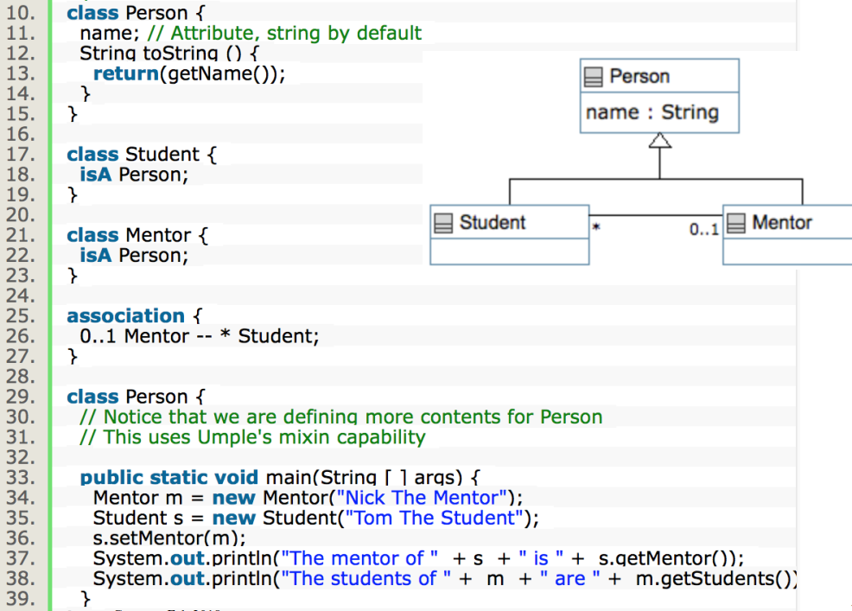
center h:550

Key tools:
- UMPLE Online
- Command-Line
- User Manual

Hello World example 2 in UMPLEOnline
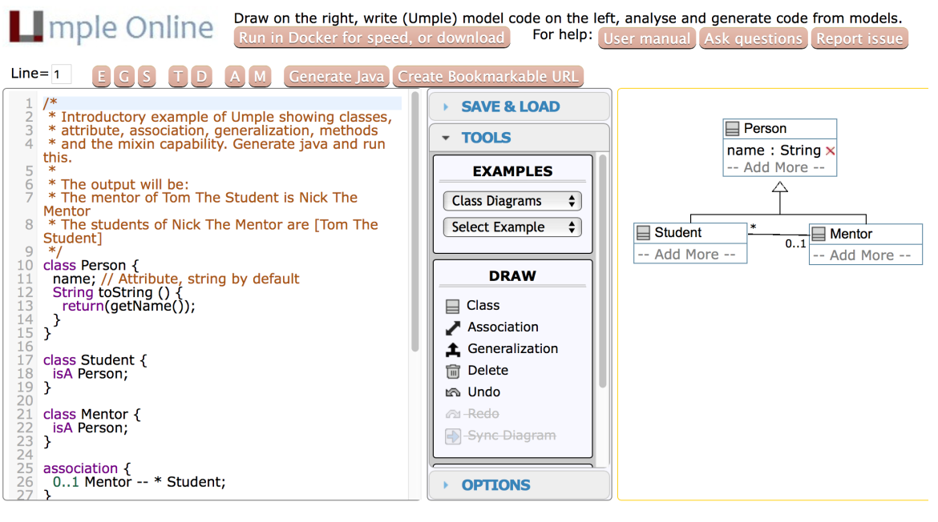
center h:500

Exploration of UMPLEOnline
- Explore class diagram examples
- Options
  - T or Control-t (hide and show text)
  - D or Control-d (hide and show diagram)
  - A, M to hide and show attributes, methods
  - Default diagram types
    - G/Control-g (Graphviz), S/Control-s (State Diagram)
    - E/Control-e (Editable class diagram)
- Generate code and look at the results
  - In UMPLE you never should modify generated code
  - It is designed to be readable for educational purposes

Use of the UMPLEOnline Docker image
- UMPLE’s server can handle 80,000 transactions per hour
  - Code generations, edits
- But needs a good Internet connection (sometimes hundreds of students have assignments due)
- To maximize speed of UMPLEOnline run it in your local machine:
  - Follow the instructions at http://docker.UMPLE.org

Demo of compiling on the command line
- To compile on the command line you will need Java 8
- Download UMPLE from http://dl.UMPLE.org
- Basic compilation
java -jar UMPLE.jar model.ump
- Help for features and commands
java -jar UMPLE.jar --help
- To generate and compile the java to a final system
java –jar UMPLE.jar model.ump -c -

Quick walkthrough of the user manual
- http://manual.UMPLE.org
Note in particular
- Key sections:
  - attributes,
  - associations,
  - state machines
- Grammar
- Generated API
- Errors and warnings
- Editing pages in github

UMPLE Attributes
- More than just variables
  - http://attributes.UMPLE.org

Attributes
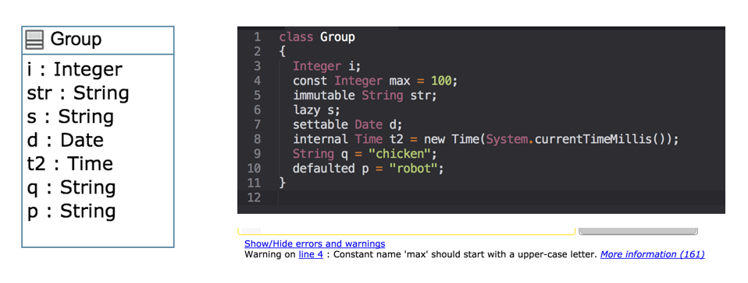
center h:400

Attributes Exercise #1
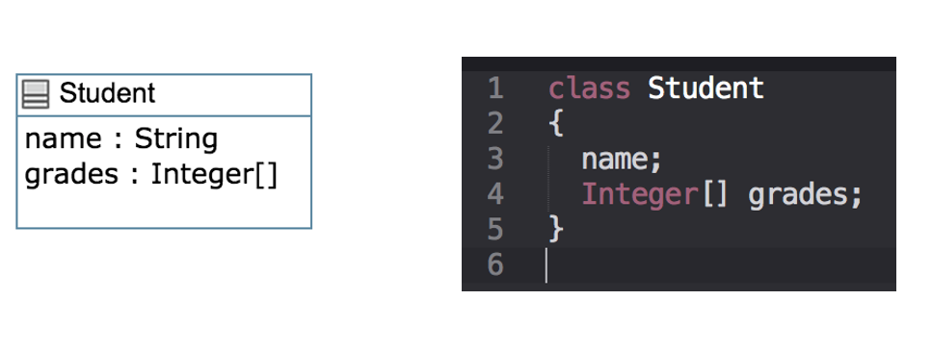
center h:400

Attributes
- “Instance variables”
  - Part of the state of an object
  - Simple data that will always be present in each instance
- Specified like a Java or C++ field or member variable
- But, intended to be more abstract!
  - Example, with an initial value
a = "init value";

Attributes
- As in UML, more abstract than instance variables
  - Always private by default
  - Should only be accessed get, set methods
  - Can be stereotyped (upcoming slides) to affect code generation
  - Can have aspects applied (discussed later)
  - Can be constrained (discussed later)

Code generation from attributes
- Default code generation
  - Generates a getName() and setName() method for name
    - public
- Creates an arguments in the class constructor by default
- An attribute is private to the class by default
  - Should only be accessed get, set methods

Code Generation (JavaDocs)
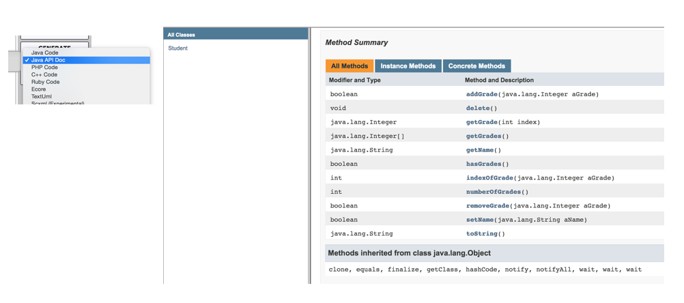
center h:500

Code Generation Patterns
- Attributes
  - Set/Get (UB = 1)
  - Add/Remove/NumberOf/IndexOf/Get (UB > 1)
  - Lazy immutability
  - Default values
  - Constants
  - Before / After cod
- UB = upper bound

Code Generation Patterns
- Associations
  - Set/Get (UB = 1)
  - Add/Remove/NumberOf/IndexOf/Get (UB > 1)
  - Referential Integrity
  - Multiplicity Constraints
  - 42 different cases
- UB = upper bound

Code Generation (Semantics)
- http://api.UMPLE.org/
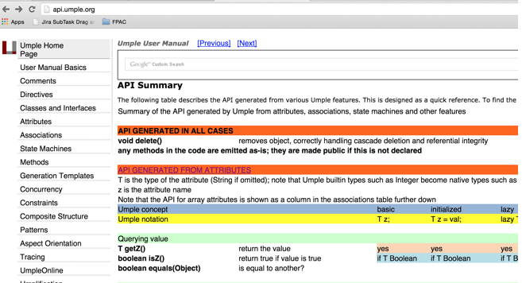
center h:500

UMPLE builtin datatypes
String // (default if none specified)
Integer
Float
Double
Boolean
Time
Date
- The above will generate appropriate code in Java, C++ etc.
  - e.g. Integer becomes int
- Other (native) types can be used but without guaranteed correctness

Attribute stereotypes (1)
- Code generation can be controlled through stereotypes:
  - lazy - don’t add a constructor argument
lazy b; // sets it to null, 0, "" depending on type
- Defaulted – can be reset
defaulted s = "def"; // resettable to the default

Attribute stereotypes (2)
- autounique – provide a unique value to each instance
autounique x; // sets attribute to 1, 2, 3 ...
- internal – don’t generate any methods
internal i; // doesn't generate any get/set either

Immutability
- Useful for objects where you want to guarantee no possible change once created
  - e.g. a geometric point
- Generate a constructor argument and get method but no set method
immutable String str;
- No constructor argument, but allows setting just once.
lazy immutable z;

Lets explore attributes by example
- Go to
  - http://attributes.UMPLE.org

Derived attributes
- These generate a get method that is calculated.
class Point
{
// Cartesian coordinates
Float x;
Float y;
// Polar coordinates
Float rho =
{Math.sqrt(Math.pow(getX(), 2) + Math.pow(getY(), 2))}
Float theta =
{Math.toDegrees(Math.atan2(getY(),getX()))}
}

Multi-valued attributes
- Limit their use. Associations are generally better.
class Office {
Integer number;
Phone[] installedTelephones;
}
class Phone {
String digits;
String callerID;
}

Keys
- Enable UMPLE to generate an equals() and a hashcode() method
class Student {
Integer id;
name;
key { id }
}
- The user manual has a sports team example showing keys on associations too
- Note how this feature is not inherited from UML

Takeaway: UMPLE Class Modeling & Attributes
- UMPLE classes look like simplified Java/C++ with UML-level abstractions
- Attribute types: basic, defaulted (with initial value), derived (computed), immutable (set once)
- Lazy attributes: initialized only when first accessed
- Autounique attributes: automatically assigned unique integer values
- UMPLE generates complete getter/setter methods and constructor logic from attribute declarations

Module D: Generalization, Methods & Associations

Module Outline
- UMPLE Generalization and Interfaces
- UMPLE Methods
- UMPLE Associations (Types, Multiplicity, Reflexive, Sorted, Qualifiers)

UMPLE Generalization and interfaces

Generalization in UMPLE
- UMPLE uses the isA keyword to indicate generalization
- Used to indicate superclass, used trait, implemented interface
class Shape {
colour;
}
class Rectangle {
isA Shape;
}

Avoiding unnecessary generalizations
Open in UMPLE
- Inappropriate hierarchy of Classes
- What should the model be?
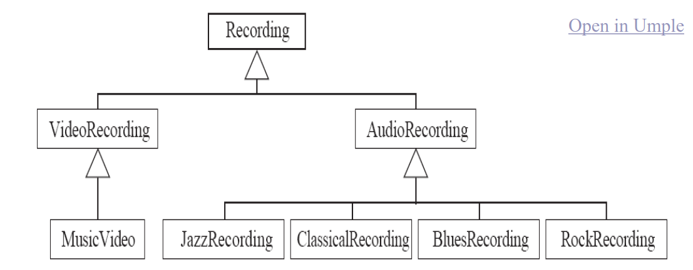
center h:300

Interfaces
- Declare signatures of a group of methods that must be implemented by various classes
- Also declared using the keyword isA
- Essentially the same concept as in Java
- Let’s explore examples in the user manual …

UMPLE Methods

User-written Methods in UMPLE
- Methods can be added to any UMPLE code.
- UMPLE parses the signature only; the rest is passed to the generated code.
- You can specify different bodies in different languages
- We will look at examples in the user manual …

UMPLE Associations
- http://associations.UMPLE.org
  - Notice the inline and independent state machines

Associations
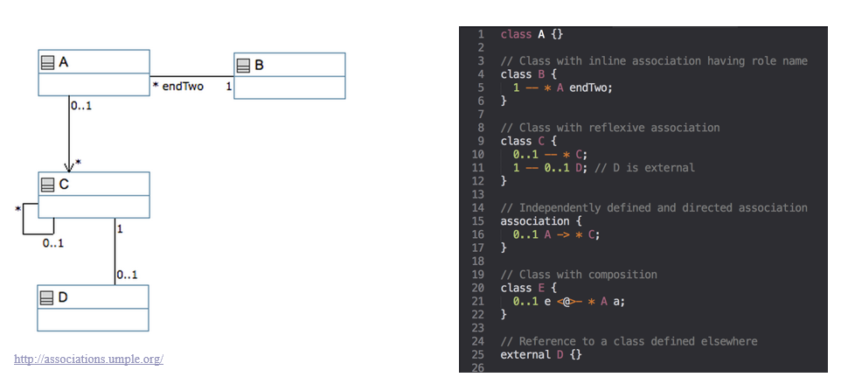
center h:500

Associations Exercise #1
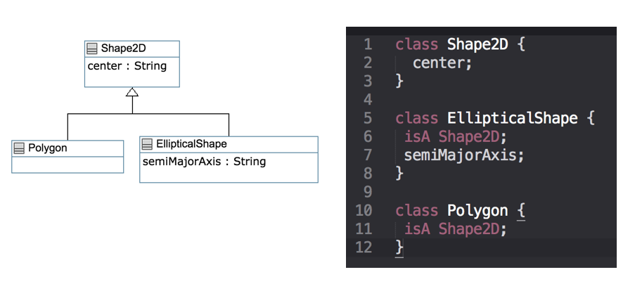
center h:500

Associations Exercise #2
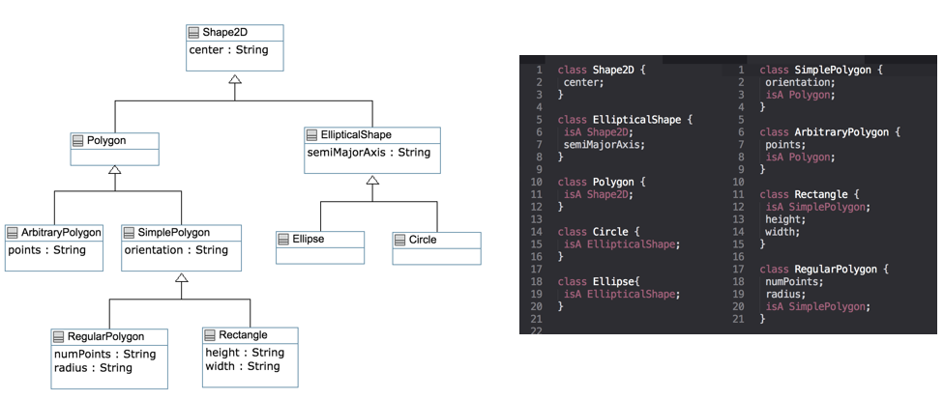
center h:500

Associations
- Describe how instances of classes are linked at runtime
  - Bidirectional -- or
  - Unidirectional ->
- Multiplicity:
  - Bounds on the number of linked instances
- * Or 0..* $→$ 0 or more
- 1..* $→$ 1 or more
- 1 $→$ Exactly 1
- 2 $→$ Exactly 2
- 1..3 $→$ Between 1 and 3
- 0..2 $→$ Up to 2

Association Relationships
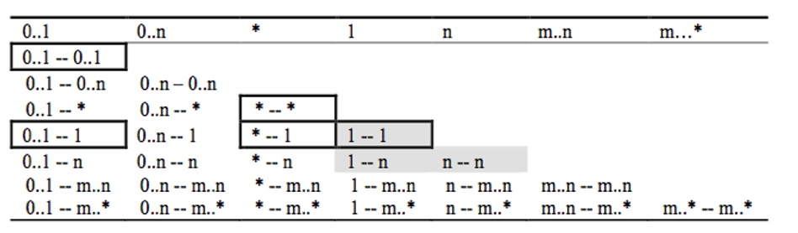
center h:400

Association Relationships
- Directional Associations
* -> 0..1, * -> 1, * -> *, * -> m..n, * - >n, *->m..* and*->0..n.
- Symmetric Reflexive
0..1, 0..n, *, 1, n, m..n,m..*

Basic UML associations
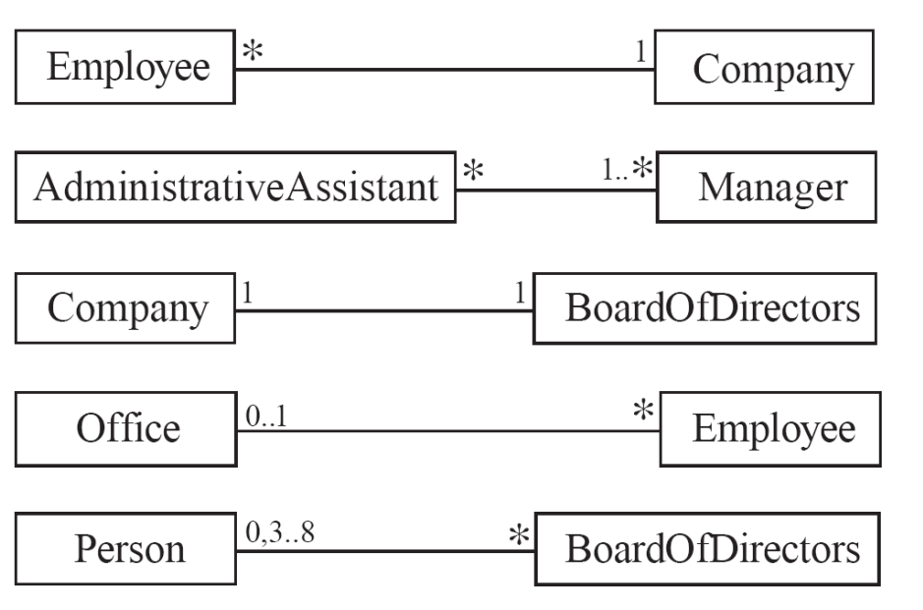
center h:500

Many-to-one associations (1)
class Employee {
id;
firstName;
lastName;
}
class Company {
name;
1 -- * Employee;
}

Many-to-one associations (2)
- A company has many employees,
- An employee can only work for one company.
  - This company will not store data about the moonlighting activities of employees!
- A company can have zero employees
  - E.g. a ‘shell’ company
- It is not possible to be an employee unless you work for a company
- Let’s draw and write this in UMPLEOnline:
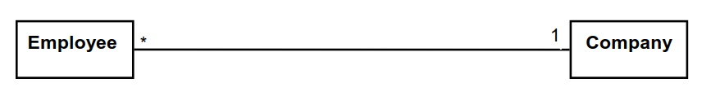
center h:150

Role names (optional, in most cases)
- Allow you to better label either end of an association
class Person{
id;
firstName;
lastName;
}
class Company {
name;
1 employer -- * Person employee;
}

Referential Integrity
- When an instance on one side of the association changes
  - The linked instances on the other side know …
  - And vice-versa
- This is standard in UMPLE associations, which are bidirectional

Many-to-Many Associations
- An assistant can work for many managers
- A manager can have many assistants
- Assistants can work in pools working for several managers
- Managers can have a group of assistants
- Some managers might have zero assistants.
- Is it possible for an assistant to have, perhaps temporarily, zero managers?
Open in UMPLE
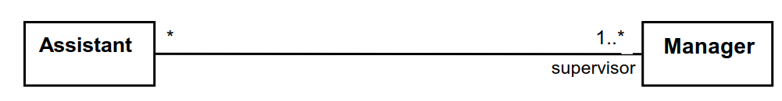
center h:150

One-to-One Associations (Use cautiously)
- For each company, there is exactly one board of directors
- A board is the board of only one company
- A company must always have a board
- A board must always be of some company
Open in UMPLE

center h:150

Typical erroneous use of one-to-one
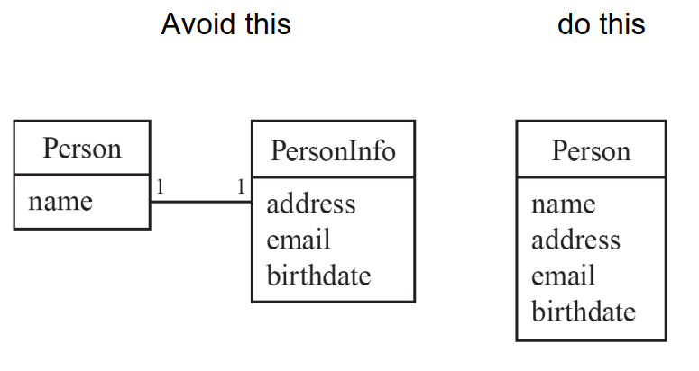
center h:500

Unidirectional Associations
- Associations are by default bi-directional
- It is possible to limit the direction of an association by adding an arrow at one end
- In the following unidirectional association
  - A Day knows about its notes, but a Note does not know which Day is belongs to
  - Note remains ‘uncoupled’ and can be used in other contexts
class Day {
* -> 1 Note;
}
class Note {}
Open in UMPLE
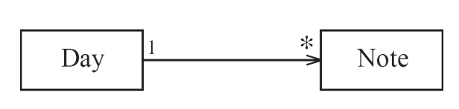
center h:150

Association Classes
- Sometimes, an attribute that concerns two associated classes cannot be placed in either of the classes
Open in UMPLE
and Extended Example
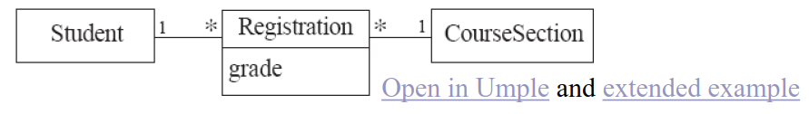
center h:100
- The following are nearly equivalent
  - The only difference:
    - in the association class there can be only a single registration of a given Student in a CourseSection
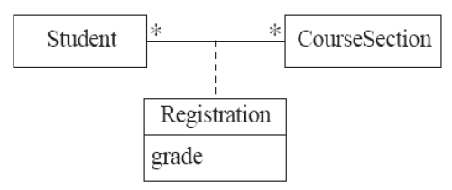
center h:200

Association classes (cont.)
- UMPLE code
class Student {}
class CourseSection {}
associationClass Registration {
* Student;
* CourseSection;
}
- Open in UMPLEOnline, and then generate code

Reflexive Associations
- An association that connects a class to itself
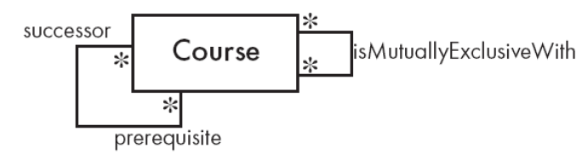
center
Open in UMPLE
class Course {
* self isMutuallyExclusiveWith; // Symmetric
}
association {
* Course successor -- * Course prerequisite;
}

Inline vs. Standalone associations
- The following are equivalent to allow flexibility:
class X {}
class Y {
1 -- * X;
}
class X {}
class Y {}
association {
1 Y -- * X;
}

Aggregation
- Aggregations are ordinary associations that represent part-whole relationships.
  - The ‘whole’ side is often called the assembly or the aggregate
  - This is a shorthand for association named isPartOf
  - UMPLE has no special syntax currently
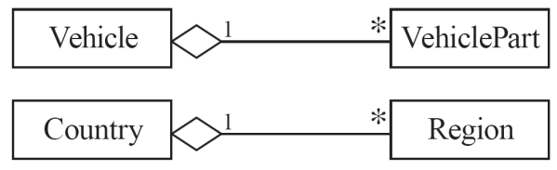
center
class Vehicle {
1 whole -- * VehiclePart part;
}
class VehiclePart{
}

Composition
- A composition is a strong kind of aggregation
  - If the aggregate is destroyed, then the parts are destroyed as well
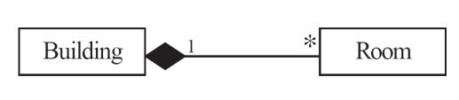
class Building {
1 <@>- * Room;
}
class Room{
}

Sorted Associations
- Order objects in the association according to a specific key
class Academy {
1 -- * Student registrants sorted {id};
}
class Student {
Integer id;
name;
}
- We will look at a more complete example in the User Manual

A final word on associations
- More help and examples are in the user manual online at
  - http://associations.UMPLE.org

Takeaway: Generalization, Methods & Associations
- UMPLE supports inheritance (isA keyword) and interface implementation
- Methods can be added directly in UMPLE alongside UML constructs
- Associations define relationships between classes with multiplicity (, 0..1, 1.., etc.)
- UMPLE generates referential integrity code for associations automatically
- Special association features: reflexive, sorted, qualified associations

References
- UMPLE Tutorials
- UMPLE Github
- UMPLE Online
- UMPLE Documentation
- UMPLE CSI5112– February 2018
- UMPLE Tutorial: Models 2020 Web
- UMPLE Tutorial: Models 2020 Pdf

References
- Getting Started in UMPLE
- Experiential Learning for Software Engineering Using Agile Modeling in UMPLE (Youtube)
- Experiential Learning for Software Engineering Using Agile Modeling in UMPLE (Slide)
- Tomassetti Code Generation

$End−Of−Week−6$

