CE204 Object-Oriented Programming

UMPLE - Part 2

Author: Asst. Prof. Dr. Uğur CORUH

## CE204 Object-Oriented Programming

## Week-7 (UMPLE - Part 2)

#### Spring Semester, 2021-2022

Download [DOC-PDF](ce204-week-7.tr.md_doc.pdf), [DOC-DOCX](ce204-week-7.tr.md_word.docx), [SLIDE](ce204-week-7.tr.md_slide.pdf), [PPTX](ce204-week-7.tr.md_slide.pptx),

## UMPLE

### Common Scope

* What is UMPLE?
* What is its purpose?
* How to create a UML model with UMPLE?
* What is philosophy of UMPLE?

### Common Scope

* How to use UMPLE?
  + UMPLE Online
  + Command-Line
  + Eclipse Plugin
  + Visual Studio Code Plugin

### Common Scope

* How to learn UMPLE?
  + Online Documentations
  + Video Tutorials
  + UMPLE Community

### Common Scope

* Overview of the basics of Umple
* Associations in Umple
* State machines in Umple
* Product lines in Umple: Mixins and Mixsets
* Other separation of concerns mechanisms: (Aspects and traits) and their code generation
* Other advanced features of Umple
* Hands-on exercise developing versions of a concurrent system using state machines and product lines.
* Umple as written in itself: A case study.

### Common Scope

* Introduction:
* Overview of Model-Driven Development
  + Languages / Tools / Motivation for Umple
* Class Modeling
  + Tools / Attributes / Methods / Associations / Exercises / Patterns
* Modeling with State Machines
  + Basics / Concurrency / Case study and exercises
* Separation of Concerns in Models
  + Mixins / Aspects / Traits
* More Case Studies and Hands-on Exercises
  + Umple in itself / Real-Time / Data Oriented
* Conclusion

### Outline - Part 2

* Modeling exercises
* Simple patterns (if time)
* Basic state machines
* Analysing models
* Concurrency
* State machine case study
* Mixins
* Aspect orientation

### Outline - Part 2

* Traits
* Mixins and Traits together
* Mixsets
* Case Studies
* Unit Testing with UMPLE
* UMPLE issues list
* UMPLE’s Architecture
* Umplification
* Conclusion

## **Modeling exercises**

### Modeling Exercise

* Build a class diagram for the following description.
* If you think there are key requirements missing, then add them.
  + A football (soccer) team has players. Each player plays a position. The team plays some games against other teams during each season. The system needs to record who scored goals, and the score of each game.

## **Simple patterns (if time)**

### Singleton pattern

* Standard pattern to enable only a single instance of a class to be created.
  + private constructor
  + getInstance() method
* Declaring in Umple

class University {  
singleton;  
name;  
}

### Delegation pattern

* A class calls a method in its “**neighbour**”

class RegularFlight {  
flightNumber;  
}  
  
Class SpecificFlight {  
* -- 1 RegularFlight;  
flightNumber = {getRegularFlight().getFullNumber()}  
}

* Full details of this example in the user manual

### Basic constraints

* Shown in square brackets
  + Code is added to the constructor and the set method

class X {  
Integer i;  
[! (i == 10)]  
}

* We will see constraints later in state machines

## **Basic state machines**

* http://statemachines.umple.org

### Basics of state machines

* At any given point in time, the system is in one state.
* It will remain in this state until an event occurs that causes it to change state.
* A state is represented by a rounded rectangle containing the name of the state.
* Special states:
  + A black circle represents the *start state*
  + A circle with a ring around it represents an *end state*

### Garage door state machine

class GarageDoor{  
 status {  
 Open {  
 buttonOrObstacle -> Closing;  
 }  
 Closing {  
 buttonOrObstacle -> Opening;  
 reachBottom -> Closed;  
 }  
 Closed {  
 buttonOrObstacle -> Opening;  
 }  
 Opening {  
 buttonOrObstacle -> HalfOpen;  
 reachTop -> Open;  
 }  
 HalfOpen {  
 buttonOrObstacle -> Opening;  
 }  
 }  
}

### Events

* An occurrence that may trigger a change of state
  + Modeled in Umple as generated methods that can be called
* Several states may be able to respond to the same event

### Transitions

* A change of state in response to an event.
  + It is considered to occur **instantaneously**.
* The label on each transition is the event that causes the change of state.

### State diagrams – an example with conditional transitions

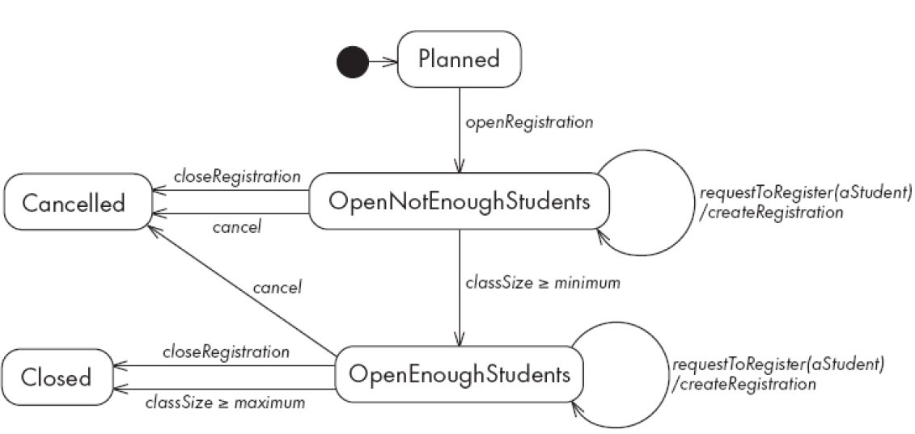

center h:500

### Actions in state diagrams

* An action is a block of code that must be executed effectively instantaneously
  + When a particular transition is taken,
  + Upon entry into a particular state, or
  + Upon exit from a particular state
* An action should consume no noticeable amount of time

### Nested substates and guard conditions

* A state diagram can be nested inside a state.
  + The states of the inner diagram are called substates.

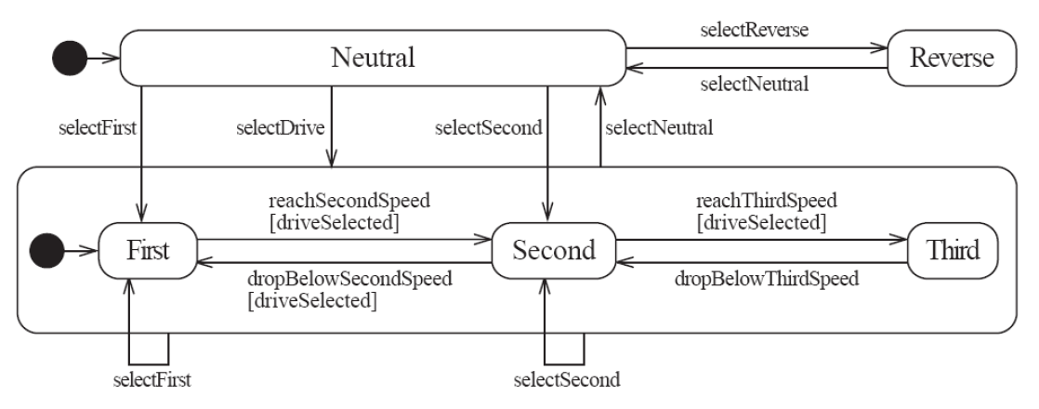

center

### Nested state diagram – Another example

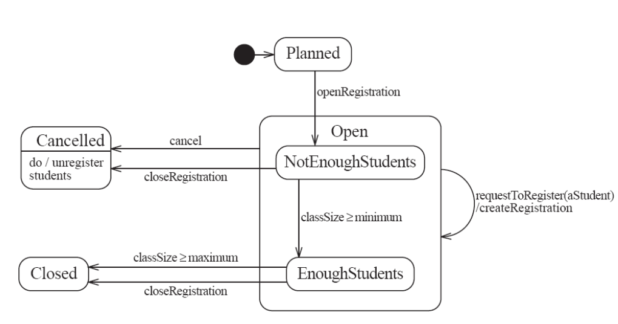

center

### Auto-transitions

* A transition taken immediately upon entry into a state
  + Unless guarded
* We will look at an example in the user manual

### Events with parameters

* Parameters can be referenced in guards and actions.
* We will look at an example in the user manual.

## **Analysing models**

### Models can be analysed in several ways

* Visually
* Automatically generated errors and warnings
* State tables (next slide)
* Metrics
* Formal methods (nuXMV)

### State tables and simulations

* Allow analysis of state machines statically without having to write code
* We will explore these in UmpleOnline by looking at state machine examples and generating tables and simulations

## **Concurrency**

### Do activities and concurrency

* A do activity executes
  + In a separate thread
  + Until
    - Its method terminates, or
    - The state needs to exit (killing the tread)
* Example uses:
  + Outputting a stream (e.g. playing music)
  + Monitoring something
  + Running a motor while in the state
  + Achieving concurrency, using multiple do activities

### Active objects

* These start in a separate thread as they are instantiated.
* Declared with the keyword

active

### Default threading in state machines

* As discussed so far, code generated for state machines has the following behaviour:
  + A single thread:
    - Calls an event
    - Executes the event (running any actions)
    - Returns to the caller and continues
* This has two problems:
  + If another thread calls the event at the same time they will **interfere**
  + There can be **deadlocks** if an action itself triggers an event

### Queued state machines

* Solve the threading problem:
  + Callers can add events to a queue without blocking
  + A separate thread takes items off the queue ‘as fast as it can’ and processes them
* Umple syntax: queued before the state machine declaration
* *We will look at examples in the manual*

### Pooled state machines

* Default Umple Behavior (including with queued):
  + If an event is received but the system is not in a state that can handle it, then the event is ignored.
* Alternative pooled stereotype:
  + Uses a queue (see previous slide)
  + Events that cannot be processed in the current state are left at the head of the queue until a relevant state reached
  + The first relevant event nearest the head of the queue is processed
  + Events may hence be processed out of order, but not ignored

### **Unspecified** pseudo-event

* Matches any event that is not listed
* Can be in any state, e.g.

unspecified -> error;

### Example using unspecified

class AutomatedTellerMachine{  
 queued sm {  
 idle {  
 cardInserted -> active; maintain -> maintenance;  
 unspecified -> error1;  
 }   
 maintenance { isMaintained -> idle; }  
 active {  
 entry /{addLog("Card is read");}  
 exit /{addLog("Card is ejected");}  
 validating {  
 validated -> selecting;  
 unspecified -> error2;  
 }  
 selecting {select -> processing; }  
 processing {  
 selectAnotherTransiction -> selecting;  
 finish -> printing;  
 }  
 printing {receiptPrinted -> idle;}  
 cancel -> idle;  
 }  
 error1 {entry / {printError1();} ->idle;}  
 error2 {entry / {printError2();} ->validating;}  
 }  
}

### State machines in the user manual

* http://statemachines.umple.org

## **State machine case study**

### State machine for a phone line

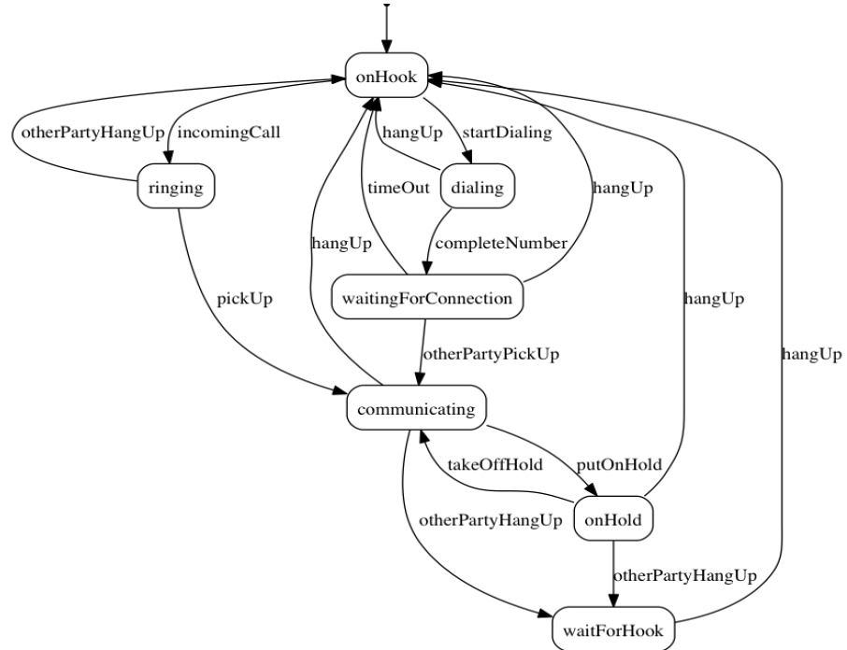

center h:550

### Umple for the phone line example

class phone {  
state {  
onHook {  
startDialing -> dialling;  
incomingCall -> ringing;  
  
}  
  
ringing {  
pickUp -> communicating;  
otherPartyHangUp -> onHook;  
  
}  
  
communicating {  
hangUp -> onHook;  
otherPartyHangUp -> waitForHook;  
putOnHold -> onHold;  
  
}  
  
onHold {  
hangUp -> onHook;  
otherPartyHangUp -> waitForHook;  
takeOffHold -> communicating;  
  
}

* next slide

### Umple for the phone line example

* con’t.

dialing {  
completeNumber ->   
waitingForConnection;  
hangUp -> onHook;  
  
}  
  
waitingForConnection {  
otherPartyPickUp -> communicating;  
hangUp -> onHook;  
timeOut -> onHook;  
  
}  
  
waitForHook {  
hangUp -> onHook;  
  
}  
  
}  
  
}

### In-class modeling exercise for state machines

* Microwave oven system state machine
  + Events include
    - pressing of buttons
    - door opening
    - door closing
    - timer ending
    - etc.

## **Mixins**

### Mixins : Motivation

* Product variants have long been important for
  + Product lines/families, whose members target different:
    - hardware, OS, feature sets, basic/pro versions
  + Feature-oriented development (separation of concerns)

### Separation of concerns by mixins in Umple

* Mixins allow including attributes, associations, state machines, groups of states, stereotypes, etc
* Example:
* class X { a; }  
  class X { b; }
  + The result would be a class with both a and b.
* It doesn’t matter whether the mixins are
  + Both in the same file
  + One in one file, that includes the other in an other file
  + In two separate files, with a third file invoking them

### Typical ways of using mixins

* Separate groups of classes for
  + model (classes, attributes, associations)
  + Methods operating on the model
* Allows a clearer view of the core model
* Another possibility
  + One feature per file

### Typical ways of using mixins

* Separate model files (classes, attributes associations)
* … from files for the same class containing methods
  + Allows a clearer view of the core model
* Separate system features, each into a separate file

### Advantages and disadvantages of mixins

* Advantages:
  + Smaller files that are easier to understand
  + Different versions of a class for different software versions (e.g. a professional version) can be built by using different mixins
* Disadvantage
  + Delocalization:
    - Bits of functionality of a class in different files
    - The developer may not know that a mixin exists unless a tool helps show this

## **Aspect orientation**

### Aspects : Motivation

* We often don’t quite like the code as generated

Or

* We want to do a little more than what the generated code does

Or

* We want to inject some feature (e.g. security checks) into many places of generated or custom code

### Aspect orientation : General Concept

* Create a pointcut that specifies (advises) where to inject code at multiple points elsewhere in a system
  + The pointcut uses a pattern
  + Pieces of code that would otherwise be scattered are thus gathered into the aspect
* But: There is potentially acute sensitivity to change
  + If the code changes the aspect may need to change
  + Yet without tool support, developers wouldn’t know this
* Drawback : **Delocalization even stronger than for mixins**

### Aspect orientation in Umple

* It is common to limit a pointcuts a single class
  + Inject code before, after, or around execution of custom or generated methods and constructors

class Person {  
name;  
before setName {  
if (aName != null && aName.length() > 20) { return false;  
}  
}  
}

* We have found these limited abilities nonetheless solve key problems

## **Traits**

### Traits : Motivation

* We may want to inject similar elements into unrelated classes
  + without complex multiple inheritance
* Elements can be
  + Methods
  + Attributes
  + Associations
  + States or state machines
  + .. Anything

### Separation of Concerns by Traits

* Allow modeling elements to be made available in multiple classes

trait Identifiable {  
firstName;  
lastName;  
address;  
phoneNumber;  
fullName = {firstName + " " + lastName}  
Boolean isLongName() {return lastName.length() > 1;}   
}  
  
class Person {  
isA Identifiable;  
}

* *See more complete version of this in the user manual*

### Another Trait example

trait T1{  
 abstract void method1(); /* required method */  
 abstract void method2();  
 void method4(){/*implementation – provided method*/ }   
}  
  
trait T2{  
 isA T1;  
 void method3();  
 void method1(){/*implementation*/ }   
 void method2(){/*implementation*/ }   
}  
  
class C1{  
 void method3(){/*implementation*/ }  
}   
  
class C2{ isA C1; isA T2;   
 void method2(){/*implementation*/ }  
}

### Traits With Parameters

trait T1< TP isA I1 > {  
abstract TP method2(TP data);  
String method3(TP data){ /*implementation*/ }   
}  
interface I1{   
void method1();   
}   
class C1{ isA I1;  
isA T1<TP = C1>;  
void method1(){/*implementation*/}  
C1 method2(C1 data){ /*implementation*/ }   
}  
class C2{   
isA I1;  
isA T1< TP = C2 >;  
void method1(){/*implementation*/}  
C2 method2(C2 data){ /*implementation*/ }  
}

### Trait Parameters in Methods

trait T1 <TP>{   
String method1();  
String method2(){  
#TP# instance = new #TP#();  
return method1() +":"+instance.process();  
}  
}  
class C1{  
String process(){/*implementation*/}  
}  
class C2{  
isA T1< TP = C1 >;  
String method1(){/*implementation*/ }  
}

### Selecting Subsets of Items in Traits

trait T1{  
abstract method1();  
void method2(){/*implementation*/}  
void method3(){/*implementation*/}  
void method4(){/*implementation*/}  
void method5(){/*implementation*/}  
}  
class C1{  
isA T1<-method2() , -method3()>;  
void method1() {/*implementation related to C1*/}  
}  
class C2{  
isA T1<+method5()>;  
void method1() {  
/*implementation related to C2*/}  
}

### Renaming Elements when Using Traits

trait T1{  
abstract method1();  
void method2(){/*implementation*/}  
void method3(){/*implementation*/}  
void method4(){/*implementation*/}  
void method5(Integer data){/* implementation*/}  
}  
class C1{  
isA T1< method2() as function2 >;  
void method1() {/*implementation related to C1*/}  
}  
class C2{  
isA T1< method3() as private function3 >;  
void method1() {/*implementation related to C2*/}  
}  
class C3{  
isA T1< +method5(Integer) as function5 >;  
void method1() {/*implementation related to C3*/}  
}

### Associations in Traits: Observer Pattern

class Dashboard{  
void update (Sensor sensor){ /*implementation*/ }  
}  
class Sensor{  
isA Subject< Observer = Dashboard >;  
}  
trait Subject <Observer>{  
0..1 -> * Observer;  
void notifyObservers() { /*implementation*/ }  
}

### Using Traits to Reuse State Machines

trait T1 {  
sm1{  
s0 {e1-> s1;}  
s1 {e0-> s0;}  
}  
}  
trait T2 {  
isA T1;  
sm2{  
s0 {e1-> s1;}  
s1 {e0-> s0;}  
}  
}  
class C1 {  
isA T2;  
}

### Satisfaction of Required Methods Through State Machines

trait T1{  
Boolean m1(String input);  
Boolean m2();  
sm1{  
s1{  
e1(String data) -> /{ m1(data); } s2; }  
s2{  
e2 -> /{ m2(); } s1; }  
}  
}  
class C1{  
isA T1;  
sm2{  
s1{ m1(String str) -> s2;}  
s2{ m2 -> s1;}  
}  
}

### Changing Name of a State Machine Region

trait T1{  
sm {  
s1{  
r1{ e1-> r11; }  
r11{}  
||  
r2{ e2-> r21; }  
r21{}  
}  
}  
}  
class C1{  
isA T1<sm.s1.r1 as region1,sm.s1.r2 as region2>;  
}

### Changing the Name of an Event

trait T1 {  
sm1{  
s0 { e1(Integer index)-> s1;}  
s1 {e0-> s0;}  
}  
sm2{  
t0 {e1(Integer index)-> t1;}  
t1 {e0-> t0;}  
}  
}  
class C1 {  
isA T1<sm1.e1(Integer) as event1, *.e0() as event0>;  
}

## **Mixins and Traits together**

* Examples of mixins and traits combined in the user manual:
* Mixins with traits:
  + https://cruise.umple.org/umple/TraitsandUmpleMixins.html

## **Mixsets**

### Mixsets: Motivations

* A feature or variant needs to inject or alter code in many places
  + Historically tools like the C Preprocessor were used
  + Now tools like “Pure: Variants”
* There is also a need to
  + Enable **model variants** in a very straightforward way
  + Blend variants with code/models in core compilers
    - With harmonious syntax + analysable semantics
    - Without the need for tools external to the compiler

### Mixsets: Top-Level Syntax

* Mixsets are named sets of mixins

mixset Name {  
// Anything valid in Umple at top level  
}

* The following syntactic sugar works for top level elements (class, trait, interface, association, etc.)

mixset Name class Classname {  
}

### Use Statements

* A use statement specifies inclusion of either
  + A file, or
  + A mixset

use Name;

* A mixset is conceptually a virtual file that is composed of a set of model/code elements
* The use statement for a mixset can appear
  + Before, after or among the definition of the mixset parts
  + In another mixset
  + On the command line to generate a variant

### Mixsets and Mixins: Synergies

* The blocks defined by a mixset are mixins
  + Mixsets themselves can be composed using mixins
    - e.g.

mixset Name1 {class X { a; } }

* And somewhere else

mixset Name1 {class X { b; } }  
use Name1;

* Would be the same as:

class X { a; b;}

### Mixset Definitions Internal to a Top-Level Element

class X {  
mixset Name2 {a;}  
b;  
  
}

* Is the same as,

mixset Name2 class X {a;}  
class X {b;}

* The above works for attributes, associations, state machines, states, etc.

### Motivating Example: **Umple Model/Code for Basic Bank**

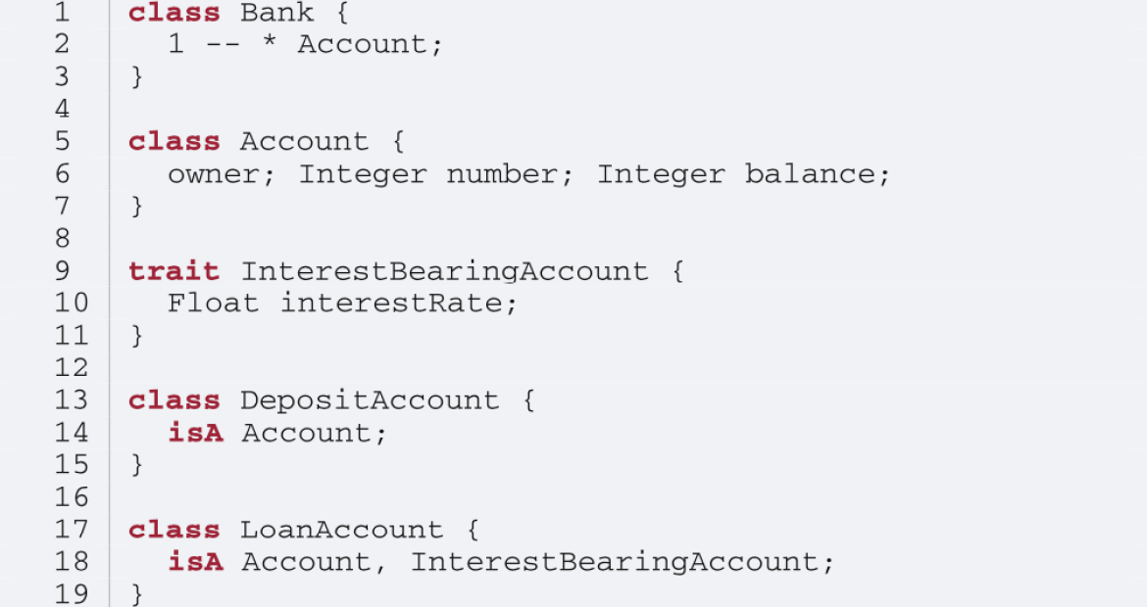

center h:550

### Class Diagram of Basic Bank Example:

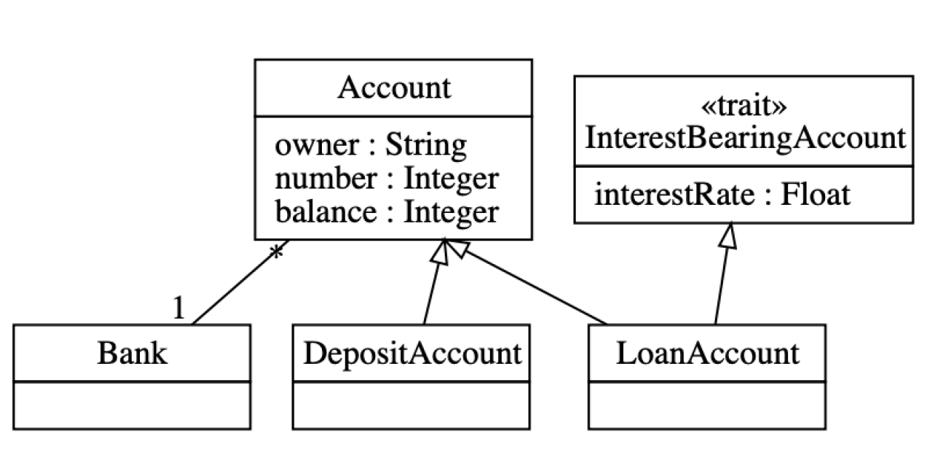

center h:550

### Adding Optional Multi-branch Feature

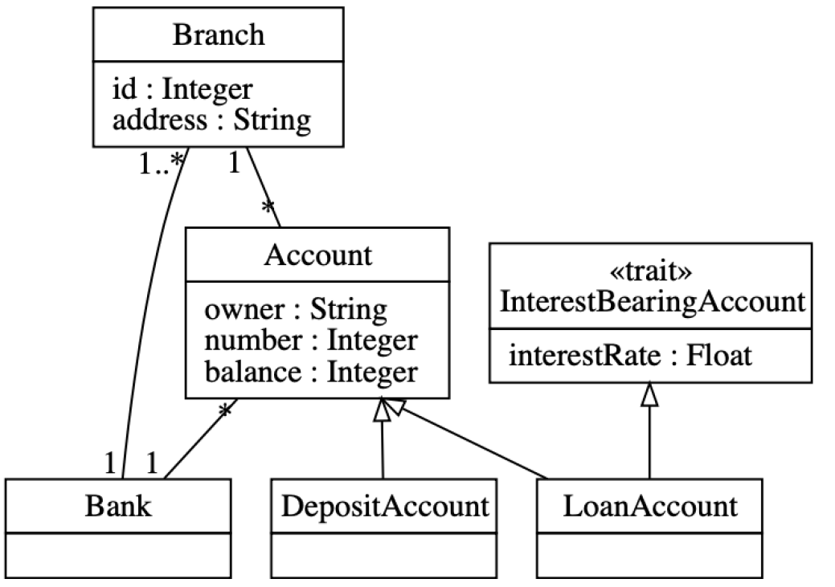

center h:550

### Example: Multi-branch Umple Model/Code

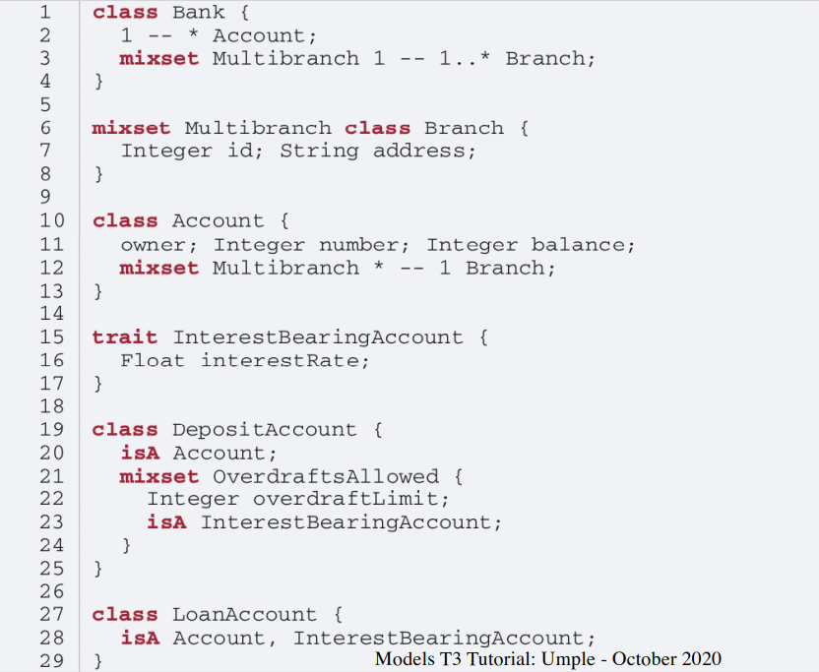

center h:550

### Alternative Approach (same system)

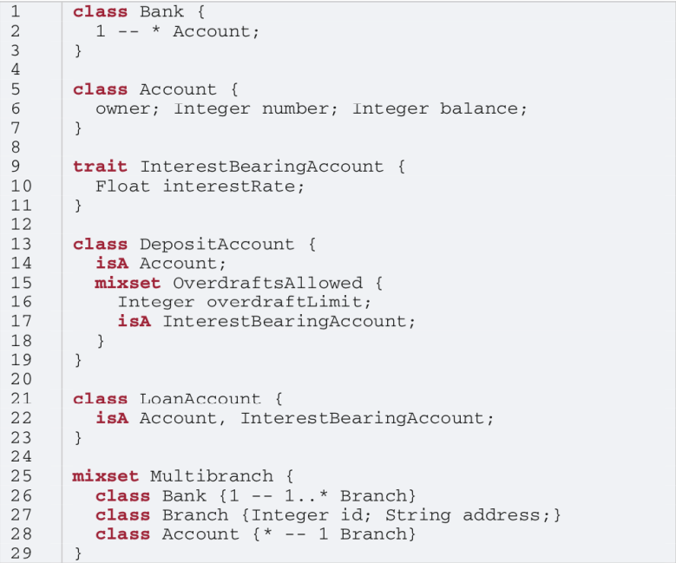

center h:550

### Constraints on Mixsets

require [Mixset1 or Mixset2];

* Allowed operators
  + and, or, xor
  + not
  + n..m of {…}
* Parentheses allowed

opt X (means 0..1 of {X})

### Case Study and Exercise 1: **Modifying the banking example**

* I will give you the text of the banking example and set up a task for you to:
  + Add the ability to have one or more account holders
  + Add the ability to have one or more co-signers

### Case Study and Exercise 2: **Dishwasher example**

* We will start with the Dishwasher example in UmpleOnline
* We will use UmpleOnline’s Task capability to ask you to split the Dishwasher example into two versions
  + A cheap version that only does normal wash and not fast wash
  + A full version that does everything
* Hint: Pull out the relevant state and transition for fast wash and wrap it in a mixset

### Case Study 3: **Umple itself, written in Umple**

* We will look at:
  + Code in Github
  + Generated Architecture diagrams
  + Generated Javadoc
  + Sample master code
  + Sample test output
  + Sample code for generators (that replaced Jet)
  + UmpleParser (that replaced Antlr

## **Unit Testing with UMPLE**

### Unit Testing with Umple

* To see how to integrate Unit Testing with Umple, see the sample project at
  + https://github.com/umple/umple/tree/master/sandbox
* And the build script at
  + https://github.com/umple/umple/blob/master/build/build.sandbox.xml
* Command line from build directory

ant -f build.xml sandbox

### A Look at How Umple is Written in Itself

* Source:
  + https://github.com/umple/umple/tree/master/cruise.umple/src
* Umple’s own class diagram generated by itself from itself:
  + http://metamodel.umple.org
  + Colours represent key subsystems
  + Click on classes to see Javadoc, and then Umple Code

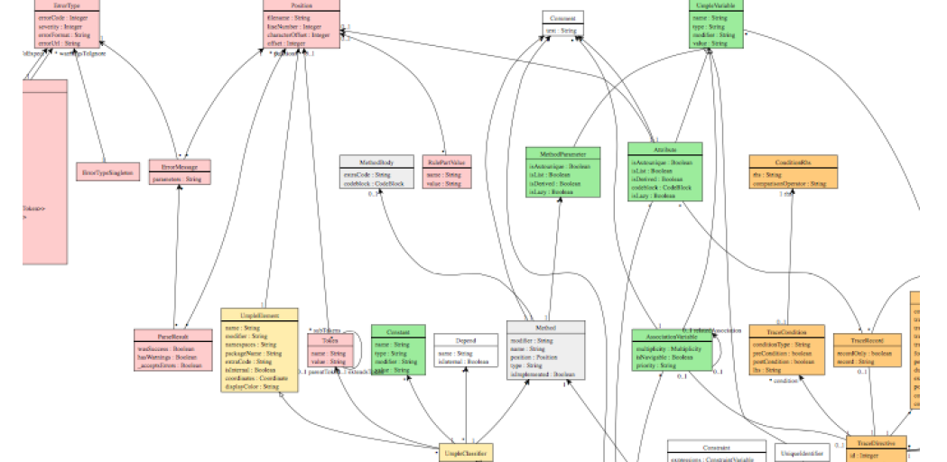

center h:300

### Testing: TDD with100% pass always required

* Multiple levels: https://cruise.eecs.uottawa.ca/qa/index.php
* **Parsing tests**: basic constructs
* **Metamodel tests**: ensure it is populated properly
* E.g.
  + https://github.com/umple/umple/blob/master/cruise.umple/test/cruise/umple/compiler/AssociationTest.java
* **Implementation template tests**: to ensure constructs generate code that looks as expected
* **Testbed semantic tests**: Generate code and make sure it behaves the way it should

## **UMPLE issues list**

### UMPLE issues list

* Tagged by
* Priority
* Perceived difficulty
* Scale (bug, project, research project)
* Milestone (slow release)

http://bugs.umple.org

## **Using Umple with Builds and Continuous Integration**

### Using Umple with Builds and Continuous Integration

* Example build scripts
* Example [travis.yml](https://github.com/umple/umple/blob/10e9b6a8124942b4f24b89e2d85dcc4260989cad/.travis.yml)
* Umple’s own [Travis](https://travis-ci.org/github/umple/umple) page

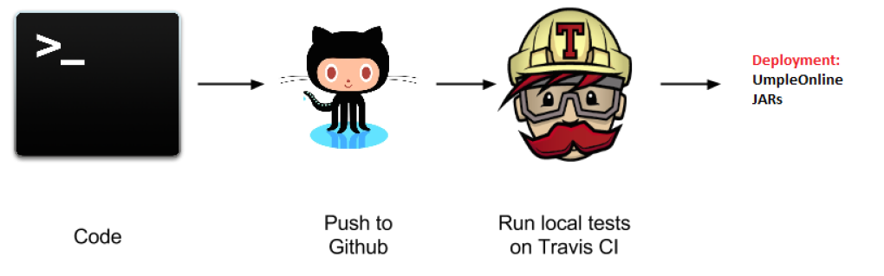

center h:300

## **UMPLE’s Architecture**

### Umple’s Architecture

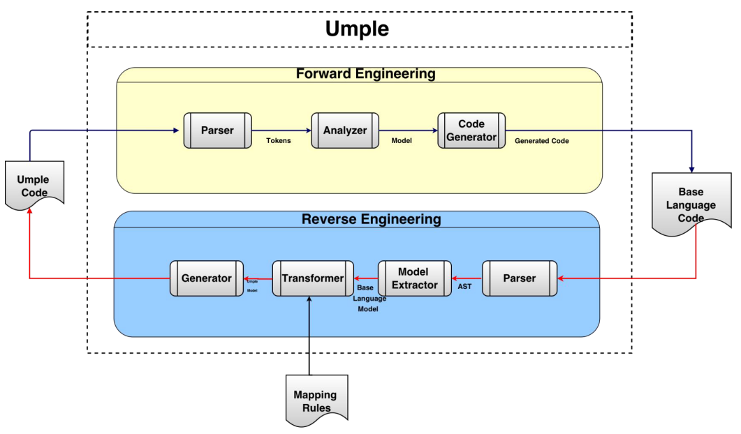

center h:550

## **Umplification**

### Umplification

* Umplification: ‘amplication’ + converting into Umple.
* Produces a program with behavior identical to the original one but written in Umple.
* Eliminates the distinction between code and model. Proceeds incrementally until the desired level of abstraction is achieved.

### Umplification: The Transformation Steps

* **Transformation 0**: Initial transformation
* **Transformation 1**: Transformation of generalization, dependency, and namespace declarations.
* **Transformation 2**: Analysis and conversion of many instance variables, along with the methods that use the variables.
  + **Transformation 2a**: Transformation of variables to UML/Umple attributes.
  + **Transformation 2b**: Transformation of variables in one or more classes to UML/Umple associations.
  + **Transformation 2c**: Transformation of variables to UML/Umple state machines.

### Umplification Process

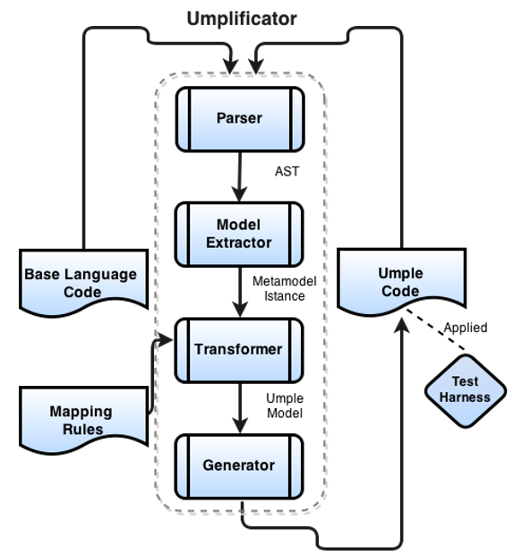

center h:550

### Umplificator Architecture

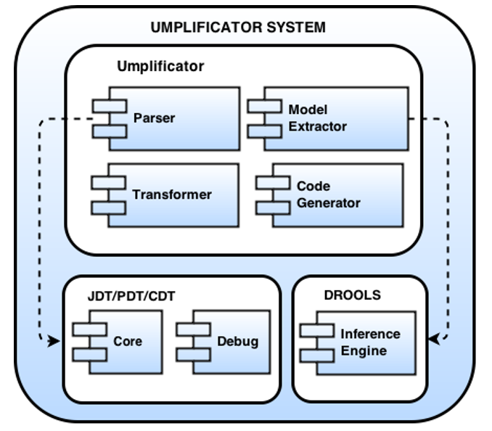

center h:550

### Umplification - Example

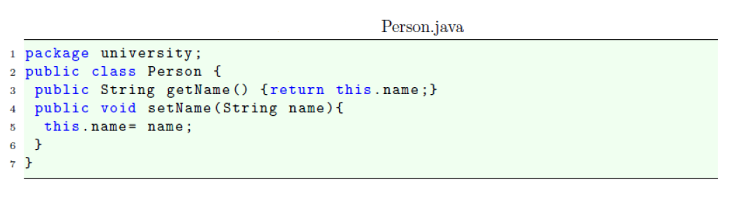

center h:400

### Umplification - Example

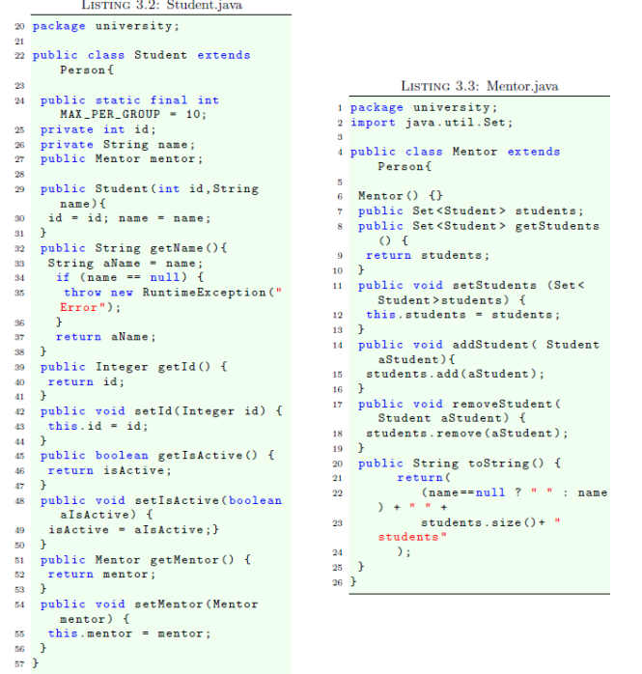

center h:550

### Systems umplified (JhotDraw 7.5.1)

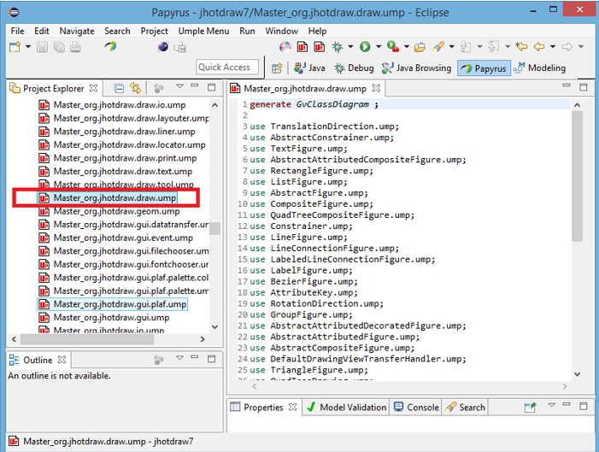

center h:550

### Systems umplified (JhotDraw 7.5.1)

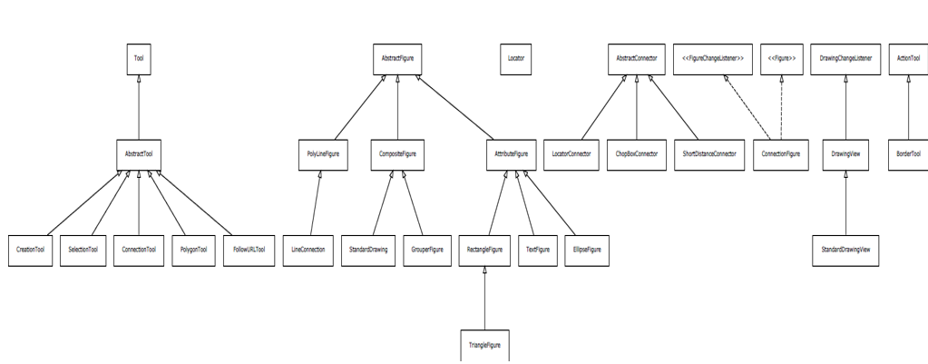

center h:550

### Systems umplified

* Weka
  + Associations umplified
* Args4J- Modernization
  + Original Args4j source code is composed of 61 classes and 2223 LOC.
  + Umplified Args4j source code is composed of 122 (2 per input class) umple files and 1980 LOC.
* # LOC in files containing modeling constructs (X.ump) is 312.
* # LOC in files with algorithmic/logic code (X code.ump) is 1668.

*The developer must then translate 1518 lines of code rather than 2223 lines of code.*

## **Conclusion**

### Conclusion

* Umple
  + Is simple but powerful modeling tool
  + Generates state-of-the-art code
  + Enables agility + model-driven development
* We call the overall approach model-based programming

### Umple Examples More ..

* http://try.umple.org
* https://github.com/umple/umple/wiki/examples
* http://umpr.a4word.com/
* http://code.umple.org
* http://metamodel.umple.org

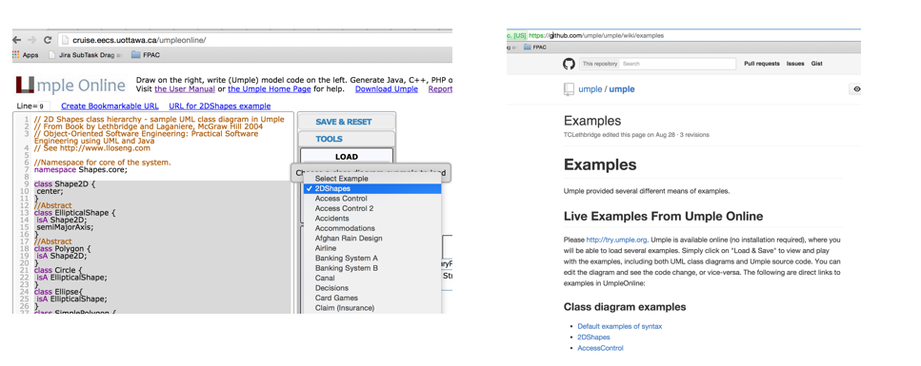

center h:250

## **References**

### References

* [UMPLE Tutorials](https://github.com/umple/umple/wiki/Tutorials)
* [UMPLE Github](https://github.com/umple/umple)
* [UMPLE Online](https://umple.org)
* [UMPLE Documentation](https://cruise.umple.org/umple/)
* [UMPLE CSI5112– February 2018](http://www.site.uottawa.ca/~mgarz042/files/CSI5112-Umple.pdf)
* [Umple Tutorial: Models 2020 Web](https://cruise.umple.org/presentations/umpleModels2020Tutorial/)
* [Umple Tutorial: Models 2020 Pdf](https://cruise.umple.org/presentations/umpleModels2020Tutorial/UmpleTutForModels2020.pdf)

### References

* [Getting Started in UMPLE](https://cruise.umple.org/umple/GettingStarted.html)
* [Experiential Learning for Software Engineering Using Agile Modeling in Umple (Youtube)](https://www.youtube.com/watch?v=yif1clbrXnI&ab_channel=CSEETconf)
* [Experiential Learning for Software Engineering Using Agile Modeling in Umple (Slide)](https://cruise.umple.org/presentations/UmpleTutorialCSEET2020.pdf)
* [Tomassetti Code Generation](https://tomassetti.me/code-generation/)