CE205 Data Structures Week-1
Introduction to Data Structure
Author: Asst. Prof. Dr. Uğur CORUH

CE205 Data Structures

Week-1

Course Plan and Communication, Course Plan and Communication, Introduction to Linear & Non-Linear Data Structure and Performance Analysis, Implementing Pointer and Objects for Data and Variables Basic of ASN.1 / BER TLV / PER TLV
Download DOC, SLIDE, PPTX

Introduction to Data Structures
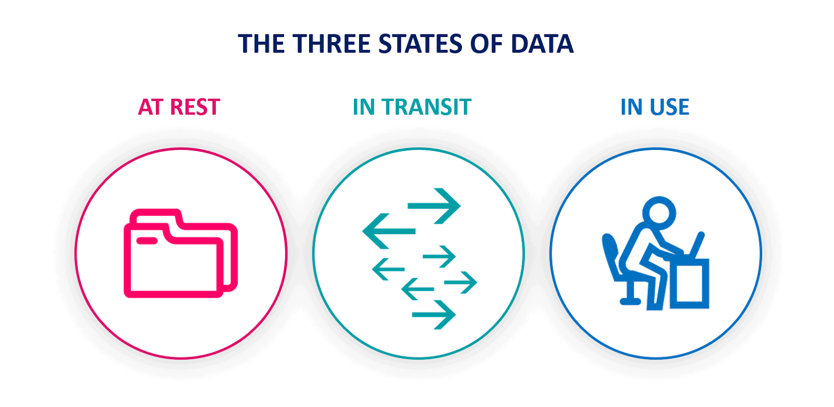

Data-in-use
- Data in use - Wikipedia
Data-in-transit
- Data in transit - Wikipedia
Data-at-rest
- Data at rest - Wikipedia

Performance Analysis
- Data Structures Tutorials - Performance Analysis with examples
Space Complexity
- Data Structures Tutorials - Space Complexity with examples
Time Complexity
- Data Structures Tutorials - Time Complexity with examples

Data and Variables
- C++ Data Types

Linear & Non-Linear Data Structures
- Data Structures Tutorials - Linear and Non-linear types
- Data Structure and Types

Implementing Pointer and Objects
- Check CS50 Pointer Notes
- Week 0 - CS50

- ASN.1 / BER TLV / PER TLV
  - http://lionet.info/asn1c/download.html
  - GitHub - ucoruh/asn1c-wsl-sample: ASN.1 C WSL and Windows Execution, Debugging and Code Generation Sample

- Sample Standard for ASN.1 Usage
  - https://www.etsi.org/deliver/etsi_ts/125400_125499/125413/04.09.00_60/ts_125413v040900p.pdf

- Payment BER TLV Parser Sample
  - TLV Utilities
  - https://paymentcardtools.com/

Week-1 End

Week-1 End

