CE205 Data Structures Week-1

Introduction to Data Structure

Author: Asst. Prof. Dr. Uğur CORUH

# CE205 Data Structures

## Week-1

#### Course Plan and Communication, Course Plan and Communication, Introduction to Linear & Non-Linear Data Structure and Performance Analysis, Implementing Pointer and Objects for Data and Variables Basic of ASN.1 / BER TLV / PER TLV

Download [DOC](ce205-week-1-intro.md_doc.pdf), [SLIDE](ce205-week-1-intro.md_slide.pdf), [PPTX](ce205-week-1-intro.md_slide.pptx)

### Outline

* Data States
* Data Structure Metrics
* Data Mapping
* Data Structure Selection
* Data Structure References
* Industrial Data Standards (ASN.1,BER-TLV,etc.)
* Trends (Open API, 5G Systems etc.)

## Introduction to Data Structures

### Data States

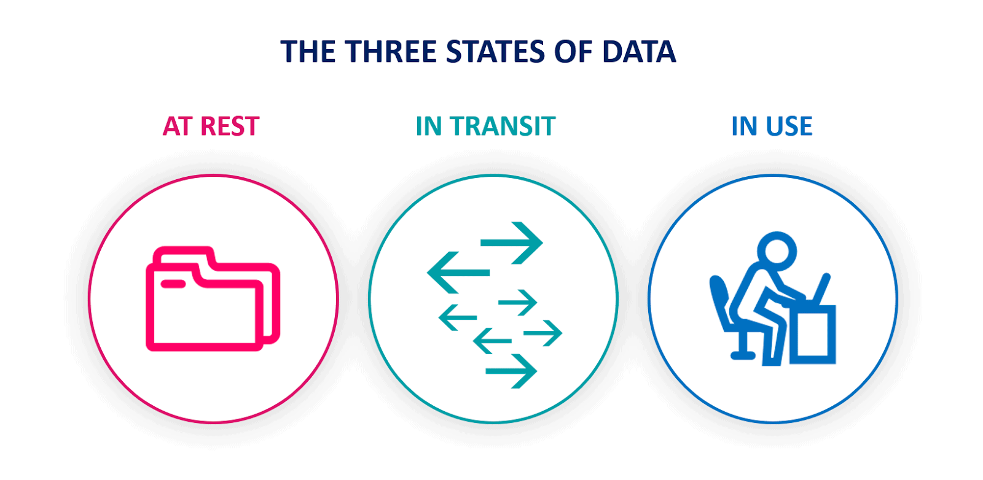

center width:900px

### Data States

Data-in-use

* [Data in use - Wikipedia](https://en.wikipedia.org/wiki/Data_in_use)

Data-in-transit

* [Data in transit - Wikipedia](https://en.wikipedia.org/wiki/Data_in_transit)

Data-at-rest

* [Data at rest - Wikipedia](https://en.wikipedia.org/wiki/Data_at_rest)

### Data Structure Metrics

Performance Analysis

* [Data Structures Tutorials - Performance Analysis with examples](http://www.btechsmartclass.com/data_structures/performance-analysis.html)

Space Complexity

* [Data Structures Tutorials - Space Complexity with examples](http://www.btechsmartclass.com/data_structures/space-complexity.html)

Time Complexity

* [Data Structures Tutorials - Time Complexity with examples](http://www.btechsmartclass.com/data_structures/time-complexity.html)

### Data Mapping

Data and Variables

* [C++ Data Types](https://www.tutorialspoint.com/cplusplus/cpp_data_types.htm)

### Data Structure Selection

Linear & Non-Linear Data Structures

* [Data Structures Tutorials - Linear and Non-linear types](http://www.btechsmartclass.com/data_structures/linear-non-linear-data-structures.html)
* [Data Structure and Types](https://www.programiz.com/dsa/data-structure-types)

### Data Structure References

Implementing Pointer and Objects

* Check [CS50 Pointer Notes](files/CS50%20Modified.pdf)
* [Week 0 - CS50](https://cs50.harvard.edu/college/2021/fall/weeks/0/)

### Industrial Data Standards

* ASN.1 / BER TLV / PER TLV
  + http://lionet.info/asn1c/download.html
  + [GitHub - ucoruh/asn1c-wsl-sample: ASN.1 C WSL and Windows Execution, Debugging and Code Generation Sample](https://github.com/ucoruh/asn1c-wsl-sample)
  + [Open Source ASN.1 Compiler: asn1c 0.9.28](http://lionet.info/asn1c/download.html)

### Industrial Data Standards - Telco

* Sample Standard for ASN.1 Usage
  + https://www.etsi.org/deliver/etsi_ts/125400_125499/125413/04.09.00_60/ts_125413v040900p.pdf

### Industrial Data Standards - Payment

* Payment BER TLV Parser Sample
  + [TLV Utilities](https://emvlab.org/tlvutils/?data=6F1A840E315041592E5359532E4444463031A5088801025F2D02656E)
  + https://paymentcardtools.com/

### Industrial Data Standards - Telco

#### ASN.1 Standartları

* ETSI
  + https://portal.etsi.org/Services/Centre-for-Testing-Interoperability/ETSI-Approach/Specification-Languages/ASN1
* ITU-T
  + https://www.itu.int/ITU-T/recommendations/fl.aspx?lang=1
* ASN.1 Book
  + https://www.oss.com/asn1/resources/books-whitepapers-pubs/dubuisson-asn1-book.PDF

#### Network Measurement Results Data

* NMR
  + https://www.etsi.org/deliver/etsi_ts/101500_101599/101503/08.27.00_60/ts_101503v082700p.pdf
* GSM API
  + https://www.etsi.org/deliver/etsi_ts/101400_101499/101476/08.04.01_60/ts_101476v080401p.pdf
* UTRAN
  + https://www.etsi.org/deliver/etsi_ts/125300_125399/125331/13.01.00_60/ts_125331v130100p.pdf
* E-UTRAN
  + https://www.etsi.org/deliver/etsi_ts/136300_136399/136331/15.03.00_60/ts_136331v150300p.pdf

### Open Source 5G Projects

* <https://open5gs.org/>
* [5g nr development and setup · Wiki · oai / openairinterface5G · GitLab](https://gitlab.eurecom.fr/oai/openairinterface5g/-/wikis/5g-nr-development-and-setup)

### OPEN API

* Open API Generator
  + <https://openapi-generator.tech/>
* Open API Yaml Configurations
  + [GitHub - jdegre/5GC_APIs: RESTful APIs of main Network Functions in the 3GPP 5G Core Network](https://github.com/jdegre/5GC_APIs)
* Open API AUSF Yaml Configuration
  + https://www.etsi.org/deliver/etsi_TS/129500_129599/129509/17.06.00_60/ts_129509v170600p.pdf
  + https://www.etsi.org/deliver/etsi_TS/129500_129599/129509/17.06.00_60/ts_129509v170600p0.zip