CE205 Data Structures Week-4

Tree Data Structure Types and Applications (Binary Tree, Tree Traversals, Heaps)

Author: Asst. Prof. Dr. Uğur CORUH

# CE205 Data Structures

# Week-4

### Tree Data Structure Types and Applications (Binary Tree, Tree Traversals, Heaps)

Download [DOC](ce205-week-4-tree-structures.md_doc.pdf), [SLIDE](ce205-week-4-tree-structures.md_slide.pdf), [PPTX](ce205-week-4-tree-structures.md_slide.pptx)

### Outline

* Graph Representation Tools
* Tree Structures and Binary Tree and Traversals (In-Order, Pre-Order, Post-Order)
* Heaps (Max, Min, Binary , Binomial, Fibonacci, Leftist, K-ary) and Priority Queue
* Heap Sort
* Huffman Coding

### Graph Representation Tools

* Microsoft Automatic Graph Layout
  + https://www.microsoft.com/en-us/download/details.aspx?id=52034
  + https://github.com/microsoft/automatic-graph-layout
* Graphviz
  + https://graphviz.org/resources/
* Plantuml
  + https://ucoruh.github.io/ce204-object-oriented-programming/week-5/ce204-week-5/#calling-plantuml-from-java_1

### Tree - Terminology

* Btech Smart Class
  + http://www.btechsmartclass.com/data_structures/tree-terminology.html

### Tree Representations

* Btech Smart Class
  + http://www.btechsmartclass.com/data_structures/tree-representations.html

### Binary Tree Datastructure

1. Construction and Conversion
2. Checking and Printing
3. Summation
4. Longest Common Ancestor

* Btech Smart Class
  + http://www.btechsmartclass.com/data_structures/binary-tree.html
* William Fiset
  + https://www.youtube.com/watch?v=sD1IoalFomA&ab_channel=WilliamFiset

### Longet Common Ancestor

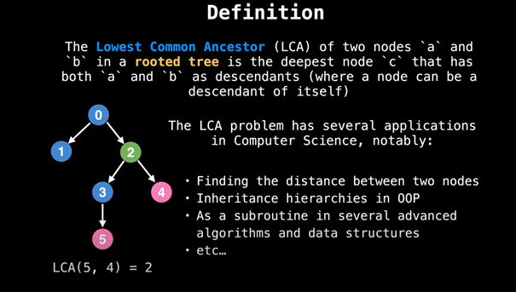

### Longet Common Ancestor

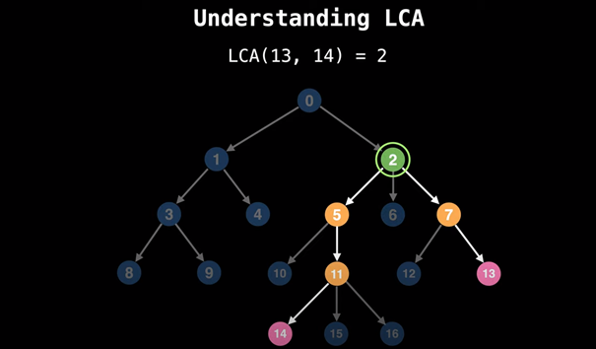

### Binary Tree Representations

* Btech Smart Class
  + http://www.btechsmartclass.com/data_structures/binary-tree-representations.html

### Binary Tree Traversals

* Btech Smart Class
  + http://www.btechsmartclass.com/data_structures/binary-tree-traversals.html
    - In-Order
    - Pre-Order
    - Post-Order

### Threaded Binary Trees

* Btech Smart Class
  + http://www.btechsmartclass.com/data_structures/threaded-binary-trees.html

### Max Priority Queue

* Btech Smart Class
  + http://www.btechsmartclass.com/data_structures/max-priority-queue.html
* William Fiset
  + https://www.youtube.com/watch?v=wptevk0bshY&t=0s&ab_channel=WilliamFiset
  + https://github.com/williamfiset/Algorithms/tree/master/src/main/java/com/williamfiset/algorithms/datastructures/priorityqueue

### Heap Data Structure

* Heap Sort
  + https://ucoruh.github.io/ce100-algorithms-and-programming-II/week-4/ce100-week-4-heap/

### Heap Data Structure

* Programiz
  + https://www.programiz.com/dsa/heap-data-structure
* Btech Smart Class
  + Max-Heap
    - http://www.btechsmartclass.com/data_structures/max-heap.html
* Geeks for Geeks
  + Binary Heap
    - https://www.geeksforgeeks.org/binary-heap/?ref=lbp
    - https://www.geeksforgeeks.org/difference-between-binary-heap-binomial-heap-and-fibonacci-heap/?ref=rp

### Heap Data Structure

* Binomial Heap
  + Geeks for Geeks
    - https://www.geeksforgeeks.org/binomial-heap-2/

### Heap Data Structure

1. Structure of Fibonacci Heaps
2. Mergeable-heap operations

* Fibonacci Heap
  + William Fiset
    - https://github.com/williamfiset/Algorithms/tree/master/src/main/java/com/williamfiset/algorithms/datastructures/fibonacciheap
  + Geeks for Geeks
    - https://www.geeksforgeeks.org/fibonacci-heap-set-1-introduction/?ref=lbp

### Heap Data Structure

1. Decreasing a key and deleting a node
2. Bounding the maximum degree

* Heap Operations
  + https://www.geeksforgeeks.org/fibonacci-heap-insertion-and-union/?ref=lbp
  + https://www.geeksforgeeks.org/fibonacci-heap-deletion-extract-min-and-decrease-key/?ref=lbp

### Heap Data Structure

* Leftist Heap
  + Geeks for Geeks
    - https://www.geeksforgeeks.org/leftist-tree-leftist-heap/?ref=lbp
  + Toronto
    - https://www.dgp.toronto.edu/public_user/JamesStewart/378notes/10leftist/

### Heap Data Structure

* Geeks for Geeks
  + https://www.geeksforgeeks.org/k-ary-heap/?ref=lbp

### Heap Data Structure

* Heap Sort
  + https://ucoruh.github.io/ce100-algorithms-and-programming-II/week-4/ce100-week-4-heap/

### Heap Data Structure

* Huffman Coding
  + Geeks for Geeks
    - https://www.geeksforgeeks.org/difference-between-binary-heap-binomial-heap-and-fibonacci-heap/?ref=rp

$$End−Of−Week−4$$