CE205 Data Structures Week-3

Stacks, Queue Structures and Related Algorithms and Problems.

Author: Asst. Prof. Dr. UÄŸur CORUH

## CE205 Data Structures

### Week-3

#### Stacks, Queue Structures, and Related Algorithms and Problems.

Download [PDF](pandoc_ce205-week-3-stack.tr_doc.pdf),[DOCX](pandoc_ce205-week-3-stack.tr_word.docx), [SLIDE](ce205-week-3-stack.tr_slide.pdf), [PPTX](ce205-week-3-stack.tr_slide.pptx)

### Outline-1

* Stack ADT
  + Stack Using Array
  + Stack Using Linked List
* Expressions
  + Infix
  + Postfix
  + Prefix
  + Infix to Postfix Conversion
  + Postfix Expression Evaluation

### Outline-2

* Queue ADT
  + First Come First Serve, FCFS, FIFO
  + Queue Data structure Using Array
  + Queue Using Linked List
  + Circular Queue Data structure
  + Double Ended Queue Data structure
  + Multilevel Queue (MLQ)
* Hanoi Tower

### Stack ADT

* BTech Smart Class
  + http://www.btechsmartclass.com/data_structures/stack-adt.html

### Stack Data Structure

In this tutorial, you will learn about the stack data structure and its implementation in Python, Java and C/C++.

A stack is a linear data structure that follows the principle ofÂ **Last In First Out (LIFO)**. This means the last element inserted inside the stack is removed first.

You can think of the stack data structure as the pile of plates on top of another.



* Stack representation similar to a pile of plate
* Here, you can:
  + Put a new plate on top
  + Remove the top plate
* And, if you want the plate at the bottom,
* You must first remove all the plates on top.
* This is exactly how the stack data structure works.

### LIFO Principle of Stack

* In programming terms, putting an item on top of the stack is calledÂ **push**Â and removing an item is calledÂ **pop**.



* In the above image, although itemÂ **3**Â was kept last, it was removed first. This is exactly how theÂ **LIFO (Last In First Out) Principle**Â works.
* We can implement a stack in any programming language like C, C++, Java, Python or C#, but the specification is pretty much the same.

### Basic Operations of Stack

* Some basic operations allow us to perform different actions on a stack.
  + **Push**: Add an element to the top of a stack
  + **Pop**: Remove an element from the top of a stack
  + **IsEmpty**: Check if the stack is empty
  + **IsFull**: Check if the stack is full
  + **Peek**: Get the value of the top element without removing it

### Working of Stack Data Structure

The operations work as follows:

1. A pointer calledÂ TOPÂ is used to keep track of the top element in the stack.
2. When initializing the stack, we set its value to -1 so that we can check if the stack is empty by comparingÂ TOP == -1.
3. On pushing an element, we increase the value ofÂ TOPÂ and place the new element in the position pointed to byÂ TOP.
4. On popping an element, we return the element pointed to byÂ TOPÂ and reduce its value.
5. Before pushing, we check if the stack is already full
6. Before popping, we check if the stack is already empty



### What is a Stack?

* Stack is a linear data structure in which the insertion and deletion operations are performed at only one end.
* In a stack, adding and removing of elements are performed at a single position which is known as “**top**”.
* That means, a new element is added at top of the stack and an element is removed from the top of the stack.
* In stack, the insertion and deletion operations are performed based onÂ **LIFO**Â (Last In First Out) principle.

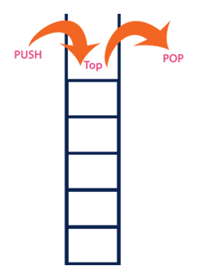

In a stack, the insertion operation is performed using a function calledÂ **“push”**Â and deletion operation is performed using a function calledÂ **“pop”**.

* In the figure, PUSH and POP operations are performed at a top position in the stack.
  + That means, both the insertion and deletion operations are performed at one end (i.e., at Top)
* A stack data structure can be defined as follows
* Stack is a linear data structure in which the operations are performed based on LIFO principle.
* Stack can also be defined as
  + “A Collection of similar data items in which both insertion and deletion operations are performed based on LIFO principle”.

### Stack Example

* If we want to create a stack by inserting 10,45,12,16,35 and 50.
* Then 10 becomes the bottom-most element and 50 is the topmost element.
* The last inserted element 50 is at Top of the stack as shown in the image below.

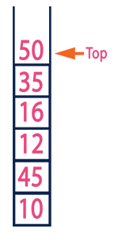

### Operations on a Stack

* The following operations are performed on the stack
  + Push (To insert an element on to the stack)
  + Pop (To delete an element from the stack)
  + Display (To display elements of the stack)

### Implementation of a Stack

* Stack data structure can be implemented in two ways.
  + Using Array
  + Using Linked List
* When a stack is implemented using an array, that stack can organize an only limited number of elements.
* When a stack is implemented using a linked list, that stack can organize an unlimited number of elements.

### Stack Using Array

* BTech Smart Class
  + http://www.btechsmartclass.com/data_structures/stack-using-array.html
* A stack data structure can be implemented using a one-dimensional array.
* But stack implemented using array stores only a fixed number of data values. This implementation is very simple.
* Just define a one dimensional array of specific size and insert or delete the values into that array by usingÂ **LIFO principle**Â with the help of a variable calledÂ **‘top’**.
* Initially, the top is set to -1.
* Whenever we want to insert a value into the stack, increment the top value by one and then insert.
* Whenever we want to delete a value from the stack, then delete the top value and decrement the top value by one.

### Stack Operations using Array

* A stack can be implemented using array as follows
  + Before implementing actual operations, first follow the below steps to create an empty stack.
* Step 1 -Â Include all theÂ **header files**Â which are used in the program and define a constantÂ **‘SIZE’**Â with specific value.
* Step 2 -Â Declare all theÂ **functions**Â used in stack implementation.
* Step 3 -Â Create a one dimensional array with fixed size (**int stack[SIZE]**)
* Step 4 -Â Define a integer variableÂ **‘top’**Â and initialize withÂ **‘-1’**. (**int top = -1**)
* Step 5 -Â In main method, display menu with list of operations and make suitable function calls to perform operation selected by the user on the stack.

**push(value) - Inserting value into the stack**

* In a stack, push() is a function used to insert an element into the stack.
* In a stack, the new element is always inserted atÂ **top**Â position.
* Push function takes one integer value as parameter and inserts that value into the stack. We can use the following steps to push an element on to the stack
* Step 1 -Â Check whetherÂ **stack**Â isÂ **FULL**. (**top == SIZE-1**)
* Step 2 -Â If it isÂ **FULL**, then displayÂ **“Stack is FULL!!! Insertion is not possible!!!”**Â and terminate the function.
* Step 3 -Â If it isÂ **NOT FULL**, then incrementÂ **top**Â value by one (**top++**) and set stack[top] to value (**stack[top] = value**).

**pop() - Delete a value from the Stack**

* In a stack, pop() is a function used to delete an element from the stack.
* In a stack, the element is always deleted fromÂ **top**Â position.
* Pop function does not take any value as parameter.
* We can use the following steps to pop an element from the stack
* Step 1 -Â Check whetherÂ **stack**Â isÂ **EMPTY**. (**top == -1**)
* Step 2 -Â If it isÂ **EMPTY**, then displayÂ **“Stack is EMPTY!!! Deletion is not possible!!!”**Â and terminate the function.
* Step 3 -Â If it isÂ **NOT EMPTY**, then deleteÂ **stack[top]**Â and decrementÂ **top**Â value by one (**top–**).

**display() - Displays the elements of a Stack**

* We can use the following steps to display the elements of a stack
  + Step 1 -Â Check whetherÂ **stack**Â isÂ **EMPTY**. (**top == -1**)
  + Step 2 -Â If it isÂ **EMPTY**, then displayÂ **“Stack is EMPTY!!!”**Â and terminate the function.
  + Step 3 -Â If it isÂ **NOT EMPTY**, then define a variable ‘**i**’ and initialize with top. DisplayÂ **stack[i]**Â value and decrementÂ **i**Â value by one (**i–**).
  + Step 3 -Â Repeat above step untilÂ **i**Â value becomes ‘0’.

### Stack Array Implementation in C

#include<stdio.h>  
#include<conio.h>  
  
#define SIZE 10  
  
void push(int);  
void pop();  
void display();  
  
...

### Stack Array Implementation in C

...  
  
int stack[SIZE], top = -1;  
  
...

...  
  
void main()  
{  
 int value, choice;  
 clrscr();  
 while(1){  
 printf("\n\n***** MENU *****\n");  
 printf("1. Push\n2. Pop\n3. Display\n4. Exit");  
 printf("\nEnter your choice: ");  
 scanf("%d",&choice);  
 switch(choice){  
 case 1: printf("Enter the value to be insert: ");  
 scanf("%d",&value);  
 push(value);  
 break;  
 case 2: pop();  
 break;  
 case 3: display();  
 break;  
 case 4: exit(0);  
 default: printf("\nWrong selection!!! Try again!!!");  
 }  
 }  
}  
  
...

...  
  
void push(int value){  
 if(top == SIZE-1)  
 printf("\nStack is Full!!! Insertion is not possible!!!");  
 else{  
 top++;  
 stack[top] = value;  
 printf("\nInsertion success!!!");  
 }  
}  
  
...

...  
  
void pop(){  
 if(top == -1)  
 printf("\nStack is Empty!!! Deletion is not possible!!!");  
 else{  
 printf("\nDeleted : %d", stack[top]);  
 top--;  
 }  
}  
  
...

...  
  
void display(){  
 if(top == -1)  
 printf("\nStack is Empty!!!");  
 else{  
 int i;  
 printf("\nStack elements are:\n");  
 for(i=top; i>=0; i--)  
 printf("%d\n",stack[i]);  
 }  
}

### Output

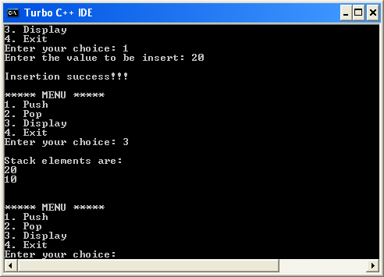

### Stack Array Implementation in Java

// Stack implementation in Java  
  
class Stack {  
 private int arr[];  
 private int top;  
 private int capacity;  
  
...

...  
  
 // Creating a stack  
 Stack(int size) {  
 arr = new int[size];  
 capacity = size;  
 top = -1;  
 }  
  
...

...  
 // Add elements into stack  
 public void push(int x) {  
 if (isFull()) {  
 System.out.println("OverFlow\nProgram Terminated\n");  
 System.exit(1);  
 }  
  
 System.out.println("Inserting " + x);  
 arr[++top] = x;  
 }  
  
...

...  
 // Remove element from stack  
 public int pop() {  
 if (isEmpty()) {  
 System.out.println("STACK EMPTY");  
 System.exit(1);  
 }  
 return arr[top--];  
 }  
  
...

...  
 // Utility function to return the size of the stack  
 public int size() {  
 return top + 1;  
 }  
  
...

...  
 // Check if the stack is empty  
 public Boolean isEmpty() {  
 return top == -1;  
 }  
  
...

...  
 // Check if the stack is full  
 public Boolean isFull() {  
 return top == capacity - 1;  
 }  
  
...

...  
 public void printStack() {  
 for (int i = 0; i <= top; i++) {  
 System.out.println(arr[i]);  
 }  
 }  
  
...

...  
 public static void main(String[] args) {  
 Stack stack = new Stack(5);  
  
 stack.push(1);  
 stack.push(2);  
 stack.push(3);  
 stack.push(4);  
  
 stack.pop();  
 System.out.println("\nAfter popping out");  
  
 stack.printStack();  
  
 }  
}

### Stack Array Implementation in C

// Stack implementation in C  
  
#include <stdio.h>  
#include <stdlib.h>  
  
#define MAX 10  
  
int count = 0;  
  
// Creating a stack  
struct stack {  
 int items[MAX];  
 int top;  
};  
typedef struct stack st;  
  
...

### Stack Array Implementation in C

...  
  
// Stack implementation in C  
  
void createEmptyStack(st *s) {  
 s->top = -1;  
}  
  
...

...  
  
// Check if the stack is full  
int isfull(st *s) {  
 if (s->top == MAX - 1)  
 return 1;  
 else  
 return 0;  
}  
  
...

...  
  
// Check if the stack is empty  
int isempty(st *s) {  
 if (s->top == -1)  
 return 1;  
 else  
 return 0;  
}  
  
...

...  
  
// Add elements into stack  
void push(st *s, int newitem) {  
 if (isfull(s)) {  
 printf("STACK FULL");  
 } else {  
 s->top++;  
 s->items[s->top] = newitem;  
 }  
 count++;  
}  
  
...

...  
  
// Remove element from stack  
void pop(st *s) {  
 if (isempty(s)) {  
 printf("\n STACK EMPTY \n");  
 } else {  
 printf("Item popped= %d", s->items[s->top]);  
 s->top--;  
 }  
 count--;  
 printf("\n");  
}  
  
...

...  
  
// Print elements of stack  
void printStack(st *s) {  
 printf("Stack: ");  
 for (int i = 0; i < count; i++) {  
 printf("%d ", s->items[i]);  
 }  
 printf("\n");  
}  
  
...

...  
  
// Driver code  
int main() {  
 int ch;  
 st *s = (st *)malloc(sizeof(st));  
  
 createEmptyStack(s);  
  
 push(s, 1);  
 push(s, 2);  
 push(s, 3);  
 push(s, 4);  
  
 printStack(s);  
  
 pop(s);  
  
 printf("\nAfter popping out\n");  
 printStack(s);  
}

// Stack implementation in C++  
  
#include <stdlib.h>  
#include <iostream>  
  
using namespace std;  
  
#define MAX 10  
int size = 0;  
  
// Creating a stack  
struct stack {  
 int items[MAX];  
 int top;  
};  
typedef struct stack st;  
  
...

### Stack Array Implementation in CPP

void createEmptyStack(st *s) {  
 s->top = -1;  
}  
  
...

// Check if the stack is full  
int isfull(st *s) {  
 if (s->top == MAX - 1)  
 return 1;  
 else  
 return 0;  
}  
  
...

// Check if the stack is empty  
int isempty(st *s) {  
 if (s->top == -1)  
 return 1;  
 else  
 return 0;  
}  
  
...

// Add elements into stack  
void push(st *s, int newitem) {  
 if (isfull(s)) {  
 cout << "STACK FULL";  
 } else {  
 s->top++;  
 s->items[s->top] = newitem;  
 }  
 size++;  
}  
  
...

// Remove element from stack  
void pop(st *s) {  
 if (isempty(s)) {  
 cout << "\n STACK EMPTY \n";  
 } else {  
 cout << "Item popped= " << s->items[s->top];  
 s->top--;  
 }  
 size--;  
 cout << endl;  
}  
  
...

// Print elements of stack  
void printStack(st *s) {  
 printf("Stack: ");  
 for (int i = 0; i < size; i++) {  
 cout << s->items[i] << " ";  
 }  
 cout << endl;  
}  
  
...

// Driver code  
int main() {  
 int ch;  
 st *s = (st *)malloc(sizeof(st));  
  
 createEmptyStack(s);  
  
 push(s, 1);  
 push(s, 2);  
 push(s, 3);  
 push(s, 4);  
  
 printStack(s);  
  
 pop(s);  
  
 cout << "\nAfter popping out\n";  
 printStack(s);  
}

### Stack Time Complexity

For the array-based implementation of a stack, the push and pop operations take constant time, i.e.Â O(1).

### Applications of Stack Data Structure

* Although stack is a simple data structure to implement, it is very powerful. The most common uses of a stack are:
  + **To reverse a word**Â - Put all the letters in a stack and pop them out. Because of the LIFO order of stack, you will get the letters in reverse order.
  + **In compilers**Â - Compilers use the stack to calculate the value of expressions likeÂ 2 + 4 / 5 * (7 - 9)Â by converting the expression to prefix or postfix form.
  + **In browsers**Â - The back button in a browser saves all the URLs you have visited previously in a stack. Each time you visit a new page, it is added on top of the stack. When you press the back button, the current URL is removed from the stack, and the previous URL is accessed.

### Stack Using Linked List

* BTech Smart Class
  + http://www.btechsmartclass.com/data_structures/stack-using-linked-list.html
* The major problem with the stack implemented using an array is, it works only for a fixed number of data values.
* That means the amount of data must be specified at the beginning of the implementation itself.
* Stack implemented using an array is not suitable, when we don’t know the size of data which we are going to use.
* A stack data structure can be implemented by using a linked list data structure. The stack implemented using linked list can work for an unlimited number of values.
* That means, stack implemented using linked list works for the variable size of data. So, there is no need to fix the size at the beginning of the implementation. The Stack implemented using linked list can organize as many data values as we want.

In linked list implementation of a stack, every new element is inserted as ‘**top**’ element. That means every newly inserted element is pointed by ‘**top**’. Whenever we want to remove an element from the stack, simply remove the node which is pointed by ‘**top**’ by moving ‘**top**’ to its previous node in the list. TheÂ **next**Â field of the first element must be alwaysÂ **NULL**.

### Stack Using Linked List Example

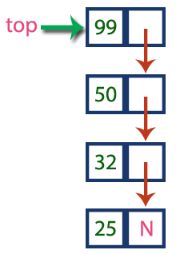

* In the above example, the last inserted node is 99 and the first inserted node is 25. The order of elements inserted is 25, 32,50 and 99.

### Stack Operations using Linked List

* To implement a stack using a linked list, we need to set the following things before implementing actual operations.
  + Step 1 -Â Include all theÂ **header files**Â which are used in the program. And declare all theÂ **user defined functions**.
  + Step 2 -Â Define a ‘**Node**’ structure with two membersÂ **data**Â andÂ **next**.
  + Step 3 -Â Define aÂ **Node**Â pointer ‘**top**’ and set it toÂ **NULL**.
  + Step 4 -Â Implement theÂ **main**Â method by displaying Menu with list of operations and make suitable function calls in theÂ **main**Â method.
* **push(value) - Inserting an element into the Stack**
* We can use the following steps to insert a new node into the stack…
  + Step 1 -Â Create aÂ **newNode**Â with given value.
  + Step 2 -Â Check whether stack isÂ **Empty**Â (**top**Â ==Â **NULL**)
  + Step 3 -Â If it isÂ **Empty**, then setÂ **newNode â†’ next**Â =Â **NULL**.
  + Step 4 -Â If it isÂ **Not Empty**, then setÂ **newNode â†’ next**Â =Â **top**.
  + Step 5 -Â Finally, setÂ **top**Â =Â **newNode**.
* **pop() - Deleting an Element from a Stack**
* We can use the following steps to delete a node from the stack…
  + Step 1 -Â Check whetherÂ **stack**Â isÂ **Empty**Â (**top == NULL**).
  + Step 2 -Â If it isÂ **Empty**, then displayÂ **“Stack is Empty!!! Deletion is not possible!!!”**Â and terminate the function
  + Step 3 -Â If it isÂ **Not Empty**, then define aÂ **Node**Â pointer ‘**temp**’ and set it to ‘**top**’.
  + Step 4 -Â Then set ‘**top**Â =Â **top â†’ next**’.
  + Step 5 -Â Finally, delete ‘**temp**’. (**free(temp)**).
* **display() - Displaying stack of elements**
* We can use the following steps to display the elements (nodes) of a stack…
  + Step 1 -Â Check whether stack isÂ **Empty**Â (**top**Â ==Â **NULL**).
  + Step 2 -Â If it isÂ **Empty**, then displayÂ **‘Stack is Empty!!!’**Â and terminate the function.
  + Step 3 -Â If it isÂ **Not Empty**, then define a Node pointerÂ **‘temp’**Â and initialize withÂ **top**.
  + Step 4 -Â Display ‘**temp â†’ data**Â —>’ and move it to the next node. Repeat the same untilÂ **temp**Â reaches to the first node in the stack. (**temp â†’ next**Â !=Â **NULL**).
  + Step 5 -Â Finally! Display ‘**temp â†’ data**Â —>Â **NULL**’.

### Stack using Linked List in C

#include<stdio.h>  
#include<conio.h>  
  
struct Node  
{  
 int data;  
 struct Node *next;  
}*top = NULL;  
  
...

### Stack using Linked List in C

...  
  
void push(int);  
void pop();  
void display();  
  
...

...  
  
void main()  
{  
 int choice, value;  
 clrscr();  
 printf("\n:: Stack using Linked List ::\n");  
 while(1){  
 printf("\n****** MENU ******\n");  
 printf("1. Push\n2. Pop\n3. Display\n4. Exit\n");  
 printf("Enter your choice: ");  
 scanf("%d",&choice);  
 switch(choice){  
 case 1: printf("Enter the value to be insert: ");  
 scanf("%d", &value);  
 push(value);  
 break;  
 case 2: pop(); break;  
 case 3: display(); break;  
 case 4: exit(0);  
 default: printf("\nWrong selection!!! Please try again!!!\n");  
 }  
 }  
}  
  
...

...  
  
void push(int value)  
{  
 struct Node *newNode;  
 newNode = (struct Node*)malloc(sizeof(struct Node));  
 newNode->data = value;  
 if(top == NULL)  
 newNode->next = NULL;  
 else  
 newNode->next = top;  
 top = newNode;  
 printf("\nInsertion is Success!!!\n");  
}  
  
...

...  
void pop()  
{  
 if(top == NULL)  
 printf("\nStack is Empty!!!\n");  
 else{  
 struct Node *temp = top;  
 printf("\nDeleted element: %d", temp->data);  
 top = temp->next;  
 free(temp);  
 }  
}  
...

...  
void display()  
{  
 if(top == NULL)  
 printf("\nStack is Empty!!!\n");  
 else{  
 struct Node *temp = top;  
 while(temp->next != NULL){  
 printf("%d--->",temp->data);  
 temp = temp -> next;  
 }  
 printf("%d--->NULL",temp->data);  
 }  
}

### Output

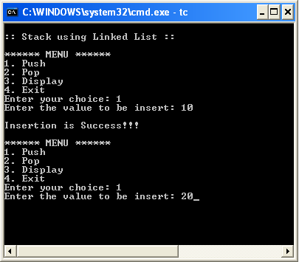

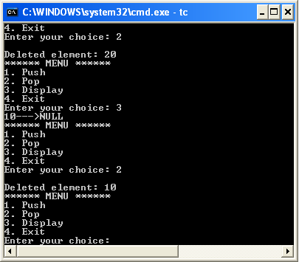

### Expressions

* BTech Smart Class
  + http://www.btechsmartclass.com/data_structures/expressions.html
    - Infix
    - Postfix
    - Prefix

### What is an Expression?

* In any programming language, if we want to perform any calculation or to frame a condition etc.,
* we use a set of symbols to perform the task.
* These set of symbols makes an expression.
* An expression is a collection of operators and operands that represents a specific value.
* In above definition,Â **operator**Â is a symbol which performs a particular task like arithmetic operation or logical operation or conditional operation etc.,
* **Operands**Â are the values on which the operators can perform the task. Here operand can be a direct value or variable or address of memory location.

### Expression Types

* Based on the operator position, expressions are divided into THREE types. They are as follows…
  + Infix Expression
  + Postfix Expression
  + Prefix Expression

### Infix Expression

* In infix expression, operator is used in between the operands.
* The general structure of an Infix expression is as follows.

Operand1 Operator Operand2

### Infix Expression Example

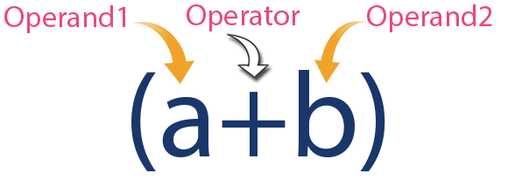

### Postfix Expression

* In postfix expression, operator is used after operands.
* We can say that “**Operator follows the Operands**”.
* The general structure of Postfix expression is as follows.

Operand1 Operand2 Operator

### Postfix Expression Example

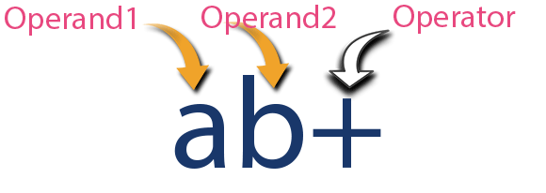

### Prefix Expression

* In prefix expression, operator is used before operands.
* We can say that “**Operands follows the Operator**”.
* The general structure of Prefix expression is as follows.

Operator Operand1 Operand2

### Prefix Expression Example

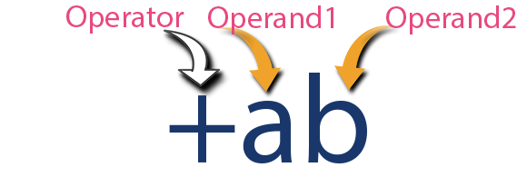

* Every expression can be represented using all the above three different types of expressions.

### Expression Conversions

* And we can convert an expression from one form to another form likeÂ
  + **Infix to Postfix**,Â
  + **Infix to Prefix**,Â
  + **Prefix to Postfix**Â and vice versa.

### Infix to Postfix Conversion

* BTech Smart Class
  + http://www.btechsmartclass.com/data_structures/infix-to-postfix.html
* Any expression can be represented using three types of expressions (Infix, Postfix, and Prefix).
* We can also convert one type of expression to another type of expression like
  + Infix to Postfix,
  + Infix to Prefix,
  + Postfix to Prefix and vice versa.
* To convert any Infix expression into Postfix or Prefix expression we can use the following procedure.
  + 1. Find all the operators in the given Infix Expression.
    2. Find the order of operators evaluated according to their Operator precedence.
    3. Convert each operator into required type of expression (Postfix or Prefix) in the same order.

### Infix to Postfix Example

* Consider the following Infix Expression to be converted into Postfix Expression.
* D = A + B * C
  + Step 1 -Â The Operators in the given Infix Expression :Â = , + , *
  + Step 2 -Â The Order of Operators according to their preference :Â * , + , =
  + Step 3 -Â Now, convert the first operatorÂ * ->Â D = A +Â B C *
  + Step 4 -Â Convert the next operatorÂ +Â ->Â D =Â A BC* +
  + Step 5 -Â Convert the next operatorÂ =Â ->Â D ABC*+ = Finally, given Infix Expression is converted into Postfix Expression as follows… D A B C * + =

### Infix to Postfix Conversion using Stack Data Structure

* To convert Infix Expression into Postfix Expression using a stack data structure, We can use the following steps
  + 1. Read all the symbols one by one from left to right in the given Infix Expression.
    2. If the reading symbol isÂ operand, then directly print it to the result (Output).
    3. If the reading symbol isÂ left parenthesis ‘(’, then Push it on to the Stack.
    4. If the reading symbol isÂ right parenthesis ‘)’, then Pop all the contents of stack until respective left parenthesis is poped and print each poped symbol to the result.
    5. If the reading symbol isÂ operator (+ , - , * , / etc.,), then Push it on to the Stack. However, first pop the operators which are already on the stack that have higher or equal precedence than current operator and print them to the result.

### Infix to Postfix Conversion Example

Consider the following Infix Expression…

* ( A + B ) * ( C - D )
* The given infix expression can be converted into postfix expression using Stack data Structure as follows.

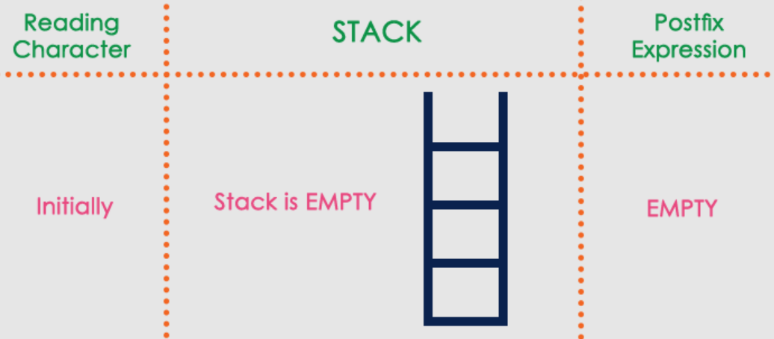

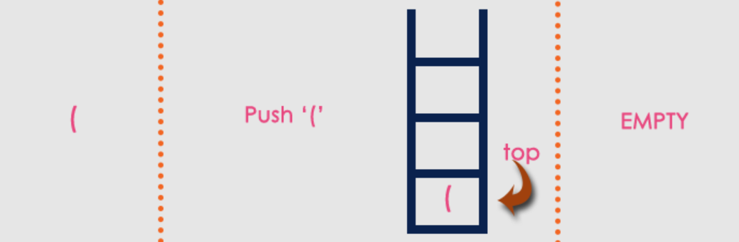

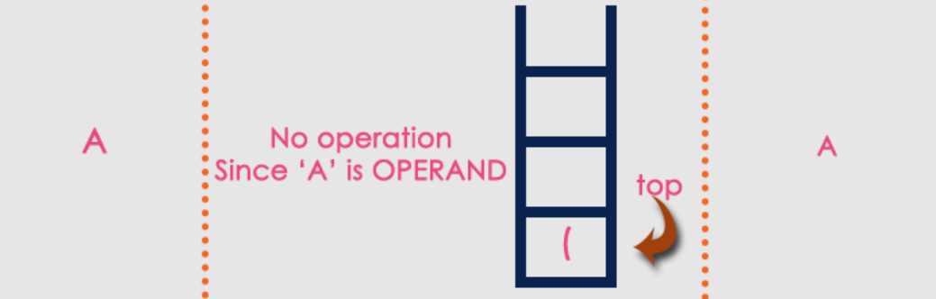

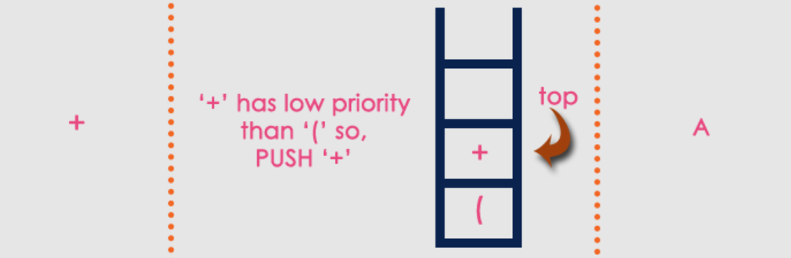

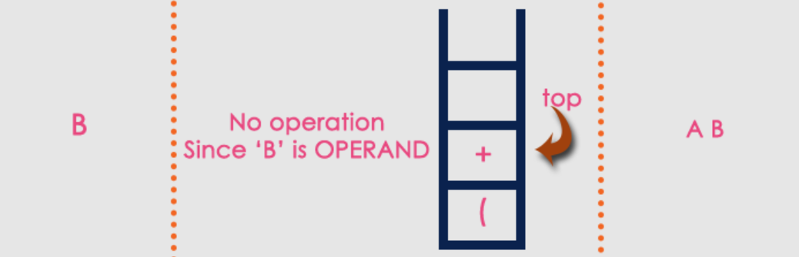

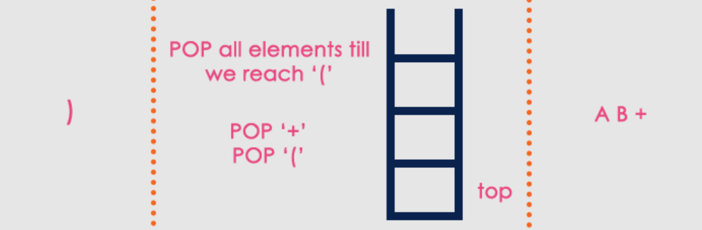

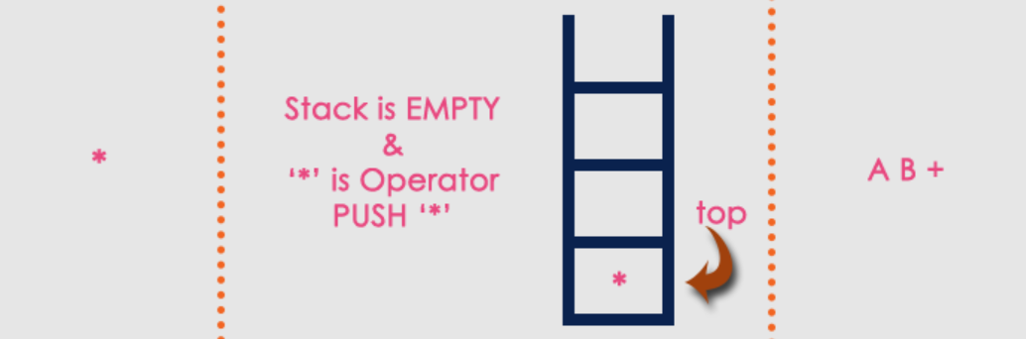

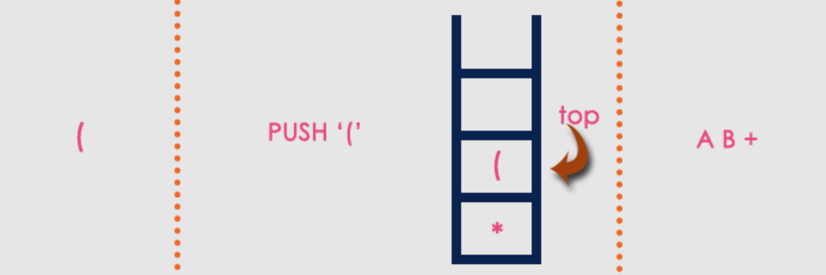

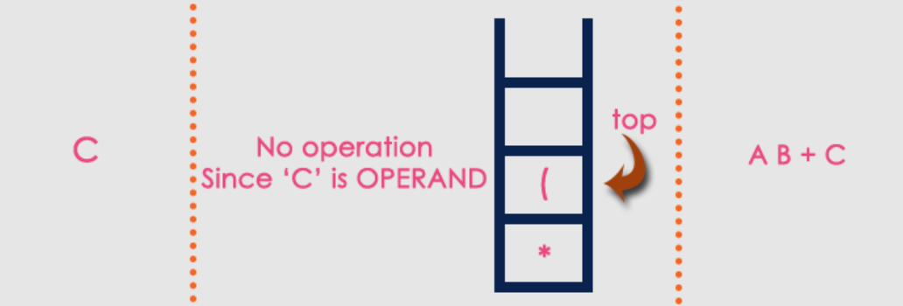

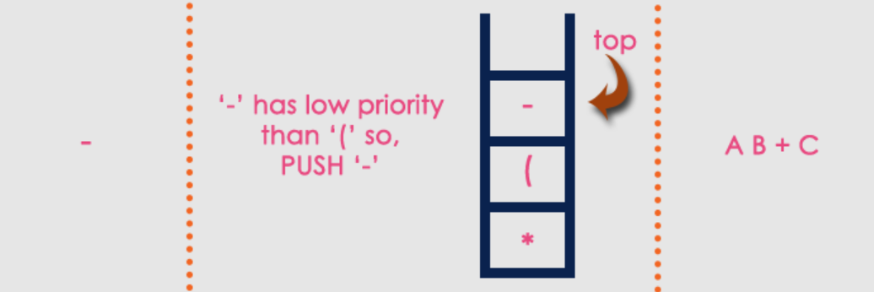

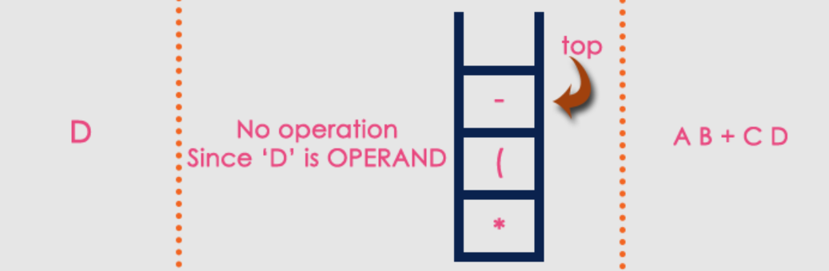

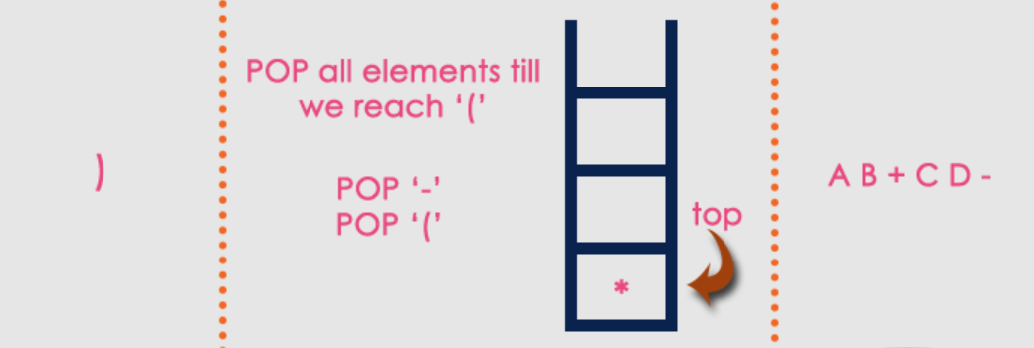



The final Postfix Expression is as follows…

* A B + C D - *

### Postfix Expression Evaluation

* BTech Smart Class
  + http://www.btechsmartclass.com/data_structures/postfix-evaluation.html
* A postfix expression is a collection of operators and operands in which the operator is placed after the operands.
* That means, in a postfix expression the operator follows the operands.

Postfix Expression has following general structure

Operand1 Operand2 Operator

### Postfix Expression Evaluation Example



### Postfix Expression Evaluation using Stack Data Structure

* A postfix expression can be evaluated using the Stack data structure.
* To evaluate a postfix expression using Stack data structure we can use the following steps
  + 1. Read all the symbols one by one from left to right in the given Postfix Expression
    2. If the reading symbol isÂ operand, then push it on to the Stack.
    3. If the reading symbol isÂ operator (+ , - , * , / etc.,), then perform TWO pop operations and store the two popped oparands in two different variables (operand1 and operand2). Then perform reading symbol operation using operand1 and operand2 and push result back on to the Stack.
    4. Finally! perform a pop operation and display the popped value as final result.

### Postfix Expression Evaluation Example

* Consider the following Expression.

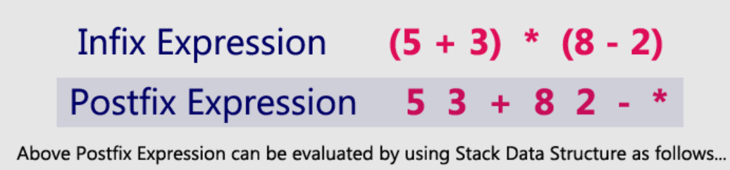

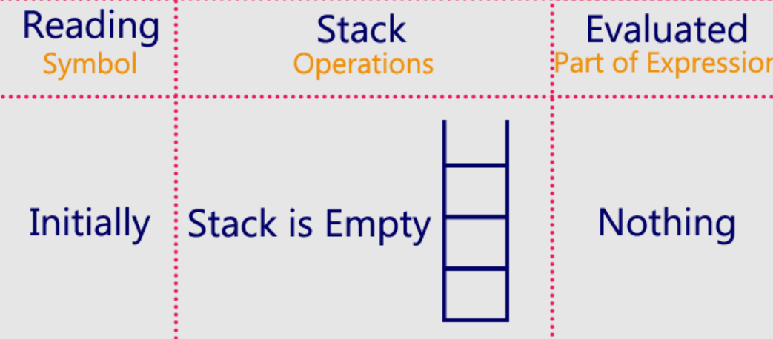

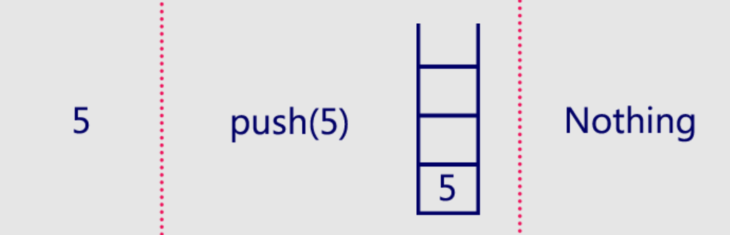

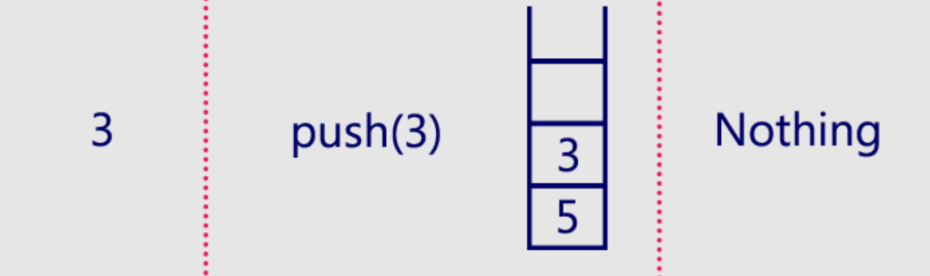

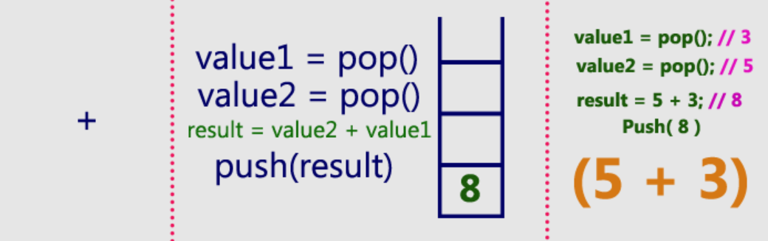

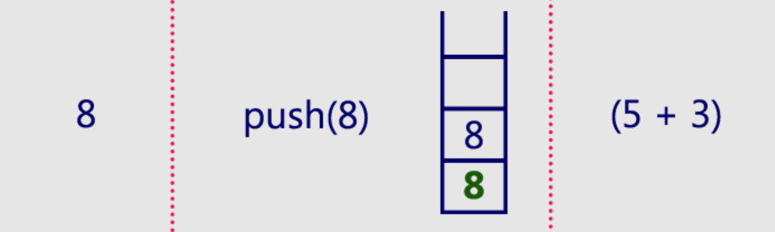

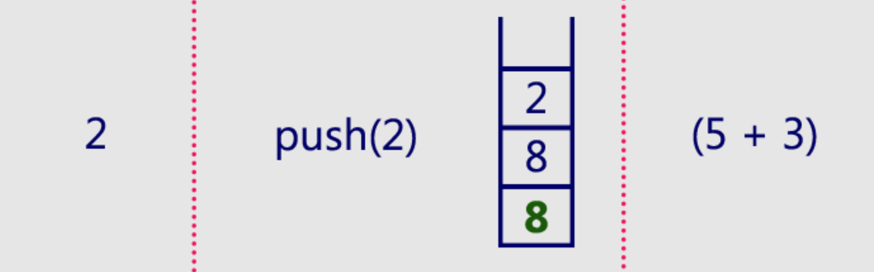

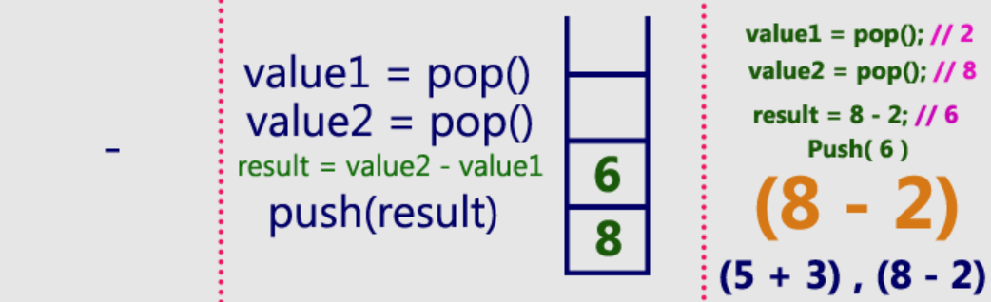

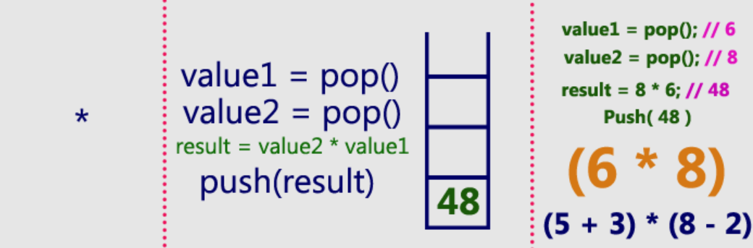

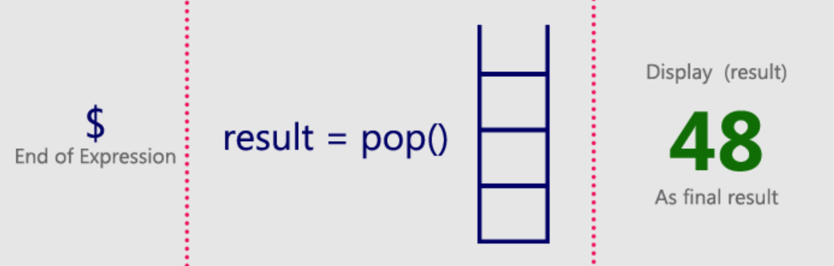

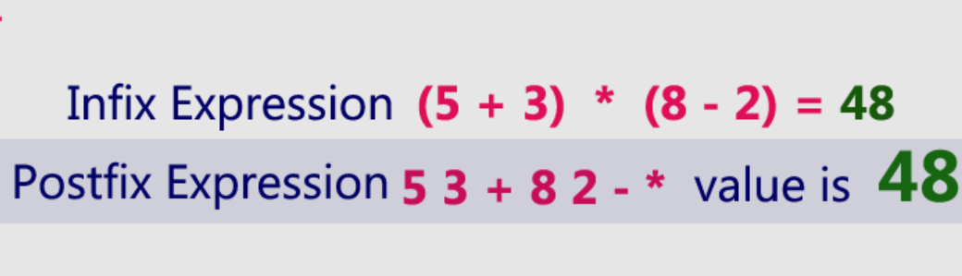

### Queue ADT

* BTech Smart Class
  + http://www.btechsmartclass.com/data_structures/queue-adt.html

### Queue Data Structure

* In this tutorial, you will learn what a queue is. Also, you will find implementation of queue in C, C++, Java and Python.
* A queue is a useful data structure in programming. It is similar to the ticket queue outside a cinema hall, where the first person entering the queue is the first person who gets the ticket.
* Queue follows theÂ **First In First Out (FIFO)**Â rule - the item that goes in first is the item that comes out first.
* FIFO Representation of Queue



* In the above image, since 1 was kept in the queue before 2,
* it is the first to be removed from the queue as well.
* It follows theÂ **FIFO**Â rule.
* In programming terms, putting items in the queue is calledÂ **enqueue**, and removing items from the queue is calledÂ **dequeue**.
* We can implement the queue in any programming language like C, C++, Java, Python or C#, but the specification is pretty much the same.

### Basic Operations of Queue

* A queue is an object (an abstract data structure - ADT) that allows the following operations:
  + **Enqueue**: Add an element to the end of the queue
  + **Dequeue**: Remove an element from the front of the queue
  + **IsEmpty**: Check if the queue is empty
  + **IsFull**: Check if the queue is full
  + **Peek**: Get the value of the front of the queue without removing it

### Working of Queue

* Queue operations work as follows:
  + two pointersÂ FRONTÂ andÂ REAR
  + FRONTÂ track the first element of the queue
  + REARÂ track the last element of the queue
  + initially, set value ofÂ FRONTÂ andÂ REARÂ to -1

### Enqueue Operation

* check if the queue is full
* for the first element, set the value ofÂ FRONTÂ to 0
* increase theÂ REARÂ index by 1
* add the new element in the position pointed to byÂ REAR

### Dequeue Operation

* check if the queue is empty
* return the value pointed byÂ FRONT
* increase theÂ FRONTÂ index by 1
* for the last element, reset the values ofÂ FRONTÂ andÂ REARÂ to -1

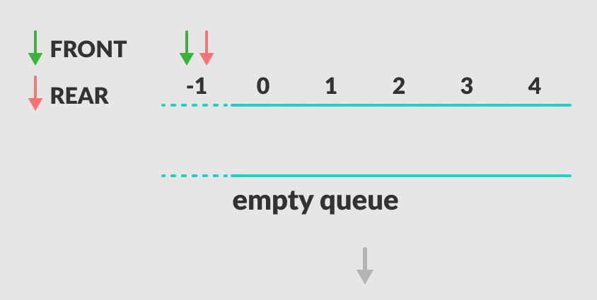

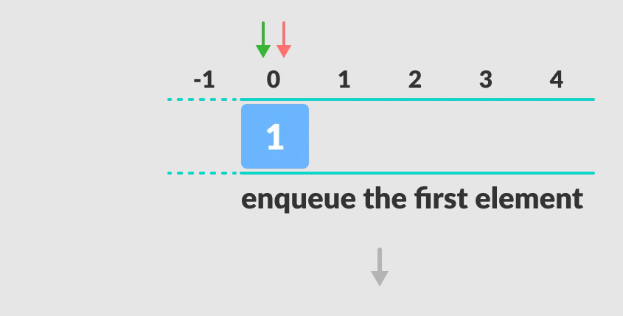

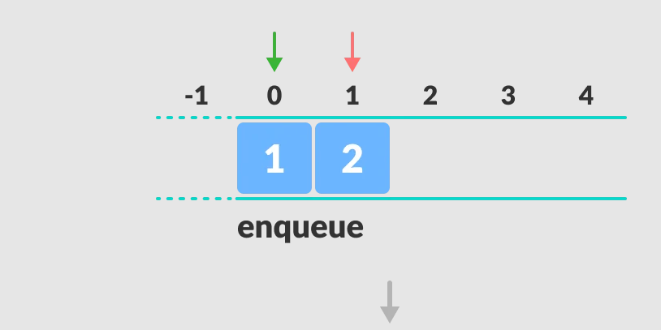

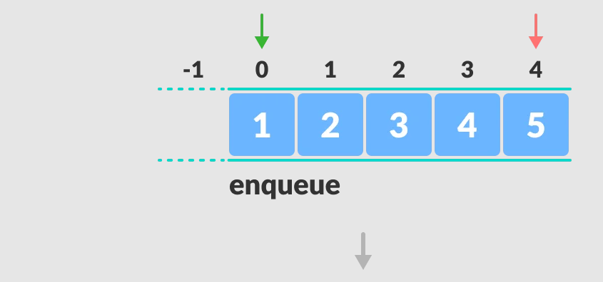

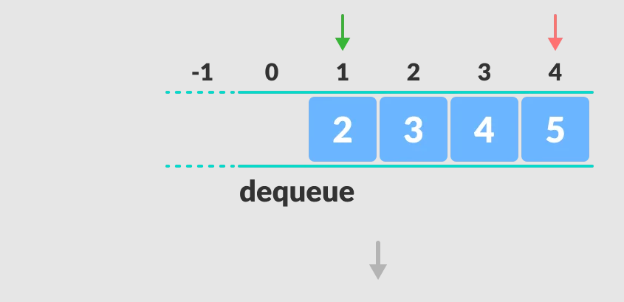

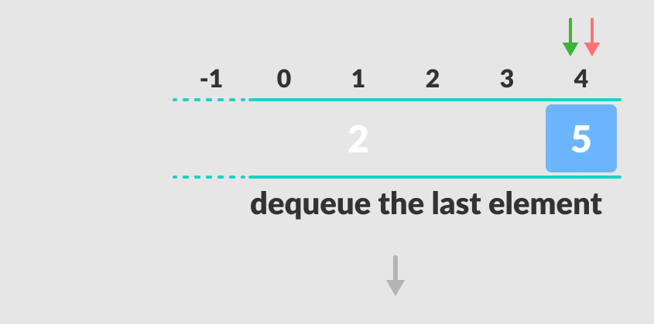

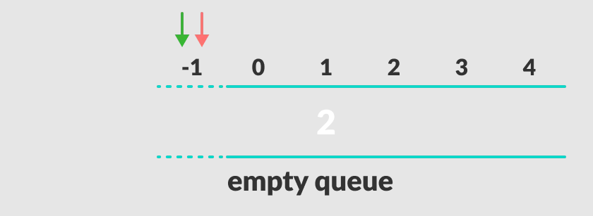

### Enqueue and Dequeue Operations in C

// Queue implementation in C  
  
#include <stdio.h>  
#define SIZE 5  
  
void enQueue(int);  
void deQueue();  
void display();  
  
...

### Enqueue and Dequeue Operations in C

...  
  
int items[SIZE], front = -1, rear = -1;

...  
int main() {  
 //deQueue is not possible on empty queue  
 deQueue();  
  
 //enQueue 5 elements  
 enQueue(1);  
 enQueue(2);  
 enQueue(3);  
 enQueue(4);  
 enQueue(5);  
  
 // 6th element can't be added to because the queue is full  
 enQueue(6);  
  
 display();  
  
 //deQueue removes element entered first i.e. 1  
 deQueue();  
  
 //Now we have just 4 elements  
 display();  
  
 return 0;  
}

...  
void enQueue(int value) {  
 if (rear == SIZE - 1)  
 printf("\nQueue is Full!!");  
 else {  
 if (front == -1)  
 front = 0;  
 rear++;  
 items[rear] = value;  
 printf("\nInserted -> %d", value);  
 }  
}

...  
void deQueue() {  
 if (front == -1)  
 printf("\nQueue is Empty!!");  
 else {  
 printf("\nDeleted : %d", items[front]);  
 front++;  
 if (front > rear)  
 front = rear = -1;  
 }  
}

...  
// Function to print the queue  
void display() {  
 if (rear == -1)  
 printf("\nQueue is Empty!!!");  
 else {  
 int i;  
 printf("\nQueue elements are:\n");  
 for (i = front; i <= rear; i++)  
 printf("%d ", items[i]);  
 }  
 printf("\n");  
}

### Enqueue and Dequeue Operations in C++

...  
// Queue implementation in C++  
  
#include <iostream>  
#define SIZE 5  
  
using namespace std;  
  
class Queue {  
 private:  
 int items[SIZE], front, rear;  
  
 public:  
   
 Queue() {  
 front = -1;  
 rear = -1;  
 }  
  
...

### Enqueue and Dequeue Operations in C++

...  
 bool isFull() {  
 if (front == 0 && rear == SIZE - 1) {  
 return true;  
 }  
 return false;  
 }  
  
...

...  
 bool isEmpty() {  
 if (front == -1)  
 return true;  
 else  
 return false;  
 }  
...

...  
 void enQueue(int element) {  
 if (isFull()) {  
 cout << "Queue is full";  
 } else {  
 if (front == -1) front = 0;  
 rear++;  
 items[rear] = element;  
 cout << endl  
 << "Inserted " << element << endl;  
 }  
 }  
  
...

...  
 int deQueue() {  
 int element;  
 if (isEmpty()) {  
 cout << "Queue is empty" << endl;  
 return (-1);  
 } else {  
 element = items[front];  
 if (front >= rear) {  
 front = -1;  
 rear = -1;  
 } /* Q has only one element, so we reset the queue after deleting it. */  
 else {  
 front++;  
 }  
 cout << endl  
 << "Deleted -> " << element << endl;  
 return (element);  
 }  
 }  
  
...

...  
 void display() {  
 /* Function to display elements of Queue */  
 int i;  
 if (isEmpty()) {  
 cout << endl  
 << "Empty Queue" << endl;  
 } else {  
 cout << endl  
 << "Front index-> " << front;  
 cout << endl  
 << "Items -> ";  
 for (i = front; i <= rear; i++)  
 cout << items[i] << " ";  
 cout << endl  
 << "Rear index-> " << rear << endl;  
 }  
 }  
};  
  
...

...  
int main() {  
 Queue q;  
  
 //deQueue is not possible on empty queue  
 q.deQueue();  
  
 //enQueue 5 elements  
 q.enQueue(1);  
 q.enQueue(2);  
 q.enQueue(3);  
 q.enQueue(4);  
 q.enQueue(5);  
  
 // 6th element can't be added to because the queue is full  
 q.enQueue(6);  
  
 q.display();  
  
 //deQueue removes element entered first i.e. 1  
 q.deQueue();  
  
 //Now we have just 4 elements  
 q.display();  
  
 return 0;  
}

### Enqueue and Dequeue Operations in Java

// Queue implementation in Java  
  
public class Queue {  
 int SIZE = 5;  
 int items[] = new int[SIZE];  
 int front, rear;  
  
 Queue() {  
 front = -1;  
 rear = -1;  
 }  
  
...

...  
  
 boolean isFull() {  
 if (front == 0 && rear == SIZE - 1) {  
 return true;  
 }  
 return false;  
 }  
  
...

...  
 boolean isEmpty() {  
 if (front == -1)  
 return true;  
 else  
 return false;  
 }  
  
...

...  
 void enQueue(int element) {  
 if (isFull()) {  
 System.out.println("Queue is full");  
 } else {  
 if (front == -1)  
 front = 0;  
 rear++;  
 items[rear] = element;  
 System.out.println("Inserted " + element);  
 }  
 }  
  
...

...  
 int deQueue() {  
 int element;  
 if (isEmpty()) {  
 System.out.println("Queue is empty");  
 return (-1);  
 } else {  
 element = items[front];  
 if (front >= rear) {  
 front = -1;  
 rear = -1;  
 } /* Q has only one element, so we reset the queue after deleting it. */  
 else {  
 front++;  
 }  
 System.out.println("Deleted -> " + element);  
 return (element);  
 }  
 }  
  
...

...  
 void display() {  
 /* Function to display elements of Queue */  
 int i;  
 if (isEmpty()) {  
 System.out.println("Empty Queue");  
 } else {  
 System.out.println("\nFront index-> " + front);  
 System.out.println("Items -> ");  
 for (i = front; i <= rear; i++)  
 System.out.print(items[i] + " ");  
  
 System.out.println("\nRear index-> " + rear);  
 }  
 }  
  
...

...  
 public static void main(String[] args) {  
 Queue q = new Queue();  
  
 // deQueue is not possible on empty queue  
 q.deQueue();  
  
 // enQueue 5 elements  
 q.enQueue(1);  
 q.enQueue(2);  
 q.enQueue(3);  
 q.enQueue(4);  
 q.enQueue(5);  
  
 // 6th element can't be added to because the queue is full  
 q.enQueue(6);  
  
 q.display();  
  
 // deQueue removes element entered first i.e. 1  
 q.deQueue();  
  
 // Now we have just 4 elements  
 q.display();  
  
 }  
}

### Limitations of Queue

* As you can see in the image below, after a bit of enqueuing and dequeuing, the size of the queue has been reduced.



* And we can only add indexes 0 and 1 only when the queue is reset (when all the elements have been dequeued).
* AfterÂ REARÂ reaches the last index,
  + if we can store extra elements in the empty spaces (0 and 1),
  + we can make use of the empty spaces. This is implemented by a modified queue called theÂ [circular queue](https://www.programiz.com/data-structures/circular-queue).

### Complexity Analysis

* The complexity of enqueue and dequeue operations in a queue using an array isÂ O(1). If you useÂ pop(N)Â in python code,
* then the complexity might beÂ O(n)Â depending on the position of the item to be popped.

### Applications of Queue

* CPU scheduling, Disk Scheduling
* When data is transferred asynchronously between two processes.The queue is used for synchronization. For example: IO Buffers, pipes, file IO, etc
* Handling of interrupts in real-time systems.
* Call Center phone systems use Queues to hold people calling them in order.

### What is a Queue?

* Queue is a linear data structure in which the insertion and deletion operations are performed at two different ends.
* In a queue data structure, adding and removing elements are performed at two different positions.
* The insertion is performed at one end and deletion is performed at another end. - In a queue data structure, the insertion operation is performed at a position which is known as ‘**rear**’ and the deletion operation is performed at a position which is known as ‘**front**’.
* In queue data structure, the insertion and deletion operations are performed based onÂ **FIFO (First In First Out)**Â principle.
* In a queue data structure,
  + the insertion operation is performed using a function called “**enQueue()**” and
  + deletion operation is performed using a function called “**deQueue()**”.

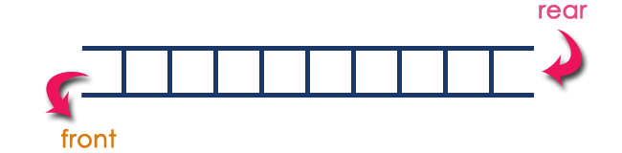

* Queue data structure can be defined as follows.
* Queue data structure is a linear data structure in which the operations are performed based on FIFO principle.
* A queue data structure can also be defined as
* “Queue data structure is a collection of similar data items in which insertion and deletion operations are performed based on FIFO principle”.

Queue after inserting 25, 30, 51, 60 and 85.

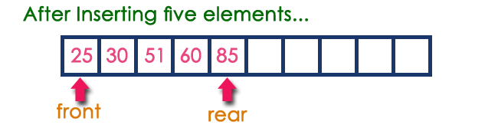

### Operations on a Queue

* The following operations are performed on a queue data structure
  + 1. enQueue(value) - (To insert an element into the queue)
    2. deQueue() - (To delete an element from the queue)
    3. display() - (To display the elements of the queue)

### Queue Implementation

* Queue data structure can be implemented in two ways. They are as follows…
  + 1. Using Array
    2. Using Linked List
* When a queue is implemented using an array, that queue can organize an only limited number of elements.
* When a queue is implemented using a linked list, that queue can organize an unlimited number of elements.

### First Come First Serve, FCFS, FIFO

* BTech Smart Class
  + http://www.btechsmartclass.com/downloads/lab-manuals/Operating-System-Lab-Manual-R18-JNTUH.pdf

### Queue Data structure Using Array

* BTech Smart Class
  + http://www.btechsmartclass.com/data_structures/queue-using-array.html
* A queue data structure can be implemented using one dimensional array.
* The queue implemented using array stores only fixed number of data values.
* The implementation of queue data structure using array is very simple.
* Just define a one dimensional array of specific size and insert or delete the values into that array by usingÂ **FIFO (First In First Out) principle**Â with the help of variablesÂ **‘front’**Â and ‘**rear**’.
* Initially both ‘**front**’ and ‘**rear**’ are set to -1. Whenever, we want to insert a new value into the queue, increment ‘**rear**’ value by one and then insert at that position.
* Whenever we want to delete a value from the queue, then delete the element which is at ‘front’ position and increment ‘front’ value by one.

### Queue Operations using Array

* Queue data structure using array can be implemented as follows.
* Before we implement actual operations, first follow the below steps to create an empty queue.
  + Step 1 -Â Include all theÂ **header files**Â which are used in the program and define a constantÂ **‘SIZE’**Â with specific value.
  + Step 2 -Â Declare all theÂ **user defined functions**Â which are used in queue implementation.
  + Step 3 -Â Create a one dimensional array with above defined SIZE (**int queue[SIZE]**)
  + Step 4 -Â Define two integer variablesÂ **‘front’**Â and ‘**rear**’ and initialize both withÂ **‘-1’**. (**int front = -1, rear = -1**)
  + Step 5 -Â Then implement main method by displaying menu of operations list and make suitable function calls to perform operation selected by the user on queue.

**enQueue(value) - Inserting value into the queue**

* In a queue data structure, enQueue() is a function used to insert a new element into the queue.
* In a queue, the new element is always inserted atÂ **rear**Â position.
* The enQueue() function takes one integer value as a parameter and inserts that value into the queue. We can use the following steps to insert an element into the queue
  + Step 1 -Â Check whetherÂ **queue**Â isÂ **FULL**. (**rear == SIZE-1**)
  + Step 2 -Â If it isÂ **FULL**, then displayÂ **“Queue is FULL!!! Insertion is not possible!!!”**Â and terminate the function.
  + Step 3 -Â If it isÂ **NOT FULL**, then incrementÂ **rear**Â value by one (**rear++**) and setÂ **queue[rear]**Â =Â **value**.

**deQueue() - Deleting a value from the Queue**

* In a queue data structure, deQueue() is a function used to delete an element from the queue.
* In a queue, the element is always deleted fromÂ **front**Â position.
* The deQueue() function does not take any value as parameter.
* We can use the following steps to delete an element from the queue.
  + Step 1 -Â Check whetherÂ **queue**Â isÂ **EMPTY**. (**front == rear**)
  + Step 2 -Â If it isÂ **EMPTY**, then displayÂ **“Queue is EMPTY!!! Deletion is not possible!!!”**Â and terminate the function.
  + Step 3 -Â If it isÂ **NOT EMPTY**, then increment theÂ **front**Â value by one (**front ++**). Then displayÂ **queue[front]**Â as deleted element. Then check whether bothÂ **front**Â andÂ **rear**Â are equal (**front**Â ==Â **rear**), if itÂ **TRUE**, then set bothÂ **front**Â andÂ **rear**Â to ‘**-1**’ (**front**Â =Â **rear**Â =Â **-1**).

**display() - Displays the elements of a Queue**

-We can use the following steps to display the elements of a queue… - Step 1 -Â Check whetherÂ **queue**Â isÂ **EMPTY**. (**front == rear**) - Step 2 -Â If it isÂ **EMPTY**, then displayÂ **“Queue is EMPTY!!!”**Â and terminate the function. - Step 3 -Â If it isÂ **NOT EMPTY**, then define an integer variable ‘**i**’ and set ‘**i**Â =Â **front+1**’. - Step 4 -Â Display ‘**queue[i]**’ value and increment ‘**i**’ value by one (**i++**). Repeat the same until ‘**i**’ value reaches toÂ **rear**Â (**i**Â <=Â **rear**)

### Queue Datastructure using Array in C

#include<stdio.h>  
#include<conio.h>  
#define SIZE 10  
  
void enQueue(int);  
void deQueue();  
void display();  
  
...

### Queue Datastructure using Array in C

...  
  
int queue[SIZE], front = -1, rear = -1;  
  
...

...  
  
void main()  
{  
 int value, choice;  
 clrscr();  
 while(1){  
 printf("\n\n***** MENU *****\n");  
 printf("1. Insertion\n2. Deletion\n3. Display\n4. Exit");  
 printf("\nEnter your choice: ");  
 scanf("%d",&choice);  
 switch(choice){  
 case 1: printf("Enter the value to be insert: ");  
 scanf("%d",&value);  
 enQueue(value);  
 break;  
 case 2: deQueue();  
 break;  
 case 3: display();  
 break;  
 case 4: exit(0);  
 default: printf("\nWrong selection!!! Try again!!!");  
 }  
 }  
}  
  
...

...  
  
void enQueue(int value){  
 if(rear == SIZE-1)  
 printf("\nQueue is Full!!! Insertion is not possible!!!");  
 else{  
 if(front == -1)  
 front = 0;  
 rear++;  
 queue[rear] = value;  
 printf("\nInsertion success!!!");  
 }  
}  
  
...

...  
  
void deQueue(){  
 if(front == rear)  
 printf("\nQueue is Empty!!! Deletion is not possible!!!");  
 else{  
 printf("\nDeleted : %d", queue[front]);  
 front++;  
 if(front == rear)  
 front = rear = -1;  
 }  
}  
  
...

...  
  
void display(){  
 if(rear == -1)  
 printf("\nQueue is Empty!!!");  
 else{  
 int i;  
 printf("\nQueue elements are:\n");  
 for(i=front; i<=rear; i++)  
 printf("%d\t",queue[i]);  
 }  
}

### Output

[center h:400px](assets/Queue_Output.png)

### Queue Using Linked List

* BTech Smart Class
  + http://www.btechsmartclass.com/data_structures/queue-using-linked-list.html
* The major problem with the queue implemented using an array is,
* It will work for an only fixed number of data values.
* That means, the amount of data must be specified at the beginning itself.
* Queue using an array is not suitable when we don’t know the size of data which we are going to use.
* A queue data structure can be implemented using a linked list data structure. The queue which is implemented using a linked list can work for an unlimited number of values.
* That means, queue using linked list can work for the variable size of data (No need to fix the size at the beginning of the implementation).
* The Queue implemented using linked list can organize as many data values as we want.
* In linked list implementation of a queue, the last inserted node is always pointed by ‘**rear**’ and the first node is always pointed by ‘**front**’.

### Queue Using Linked List Example

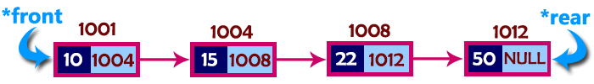

* In above example, the last inserted node is 50 and it is pointed by ‘**rear**’ and the first inserted node is 10 and it is pointed by ‘**front**’. The order of elements inserted is 10, 15, 22 and 50.

### Operations

* To implement queue using linked list, we need to set the following things before implementing actual operations.
  + Step 1 -Â Include all theÂ **header files**Â which are used in the program. And declare all theÂ **user defined functions**.
  + Step 2 -Â Define a ‘**Node**’ structure with two membersÂ **data**Â andÂ **next**.
  + Step 3 -Â Define twoÂ **Node**Â pointers ‘**front**’ and ‘**rear**’ and set both toÂ **NULL**.
  + Step 4 -Â Implement theÂ **main**Â method by displaying Menu of list of operations and make suitable function calls in theÂ **main**Â method to perform user selected operation.

### enQueue(value) - Inserting an element into the Queue

* We can use the following steps to insert a new node into the queue…
  + Step 1 -Â Create aÂ **newNode**Â with given value and set ‘**newNode â†’ next**’ toÂ **NULL**.
  + Step 2 -Â Check whether queue isÂ **Empty**Â (**rear**Â ==Â **NULL**)
  + Step 3 -Â If it isÂ **Empty**Â then, setÂ **front**Â =Â **newNode**Â andÂ **rear**Â =Â **newNode**.
  + Step 4 -Â If it isÂ **Not Empty**Â then, setÂ **rear â†’ next**Â =Â **newNode**Â andÂ **rear**Â =Â **newNode**.

### deQueue() - Deleting an Element from Queue

* We can use the following steps to delete a node from the queue…
  + Step 1 -Â Check whetherÂ **queue**Â isÂ **Empty**Â (**front == NULL**).
  + Step 2 -Â If it isÂ **Empty**, then displayÂ **“Queue is Empty!!! Deletion is not possible!!!”**Â and terminate from the function
  + Step 3 -Â If it isÂ **Not Empty**Â then, define a Node pointer ‘**temp**’ and set it to ‘**front**’.
  + Step 4 -Â Then set ‘**front**Â =Â **front â†’ next**’ and delete ‘**temp**’ (**free(temp)**).

### display() - Displaying the elements of Queue

* We can use the following steps to display the elements (nodes) of a queue…
  + Step 1 -Â Check whether queue isÂ **Empty**Â (**front**Â ==Â **NULL**).
  + Step 2 -Â If it isÂ **Empty**Â then, displayÂ **‘Queue is Empty!!!’**Â and terminate the function.
  + Step 3 -Â If it isÂ **Not Empty**Â then, define a Node pointerÂ **‘temp’**Â and initialize withÂ **front**.
  + Step 4 -Â Display ‘**temp â†’ data**Â —>’ and move it to the next node. Repeat the same until ‘**temp**’ reaches to ‘**rear**’ (**temp â†’ next**Â !=Â **NULL**).
  + Step 5 -Â Finally! Display ‘**temp â†’ data**Â —>Â **NULL**’.

### Queue using Linked List in C

#include<stdio.h>  
#include<conio.h>  
  
struct Node  
{  
 int data;  
 struct Node *next;  
}*front = NULL,*rear = NULL;  
  
...

### Queue using Linked List in C

...  
void insert(int);  
void delete();  
void display();  
  
...

...  
void main()  
{  
 int choice, value;  
 clrscr();  
 printf("\n:: Queue Implementation using Linked List ::\n");  
 while(1){  
 printf("\n****** MENU ******\n");  
 printf("1. Insert\n2. Delete\n3. Display\n4. Exit\n");  
 printf("Enter your choice: ");  
 scanf("%d",&choice);  
 switch(choice){  
 case 1: printf("Enter the value to be insert: ");  
 scanf("%d", &value);  
 insert(value);  
 break;  
 case 2: delete(); break;  
 case 3: display(); break;  
 case 4: exit(0);  
 default: printf("\nWrong selection!!! Please try again!!!\n");  
 }  
 }  
}  
  
...

...  
  
void insert(int value)  
{  
 struct Node *newNode;  
 newNode = (struct Node*)malloc(sizeof(struct Node));  
 newNode->data = value;  
 newNode -> next = NULL;  
 if(front == NULL)  
 front = rear = newNode;  
 else{  
 rear -> next = newNode;  
 rear = newNode;  
 }  
 printf("\nInsertion is Success!!!\n");  
}  
  
...

...  
void delete()  
{  
 if(front == NULL)  
 printf("\nQueue is Empty!!!\n");  
 else{  
 struct Node *temp = front;  
 front = front -> next;  
 printf("\nDeleted element: %d\n", temp->data);  
 free(temp);  
 }  
}  
  
...

...  
void display()  
{  
 if(front == NULL)  
 printf("\nQueue is Empty!!!\n");  
 else{  
 struct Node *temp = front;  
 while(temp->next != NULL){  
 printf("%d--->",temp->data);  
 temp = temp -> next;  
 }  
 printf("%d--->NULL\n",temp->data);  
 }  
}

### Output

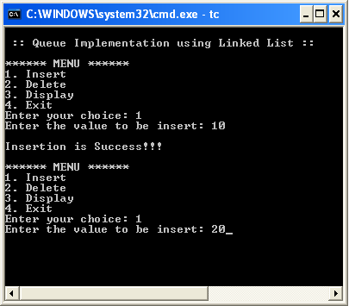

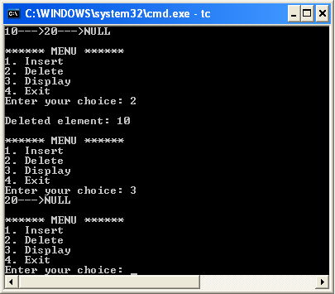

### Circular Queue Data structure

* BTech Smart Class
  + http://www.btechsmartclass.com/data_structures/circular-queue.html
* In a normal Queue Data Structure, we can insert elements until queue becomes full.
* But once the queue becomes full, we can not insert the next element until all the elements are deleted from the queue.
* For example, consider the queue below.
* The queue after inserting all the elements into it is as follows…

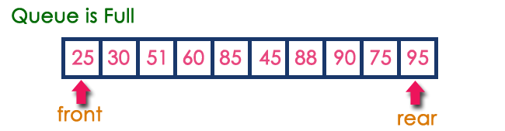

* Now consider the following situation after deleting three elements from the queue.

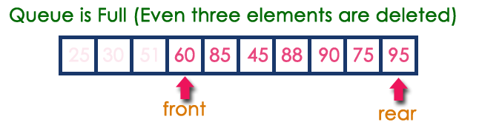

* This situation also says that Queue is Full and we cannot insert the new element because ‘**rear**’ is still at last position.
* In the above situation, even though we have empty positions in the queue we can not make use of them to insert the new element.
* This is the major problem in a normal queue data structure.
* To overcome this problem we use a circular queue data structure.

### What is Circular Queue?

* A Circular Queue can be defined as follows.
* A circular queue is a linear data structure in which the operations are performed based on FIFO (First In First Out) principle and the last position is connected back to the first position to make a circle.
* Graphical representation of a circular queue is as follows.

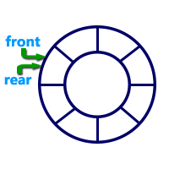

### Implementation of Circular Queue

To implement a circular queue data structure using an array, we first perform the following steps before we implement actual operations.

* Step 1 -Â Include all theÂ **header files**Â which are used in the program and define a constantÂ **‘SIZE’**Â with specific value.
* Step 2 -Â Declare allÂ **user defined functions**Â used in circular queue implementation.
* Step 3 -Â Create a one dimensional array with above defined SIZE (**int cQueue[SIZE]**)
* Step 4 -Â Define two integer variablesÂ **‘front’**Â and ‘**rear**’ and initialize both withÂ **‘-1’**. (**int front = -1, rear = -1**)
* Step 5 -Â Implement main method by displaying menu of operations list and make suitable function calls to perform operation selected by the user on circular queue.

### enQueue(value) - Inserting value into the Circular Queue

In a circular queue, enQueue() is a function which is used to insert an element into the circular queue. In a circular queue, the new element is always inserted atÂ **rear**Â position. The enQueue() function takes one integer value as parameter and inserts that value into the circular queue. We can use the following steps to insert an element into the circular queue…

* Step 1 -Â Check whetherÂ **queue**Â isÂ **FULL**. (**(rear == SIZE-1 && front == 0) || (front == rear+1)**)
* Step 2 -Â If it isÂ **FULL**, then displayÂ **“Queue is FULL!!! Insertion is not possible!!!”**Â and terminate the function.
* Step 3 -Â If it isÂ **NOT FULL**, then checkÂ **rear == SIZE - 1 && front != 0**Â if it isÂ **TRUE**, then setÂ **rear = -1**.
* Step 4 -Â IncrementÂ **rear**Â value by one (**rear++**), setÂ **queue[rear]**Â =Â **value**Â and check ‘**front == -1**’ if it isÂ **TRUE**, then setÂ **front = 0**.

### deQueue() - Deleting a value from the Circular Queue

In a circular queue, deQueue() is a function used to delete an element from the circular queue. In a circular queue, the element is always deleted fromÂ **front**Â position. The deQueue() function doesn’t take any value as a parameter. We can use the following steps to delete an element from the circular queue.

* Step 1 -Â Check whetherÂ **queue**Â isÂ **EMPTY**. (**front == -1 && rear == -1**)
* Step 2 -Â If it isÂ **EMPTY**, then displayÂ **“Queue is EMPTY!!! Deletion is not possible!!!”**Â and terminate the function.
* Step 3 -Â If it isÂ **NOT EMPTY**, then displayÂ **queue[front]**Â as deleted element and increment theÂ **front**Â value by one (**front ++**). Then check whetherÂ **front == SIZE**, if it isÂ **TRUE**, then setÂ **front = 0**. Then check whether bothÂ **front - 1**Â andÂ **rear**Â are equal (**front -1**Â ==Â **rear**), if itÂ **TRUE**, then set bothÂ **front**Â andÂ **rear**Â to ‘**-1**’ (**front**Â =Â **rear**Â =Â **-1**).

### display() - Displays the elements of a Circular Queue

We can use the following steps to display the elements of a circular queue…

* Step 1 -Â Check whetherÂ **queue**Â isÂ **EMPTY**. (**front == -1**)
* Step 2 -Â If it isÂ **EMPTY**, then displayÂ **“Queue is EMPTY!!!”**Â and terminate the function.
* Step 3 -Â If it isÂ **NOT EMPTY**, then define an integer variable ‘**i**’ and set ‘**i**Â =Â **front**’.
* Step 4 -Â Check whether ‘**front <= rear**’, if it isÂ **TRUE**, then display ‘**queue[i]**’ value and increment ‘**i**’ value by one (**i++**). Repeat the same until ‘**i <= rear**’ becomesÂ **FALSE**.
* Step 5 -Â If ‘**front <= rear**’ isÂ **FALSE**, then display ‘**queue[i]**’ value and increment ‘**i**’ value by one (**i++**). Repeat the same until’**i <= SIZE - 1**’ becomesÂ **FALSE**.
* Step 6 -Â SetÂ **i**Â toÂ **0**.
* Step 7 -Â Again display ‘**cQueue[i]**’ value and incrementÂ **i**Â value by one (**i++**). Repeat the same until ‘**i <= rear**’ becomesÂ **FALSE**.

### Circular Queue using array in C

#include<stdio.h>  
#include<conio.h>  
#define SIZE 5  
  
...

### Circular Queue using array in C

...  
  
void enQueue(int);  
void deQueue();  
void display();  
  
...

...  
  
int cQueue[SIZE], front = -1, rear = -1;  
  
...

...  
  
void main()  
{  
 int choice, value;  
 clrscr();  
 while(1){  
 printf("\n****** MENU ******\n");  
 printf("1. Insert\n2. Delete\n3. Display\n4. Exit\n");  
 printf("Enter your choice: ");  
 scanf("%d",&choice);  
 switch(choice){  
 case 1: printf("\nEnter the value to be insert: ");  
 scanf("%d",&value);  
 enQueue(value);  
 break;  
 case 2: deQueue();  
 break;  
 case 3: display();  
 break;  
 case 4: exit(0);  
 default: printf("\nPlease select the correct choice!!!\n");  
 }  
 }  
}  
...

...  
  
void enQueue(int value)  
{  
 if((front == 0 && rear == SIZE - 1) || (front == rear+1))  
 printf("\nCircular Queue is Full! Insertion not possible!!!\n");  
 else{  
 if(rear == SIZE-1 && front != 0)  
 rear = -1;  
 cQueue[++rear] = value;  
 printf("\nInsertion Success!!!\n");  
 if(front == -1)  
 front = 0;  
 }  
}  
...

...  
  
void deQueue()  
{  
 if(front == -1 && rear == -1)  
 printf("\nCircular Queue is Empty! Deletion is not possible!!!\n");  
 else{  
 printf("\nDeleted element : %d\n",cQueue[front++]);  
 if(front == SIZE)  
 front = 0;  
 if(front-1 == rear)  
 front = rear = -1;  
 }  
}  
...

...  
  
void display()  
{  
 if(front == -1)  
 printf("\nCircular Queue is Empty!!!\n");  
 else{  
 int i = front;  
 printf("\nCircular Queue Elements are : \n");  
 if(front <= rear){  
 while(i <= rear)  
 printf("%d\t",cQueue[i++]);  
 }  
 else{  
 while(i <= SIZE - 1)  
 printf("%d\t", cQueue[i++]);  
 i = 0;  
 while(i <= rear)  
 printf("%d\t",cQueue[i++]);  
 }  
 }  
}

### Output

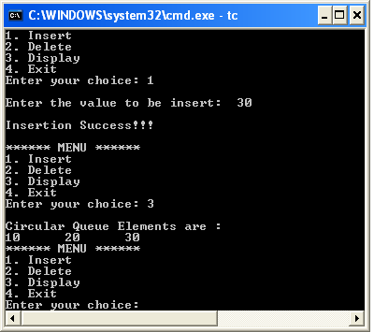

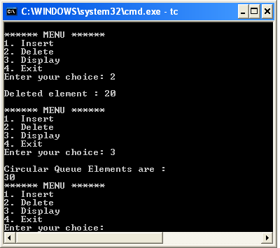

### Double Ended Queue Data structure

* BTech Smart Class
  + http://www.btechsmartclass.com/data_structures/double-ended-queue.html
* Double Ended Queue is also a Queue data structure in which the insertion and deletion operations are performed at
  + both the ends (**front**Â andÂ **rear**).
* That means, we can insert at both front and rear positions and can delete from both front and rear positions.

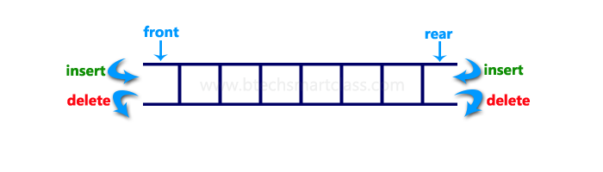

* Double Ended Queue can be represented in TWO ways, those are as follows.
  + 1. Input Restricted Double Ended Queue
    2. Output Restricted Double Ended Queue

### Input Restricted Double Ended Queue

* In input restricted double-ended queue, the insertion operation is performed at only one end and deletion operation is performed at both the ends.

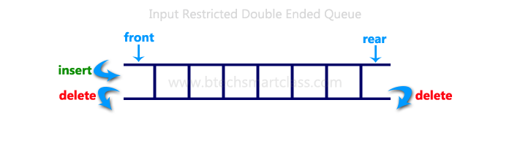

In output restricted double ended queue, the deletion operation is performed at only one end and insertion operation is performed at both the ends.

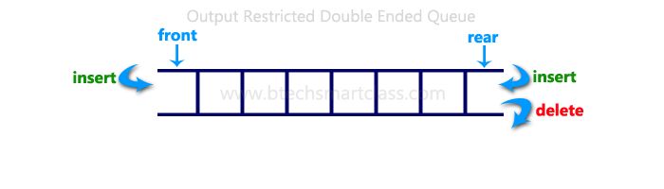

### Double Ended Queue using Array in C

#include<stdio.h>  
#include<conio.h>  
#define SIZE 100  
  
void enQueue(int);  
int deQueueFront();  
int deQueueRear();  
void enQueueRear(int);  
void enQueueFront(int);  
void display();  
  
...

### Double Ended Queue using Array in C

...  
  
int queue[SIZE];  
int rear = 0, front = 0;  
  
...

...  
  
int main()  
{  
 char ch;  
 int choice1, choice2, value;  
 printf("\n******* Type of Double Ended Queue *******\n");  
 do  
 {  
 printf("\n1.Input-restricted deque \n");  
 printf("2.output-restricted deque \n");  
 printf("\nEnter your choice of Queue Type : ");  
 scanf("%d",&choice1);  
 switch(choice1)  
 {  
  
...

...  
  
 case 1:   
 printf("\nSelect the Operation\n");  
 printf("1.Insert\n2.Delete from Rear\n3.Delete from Front\n4. Display");  
 do  
 {  
 printf("\nEnter your choice for the operation in c deque: ");  
 scanf("%d",&choice2);  
 switch(choice2)  
 {   
 case 1: enQueueRear(value);  
 display();  
 break;  
 case 2: value = deQueueRear();  
 printf("\nThe value deleted is %d",value);  
 display();  
 break;  
 case 3: value=deQueueFront();  
 printf("\nThe value deleted is %d",value);  
 display();  
 break;  
 case 4: display();  
 break;  
 default:printf("Wrong choice");  
 }  
 printf("\nDo you want to perform another operation (Y/N): ");  
 ch=getch();  
 }while(ch=='y'||ch=='Y');  
 getch();  
 break;   
  
...

...  
  
 case 2 :  
 printf("\n---- Select the Operation ----\n");  
 printf("1. Insert at Rear\n2. Insert at Front\n3. Delete\n4. Display");  
 do  
 {  
 printf("\nEnter your choice for the operation: ");  
 scanf("%d",&choice2);  
 switch(choice2)  
 {   
 case 1: enQueueRear(value);  
 display();  
 break;  
 case 2: enQueueFront(value);  
 display();  
 break;  
 case 3: value = deQueueFront();  
 printf("\nThe value deleted is %d",value);   
 display();  
 break;  
 case 4: display();  
 break;  
 default:printf("Wrong choice");  
 }  
 printf("\nDo you want to perform another operation (Y/N): ");  
 ch=getch();  
 } while(ch=='y'||ch=='Y');  
 getch();  
 break ;  
 }  
 printf("\nDo you want to continue(y/n):");  
 ch=getch();  
 }while(ch=='y'||ch=='Y');  
}  
  
...

...  
  
void enQueueRear(int value)  
{   
 char ch;  
 if(front == SIZE/2)  
 {  
 printf("\nQueue is full!!! Insertion is not possible!!! ");  
 return;  
 }  
 do  
 {  
 printf("\nEnter the value to be inserted:");  
 scanf("%d",&value);  
 queue[front] = value;  
 front++;  
 printf("Do you want to continue insertion Y/N");  
 ch=getch();  
 }while(ch=='y');  
}  
  
...

...  
  
void enQueueFront(int value)  
{   
 char ch;  
 if(front==SIZE/2)  
 {  
 printf("\nQueue is full!!! Insertion is not possible!!!");  
 return;  
 }  
 do  
 {  
 printf("\nEnter the value to be inserted:");  
 scanf("%d",&value);  
 rear--;  
 queue[rear] = value;  
 printf("Do you want to continue insertion Y/N");  
 ch = getch();  
 }  
 while(ch == 'y');  
}  
...

...  
  
int deQueueRear()  
{  
 int deleted;  
 if(front == rear)  
 {  
 printf("\nQueue is Empty!!! Deletion is not possible!!!");  
 return 0;  
 }  
 front--;  
 deleted = queue[front+1];  
 return deleted;  
}  
...

...  
  
int deQueueFront()  
{  
 int deleted;  
 if(front == rear)  
 {  
 printf("\nQueue is Empty!!! Deletion is not possible!!!");  
 return 0;  
 }  
 rear++;  
 deleted = queue[rear-1];  
 return deleted;  
}  
...

...  
  
void display()  
{  
 int i;  
 if(front == rear)  
 printf("\nQueue is Empty!!! Deletion is not possible!!!");  
 else{  
 printf("\nThe Queue elements are:");  
 for(i=rear; i < front; i++)  
 {  
 printf("%d\t ",queue[i]);  
 }  
 }  
}

### Output

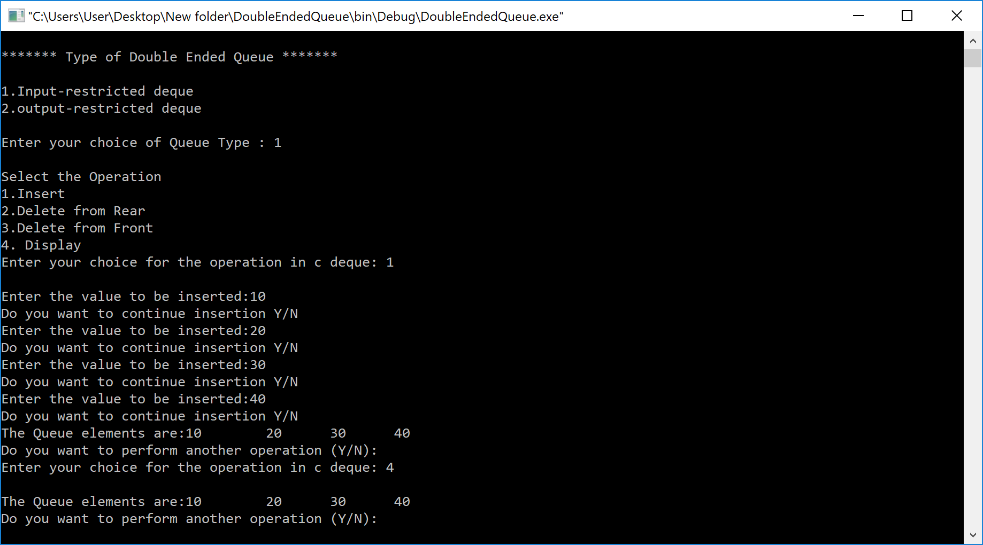

### Multilevel Queue (MLQ)

* Geeks for Geeks
  + https://www.geeksforgeeks.org/multilevel-queue-mlq-cpu-scheduling/

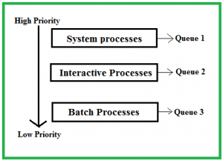

## Priority Queue

* A priority queue is a special type of queue in which each element is associated with a priority and is served according to its priority. If elements with the same priority occur, they are served according to their order in the queue.



* Insertion occurs based on the arrival of the values and removal occurs based on priority.

### Hanoi Tower

* Geeks for Geeks
  + Recursive Version
    - [Program for Tower of Hanoi - GeeksforGeeks](https://www.geeksforgeeks.org/c-program-for-tower-of-hanoi/)
  + Iterative Version
    - [Iterative Tower of Hanoi - GeeksforGeeks](https://www.geeksforgeeks.org/iterative-tower-of-hanoi/)

### Hanoi Tower Iterative Algorithm:

S = Source  
A = Aux  
D = Dest

Calculate the total number of moves required i.e.

here n is number of disks.

* If number of disks (i.e. n) is **even** then interchange **destination pole** and **auxiliary pole**.
* for i = 1 to total number of moves:
  + if i%3 == 1:
    - legal movement of top disk between source pole and destination pole
  + if i%3 == 2:
    - legal movement top disk between source pole and auxiliary pole
  + if i%3 == 0:
    - legal movement top disk between auxiliary pole and destination pole

### Hanoi Tower Iterative Algorithm

* Tower of Hanoi is a mathematical puzzle where we have three rods (**A**,Â **B**, andÂ **C**) andÂ **N**Â disks.
* Initially, all the disks are stacked in decreasing value of diameter
  + i.e., the smallest disk is placed on the top and they are on rodÂ **A**.
* The objective of the puzzle is to move the entire stack to another rod (here consideredÂ **C**), obeying the following simple rules
* Only one disk can be moved at a time.
* Each move consists of taking the upper disk from one of the stacks and placing it on top of another stack i.e. a disk can only be moved if it is the uppermost disk on a stack.
* No disk may be placed on top of a smaller disk.

### Hanoi Tower Iterative Algorithm Examples

**Input**: 2   
**Output:**Â Disk 1 moved from A to B   
Disk 2 moved from A to C   
Disk 1 moved from B to C

**Input:**Â 3   
**Output:**Â Disk 1 moved from A to C   
 Disk 2 moved from A to B   
 Disk 1 moved from C to B   
 Disk 3 moved from A to C   
 Disk 1 moved from B to A   
 Disk 2 moved from B to C   
 Disk 1 moved from A to C

### Tower of Hanoi using Recursion

* The idea is to use the helper node to reach the destination using recursion. Below is the pattern for this problem:
  + Shift N-1 disks from A to B, using C.
  + Shift last disk from A to C.
  + Shift N-1 disks from B to C, using A.

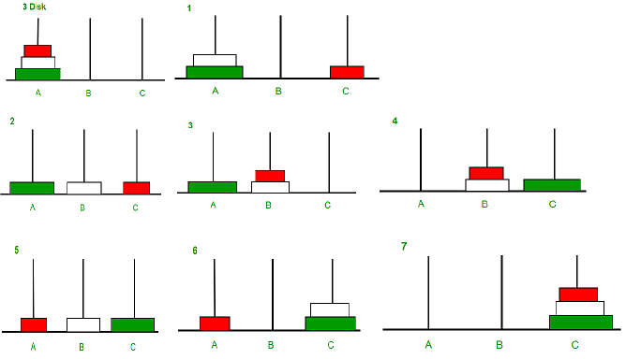

Image illustration for 3 disks

* Follow the steps below to solve the problem
  + Create a functionÂ **towerOfHanoi**Â where pass theÂ **N**Â (current number of disk),Â **from_rod**,Â **to_rod**,Â **aux_rod.**
  + Make a function call for N â€“ 1 th disk.
  + Then print the current the disk along withÂ **from_rod**Â andÂ **to_rod**
  + Again make a function call for N â€“ 1 th disk.

### Tower of Hanoi in C++ Recursive

// C++ recursive function to  
// solve tower of hanoi puzzle  
#include <bits/stdc++.h>  
using namespace std;  
  
void towerOfHanoi(int n, char from_rod, char to_rod,  
 char aux_rod)  
{  
 if (n == 0) {  
 return;  
 }  
 towerOfHanoi(n - 1, from_rod, aux_rod, to_rod);  
 cout << "Move disk " << n << " from rod " << from_rod  
 << " to rod " << to_rod << endl;  
 towerOfHanoi(n - 1, aux_rod, to_rod, from_rod);  
}  
  
...

### Tower of Hanoi in C++ Recursive

...  
  
// Driver code  
int main()  
{  
 int N = 3;  
  
 // A, B and C are names of rods  
 towerOfHanoi(N, 'A', 'C', 'B');  
 return 0;  
}

### Tower of Hanoi in Java Recursive

// JAVA recursive function to  
// solve tower of hanoi puzzle  
import java.io.*;  
import java.math.*;  
import java.util.*;  
class GFG {  
  
  
...

...  
 static void towerOfHanoi(int n, char from_rod,  
 char to_rod, char aux_rod)  
 {  
 if (n == 0) {  
 return;  
 }  
 towerOfHanoi(n - 1, from_rod, aux_rod, to_rod);  
 System.out.println("Move disk " + n + " from rod "  
 + from_rod + " to rod "  
 + to_rod);  
 towerOfHanoi(n - 1, aux_rod, to_rod, from_rod);  
 }  
  
...

...  
 // Driver code  
 public static void main(String args[])  
 {  
 int N = 3;  
  
 // A, B and C are names of rods  
 towerOfHanoi(N, 'A', 'C', 'B');  
 }  
}

### Tower of Hanoi in C# Recursive

// C# recursive program to solve tower of hanoi puzzle  
using System;  
class GFG {  
 static void towerOfHanoi(int n, char from_rod,  
 char to_rod, char aux_rod)  
 {  
 if (n == 0) {  
 return;  
 }  
 towerOfHanoi(n - 1, from_rod, aux_rod, to_rod);  
 Console.WriteLine("Move disk " + n + " from rod "  
 + from_rod + " to rod " + to_rod);  
 towerOfHanoi(n - 1, aux_rod, to_rod, from_rod);  
 }  
  
...

...  
 // Driver method  
 public static void Main(String[] args)  
 {  
 int N = 3;  
  
 // A, B and C are names of rods  
 towerOfHanoi(N, 'A', 'C', 'B');  
 }  
}

### Output

Move disk 1 from rod A to rod C  
Move disk 2 from rod A to rod B  
Move disk 1 from rod C to rod B  
Move disk 3 from rod A to rod C  
Move disk 1 from rod B to rod A  
Move disk 2 from rod B to rod C  
Move disk 1 from rod A to rod C

### Time complexity

* + There are two possibilities for every disk.
  + Therefore, 2 * 2 * 2 * . . . * 2(N times) is 2N

### Auxiliary Space

* + Function call stack space

### Tower of Hanoi in Java Recursive

// Assuming n-th disk is  
// bottom disk (count down)  
class GFG {  
  
static void tower(int n, char sourcePole,  
 char destinationPole, char auxiliaryPole)  
{  
 // Base case (termination condition)  
 if (0 == n)  
 return;  
  
 // Move first n-1 disks from source pole  
 // to auxiliary pole using destination as  
 // temporary pole  
 tower(n - 1, sourcePole, auxiliaryPole,  
 destinationPole);  
  
 // Move the remaining disk from source  
 // pole to destination pole  
 System.out.printf("Move the disk %d from %c to %c\n",  
 n, sourcePole, destinationPole);  
  
 // Move the n-1 disks from auxiliary (now source)  
 // pole to destination pole using source pole as  
 // temporary (auxiliary) pole  
 tower(n - 1, auxiliaryPole, destinationPole, sourcePole);  
}

public static void main(String[] args)  
{  
 tower(3, 'S', 'D', 'A');  
}  
}  
  
// This code is contributed by Smitha Dinesh Semwal.

### Tower of Hanoi in C# Recursive

// Assuming n-th disk is bottom disk  
// (count down)  
using System;  
  
class GFG {  
  
 static void tower(int n, char sourcePole,  
 char destinationPole,  
 char auxiliaryPole)  
 {  
  
 // Base case (termination condition)  
 if (0 == n)  
 return;  
  
 // Move first n-1 disks from source  
 // pole to auxiliary pole using  
 // destination as temporary pole  
 tower(n - 1, sourcePole, auxiliaryPole,  
 destinationPole);  
  
 // Move the remaining disk from source  
 // pole to destination pole  
 Console.WriteLine("Move the disk " + n  
 + "from " + sourcePole + "to "  
 + destinationPole);  
  
 // Move the n-1 disks from auxiliary  
 // (now source) pole to destination  
 // pole using source pole as temporary  
 // (auxiliary) pole  
 tower(n - 1, auxiliaryPole,  
 destinationPole, sourcePole);  
 }

// Driver code  
 public static void Main()  
 {  
 tower(3, 'S', 'D', 'A');  
 }  
}

#include<stdio.h>  
  
// Assuming n-th disk is bottom disk (count down)  
void tower(int n, char sourcePole, char destinationPole, char auxiliaryPole)  
{  
// Base case (termination condition)  
if(0 == n)  
 return;  
  
// Move first n-1 disks from source pole  
// to auxiliary pole using destination as  
// temporary pole  
tower(n-1, sourcePole, auxiliaryPole,  
 destinationPole);  
  
 // Move the remaining disk from source  
// pole to destination pole  
printf("Move the disk %d from %c to %c\n",  
 n,sourcePole, destinationPole);  
  
// Move the n-1 disks from auxiliary (now source)  
// pole to destination pole using source pole as  
// temporary (auxiliary) pole  
tower(n-1, auxiliaryPole, destinationPole,  
 sourcePole);  
}  
  
...

### Tower of Hanoi in C Recursive

...  
  
int main()  
{  
tower(3, 'S', 'D', 'A');  
  
return 0;  
}

// Assuming n-th disk is bottom disk  
// (count down)  
using System;  
  
class GFG {  
  
 static void tower(int n, char sourcePole,  
 char destinationPole,  
 char auxiliaryPole)  
 {  
  
 // Base case (termination condition)  
 if (0 == n)  
 return;  
  
 // Move first n-1 disks from source  
 // pole to auxiliary pole using  
 // destination as temporary pole  
 tower(n - 1, sourcePole, auxiliaryPole,  
 destinationPole);  
  
 // Move the remaining disk from source  
 // pole to destination pole  
 Console.WriteLine("Move the disk " + n  
 + "from " + sourcePole + "to "  
 + destinationPole);  
  
 // Move the n-1 disks from auxiliary  
 // (now source) pole to destination  
 // pole using source pole as temporary  
 // (auxiliary) pole  
 tower(n - 1, auxiliaryPole,  
 destinationPole, sourcePole);  
 }

// Driver code  
 public static void Main()  
 {  
 tower(3, 'S', 'D', 'A');  
 }  
}