CE208-Database Management Systems

Intro

Author: Asst. Prof. Dr. Yıldıran YILMAZ

## CE208-Database Management Systems

### Week-1 (Intro)

#### Spring Semester, 2021-2022

**Instructor:** Yıldıran Yılmaz **Email:** yildiran.yilmaz@erdogan.edu.tr **Office Hours:** Thursday

Download [PDF-MS](1_veri_tabani_giris_week_1.pdf), [PDF-MD](week-1.en.md_slide.pdf), [PPTX-MD](week-1.en.md_slide.pptx), [PPTX-MS](1_veri_tabani_giris_week_1.pptx)

### Outline

* What is Database?
* Database Examples
* Database
* What is Database Management System?
* Classification of Database Management Systems

### Outline

* Hierarchical databases
  + Network databases
  + Relational databases
  + Object Oriented databases
* Why use a database?
* Advantages of the Database Approach
* Database Management Systems

### Outline

* Database Structure
* Table
* Data Types
  + MYSQL Data Types
* Key
* Primary key
* Foreign key
* Database Design

## What is Database?

* It is an information repository where data that is related to each other is kept.
* The collection of data arranged in accordance with the purpose of use
* They are information stores with their logical and physical definitions.

## Database Examples

* University - Student Affairs Information System
* Hospital - Patient, doctor, treatment, equipment, financial information
* A commercial company - Customer, Product, Sales, Payment, Delivery information
* Bank - Customer, deposit, credit card, credit information

## Database

* The database concept was first introduced in the 1980s.
* It is used in everywhere from a simple web application up to large and complex data of international organizations
* Database applications are needed in many areas.

## What is Database Management System?

It is a software system in which various complex following operations are performed.

* Creating a new database,
* Editing the database
* To use,
* Develop
* to take care of (maintanance)

## Classification of Database Management Systems

* By Data Model
  + Hierarchical
  + Network
  + relational
  + Object Oriented
* By Number of Users
  + single user
  + multi-user

### Hierarchical databases

* It is the first model used for databases.
* Hierarchical databases store information in a tree structure.

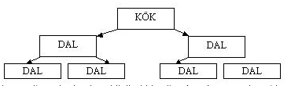

center h:300px

### Network databases

* When hierarchical databases were insufficient, a structure in which data was stored in the form of graphs, which is a more advanced version of trees, emerged at the end of the 1960s.

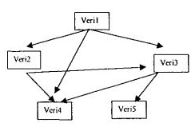

center h:350px

### Relational databases

* It was developed in the early 1970s.
* In this system, data is stored in tabular form.
* Connections between tables are represented by mathematical relationships.
* Almost all database programs today have this structure.

### Relational databases

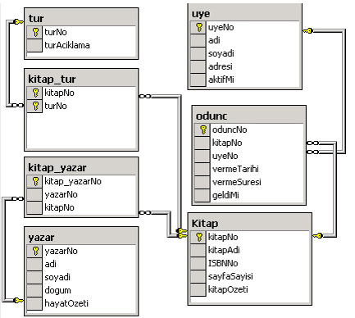

center h:500px

### Object Oriented databases

* Objects used in many word processor and spreadsheet programs today are also used in databases.
* Object-oriented database means a database created and used in an object-oriented language such as
  + C++,
  + C#,
  + java,
  + Visual Basic.

## Why use a database?

* The traditional approach to holding, storing and accessing data uses the approach of grouping data into separate files.
* With the increase in data and the need to access and edit data at the same time, the traditional approach has been inadequate.

## Advantages of the Database Approach

* Preventing duplication of common data;
* Ensuring centralized control and consistency of data
* Ensuring data sharing
* Hiding physical structure and access method complexities from the user with multi-layered architectures,
* Presenting only the data that is of interest to each user in easy, understandable structures

## Advantages of the Database Approach

* Ease of application software development with the analysis, design and development tools provided.
* Providing the necessary facilities for data integrity,
* Ensuring the desired level of security and confidentiality
* Solving operational problems such as backup, reboot, repair

## Database Management Systems

* Oracle database
* IBM DB/2
* Adaptive Server Enterprise
* Informix
* Microsoft Access
* Microsoft SQL Server
* Microsoft Visual FoxPro
* MySQL

## Database Management Systems

* PostgreSQL
* Progress
* SQLite
* Teradata
* CSQL
* OpenLink Virtuoso

## Database Structure

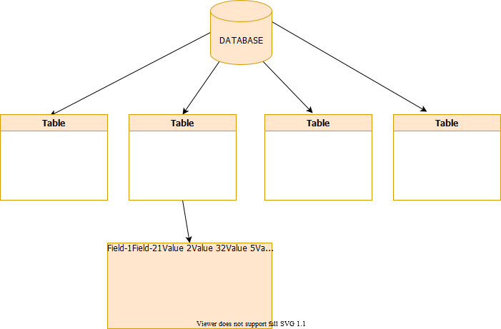

center h:500px

## Table

* A database consists of data stored in tables.
* Tables are a group of data that is formed by arranging data in rows and columns.
* For example, 2 tables are created to store the course content and student information in the database:
  + Student information
  + contents

## Table

* Each piece of information in the table is called a **record** , and the columns are called **a field** .
* For example, in the student information table, following information is included.
  + Student number,
  + Name and surname,
  + date of birth,
  + Place of birth,
  + E mail address

## Table

| Ogr_no | Ad_soyad | d_tarih | d_yeri | e-mail |
| --- | --- | --- | --- | --- |
| 1 | Ayşe Öztürk | 01.11.1979 | Konya | ayse@gazi.edu.tr |
| 2 | Sema Özdemir | 24.05.1975 | Ankara | sema@gazi.edu.tr |
| 3 | Serdar Gülpınar | 06.06.1983 | Adana | serdar@gazi.edu.tr |
| 4 | Mehmet Efe | 11.02.1978 | Niğde | mehmet@gazi.edu.tr |
| 5 | Zerrin Polat | 22.08.1980 | Antalya | zerrin@gazi.edu.tr |
| 6 | Ulviye Kubalı | 12.12.1984 | İstanbul | ulviye@gazi.edu.tr |

## Table

**Fields**

| Ogr_no | Ad_soyad | d_tarih | d_yeri | e-mail |
| --- | --- | --- | --- | --- |

**Record**

|  |  |  |  |  |
| --- | --- | --- | --- | --- |
| 1 | Ayşe Öztürk | 01.11.1979 | Konya | ayse@gazi.edu.tr |
| 2 | Sema Özdemir | 24.05.1975 | Ankara | sema@gazi.edu.tr |

## Data Types

* In order to have information about the structure of the records kept in the database, some properties of the fields must be defined beforehand.
* *For example*, the personnel registration number must be made up of integers, names and surnames must be words.

### MYSQL Data Types

* **Numeric**
* **Date and Time**
* **Textual (String)**
* **Spatial**

### MYSQL Data Types

#### TINYINT :

* For very small integer values
* When Signed is defined, the values are between -128 and 127.
* Unsigned defined range is between 0 and 255.

### MYSQL Data Types

#### SMALLINT :

* For small integer values
* When Signed is defined, the values are between -32768 and 32767.
* Unsigned defined range is 0 to 65535.

### MYSQL Data Types

#### MEDIUMINT :

* For medium-sized integer values.
* When Signed is defined, the values are between -8388608 and 8388607.
* Unsigned defined range is between 0 and 16777215.

### MYSQL Data Types

#### INT(n):Interger

* For normal-sized integer values.
* When Signed is defined, the values are between -2147483648 and 2147483647.
* Unsigned defined range is between 0 and 4294967295.

### MYSQL Data Types

#### BIGINT :

* For large integer values.
* Can take integer value -9223372036854775808 to 9223372036854775807

### MYSQL Data Types

#### FLOAT :

* Keeps numbers with their fractions.
* Max. character width is taken as a parameter. (up to 23 digits)

### MYSQL Data Types

#### DOUBLE:

* Keeps numbers with their fractions.
* Max. character width is taken as a parameter. (24 to 53 digits)

### MYSQL Data Types

#### DECIMAL:

* Keeps numbers with their fractions.
* The integer part can have a maximum 64 digits, and the fractional part a maximum 30 digits.

### MYSQL Data Types

#### DATETIME:

* Datetime information in Year+Month+Day+Hour+Minute+Second format

YYYY-MM-DD HH:MM:SS

### MYSQL Data Types

#### TIMESTAMP:

* Time information from January 1, 1970 to January 18, 2038, in the format Year+Month+Day+Hour+Minute+Second.

YYYYMMDDHHMMSS

### MYSQL Data Types

#### DATE:

* Date field that can change from 1000-01-01 to 9999-12-31.

YYYY-MM-DD

### MYSQL Data Types

#### CHAR(n):

* Fixed-length data with n characters.

### MYSQL Data Types

#### TEXT:

* A text field that can hold up to 65535 characters.

### MYSQL Data Types

#### MEDIUMTEXT:

* Text field up to 16777215 characters

### MYSQL Data Types

#### VARCHAR(n):

* Characters of varying size, not exceeding n

### MYSQL Data Types

#### BOOL:

* A data type that takes the value 0 or 1. or True/ False

## Key

* A key forces one or more fields to be entered as qualifiers for a row.
* There are 2 types of keys:
  + Primary Key
  + Foreign Key

## Primary key

* It is the key data that will enable access to a record.
* For example, there are two Ahmet among the students. Each student must have a unique number in order to find the Ahmet we want while searching.
* For example student number could be a primary key
* Multiple fields can have primary keys together

## Foreign key

* A foreign key is a set of attributes in a table that refers to the primary key of another table. The foreign key links these two tables.

## Foreign key

**Persons Table**

| PersonID | LastName | FirstName | Age |
| --- | --- | --- | --- |
| 1 | Hansen | Ola | 30 |
| 2 | Svendson | Tove | 23 |
| 3 | Pettersen | Kari | 20 |

## Foreign key

**Orders Table**

| OrderID | OrderNumber | PersonID |
| --- | --- | --- |
| 1 | 77895 | 3 |
| 2 | 44678 | 3 |
| 3 | 22456 | 2 |
| 4 | 24562 | 1 |

## Foreign key

* Notice that the “PersonID” column in the “Orders” table points to the “PersonID” column in the “Persons” table.
* The “PersonID” column in the “Persons” table is the **PRIMARY KEY** in the “Persons” table.
* The “PersonID” column in the “Orders” table is a **FOREIGN KEY** in the “Orders” table.
* The **FOREIGN KEY** constraint prevents invalid data from being inserted into the foreign key column, because it has to be one of he values contained in the parent table.

## Database Design

* Objects are defined
  + **Library system:** books, members, types, loan movements

## Designing a database

* A table is created for each object:
  + book,
  + members,
  + types,
  + woodc_movements

## Designing a database

* A key field is selected for each table
  + **book table:** *book no*
  + **Members table:** *Userno*

## Designing a database

* A column is added to the table for each property of the objects
  + **Book table:** book number, year, author, name, related field

## Designing a database

* Additional tables are created for recurring object properties.
  + **request table:**

| userno | request_date | Book_name | Book_date | Book_author | Related_field |
| --- | --- | --- | --- | --- | --- |
| . | . | . | . | . | . |
| . | . | . | . | . | . |

## Designing a database

* Fields that are not directly related to the table are determined.
  + The address of the member who borrowed the book in the loan transactions table is not directly related to this table.
  + This data should be included in the **members table** where member information is kept.

## Designing a database

* Relationships between tables should be defined.
  + The relationship between the **fields** in a **table** is defined.
  + For example, the **userno** field in the **members table** should be associated with the **userno** field in the **request table**.

## Resources

* Köseoğlu, K. (2005). Veri Tabanı Mantığı. Şefik Matbaası. İstanbul
* Alokoç Burma, Z. (2005). Veritabanı Yönetim Sistemleri ve SQL / PL - SQL / T – SQL. Seçkin Yayıncılık. Ankara

$End−Of−Week−1−Module$