*Below is the entity-relationship diagram of the automation system of a multi-divisional company that produces various projects and sells over the internet.*

1. Please explain how many elements there are in all the relations in the diagram, and the participation constraints of all the relations, by specifying the relation number. (Example: "A doctor can care for more than one patient; every patient must be treated by a doctor.")

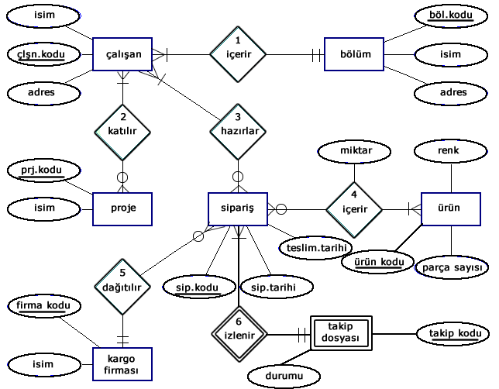

2) In the entity relation diagram below;

* Determine the degrees of relations
* Express the entities, attributes and constraints based on the given entity relation diagram.

