CE208-Database Management Systems

Database and Fundamental Concepts

Author: Asst. Prof. Dr. Yıldıran YILMAZ

## CE208-Database Management Systems

### Week-2 (Database and Fundamental Concepts)

#### Spring Semester, 2021-2022

**Instructor:** Yıldıran Yılmaz **Email:** yildiran.yilmaz@erdogan.edu.tr **Office Hours:** Thursday

Download [PDF-MS](../files/week-2.pdf), [PDF-MD](week-2.tr.md_slide.pdf), [DOCX-MD](week-2.tr.md_word.docx), [PPTX-MD](week-2.tr.md_slide.pptx), [PPTX-MS](../files/week-2.pptx)

## Why we use the database?

* The purpose of the database;
  + helping people and organizations keep track of things.

## Why we use the database?

* Lists are used to keep track of things without using a database.
  + Shopping list,
  + to-do list,
  + List of paid invoices

## Why we use the database?

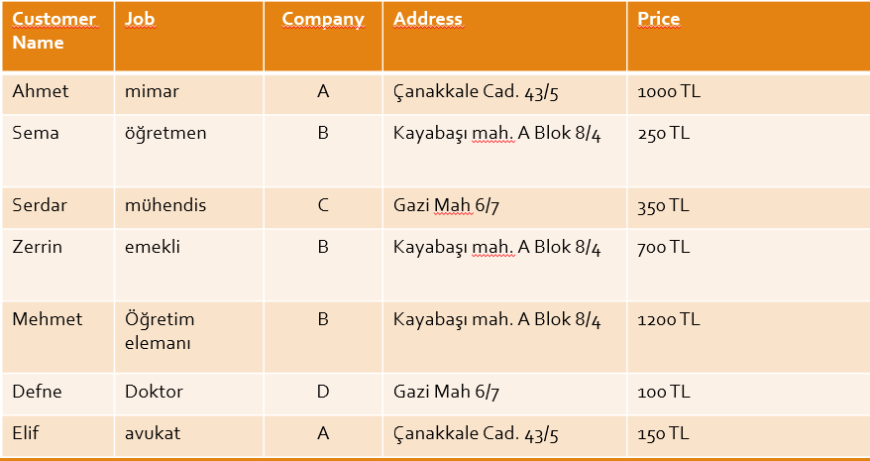

center h:450px

## Why we use the database?

* Problems with lists;
  + For example, the address of company B has changed.
  + Address information in 3 lines should also change
  + If it is missing, information inconsistency occurs.
  + It can cause both **a waste of time** and an **error**.

## Why we use the database?

* Problems with lists;
  + For example, company A no longer works with your company,
  + If you delete the record related to company A from the list, you will lose information such as customer information and company address where the product was sold.

## Why we use the database?

* Problems with shared data;
* For example, different departments of your company need to display company information;
  + Communication department: company, address
  + Marketing department: company, price
  + Customer service: customer name, job, company

## Why we use the database?

* Problems with shared data;
  + Sharing all of this information with all departments is inconvenient for different reasons.
  + Security
  + customer privacy
  + etc.

## Why we use the database?

* The biggest drawback for lists is that it combines different types of information into a table.

## Why we use the database?

* For DMS, the process of placing different types of information in different tables is called **normalisation**.
* For the previous list;
  + customers
  + Worked companies
  + sales information

## Why we use the database?

* Customers

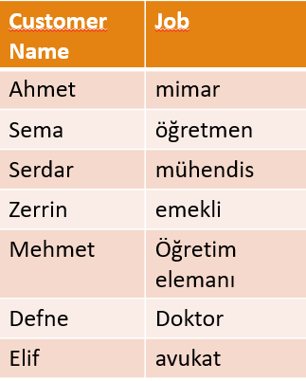

center h:450px

## Why we use the database?

* Worked Companies

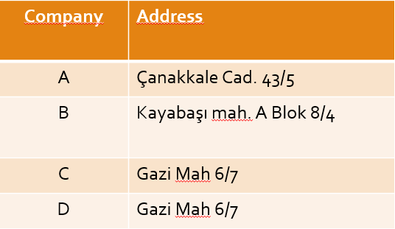

center h:450px

## Why we use the database?

* Sales Information

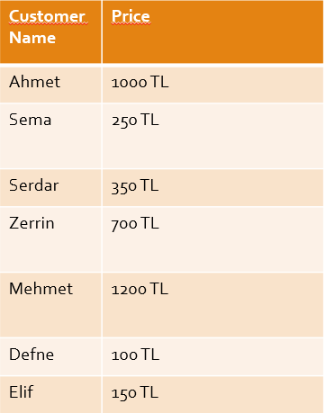

center h:450px

## Why we use the database?

* When different types of information are placed in different tables, most of the problems related to the following works are eliminated;
  + changing information
  + deleted information
  + with shared information.

## Why we use the database?

* When different types of data are in different tables;
  + Relationships need to be established in order to answer questions such as which customer bought the product from which company ?

## Why we use the database?

* Relations

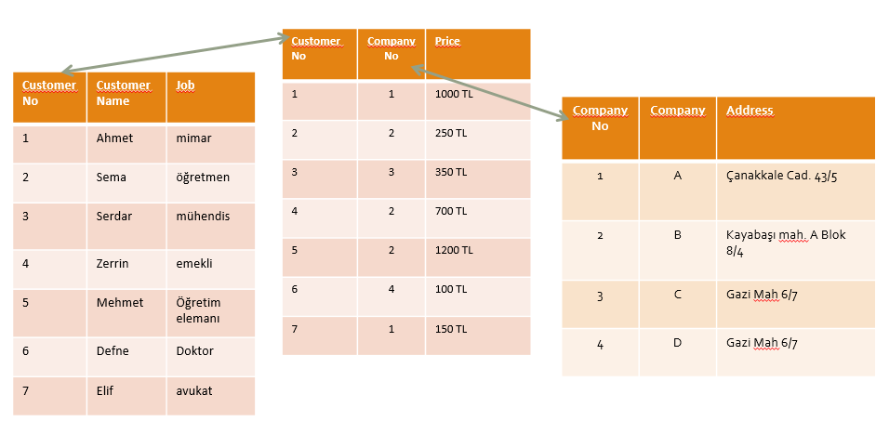

center h:450px

## Why we use the database?

* Relations

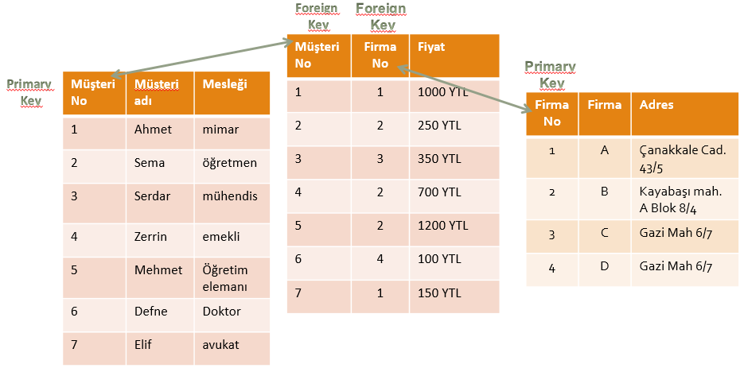

center h:450px

## Why we use the database?

* Joining tables
  + So what is done to get the initial holistic list?
  + SQL language is used.

## What is database management system?

* Components of the database system;

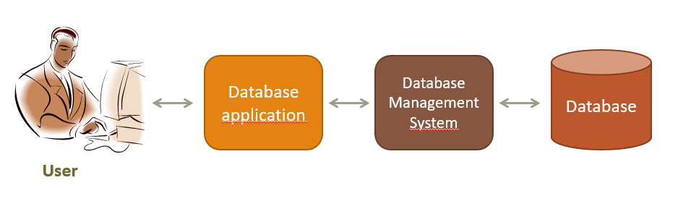

center h:450px

## What is database management system?

* The user does the following:
  + It uses the database to perform its work,
  + Adds new data
  + Modify existing data,
  + deletes data,
  + Reads data through queries or reports

## What is database management system?

* Database Application:
  + It is one or more computer programs that provide communication between the database management system and the user.
  + Creates queries and reports,
  + Receives data from the user or sends the data to the user,

## What is database management system?

* Database Management System:
  + It receives requests from the application and performs them by reading or writing data on database files,
  + It reads SQL statements and converts these statements into instructions for the computer’s operating system to read or write data on database files.

## What is database management system?

* Functions of Database Application
* Functions of Database Management System

## What is database management system?

* Database Application:
  + Creates and processes forms,
  + Creates queries and forwards queries,
  + Creates and operates reports,
  + Performs application logic,
  + Controls the application.

## What is database management system?

* Database Application:
* Creates and processes forms, for example, in a web-based application;
  + Creates HTML and other web formats to be displayed on the user’s computer,
  + When the user fills out the forms and sends the data back, it sends the DBMS requests for the necessary adjustments.
  + If an error occurs in the process, it displays the necessary message to the user and/or performs the necessary actions.

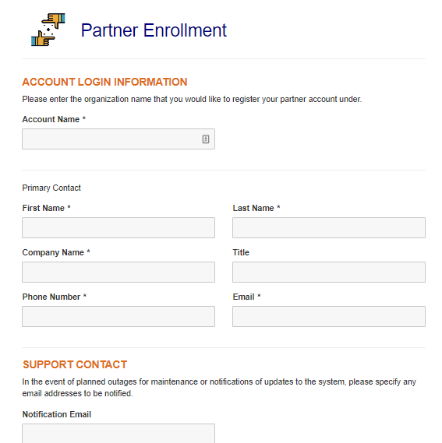

bg right:30% h:400

## What is database management system?

* Database Application:
* Creates queries and forwards queries,
  + Generates the query to be transmitted to DBMS,
  + These requests are usually expressed in SQL,
  + When the query is executed, the results are formatted and transmitted to the user,

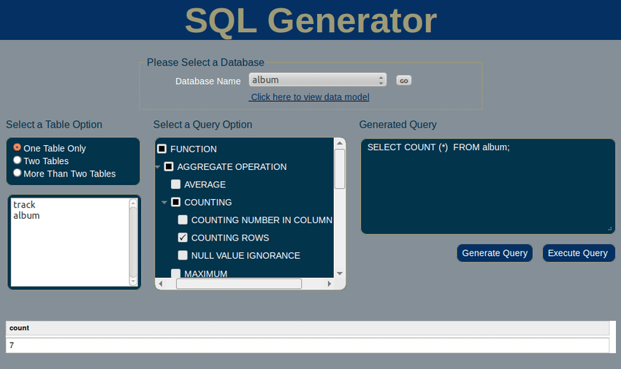

bg right:50% h:380px

## What is database management system?

* Database Application:
* Creates and operates reports,
  + Data is requested from DBMS through queries and query results are presented in the form of reports,

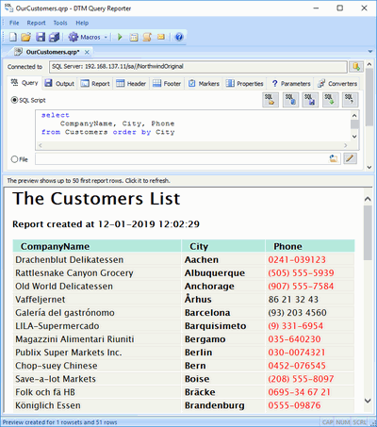

bg right:50% h:650

## What is database management system?

* Database Application:
* Performs application logic,
  + For example, the user made a request for 10 units, but 8 units were found in stock,
  + What happens depends on the logic of the program,
  + It is the task of the application program to implement the appropriate logic.

## What is database management system?

* Database Application:
  + Controls the application

## What is database management system?

* The Database Management System does the following:
  + Creating the database, creating the tables,
  + Reading data from the database and updating the data,
  + Realizing the limitations on data values,
  + It prevents one user’s process from interfering with the other user’s process.
  + Allowing users to take action within the limits of their authority,
  + Backing up data in the database.

## Database

* Database is data stores that consist of following related records.
  + Metadata (metadata)
  + index
  + stored procedure
  + trigger
  + data integrity (referential integrity)

## Database

* Data about the structure of the database is called metadata.
  + Table names
  + column names
  + Properties of tables and columns etc.

## Database

* Metadata example:

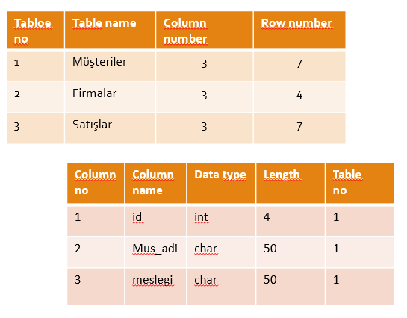

center h:450px

## Database

* Some databases contain application metadata.
* This metadata defines application components such as forms and reports.
* DBMS has several tools to show the structure of the database.

## Database

* At the same time, there are indexes used in databases to improve the performance of the database.
* Indexes are tools that show which records are in which tables.

## Database

* Stored procedures are compiled SQL statements.
* Because they are database objects, they are directly included in the database manager program.
* For example, stored procedures can be created for the purpose of taking a backup of data in a table or remove a backup of data that has passed more than a year.

## Database

* Stored procedures are codes for doing a specific duty defined in a database.
* These codes are optimized because they are compiled at the same time as they are written, and they are the fastest ready-to-run codes.

## Database

* A trigger is a special type of stored procedure that automatically runs when an event occurs in the database server.
* The events that trigger the triggers on the table are insert, update, delete events.

## Database

* For example, it is a typical use of triggers to decrease or increase the amount of stock as a result of stock movements.

## Database

* Since both **triggers** and **stored procedures** are codes on the database, they run on the database server.
* It is one of the powerful components of the Client & Server architecture.
* There are databases in client & server architecture as follows.
  + Oracle, Sybase, MS SQL, Interbase, FireBird etc.

## Database

* Because they work on the server where the data is located, the data does not go back and forth between the client and the server.
* Therefore minimal data is sent from the server to the client side.

## Database

* In a relational database
* Let’s assume that the department information of the person in the **PERSONNEL** table is kept in the **SECTION_NO** variable and
* the name of the department is in the **SECTION** table.

## Database

* If the section numbered as 1 is used by any personnel, the record with SECTION_NO value of 1 from the SECTION table must not be deleted.
* Protecting data integrity by making such controls is called **referential integrity**.

## Database

* The use of triggers is highly preferred in order to ensure data integrity.

## Database

* There can be 3 types of database systems:
  + used by a single person,
  + used by small businesses,
  + Used by large international companies

## Database

* used by a single person,
  + Painter
  + Whose house was painted, when and how much?
  + What was painted in the painting, what colors and styles were used?
  + Who referenced others? Who are the referrals?

## Database Systems

used by a single person,

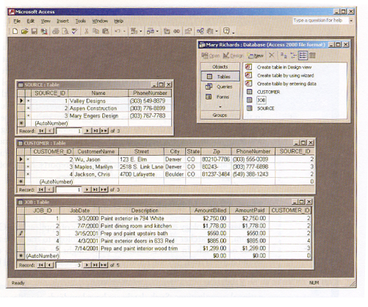

center h:450px

## Database Systems

used by a single person,

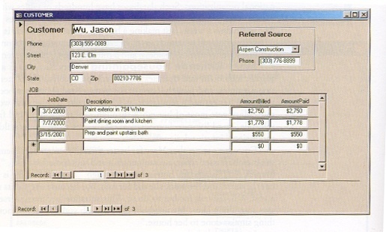

center h:450px

## Database Systems

used by a single person,

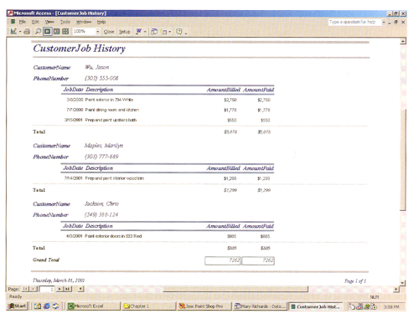

center h:450px

## Database Systems

* used by small businesses,
  + What are the rented musical instruments? How much is it rented?
  + Which musical instruments are rented the most?
  + Who made the lease? (multi-user database)
  + The same instrument cannot be selected by two different dealers at the same time!

## Database Systems

used by small businesses,

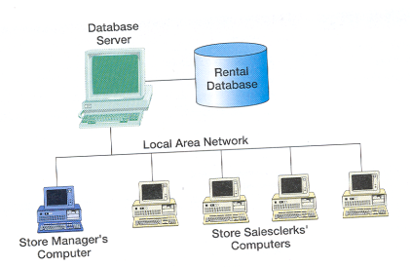

center h:450px

## Database Systems

used by small businesses,

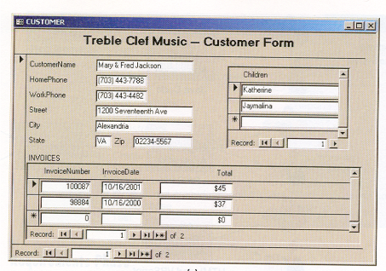

center h:450px

## Database Systems

used by small businesses,

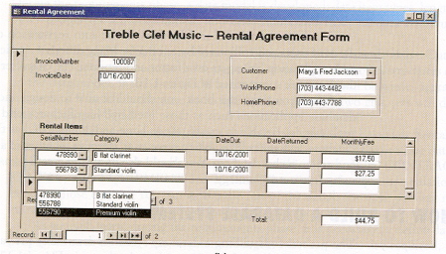

center h:450px

## Database Systems

used by small businesses,

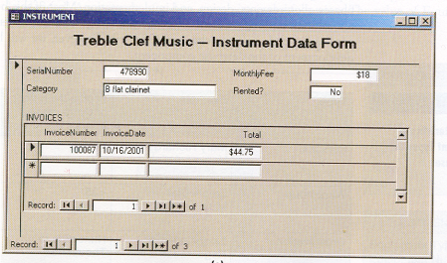

center h:450px

## Database Systems

* Used by large international companies,
  + Driver licensing and auto registration office
  + It has 52 different centers
  + Accidents of people, traffic violations are kept,
  + Is the license renewable, are there any limitations?
  + Database is used by 100s of people
    - Licensing and registration staff
    - Those who follow law enforcement
    - Finance department staff
  + Reachable 24 hours a day, 7 days a week

## Database Systems

Used by large international companies,

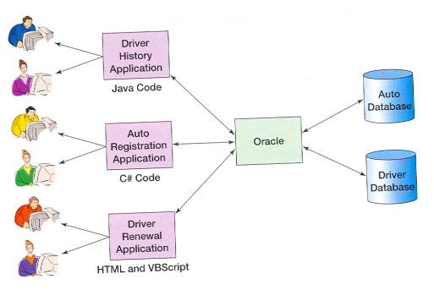

center h:450px

# References

* Kroenke, D. M. (2006). **Database Processing:** **Fundamentals, Design, and Implementation** .Pearson Education International. Singapore,Canada,Japan.
* http://www.delphiturkiye.com/trigger.htm