UCOSA WORLDWIDE DEVELOPMENT ACTIVITIES IN UGBEKA COLLEGE

The Staff Quarters Building Renovation Project ( 2022)
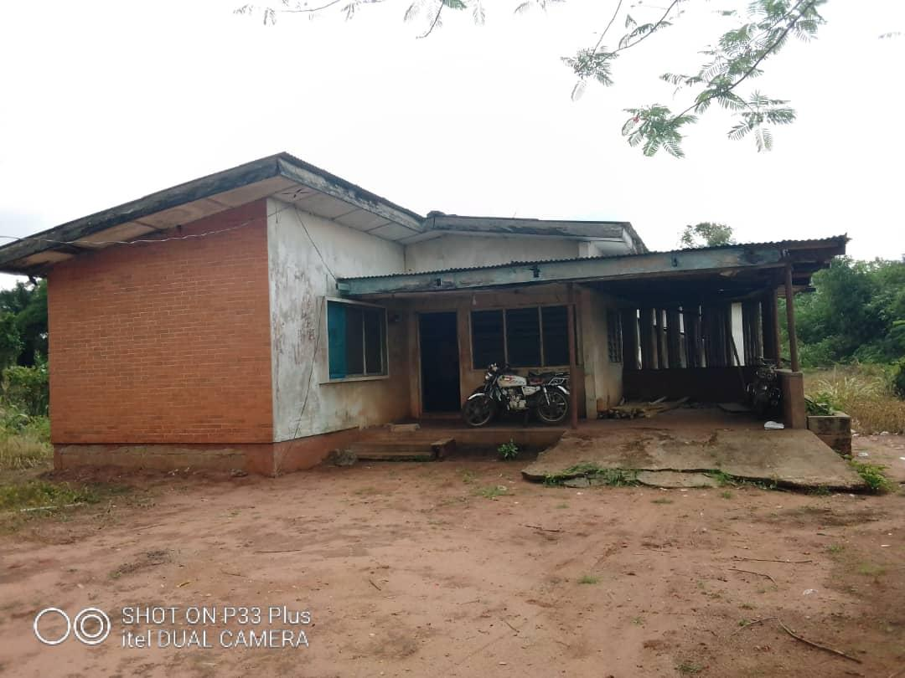
Before
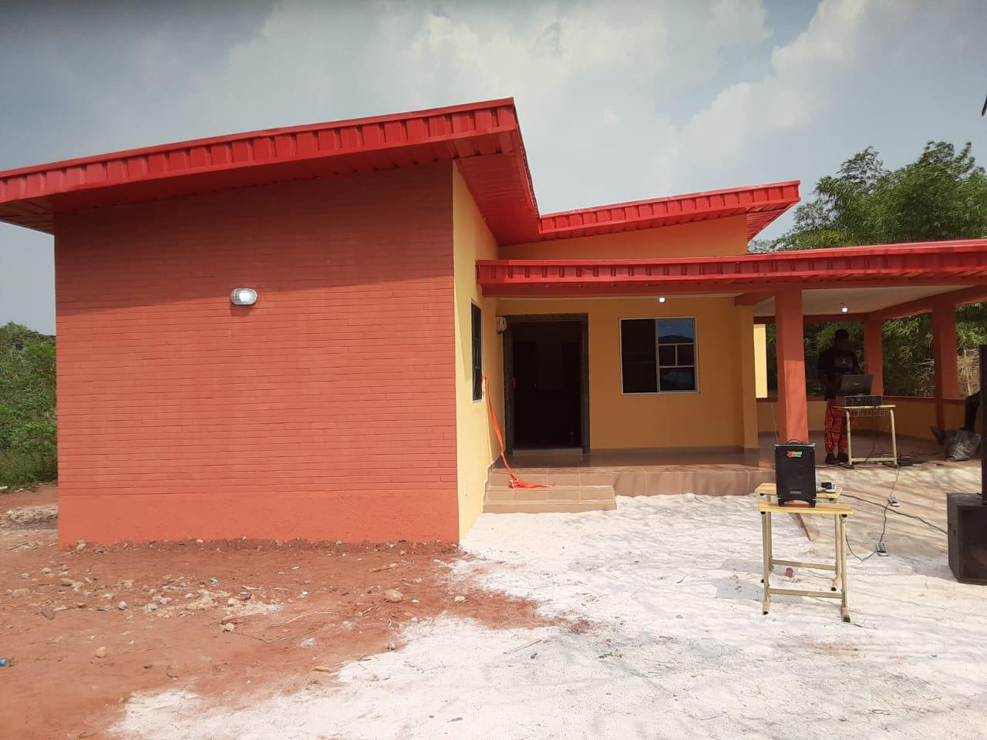
After
This building was Commissioned and handed over in April 2022.

