UCOSA WORLDWIDE DEVELOPMENT ACTIVITIES IN UGBEKA COLLEGE

Renovated Classrooms Blocks - 2023

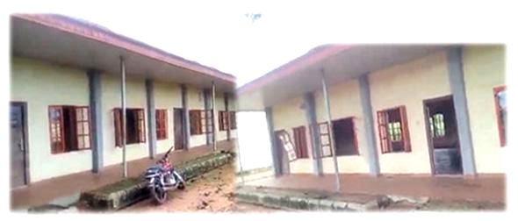

Before

