Structure and dynamics of neural cell adhesion molecule 2
Nikolaj Kulahin, Ole Kristensen, Lars Olsen, Patrick Rydberg, Bente Vestergaard, Jette S. Kastrup, Michael Gajhede
Biostructural Research, Department of Medicinal Chemistry, Faculty of Pharmaceutical Sciences, University of Copenhagen

Neural cell adhesion molecules (CAMs) have adhesive properties and are pivotal for the self assembly of the billions of interconnections between cells in the mammalian brain. CAMs are generally multi-domain proteins with the extracellular part build up of Ig-like domains in tandem arrangement. Within all classes the molecular mechanisms controlling the various functions of CAMs have attracted much attention not in the least within the field of drug discovery.
Neural cell adhesion molecule 2 (NCAM2/OCAM/RNCAM) was originally described in 1986 as a membrane associated 125 kDa protein. The expression of NCAM2 has been suggested to influence certain types of neurological diseases and to modulate neurite outgrowth, axonal guidance, synapse formation in the olfactory system and formation of dendritic bundles in the brain. Studies have also indicated that the expression of NCAM2 plays a role in the development of certain carcinomas.

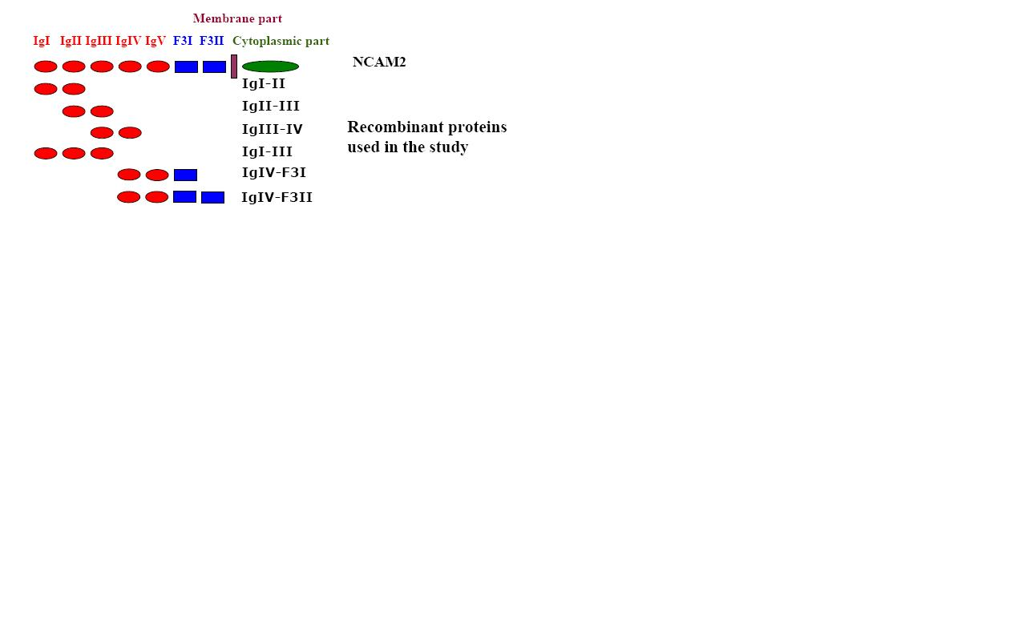

Figure 1. The extracellular part of NCAM2 consists of five N-terminal Ig domains (Ig1-5) followed by two Fibronectin type III domains (FnIII1-2).

We have determined six x-ray structures of various modules of NCAM2, covering the whole extracellular part of the protein (figure 1). In order to construct a complete model comprising all seven extracellular domains, an understanding of flexibility in solution caused by the modular construction of the protein is required. Also, stabilization of specific conformations by ligands, e.g. HEPES, needs to be investigated. NCAM2 flexibility/stability can be studied by molecular dynamics simulations, using the program AMBER. However, these calculations demands lots of computer power to give reliable results and finish within reasonable time for protein complexes of this size (up to 700 amino acids). Therefore, “sandkassetid” at the Danish Center for Scientific Computing is essential for completion of the project.

