College of Engineering Drill Press Safe Operating Procedure
Compiled from COE Machine Shop Safety Handout, Drill Press SOP by Trevor Marks
July 2020 by Jeran Bruce

Location of Drill Presses
- Craftsman 10-inch drill press: Engr. II Rm 2226
- Wen 15-inch floor standing drill press: 2448 Eilings hall
- Standing/floor drill presses: COE Machine Shop Arts Bldg 534
For specific information about each drill press, consult their respective manuals.
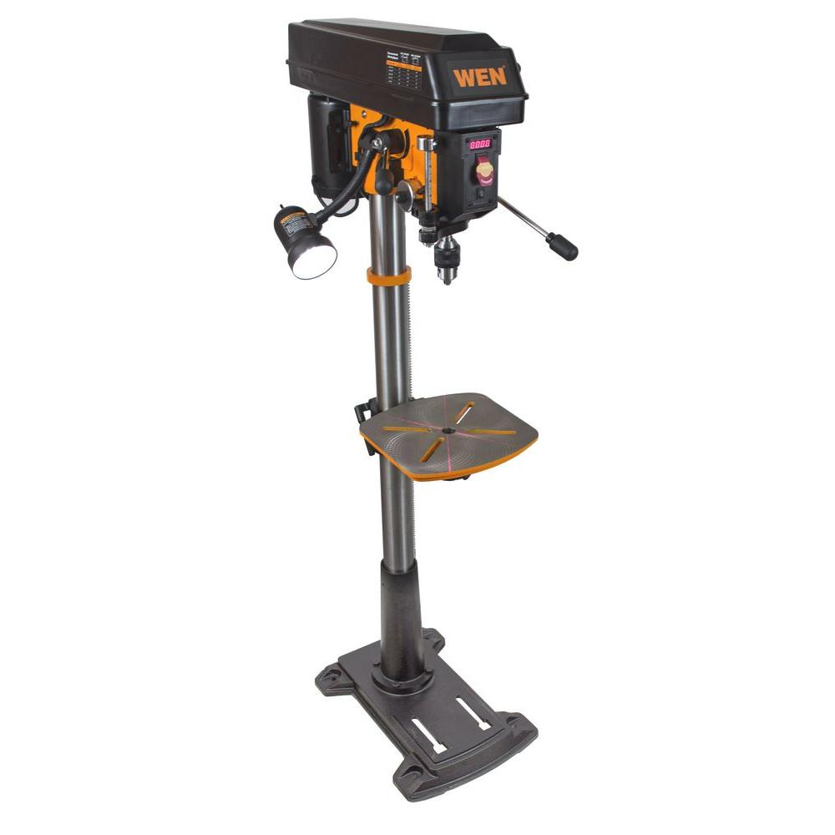
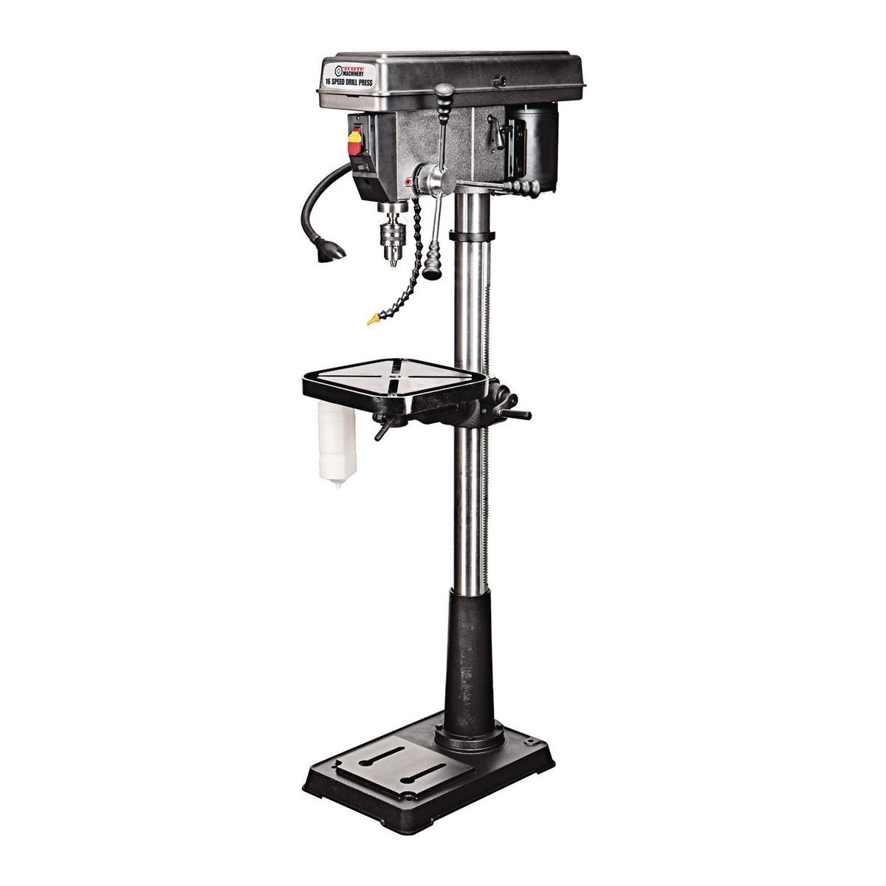
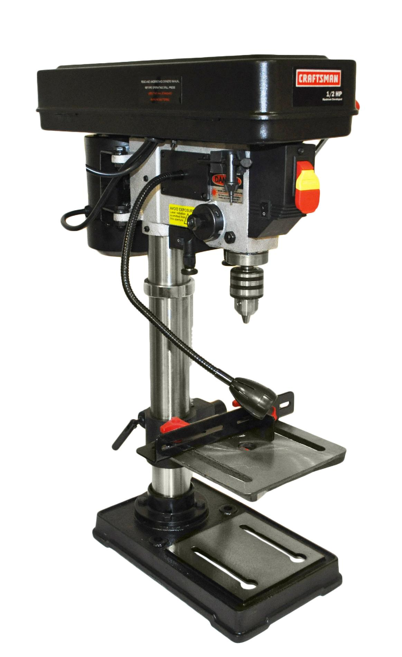

Machine Hazards
- Eye injury from flying chips or broken bits
- Cuts from contact with sharp cutting tools or exposed chips and burrs
- Entanglement of hair or clothing/jewelry in rotating machine parts
- Pinch from moving machine parts
- Burns from hot tools or hot work pieces and metal chips
- Tripping hazards around the machine due to poor housekeeping
- Leaving machine running while unattended
- Breakings cutting tool due to improper cutting speed or feed rate

Safety Precautions
- Always wear eye protection
- Always wear closed toed shoes
- Do not have loose hair or wear any type of rings/jewelry
- Do not wear gloves as they could be caught in the machine
- Never leave a machine running unattended
- Let spindle come to a stop on its own. Do not attempt to slow it by hand
- Remove chips with a brush or rag, never by hand




Pre-Use Checklist
- Ensure the workpiece is securely clamped in a vice or to the table.
- Ensure the proper drill bit is being used for the material and is not cracked or dull. Ask shop personeel if you are unsure.
- Check to ensure the cutting tool is clear of the work.
- Remove all tools and parts from the drill press table.
- Ensure the cutting tool is clear of work and can turn freely.
- Determine correct cutting speed for material and hole size (refer to ‘Speed and Feed’ section).
- For cutting metals, always use a cutting fluid. Have it accessible and apply to part using brush.

Operating Procedures
For a quick walkthrough on how to use a drill press, watch this video produced by MIT. This should only be used as a supplement and not a substitute for proper training and reading this SOP.
- Insert drill bit and lock into place using drill chuck key. Always remove drill chuck key from spindle immediately after using it.
- Identify ON/OFF switch and power machine on.
- Adjust the machine to the proper RPM based on your material and hole size (refer to ‘Speed and Feed’ section).
- Drill with an appropriate amount of pressure. Too much or too little pressure can damage the drill bit and machine.
- Use peck drilling on metal by withdrawing the bit frequently to clear chips.
- Lubricate the drill bit and workpiece often with your cutting fluid. This can be done while the machine is running if applied with a brush.
- When drilling large holes step up to the full size with successively larger drill bits.
- If cutting a through hole, ensure part is supported by parallels or some scrap material so that you do not drill into the table.

Speed and Feed
Drill speed recommendations given in feet per minute
Material | Drill | Counter Sink | Reamer
Aluminum | 300 | 200 | 150
Brass | 120 | 90 | 66
Delrin | 150 | 100 | 75
Polycarbonate | 240 | 160 | 120

Feed rate recommendation for drill press
Bit Diameter | Inch/Revolution
Under ⅛” | 0.002
⅛” to ¼” | 0.002 to 0.004
¼” to ½” | 0.004 to 0.008
½” to 1” | 0.008 to 0.012
Greater than 1” | Contact machine shop personnel

$Speed =\frac{12 * Drill Speed}{π * Diameter}$

$Feed = Speed*Feed Rate$

Speed is the speed of the work in RPM (revolutions per min). Drill Speed is the cutting tool speed at the surface in feet per min, found in the drill speed chart. Diameter is the diameter of the work piece in inches. Running a tool too slow will only decrease productivity; however, running a tool too fast with regard to speed or feed rate will result in accelerated tool wear or outright failure, so err on the side of running too slow.

Feed is the downward feed rate in inch per min. A feed that is too light will cause the drill to chatter and rapidly dull. A feed that is too great can cause chipped cutting edges, drill breakage, or excess heat — avoid too great a feed. Generally when using a drill press feed has to be felt out by the user as there is no way to precisely control the feed rate.

