**ORCHESTRATOR AGNOSTIC PLATFORM**

**Author:**

UDIT AGRAWAL

SIDDHARTH VERMA

**Mentor:**

Gajendra Ambi­­

Harish Bhatt

**CONTENTS**

1. Introduction
2. Overview
3. Components
   1. Kubernetes
   2. OpenWhisk
   3. Airflow
   4. Ansible
   5. Chef
   6. NetBox
4. Architecture
5. Workflow
6. Conclusion

**Introduction**

ICDS (IBM Cloud Deployment Services) is a cloud offering provided by IBM to deploy and provision VMs in an on/off premise environments like public and private clouds in an automated and orchestrated manner.

Currently, there are multiple Cloud Management Platforms in market supported by IBM ICDS offering, for example, vRA, OpenShift, Broker, Native Cloud, etc. Majority of these support Multi-Cloud. These perform 3 major roles – Infrastructure Provisioning, Automation and Orchestration.

But these platforms are not agnostic.

Our solution known as OAP is introduced to make Orchestrator and Automation agnostic to Cloud Management Platform. This will help to create consistency in orchestration and automation assets irrespective of increasing and changing Cloud Management Platforms.

**Overview**

The primary goal of the automation platform is to develop an architecture and automation framework that leverages across the orchestrators, and thus develop micro-service automation code that can be leveraged across clients.

It aims on making all tools as open source so that if any code is not working, or any news functionality needs to be added then the team can fix it by submitting it to open source community so that it can be a part of community product in its next version. For e.g. Kubernetes is used instead of ICP.

**Components of OAP**

1. **Kubernetes**: - Kubernetes is an engine that provides a container platform to run all the components of OAP.
2. **Openwhisk**: - Apache OpenWhisk is an open source, distributed Serverless platform that executes functions in response to events at any scale. It manages the infrastructure, servers and scaling using Docker containers, so you can focus on building amazing and efficient applications. Here, OpenWhisk hosts all the functions of OAP.
3. **Airflow**: - Airflow is a platform to programmatically author, schedule and monitor workflows. It is used to author workflows as directed acyclic graphs (DAGs) of tasks. The airflow scheduler executes your tasks on an array of workers while following the specified dependencies. Here, it will compose all the OpenWhisk functions and run them in a sequence.
4. **Ansible**: - Ansible is an open-source automation tool, or platform, used for IT tasks such as configuration management, application deployment, intraservice orchestration and provisioning.
5. **Chef**: - Chef Infra is a powerful automation platform that transforms infrastructure into code. Chef automates how infrastructure is configured, deployed, and managed across your network, no matter its size.
6. **NetBox: -** NetBox is an IP address management (IPAM) and data center infrastructure management (DCIM) tool. designed to help manage and document computer networks.

**Architecture**

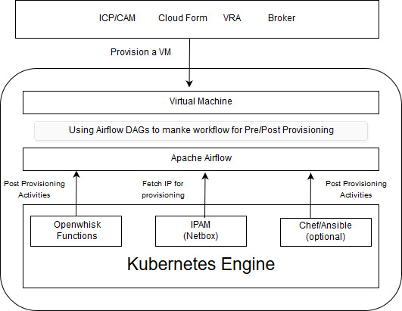

Workflow

1. User submits the request for provisioning.
2. OAP connects to vRA for performing some pre-provisioning activities.
3. OAP connects to NetBox IPAM and fetches an available IP address and assign it to vRA.
4. vRA deploys the VM on this IP address through VCenter.
5. OAP uses ansible/chef or user defined openwhisk functions for performing the post-provisioning activities on the VM like connecting to an active directory, installing some software/packages, etc.

Provision the VM

Deploy vRA VM on the VM with fetched IP

Fetch IP from a pool



USER

NetBox

OAP

Cloud Platform vRA

AD

VCenter

VM Provision

Conclusion

In the market multiple solutions are available for cloud management making life difficult for developers to manage things on all platform i.e. doing same stuff again on different platform in totally different way.

Orchestrator Agnostic platform is useful when there are multiple Cloud Management Platform and multiple cloud platforms are available to manage. This platform can play huge role in making code reusable and generic irrespective of platform you are using.

Airflow DAGs

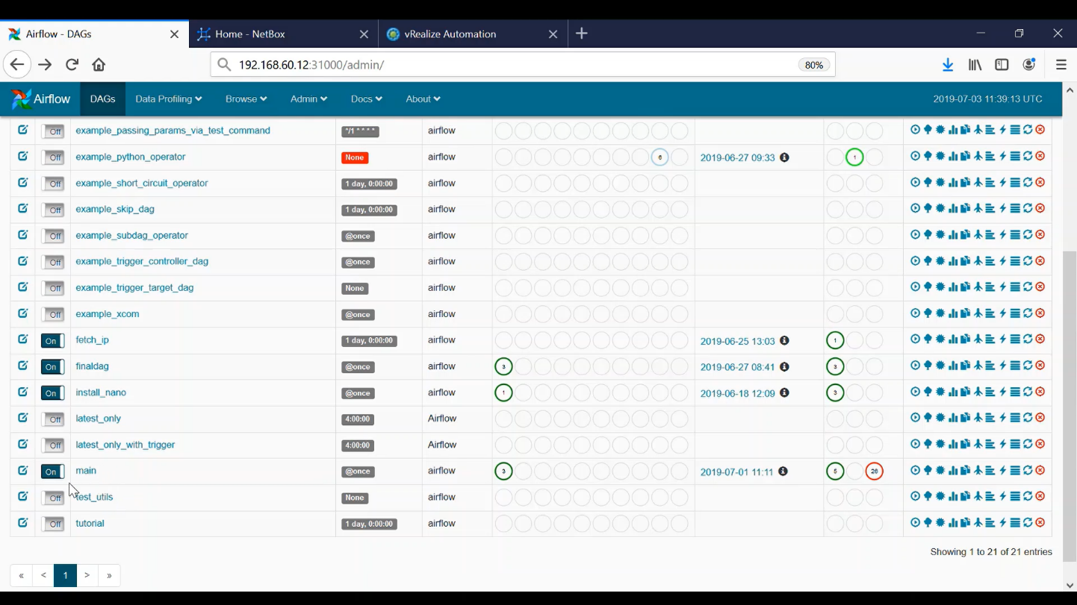

vRA ICDS

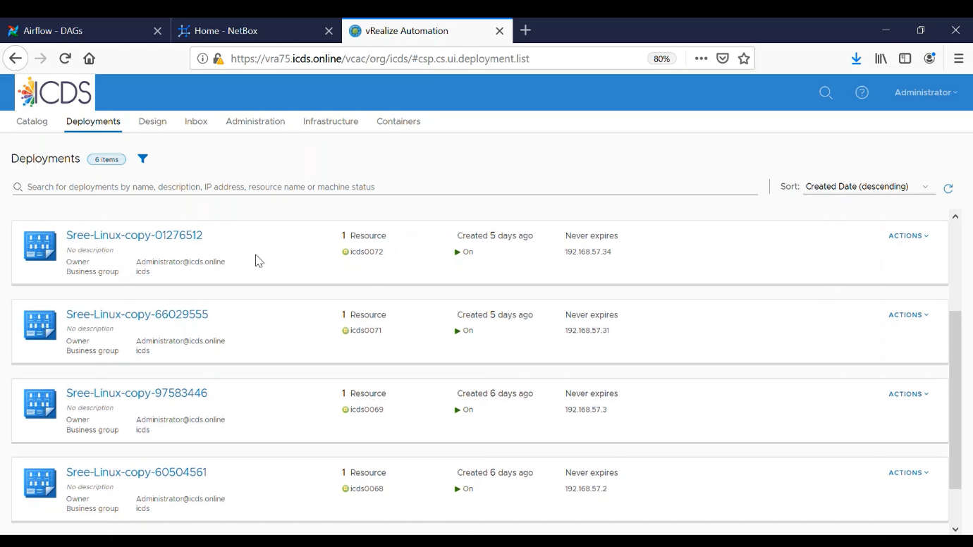

NetBox IPAM

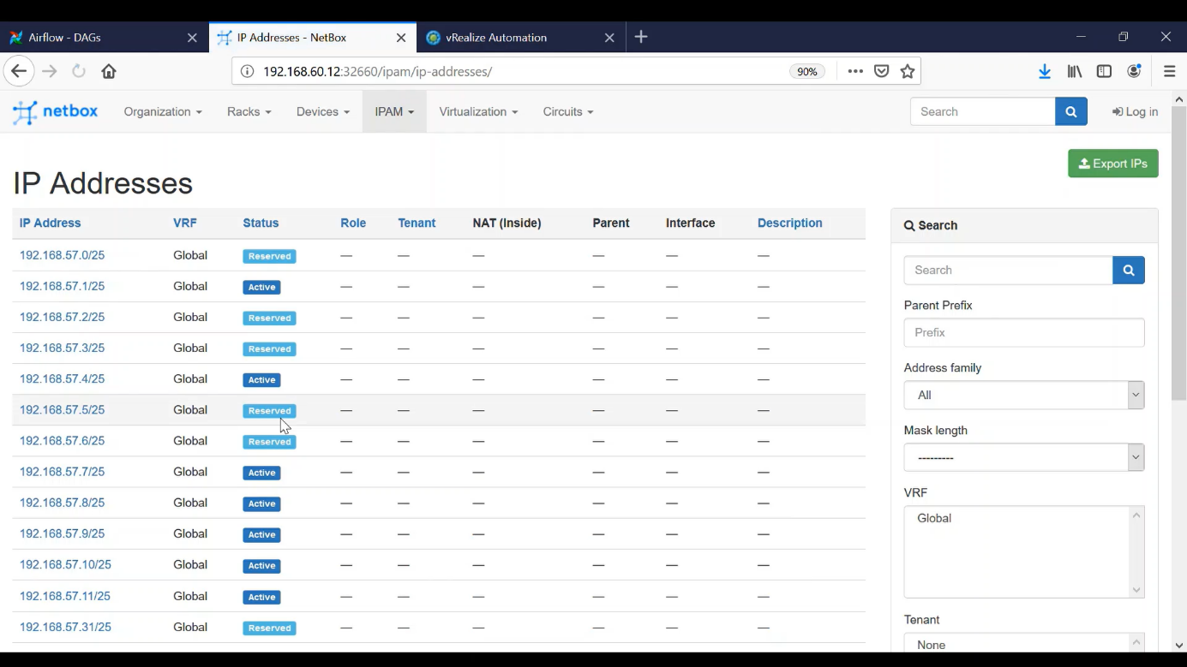

Trigger DAG using airflow

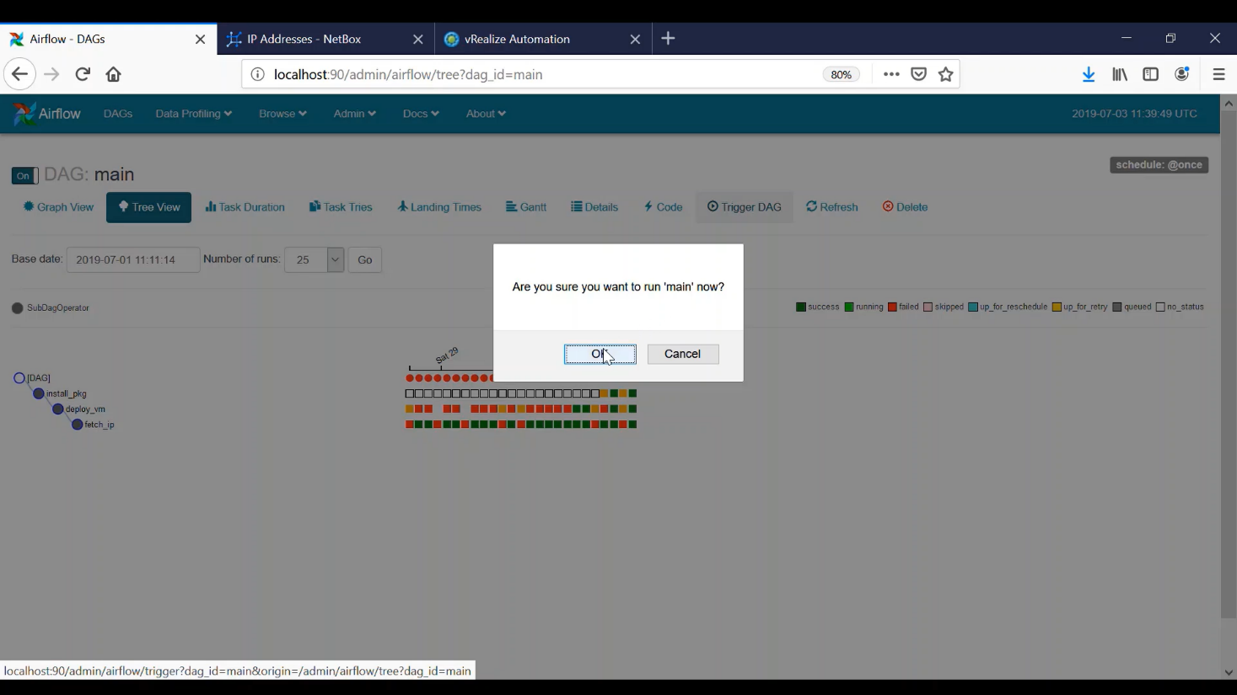

DAGs Running

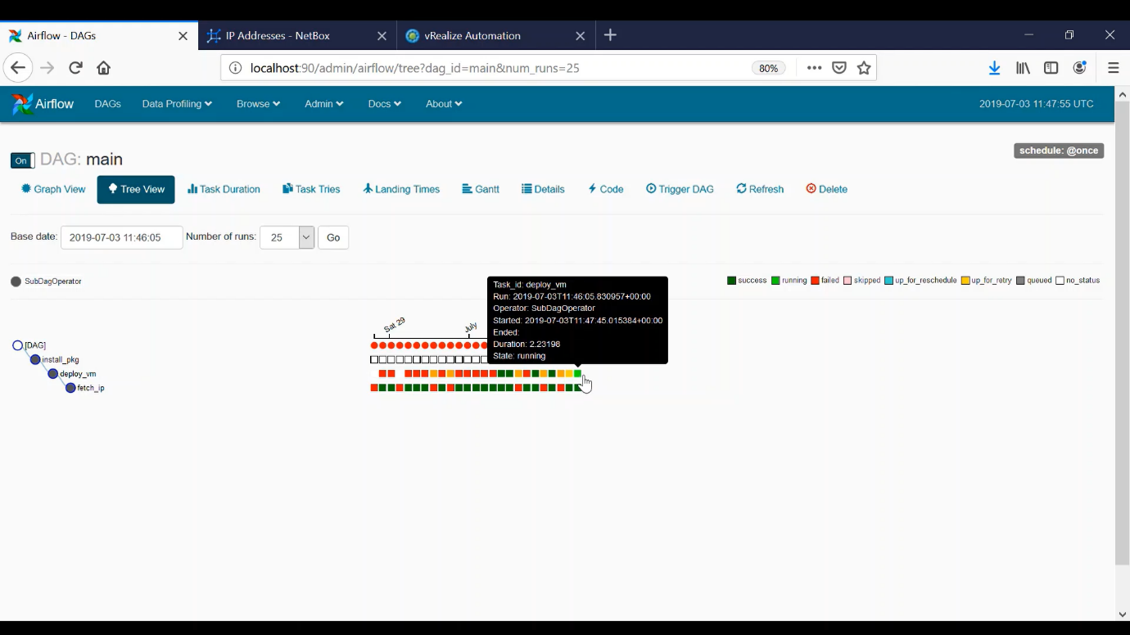

VM deployed on the fetched IP address

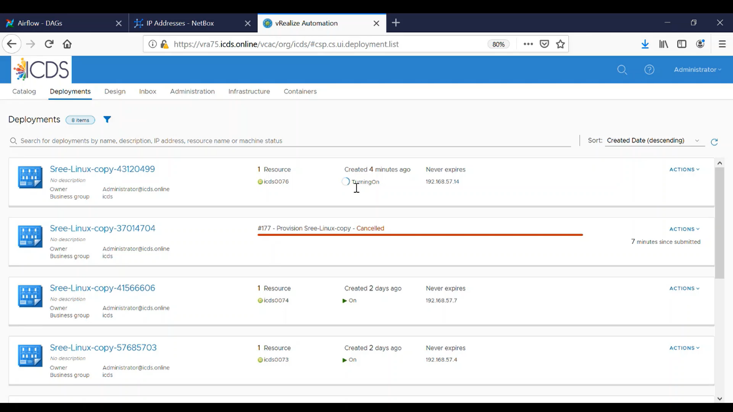

All tasks completed successfully

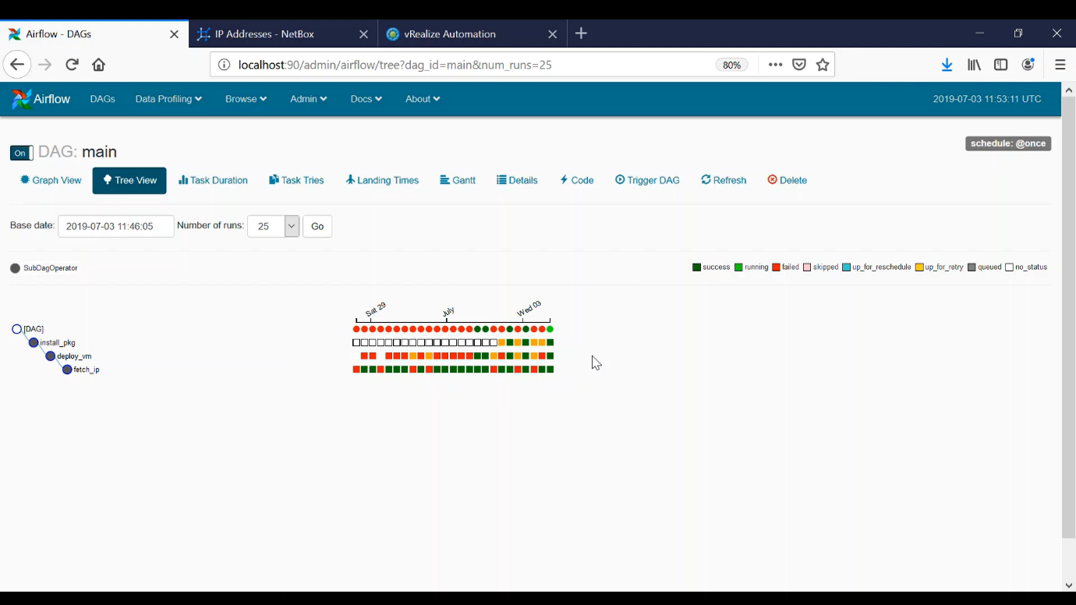

ssh into VM successful

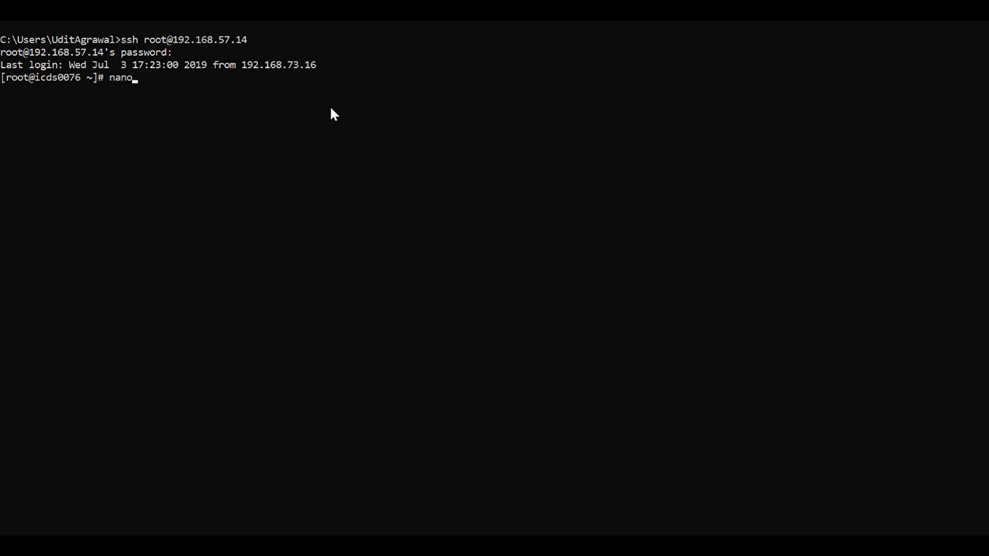

Packages installed successfully into the VM

