CSR Checklist Catalog
Companion Maintenance Application
UI5 APPLICATION DESIGN PROPOSAL
Question & Instruction Catalog · Versioning · Admin-only
Freestyle SAPUI5 · FES 2022 · OData V2 (ZCSR_CHECKLIST_SRV, shared)
Version 0.1 (Draft) · 2026-08-25

Table of Contents

1. Purpose & Scope
The catalog app replaces SM30 maintenance of ZCSR_QCATALOG with a governed admin UI. Administrators maintain, per checklist type, the Procedures (Section P — the questions analysts answer) and the Instructions / Notes texts (Section I — guidance rendered in the checklist's Instructions panel), across catalog versions. The annual audit-driven question update becomes a first-class workflow: copy the released version, edit the draft, release with a valid-from date.
- In scope: create/edit/delete/resequence catalog rows per checklist type; both sections; version copy and release; live preview of analyst rendering.
- Out of scope: editing released versions (immutable by design); maintaining value tables (LOB/segment stay in SM30); checklist instance data.

2. Application Architecture
Aspect | Decision
App ID / repo path | zcsr.catalog · catalog/webapp/ (second app in the monorepo, own ui5.yaml, own BSP + tile)
Service | Same ZCSR_CHECKLIST_SRV — no second service; QuestionSet + CatalogVersionSet + 2 function imports (see §3)
Access | Role AD only: tile assigned via PFCG catalog role; backend AUTHORITY-CHECK Z_CSR_CHK ACTVT 70 on every write
Layout | sap.f.FlexibleColumnLayout, TwoColumnsMidExpanded: begin = filtered lists (tabs), mid = editor
Save model | Explicit Save per row (no autosave) with dirty-state guard — deliberate admin edits, not drafting
Reuse | formatter.js section/status maps and .zcsr* CSS shared from the main app via library-style include or copy (prototype: copy)

3. Service Deltas (applied to metadata v0.2)
- Question entity completed to the full catalog shape: Title, ExampleText, RespRequired (replaces Required), AttachMode, NaAllowed added; plus server-computed Editable flag (version unreleased AND unbound). Keys and classification fields (QuestionId, Version, Chktype, Section, Inptype) are create-only.
- QuestionSet opened for create/update/delete. The DPC enforces: writes only where Editable is true; DELETE is physical for never-released rows (draft-only concept — no orphaned IDs in history).
- New read-only CatalogVersionSet: Version, Status (D Draft / R Released), ValidFrom, CreatedBy/At — backed by new table ZCSR_QVERS.
- New function imports: CopyCatalogVersion(SourceVersion) → creates next version as Draft, deep-copies all rows across all checklist types; ReleaseCatalogVersion(Version, ValidFrom) → Draft→Released, locks rows, becomes the version bound by GenerateInstances from ValidFrom.
- Versions are global across checklist types (one version space, matching ZCSR_HEADER.CATALOG_VERS) — a release freezes the whole catalog snapshot, which is the audit-clean interpretation.

4. Layout, Navigation & Routes
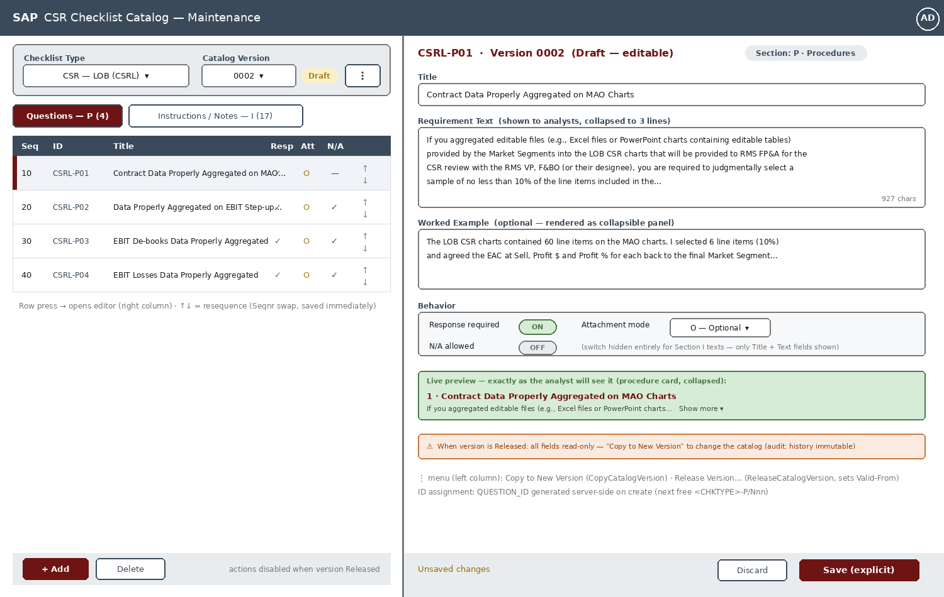
Figure 1 — FlexibleColumnLayout: filters + section tabs + list (left), row editor with live preview (right)
Route | Pattern | Column state
catalog | {chktype}/{version} | OneColumn — list only
catalogEdit | {chktype}/{version}/row/{questionId} | TwoColumnsMidExpanded — list + editor
notFound | :all*: | —
- Checklist type and version are part of the hash — deep-linkable and survives refresh. Defaults on open: first checklist type, latest version.
- Tab selection (Questions vs Instructions) is UI state, not a route segment; switching tabs closes the editor column if the open row belongs to the other section.

5. View Design

5.1 List column (begin)
- Header filters: Checklist Type sap.m.Select (domain ZCSR_D_CHKTYPE values) and Version sap.m.Select bound to CatalogVersionSet with status pill (Draft = Warning / Released = Success). Overflow menu: Copy to New Version, Release Version…
- sap.m.IconTabBar with two filters and live counts: “Questions — P” and “Instructions / Notes — I”. Binding filter: Chktype + Version + Section; sort Seqnr.
- Questions tab table columns: Seq, ID, Title, Resp (required), Att (N/O/R), N/A, reorder arrows. Instructions tab: Seq, Title, first line of text, reorder arrows — behavior flags don't apply and are not shown.
- Resequence: up/down arrows swap Seqnr with the neighbor and MERGE both rows immediately (no editor round-trip). Disabled when version Released.
- Add: creates a row in the active tab's section — Section and Inptype are derived (P/I, I/C), never user-selected. QUESTION_ID is assigned server-side (next free <CHKTYPE>-Pnn / -Nnn) and returned in the create response; the editor opens on the new row.
- Delete: confirmation dialog; allowed only in Draft versions (physical delete — the row never existed in any released snapshot).

5.2 Editor column (mid)
- Section P editor: Title (Input, 60), Requirement Text (growing TextArea with live char count — analysts see it collapsed to 3 lines), Worked Example (growing TextArea, optional), Behavior panel: Response required (Switch), Attachment mode (Select N/O/R), N/A allowed (Switch).
- Section I editor: Title (optional) + Text only. The Behavior panel is absent, not disabled — texts have no behavior.
- Live preview panel: renders the row exactly as the analyst's procedure card shows it (collapsed requirement + “Show more”, Example panel presence) — reuses the main app's formatters so preview can't drift from reality.
- Footer: Save (explicit, validates first) / Discard. Dirty guard on navigation and tab switch (“Unsaved changes — discard?”).
- Released version: entire editor read-only with an information strip: “Released — copy to a new version to change the catalog.”

6. Versioning & Editability Rules
Rule | Enforcement
Rows editable only while their version is Draft (Status D) and unbound by any ZCSR_HEADER | Server: Editable flag + write rejection; UI: read-only rendering
Copy to New Version deep-copies ALL rows of ALL checklist types from the source version | CopyCatalogVersion in one LUW; new version = Draft
Release requires ≥1 Section P row per active checklist type and a ValidFrom date | ReleaseCatalogVersion validation; itemized errors via message container
Released versions and their rows are immutable forever (audit history) | No update path exists server-side; UI offers Copy instead
GenerateInstances binds the Released version whose ValidFrom covers the period | Existing generation logic reads ZCSR_QVERS

7. Validation & UX Conventions
- Save validation (client mirror + server): Title mandatory for Section P; Requirement/Text non-empty; AttachMode within N/O/R. Errors itemized via MessageManager exactly like the main app.
- All texts i18n; section codes never displayed raw (formatter.sectionText); status by text + semantic state, never color alone.
- Char counters on long-text fields with a soft warning above 2,000 chars (analyst readability, not a hard limit).
- No client-side storage; growing lists not needed (catalog row counts are small) but bindings still server-filtered.

8. Backend Deltas Summary (for Tech Spec v0.3)
- New table ZCSR_QVERS (VERSION key, STATUS, VALID_FROM, CREATED_BY/AT) + SM30 view initially unnecessary — maintained only through the app's function imports.
- DPC_EXT: QuestionSet CREATE/UPDATE/DELETE with Editable enforcement + ID generation; CopyCatalogVersion / ReleaseCatalogVersion function imports; change documents (SCDO ZCSR) extended to ZCSR_QCATALOG and ZCSR_QVERS writes — catalog changes are audit-relevant.
- Authorization: catalog writes require Z_CSR_CHK ACTVT 70 (Administer); reads unchanged.

9. Open Items
- Whether Release should also e-mail analysts/reviewers a “catalog updated” notice (cheap via ZCL_CSR_NOTIFY — recommend yes, deferred).
- Version diff view (Draft vs last Released) — valuable for the annual audit conversation; propose for a later iteration.
- Whether Market Segment templates introduce section values beyond P/I — if so, the ZCSR_SECTION domain gains values (DDIC transport) and the tab bar becomes data-driven from the domain.

