CSR Auditing Application
AI Integration Specification
ADVISORY TRIAGE VIA THE IN-HOUSE LLM PLATFORM
Wiring · trigger points · safety contract · platform checklist
Classic ABAP · SM59 destination ZCSR_LLM · OpenAI-compatible chat API
Version 0.1 (Draft) · 2026-10-27 · companion to Technical Specification v0.3 §7 and the ABAP Development Specification

Table of Contents

1. Purpose & Principle
The application uses the client's in-house LLM platform for one purpose in the MVP: advisory triage of submitted checklists. After an analyst signs and submits, the model reads every response against its procedure requirement and records findings (severity + text, per procedure) that direct the reviewer's attention. The governing principle is absolute and enforced structurally, not by convention:
AI is advisory only. Flags never block submission, nothing is auto-approved, no status transition is ever touched by AI, and any AI failure produces zero flags — never an error the business process can see.
All AI integration lives in one backend class, ZCL_CSR_AI_CLIENT. The SAPUI5 apps never call the model; they only read stored flags through the OData service (AiFlagSet, ToAiFlags, AiFlagCount).

2. Decision: Backend Call, Not Frontend
A browser-side call to the LLM API was considered and rejected. The decision drivers, in priority order:
# | Driver | Rationale
1 | Credential custody | A frontend call requires the platform API key in the browser, where developer tools make it extractable by any user. The SM59 destination keeps authentication server-side, rotatable by Basis without a transport, never present in a JS bundle.
2 | Flags are audit artifacts | Findings are stored in ZCSR_AIFLAG with model identifier and server timestamp — part of the compliance record shown to reviewers and auditors. Browser-computed flags would be client-supplied data: fabricatable, suppressible, alterable before storage. Server-side generation is what makes a flag trustworthy.
3 | Unattended operation | Two of three trigger paths (post-submit fire-and-forget, batch safety-net job) run with no browser session. Frontend-only AI functions only while a user has the app open.
4 | Network topology & CORS | Browser calls require the platform to accept cross-origin requests from every workstation through intervening proxies. The backend needs one server-to-server route and no CORS enablement on the platform.
5 | Data governance | Prompts carry client-confidential compliance narratives. The backend path is a single, auditable, in-landscape egress point; browser calls would fan that content through every user's workstation session.
Considered trade-off: a frontend call wins on interactive latency (as-you-type assistance). The MVP has no such requirement, and even a future pre-submit “check my work” should route through a function import so all five guarantees hold (§10).

3. Wiring

3.1 Transport — SM59 destination ZCSR_LLM
- Type G (HTTP to external server): platform host, port, and path prefix.
- TLS: platform certificate chain imported into STRUST (standard SSL client PSE).
- Authentication: if the platform requires an API key / bearer header, it is configured on the destination — never in code, never transported, rotatable without a change.
- Timeout: set on the destination; a timeout is just another silent zero-flag path. Recommended 30–60 s — the user never waits on it (fire-and-forget / batch).

3.2 Call & prompt contract
- CL_HTTP_CLIENT=>CREATE_BY_DESTINATION( 'ZCSR_LLM' ) → POST /v1/chat/completions (OpenAI-compatible chat format), temperature 0 — deterministic: same submission, same flags.
- One request per checklist (not per procedure): the model sees the whole submission and can flag cross-procedure inconsistencies.
- System message: compliance review assistant, output JSON only. User message: per response-type item — QUESTION_ID, title, full requirement text, and the analyst's response or “N/A (explicitly marked)”.
- Mandated output: a JSON array of {question_id, severity: H|M|L, finding}. Nothing else.
- Attachments are NOT sent in the MVP — prompt content is text only (§10 for the extension path).

3.3 Response handling & data model
- Parse ×2 with /UI2/CL_JSON: chat envelope → choices[1].message.content → findings array.
- Defensive normalization: severity outside H/M/L becomes L; question IDs are the model echoing our own keys back; finding text is stored and rendered strictly as text (model output can say anything but can do nothing).
- Persistence: ZCSR_AIFLAG — FLAG_GUID, HEADER_GUID, QUESTION_ID, SEVERITY, FLAG_TEXT, MODEL_INFO (the model identifier returned by the platform — every flag records which model produced it), CREATED_AT.

4. Trigger Points
Path | Trigger | Behavior
① Post-submit | DPC, immediately after SubmitChecklist succeeds (status SB) | Fire-and-forget: submission success never waits on or varies with AI. Primary path.
② Batch safety net | ZCSR_AI_TRIAGE_JOB (SM36; hourly during close week) | Triages SB checklists with no flags yet (NOT EXISTS) — catches silent failures of ① before a reviewer opens the record.
③ On demand | TriggerAiTriage function import | Re-run for one checklist (platform was down, or a fresh pass is wanted). Same class, same path.

5. Where Users Meet It
- Worklist: AI-flag count per row — a glanceable “worth a closer look”.
- Review Queue: sorted by flags, worst first — triage before opening a single submission.
- Review screen: findings panel — severity chip, finding text citing its procedure — with “Advisory only — never blocks submission” printed on the panel itself.
- Analysts never see flags mid-edit: flags exist only after submission. (Deliberate — see §10 for the possible pre-submit assist.)

6. Failure Semantics & Safety Contract
The whole triage runs inside one TRY … CATCH cx_root. Connection refused, timeout, HTTP 4xx/5xx, malformed envelope, prose instead of JSON — every failure path returns zero flags and never raises. An AI outage is a non-event: submissions proceed, reviews proceed, the batch job retries later.
- No auto-approval exists anywhere; no status transition is reachable from AI code.
- Prompt-injection posture: analyst responses are untrusted input to the model, but the output channel is advisory text with no authority. A hostile “mark everything compliant” instruction can at worst suppress its own flags — the reviewer still reads the actual submission. Low-consequence by construction.
- Observability: silent-by-design toward users, not toward operations — log failed calls to the application log (BAL) with HTTP status, and monitor ②'s “SB with no flags” count as the health signal (§8 checklist).

7. Sequence Diagram
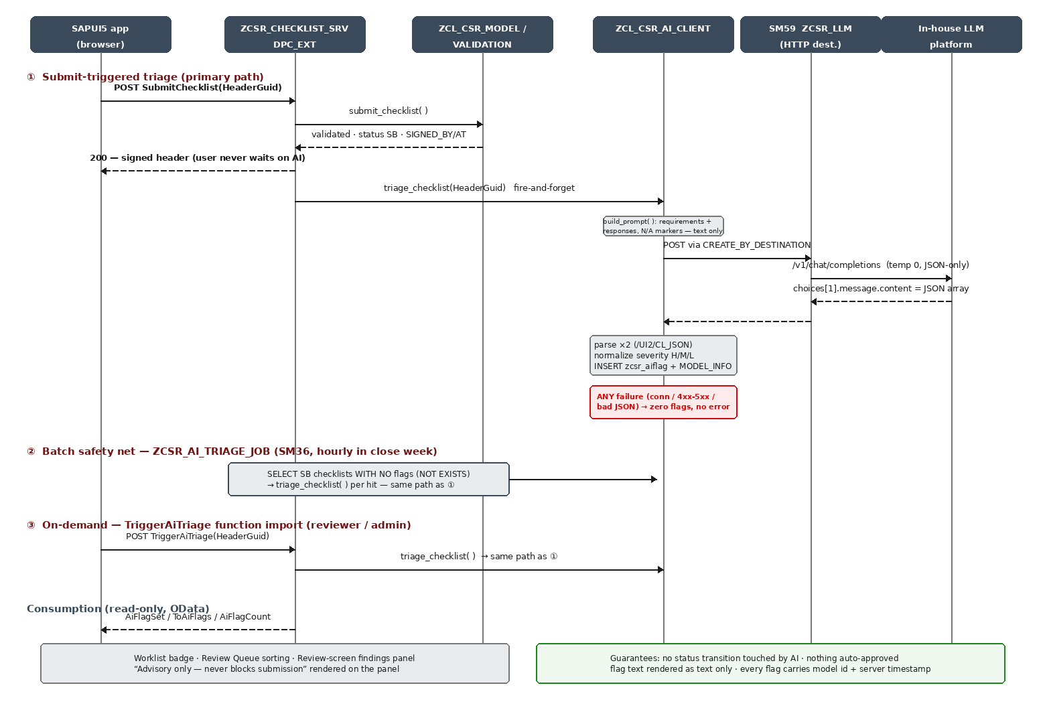
Figure 1 — AI triage: trigger paths, platform call, persistence, consumption

8. Platform Confirmation Checklist
To be confirmed with the LLM platform team before integration test — each “no” has a known, contained adaptation:
# | Question | If different
1 | Endpoint path is /v1/chat/completions (OpenAI chat format)? | Adapt the path constant and payload builder in ZCL_CSR_AI_CLIENT->call_llm — single method.
2 | Auth: none / API key header / bearer token? Header name? | Configure on the SM59 destination; no code change.
3 | Response envelope: choices[n].message.content + model field? | Adapt the envelope types in call_llm.
4 | Model selection by name required? Which identifier? | Set via the TVARVC parameter (§9).
5 | Max context / request size? (7 procedures × ~1.6k chars ≈ small) | If tight: truncate requirement texts in build_prompt, keep responses whole.
6 | Rate limits relevant at our volume (tens of calls per quarter-close day)? | Batch job already serializes; add a WAIT between calls if required.
7 | TLS: internal CA chain available for STRUST import? | Basis task; HTTP-only internal endpoint is possible but discouraged.
8 | Data policy: confirmation that prompt content (compliance narratives) may be sent and is not retained for training? | Written confirmation for the audit file; retention/logging settings per platform.
9 | Expected p95 latency for a ~4k-token request? | Sets the SM59 timeout and whether ① stays in-process or moves to the job only.

9. Proposed Change: Parameterize Model & Path (TVARVC)
The delivered class sends model: 'default' and a hard-coded path. Before integration test, move both to TVARVC so operations can switch models or path without a transport. Proposed delta to ZCL_CSR_AI_CLIENT (apply in SE80/ADT; sync the ABAP/ reference copy afterwards):
* Constants become defaults; TVARVC overrides when maintained:
CONSTANTS c_default_model TYPE string VALUE 'default'.
CONSTANTS c_default_path TYPE string VALUE '/v1/chat/completions'.

METHODS get_config
EXPORTING ev_model TYPE string
ev_path TYPE string.

METHOD get_config.
" Parameter ZCSR_LLM_MODEL — model identifier for the platform
SELECT SINGLE low FROM tvarvc INTO @ev_model
WHERE name = 'ZCSR_LLM_MODEL' AND type = 'P'.
IF sy-subrc <> 0 OR ev_model IS INITIAL.
ev_model = c_default_model.
ENDIF.
" Parameter ZCSR_LLM_PATH — endpoint path (rarely changed)
SELECT SINGLE low FROM tvarvc INTO @ev_path
WHERE name = 'ZCSR_LLM_PATH' AND type = 'P'.
IF sy-subrc <> 0 OR ev_path IS INITIAL.
ev_path = c_default_path.
ENDIF.
ENDMETHOD.

* In call_llm: replace the literals —
get_config( IMPORTING ev_model = DATA(lv_model)
ev_path = DATA(lv_path) ).
cl_http_utility=>set_request_uri( request = lo_client->request
uri = lv_path ).
" ls_request-model = lv_model.

- New TVARVC parameters: ZCSR_LLM_MODEL (platform model id), ZCSR_LLM_PATH (endpoint path). Both optional — absent entries fall back to the shipped defaults, so the change is risk-free to existing behavior.

10. Explicit Non-Goals & Future Options

Not in the MVP, by decision
- No attachment content in prompts (no file text extraction / OCR).
- No AI drafting of analyst responses; no AI-generated review notes.
- No frontend access to the model, direct or proxied.

Future options — each must preserve the advisory-only contract
Option | Shape | Note
Pre-submit check | “Check my work” button → function import → same triage, flags shown to the analyst before signing | Highest value next step; zero new infrastructure
Attachment awareness | Extract text server-side (xlsx/pdf) and include per-procedure evidence summaries in the prompt | Needs §8 item 5 headroom; extraction stays in ABAP
Cross-quarter signals | Compare against prior-quarter responses (“narrative unchanged since Q2”) | Prompt-only change; data already in ZCSR_ITEM history
Reviewer summary | One-paragraph model summary of the whole submission atop the findings panel | Same call, one extra output field

