CSR Auditing Application
Quarterly Checklist & Audit Platform
UI5 APPLICATION DESIGN PROPOSAL
App Skeleton · Navigation Model · View Design
Freestyle SAPUI5 · FES 2022 · OData V2 (ZCSR_CHECKLIST_SRV)
Version 0.2 (Draft) · 2026-08-04

Table of Contents

1. Application Structure
App ID zcsr.checklist, freestyle SAPUI5 (1.108 baseline per FES 2022), manifest-first, deployed to the FES BSP repository and exposed as a launchpad tile. Minimum library set: sap.m, sap.ui.core, sap.ui.layout, sap.f.

1.1 Project Layout
Path | Purpose
webapp/manifest.json | App descriptor: models, routing, dependencies
webapp/Component.js | UIComponent init: role bootstrap, device model, error registration
webapp/view/App.view.xml | Root sap.m.App nav container
webapp/view/Worklist.view.xml + controller | Analyst home
webapp/view/ChecklistDetail.view.xml + controller | Shared analyst/reviewer detail (mode-driven)
webapp/view/ReviewQueue.view.xml + controller | Reviewer home
webapp/view/AdminBoard.view.xml + controller | Admin status matrix
webapp/fragment/*.fragment.xml | UploadDialog, ReturnNotesDialog, ReassignDialog, ExportDialog, MessagePopover
webapp/model/formatter.js | Status/severity/color-semantics formatters
webapp/model/roles.js | Role model helper (AN/RV/AD/AU) from ZCSR_ASSIGN
webapp/css/style.css | Color-semantic classes (see §5)
webapp/i18n/i18n.properties | All texts externalized

1.2 Models (manifest)
Model | Type | Notes
(default) | sap.ui.model.odata.v2.ODataModel | ZCSR_CHECKLIST_SRV; useBatch=true; defaultBindingMode=TwoWay; refreshAfterChange=false (manual refresh after actions)
device | JSONModel | sap.ui.Device, oneWay
app | JSONModel | UI state: busy, mode (edit/review), role flags, dirty/autosave timestamp
i18n | ResourceModel | i18n.properties
Role bootstrap: Component.init reads a lightweight entity (current user's ZCSR_ASSIGN roles, exposed via the value-help pattern or an app/roles function import) and sets boolean flags {app>/isAnalyst}, {app>/isReviewer}, {app>/isAdmin} used for target gating and control visibility. UI gating is convenience only — the backend AUTHORITY-CHECK remains authoritative.

2. Navigation Model
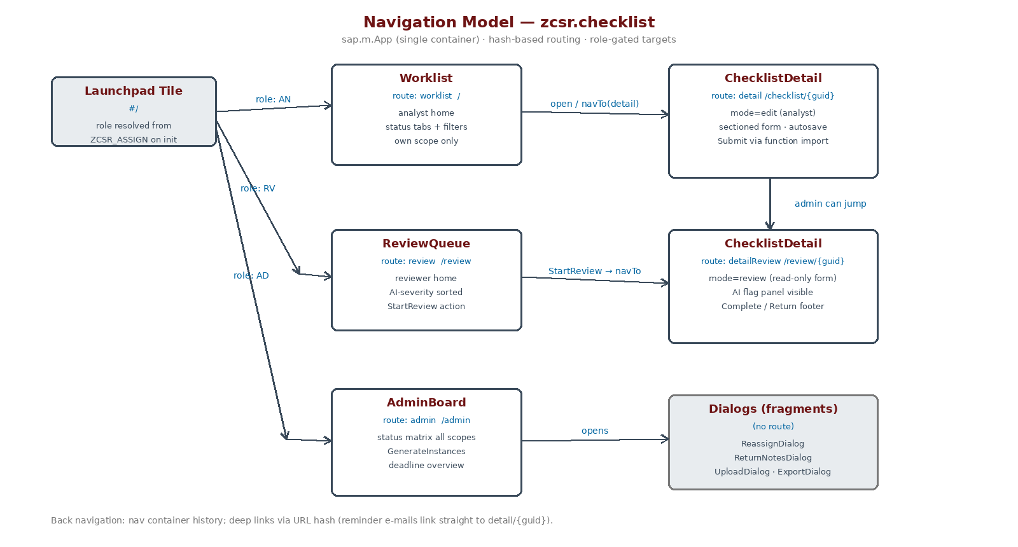
Figure 1 — Route map and role-gated entry points

2.1 Routing Table (manifest.json)
Route | Pattern | Target View | Guard
worklist | (empty) | Worklist | default; AN/AD
detail | checklist/{headerGuid} | ChecklistDetail (mode=edit) | owner/backup or AD
review | review | ReviewQueue | RV/AD
detailReview | review/{headerGuid} | ChecklistDetail (mode=review) | RV/AD
admin | admin | AdminBoard | AD
notFound | …rest | NotFound | —
- Role-based landing: Component decides the initial route — analysts land on Worklist, pure reviewers on ReviewQueue, admins on Worklist with the admin tab visible.
- Deep links: reminder e-mails carry #/checklist/{guid} — the pattern matches with no session state required; the guard check runs in onPatternMatched and falls back to NotFound on a 403.
- One detail view, two modes: ChecklistDetail renders edit vs. review from the route, not from duplicated views — single form logic, single formatter set, no drift between analyst and reviewer rendering.

3. View Design

3.1 Worklist (analyst home)
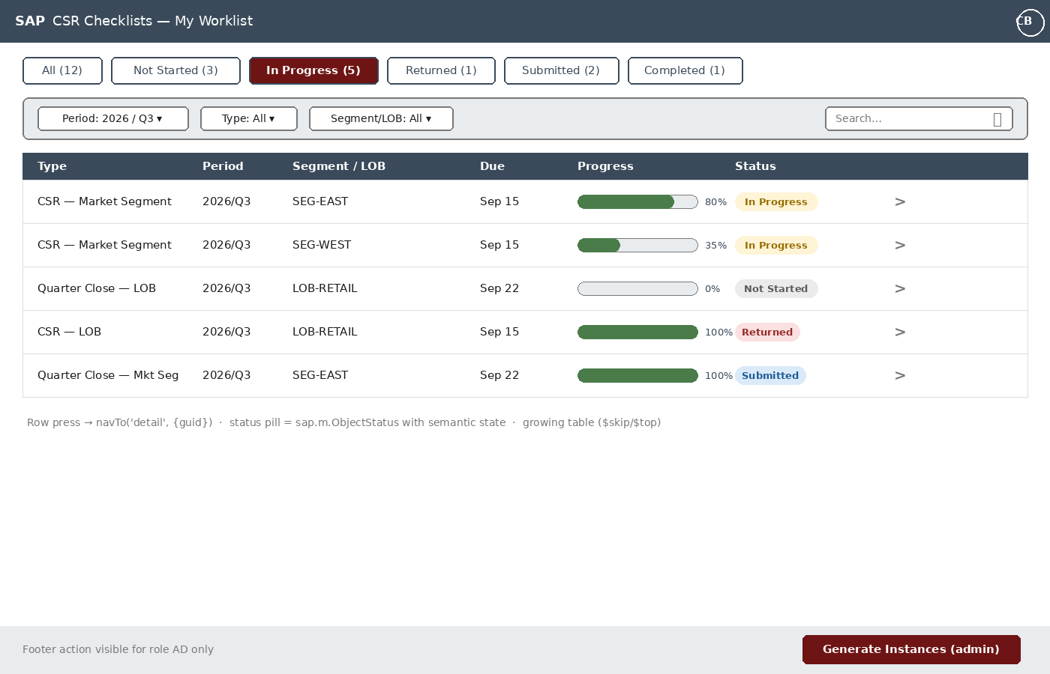
Figure 2 — Worklist: status IconTabBar, filter bar, growing table
- sap.m.IconTabBar with status filters mapped to $filter on Status; counts via $count requests batched with the list read.
- Filter bar: cascading LOB → Market Segment ComboBoxes fed by MarketSegVH's Lob property; whole-LOB CSR instances display Segment = 'All'.
- Table is sap.m.Table with growing=true (growingThreshold 25) — $skip/$top paging against ChecklistHeaderSet; default sort DueDate asc.
- Status pill = sap.m.ObjectStatus with semantic state from formatter (see §5); progress = sap.m.ProgressIndicator bound to CompletionPct.
- Row press navigates to detail; no inline editing in the list.
- Generate Instances footer button: visible={app>/isAdmin}, opens confirmation dialog, calls the GenerateInstances function import, then refreshes the binding.

3.2 ChecklistDetail (edit + review modes)
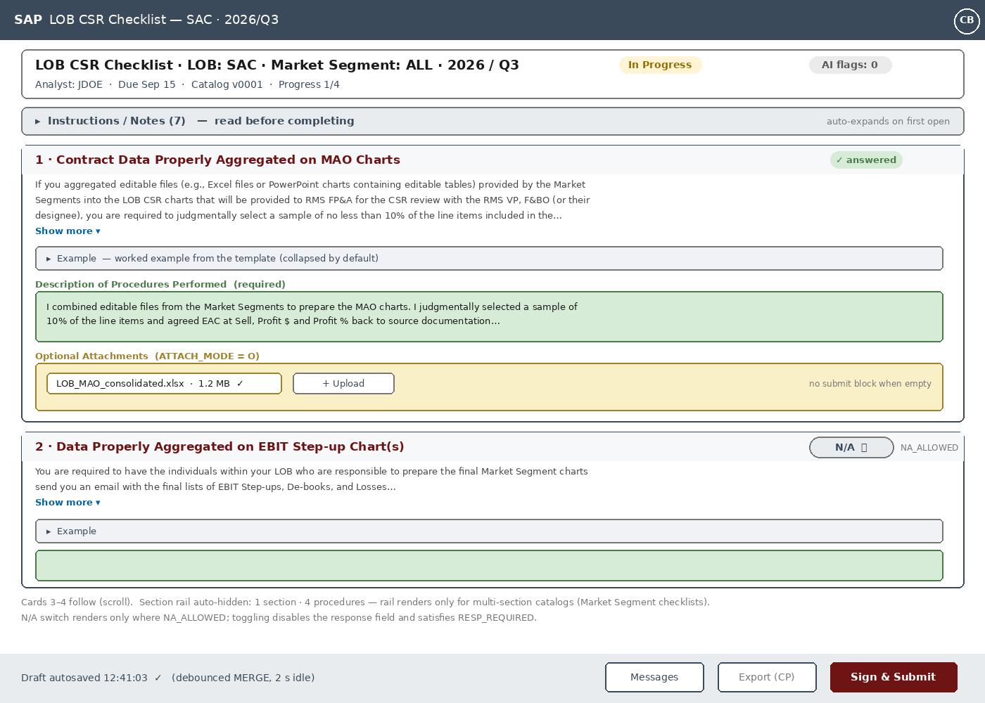
Figure 3 — Detail: procedure cards (collapsible requirement & example, per-question N/A, Sign & Submit)

Layout
- sap.f.DynamicPage: header = summary (type, LOB, segment — 'All' for whole-LOB CSR — period, status, due, catalog version, AI flag count); content = full-width procedure cards. The left section rail renders only for multi-section catalogs (Market Segment checklists); LOB checklists (one flat section, 3–4 procedures) get no rail.
- Items bound once via ToItems with $expand on open (single round trip, catalog fields denormalized per tech spec §6.1); grouped client-side by Section, ordered by Seqnr. Section list press scrolls to the section anchor (ScrollContainer.scrollToElement).

Procedure card anatomy (per catalog row)
Card element | Control | Behavior
Title bar | sap.m.Panel headerToolbar | “n · TITLE” + completion indicator (✓ answered / open / N/A)
Requirement text | sap.m.Text maxLines=3 + “Show more” link | expands full QUESTION_TEXT inline; 600–1,600 chars in real templates, so collapsed by default
Example | sap.m.Panel (collapsed) | renders EXAMPLE_TEXT verbatim — the template's 'Examples' column analysts already rely on
Response (green) | sap.m.TextArea (growing) + N/A sap.m.Switch | cssClass zcsrInput; N/A switch rendered only when NaAllowed; toggling disables the field, sets NaFlag, satisfies RespRequired
Attachments (yellow) | sap.m.upload.UploadSet bound to ToAttachments | cssClass zcsrAttach; labeled “Optional Attachments” (AttachMode O) or “Required evidence” (R); only R blocks submission when empty

Autosave & submit
- Autosave: liveChange starts a 2 s debounce timer; on idle, submitChanges() flushes the batch of MERGEs. Footer shows last-saved timestamp. beforeunload / route-leave triggers a final flush.
- Sign & Submit: button label matches the template's electronic-signature language. Calls SubmitChecklist function import. On success — status refresh, form locks, MessageToast. On business error — the message container details are pushed into MessageManager; each failing QuestionId maps back to its control (ValueState=Error + valueStateText) and the Messages popover lists all of them.
- Review mode: form renders read-only (editable=false via {app>/mode} expression binding), AI flag panel expands, footer swaps to Complete Review / Return to Analyst. Return opens ReturnNotesDialog with a required TextArea (client check + server enforcement).
- Returned banner: when Status=RT, a MessageStrip at the top shows the latest ToReviews note so the analyst sees why it came back without leaving the form.
- Instructions panel: collapsed sap.m.Panel above the first card renders the catalog's Instructions/Notes rows (INPTYPE C) — auto-expanded on a checklist's first open, collapsed on return visits. Fixes the template's buried-instructions problem.

3.3 ReviewQueue (reviewer home)
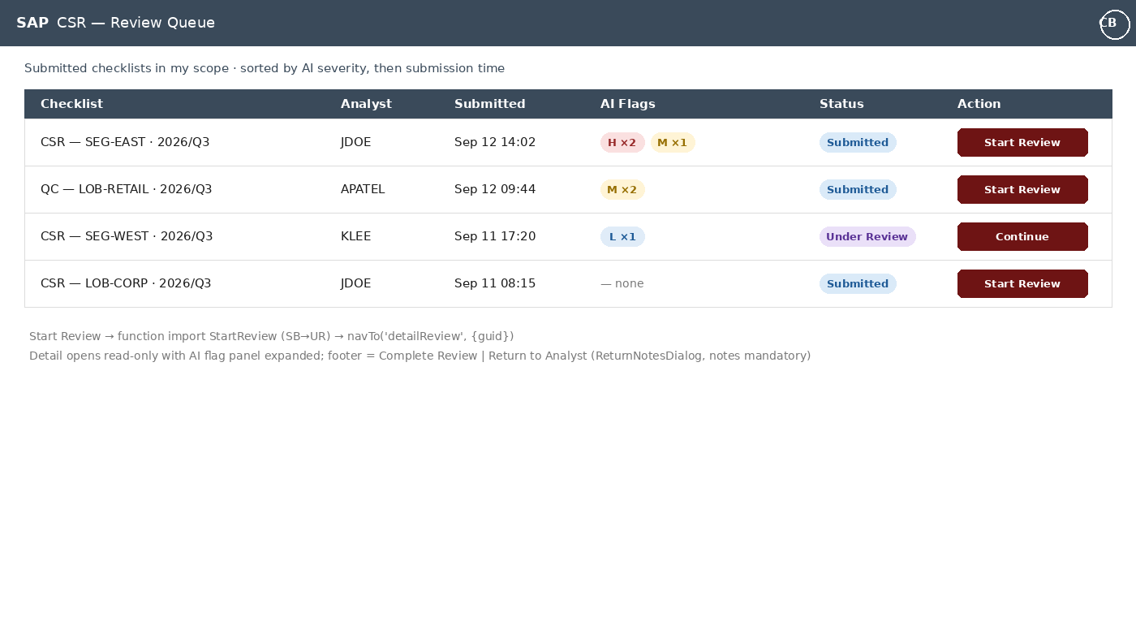
Figure 4 — Review queue sorted by AI severity
- Reads ChecklistHeaderSet with $filter=Status eq 'SB' or Status eq 'UR' (reviewer scope applied server-side); default sort: AI severity desc (server-computed AiFlagCount + max severity), then SignedAt asc.
- Severity chips aggregate ToAiFlags counts by H/M/L; empty state renders “— none”.
- Start Review triggers the StartReview function import (SB→UR) and navigates to detailReview; Continue navigates directly for UR items owned by the current reviewer.

3.4 AdminBoard
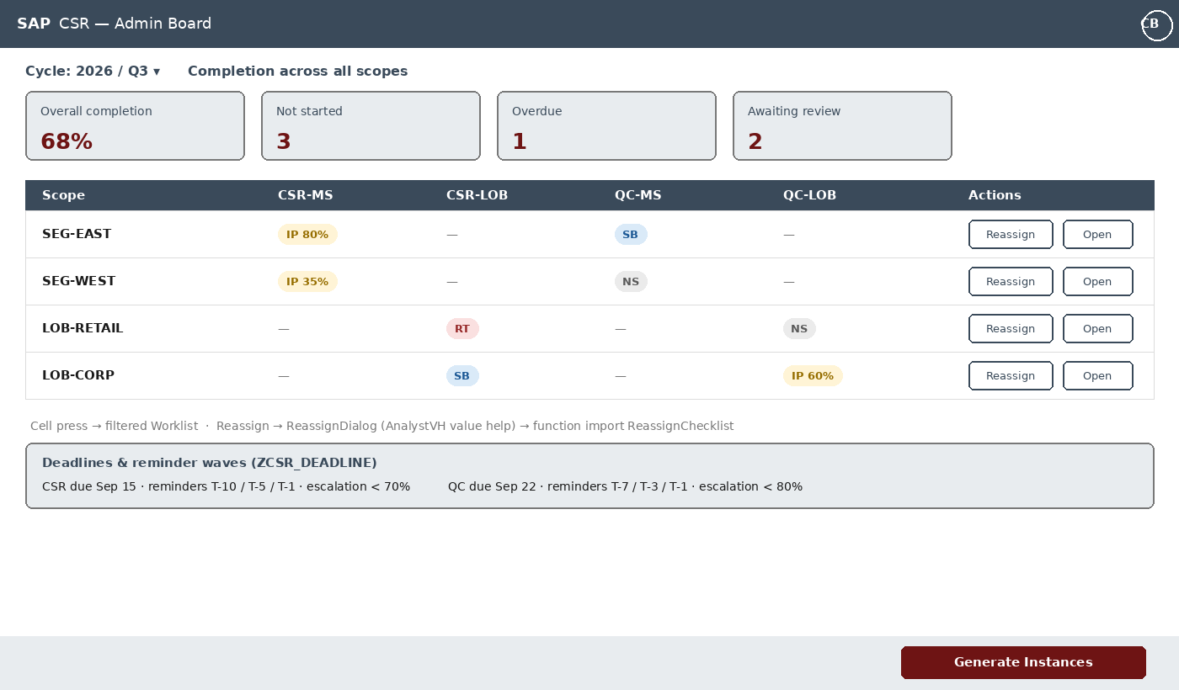
Figure 5 — Admin status matrix with KPIs and deadline strip
- KPI header tiles (overall completion, not started, overdue, awaiting review) computed from one aggregated read.
- Matrix: rows = scopes (segment/LOB), columns = four checklist types; cell renders status pill + completion; cell press navigates to Worklist pre-filtered to that scope.
- Reassign opens ReassignDialog with AnalystVH value help → ReassignChecklist function import → matrix refresh. Action is change-documented server-side.
- Deadline strip surfaces ZCSR_DEADLINE config (read-only in prototype; maintained via SM30).

4. Shared Fragments
Fragment | Trigger | Contents
UploadDialog | Add file on an attachment item | UploadSet instance; shows per-file progress; rejects >25 MB client-side (server enforces too)
ReturnNotesDialog | Return to Analyst (review mode) | Required TextArea; Cancel/Return; Return disabled until non-empty
ReassignDialog | AdminBoard / Detail (admin) | AnalystVH ComboBox, effective-immediately note
ExportDialog | Export button (Status=CP) | Calls ExportEvidence (GET, Edm.Binary) → triggers browser download of the ZIP
MessagePopoverFrag | Messages footer button | Bound to MessageManager model; message press focuses the failing control

5. Formatters & Color Semantics
The Excel color language carries over 1:1 so analysts need zero retraining:
CSS class | Applied to | Style
.zcsrInput | response controls (INPTYPE I) | light green background, green border (matches current template)
.zcsrAttach | attachment areas (ATTACH_MODE O/R) | light yellow background, ochre border
.zcsrComment | guidance strips (INPTYPE C) | neutral gray info styling
Formatter map (in formatter.js): statusState NS→None · IP→Warning · SB→Information · UR→Information · RT→Error · CP→Success; severityState H→Error · M→Warning · L→Information; statusText resolves via i18n keys, never hard-coded.
- Theme: standard sap_horizon (FES 2022 default) — the custom classes shade only the response controls, keeping Fiori look-and-feel elsewhere. No custom theme build required.

6. Cross-Cutting Concerns
- Central OData error handler registered in Component on metadataFailed/requestFailed: parses the V2 error envelope (leading message + inner details) into MessageManager; technical errors get a generic dialog, business errors flow to the popover.
- Busy handling: app>/busy drives a single BusyIndicator per view; function-import calls set it explicitly (batch autosave stays silent).
- CSRF: standard V2 model token handling; UploadSet gets the token injected into its headers before upload.
- i18n: all labels/messages in i18n.properties from day one — cheap now, painful later.
- Accessibility: labels via labelFor/ariaLabelledBy, section list is keyboard navigable, status conveyed by text + state (not color alone) — relevant given the color-semantic design.
- No client-side storage: all draft state lives in the OData backend via autosave; a browser crash loses at most the 2 s debounce window.

7. Open Design Items
- Section anchors vs. IconTabBar inside the form for very long checklists — decide after seeing real question counts per section.
- Whether AdminBoard KPIs warrant a dedicated aggregate entity or client-side reduction over ChecklistHeaderSet (prototype: client-side; revisit if scope count grows).
- Max upload size and allowed MIME types — confirm with audit team; enforced in CREATE_STREAM either way.

