P_ << 0.0225,0,0,0,0, 0,0.0225,0,0,0, 0,0,1,0,0, 0,0,0,1,0, 0,0,0,0,1;

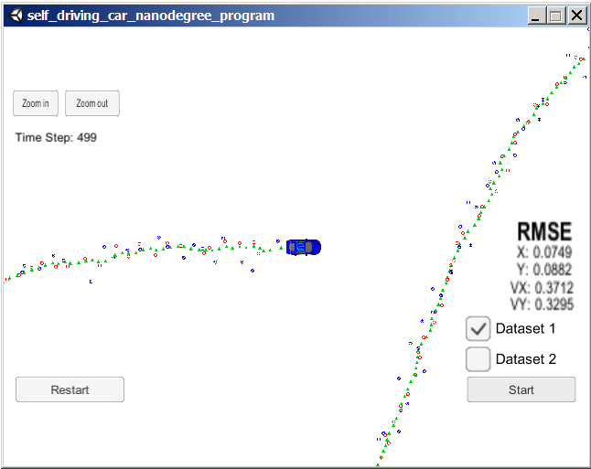

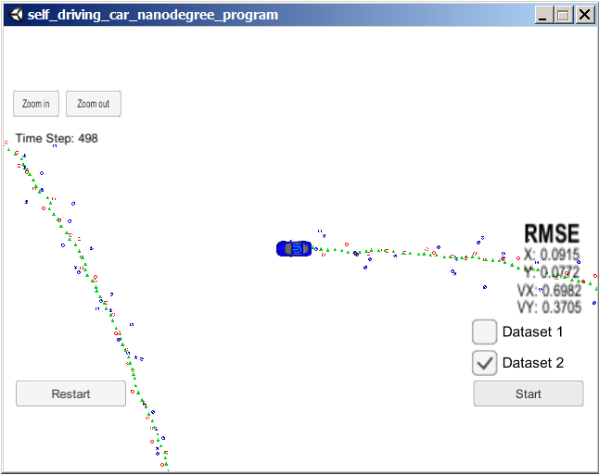

P_ << 1,0,0,0,0, 0,1,0,0,0, 0,0,1,0,0, 0,0,0,1,0, 0,0,0,0,1;

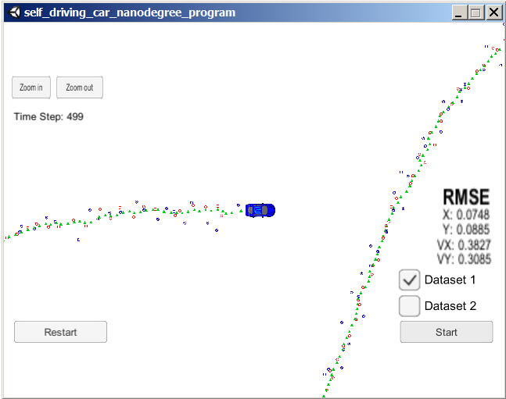

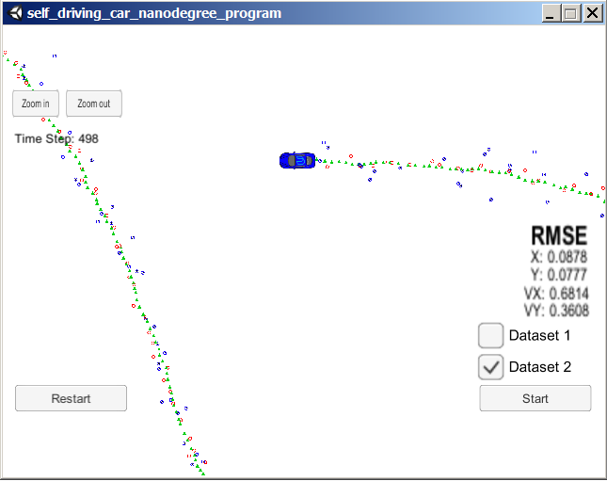

P_ << 0.0225,0,0,0,0, 0,0.0225,0,0,0, 0,0,0.5,0,0, 0,0,0,0.25,0, 0,0,0,0,0.5;

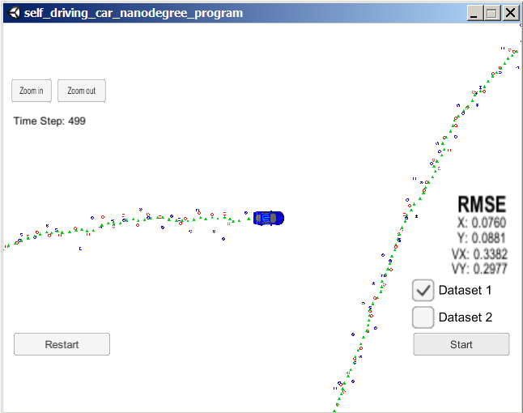

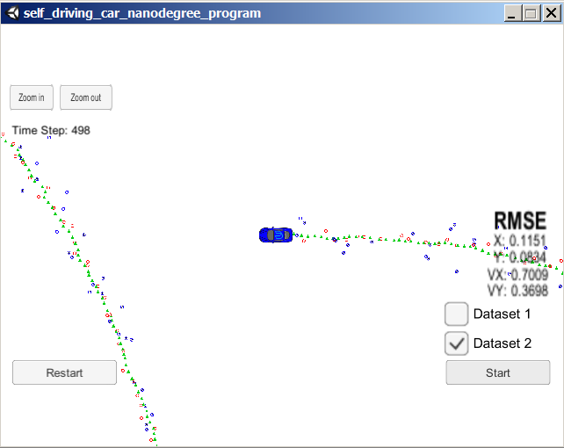

P_ << 0.0225,0,0,0,0, 0,0.0225,0,0,0, 0,0,10,0,0, 0,0,0,20,0, 0,0,0,0,30;

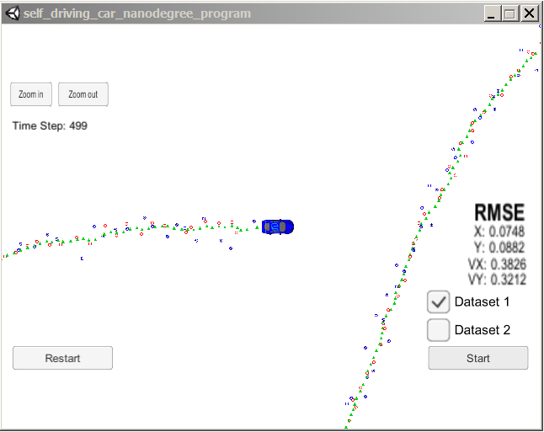

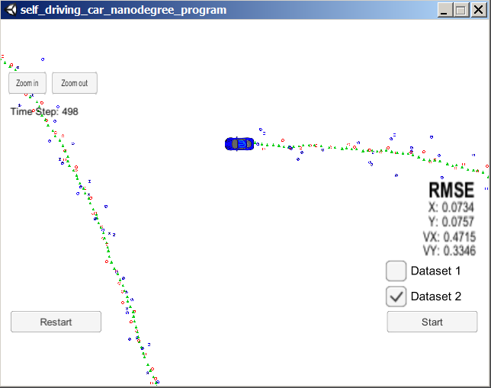

P_ << 0.0225,0,0,0,0, 0,0.0225,0,0,0, 0,0,50,0,0, 0,0,0,50,0, 0,0,0,0,50;

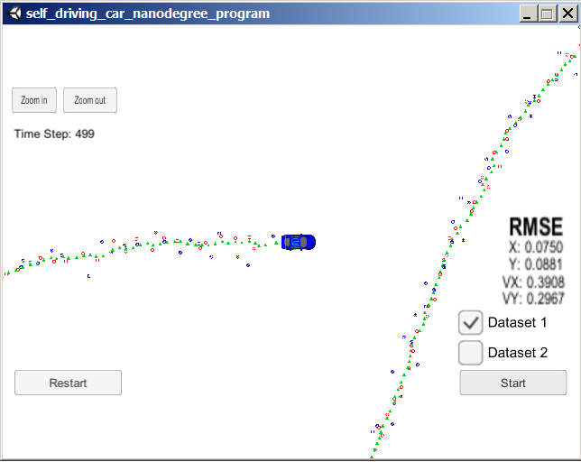

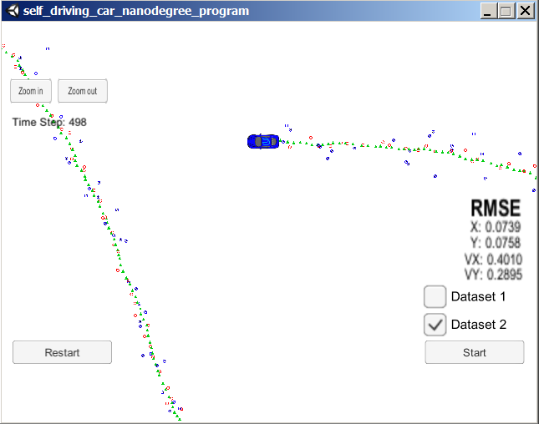

P_ << 0.0225,0,0,0,0, 0,0.0225,0,0,0, 0,0,30,0,0, 0,0,0,50,0, 0,0,0,0,50;

