# Lidar Point Cloud Generation And Detection

## Scene Generation

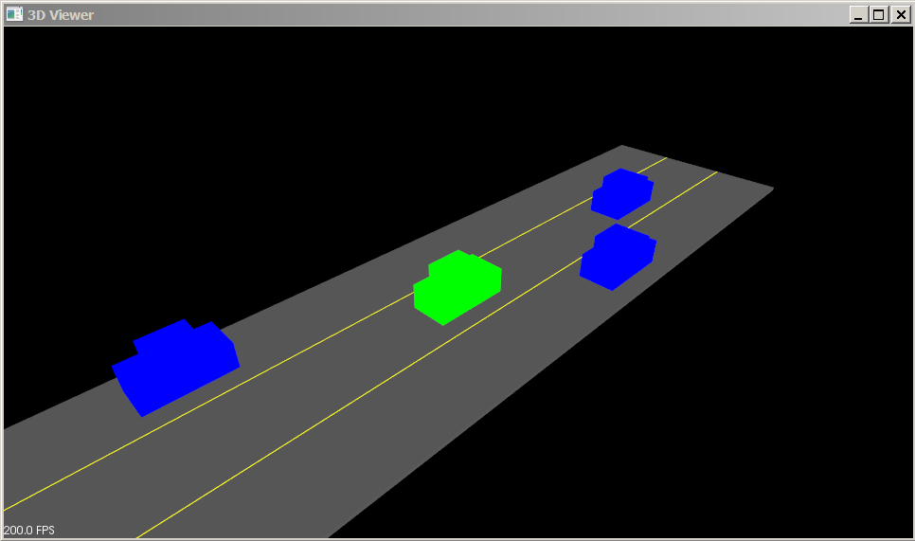A highway scene is rendered using Point Cloud Library(PCL). PCL is an open source C++ library for working with point clouds. It is used to render shapes, generate point, visualize data etc. On the left an ego(green) and 3 targets(blue) are generated.

## Ray Casting

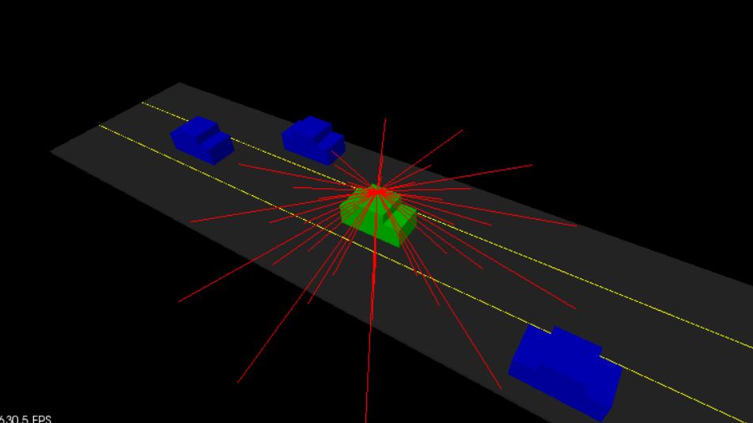A Lidar sensor is mounted on top of the ego and it senses its surroundings by doing ray casting. On the right, the Lidar parameters are down-tuned to show both the rays and targets.

The Lidar settings used for this project generates the rays as shown below.

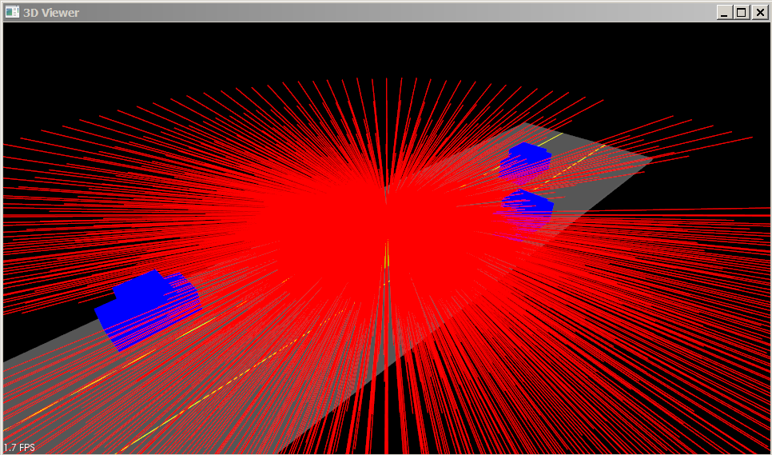

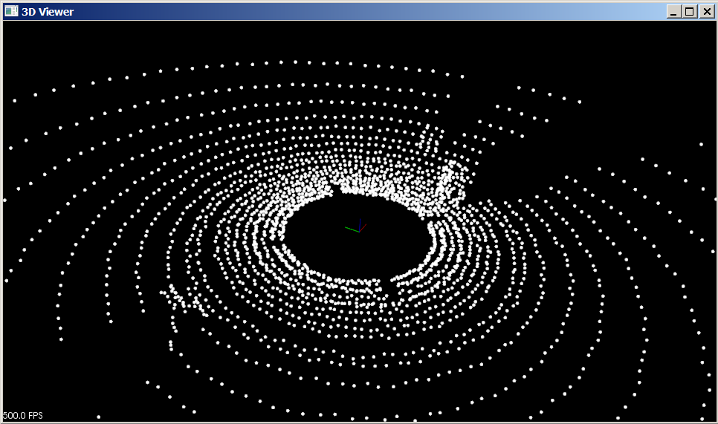On the left is the view of point cloud which is the result of ray casting. The targets can be seen clearly though they are of same color as road points.

## Point Cloud Segmentation

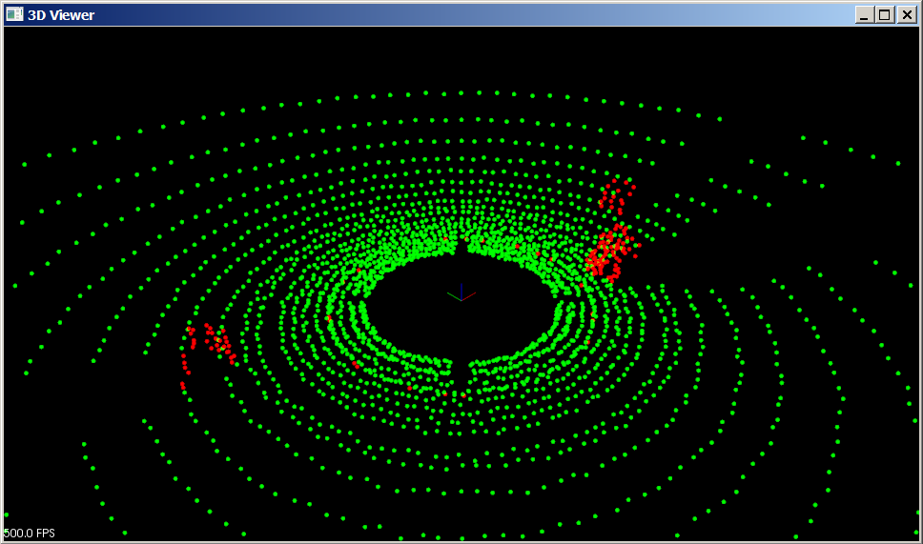In order to filter and process only the target point clouds, a method called Planar Segmentation, which uses the RANSAC(Random Sample Consensus) algorithm, is used. On the left is the output of planar segmentation with green being road plane and red non-road points.

## Clustering

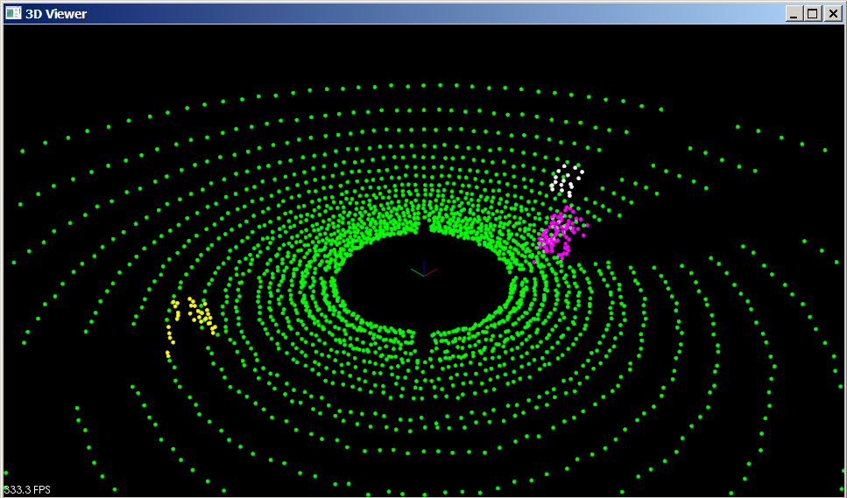Euclidean Clustering is used to group target points thereby supporting multiple object tracking. On the right, the three targets are grouped as yellow, pink and white point clouds. To do the nearest neighbor search efficiently, a KD-Tree data structure is used.

## Bounding Box

Finally, a bounding box is added around the cluster to get definite shape. Below, three bounding boxes are formed around the three clusters.

