# Radar Target Generation And Detection

## Target Generation

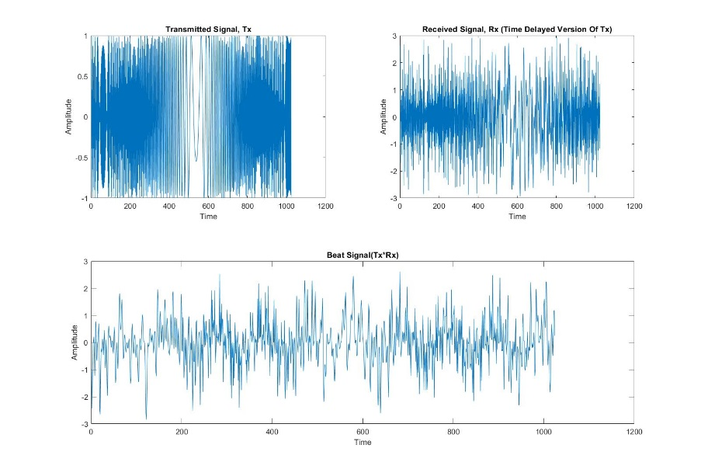A Transmit signal, Tx, is chosen and a time delayed version of Tx(which becomes the Received signal, Rx) is generated which mimics the reflected signal from targets. A Beat signal is fabricated by mixing(multiplying) the Tx and Rx. In the case on the left, the Rx signal is a mixture of 3 delayed versions of Tx to mimic 3 targets at range 10m, 60m and 180m with velocity -50m/s, 25m/s and 10m/s respectively.

## FFT

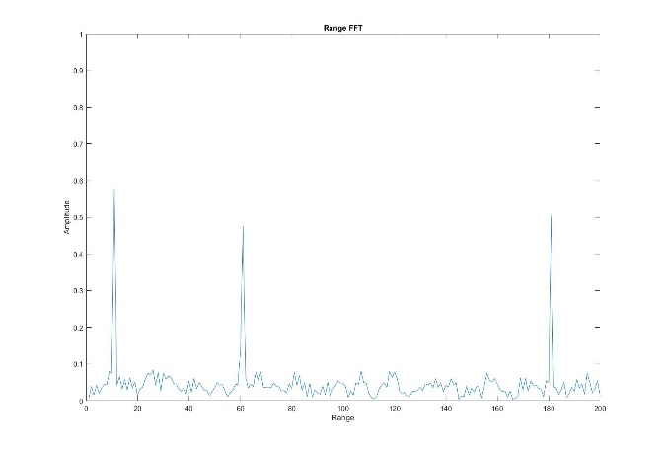On the right is the result of FFT(Range FFT) on the Beat Signal. It shows three peaks corresponding to the three targets.

A 2D FFT is implemented on the result of Range FFT which generates a Range-Doppler Map(RDM) as shown below. A top view of the same is also shown.

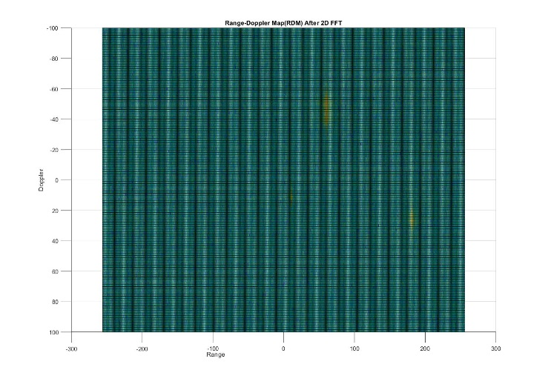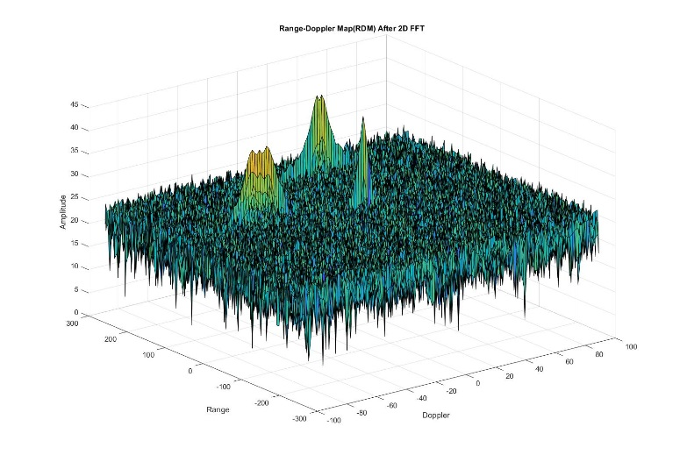

## 2D-CFAR

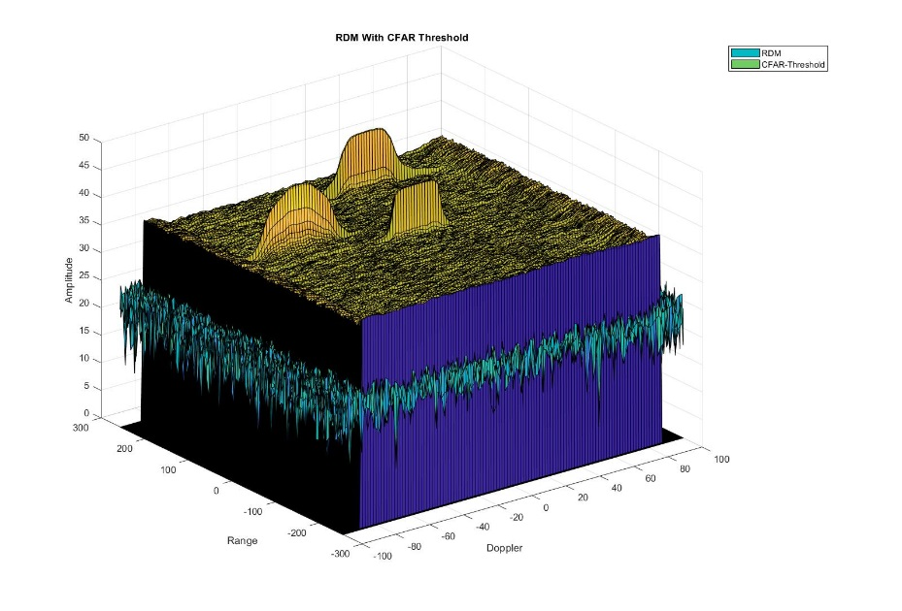Cell Averaging(CA) 2D CFAR is implemented on the RDM which gives the threshold for each cell. Left plot shows RDM with threshold calculated using CA-CFAR.

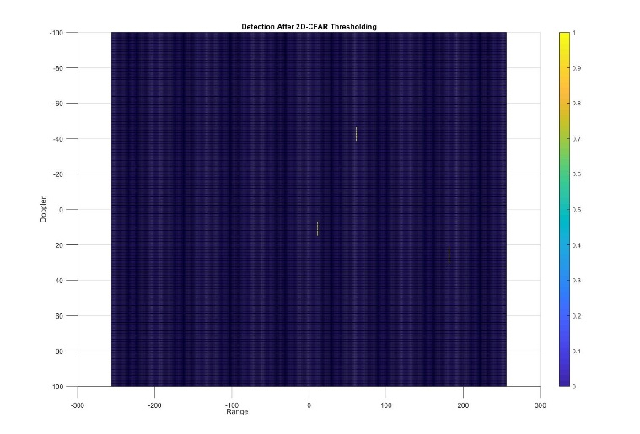

All those RDM cells which are below the threshold are discarded and below is the final result showing the detections at the corresponding ranges. On the right is the top view of the same.

