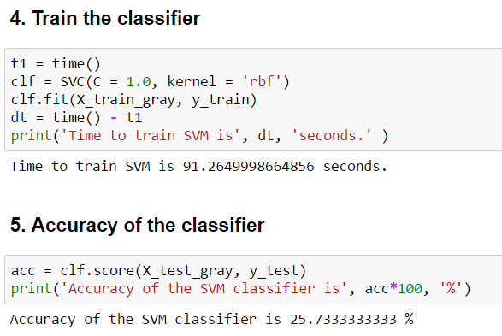

1. Start with simple model of one CNN and one FC layer

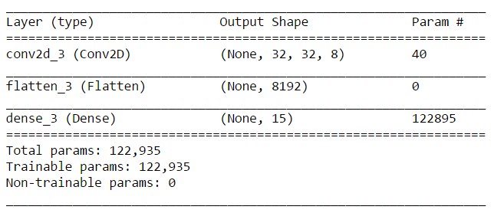

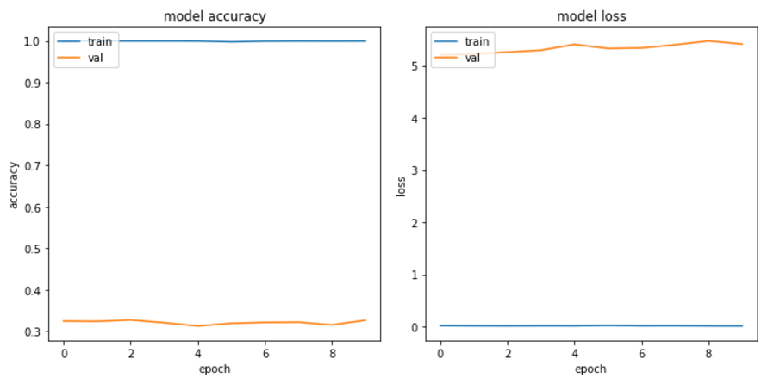

Test accuracy of the model is around 35%. This already better than the test accuracy of my benchmark model, SVM. The model does great on training set but performs very poorly on validation set.

1. Adding one more convolution layer so that the model learns more features. Two CNN and one FC layer

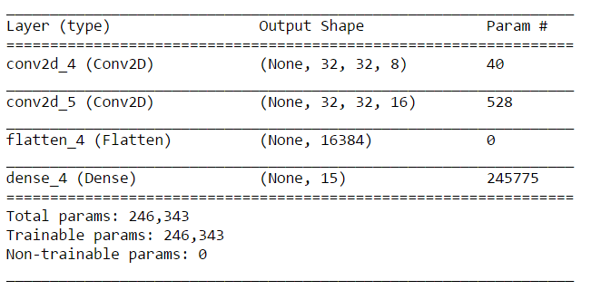

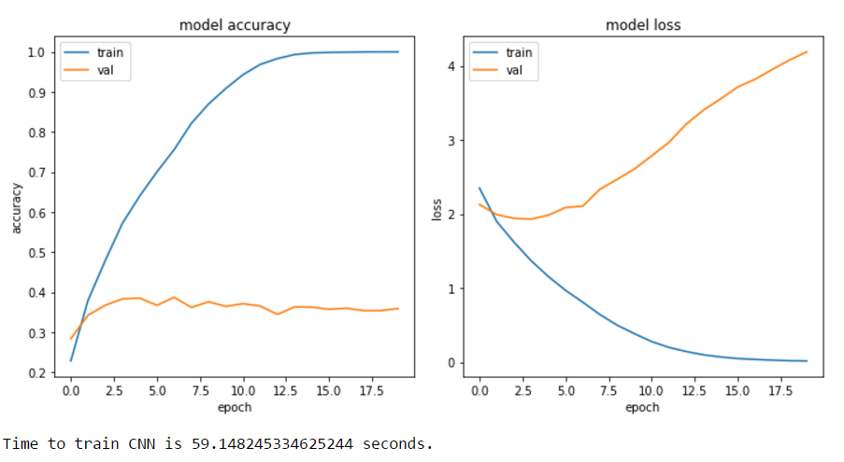

Looking at the training curve, the model now seems to learn but the model is overfitting as shown by validation curve.The overfitting can be reduced by adding non-linear layers like droupout or max pooling

1. Adding dropout layer

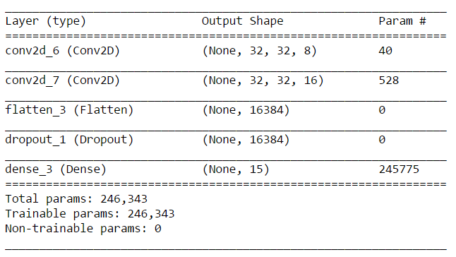

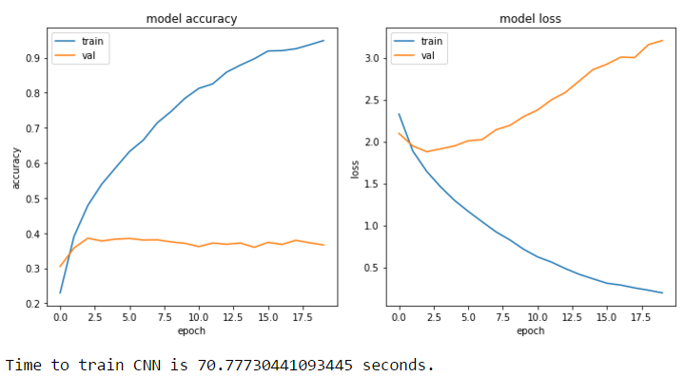  
There is no improvement. Now let’s try with maxpooling layer instead of dropout.

1. Adding maxpooling layer

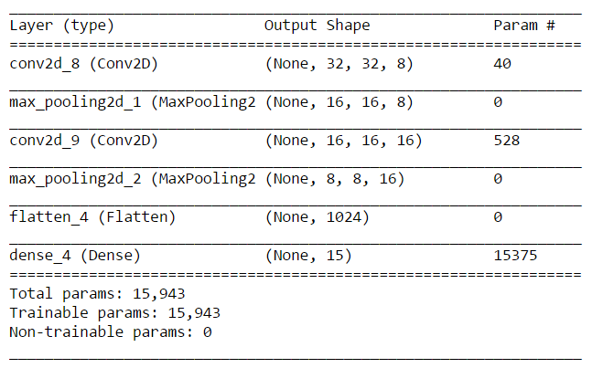

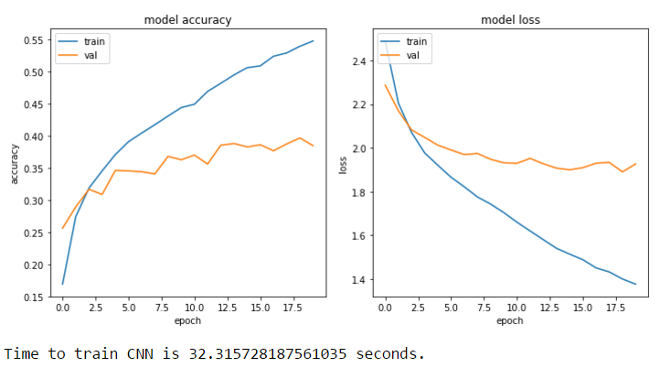

The maxpooling layer has removed the overfitting but the training curve is performing poorly. Let’s check if the model does any good by adding another convolution layer so that it can learn more features

1. Adding another convolution layer.

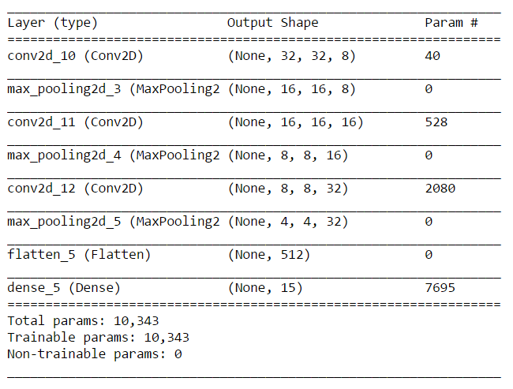

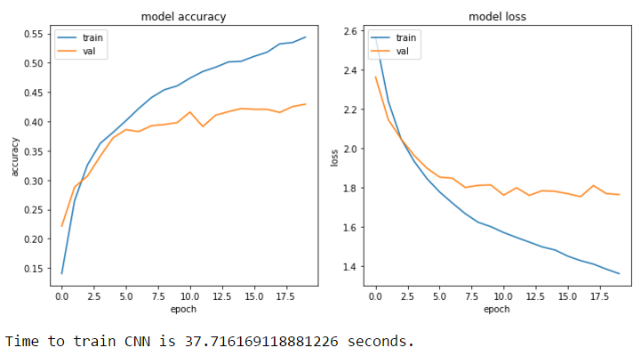

Adding another convolution layer seems to have improved the model performance on validation set but there is not much improvement on training set. Testing accuracy of the model is 42.7333%. Let’s now add one more dense layer to check if training improves.

1. Adding a dense layer

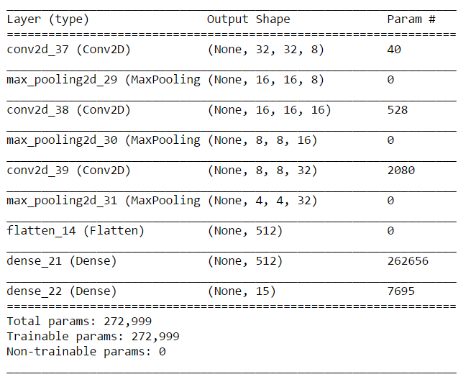

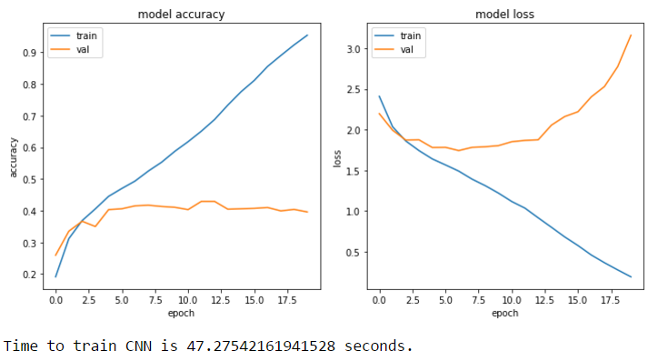

As seen, adding dense layer has increased the accuracy of training set and slightly reduced accuracy on validation set. Also the model is overfitting on validation set. Check now by adding dropout on dense layers

1. Adding dropout with 0.5

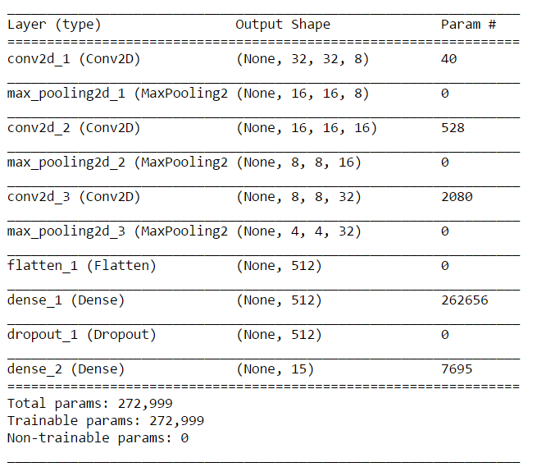

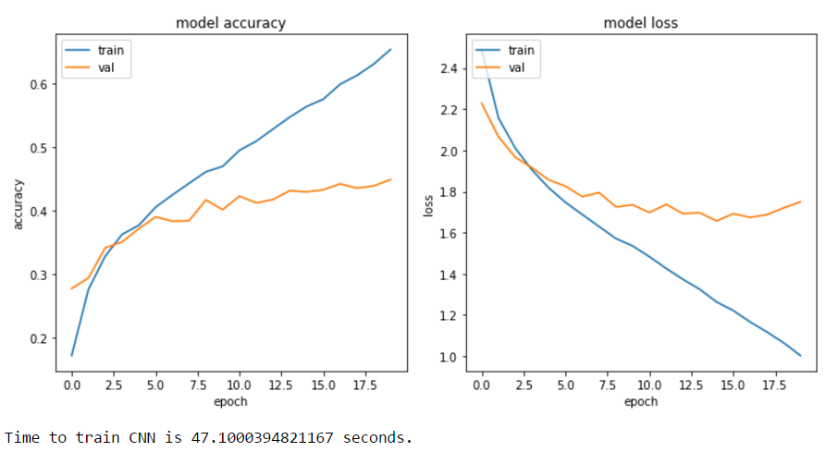

Accuracy is 45.13%. The overfitting on validation set is reduced but at the cost of training accuracy. Add more dense layers to improve training set

1. Add one more dense layer with dropout 0.5

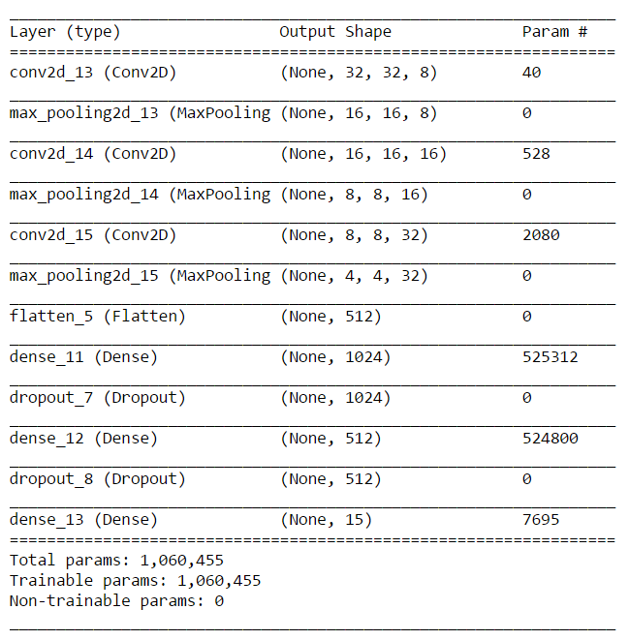

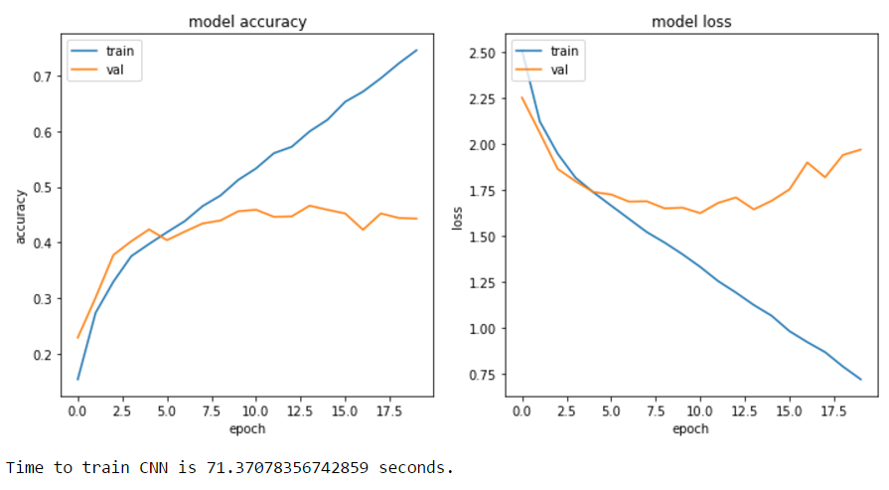

Accuracy is 44.27%. The test accuracy reduced with no significant improvement in training curve.

1. Add one more dense with dropout 0.5

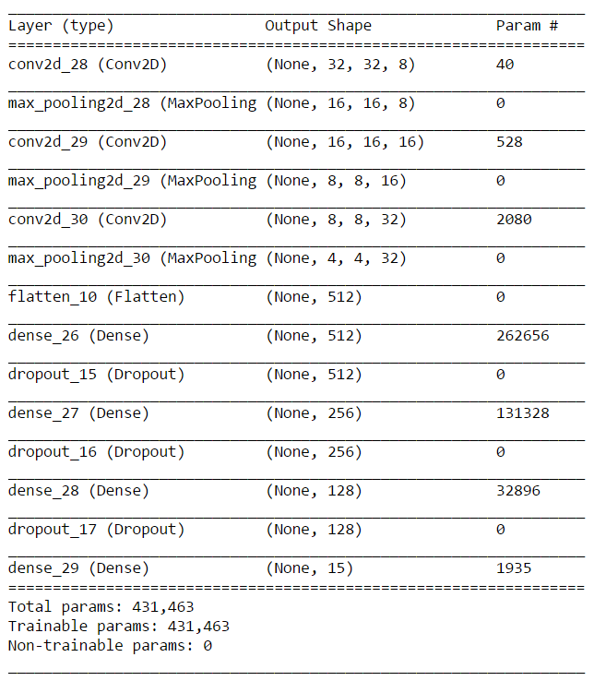

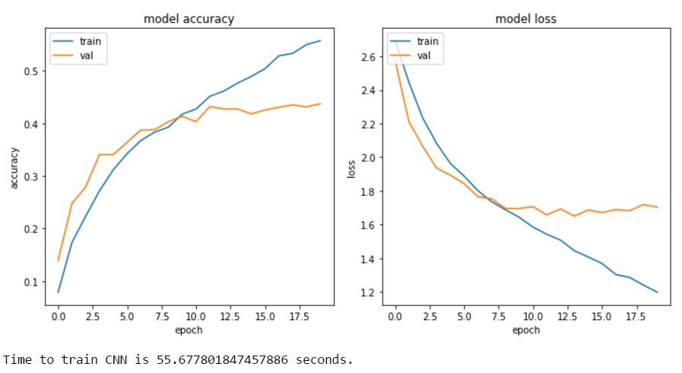

Accuracy is 45.13%. Adding more dense layer doesn’t make a significant difference. So going back to model with 2 dense layers

1. Final model

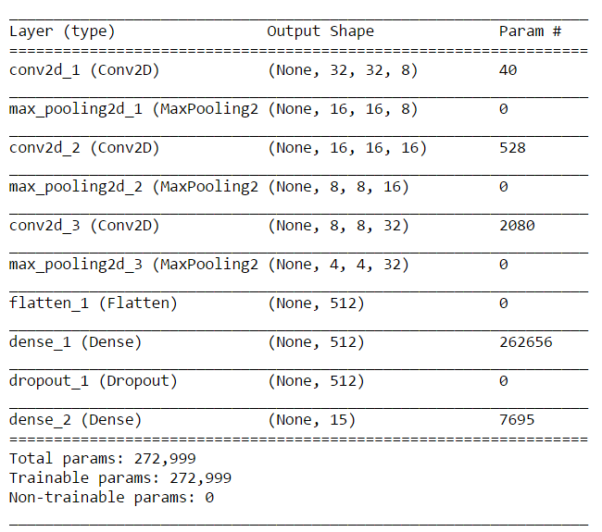

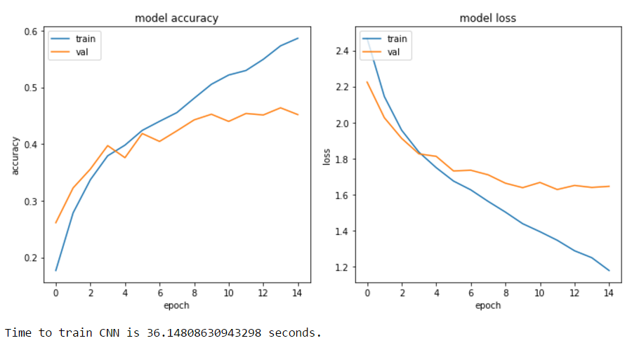

Test accuracy is 45.27%

1. Three CNN and one FC layer

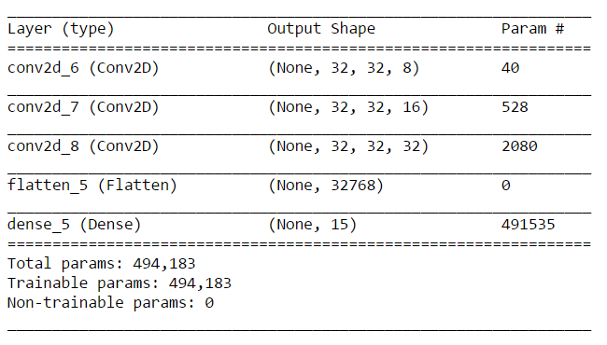

The number of parameters has increased and this has impact on training time.

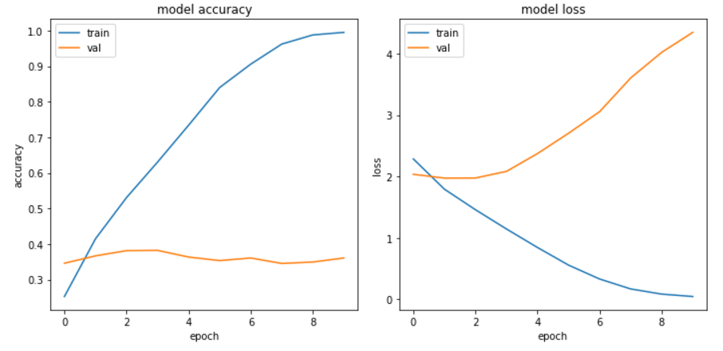

1. Dd

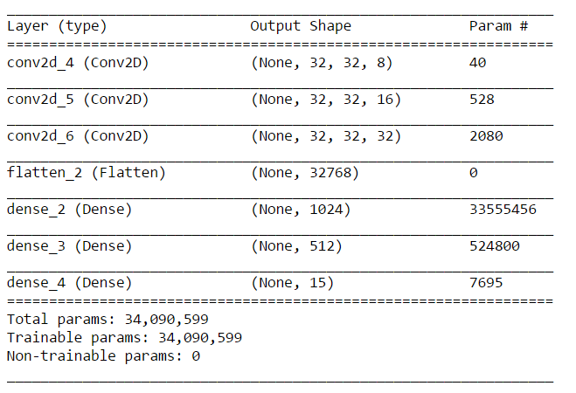

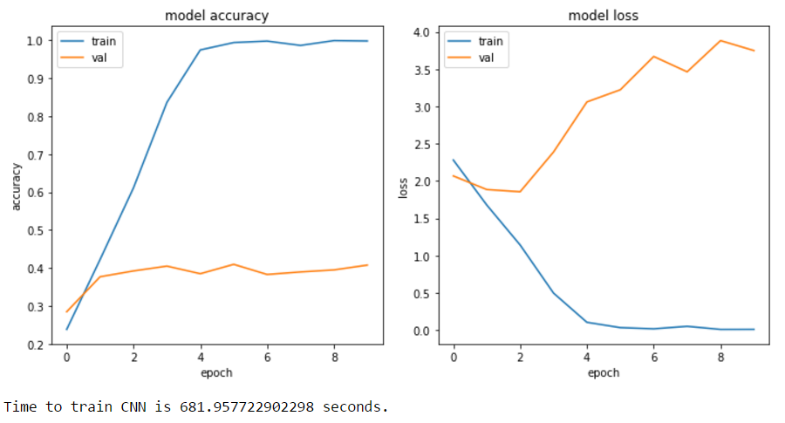

It takes a long time due to a large number of parameters. Also the model overfits.

1. Reduce the number of parameters by adding MaxPooling layer

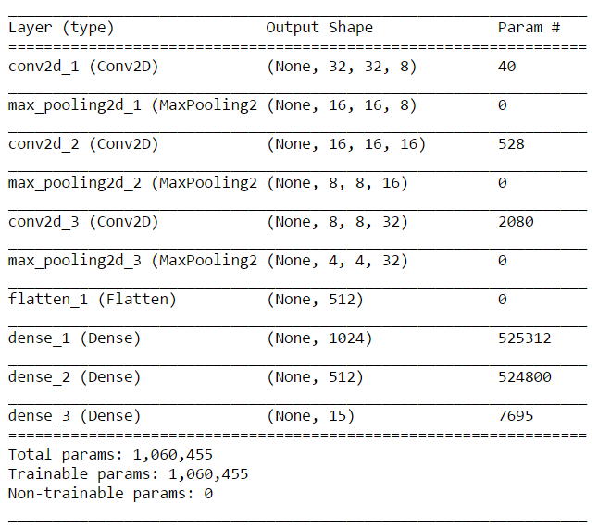

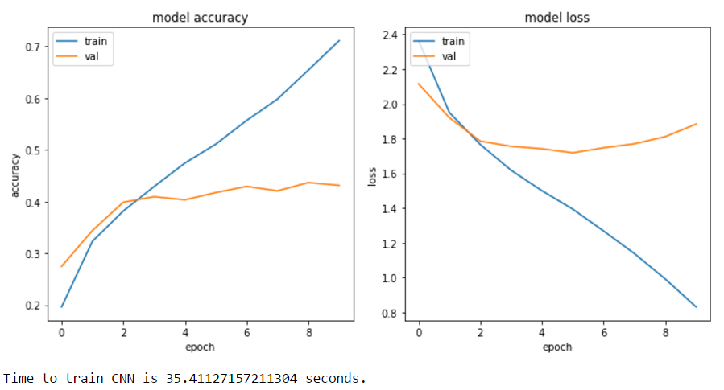

1. Add dropout to reduce overfitting

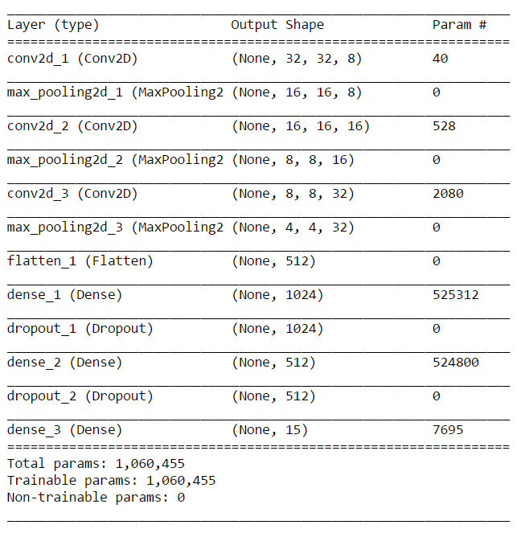

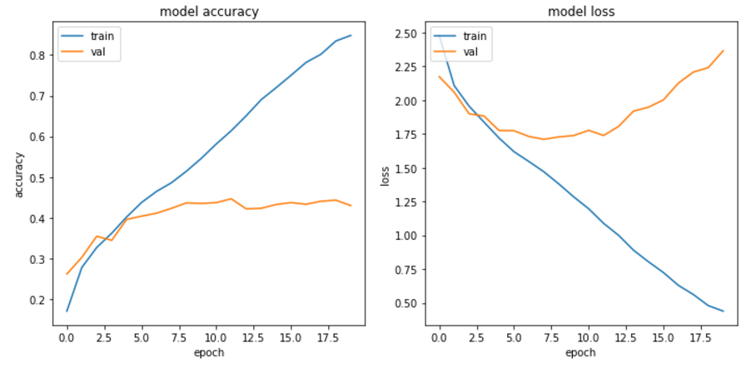

1. Ff

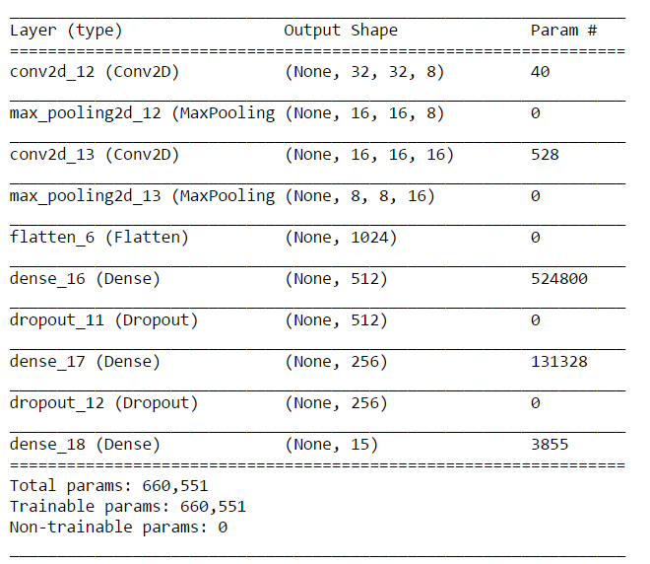

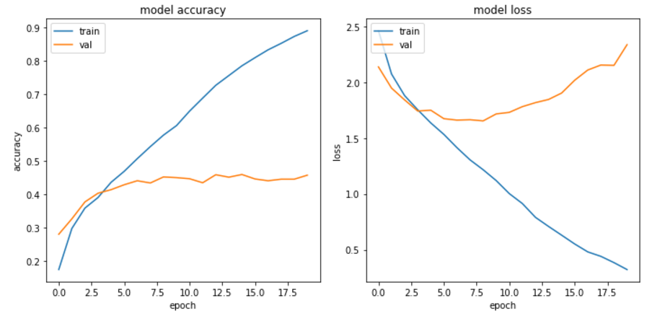

1. Sfdf

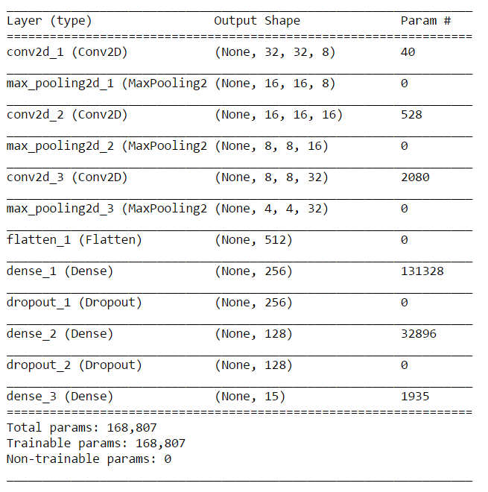

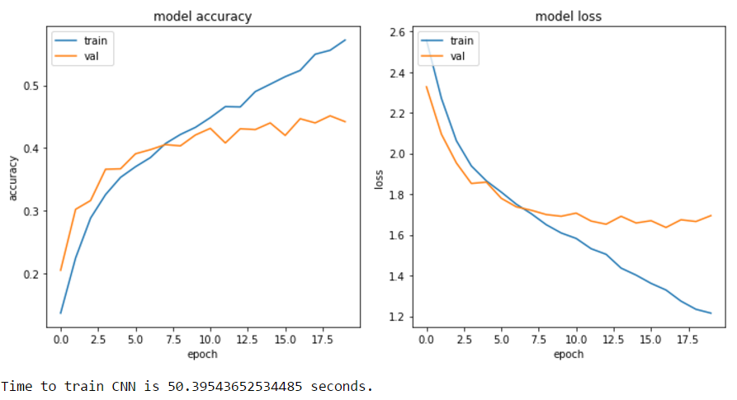

1. Sdf

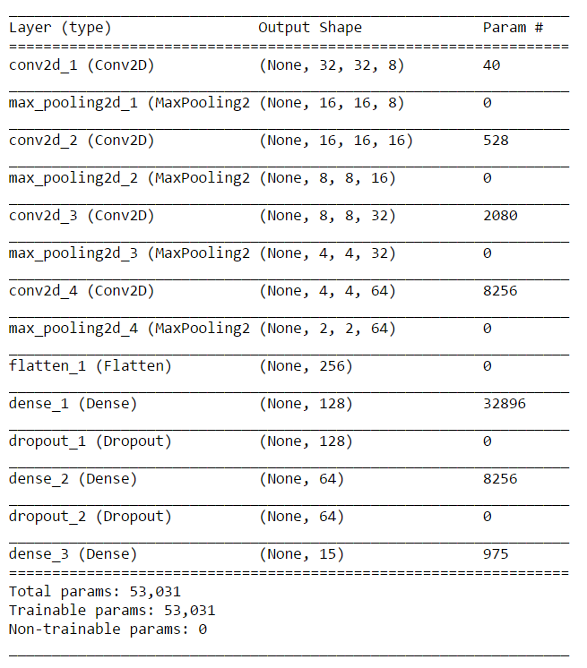

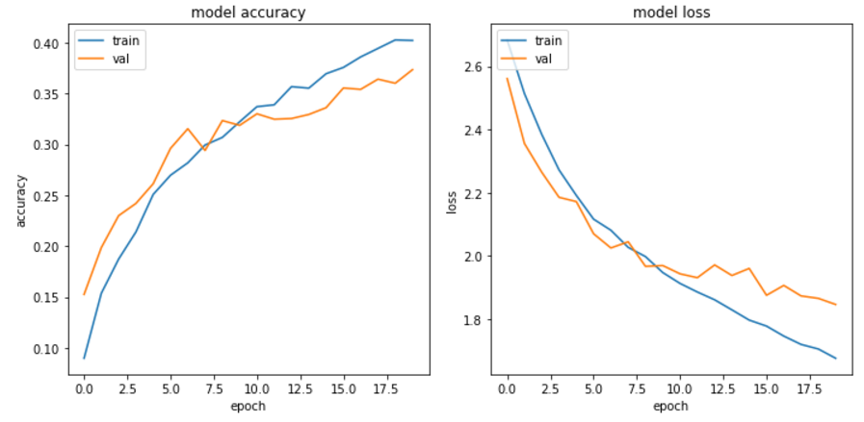

1. Dd

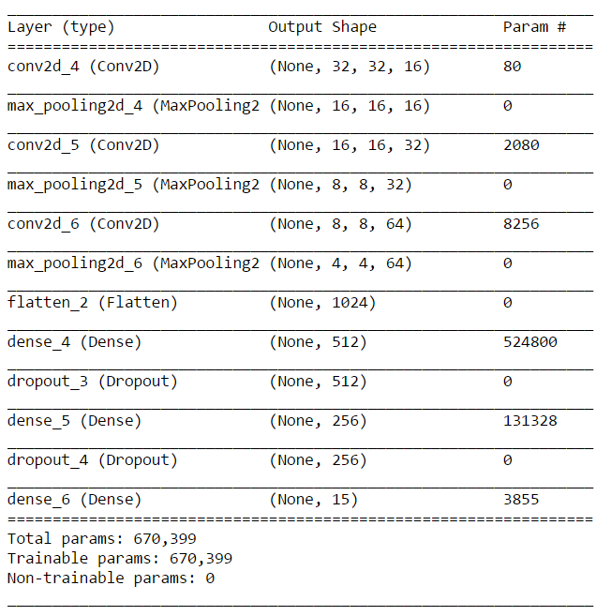

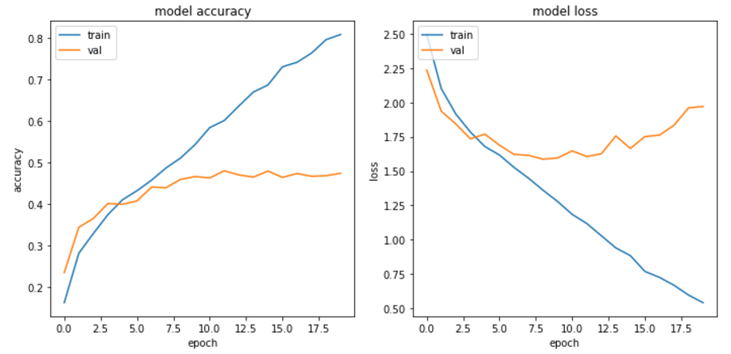

1. Ddd

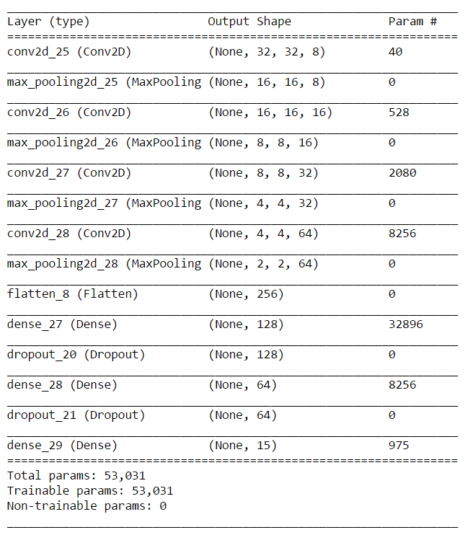

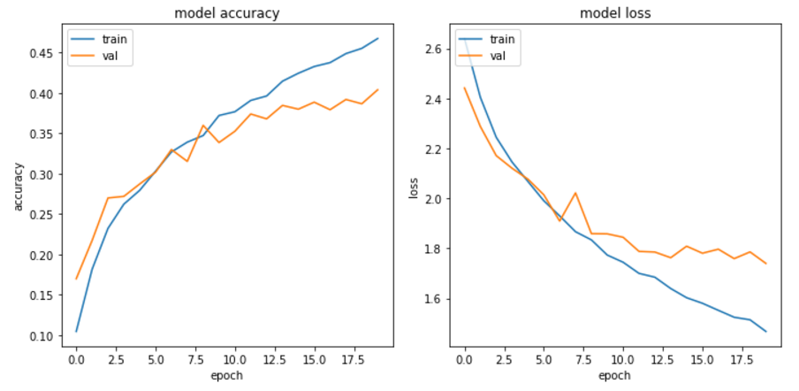

Test accuracy is 41.6%. Next check the performance of training set(blue) if the last convolution layer is removed.

1. D

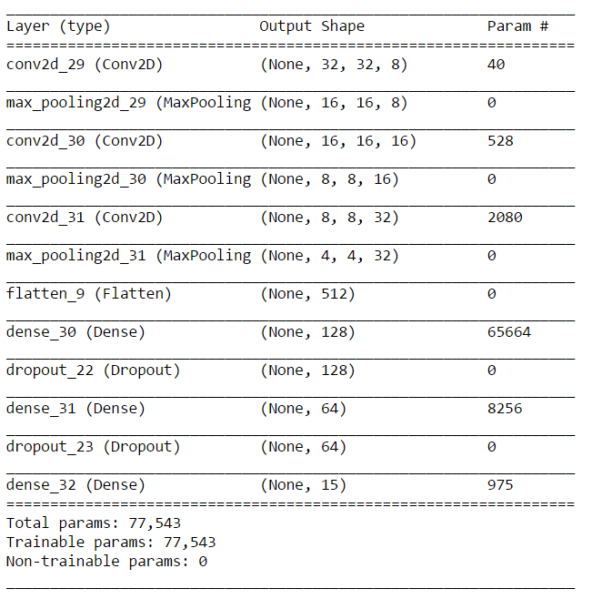

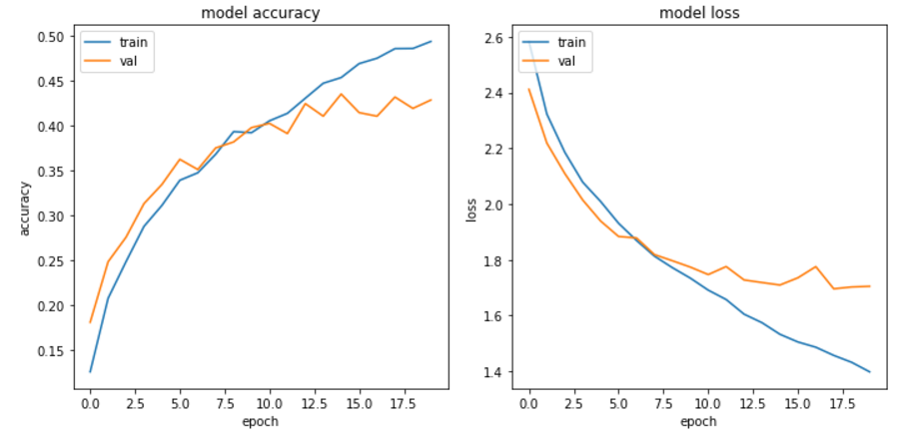

Test accuracy improved a bit 42.6%. Check what happens if one more convolution layer is removed.

1. Fff

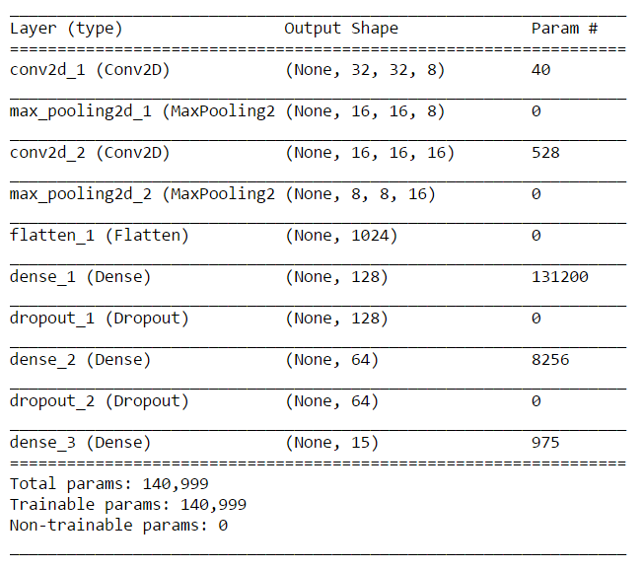

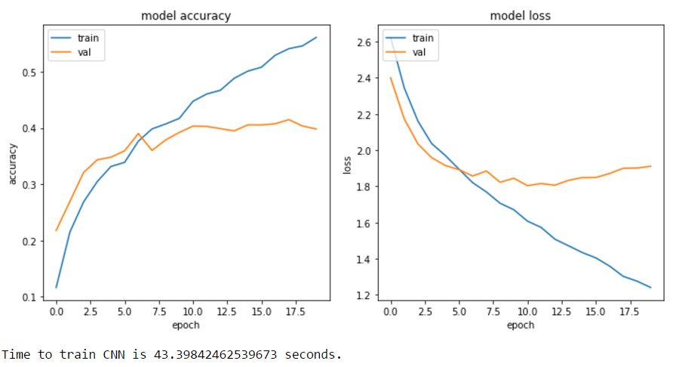

The training curve improved but the model ovefits on validation set. Play with the dense layer

1. Ff

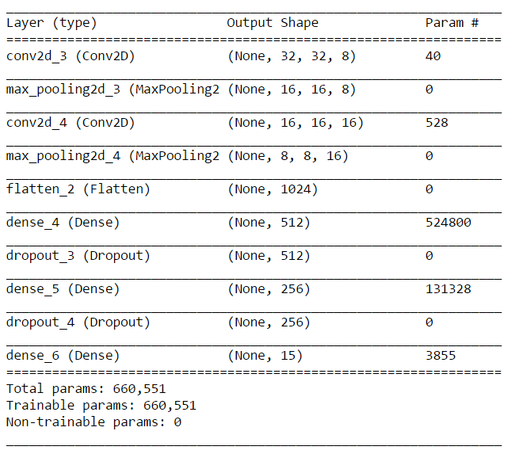

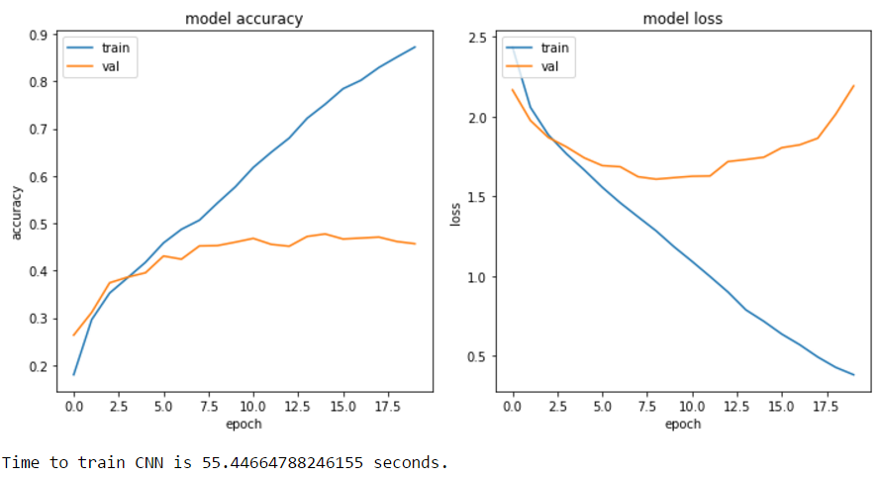

The training curve did well. Add one more dense layer to check if training curve improves. The validation curve indicates overfitting is still present which we will look into later.

1. Ff

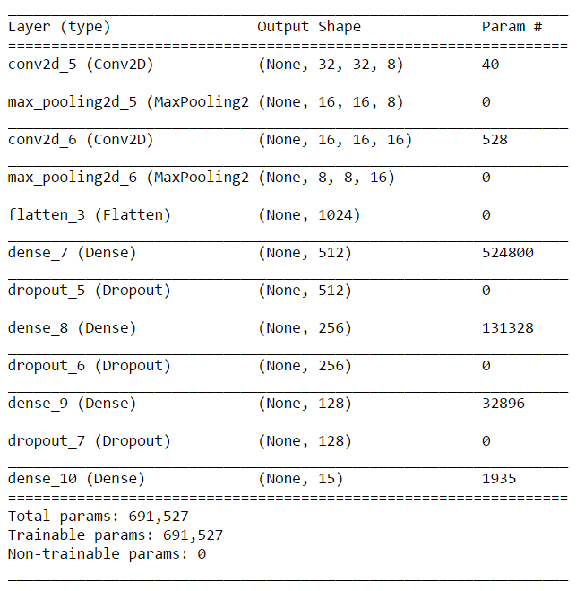

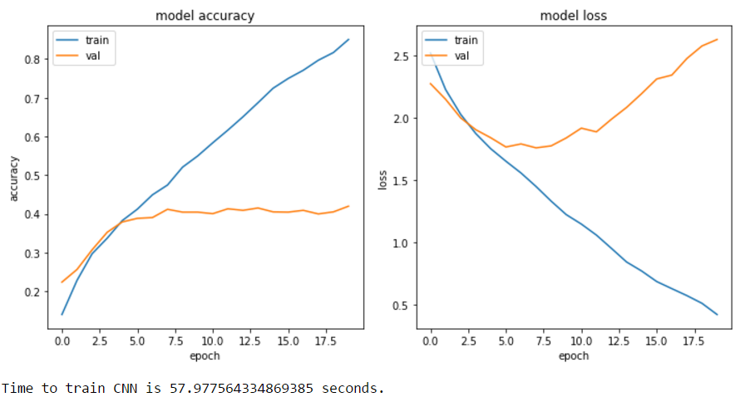

There is no improvement in training curve, So we move back to previous model(only 3 dense layers) and play with dropout to reduce overfitting on validation set

1. Ff