Logs are indexed to Splunk.

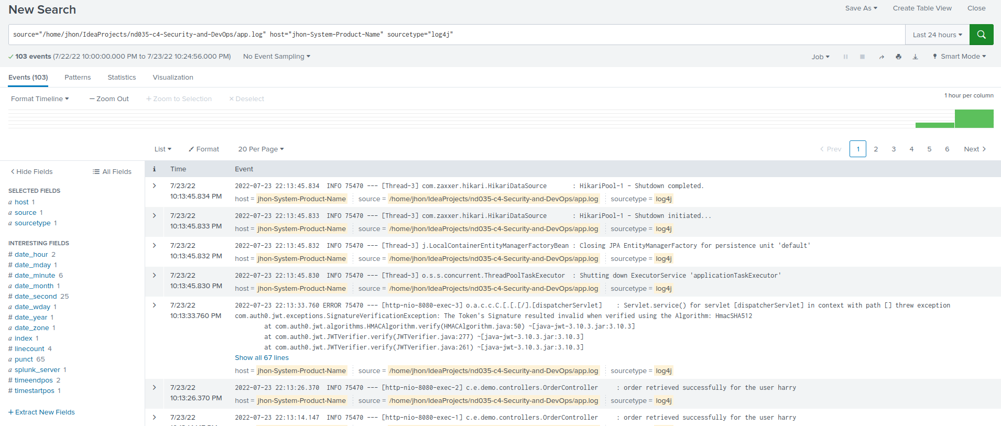
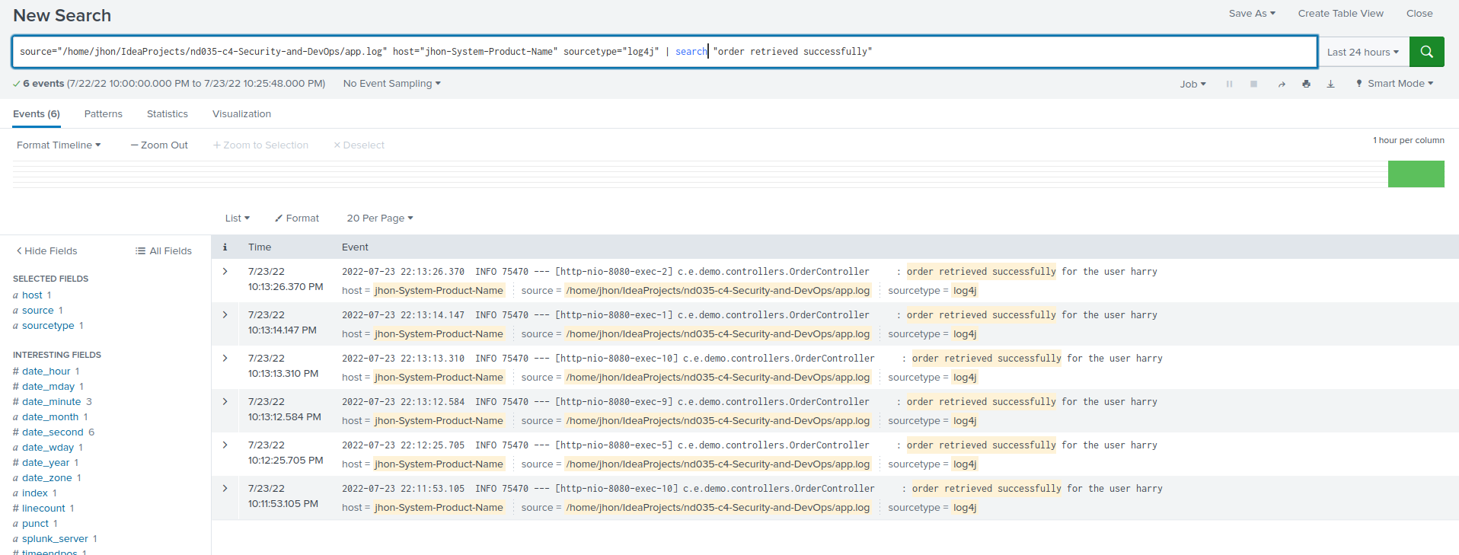

The code sets up at least one alert (of your choice) for the system.
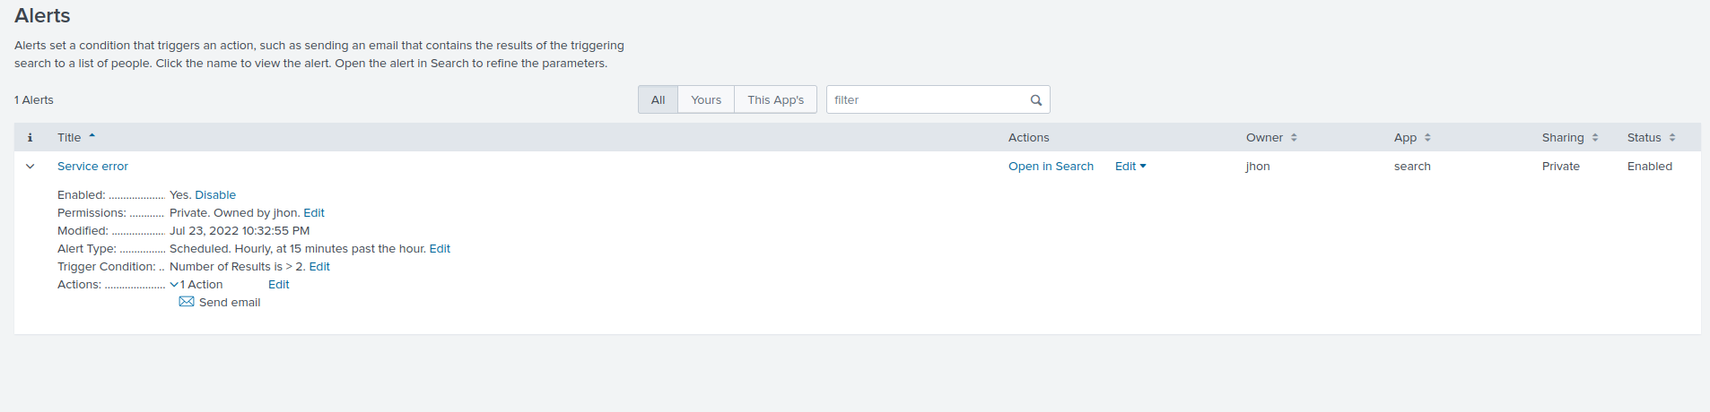
For example:
Create dashboard for success rate per minute of any one CreateUser and order, and take a screenshot.

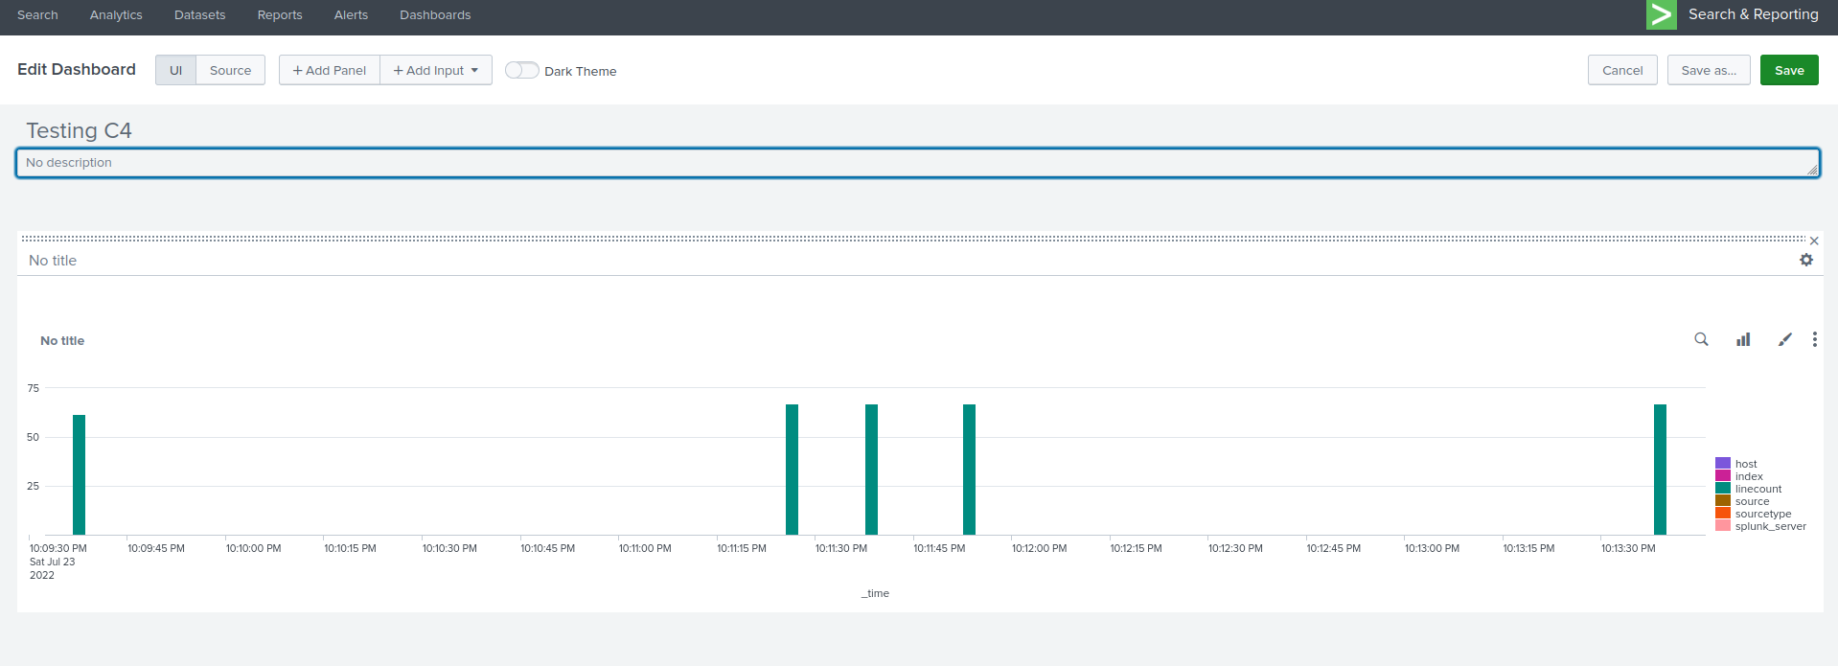

Screenshots are provided showing some query results and the alert setup.

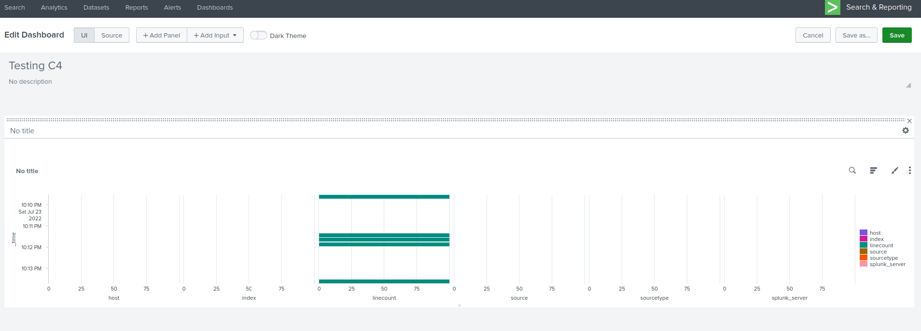

The submission manages build and deployment of the application with Jenkins:

Submission includes logs or screenshot showing successful Jenkins build and project setup

