**Tutoral 2 -- SocketPro secure communication and built-in bi-directional message pushes**

**Contents:**

***Introduction***

***Use SSL/TLs for secure communication***

* *Enable SSL/TLs at server side*
* *Enable SSL/TLS at client side and server certificate authentication*

***SocketPro built-in bi-directional message pushes***

* *Two types of message pushes*

1. *One-to-many*
2. *One-to-one*

* *Register a few chat groups at server side*
* *Subscribe for one or more chat groups of messages*
* *Track message push event at server side*
* *Track message push event at client side*

***Send messages***

* *Server side*
* *Client side*

1. **Introduction**

In short, we need to secure sensitive data movement among computers such as passwords, credit cards, personal identification numbers, financial data, and so on. To achieve this purpose, SocketPro uses popular [openssl](https://www.openssl.org) (Linux) and SSPI (windows) libraries across all supported platforms.

A typical distributed application is involved with a network communication between the client and server only, but there is no communication among connected clients at all. However, this typical architecture does not meet application requirements under many cases. An application may require some ways to enable communications among clients whenever an interested thing happens. This type of communication is similar to Internet chat among a group of people. Therefore, SocketPro provides this type of chat service, which is a built-in service for all of connected socket connections.

For your information, the built-in chat service is also called message bus, message push, subscribe/publish communication model or pattern, or real-time notification service. These terminologies are used interchangeably within SocketPro.

Finally, the tutorial sample projects are located at the directory ../socketpro/tutorials/(csharp|vbnet|cplusplus|java\src|ce|python)/pub_sub. The Node.js sample is at the file ../socketpro/src/njadapter/hello_world.js.

1. **Use SSL/TLS for secure communication**

To use SSL/TLS for secure communication, you must enable it at both client and server sides.

**Enable SSL/TLS at server side:** It is very simple to enable SSL/TLS at server side. All you need to do is call the method *UseSSL* as shown in the below Figure 1 before running a SocketPro server.

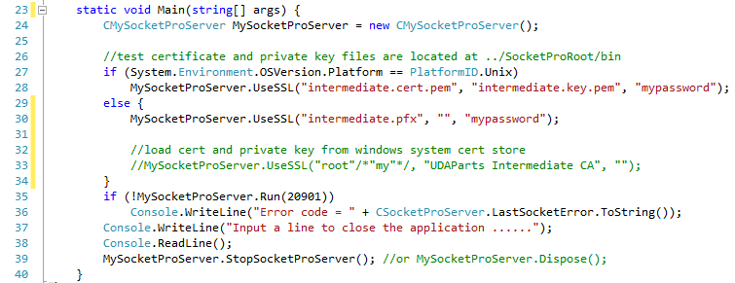

*Figure 1: Enable SSL/TLS at server side as shown at the line 28 (Linux) or 30 (windows)*

This sample uses sample CA root cert (ca.cert.pem which will be used at client side), server certificate (intermediate.cert.pem) and private key (intermediate.key.pem). The third input (“mypassword”) is password to be used to read a password-protected private key from the private key file intermediate.key.pem. All of them can be found at the directory ../socketpro/bin.

**Enable SSL/TLS for client side and server certification authentication:** To enable SSL/TLS at client side, we need to set it as you see the TLSv1 at the end of line 29 on a connection context as shown in the following Figure 2.

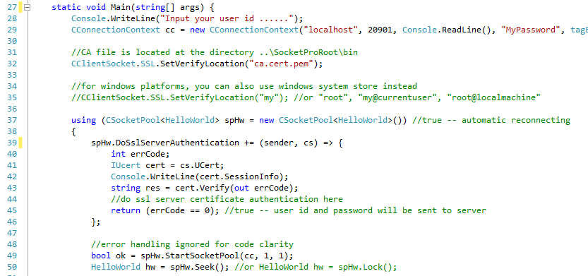

*Figure 2: Enable SSL/TLS at client side and certification authentication*

In addition to enable SSL/TLS at client side, it is also required to authenticate a server certificate as expected before sending any sensitive data from the client to a remote server. This step ensures there is no possibility of a middle-man attack.

To do so, we need to set a callback and check if a certificate from a server is expected. SocketPro uses an event as shown from lines 39 to 46 of the above Figure 2. Inside the callback, we are able to get an interface to the certificate from the remote server. Afterward, we can simply check it with a local saved certificate as you can see at line 43. After both match, certificate chain is verified successfully and the callback returns true, SocketPro will send sensitive data such as user id and password. Otherwise if it returns false, SocketPro does not send the two sensitive data but closes socket connection automatically.

1. **SocketPro built-in bidirectional message pushes**

SocketPro supports two types of real-time notification, one-to-many and one-to-one.

**One-to-many:** As shown in Figure 3, a sender is able to send a message to one or more groups of chatters or subscribers. You can do so from either the client or server side. SocketPro server is able to distribute the message based on an array of input chat group identification numbers (or topic ids) on behalf of the sender. If you use this notification model, a listener or subscriber must first subscribe to one or more chat groups for expected groups of messages. However, a message publisher does not have to do so.

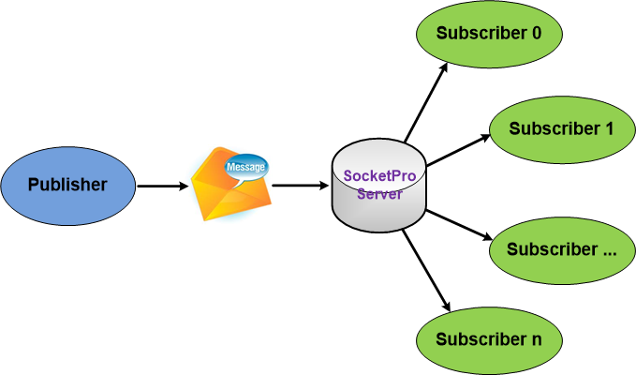

*Figure 3: One-to-many real-time notification within SocketPro server*

**One-to-one:** As shown in the Figure 4, SocketPro is also able to send a message from a client to another client with an input receiver user id (case-insensitive).

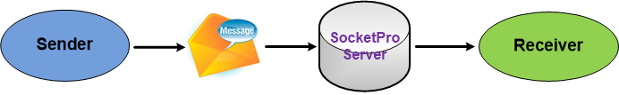

*Figure 4: One-to-one real-time notification within SocketPro server*

Note that a sender is always able to send a message to a receiver without requirement of any type of subscription, contrary to the previous one-to-many notification model.

**Register a few chat groups at server side:** Under many cases, we like to use the one-to-many notification model. To do so, we must create a few chat groups or topics at the server side as shown below in Figure 5 before starting SocketPro server.

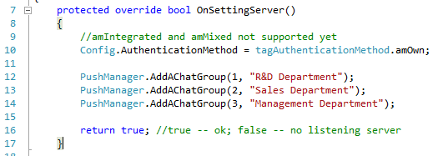

*Figure 5: Register a few chat groups at server side*

We usually create these chat groups or topics within the virtual function *OnSettingServer*. Lines 12 through 14 register three chat groups. Now, a message sender is able to tell a SocketPro server how to distribute a message from a given array of chat group identification numbers.

If you just use one-to-one notification model only, there is no need to register these chat groups at all.

**Subscribe for one or more chat groups of messages:** To use the one-to-many chat model, a subscriber or listener for messages must subscribe to the expected groups of messages. You can do so from either the client or server side. This tutorial sample demonstrates when subscribing for two chat groups of message from the server side as shown in the below Figure 6. We let you find how to subscribe chat groups of messages from the client side after you go through this tutorial.

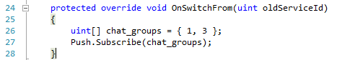

*Figure 6: Subscribe two chat groups of message at line 27 at server side*

Since this tutorial server is able to support both one-to-many and one-to-one notification models, we need demos to track notification events at both client and server sides.

**Track notification events at server side:** As shown in the below Figure 7, SocketPro uses virtual functions to track notification events. Therefore, you need to override these virtual functions.

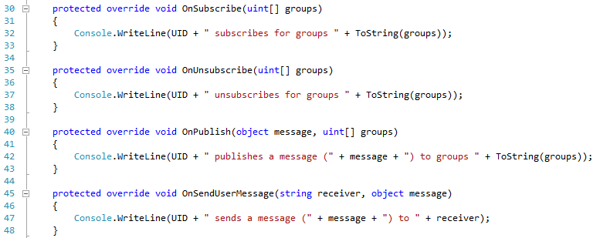

*Figure 7: Track common notification events at server side by overriding a set of virtual functions OnXXX*

Lines 45 through 48 are used for tracking one-to-one message model messages. All other lines of codes are for tracking message events related to the one-to-many notification model.

**Track notification events at client side:** At client side, SocketPro uses events approach instead. See Figure 8 below for details.

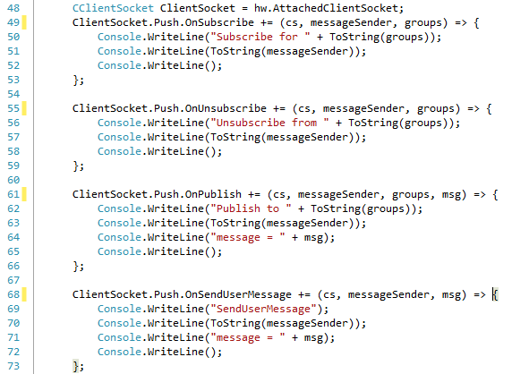

*Figure 8: Track common notification messages at client side*

Similarly, to the server side, lines 68 through 73 in the above Figure 8 are used for tracking one-to-one message model messages. All other lines of codes are for tracking message events related with the one-to-many notification model.

1. **Send messages**

At last, we need some ways to send a message to one or more subscribers (or listeners) as long as there is an interesting thing happening. SocketPro supports sending a message at either client or server side.

**Server side:** You can call the method *Publish* after obtaining the property *Push* as shown in the Figure 9.



*Figure 9: Send a message onto two chat groups of subscribers at server side*

Similarly, you can send a message to a receiver identified by its user id with the method *SendUserMessage*.

**Client side:** You are still able to use the class *CClientSocket* property *Push* to send your interesting messages as shown in the below Figure 10.

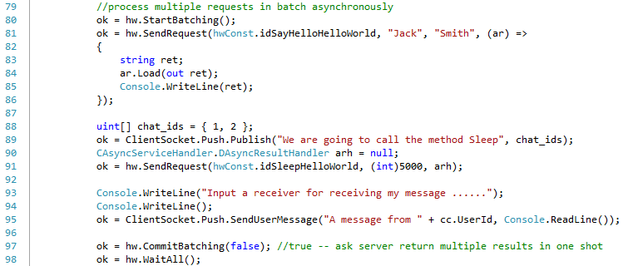

*Figure 10: Send messages at client side*

Figure 10 demonstrates publishing a message from line 89 to two chat groups of subscribers, and then sending one message to one receiver as identified by an input user id at line 95.