**Sharing a Socket Pool of Asynchronous Handlers among Multiple Threads**

**Introduction**

SocketPro is next generation technology that streams both requests and responses. It is written from scratch with continuous in-line request/result batching, asynchronous data transferring and parallel computation in mind. It prefers streaming all requests by use of one single socket connection at client side from different threads for the best network efficiency through SocketPro inner batching algorithm. Therefore, you, a software developer or architect, must know how to share one single socket connection or its associated asynchronous handler among multiple threads within a multithreaded environment.

This short article is focused on sharing a pool of asynchronous handlers among multiple threads for client side development.

**Source Codes and Samples**

All source codes and samples are located at https://github.com/udaparts/socketpro. After cloning it into your computer by GIT and having a quick look at the subdirectory socketpro/samples/fatclient_thread, you will find that there are four subdirectories, cplusplus, dotnet, java_demo and python_demo for C++, C#, Java and Python development languages, respectively. It is noted that all of them are focused on client side development. However, this article only uses C# code example for explanations as usual.

To running one of these client side applications, we need a sample SQLite server application test_ssqlite inside a subdirectory win or linux of socketpro/bin. The sample server, which is described at the article socketpro/doc/sqlstream_sqlite.pdf, is very simple to run without any required configuration for you to understand ahead. SocketPro many demonstration samples are using the server for demonstration purpose.

You should distribute these system libraries inside the directory socketpro/bin into your system directory before running these sample applications. In regards to SocketPro communication framework, you may also refer to its development guide documentation at socketpro/doc/SocketPro development guide.pdf.

**Main Function**

First, let’s see the below Figure 1 for main function.

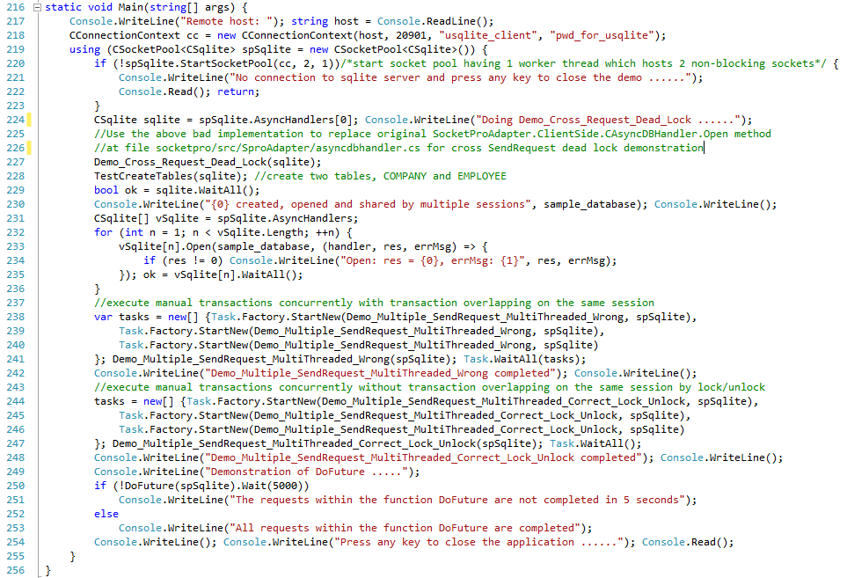

*Figure 1: Main function for parallel processing within multi-threaded environment*

We use the main function in the above Figure 1 to demonstrate the following topics:

* Cross request dead lock as shown at line 227
* Sharing one single connection by multiple threads concurrently at lines 238 through 241
* Locking one single connection from a pool of sockets by one of threads at lines 244 through 247
* Waiting one result for one specific request at line 250

This short article is designed to focus on the above four topics.

**Cross request dead lock**

The first issue is dead lock which you must keep away from, when you create an own asynchronous handler. This is specific issue to SocketPro request streaming technology, which you will not see with traditional non-streaming client/server communication frameworks. To help you recognize the dead lock, see the below Figure 2 which is a bad implementation for original method *Open* of the class *CAsyncDBHander*.

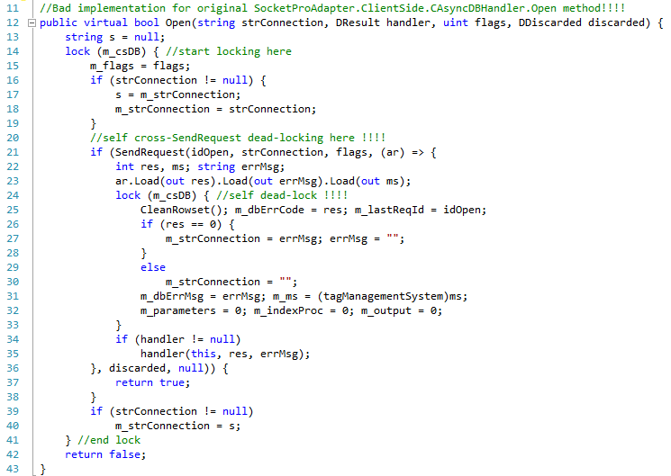

*Figure 2: Cross request dead lock demonstration by method Open of class CAsyncDBHandler*

The class *CAsyncDBHandler* has a member *m_csDB*, which is used to synchronize all its members, *m_flags, m_strConnection, m_dbErrMsg*, and others. It starts locking from line 14 through line 41. The lock is crossing the request at line 21, whose request data will be sent to a remote SocketPro server for processing. Further, the lock is used to lock all statements between lines 25 and 32 inside a callback or Lambda expression that will be called by one of socket pool threads.

When many requests are streamed from your calling thread and too much request data may be queued in memory at client side, SocketPro client core library will silently wait to prevent too many requests queued or too much memory consumed which leads to a dead lock. The dead lock is named as cross request dead lock within SocketPro technology, which may happen **only if all** the following three situations meet at the same time.

* Many requests are streamed at client side
* There is a lock cross request, and the lock is also used to synchronize other data within anyone of functions that are called by one of socket pool threads
* Request sending speed is faster than network and server processing speeds

To solve the issue completely, you may use a new locking algorithm so that there is no lock across the method *SendRequest* at line 21 in the above Figure 2. This is the first way. In case you don’t see the issue at glance, you can write a unit test code to detect the dead lock as shown in the below Figure 3.

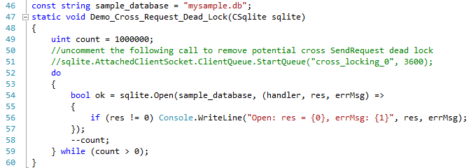

*Figure 3: A sample unit test code snippet to detect cross request dead lock within method Open*

As hinted in the above Figure 3, you can open a local message queue to avoid this dead lock because requests can be queued into the message queue file instead of memory. This is the second way to get rid of the dead lock. However, this way may slow sending requests because of cost of saving requests into disk. As a software developer for writing asynchronous handler, you should do your best to use the first way instead. Just for your information, all client handlers except the class *CStreamingFile* inside an adapter use the first way to avoid the cross request dead lock.

As hinted at lines 225 and 226 in Figure 1, you can replicate the dead lock by replacing the original implementation with this bad one.

**Sharing one single connection by multiple threads concurrently**

SocketPro favors that multiple threads share one single connection so that requests are streamed for the best network efficiency and processing sequence in general. The class CSocketPool at client side provides two sets of methods to find a proper handler from one of calling threads. Multiple threads may send different requests possibly by the same handler through calling one of the first set of methods Seek and SeekByQueue as shown at left side of the below Figure 4. This is situation leading to no request streaming synchronization.

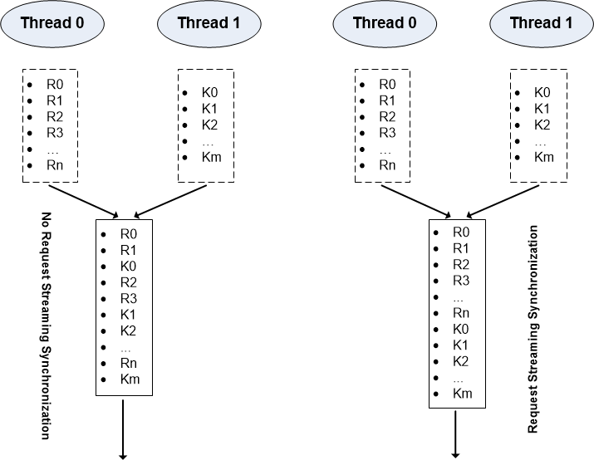

*Figure 4: Share one single socket connection by two calling threads*

Under many cases, no request streaming synchronization is just fine if there is no request sequence requirement for a stream of requests. For example, a client sends a stream of SQL query statements from different working threads by use of socket connection. However, request streaming synchronization is often a must, which is shown at right side of the above Figure 4. For example, you like to update (insert, update and delete) database tables in manual transaction style. Another example is to execute SQLs by parameterized statements in such an order like preparing at first, sending multiple sets of parameter data at next, and executing at last. To make sure request streaming synchronization, we can use the method *Lock* of the class *CSocketPool*.

To demonstrate how to use the above two sets of methods, we need a sample of streaming a series of SQL statements in a manual transaction as shown in the below Figure 5.

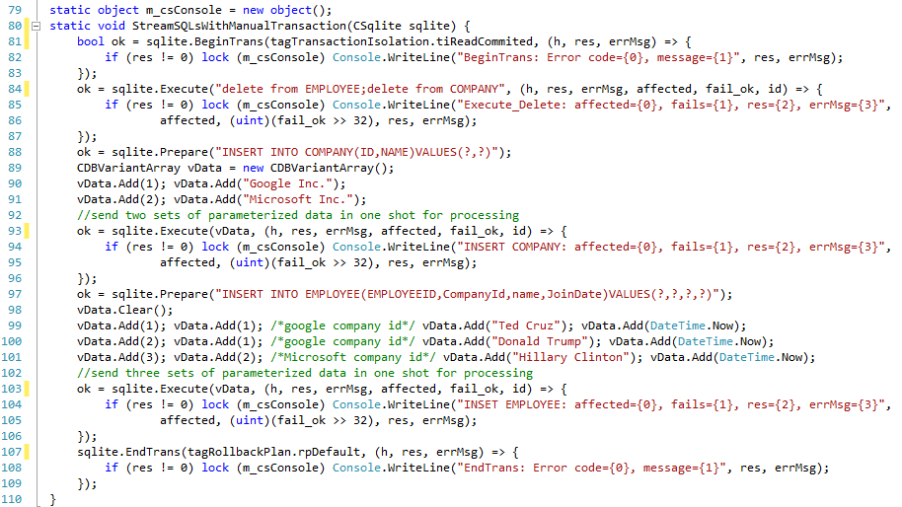

*Figure 5: Stream a number of SQL statements within a manual transaction*

The above Figure 5 starts a manual transaction at line 81. Afterwards, it does deleting all records of tables EMPLOYEE and COMPANY at line 84. Next, it sends a request for preparing at line 88. Next, it executes two inserts with two sets of data in one shot. Next, it sends a new prepare statement at line 97. At end, it executes three inserts with three sets of data in batch. Finally, it ends the manual transaction at line 107. Totally, there are seven requests streamed, which must be synchronized with no overlapping among threads at client side for properly processing at remote server side as shown in the bottom method of the below Figure 6.

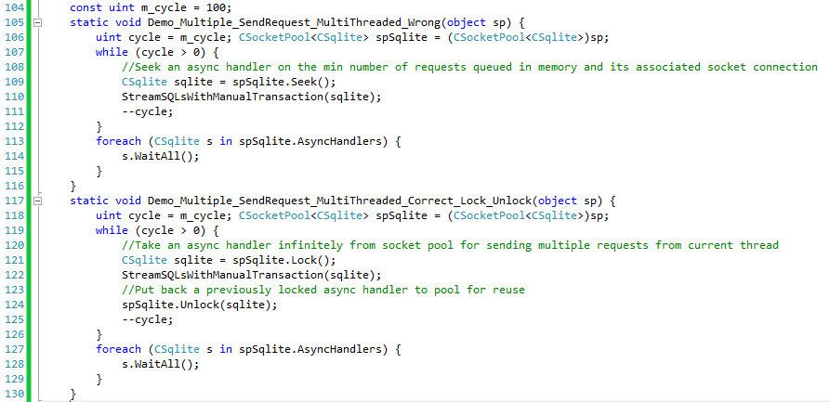

*Figure 6: Sharing a connection among multiple calling threads by methods, Seek and Lock*

It is noted that the top method *Demo_Multiple_SendRequest_MultiThreaded_Wrong* is good for streaming a series of SQL queries but not good for streaming a series of update or parameterized statements, which is demonstrated at lines 238 through 241 of Figure 1. Contrarily, the bottom one *Demo_Multiple_SendRequest_MultiThreaded_Correct_Lock_Unlock* is good for all cases, which is verified at lines 244 through 247 of Figure 1.

**Locking one single connection from a pool of sockets**

As shown at bottom of Figure 6, a calling thread could lock a handler from a socket pool by the method *Lock* first so that no other calling threads are able to get the same handler at a moment. By this way, it ensures request streaming synchronization as shown at right side of Figure 4, which ensures a remote server to process all streamed requests properly in order. At last, don’t forget calling the method *Unlock* and putting a previously locked handler back into pool for reuse by other threads as soon as possible.

**Waiting one result for one specific request**

We use the method *WaitAll* at client side to wait until all requests queued on one socket connection are processed and returned. This is usually fine within one thread as shown in most of samples for code snippet clarity. However, the method may not work as you expected in case a handler or its associated socket connection is being shared by multiple calling threads. The method may be not returned to a calling thread if another calling thread is keeping sending requests continuously through the same handler or sever is processing requests at slow speed.

Under such a situation, we must have a way to wait for a specific request returned. We could use future for this purpose. SocketPro adapters for Python and Java have a simple class *UFuture* for help. However, there is no such class in .NET and C++ adapters, as it is very simple for us to write code for waiting one specific request *EndTrans* at line 166 as shown in the below Figure 7.

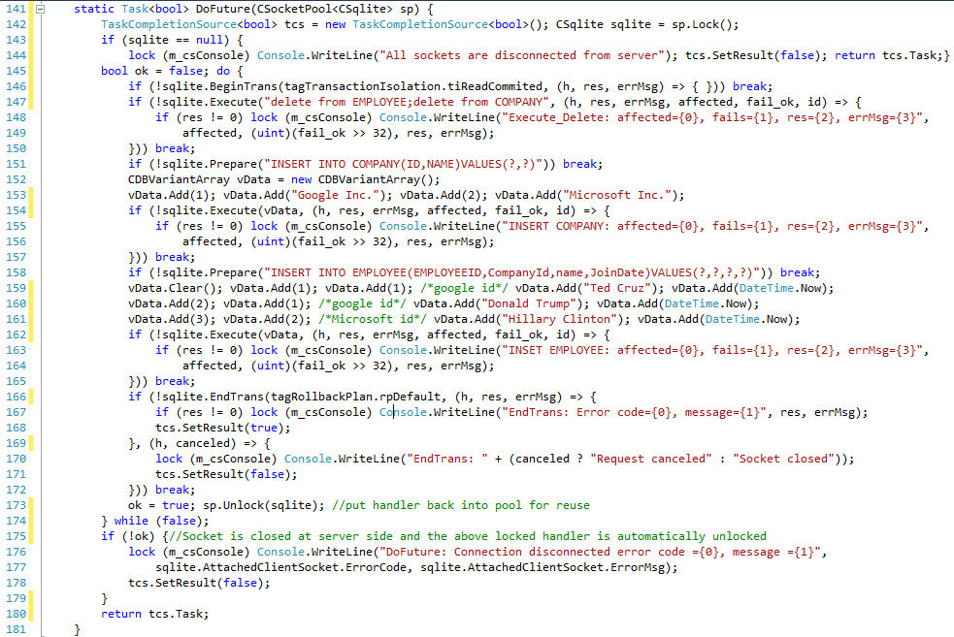

Figure 7: Wait for a specific request processed by use of future

It is noted that this implementation is nearly the same as one of Figure 5. After creating a task at line 142, we must call the method *SetResult* properly, which is shown at lines 144, 168, 171 and 178, after either an error happens or a result is returned from server.

You can see the lines 250 through 253 in Figure 1 to find how to call the sample method *DoFuture*.

Finally, it is pointed that you’d better use the future instead of *WaitAll* within multi-thread environments (for example, middle tier and web server developments) in most cases. The method WaitAll is given for simplicity, clarity and single thread environment.