To understand the challenges and needs for Wide Area Network (WAN) monitoring we need to understand why we are making the measurements. The root reason is exemplified by the old adage “You can’t manage what you can’t measure”. The measurements are needed for three main purposes:
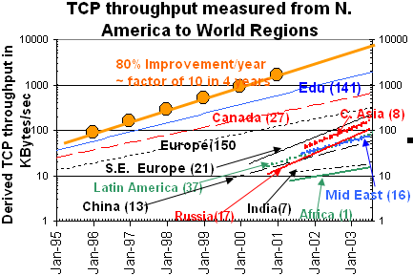
- For planning, characterization, setting expectations, and guiding policy makers. An example of how WAN measurements can be for such purposes can be seen in Fig. 1. This shows the performance in Kbytes/s from the U.S. to various regions of the world since the beginning of 1995. Such data shows the rate of improvement, which regions have poorer performance, how far in time they are behind the developed world, whether they are catching up, keeping up or falling behind. Such measurements enable policy makers and funding agencies decide where to focus efforts and help quantify the extent of the Digital Divide.
- For trouble-shooting with a goal of providing high reliability and optimum performance. This is made hard since:
  - Problems may not be logical in fact most Internet problems are caused by operator errors (Sci. Am. June ’03), most Local Area Network (LAN) problems are caused by Ethernet duplex problems, mis-configured hosts and bugs.
  - The deliberate transparency of the network together with its increasing size and the rapid rates of change make invariants hard to come by and predictions hard to make. As Butler Lampson said: A distributed system is one in which I can’t get my work done because a computer I never heard of has failed.
- Application steering (e.g. Grid data replication).
Today the critical metric for the user is the end-to-end performance. There are two classes of tools for making end-to-end measurements.
- The most common way is by means of active measurements where probes are sent into the network. Typical tools include ping, traceroute, owamp, Pathload/abwe, iperf and major applications such as bbftp. Typically these are used between end-hosts. Problems with such tools include the traffic inserted onto the network, scheduling of tests to avoid interference between disjoint tests that inject large amounts of data (e.g. iperf or bbftp), correctly configuring the tools (e.g. how to choose the right TCP window sizes and numbers of parallel streams), the lightweight packet separation dispersion tools such as Pathload have problems at > 1Gbits/s bottleneck due to timing (e.g. interrupt coalescence, the times between packets is similar to the system clock granularity).
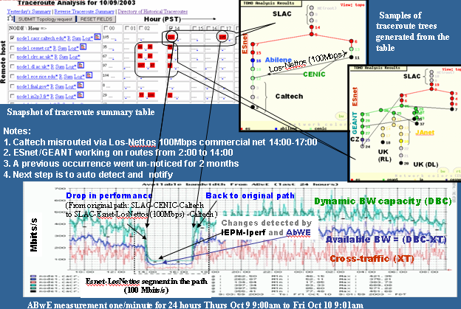
- Passive tools such as NetFlow, cflowd, SNMP also provide useful information for understand end-to-end traffic. Typically these are used at site border and network interchanges and network devices and require access to network devices. Problems include lack of control, the amount of data that is generated and the need to be able to access information from inside the network (e.g. router MIBs or NetFlow information, spanning switch port traffic, or inserting splitters).
These classes and tools are complementary to one another, and should be used together to more completely understand the network. Fig. 2 shows an example of using traceroute and abwe and a topology mapping tool together to multiple hosts in order to correlate route changes affecting multiple paths simultaneously, and to show the effect of a route change on available bandwidth.
Other challenges for monitoring are making the information understandable (help reduce the “Wizard Gap”) for a wide audience and automating the detection of events of interest from the possibly thousands or even tens of thousands of reports generated each day.
There are today many production public domain Network Measurement Infrastructures (NMI) with different emphases and serving different communities. Some of the emphases include (for a table comparing 13 public sector public domain infrastructures, see: http://www.slac.stanford.edu/grp/scs/net/proposals/infra-mon.html):
- Passive measurement infrastructures are often deployed by service providers or site network administrators at the site borders. Typically they can be used to characterize traffic, provide intrusion detection, or gather traces for detailed analysis.
- Active measurement infrastructures are usually deployed by end users (e.g. network administrators at end node sites). They can be further subdivided according to the amount of traffic they inject into the network:
  - Lightweight infrastructures such as PingER, AMP, Surveyor and RIPE
  - Medium weight infrastructures such as PiPES, NWS, and IEPM-LITE
  - Heavyweight infrastructures such as IEPM-BW, and NTAF.
- One can also separate based on whether the infrastructure is for end-to-end measurements or for network centric measurements such as skitter or other macroscopic network views.
- Other discriminators include: whether the measurements are repetitive (e.g. PingER, AMP, PiPES, NWS, NTAF) or on demand (e.g. NDT, NIMI, PiPES); whether they use dedicated hardware (e.g. AMP, RIPE, PlanetLab) or are software based (IEPM); whether measurements are hierarchical (e.g. PingER, IEPM) or full mesh (e.g. AMP).
Some challenges faced by today’s NMIs include:
- Scaling beyond hundreds of hosts is hard in the long term:
  - Hosts change, they are upgraded, with new OS, security patches
  - Hosts need updating to support higher speeds
  - Advanced TCP kernel and/or Web100 upgrades are not coordinated with OS upgrades
  - Policies at remote sites make it hard to install hosts, may block ports, pings, traceroutes
  - Distributing software updates, key distribution, accounts, passwords
- Deployment/operation in a multi-agency/international environment, how does one get funding for a sustainable NMI when it is funded by a single agency.
Today the scaling problems together with the different interests and needs of different administrative domains mean that multiple NMIs will be deployed. Thus we need to address the need to create and tie together a federation of NMIs. To do this the NMIs in the federation must work together, they need to share standard methods to discover, make request for data and respond to these requests with a standard naming convention. This will enable a much improved overall view of the network using multiple measurements form multiple sources.
The MAGGIE (Measurement and Analysis for the Global Grid and Internet End-to-end performance) proposal directly addresses this issue. It brings together several major NMI participants including LBNL (NTAP, SCNM), SLAC (IEPM-PingER/BW/LITE), Internet2 (PiPES, NDT), PSC (NIMI) together with, and U. Delaware (NWS) together with network operators (Internet2 and ESnet). They will also work with others including MonALISA, AMP, UltraLight, PPDG, StarLight and the DoE UltraScienceNet. They plan to use and contribute to the GGF NMWG naming hierarchy and schema standard for discovery, request and reporting of information and are leading member of the effort. They plan to develop web services tools to allow sharing of the information. The federation goals are: appropriate security; interoperability; useful for applications, network engineers, scientists and end-users; easy to deploy and configure; as un-intrusive as possible; as accurate and timely as possible, and to identify the most useful features of each NMI so as to improve each NMI faster than working alone.
The JET can play a role by considering and making recommendations concerning:
- Incent multi-disciplinary teams including people close to the “end users” (maybe scientists, and/or the network operations teams), this will help ensure what is produced is tested and used in real environments.
- Include deployment in proposals.
- Recognize that network management research is legitimate.
- Address the needs for network monitoring/management to cross agency boundaries, international boundaries and even the Digital Divide.

