Asynchronous OpenStack
A business proposal for reverse engineering of OpenStack core components
Yuancai (Charlie) Ye
2/14/2017

Executive summary
AsyncOpenStack Inc. (TBD) will be a startup company whose vision is to rewrite a set of core components of OpenStack (http://www.openstack.org) with continuous inline request/result batching, real-time streaming processing, asynchronous data transferring and parallel computation in mind to reach the following goals.
- The new OpenStack (named as AsyncOpenStack from now on) will be fully compatible to the existing OpenStack. Companies, who are using OpenStack as their computing platform, are not required to rewrite their existing applications if they switch to AsyncOpenStack cloud platform. AsyncOpenStack is fully accessible by all existing OpenStack components and tools that are already developed by others. Further, AsyncOpenStack will keep all the existing OpenStack advantages.
- AsyncOpenStack will have much simpler daily operation complexities in comparison with the existing OpenStack. Simplicity of cloud daily operation and customer development will be put on the highest priority when developing the new AsyncOpenStack cloud platform.
- In addition to Linux platforms, AsyncOpenStack will also add support to windows platforms so that AsyncOpenStack platform will be an alternative choice to Microsoft Azure (https://azure.microsoft.com/en-us/) cloud platform for windows developers.
- AsyncOpenStack cloud will be runnable on one normal laptop computer to help individual software engineers or students learn cloud computing no matter windows or Linux operation system is used by default.
- AsyncOpenStack will be easily scaled up to support even millions of computers across multiple data centers to meet various challenging business requirements of not only small companies but also larger enterprises.
- AsyncOpenStack cloud will be significantly improved in performance in comparison to the existing OpenStack. Further, AsyncOpenStack cloud will be also better in performance than Amazon AWS and Microsoft Azure clouds.
- A few key migration tools will be developed from the existing OpenStack ones. In addition, a few adapters will be developed to simplify AsyncOpenStack APIs for key development languages.
- Linux distribution package and window installation program will be created to simplify AsyncOpenStack deployment.
- Similar to other cloud service website, a website will be started and gradually enhanced for marketing AsyncOpenStack cloud platform.
Industrial background
Recently, cloud computing is progressing at high speed. Here is a figure that shows the whole industrial revenue trend from 2008 to 2018 (http://dazeinfo.com/2015/07/01/the-future-of-cloud-computing-127-billion-market-by-2018-report/).
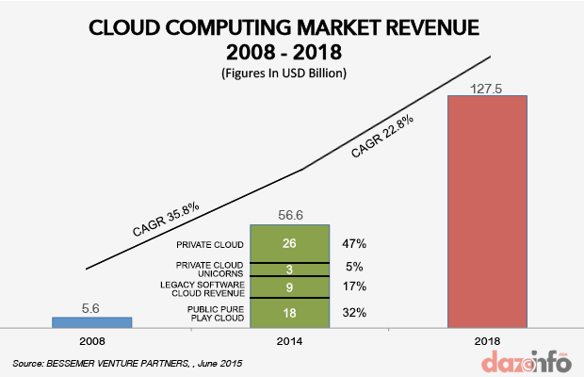
Figure 1: Cloud computing market revenue trend from year 2008 to 2018.
World widely speaking, leading cloud providers are Amazon, Microsoft, IBM, Google, and Salesforce. Here is the Figure 2 (https://rcpmag.com/articles/2016/08/02/microsoft-behind-aws-in-cloud.aspx) that represents cloud market share in Q1 2014 and Q1 2015 among the top five cloud providers with yearly growth rate.
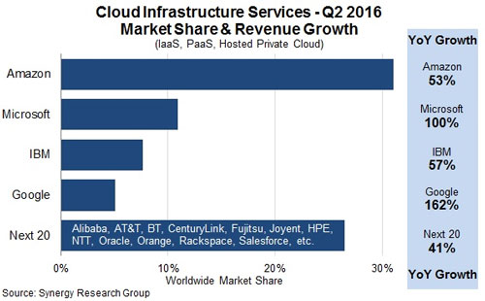
Figure 2: Cloud market share among world top five providers in Q2 2016.
The above leading cloud service providers, except IBM, are giant software enterprises that are able to develop their own proprietary cloud platforms without opening their source codes. All of others wish to compete in market by use of some opened source cloud platforms. The most popular opened source cloud platform is OpenStack (http://www.openstack.org/). The leading companies using the OpenStack can be represented from the following Figure 3 (http://seekingalpha.com/article/2523745-hp-is-the-new-openstack-leader-what-does-it-mean-for-red-hat).
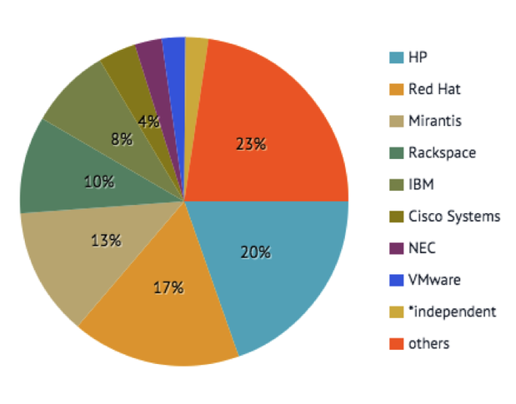
Figure 3: Leading companies using OpenStack as their cloud platform.
AsyncOpenStack Inc. will focus the revolution of OpenStack by rewriting its core components to develop own cloud platform.
Competitor analysis
After reading through the above section Industrial background, it is easy for us to obtain the following conclusions.
- Amazon AWS cloud is leading in overall because Amazon is a pioneer in cloud computing industry. Specially, most of companies, which are extensively using Linux/Unix platforms as their IT development environments, will use Amazon AWS cloud. However, Amazon AWS cloud lacks competition to the companies whose development environments are majorly based on window platforms. In addition, the Companies, which want their own cloud and do not want their data accessible from an external company, will not use Amazon AWS cloud because Amazon does not open its cloud platform source code. Also, it is not expected Amazon will customize its cloud platform for each of its customers.
- Microsoft Azure cloud is the number 2. Microsoft Azure cloud is especially popular among companies whose development environments are majorly based on window platforms. It is expected that Microsoft is lost to Amazon for companies using Linux/Unix platforms as their IT development environments. Similarly to Amazon AWS cloud, the companies which want their own cloud and do not want their data accessible from an external company will not use Microsoft Azure cloud because Microsoft does not open its cloud platform source code. Further, it is not expected Microsoft will customize its cloud platform for each of its customers.
- Google and other proprietary cloud platforms are far from popular in IT industry, although they are somewhat attractive to Linux/Unix development customers. Similarly to Amazon AWS and Microsoft Azure clouds, the companies which want their own cloud and do not want their data accessible from an external company will not use Google or other proprietary cloud platforms because they do not open their cloud platform source codes. Also, it is not expected that there will be any customizations to their customers at all.
- Openstack-based cloud platforms are estimated to currently have market share around 15% all together. The above Figure 3 shows leading companies provide Openstack-based cloud services. Currently, Openstack-based cloud platforms cannot be installed on window platforms. Therefore, OpenStack cloud platforms have very least competition to companies whose development environments are majorly based on window platforms. However, OpenStack-based cloud is especially attractive to the companies which want their own cloud using Linux/Unix platforms as development environments and do not want their data accessible from an external company. Small or middle sizes of companies will not use OpenStack as their own cloud platform because it is too complicated with huge learning curve and many daily operation complexities. These companies cannot afford running OpenStack by themselves.
As far as we know, market has no cloud platform that can be directly distributed on Microsoft window machines and independently managed by companies themselves yet. Cloud computation industry is still young and not matured. Therefore, it is expected that AsyncOpenStack cloud platform would be developed to focus on companies that want their own Openstack-based clouds without exposing their data to any external company no matter window, Linux or both platforms are extensively used for their developments from business view.
AsyncOpenStack improvements over OpenStack
Although OpenStack is the most popular open-source cloud platform with a strong ecosystem on which thousands of large enterprises are relying, it actually has a number of challenges that is currently influencing its adoption very badly.
- OpenStack daily operations are too complex so that companies relying on OpenStack are crying for many OpenStack experts having cross-domain knowledge on the job market. It is not uncommon that software engineers are forced to dig into its source codes spreading over different core components for solving issues, which will significantly increase not only daily operation but also development costs. After analyzing source codes of OpenStack core components, we have found clues and gotten new ideas leading to reduce cloud daily operation complexities. AsyncOpenStack will use these discoveries to rewrite OpenStack core components with new ideas to avoid daily operation complexities as many as possible.
- OpenStack doesn’t support agility and deployment well. In IT industry, everything is changing fast. Therefore, it is required that various deployed software components and running machines should be easily shutdown, upgraded and replaced for better deployment, agility and modularity. In addition to better modularity, AsyncOpenStack will have huge improvements in agility and deployment over OpenStack.
- It is assured that AsyncOpenStack will have huge improvements over OpenStack in performance for accessing storage data. OpenStack has four core components (compute, object store, block storage and image service) for managing different types of storage data (http://ken.pepple.info/openstack/2012/09/25/openstack-folsom-architecture/). Under most cases, all communications among them are completed synchronously within OpenStack. We have already completed an asynchronous communication framework (ACF) with excellent performance and scalability. In contrary to OpenStack, AsyncOpenStack will use the ACF for asynchronously remoting various types of data among the four components under all cases.
- AsyncOpenStack will support window platforms. Currently, the existing OpenStack does not run on windows platform.
Once required, we are able to deliver a new presentation for detailed analysis of AsyncOpenStack improvements over the existing OpenStack from technical view.
Financial plan for initial development of AsyncOpenStack
It is estimated that an initial two-year development period is required for rewriting such OpenStack core components, identity (keystone), object storage (swift), block storage (cinder), image (glance), compute (nova), network (quantum) and dashboard (horizon) as well as important migration tools, distribution package plus AsyncOpenStack adapters for major development languages with three technical/management leaders and four middle-level software engineers. A two-million-dollar fund is expected for salary, equipment and other operation costs to support early development of AsyncOpenStack cloud platform.
An asynchronous communication framework, named as SocketPro, is already developed at UDAParts (https://github.com/udaparts/socketpro). The framework will be extensively used to take care of all communications among all AsyncOpenStack core components. Currently, this framework is already used by more than ten companies from different countries.
SWOT (strengths, weaknesses, opportunities and threads) analysis at early stage
Strengths are listed in the below:
- AsyncOpenStack cloud platform will run significantly faster than all known cloud platforms.
- In comparison to OpenStack, daily operation complexities with AsyncOpenStack cloud platform will be considerably reduced in the aspects of deployment, upgrade and reboot of both software and hardware. As a result, cloud operating expenses will be reduced.
- AsyncOpenStack cloud platform can be manageable to small companies and even individuals. AsyncOpenStack cloud platform could be free to all individuals who are using Linux, Window or both as their development environments.
Weaknesses are:
- AsyncOpenStack cloud platform has not been developed yet.
- Software engineers are not used to writing codes to support asynchronous communication among different platforms at early time.
- No enough funds are raised to hire people for development of AsyncOpenStack cloud platform.
Opportunities include:
- AsyncOpenStack cloud platform will be first or only cloud platform targeted on companies, whose development environment is based on Microsoft window platforms, does not want their data accessed by anyone of external companies.
- AsyncOpenStack cloud platform will be attractive to OpenStack based companies that may be sick and tired of OpenStack cloud as its daily operation complexities and high operation expenses.
- AsyncOpenStack cloud platform will be very good tool to help new software engineers learn cloud computation.
Threats may be:
- Large companies such as Amazon, Microsoft and Google may distribute their cloud platforms to run on the machines owned and managed directly by middle- or large-size companies.
- OpenStack may be reversely engineered to come back and compete AsyncOpenStack after stealing its technical advantages.
Management of initial development of AsyncOpenStack
Yuancai (Charlie) Ye, as a CTO, is able to lead a small number of engineers for design and development of AsyncOpenStack core components at the first year. It is desired to have a new CEO for fund raising, daily management, business planning and marketing so that Charlie Ye is able to focus on development of AsyncOpenStack cloud platform beginning from the second year. Charlie Ye got his PhD degree from Clemson University in 1998. He is a very senior software engineer, and also an expert at asynchronous TCP/IP communication. He has been working at SocketPro for more than fifteen years. He used to work with OpenStack at Rackspace for two years and is familiar with OpenStack cloud platform. While developing SocketPro, Charlie Ye is seeking for the opportunities of application of SocketPro onto various large-scale distributed systems. Charlie Ye believes SocketPro has an important role on cloud computation.
Company summary
AsyncOpenStack Inc. is initially a startup company located at North Atlanta area of Georgia. The following assets and professional services will be needed for the formation and start of operations.
- Three technical/management leaders and four middle-level software engineers for development
- An initial office location for about ten employees
- Accounting services
- Two high-performance servers, five regular servers, ten workstations for development and five laptops
- Legal services for company formation
- Cubicle furniture for ten employees
- Lunch room furniture and appliances including a refrigerator and microwave
- Printer, copier and fax machine
- Microsoft visual studio and MSDN
- Telephone system with a dozen of extensions
- Others

