
B.Sc. (Hons) in Software Engineering
Software Engineering Cohort 1 – Trimester 1
Digital Artifact Documentation

Contents

Section 01-Installations and Guide 4
1. Testvar Flashcard Sharing Platform 4
2. Prerequisites 4
3. Installation 4
4. Optional Installation. 6
5. Technical Explanation. 7
Section 02 - Server Documentation 8
Server Testing Documentation 8
Testvar Flashcard Sharing Platform 8
2.1 POSTMAN 8
POSTMAN Overview 8
2.2 Environmental Setup 8
2.3 Sever Testing on User Registration Functions 10
User GET Method 10
Create a new card collection 11
Create a new card set 12
Create a new card 12
2.3 Code Functionality on Home Page. 13
Dashboard code 13
2.4 Code Functionality on Collections Page. 14
Collections code 14
2.5 Code Functionality on Flashcard set Page. 15
Flashcard set code 15
2.6 Code Functionality on Study Page. 16
Study page code 17
18
Section 03 - Client Documentation 19
Client Testing Documentation 19
Testvar Flashcard Sharing Platform 19
3.1 Selenium IDE 19
Selenium IDE overview 19
Section 04 - Visual framework 20
Home Page 20
Signup Page 20
Login Page 21
Dashboard Page 21
Collections page 22
Flashcard set page 22
Flashcard page 23
Section 05 – Database, CSS, and Other Functionalities 24
5.1 Prisma code 24
5.2 CSS Code 25
5.3 Responsive to mobile 27
Responsive to iPhone 14 Pro Max 27
Code for the adjusting to any screen 27

Section 01-Installations and Guide

1. Testvar Flashcard Sharing Platform
Welcome to the Testvar flashcard sharing platform project. This documentation will help you with how to set up and run Next.js application in addition to providing an introduction on what it does. Introduction | Next.js
This is a web-based app designed for managing aspects of flashcard, it also has a API routes that allows you to store flashcard and, learning records. And also a web interface built for users. This platform that utilizes with Next.js framework. It allows the managing of flashcards, user based roles, and sessions using Next.js built in API handling mechanism.

2. Prerequisites
Make sure your environment has the following system requirements before you beginning.
- Node.js 18.18 or later Node.js Installation
- macOS, Windows (including WSL), and Linux are supported.
Next.js is a react framework and this project also using it. The project works in Next.js v15.0.4 version. We can install it from [nextjs.org] (Getting Started: Installation | Next.js).

3. Installation
- Starting a new Next.js app with create-next-app, can recommend, it’ll have everything automatically set up for you. To create a project, run:
npx create-next-app@latest

On installation, we can see the following prompts
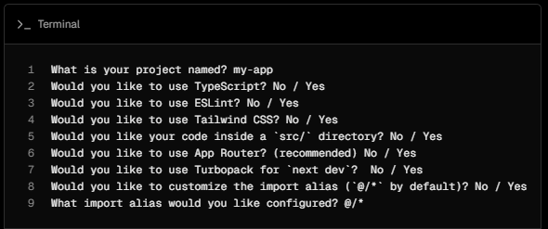

- Unzip the project archive, navigate to the project folder, and finally execute the command below to launch the next development server
npm run dev

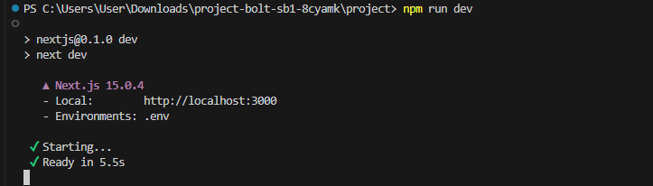
Figure 1 Run the Server
As you can see app server is running, to break the connection use Ctrl + C.
Finally open your browser, type and go to the url that started the development server as mentioned (eg: Here you can view the Testvar flashcard sharing platform http://localhost:3000 ).

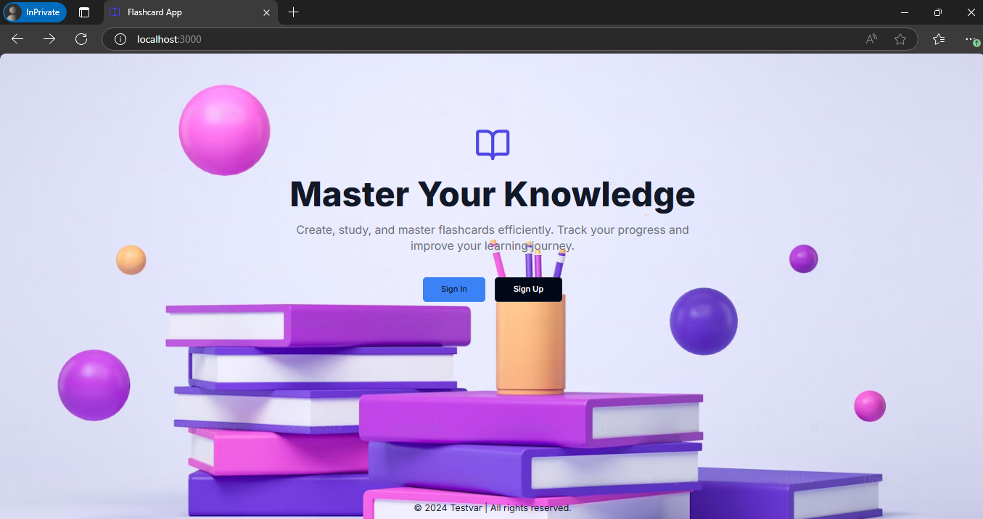
Figure 2 Testvar Home Page
By following these instructions, you should be able to set up and run the Testvar flashcard system.

4. Optional Installation.
If the project is not use automatic installation, do try installing it manually on your environment to create a new Next.js app, install the required packages
npm install next@latest react@latest react-dom@latest

Now open your package.json file inside the project folder and add the following scripts:
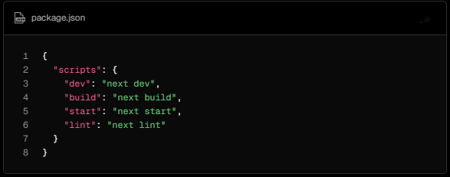

5. Technical Explanation.
A great combination for even modern web applications in development is Next.js and Prisma with everything that developers will find extremely valuable. It’s called Next.js which builds on top of React, and is described by some to be a great framework capable of running server side rendering (SSR) as well as generating static site (SSG). It allows us to create fast, SEO friendly and able to serve dynamic content well. File based routing and built in API support for the framework makes the process of setting up both frontend and backend functionality in the same project rather straight forward.
The database side of things is handled by Prisma, the best known companion to Next.js. It’s a modern ORM, making working with databases a lot less painful. Prisma lets you write type safe queries so that way there is less chance of error and better overall reliability. The schema migration tools in its tool belt are a game changer for keeping your database structure up to date with your application as it grows. When you are using next.js and connecting your backend to the database, this gives you a clean data layer and an easy way to do this using Prisma.
Pairing these two tools together provides a development environment, where Next.js handles the user interface and the Prisma provides a pleasant experience with database interactions. This setup encourages well-formed projects, faster development cycle and code which is easy to maintain in the future.
Additionally, Next.js’s flexibility allows you to integrate other tools that can enhance your project further:
- Tailwind CSS: An opinionated utility first CSS framework that helps you build visually consistent and responsive designs quickly.
- Lucide React Icons: This library helps add clean and modern icons to your app.
- TypeScript: Increases code readability and reduces errors, great addition to make your codes type safe.
Using Next.js, Prisma, or rather further combined with these additional tools, you get an absolutely wonderful stack to launch a scalable, feature rich web app either for a small side project or an elaborate complex system. With such setup, development was efficient and it was a good basis for a great future

Section 02 - Server Documentation

Server Testing Documentation

Testvar Flashcard Sharing Platform
This is Testvar flashcard sharing platform project. This Server Documentation will demonstrate server-side testing in Next.js application. To test the server, we can use Postman to interact with the API endpoints. Below are the instructions for testing with Postman.

2.1 POSTMAN

POSTMAN Overview
In software development world, Postman is a popular tool. This tool is not used for sending mails but rather an API platform that can be used for other purposes. APIs (Application Programming Interfaces) act as messengers enabling different software programs communicate with each other.
The Postman tool offers aid to application developers in coming up with these APIs, constructing and testing them, interacting on them with others through various means as well as collaborating among themselves about it all at once.
Download and Install the POSTMAN using https://www.postman.com/downloads/.

2.2 Environmental Setup
Unzip the project folder and run the server using terminal.

Figure 3 next dev Server

The web application loading perfectly
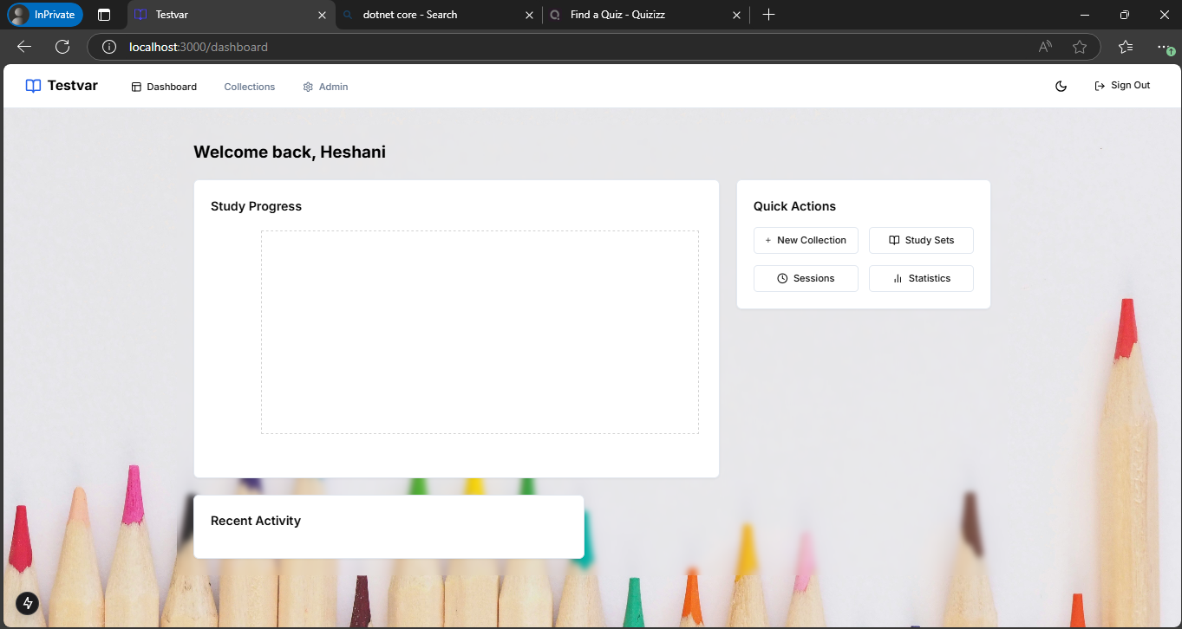
Figure 4 Testvar Flashcard Management System

Open the POSTMAN

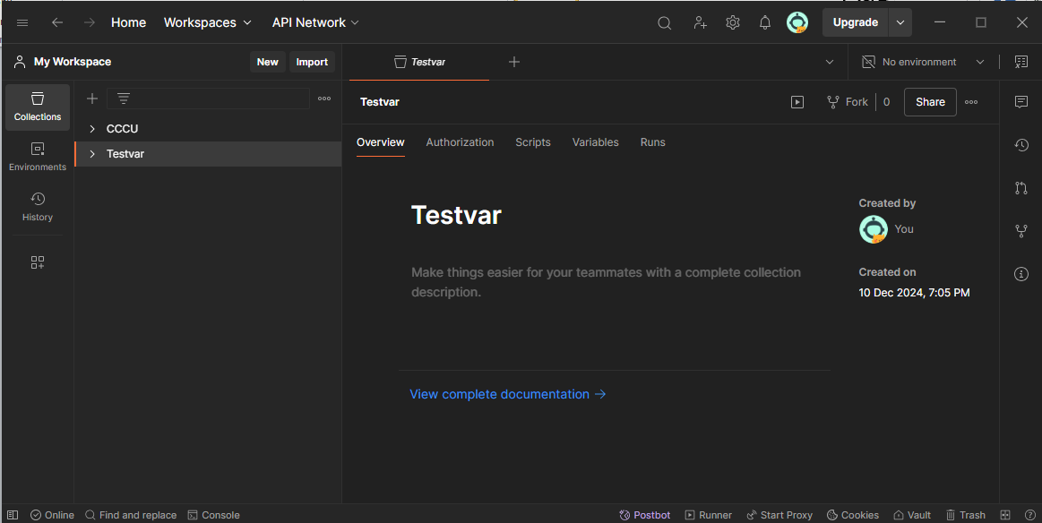

Figure 5 POSTMEN

2.3 Sever Testing on User Registration Functions
To do the user registration test, first I will add the New user to the system using postman.

User GET Method
New user added to system using below JSON query.
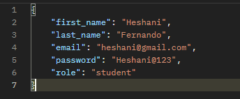

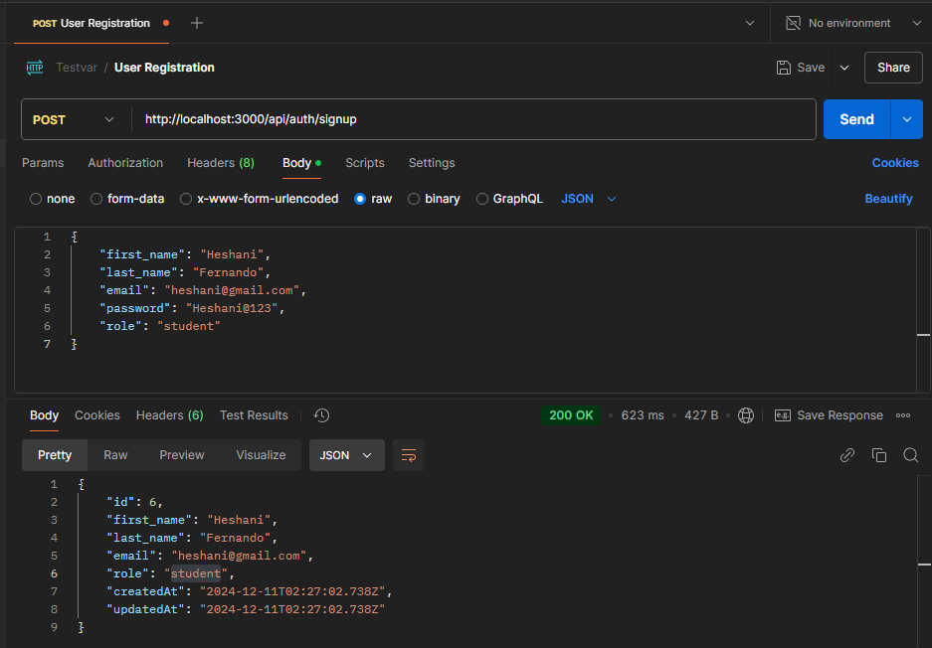
Figure 6 User GET result - Postman
Please note: In body section we can see user id. This will generate randomly by system. We need this id to make user testing. User ID is 6.
User successfully added to the database.
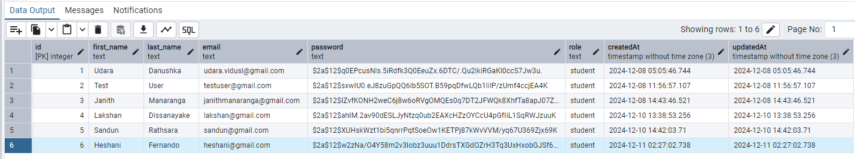

Figure 7 User GET result – database

Create a new card collection
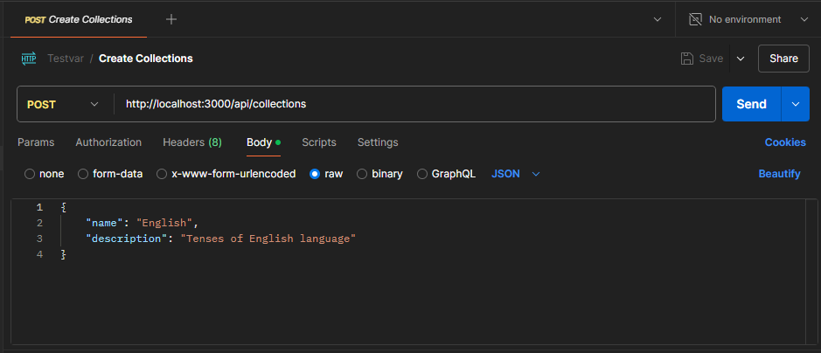

Figure 8 New card collections - Postman

Create a new card set
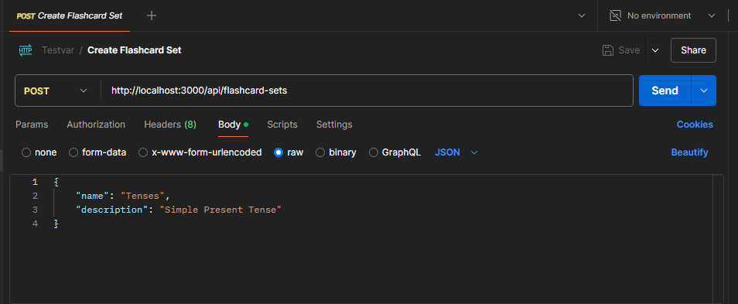

Figure 9 New card set - Postman

Create a new card
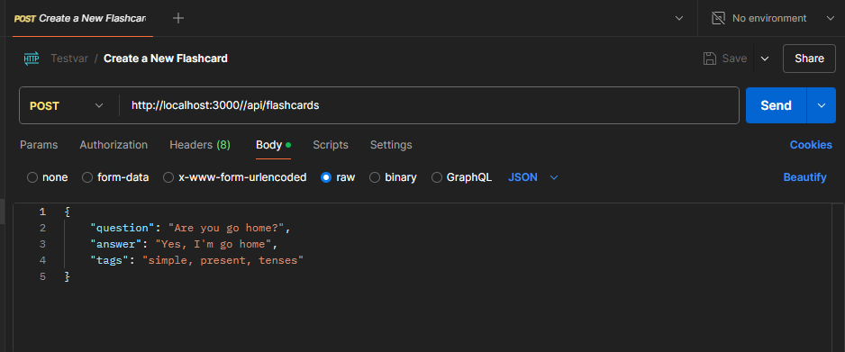

Figure 10 New cards - Postman

2.3 Code Functionality on Home Page.

The following code was written in Next framework so that it could be used as the application interface for a flashcard management module on Flashcard management software which would enable to users organize more effectively. The user can view, create flashcards. The parameters of this code are divided into a number of sections including the user interface, client-side communications and server-side calls since it works by sending requests to an API running on a web server and then updating the “front end” accordingly.

Dashboard code

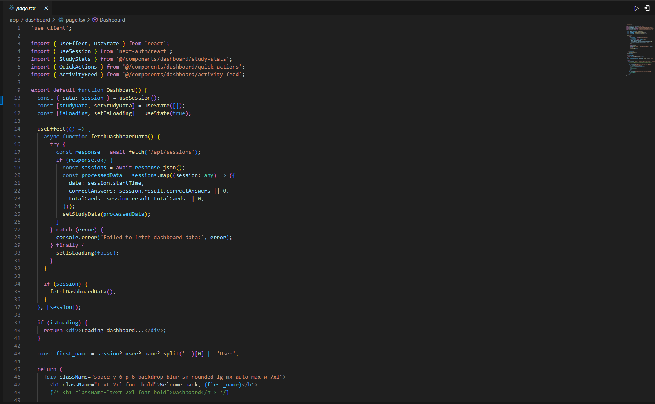
Figure 11 Dashboard code examples 1
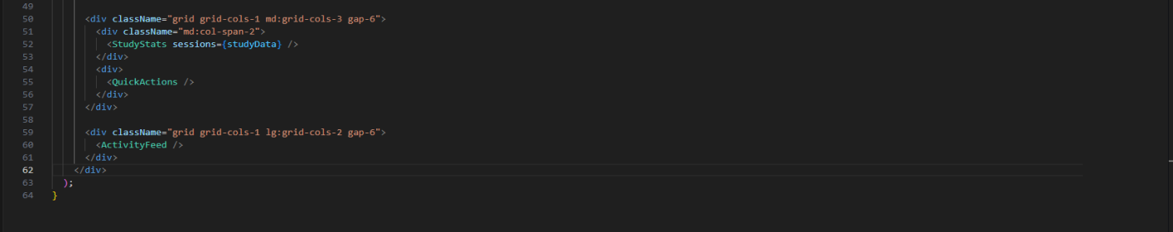

Figure 12 Dashboard code examples 2

2.4 Code Functionality on Collections Page.

Collections code

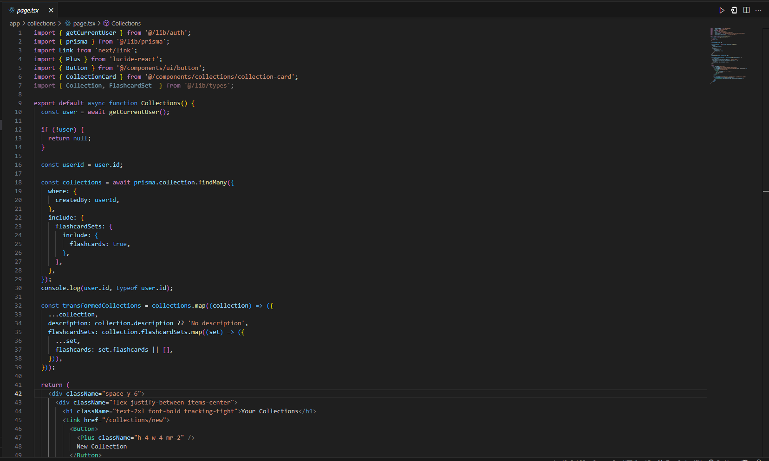
Figure 13 Collections page code example 1

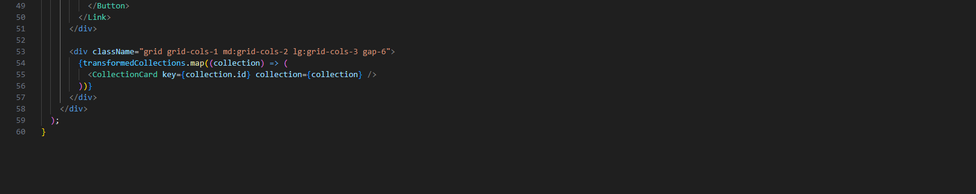
Figure 14 Collections page code example 2

2.5 Code Functionality on Flashcard set Page.

Flashcard set code

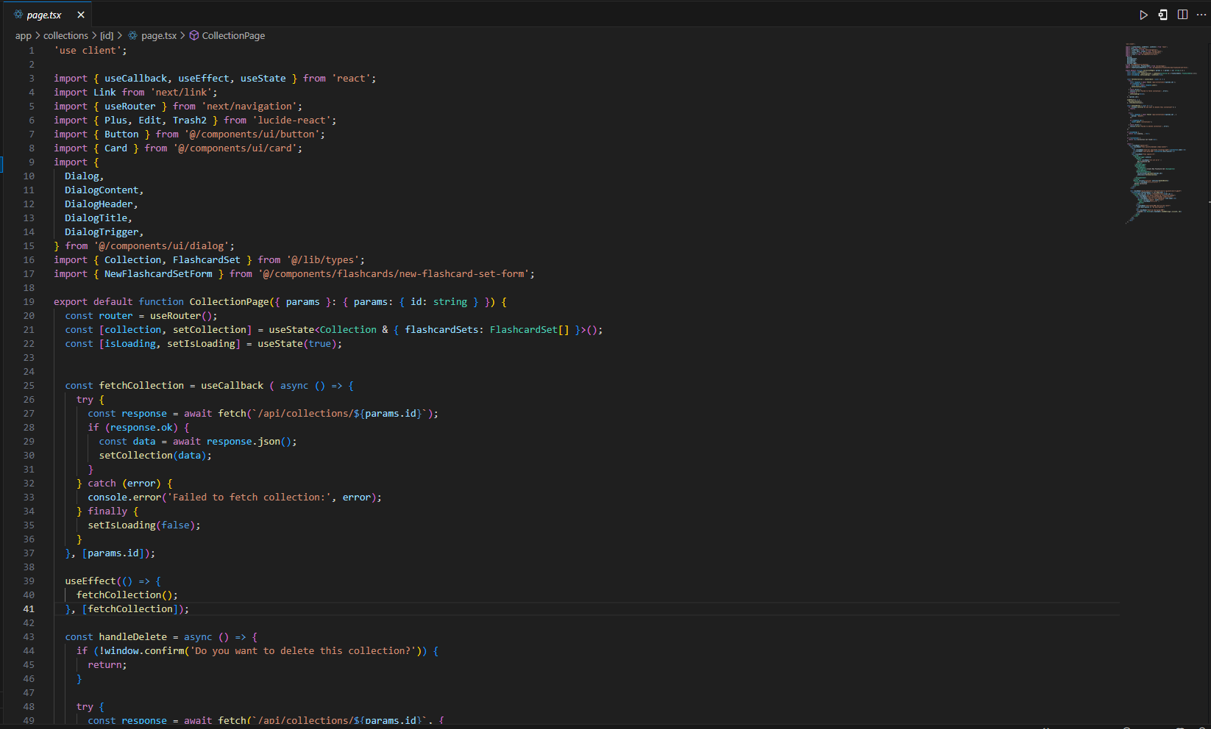

Figure 15 3 Flashcard set code example 1

2.6 Code Functionality on Study Page.

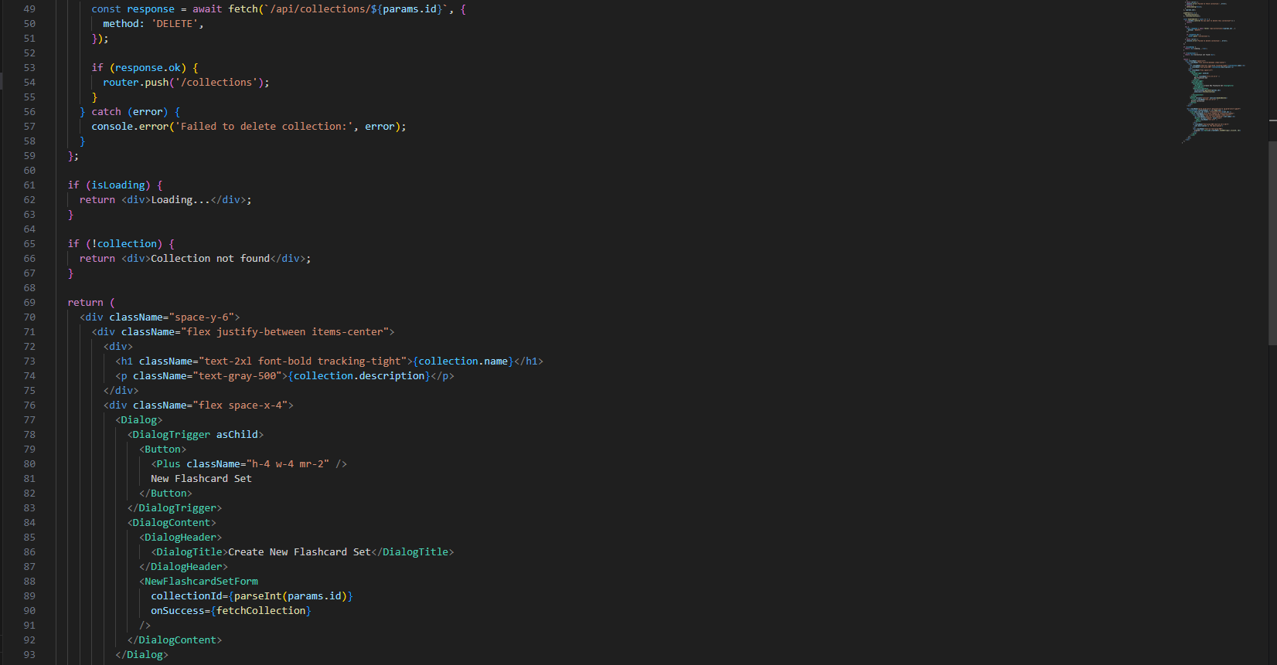
Figure 4 Flashcard set code example 2
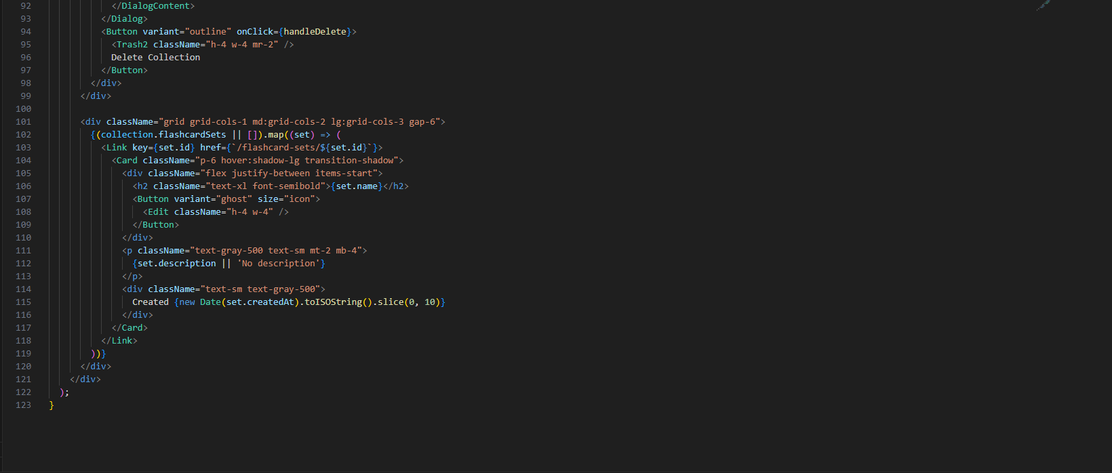
Figure 17 Flashcard set code example 3

Study page code

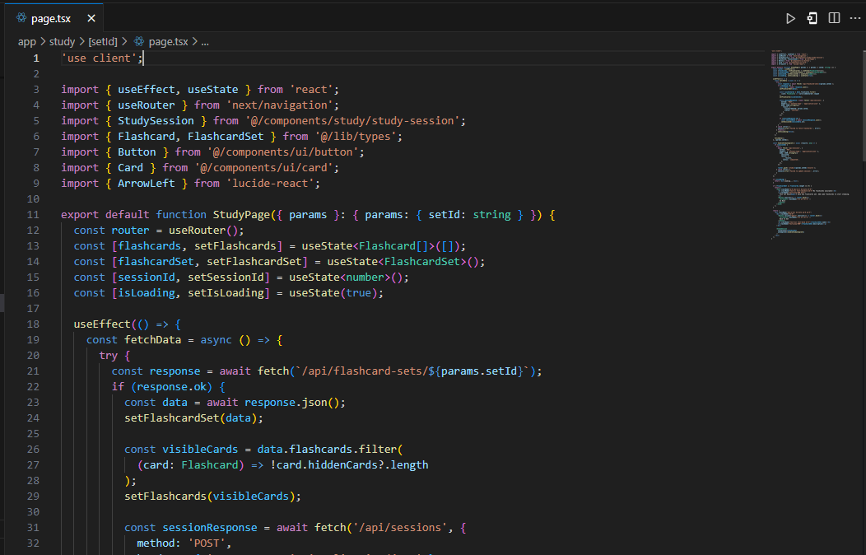

Figure 18 Study page code example 1
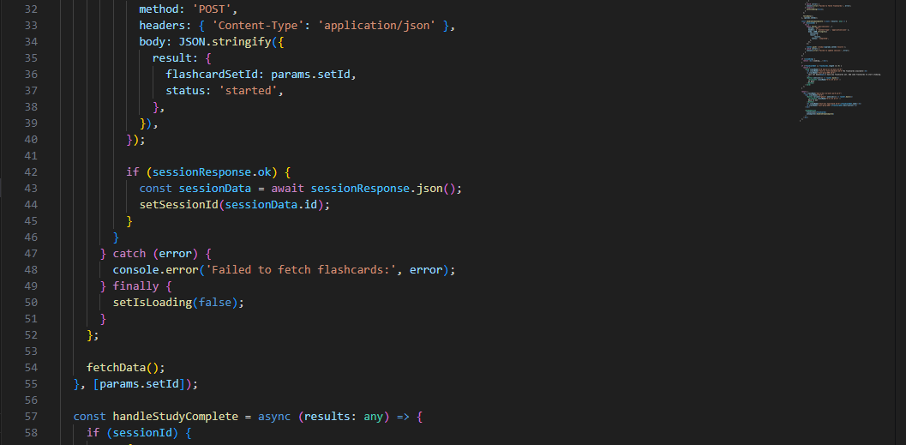

Figure 19 Study page code example 2
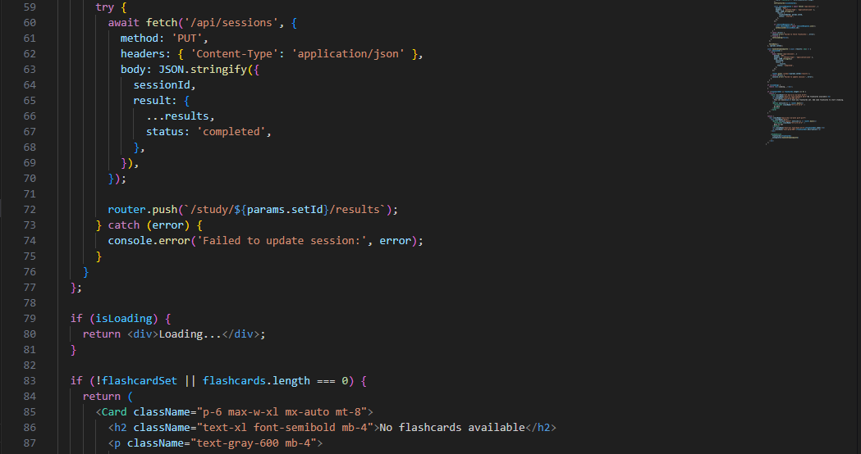

Figure 20 Study page code example 3

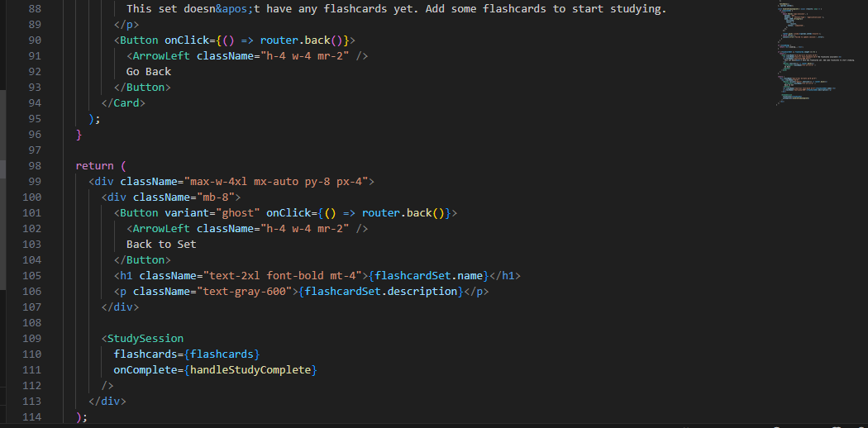

Figure 21 Study page code example 4

Section 03 - Client Documentation

Client Testing Documentation

Testvar Flashcard Sharing Platform

3.1 Selenium IDE

Selenium IDE overview
This is the procedure to examine a flashcard sharing system from the client side having its testing run under the Selenium IDE on the Chrome web browser. Tests have some basic functions like searching for a collection’s name or card’s name while others include inserting card data then changing already made collections, card sets, and card along with inserting them out traditionally made ones.
Every test is important for ensuring the application's resilience and its ease of use to guarantee smooth task performance for end-users. Thereby aiding in identification and elimination of defects before deploying so as to increase dependability and efficiency of the system in general.

Downloaded Selenium IDE on the Chrome web browser using: https://chromewebstore.google.com/detail/selenium-ide/mooikfkahbdckldjjndioackbalphokd?pli=1

Section 04 - Visual framework

Home Page


Figure 22 Home Page

Signup Page
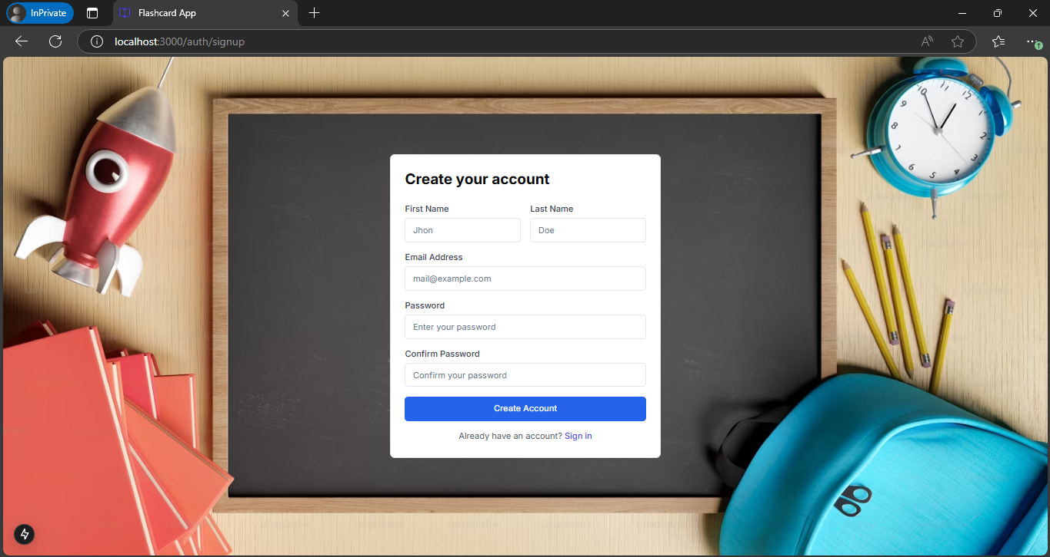

Figure 23 Signup Page

Login Page
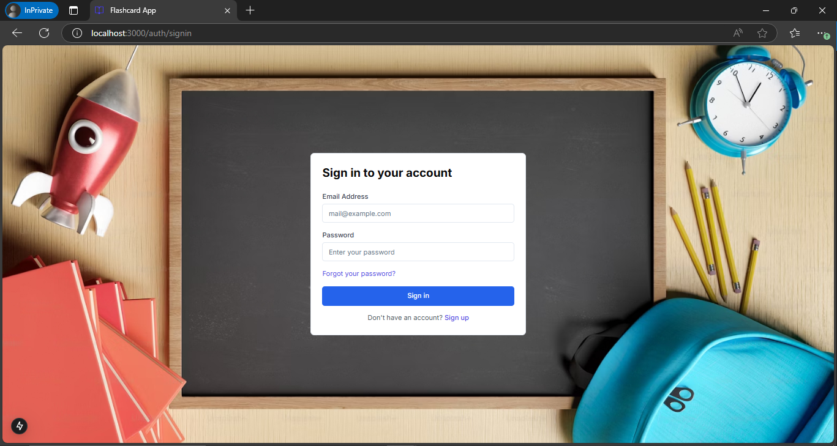

Figure 24 Login Page

Dashboard Page


Figure 25 Flashcard Dashboard Page

Collections page
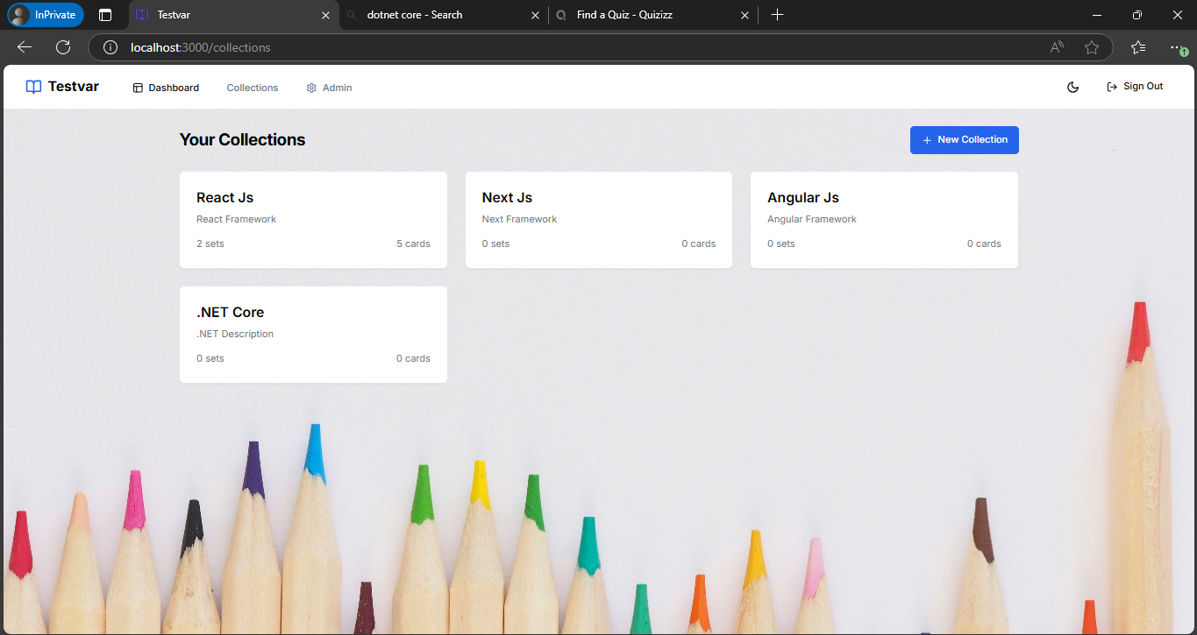

Figure 26 Collections page

Flashcard set page
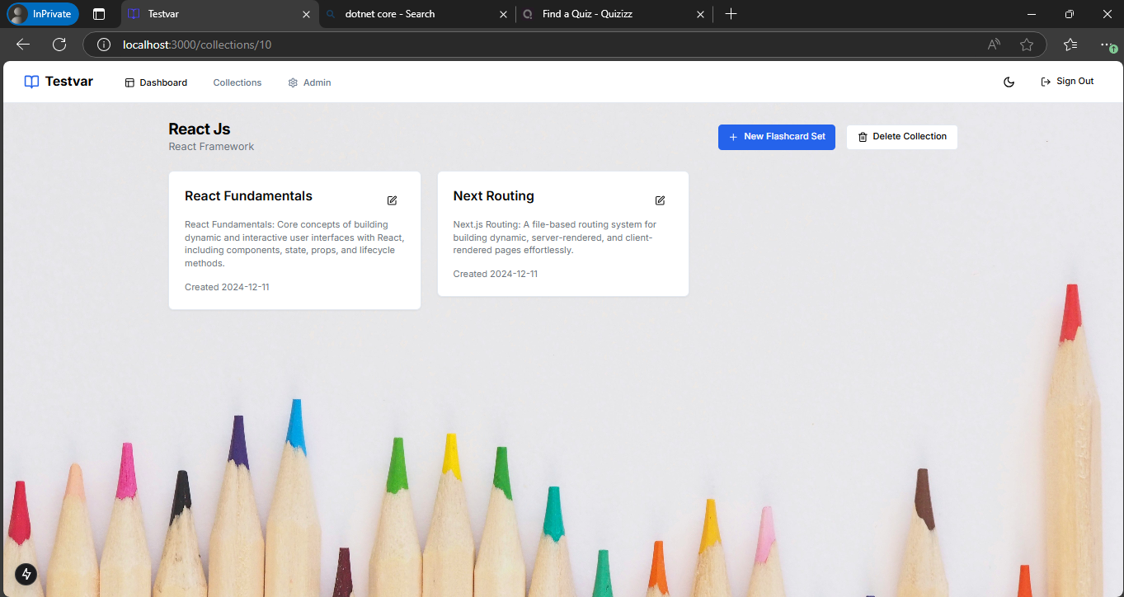

Figure 27 Flashcard set page

Flashcard page
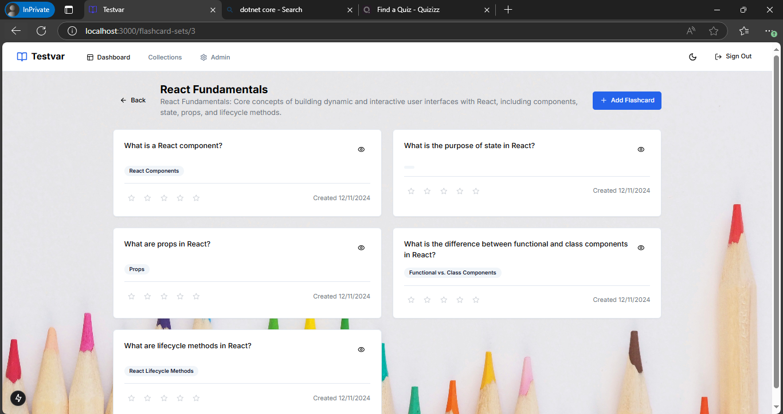

Figure 28 Flashcard page

Section 05 – Database, CSS, and Other Functionalities

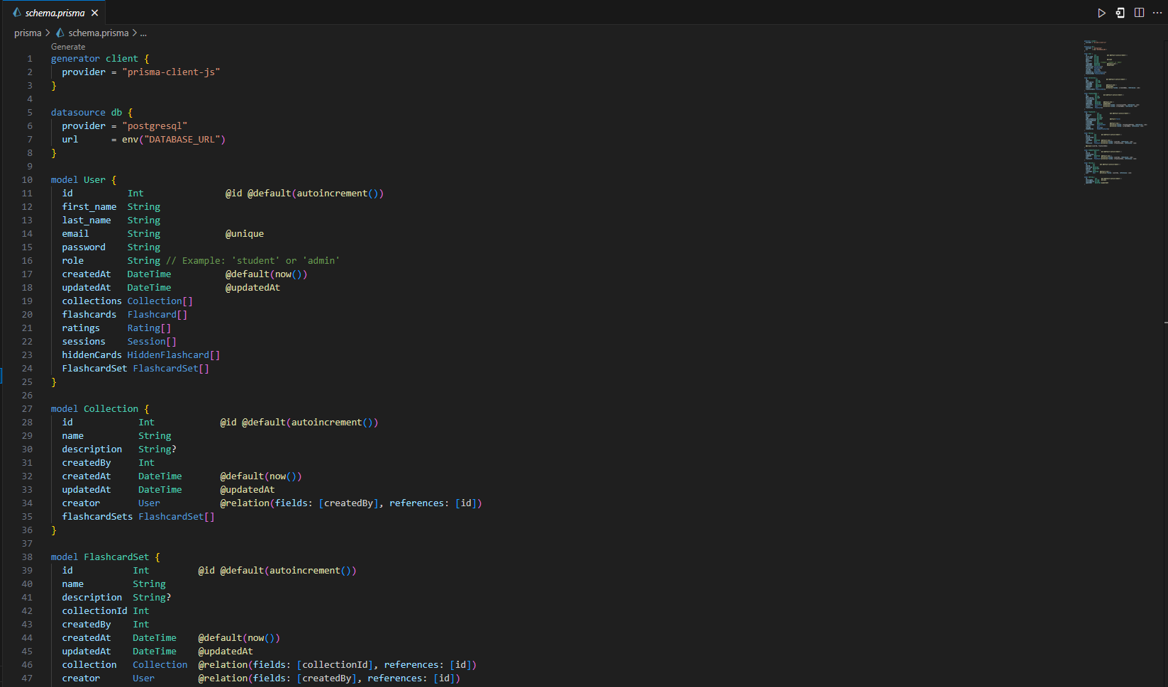
5.1 Prisma code

Figure 29 Prisma code 1

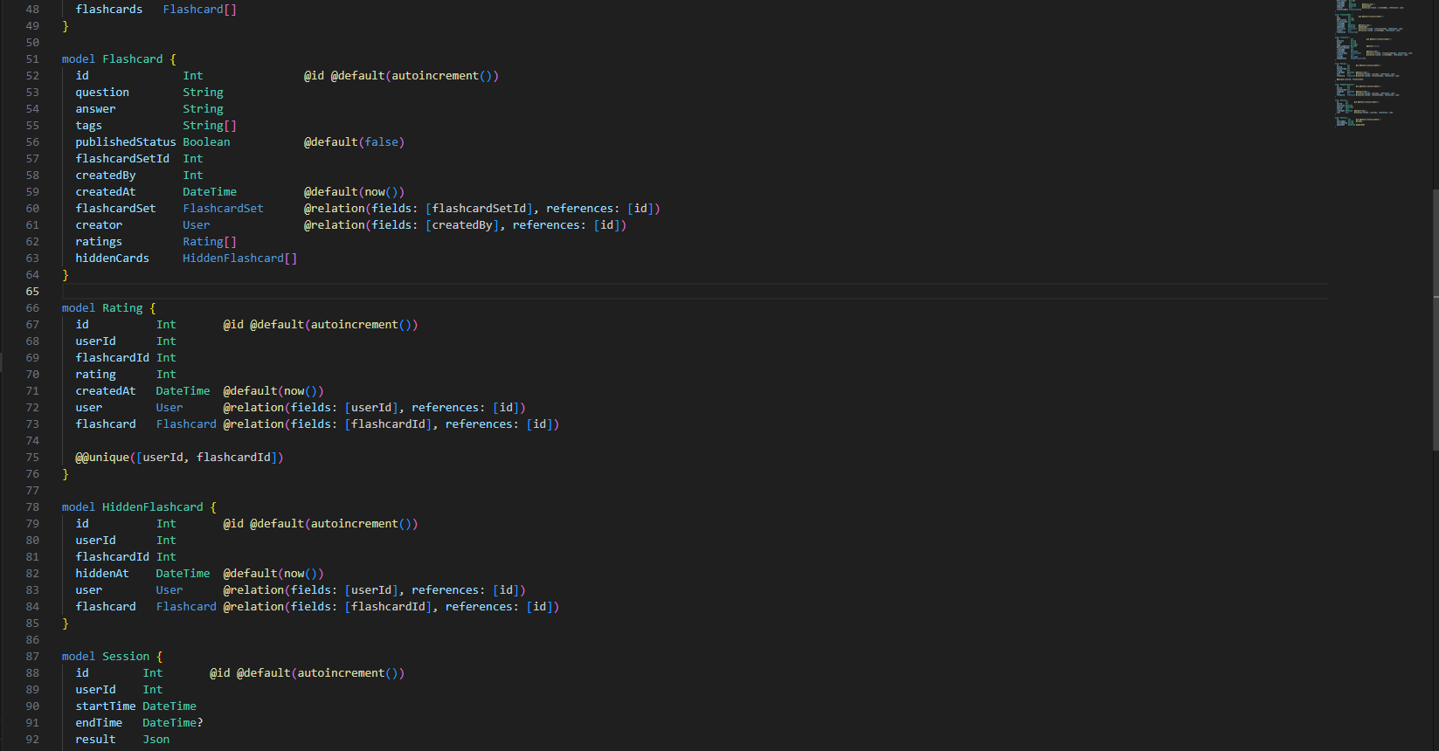

Figure 30 5Prisma codes 2
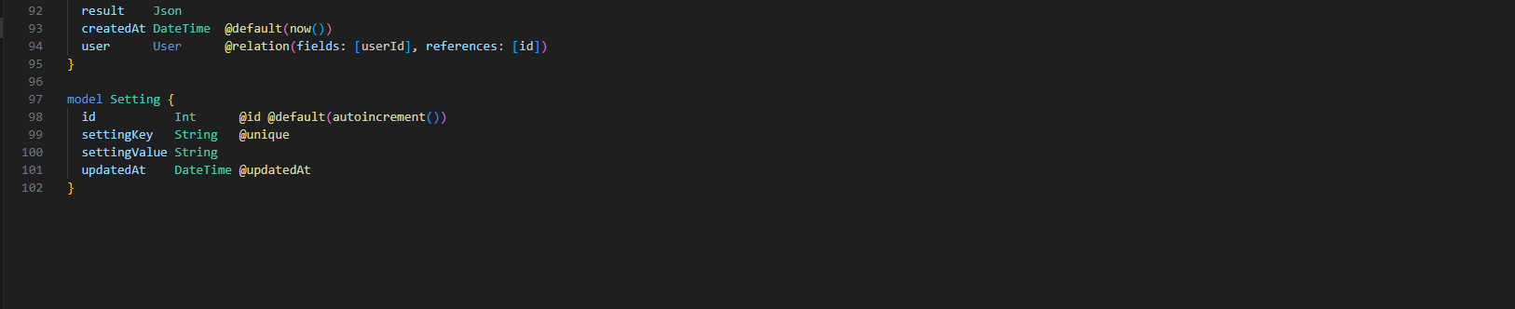
Figure 31 6Prisma codes 3

5.2 CSS Code

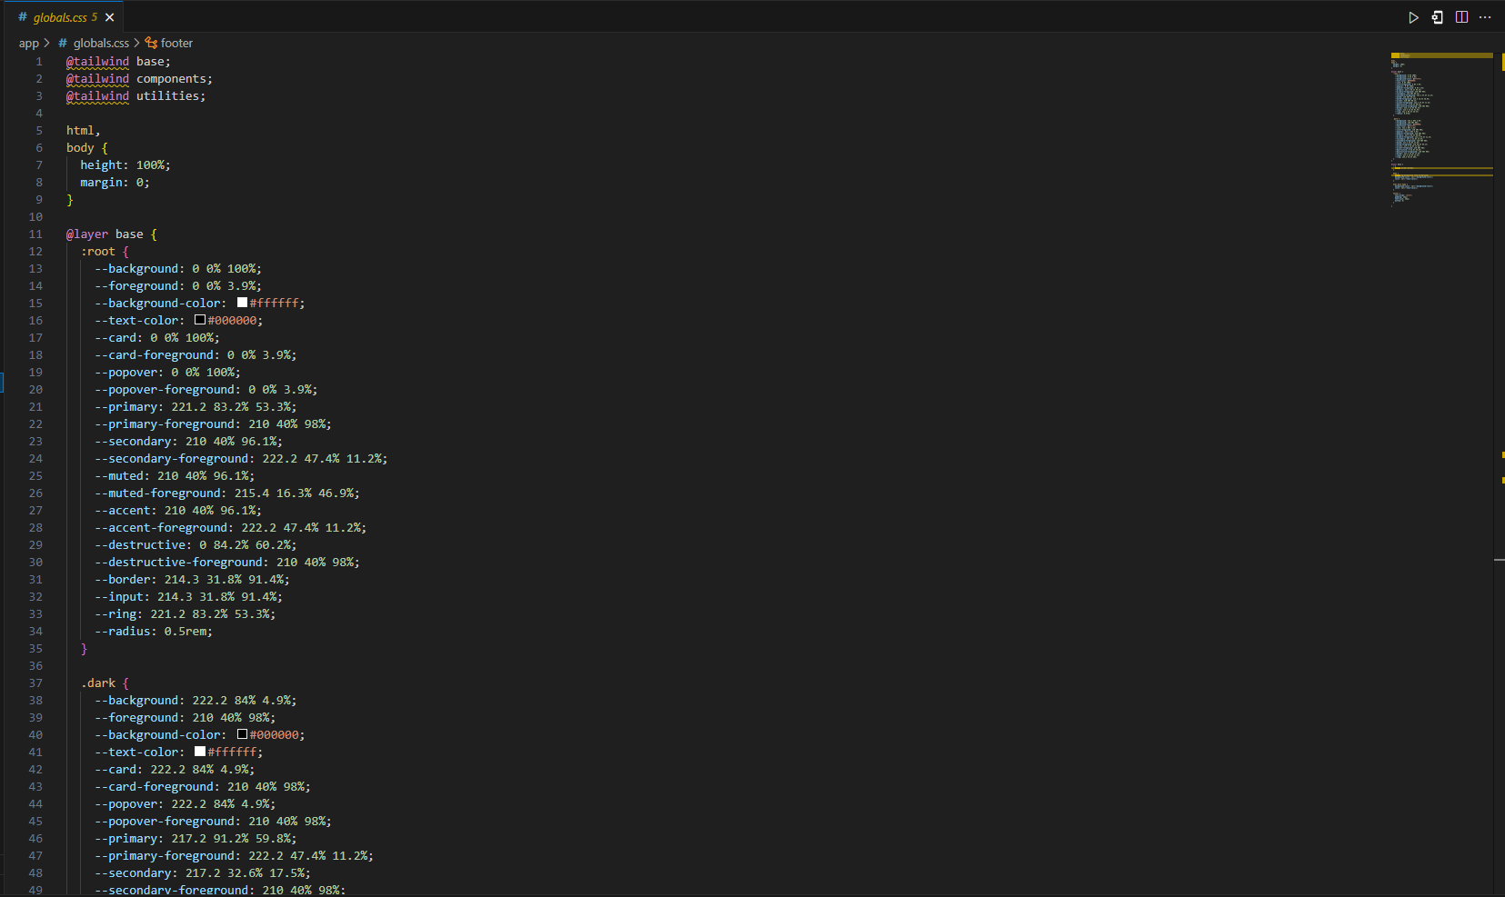
Figure 32 Global CSS Code Functionality Example 1

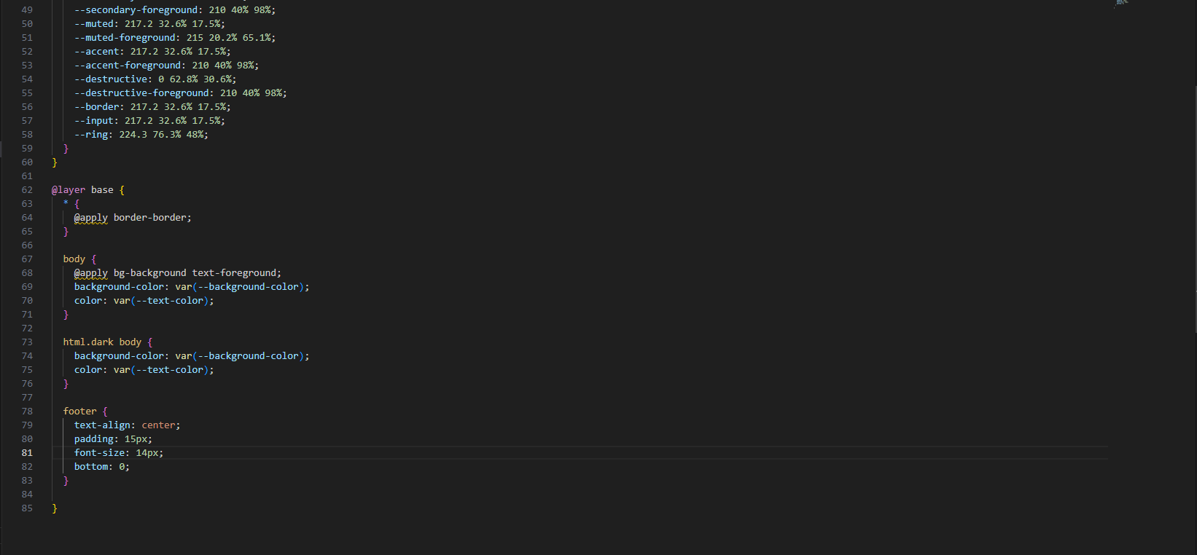
Figure 33 Global CSS Code Functionality Example 2

5.3 Responsive to mobile

Responsive to iPhone 14 Pro Max
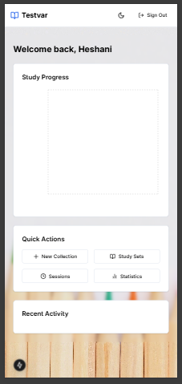


Figure 34 Responsive to iPhone 14 Pro Max

Code for the adjusting to any screen

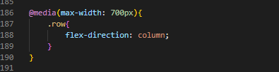
Figure 35 Code for the adjusting to any screen

