Programming
U14465

Table of Contents

Introduction 2
Critique of Chosen Approach 2
Framework Features 3
Server Framework 3
Server Tests 5
Client Framework 7
Client Tests 8
Visual Appearance 10
Form Inputs and Validation 10
Flashcard View 11
Responsiveness 11
Loading States 14
Summary 15
Hidden Cards 15
Ratings and Reviews 16
17
Admin Controlled Daily Limit 18
Clarity 20
References 21

Introduction

The Testvar Flashcard Sharing Platform is a Web based solution, implemented using modern technologies such as Next.js and Prisma. Its intended audience is for learning and is used to improve traditional learning methods with a collaborative and interactive approach. It is around user engagement platform for helping the creation, management, and sharing of flashcards effortlessly. (Anon., n.d.)
Supported features of Testvar include managing flashcard sets; implement API routes that store learning data, and a user role management. Next.js, integration, provides smooth user interface while doing server side renderings (SSR) and static site generation (SSG) can help performance and SEO. Moreover, Prisma straightens out database interactions in a simple and efficient data layer.
In this report the usage of frameworks and technologies, their use, and the target audience and purpose will be described. I will review the approach of system development, reveal parts of the framework, and case the graphical design and workings of the system.

Critique of Chosen Approach

The Single Page Application (SPA) approach was used for this Testvar Flashcard Sharing Platform respectively implemented with Next.js React framework. This choice was made because SPA offers a smooth and dynamic user experience, the kind needed on a platform for learning engagement. Because transitions between pages are instant with SPA, there’s minimal disruption during the user’s interactions and is an important feature for tasks like creating, viewing, or even studying flashcards.
SPA (server side rendering and static site generation using Next.js to render server side and SPA to be interactive and responsive) is also better than the Monolith path. In addition, use of Prisma ORM perfects SPA by allowing fast and safe database interactions. To achieve this, these features accelerate the initial load time and provide SEO capabilities on the platform, thus making them discoverable to more users. Additionally, file based routing that comes with Next.js and it’s out of the box API support makes it easy to integrate both the frontend and backend in a single project structure.
A Monolith path may centralize operations but can lack flexibility of user-centric interactivity that Testvar needs. As such, SPA was the perfect choice for more performance, modularity and scalability.

Framework Features

Next.js is used to develop the TestVar Flashcard Sharing Platform with a Single Page Application (SPA) architecture which is a mix of server side and client side rendering for high performance and pleasant user experiences. The evaluation of the framework features is based on server framework, server tests, client framework and client tests respectively. (Anon., n.d.)

Server Framework

The main server framework used is Next.js, which utilizes the features offered creatively to create optimal performance and scalability. Next.js simplifies API routes integration by using Next.js by using Next.js shown in the code snippet to user registration. For instance the [/api/auth/signup] route takes care of creating the user with well-behaved database operations using Prisma and secure password hashing using bcryptjs.
Next.js is a module based app, therefore, frontend and backend are cleanly separated. GET, POST, PUT and DELETE routes to manage flash card sets encapsulate core business logic, and utilize API routes to scale. The database querying is also integrated with Prisma through Prisma Client, which is both more robust and faster than a raw fetchQuery.

Key benefits include:
- Intuitive API structure through file based routing.
- Backend and front security where we can built in allowed or disallowed middleware, such as getCurrentUser (), to ensure authorization.
- Fully integrated with external libraries including Prisma for data persistence.
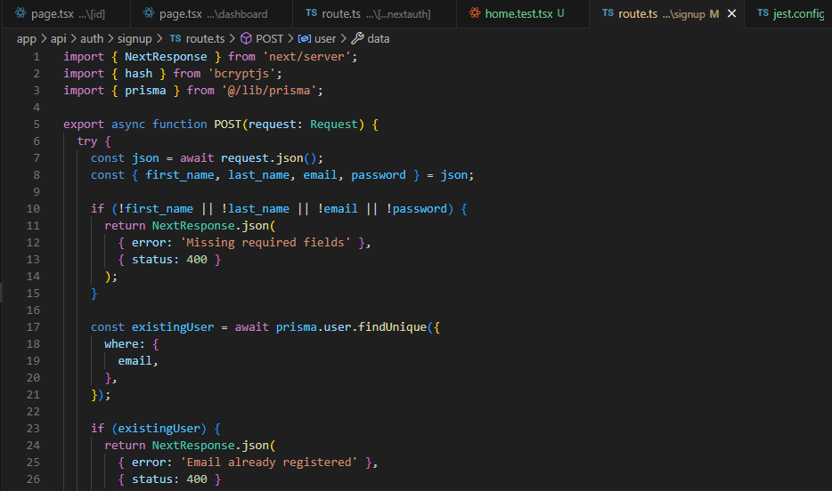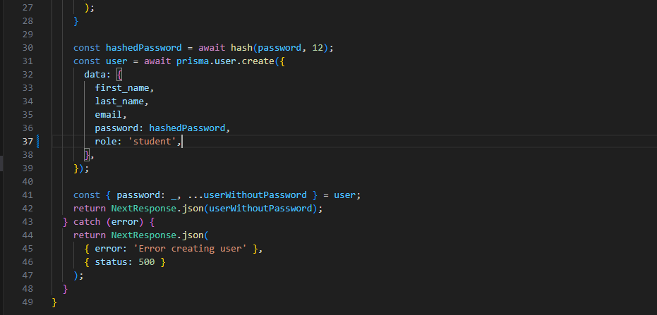
Figure 1: Code examples 1

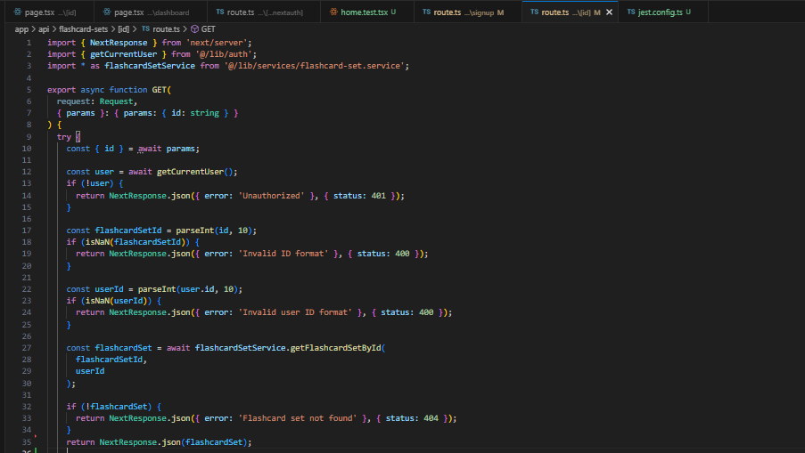
Figure 2: Code examples 2

Server Tests

The stabilizing of the server side code is tested very crucial. For that then a comprehensive approach is so needed. (Anon., n.d.) (Anon., n.d.)
- Unit Tests: Framework mocking of individual API route logic using Jest.
- Integration Tests: Checking the interaction between Next.js API routes and database, Prisma query and data validation working fine.
For example, a test for the POST [/api/auth/signup] route would validate:
- First_name, emails are required fields.
- Handling duplicates for email registration properly.
- Secure password hashing before the database insertion.
Moreover, the provision of an error handling strategy such as a 400 status to missing fields for a robust backend design is handled gracefully as the API does.
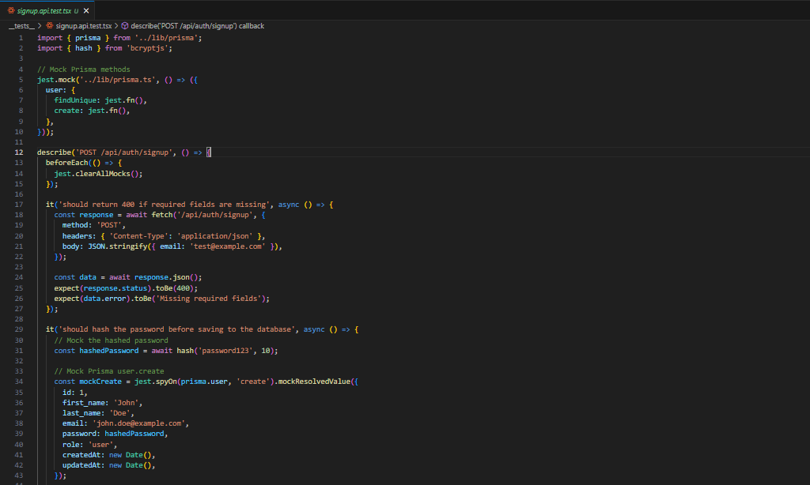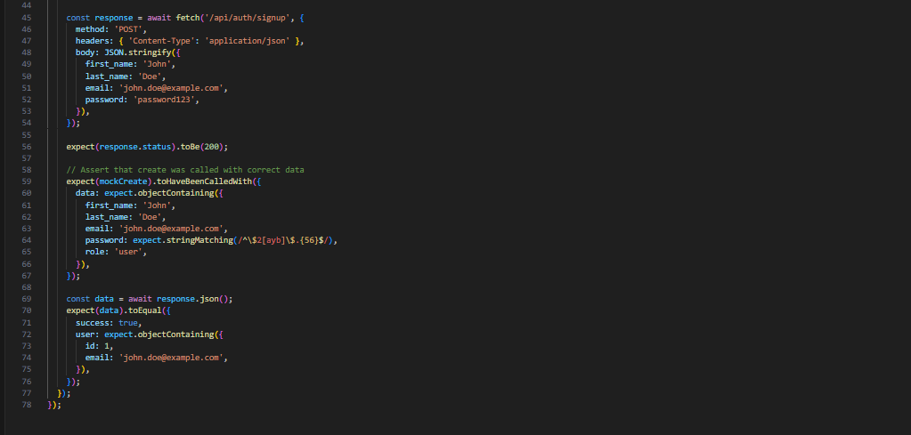
Figure 3: Code examples 3

Client Framework

Using its React integration, Next.js's client side framework uses Next.js to build dynamic responsive user interfaces. Components like SignupForm demonstrate modern React practices:
- State Management: From managing form data and error states, the useState hook is used efficiently.
- Form Validation: zod library checks client side input such as email / password from the inputs improving user experience.
- Navigation: A good example of this happens within the useRouter hook receiving seamless routing for seamlessly moving between pages such as via redirecting users to the sign in page after successful registration.
Next.js also enhances performance with following features:
- Static Site Generation (SSG): Better SEO through pre rendering pages at build time.
- Server-Side Rendering (SSR): Fetched flashcard sets on the server dynamically, rendering content so it's up to date (eg: fetching the flashcard sets dynamically).
Example: In the FlashcardSetDetail component, we show how Next.js uses useEffect to call APIs, and how data is being passed down through the paths once it gets to the component.
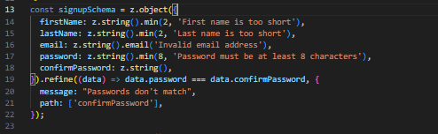
Figure 4: Code examples 4
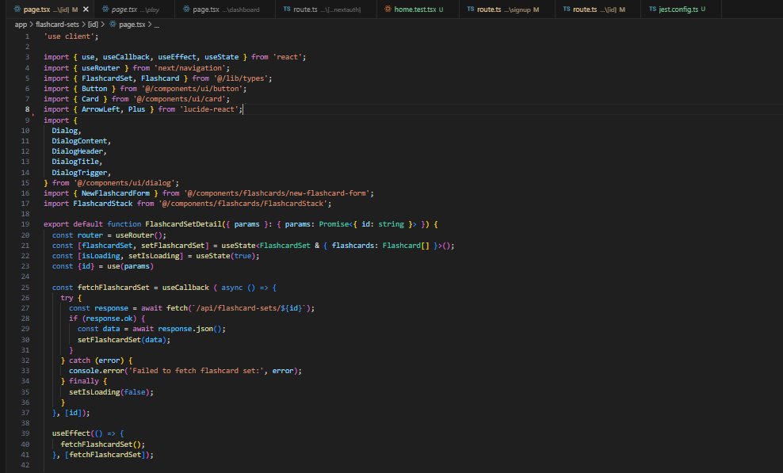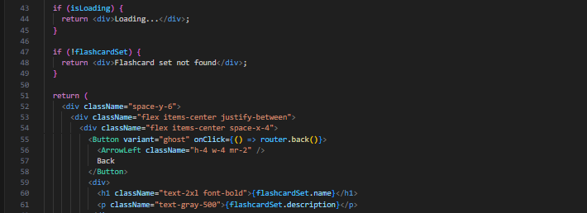
Figure 5: Code examples 5

Client Tests

This ensures is taken care of with client side testing; UI components and user interactions are checked. The best practices include:
- Unit Tests: React Testing Library with Jest refactored for individual React components (eg: SignupForm)
- Integration Tests: Selenium or simulating user workflows (example, user signs up, creates flashcards)
A test case for SignupForm might include:
- Making sure that form validation doesn’t allow the submission form with invalid inputs.
- To make sure error messages (e.g. Passwords don’t match) are displayed correctly.
- Simulating the correct registration, and ensuring the navigation for Sign-in page.
E2E tests also ensuring the platform works in its entirety to achieve features such as create and manage flashcards.
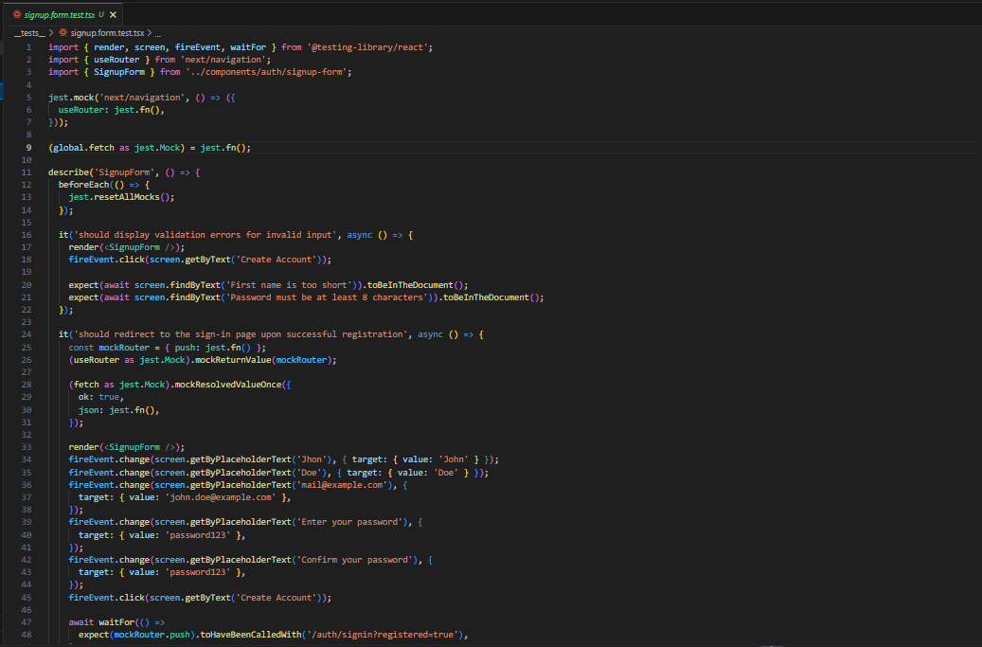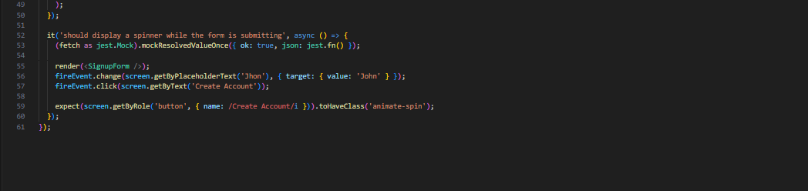
Figure 6: Code examples 6

Visual Appearance

TestVar Flashcard Sharing Platform for Next.js and Tailwind CSS is crafted with the visual design carefully thought out in order to fulfill functionality and aesthetics. Part of Next.js’ dynamic rendering means that the signup form and flashcard sets pages load quickly and respond to user interaction.
Form Inputs and Validation: The example SignupForm uses zod for client side validation to give users instant feedback on input errors (such as 'first name is too short'). Input fields are clean and intuitive, which makes them more usable thanks to Tailwind CSS styles.

Figure 7: Validation examples

Flashcard View: Next.js API routes are used to dynamically fetch and display data shown in the backend in the FlashcardSetDetail component. In a visually appealing card layout, the flashcards are displayed that is easy to navigate.
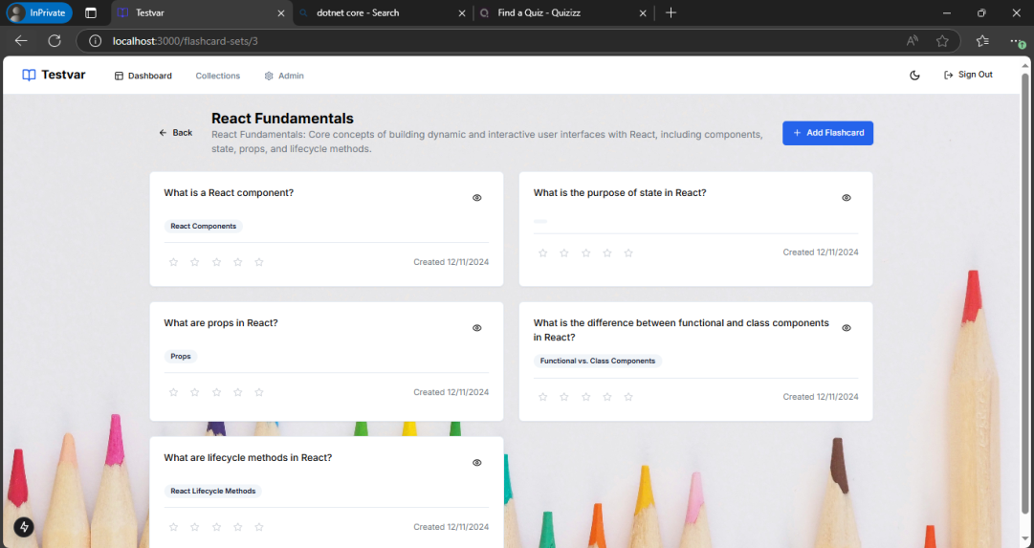
Figure 8: Flashcard view


Responsiveness: The grid system in Tailwind adjusts on various devices. For example, we have the lay out with a single column on mobile and a multi column on bigger screens when needed.

Figure 9: Web version user interface

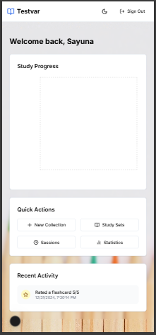

Figure 10: IPhone 14 Pro Max user interface

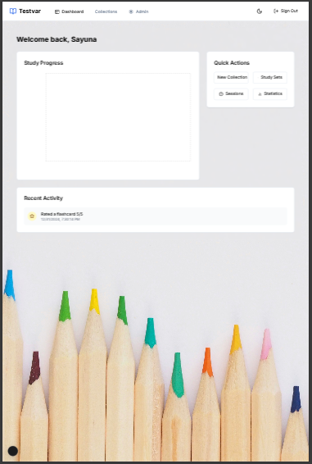

Figure 11: Surface Pro user interface

Figure 12: IPad Mini user interface

Loading States: One of those is a component like FlashcardSetDetail which utilizes loading state similar to useState and useEffect just to give some sort of feedback for loading data.
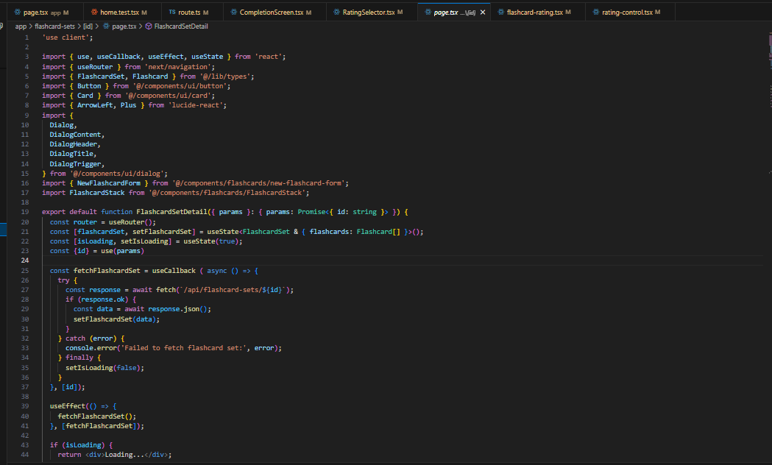
Figure 13: Coding examples 7

The integration of Next.js and Tailwind CSS enables a flowing, responsive and aesthetically wonderful experience for users.

Summary

On top of the provided OpenAPI specification, the TestVar Flashcard Sharing Platform built with Next.js includes modern features and improvements.

Hidden Cards

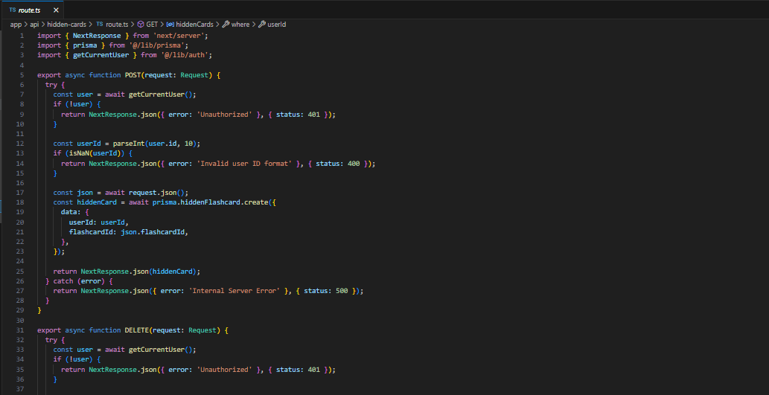
This feature is implemented via a dedicated API route (POST /api/hidden-cards) which allows the users to personalize his study experience by hiding specific flashcard. Let’s say, for example, a user hides a flashcard about "React Fundamentals" and in study sessions they can’t see it anymore. With Next.js′s API handling of updates, the database makes sure that hidden cards are user specific.

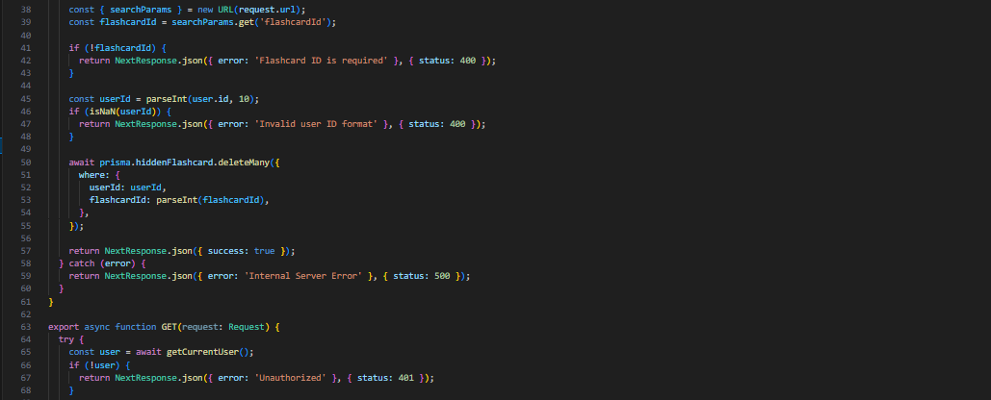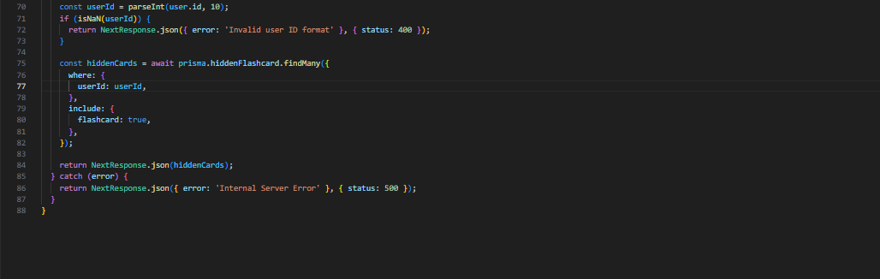
Figure 14: Coding examples 8

Ratings and Reviews


With that the 5 star rating systems comes out of the box with dynamic API routes (POST /api/ratings). For example, users can give set called “Biology” 4 stars. For instance, these ratings are aggregated and mapped dynamically on the client side with React hooks such as useEffect, and are shown in real time, with discoverability of popular sets being much better than before.
Figure 15: Rating and review interface

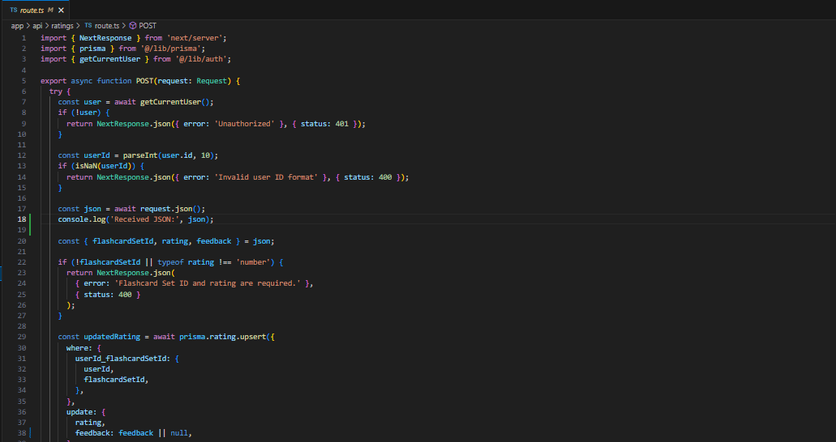

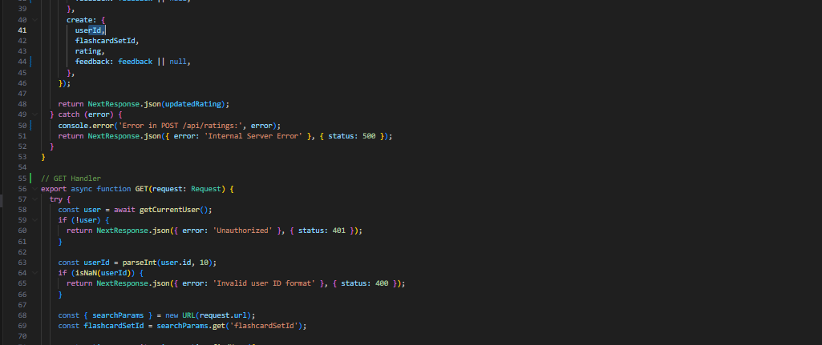

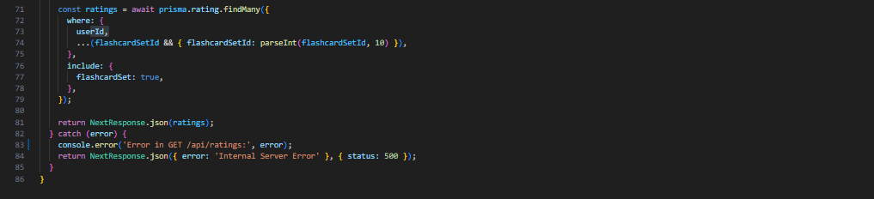
Figure 16: Coding examples 9

Admin Controlled Daily Limit

With Next.js as admin interface with flexibility to control the daily limit of flashcard sets. The admins can change the default limit (default slot size: 20 sets per day) through our PUT /api/settings route. Nextjs’ server side rendering (SSR) means this change is instantly propagated over the platform because it’s being sent across all users.
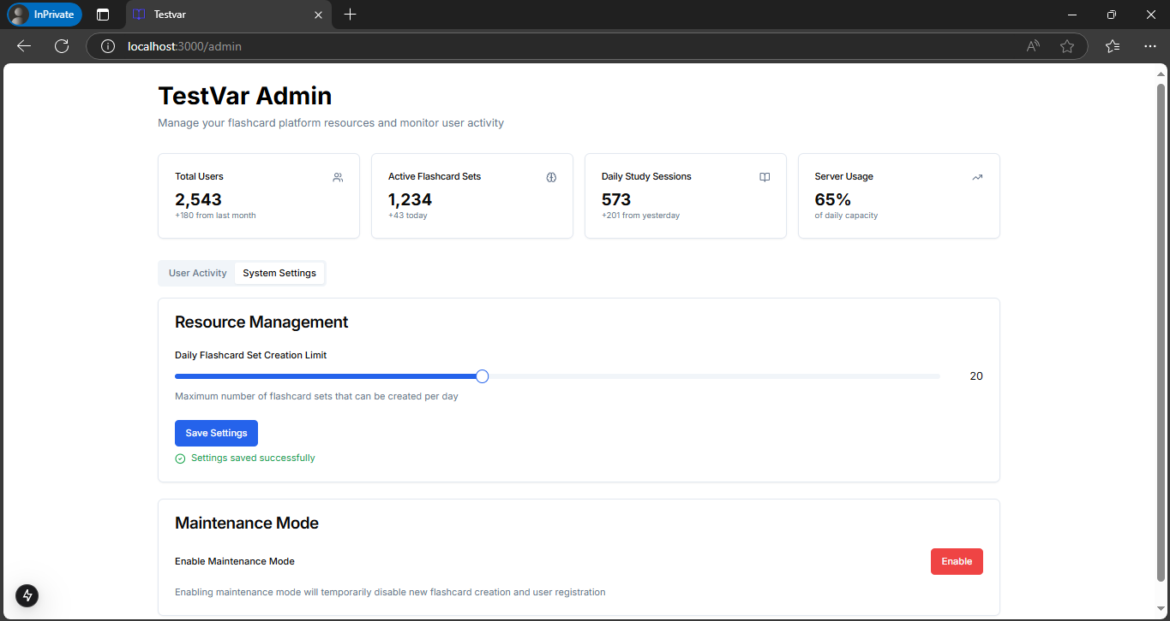
Figure 17: Admin page interface

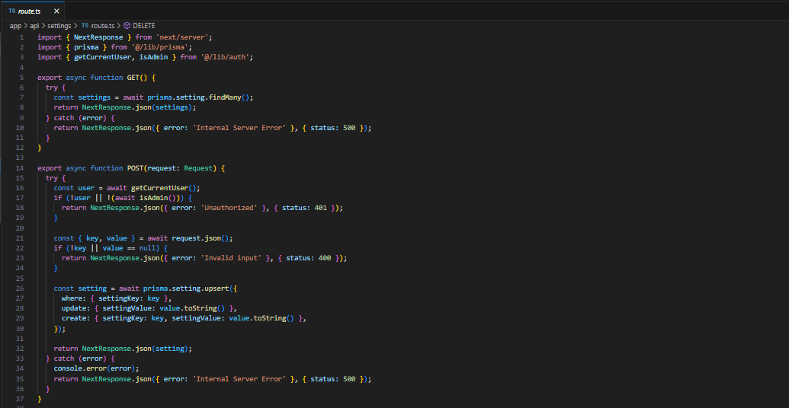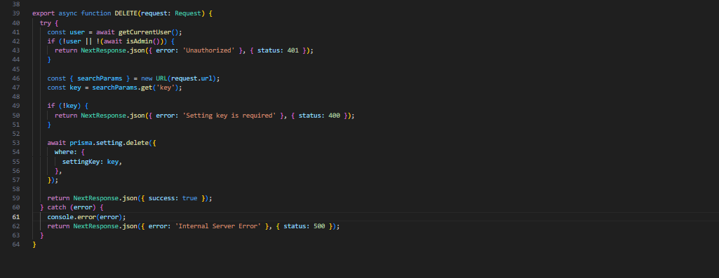
Figure 18: Coding examples 10
The platform takes advantage of Next.js full stack abilities, so that these features are easily integrated and the user experience is liked whilst at the same time guaranteeing scaled and performance.

Clarity

The TestVar Flashcard Sharing Platform maintains a well-structured project based on Next.js, which makes learning as seamless for its users as possible. Both the backend and the frontend implementations demonstrate how the logical flow of the platform comes out.
Next.js API Routes plays a huge part in serving up our core functionality: user authentication, flashcard management, and admin controlled settings. They are also designed modularity, keeping it clean and scalable. Take the POST /api/auth/signup and GET /api/flashcard-sets as an example, they run independently in the api routes and yet are completely integrated with the frontend.
On frontend we use clear navigation and responsive design to help users easily interact with the platform. Tailwind CSS allows you to have consistency on design whilst validation libraries like zod increases accuracy of input and providing user feedback.
Structured code, concise documentation and a professional interface, TestVar proves a commitment to clarity, usability, scalability and a good learning solution.

References
Anon., n.d. Jest. [Online]
Available at: https://archive.jestjs.io/docs/en/22.x/getting-started.html
Anon., n.d. Jest with Next.js. [Online]
Available at: https://nextjs.org/docs/app/building-your-application/testing/jest
Anon., n.d. Next.js. [Online]
Available at: https://nextjs.org/docs
Anon., n.d. Postman. [Online]
Available at: https://learning.postman.com/docs/introduction/overview/

