Cyber Security

U14438-C2
Table of Contents

First Part (Part A): Summary Report 2
Threat Analysis of NMRA 2
Legal and Ethical Consideration 2
Recommendations 3
Second Part (Part B): Detailed Report to the IT Team 3
Detailed Threat Analysis of NMRA 3
Security Policy Updates 4
Legal and Ethical Consideration 6
Technical Implementation 6
Real-world Scenarios 8
Conclusion 9
References 10

First Part (Part A): Summary Report

Threat Analysis of NMRA

Cybersecurity is a way of safeguarding against threat factors that originate from within a company and other from other sources using a number of technologies and good practices for protecting systems such as networks, computers and programs, and information. It should end up with keeping the confidential status of the data, accurate and within easy reach (Kelley, 2024).

Small and medium organizations are becoming exposed to Cybersecurity threats in even greater amounts compared to large scale organizations because of limited resources, skills, and ever-changing technology, particularly where there is no permanent solution to it. Current operational security frameworks can only provide short term protection. As a result, the repercussion and losses can be very serious. Effective digital service and citizen data security are both faced with similar vulnerabilities for both governments and. Therefore, a continuing risk has to be managed and prioritizing Cybersecurity is the way to achieve this objective (Goutam, 2015) (Alasmari, 2020).

Legal and Ethical Consideration

To ensure drug safety and maintain public health the National Medicines Regulatory Authority (NMRA) depends on sensitive assets such as clinical trial records, adverse reaction reports and regulatory documents as well. Breaches or mismanagement of this data could endanger the public safety and as such protecting it is critical to the credibility of NMRA. Data breaches, unauthorized access, malware, and ransomware represent real threats to NMRA services, and as such, rigorous data confidentiality, integrity, and availability measures are required to ensure that NMRA continues its role as a critical trusted regulatory authority.

Patients can be confident that NMRA is promoting data integrity through accurate, complete and secure patient data, regulatory documents, and product approvals. Unverified drugs not only increase the risk to public health but also this integrity is in danger of unauthorized access and unscrupulous tampering. The NMRA must prevent such risks through secure database management, regular account of integrity of data and encryption (mitigation, 2024) (science, 2012).

NMRA practice of preventing access to its sensitive information such as its patient health records, drug data or proprietary values as data of the internal NMRA communications also remain confidential. From phishing, to malware, to insider breaches, they can have severe consequences: legal, trust lost. Implemented solid access controls, data encryption, and comprehensive audits, should be imposed in such way that only persons who authorized to access can enter to the confidential data (AKM IQTIDAR NEWAZ) (Harsh Kupwade Patil, 2014).

NMRA service availability makes sure that critical systems and regulatory services can be available to such stakeholders as the pharmaceutical companies and the healthcare providers. DoS/DDoS attacks, Ransomware or system failures and thus delay their critical processes which are drug approvals, public health surveillance, etc. For instance, if having a prolonged service disruption, can't access regulatory services, which might affect public safety. Therefore, NMRA has to design robust disaster recovery plans, redundancy systems and secure backup solutions, to continue to provide service upon disaster (Chris Johnson) (Group, 2024).

Or else, it makes hard for NMRA to perform regulatory duties. Confidentiality, Integrity and Availability of these assets is crucial to protecting public health and continuing to act as a trusted regulatory authority.

Recommendations

As Director of Information Technology at NMRA, it is essential to inform management about the legal and ethical requirements surrounding security updates. Compliance with the Sri Lanka Data Protection Act (Sri Lanka CERT) (Commission, 2024) (Technology, 2024) is vital to safeguarding personal, health, and proprietary data (CIS Critical Security Controls). Ethically, NMRA is obligated to protect patient information and ensure transparency with stakeholders (Barker, 2016). To enhance data security, I recommend implementing automatic, encrypted backups with redundancy and a robust disaster recovery plan. Access control should be role-based and utilize multi-factor authentication (Paul A. Grassi) (Mark Wilson), while sensitive data must be encrypted both at rest and in transit. Regular security audits and vulnerability assessments (sans.org, 2024), combined with AI-driven incident detection, will improve early threat response (IBM, 2024). Additionally, secure database management with logging, digital signatures, and blockchain will help maintain data integrity. Reinforcing defenses through vendor compliance and employee training is also essential.

Finally, we argue that protecting NMRA's key assets, health data’s and regulatory documents are essential to maintain public trust and good decision making. However, confidentiality, integrity, and availability are all things to focus on for protecting against threats such as data breaches, malware, and DoS attacks. NMRA will take strong security measures that allow it to perform these critical regulatory functions in a secure and efficient manner.

Second Part (Part B): Detailed Report to the IT Team

Detailed Threat Analysis of NMRA

Cybersecurity is protecting your organization from these malicious attacks when it comes to phishing, malware and ransomware. Recent ransomware attack on Sri Lanka’s Lanka Government Cloud (LGC) makes vital lessons for National Medicines Regulatory Authority (NMRA). Between May and August 2023, it affected around 5,000 accounts victimized in this attack and locked the data in those accounts with ransomware. This, much like in this case, can be launched through phishing emails and malicious links. Finally, system vulnerabilities can be exploited by hackers by manipulation of the code and also with social techniques capable to trick the user.

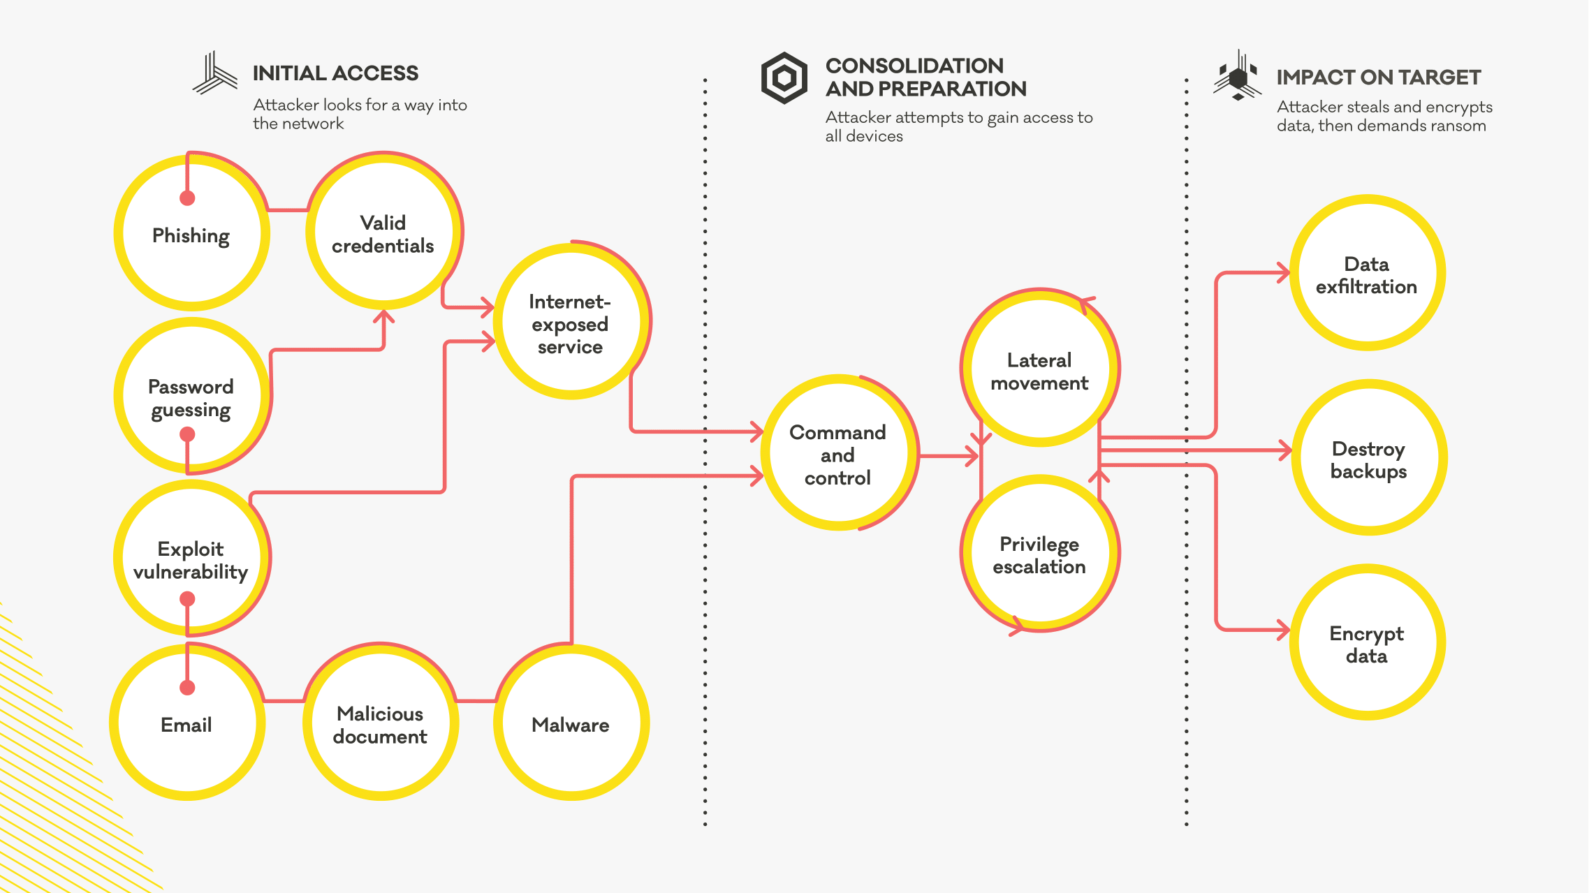
Figure 1: Flow diagram of ransomwares

An attack to NMRA’s regulatory functions could lead to severe repercussion, similar to confidential data leakage, data loss and systems corruption. These hinders such operations as medical approvals, disease monitoring and public health surveillance in such cases. LGC‐like attacks create delays in regulatory decision making, unsafe drugs approval, and jeopardize public health surveillance.

From a business perspective they destroy NMRA’s assets, interrupt operations and spoil its reputation, on the one hand. These also affect information access as well as business processes. The moral of the story here is that all systems need to be up to date, employees are trained to identify phishing, and have dependable backup systems. This need to specifically add Cybersecurity measures as a part of periodic updates, employee training on understanding phishing across digital channels, to robust backup procedures, is highlighted by the attack on LGC to the NMRA.

Security Policy Updates

NMRA has to protect the confidentiality of personal, health and proprietary data for this purpose it has to comply with the Sri Lanka Data Protection Act. Additionally, an ethical obligation is imposed upon NMRA to safeguard patient information that may be sensitive to approaches which are robust on cybersecurity. I my capacity as Director of Information Technology, I recommend critical updates to push NMRA’s cybersecurity policies to stronger standards.

For the prevention of possible breaches, NMRA should utilize preventive securities, including, but not limited to improved email filtering and URL scanning, to prevent phishing attacks. Training staff how to identify phishing attempts and staff up grading software to patch vulnerabilities should be mandatory. By adopting these standards such as ISO 27001 and NIST SP 800 53 they afford you with a structured framework for security management verified by all users and devices to minimize risk (IT Governance, 2024) (ISMS, 2024).

Access control requires enforcing Multi Factor Authentication (MFA) for the minimum amount of role data on users and providing access only to those who need it to function. By continuously verifying access of all requests, this alleviates the risk for unauthorized access, matches with the Zero Trust model, and meets ISO 27001 and NIST SP 800-63 standards.

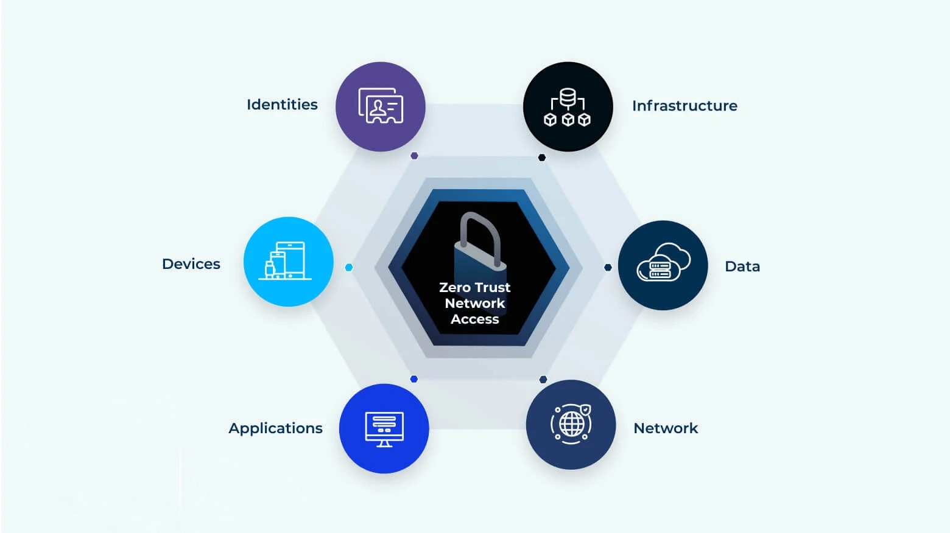
Figure 2: Zero Trust Architecture

Detecting and responding to current and future security threats is critical and requires real time, AI driven threat detection. NMRA powered by AI based anomaly detection can detect suspicious activity in real time and enables proactive Risk Management before things can escalate. Supported by ISO 27001 A.12.4.1 for regular review and logging, and NIST SP 800-94 guidelines for real time analytics in intrusion detection, this method minimizes data loss and operational disruptions.

As well, regular audits and vulnerability assessments are necessary to identify and either mitigate, prevent, or mitigate threats. NMRA should perform scheduled penetration tests and vulnerability scan to find out weaknesses and derive preventive actions. Proactive approach is a best practice in ISO 27001 A.18.2 and NIST SP 800-115, which set the occasion for continuous improvement through security reviews.

Reliable and guaranteed NMRA data is the result of effective data management practices. Activity logging, digital signatures, blockchain and secure database management create a tamper proof record of transactions that ensure regulatory data remains accurate. Logging practices according to ISO 27001 A.12.4.3 sustain data integrity, whereas blockchain is a powerful response to ensure the trustworthiness of data in the high regulation environments.

Daily secure, offline NMRA backups stored in separate locations enable rapid data restoration if needed and hit by a cyber-attack. This tracks NIST SP 800-34 of best practices in disaster recovery and the ISO 22301 standards for operational continuity. In the event of an attack NMRA also utilizes an Incident Response Plan (IRP) per NIST 800-61, to quickly contain, eradicate, and recover.

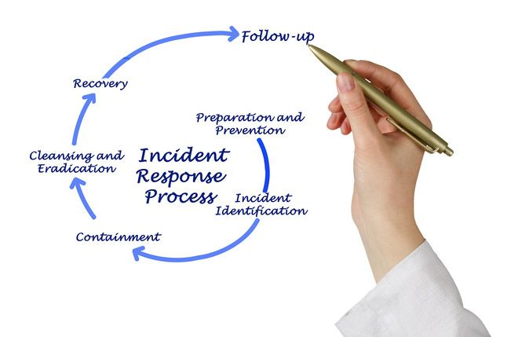
Figure 3: Incident Response Process

In addition, NMRA’s Cyber Security framework includes employee training and vendor compliance. Employee staff should also have regular cybersecurity training so they can identify phishing attempts, while third party vendors also must adhere to or meet NMRA’s security standards ISO 27001 A.7.2 and the NIST’s Cybersecurity framework.

This multi-layer comprehensive approach to strengthening NMRA’s cyber security framework does so without breaching any legal or ethical bars. With the use of recognized standards like ISO 27001 and well-set boundaries of access, incentive to keep regular training, and a robust incident response plan, NMRA issues for protection of data and maintains privacy, thereby creating public confidence and keeping to regulatory Rules.

Legal and Ethical Consideration

In cybersecurity, The National Medicines Regulatory Authority (NMRA) also has critical legal and ethical obligations, concerning data privacy, compliance and transparency for the nation. NMRA respects the Sri Lanka Data Protection Act and GDPR to protect private and health information, and cybersecurity practices will not infringe on privacy rights. A regular audit of the system updates and the vulnerability assessment will ensure compliance with the Sri Lanka Cybersecurity Bill and the GDPR, which enforce regularity and strap in place a strong cybersecurity posture especially where there are cross - border data transfers.

Furthermore, regarding employee monitoring, NMRA pledges an ethical approach to monitoring, which is respectful of individual privacy, and building the trust of the organization. Furthermore, public transparency is a requirement; NMRA must create a transparent, timely mechanism for notifying stakeholders when there is data breach, including information on such a breach and on the measures taken to prevent it.

To prevent phishing attacks in the cyber environment and to protect employee privacy and data, NMRA uses multi layered cybersecurity strategy comprising automated email filtering, URL scanning, Role Based Access Control (RBAC) and Multi Factor Authentication (MFA). However, data security is complemented by the same with AI-driven threat detection and adherence to ISO 27001 standards along. Secure database logging, blockchain, and encryption backed off line ensures data integrity. NMRA's vendor compliance and ongoing staff training is also the bedrock of our cybersecurity framework, with robust defenses which are consistent with current law and ethics and which build public trust.

Technical Implementation

To improve security and fortify against vulnerabilities NMRA’s IT must employ sophisticated productivity enhancing techniques and tools for detecting threats.

Step 1: Acquiring an AI based threat detection software, like IBM QRadar or Microsoft Azure Sentinel, which keep a runtime check on network traffic relying on machine learning for detection of anomalies. This research showcases that these AI powered tools enable 40% improvement in detection accuracy, and response time compared to manual processes.

Step 2: suggests employing widely used Intrusion Detection and Prevention Systems (IDPS, such as Snort or Palo Alto Networks), used by the financial industry. they keep a watch on the movements over the network and notice and remove any unauthorized access attempts for real time protection to NMRA.

Step 3: Discusses email security and phishing detection. Companies can use tools such as Proofpoint and Mimecast to scan emails for suspicious links or attachments and from unknown senders (phishing mails) tools which can reduce malware infection risks by up to 60 percent, especially in sectors such as healthcare. By taking this approach, NMRA enhances its capability to identify, forestall, and react to cybersecurity perils.

Step 4: Multi Factor Authentication (MFA) must be implemented to improve NMRA’s cybersecurity. Per NIST recommendations, tools such as Okta and Duo Security add a verification check for system access, which reduces unauthorized access by over 90%.

Step 5: For access based on role job, Role Based Access Control (RBAC) is also important. NMRA can enforce RBAC using tools like Microsoft Active Directory or Oracle Identity Manager, only changing a user access when they require and doing so through regular access reviews to ensure compliance with role changes. RBAC proved effective in accessing secure access through Google’s BeyondCorp Zero Trust framework.

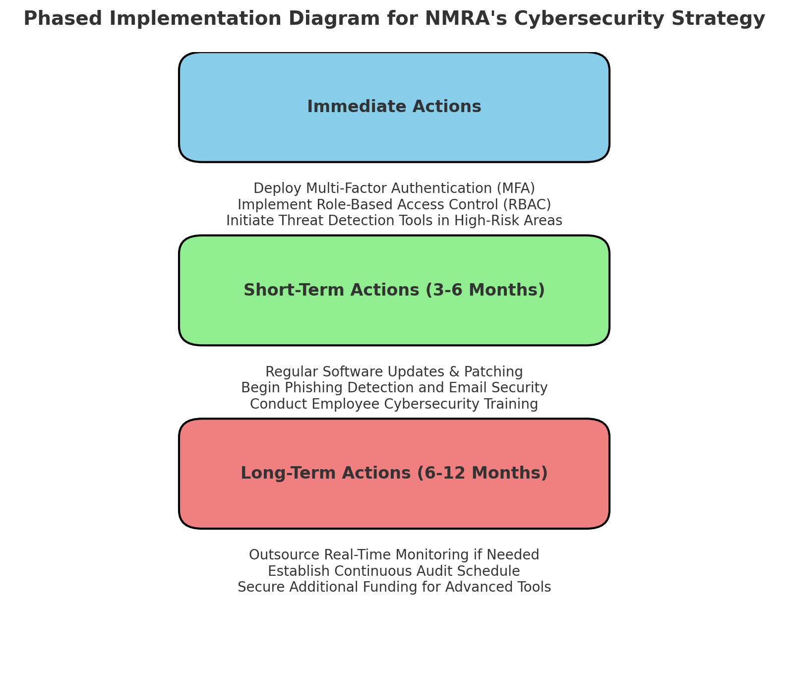

Figure 4: Implementation Diagram

Step 6: Regular Software Updates and Patching are vital to fixing things. Automating updates with Patch Manager will reduce 60 – 80% these risks since timely patching is one of the most effective things to do to stay protected against such security threats.

Step 7: Security audits and regular assessments are necessary to minimize/add to NMRA’s cybersecurity. With tools like Qualys and Nessus, we do automated scanning and audit tracking, and we keep doing quarterly audits to identify compliance gap, and document what we have to fix, and we have to show you improvement. In the same way automated tools are used in the NHS to ensure continuous security compliance with its healthcare systems.

Step 8: Real time monitoring of user activity is possible through the logging and alerting. NMRA can aggregate and monitor logs across the network using Splunk or Graylog and hope to immediately detect any suspicious behavior. Anomalies must be spotted and security monitoring and forensic investigations supported. The use of log monitoring is especially prevalent in sensitive environments, as is demonstrated by the wealth of log monitoring use cases in fraud prevention in the financial sector.

Step 9: In pursuing for cyber strength NMRA should give precedence to the training of employees by approximating phishing attacks and using cybersecurity awareness programs on KnowBe4. Continued training reduces phishing success rates by more than 75%, and training all staff should be considered essential for preparedness.

Step 10: Equal importance is attached to physical security measures. Biometric access controls and surveillance systems installed by Honeywell Security and HID Global for instance need to be implemented at critical infrastructure sites. The use of equipment policies so effective at keeping data secured in hospitals would advance NMRA’s data security needs and complement physical and cyber defense.

Real-world Scenarios

However, implementing the recommended cybersecurity measures at NMRA is not without challenge. Low budgets may limit access to these sophisticated tools, and resource constraints (especially in smaller teams) may be overwhelming to being able to run full scale security operations in these organizations. The second problem is that the employees might resist new policies, deter them from adhering strictly to the security policies. Complexity also exists in attempting to keep software up to date in the absence of such IT resources.

An application of a phased approach, however, would offer NMRA some practical advantages such as initial application to high risk areas. For instance, before making the threat detection tools go live, on boarding of multi factor authentication (MFA) and role-based access control (RBAC) for sensitive data will be high in priority and protecting the authentication credentials to an important logon system should also be on top of secure sites priority list. One response to filling financial gaps is to get the government or a joint venture to cover the costs of critical infrastructure.

To make good on the marketplace, NMRA may need to leverage managed security services or outsource the regular continuous monitoring and threat analysis part of the operation so that the internal team can enjoy broader coverage without being overloaded. As a result, employee training and audit are required to assist employees comply and meeting the security standards.

Conclusion

In particular, the proposed cybersecurity solutions are expected to substantially improve NMRA security and resilience. We can start by implementing multi factor authentication (MFA) and as pairs, take role-based access control (RBAC) and immediately make your data access more secure by restricting who can access it. It will enhance NMRA’s real time capability to detect and respond to threats using its advanced detection tools. But the limitations include, it is human error prone, trained stuff can also be tricked for phishing attack and affordability constraint that can let them not to afford the updated tools.

But to keep these it would call for continuous monitoring and evaluation. Replacements of measures should be audited every two years, and their policies revised to counter the constant change in threat. Incidents analysis, or, specifically, focused on a breach, or a cause near breach, will provide the Include Analysis team with some clues for a fine tuning of security protocols. Security awareness refreshers are scheduled to help reduce the number of human errors that employees have triggered through security awareness refreshers.

Agility is what we need to future proof NMRA’s cybersecurity. some of it, it means drawing on emerging technologies AI and machine learning driven analytics to predict and counter new threats. This will further expand upon this company's culture of pro-action security where employees both love and embrace security above all.

References
AKM IQTIDAR NEWAZ, A. K. (n.d.). A Survey on Security and Privacy Issues in Modern Healthcare Systems: Attacks and Defenses. 44. Retrieved from https://dl.acm.org/doi/pdf/10.1145/3453176
Alasmari, A. (2020). The Role of Cybersecurity to Protect our Information. Retrieved 11 04, 2024, from https://www.mecsj.com/uplode/images/photo/The_Role_of_Cybersecurity_to_Protect_our_Information.pdf
Barker, E. (2016). Guideline for Using Cryptographic Standards in the Federal Government. NIST - Computer Security Division. Retrieved 11 09, 2024, from https://nvlpubs.nist.gov/nistpubs/SpecialPublications/NIST.SP.800-175b.pdf
Chris Johnson, L. B. (n.d.). Guide to Cyber Threat Information Sharing. NIST Special Publication 800-150, 43. Retrieved 11 06, 2024, from https://nvlpubs.nist.gov/nistpubs/SpecialPublications/NIST.SP.800-150.pdf
(n.d.). CIS Critical Security Controls. Center for Internet Security. Retrieved 11 08, 2024, from https://learn.cisecurity.org/cis-controls-v8-1-guide-pdf
Commission, E. (2024, 11 08). Data protection in the EU. Retrieved from European Commission: https://commission.europa.eu/law/law-topic/data-protection/data-protection-eu_en
Goutam, R. K. (2015). Importance of Cyber Security. International Journal of Computer Applications (0975 – 8887), 4. Retrieved 11 03, 2023, from https://research.ijcaonline.org/volume111/number7/pxc3901250.pdf
Group, C. (2024, 11 07). Compliancy Group. Retrieved from Compliancy Group: https://compliancy-group.com/the-cia-triad-confidentiality-integrity-availability-for-hipaa/
Harsh Kupwade Patil, R. S. (2014). Big Data Security and Privacy Issues in Healthcare. IEEE.
IBM. (2024, 11 08). IBM. Retrieved from IBM: https://newsroom.ibm.com/2023-10-05-IBM-Announces-New-AI-Powered-Threat-Detection-and-Response-Services
ISMS. (2024, 11 10). ISMS Online. Retrieved from ISMS Online: https://www.isms.online/iso-27001/
IT Governance. (2024, 11 10). IT Governance. Retrieved from IT Governance: https://www.itgovernance.co.uk/iso27001
Kelley, K. (2024, 11 03). Simplilearn. Retrieved from Simplilearn: https://www.simplilearn.com/tutorials/cyber-security-tutorial/what-is-cyber-security
Mark Wilson, J. H. (n.d.). Computer Security. NIST. Retrieved from https://nvlpubs.nist.gov/nistpubs/Legacy/SP/nistspecialpublication800-50.pdf
mitigation, D. b. (2024). Springer Nature Link. Data breaches in healthcare: security mechanisms for attack mitigation, 8639-8654. Retrieved from Springer Nature Link: https://link.springer.com/article/10.1007/s10586-024-04507-2?fromPaywallRec=true
Paul A. Grassi, J. L. (n.d.). Digital Identity Guidelines. NIST. Retrieved 11 09, 2024, from https://nvlpubs.nist.gov/nistpubs/SpecialPublications/NIST.SP.800-63b.pdf
sans.org. (2024, 11 08). SANS. Retrieved from SANS: https://www.sans.org/blog/the-vulnerability-assessment-framework/
science, S. o. (2012). AMA Journel of ethics. Retrieved from Journel of ethics: https://journalofethics.ama-assn.org/article/electronic-health-records-privacy-confidentiality-and-security/2012-09
Sri Lanka CERT. (n.d.). Information and Cyber Security Policy for Government Organizations. Research, Policy and Projects Division, Sri Lanka CERT. Retrieved from https://www.onlinesafety.lk/database/ICS_policy_en_03-07-2022_compressed.pdf
Technology, N. I. (2024). The NIST Cybersecurity Framework (CSF) 2.0. Retrieved 11 09, 2024, from https://nvlpubs.nist.gov/nistpubs/CSWP/NIST.CSWP.29.pdf

