Cyber Security

U14438
Table of Contents

Introduction 2
First Part (Part A): Malware Detection and Mitigation Strategy 2
Malware Detection 2
Mitigation Strategies and Risks 3
Analysis of Simple Deterrent Techniques 5
1. Endpoint Protection 5
2. Multi Factor Authentication (MFA) 6
3. Email Filtering 6
4. Infrastructure Integration 6
Second Part (Part B): Preventing Future Attacks and Business Resilience Planning 7
Resilience Decision Making 7
Business Continuity vs. Disaster Recovery 7
Recommended Approach 8
References 9

Introduction

As the area of healthcare sector highly relies on sensitive data as well as highly confidential data, the healthcare sector also bears certain unique challenges of the same sort when it comes to Cybersecurity. Specialist pathology service provider, MedTest, is a particularly vulnerable entity with huge amounts of the kind of sensitive data upon which its business depends. What has just happened with the ransomware attack on Synnovis, a pathology laboratory supporting numerous NHS companies, highlights the ever increasing threat landscape facing this industry. It also becomes a critical case study of such an attack’s devastating consequences, and the many gaps in Cybersecurity preparedness that led to it.

This report will analyze the Synnovis attack, propose methodology to detect and mitigate malware, and build a comprehensive plan for resilience to stop future breaches. The report is divided into two sections covering Part A, malware detection and mitigation strategies, and Part B, long term prevention and resilience planning for MedTest to ensure that it fortifies its Cybersecurity defenses successfully. (Synnovis, 2024) (England, 2024)

First Part (Part A): Malware Detection and Mitigation Strategy

Malware Detection

MedTest‘s Cybersecurity framework stress the importance of malware detection, in spite of the recent Synnovis attack. To start detecting effectively, you get the good information from good sources like the Cybersecurity frameworks, healthcare IT security benchmarks, and threat intelligence reports. NHS Digital’s Data Security and Protection Toolkit contain methods adapted for healthcare organizations, and threat intelligence platforms deliver up to date information on the issue of emerging threats. Cutting edge solutions providing actionable insights into malware activities include things such as Microsoft Defender for Endpoint or Crowd Strike. This is done so that MedTest can adopt strategies that have been shown effective for rural healthcare IT environments.

Two types of detection techniques, which identify potential threats, include the active technique as well as the passive technique, both of which are important. Real time monitoring and analysis of network behavior is real time detection. Based on behavioral analysis tools which include Intrusion Detection Systems (IDS) and Endpoint Detection and Response (EDR) tools, a targeted behavior can be defined and anomalies of any type trying or detected can be identified, unauthorized access attempts, and detected or attempted malware. The alert systems notify administrators quickly, giving them the opportunity to respond fast to potential threat. This also provides the opportunity for the use of machine learning algorithms for detecting unusual patterns indicative of sophisticate malware attacks, like ransomware.

Historical data analysis techniques in a complementary layer of defense provide passive detection techniques, monitoring for malicious activity patterns. Part of this, is reviewing system logs, which can indicate unauthorized access attempts, or the like in data transfers. Malware behavior and intelligence gathering can also be studied using honeypots; decoy systems set up to draw attackers and risk free exposure to key infrastructure. The threat intelligence feeds provide ongoing updates, which can be used by MedTest to proactively address known vulnerabilities and attack vectors, before they become knowledge networks.

These detection mechanisms need to be piloted with MedTest’s existing IT infrastructure in mind. Integrated seamlessly with current network management systems, real time monitoring tools offer centralized visibility on potential threats. Where possible, automated log review systems should be implemented, to quickly analyze a tremendous quantity of data. Additionally, the use of honeypots isolated within parts of the network will guide malicious actors to an uninhabited area, without sacking any sensitive data. Combined, threat intelligence platforms can be incorporated into Security Information and Event Management (SIEM) systems, for a single window into newly forming threats and existing vulnerabilities.

A multi layered malware detection strategy adopted by MedTest can make a huge difference in the identification as well as mitigation of potential risk tokens. Active and passive detection techniques are combined to provide exhaustive coverage and integration into the current organizational systems strengthens the organization’s overall Cybersecurity posture. But building resistance against future malware attacks, this approach enhances not only immediate vulnerability, but also prepares the system for other attacks. (Amir Djenna, 2023)

Mitigation Strategies and Risks

To mitigate these risks from malware, a healthcare industry specific proactive solution addressing the factors that are specific to the healthcare sector is required. As a data intensive organization, MedTest has to adopt robust strategies like network segmentation, malware containment protocols as well as rapid response protocols to maintain business continuity and reduce the risk due to adverse consequences of a breach. An example of this would be network segmentation, whereby the network is broken into segmented areas that will prevent malware from moving laterally within the systems. The strategy restricts infections to a single segment and so reduces their scale and impact. Secondly, malware containment strategies include protocols that include device isolation, automated shutdown of infected devices and isolation of compromised systems. Incident response platforms like IBM Resilient, Palo Alto Cortex XSOAR, help MedTest quickly analyze threats, and coordinate with other responders and restore systems.

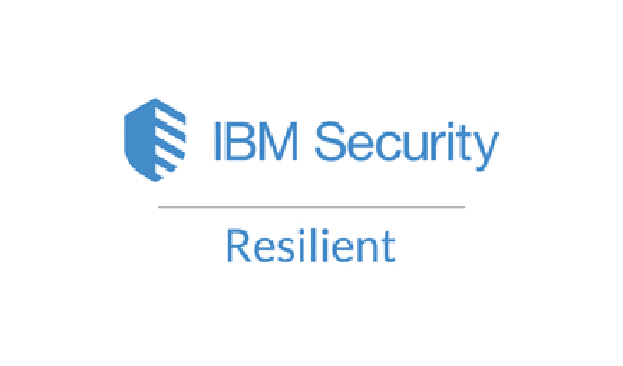


Figure 1- IBM Resilient and Palo Alto

The tools around next generation firewalls, antivirus solutions and intrusion prevention system (IPS) also have a huge role to play in mitigating. Fortinet or Palo Alto Networks firewalls that are next generation, for example, perform deep packet inspection and application layer filtering to identify and stop threats in real time.

Figure 2- Fortinet Firewall

Known malware signatures are detected by additional layers of defense, that is, Antivirus programs such as Norton or Bitdefender. In fact, IPS tools actually block suspicious traffic before it can be exploited. In total, these tools make MedTest a multi-dimensional defense strategy against Malware and Ransomware attacks.


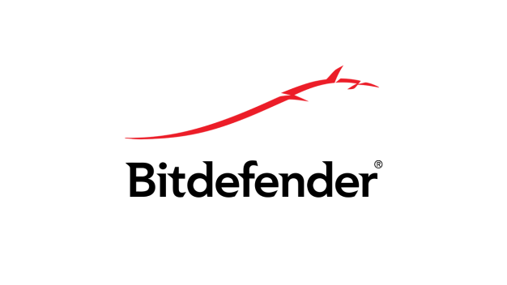

Figure 3- Antivirus Software

Another very important aspect of risk management is least privilege access policies. The third aspect is related with restriction of employees’ permissions, allowing access to only those systems and data necessary for the employee role. For instance, shouldn't have access for clinical data or patient records to administrative assistants in the hospital, since for the clinical data or patient records would be able to damage if their account is compromised.

These mitigation strategies must be evaluated to be effective continuously. Network segmentation and containment protocols both limit spread of malware outbreaks and reduce the time of system monitoring and response. Firewalls and IPS are tools that add layers of automated threat detection and prevention, and do what’s immediate action against the threat. The culture of security awareness that employee training programs create reduces an organization’s susceptibility to the types of breaches created by human error. Less than privilege policies further prevent malware from spreading and escalating within system, reducing organizational risk considerably.

These processes are critically analyzed to explain how they add strength to MedTest’s overall Cybersecurity posture. For example, segmentation and containment of the network are an effective way to limit the spread of malware but must be reviewed and tested on a regular basis because they don’t work against all evolving threats. No less valuable are employee training programs, which, however, must continue to evolve to address new attack techniques as they emerge. MedTest protects its operations and sensitive data by employing a comprehensive, layered approach to mitigation that not only helps contain current malware infections, but also prevents future incident by identifying their presence in near real time to stop them in their tracks before they can cause harm.

Analysis of Simple Deterrent Techniques

Strengthening the Cybersecurity architecture in the healthcare sector requires deterrent techniques, which are so important for MedTest. Simple but meaningful technological approaches include endpoint security, multi factor authentication (MFA) and email screening that is going to uplift the level of organization security.

Endpoint Protection

Endpoint protection solutions, such as Crowd Strike or Symantec Endpoint Protection, are able to offer some of the most robust threat isolation and detection available in knowing and securing all devices that are attached to the network. Endpoint protection is critical in a healthcare environment because of the large number of objects we have; laptops, tablets and medical devices all interacting with sensitive data and endpoint protection catches threats before they spread onto the wider network. And many of these solutions include such capabilities as malware scanning, behavioral analytics, and automated threat containment.

Despite this, endpoint protection works only if updates are constantly released and devices are compliant. It could be caused by unpatched systems (such as unnecessary office programs or systems that do not need to be updated), outdated software, or crashed systems (which mean there is no case for data recovery, which can affect the working process). It is hard for MedTest to mitigate this, this requires that MedTest enforce strict policy around regular updates and also that the endpoint protection solution is integrated seamlessly with their IT systems. Automated updates, centralized management within an easier to track monitoring environment and doing ongoing vulnerability assessments are all best practices.

Multi Factor Authentication (MFA)

MFA provides an essential extra barrier to entry by requiring users to authenticate their identity by using two or more authentication factors, including a password, a mobile authentication app, or biometric scan. Healthcare data is especially sensitive to this, which makes it all the more important for MedTest. MFA ensures that, no matter how login credentials are compromised, unauthorized access is still unlikely. This means, for example, no employee can access system in an unsecure way, such as patient records, laboratory results.

MFA benefits, but can have its problems in the healthcare environment, where operational delays can impede patient care. Biometric authentication may not work in emergencies or under sterile conditions when handling devices. In response to this, MedTest must deploy user friendly MFA methods within healthcare workflows like app based push notifications or hardware tokens. The training of employees for the use of these tools makes as much adoption as possible and reduces disruptions.

Email Filtering

Phishing, malicious attachments that can contain malware and the links that malware can use as entry points are prevented by email filtering solutions like Proof point or Microsoft Defender for Office 365. Because health care organizations are such an attractive target for phishing, organizations stand to gain greatly from advanced email filtering that blocks suspicious messages before they get to employees. But for our users’ sake, this mitigates the risk of employees accidentally disclosing remote sensitive data and ensures our users are not the target of ransomware attacks.

The problem with email filtering is that it is reliant upon excellent threat intelligence. Periodic updates and monitoring are crucial for that reason: attackers can often deploy clever technique which bypasses filters. Quite obviously, MedTest should use both employee education and automated filtering to maximize email filtering effectiveness. Another way to extend an added security is to make sure that the filter works well with other security tools like firewalls, SIEM systems etc.

Infrastructure Integration

Given costs, scaling, training and vendor support, integrating these deterrent technologies into MedTest’s infrastructure will be quite a consideration. MedTest can safely scale an endpoint protection solution to accomplish MedTest’s mission of securing all devices across its operations. Centralized dashboards from vendors usually come in with simplified management for large scale deployment. MFA solutions have an additional advantage of being cheap to implement as well as relatively easily scalable especially with cloud based solutions that minimize the cost of the infrastructure. There are also tools to tailor email filtering to match the organization’s size and threat profile for maximum cost efficiency.

These measures must be used effectively and training programs are necessary to do so. Guidance is needed for employees on how to recognize phishing emails, how to work with the MFA process, and how to remain safeguarded on the endpoints. Vendors of such strong support services as 24/7 support or frequent updates only add to the reliability of these tools.

With MedTest’s endpoint protection, MFA, and email filtering, the additional security features can go a long way towards bolstering the Cybersecurity posture without really changing workflow. With these solutions, we not only ensure that our organization’s sensitive data is safe, but we are building proactive security into the culture. Through training, updates, and integration, these measures address limitations to provide long term value, which builds MedTest’s defense to evolving threats.
(Arnal, 2022)

Second Part (Part B): Preventing Future Attacks and Business Resilience Planning

Resilience Decision Making

Cybersecurity resilience is preparing for or responding well to incidents so as to minimize the disruption. Resilience can be divided into two critical components Disaster Recovery Planning (DRP) and Business Continuity Planning (BCP). Although the two concepts go together, they refer to two different aspects of incident management.

Business Continuity vs. Disaster Recovery

Disaster Recovery Planning (DRP) looks at getting systems, applications and data back to normal, as quickly as possible, after an incident. As an example, in the Synnovis case, a strong DRP would be to restore the diagnostic systems following a ransomware attack and regain the patients records in order to limit service uptime. Similar moves could be made by MedTest, which also has its pathology services up and running quickly after a cyber-attack or systems failure.

Business Continuity Planning (BCP) however, tends towards maintaining critical operations, during and after, an incident. It focuses on how to keep such services running in adverse conditions. Suppose for example the Synnovis attack had happened then alternative diagnostic processes or backups systems would have ensured that services run un-interrupted. But for a MedTest, a BCP might be to send essential tasks to unaffected branch or activate temporary abuse manual process in order to avoid service interruption.

Though DRP is vital, BCP is vital for keeping operations running during crises. As healthcare sector relies so much on timely and accurate service, both are extremely important for healthcare organizations. (Forum, 2024)

Recommended Approach

The best strategy for MedTest is to use the combination of BCP and DRP. It ensures the organization’s capability to rapidly recover from the immediate disruptions as well as to deal with them when they arise. For example BCP ensures operational safeguard such as alternate work flows and communication protocols during downtime. As a part of DRP is supplemented by real time data backups and failover systems.

In healthcare’s unpredictable environment, relying only on DRP or BCP alternatives are insufficient. Either extremes of focusing on DRP risks to critical service interruptions, on BCP, only focusing to full recovery delay may occur. These gaps are addressed by a hybrid model, one that maintains continuity during incidents while expediting the restoration to normal operations.

Finally, the implementation of a hybrid resilience plan specifically designed for MedTest allows adopting this plan to bolster its capacity to be able to handle crises. Combining those two methods, MedTest’s use of DRP and BCP not only guarantees operational continuity, timely recovery, and strong protection for sensitive data, even under uncertain contingencies.

References

Amir Djenna, A. B. S. R. I. M. M., 2023. [Online]
Available at: https://www.researchgate.net/publication/369098842_Artificial_Intelligence-Based_Malware_Detection_Analysis_and_Mitigation
[Accessed 06 12 2024].
Arnal, C., 2022. [Online]
Available at: https://www.watchguard.com/wgrd-news/blog/why-endpoint-security-and-mfa-should-always-go-together
[Accessed 07 12 2024].
England, N., 2024. [Online]
Available at: https://www.england.nhs.uk/london/2024/06/27/update-on-cyber-incident-clinical-impact-in-south-east-london-thursday-27-june/
[Accessed 05 12 2024].
Forum, W. E., 2024. [Online]
Available at: https://www.weforum.org/stories/2024/04/cybersecurity-key-strategies-cyber-resilience-2024/
[Accessed 08 12 2024].
Synnovis, 2024. Synnovis. [Online]
Available at: https://www.synnovis.co.uk/news-and-press/cyberattack-update-01-july-2024
[Accessed 05 12 2024].

