**5. Docker Basics**

1. List few benefits of docker

* Multiple OS support
* Run applications anywhere without any concern on the tooling and dependencies
* Build with Security regulations
* Support for ci/cd and ideal platform for microservices developments.
* Support in multiple cloud providers.
* Support in multiple container orchestration.

1. Install docker
2. Check docker version and copy the output

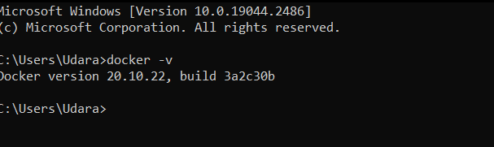

1. Create a new java project with maven
2. Create a main class and print “Hello docker example”
3. Create a jar file for the project (inside target directory)
4. Run the generated jar file inside target directory with command line
5. Display the output

1. Create a docker image for the java project. What is the command you used?

docker build -t dockertest.jar .

1. List all the docker images and show output

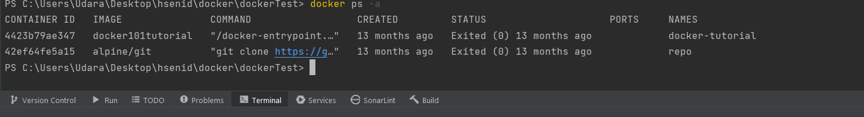

1. Run the created docker image. What is the command you used?

Docker run containerName

docker run -p 3000:3000 app-name

1. List all the docker images and show output

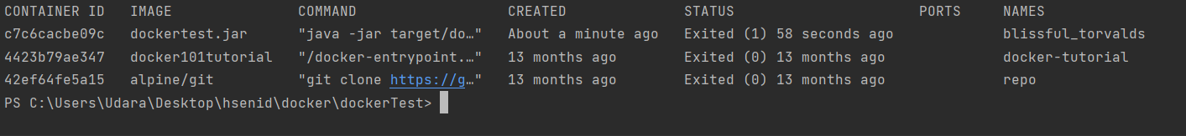

1. Stop the docker container?
2. Docker stop container id

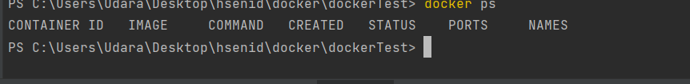

1. Remove the docker image. What is the command you used?

Docker rm container id

1. List all the docker images and show output

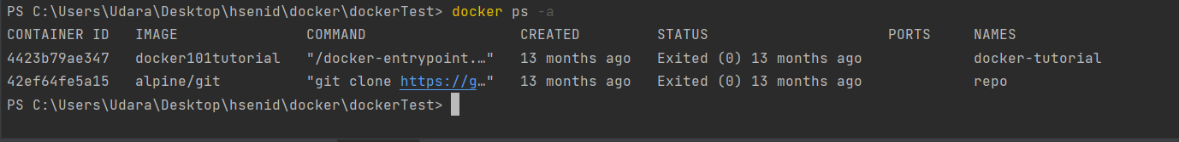

1. What is docker hub?

Docker Hub is a hosted repository service provided by Docker for finding and sharing container images

1. Pull hello-world image from docker hub

**docker pull hello-world**

1. Run hello-world image and show output

1. Pull and run mongodb as docker container

1. Open mongo shell
2. List mongodb databases

1. Add your codes and answer sheet to a directory named “docker-basic-training” and push it to your training github repository

