**4. Maven**

1. Why do we need a build tool like maven?

Because it makes easy managing and building of java-based projects. When it comes to managing, it is easy to add dependencies and jars o projects and it also provides project information such as log documents, dependency list and unit test.

1. Install maven
2. Display output of maven version

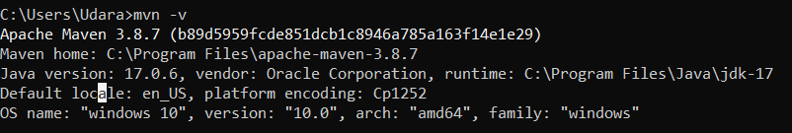

1. What is the pom.xml file?

POM is for project object model which is an essential xml file for maven project to work successfully. POM file consists with information regarding project configurations such as project dependencies, plugins and other information such as project version, description ,developers mailing lists can be specified.

1. Explain these tags found in pom.xml files?

|  |  |
| --- | --- |
| groupId | Name of the company or group that created the project |
| artifactId | Unique name of the project(artifact). Artifact is something used by or produced by a projec such as JARs ,WARs etc. |
| version | Specifies the version of the project or artifact under given group |
| packaging | Defines pckaging type of artifact such as jar or war |
| dependencies | Defines dependencies for the project |
| dependency | Jar file used by the application. Maven downloads this jar files when added this dependency to the pom file under dependencies. |
| properties | Maven properties are value placeholders . working as key value pairs. Their values are accessible anywhere within a POM. Or they can be used by plugins as default values |

1. Create a method which accept an integer as parameter and returns the square of it
2. Add junit (v5) dependency
3. Add a unit test to test the method
4. Run unit tests with maven. What is the command you used?

Mvn test

1. Create a Student class with following attributes and add getters/setters

* id: int
* name: String
* age: int
* subjects: List<String>

1. In your main method create and student object and set these values

id: 1

name: “john”

age: 20

subjects: [“Maths”, “English”, “History”]

1. Then print these student values using getters (e.g: s.getName())
2. Add lombok dependency and remove getter/setter methods from Student class
3. Explain the usage of these commands

|  |  |
| --- | --- |
| mvn clean | delete all previously compiled Java .class files and resources (like .properties) in the project and build will start from a clean slate |
| mvn install | Compile,test and pacakge java project and also copy orinstall built jar and war file into local maven repository. |
| mvn package | Complie code and package iit inits distributable format such as jar but it not install files into local maven repositoy. |

1. Explain 3 types of maven repositories

**Maven Local repository**: local repository located in user’s local system.it create when a maven command was run in local system .

%USER_HOME%/.m2 is the default local repository.

**Maven Central repository:** created bymaven community and located on the web( [http://repo1.maven.org/maven2/](https://repo1.maven.org/maven2/).).

**Maven Remote Repository** : Same as central repository located on the web .Missing libraries from the central repository should define remote repository in pom file.

1. Add your codes and answer sheet to a directory named “maven-basic-training” and push it to your training github repository.