

Topic : Vehicle Insurance Management System

Group no : MLB_10.2_10

Campus : Malabe

Submission Date : 5/20/2022

We declare that this is our own work and this Assignment does not incorporate without acknowledgment any material previously submitted by anyone else in SLIIT or any other university/Institute. And we declare that each one of us equally contributed to the completion of this Assignment.

|  |  |  |
| --- | --- | --- |
| **Registration No** | **Name** | **Contact Number** |
| IT21381140 | Udara M.G.R | 0750164012 |
| IT21199462 | Nishshanka N.A.K.B | 0769421799 |
|  |  |  |
|  |  |  |
|  |  |  |

**Requirements**

* Unregistered customer can only access the home page, about page and help page. They may view the info about insurances but to see other details they have to logged into the site.
* To register into the account guest customer has to fill the registration form and submit it. After that guest customer will get a verification code from the system and after that customer has the full access to search and purchase the insurance that they want.
* In case of forgetting the login details the customer will have an option to reset the user name and password.
* Customer can search for the insurance they need and proceed to the payment.
* If they have an issue they can also contact the company using the system and they will be get feedbacks.
* Customer can buy more than more insurance for more vehicles by adding it to the insurance cart.
* Customer can hold or remove a selected insurance only by contacting the company.
* Customer can view the ongoing payment details of the insurance that purchased.
* Customer can request a claim and in case of an accident customer has to provide location and other details as soon as possible.
* Admin can log in to the system by providing log in details.
* Admin can access the both front and back end of the system.
* Admin can update new information.
* Admin has the access to decide and remote the customers that involve with system.
* Admin can check customer details and update it.
* Admin has to get the necessary steps to avoid errors.
* Admin can reply to the feedbacks and admin has to answer the questions that customers ask.
* Admin can edit the data base
* Admin can check the payments and generate a notification via the system about the due payments.
* Admin generates reports such as payment reports, insurances reports, customer reports.
* Agent can access to the website if he needs by giving log in details.
* Agent can create and upload new polices to the system.
* Agent can check the customer policies whether they are valid or not.
* Agent can update customer details of the system.
* Agent can check and manage the payments of the customers

**Identifying the classes**

Identified nouns

|  |  |
| --- | --- |
| User | Class |
| Home page | Attribute |
| About page | Attribute |
| Help page | Attribute |
| Insurances | Class |
| Site | Out of scope |
| Account | Attribute |
| Guest customer | Redundant of unregistered customer |
| Registration form | Attribute |
| Verification code | Attribute |
| System | Out of scope |
| Password | Attribute |
| Customer | Class |
| Payment | Class |
| Company | Out of scope |
| Feedbacks | Class |
| Claim | Class |
| Location | Attribute |
| Admin | Class |
| Reports | Class |
| Database | Out of scope |
| Notification | Attributes |
| Due payments | Attributes |
| Agent | Class |
| Policies | Attributes |

**Identified Classes**

* User
* Insurances
* Customer
* Payment
* Feedbacks
* Claim
* Admin
* Reports
* Agent

**Drawing CRC Cards**

|  |  |
| --- | --- |
| **User** | |
| **Responsibilities** | **Collaborations** |
| Register as customer | Customer |
| Login as Admin | Admin |
| Login as Agent | Agent |

|  |  |
| --- | --- |
| **Customer** | |
| **Responsibilities** | **Collaborations** |
| Login | User |
| Search for insurances | Insurance |
| Purchase an insurance | Insurance |
| Hold or remove insurance | Insurance |
| Make claim | Claim |
| Give feed back | Feedback |

|  |  |
| --- | --- |
| **Insurance** | |
| **Responsibilities** | **Collaborations** |
| Display insurances details |  |
| Store details of insurances |  |

|  |  |
| --- | --- |
| **Payment** | |
| **Responsibilities** | **Collaborations** |
| Store payment details |  |
| Calculate the total amount to be paid |  |
| Validate payment |  |

|  |  |
| --- | --- |
| **Feedbacks** | |
| **Responsibilities** | **Collaborations** |
| Display feedback | Agent, customer |
| Add feedback | customer |
| Rate insurance | customer |

|  |  |
| --- | --- |
| **Claim** | |
| **Responsibilities** | **Collaborations** |
| Store claim details |  |
| Get claim details |  |
| Calculate the claim |  |

|  |  |
| --- | --- |
| **Admin** | |
| **Responsibilities** | **Collaborations** |
| Check payments | Payment |
| Update insurances information | Insurance |
| Manage errors |  |

|  |  |
| --- | --- |
| **Report** | |
| **Responsibilities** | **Collaborations** |
| Payment report | Payment |
| Insurances report | Insurance |
| Customer reports | customer |

|  |  |
| --- | --- |
| **Agent** | |
| **Responsibilities** | **Collaborations** |
| Update customer details | Customer |
| Create and upload new policies | Insurance |
| Check and manage payments | payment |

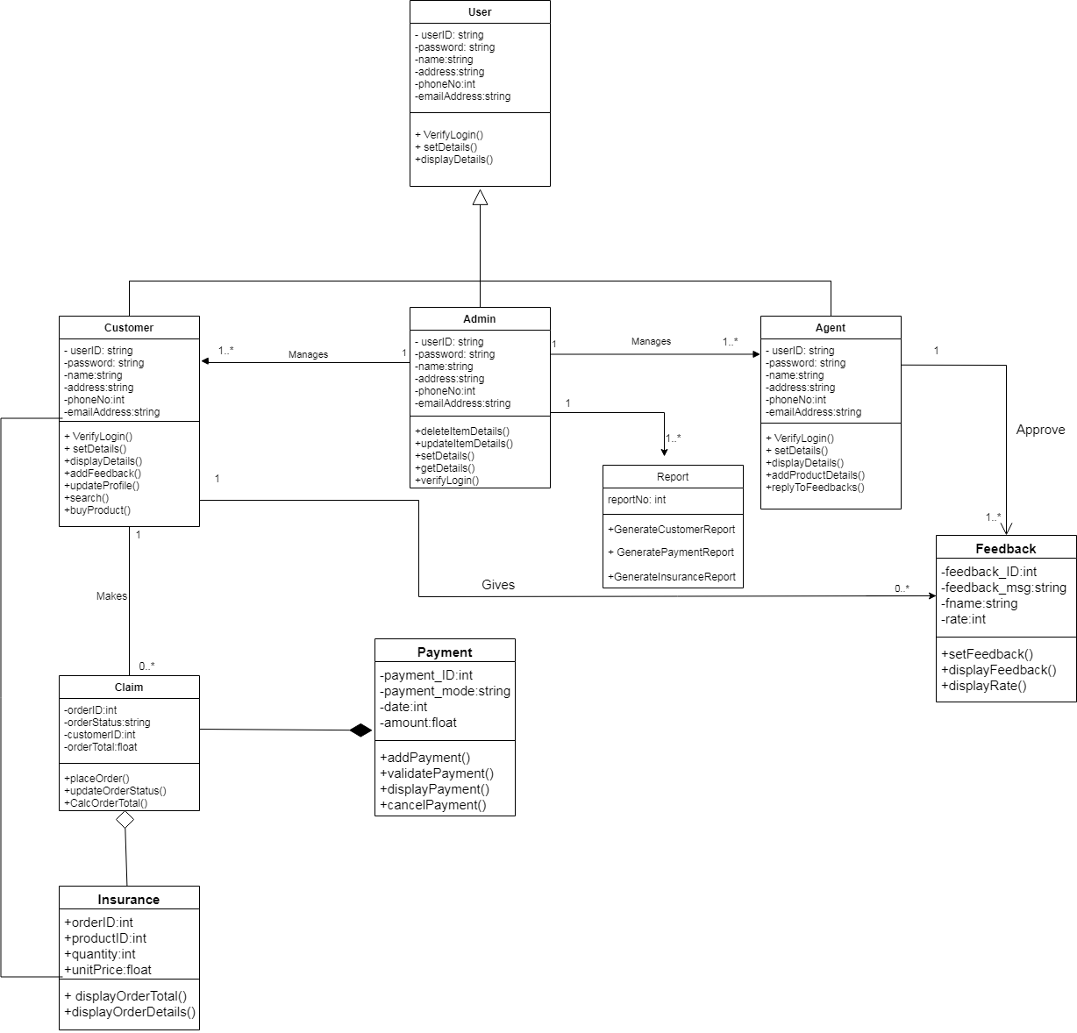**UML Diagram**

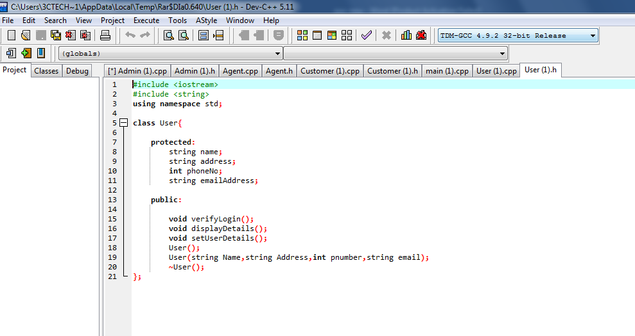**Coding**

