Open-Shift 4.2 deployment steps:

1. Open-Shift binary installation: **Bastion host**
   1. <https://mirror.openshift.com/pub/openshift-v4/clients/ocp/latest/openshift-client-linux-4.2.0.tar.gz>
   2. <https://mirror.openshift.com/pub/openshift-v4/clients/ocp/latest/openshift-install-linux-4.2.0.tar.gz>

1. Ignition file generation: **Bastion host**

root@bastion:~/ocp/installation# vim install-config.yaml

apiVersion: v1

baseDomain: nfv.com

proxy:

httpProxy: http://<proxy>:8080

httpsProxy: http://<proxy>:8080

compute:

- hyperthreading: Enabled

name: worker

replicas: 0

controlPlane:

hyperthreading: Enabled

name: master

replicas: 3

metadata:

name: ocp4

networking:

clusterNetwork:

- cidr: 10.128.0.0/14

hostPrefix: 23

networkType: OpenShiftSDN

serviceNetwork:

- 172.30.0.0/16

platform:

none: {}

pullSecret: ‘{}’

sshKey: ‘’

root@bastion: openshift-install create ignition-configs --dir=ign-files

Note: Upload the ignition files to web server along with initramfs,kernel,bios/uefi

1. Bootstrap deployment:

iPXE boot:

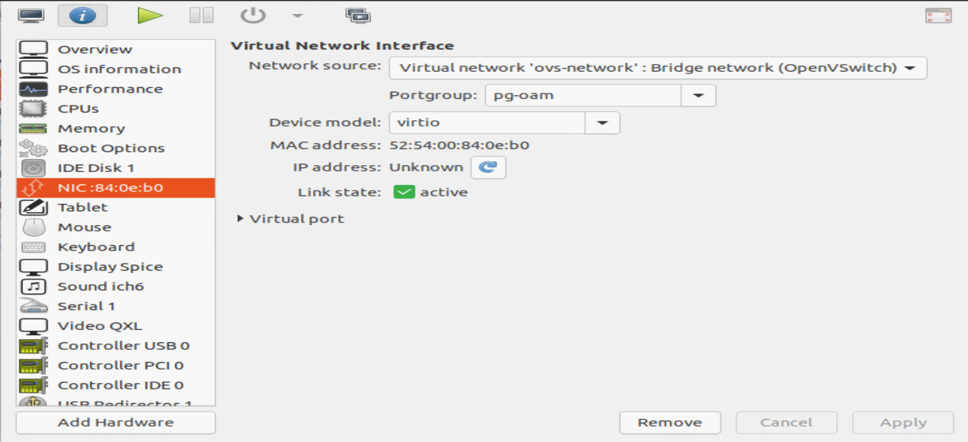

Validation: From Bastion node

openshift-install wait-for bootstrap-complete --dir=ign-files --log-level debug

DEBUG Still waiting for the Kubernetes API: Get https://api.ocp4.nfv.com:6443/version?timeout=32s: EOF

DEBUG Still waiting for the Kubernetes API: Get https://api.ocp4.nfv.com:6443/version?timeout=32s: EOF

INFO API v1.14.6+2e5ed54 up

INFO Waiting up to 30m0s for bootstrapping to complete...

Validation: From Bootstrap node

root@bastion:~/ocp/installation# ssh core@bootstrap.ocp4.nfv.com

[core@bootstrap ~]$ journalctl -b -f -u bootkube.service

bootstrap.ocp4.nfv.com bootkube.sh[1660]: https://etcd-1.ocp4.nfv.com:2379 is unhealthy: failed to connect: dial tcp 10.7.45.104:2379: connect: no route to host

bootstrap.ocp4.nfv.com bootkube.sh[1660]: https://etcd-2.ocp4.nfv.com:2379 is unhealthy: failed to connect: dial tcp 10.7.45.105:2379: connect: no route to host

bootstrap.ocp4.nfv.com bootkube.sh[1660]: https://etcd-0.ocp4.nfv.com:2379 is unhealthy: failed to connect: dial tcp 10.7.45.103:2379: connect: no route to host

bootstrap.ocp4.nfv.com bootkube.sh[1660]: Error: unhealthy cluster

bootstrap.ocp4.nfv.com bootkube.sh[1660]: etcdctl failed. Retrying in 5 seconds..

1. Master Cluster deployment:
   1. PXE boot server

root@bastion:~/ocp/installation# openshift-install wait-for install-complete --dir=ign-files/ --log-level debug

DEBUG OpenShift Installer v4.2.0

DEBUG Built from commit 90ccb37ac1f85ae811c50a29f9bb7e779c5045fb

INFO Waiting up to 30m0s for the cluster at https://api.ocp4.nfv.com:6443 to initialize...

DEBUG Still waiting for the cluster to initialize: Some cluster operators are still updating: authentication, console, image-registry

root@bastion:~/ocp/installation# oc get nodes

NAME STATUS ROLES AGE VERSION

master-0.ocp4.nfv.com Ready master,worker 111m v1.14.6+c07e432da

master-1.ocp4.nfv.com Ready master,worker 111m v1.14.6+c07e432da

master-2.ocp4.nfv.com Ready master,worker 111m v1.14.6+c07e432da

1. Remove Bootstrap node:

Validation: From Bastion node

openshift-install wait-for bootstrap-complete --dir=ign-files --log-level debug

DEBUG Still waiting for the Kubernetes API: Get https://api.ocp4.nfv.com:6443/version?timeout=32s: EOF

DEBUG Still waiting for the Kubernetes API: Get https://api.ocp4.nfv.com:6443/version?timeout=32s: EOF

INFO API v1.14.6+2e5ed54 up

INFO Waiting up to 30m0s for bootstrapping to complete...

DEBUG Bootstrap status: complete

INFO It is now safe to remove the bootstrap resources

root@bastion:~/ocp/installation# ssh core@bootstrap.ocp4.nfv.com

[core@bootstrap ~]$ journalctl -b -f -u bootkube.service

-- Logs begin at Tue 2019-10-22 03:32:51 UTC. --

Oct 22 05:20:09 bootstrap.ocp4.nfv.com bootkube.sh[1660]: Skipped "secret-aggregator-client-signer.yaml" secrets.v1./aggregator-client-signer -n openshift-kube-apiserver-operator as it already exists

Oct 22 05:20:09 bootstrap.ocp4.nfv.com bootkube.sh[1660]: Skipped "secret-control-plane-client-signer.yaml" secrets.v1./kube-control-plane-signer -n openshift-kube-apiserver-operator as it already exists

Oct 22 05:20:10 bootstrap.ocp4.nfv.com bootkube.sh[1660]: Skipped "secret-csr-signer-signer.yaml" secrets.v1./csr-signer-signer -n openshift-kube-controller-manager-operator as it already exists

Oct 22 05:20:10 bootstrap.ocp4.nfv.com bootkube.sh[1660]: Skipped "secret-kube-apiserver-to-kubelet-signer.yaml" secrets.v1./kube-apiserver-to-kubelet-signer -n openshift-kube-apiserver-operator as it already exists

Oct 22 05:20:11 bootstrap.ocp4.nfv.com bootkube.sh[1660]: Skipped "secret-loadbalancer-serving-signer.yaml" secrets.v1./loadbalancer-serving-signer -n openshift-kube-apiserver-operator as it already exists

Oct 22 05:20:11 bootstrap.ocp4.nfv.com bootkube.sh[1660]: Skipped "secret-localhost-serving-signer.yaml" secrets.v1./localhost-serving-signer -n openshift-kube-apiserver-operator as it already exists

Oct 22 05:20:12 bootstrap.ocp4.nfv.com bootkube.sh[1660]: Skipped "secret-service-network-serving-signer.yaml" secrets.v1./service-network-serving-signer -n openshift-kube-apiserver-operator as it already exists

Oct 22 05:20:12 bootstrap.ocp4.nfv.com bootkube.sh[1660]: Tearing down temporary bootstrap control plane...

Oct 22 05:20:13 bootstrap.ocp4.nfv.com bootkube.sh[1660]: bootkube.service complete

1. Adding worker nodes to cluster:

iPXE Boot worker nodes

Approve CSR