Error:1

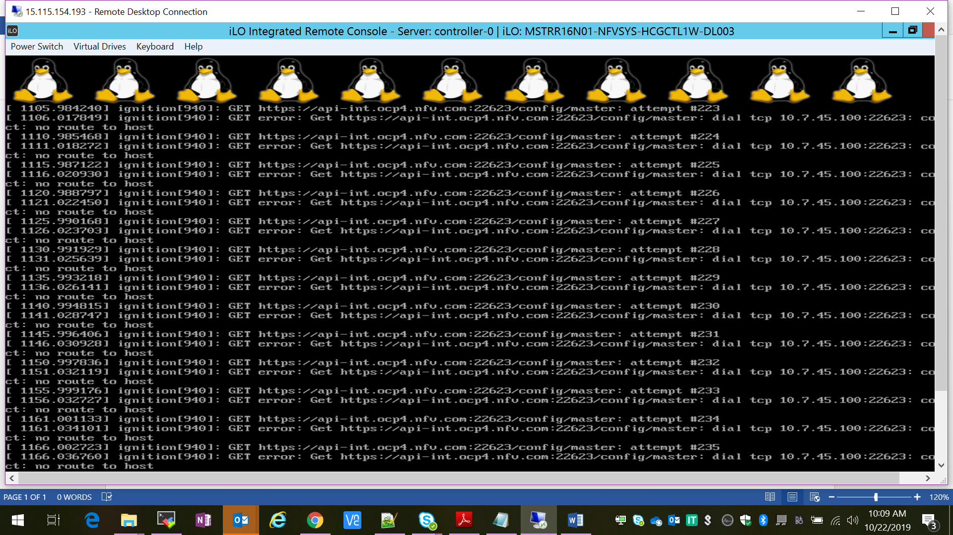

AP:

1. Check firewall on all nodes
2. Use ip=eno49:dhcp instead of ip=dhcp in install.ipxe file
3. Use name server

Error:#2

Oct 22 05:14:21 bootstrap.ocp4.nfv.com bootkube.sh[1660]: [#162] failed to fetch discovery: Get https://localhost:6443/api?timeout=32s: dial tcp [::1]:6443: connect: connection refused

AP:

root@bastion:~/ocp/installation# export KUBECONFIG=ign-files/auth/kubeconfig

root@bastion:~/ocp/installation# oc get nodes

Unable to connect to the server: x509: certificate has expired or is not yet valid

root@bastion:~/ocp# export KUBECONFIG=installation/ign-files/auth/kubeconfig

root@bastion:~/ocp# echo $KUBECONFIG

installation/ign-files/auth/kubeconfig

root@bastion:~/ocp# oc whoami

system:admin

root@bastion:~/ocp#

