**Split the column CITY and separate the code associate with each city like - Allahabad[AL2] should be only Allahabad and [A2] will be separate**.

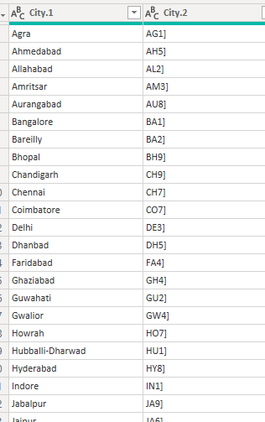

**Extract the first name from EMPLOYEE NAME column and transform the column**

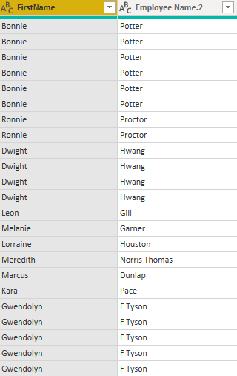

Us**ing the JOINING DATE column extract the Year and no. of days for that month .**

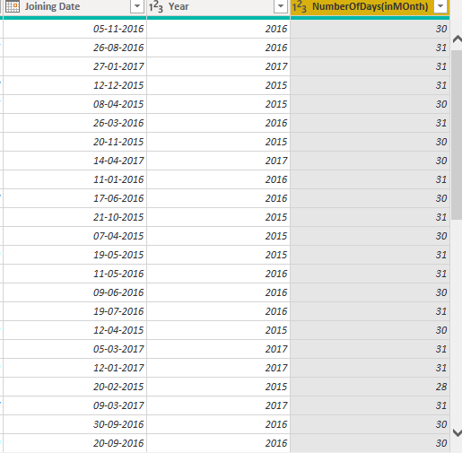

**Salary for each state—Maharashtra has highest and Chhattisgarh and Assam- lowest**

