CO3-AT1-Q1:

Name: D.Uday Kiran
Reg no: 192425161
Course Code: CSA0652
Course Name: DAA for Complexity Analysis

Railway Reservation Search System Using Binary Search
CODE:
#include<stdio.h>
int binarySearch(int trains[],int n,int key)
{
int low=0,high=n-1;
while(low<=high)
{
int mid=(low+high)/2;
if(trains[mid]==key)
return mid;
else if(trains[mid]<key)
low=mid+1;
else
high=mid-1;
}
return -1;
}
int main()
{
int trains[50],n,search,result;
printf("Enter number of train records: ");
scanf("%d",&n);
printf("Enter sorted train numbers:\n");
for(int i=0;i<n;i++)
scanf("%d",&trains[i]);
printf("Enter train number to search: ");
scanf("%d",&search);
result=binarySearch(trains,n,search);
if(result!=-1)
printf("Train found at position %d",result+1);
else
printf("Train record not found");
return 0;
}
OUTPUT:
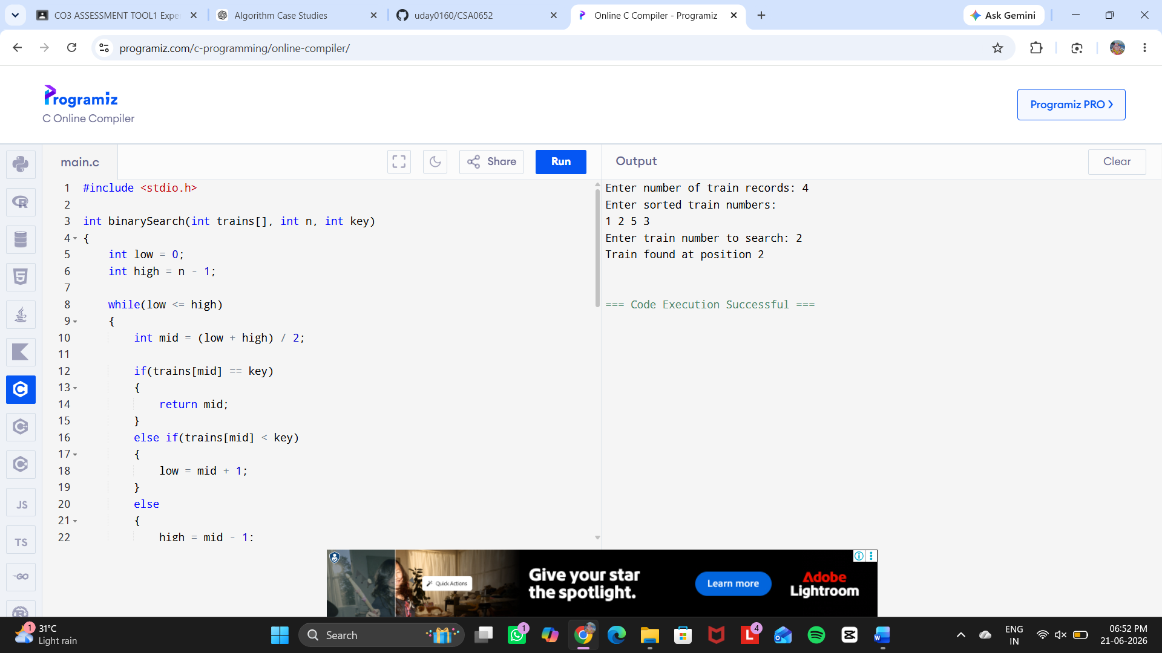
REPORT ANALYSIS:
1. Problem Statement
A railway reservation system contains a large number of train schedules and booking records. Searching a particular train number from thousands of records manually is time-consuming. This case study implements Binary Search to efficiently retrieve train information from a sorted database.

2. Objective
- To search train records quickly using Binary Search.
- To apply the Divide and Conquer approach.
- To analyze the efficiency and performance of the algorithm.
- To understand the importance of sorted indexing in database searching.

3. Problem Understanding
The railway database stores train numbers in sorted order. The system needs to find whether a particular train number exists or not.
Input:
- Number of train records
- Sorted train numbers
- Train number to search
Output:
- Position of the train record if found
- Message if record is not available

4. Algorithm Used – Binary Search
Binary Search follows the Divide and Conquer technique.
Steps:
- Take the middle element of the sorted list.
- Compare the middle value with the required train number.
- If both are equal, the record is found.
- If the search value is smaller, search the left half.
- If the search value is larger, search the right half.
- Repeat until the element is found or the search space becomes empty.

5. Requirements

Sorted Indexing
Binary Search requires data to be arranged in sorted order. Train numbers are stored in ascending order to improve searching speed.

Speed
Binary Search reduces the search area by half in every step, making it faster for large railway databases.

Accuracy
The algorithm compares exact values and provides reliable search results.

6. Time Complexity Analysis
Case | Complexity
Best Case | O(1)
Average Case | O(log n)
Worst Case | O(log n)

Space Complexity
O(1)

7. Result
The Binary Search algorithm successfully retrieves train records from a sorted railway reservation database with high efficiency.

