CO3-AT1-Q1:

Name: D.Uday Kiran
Reg no: 192425161
Course Code: CSA0652
Course Name: DAA for Complexity Analysis

Government Analytics Platform Using Merge Sort and Quick Sort
CODE:
#include<stdio.h>
void merge(int a[],int l,int m,int h)
{
int i=l,j=m+1,k=l,temp[100];
while(i<=m&&j<=h)
{
if(a[i]<=a[j])
temp[k++]=a[i++];
else
temp[k++]=a[j++];
}
while(i<=m)
temp[k++]=a[i++];
while(j<=h)
temp[k++]=a[j++];
for(i=l;i<=h;i++)
a[i]=temp[i];
}
void mergeSort(int a[],int l,int h)
{
if(l<h)
{
int m=(l+h)/2;
mergeSort(a,l,m);
mergeSort(a,m+1,h);
merge(a,l,m,h);
}
}
void quickSort(int a[],int l,int h)
{
if(l<h)
{
int pivot=a[h],i=l-1,j,temp;
for(j=l;j<h;j++)
{
if(a[j]<pivot)
{
i++;
temp=a[i];
a[i]=a[j];
a[j]=temp;
}
}
temp=a[i+1];
a[i+1]=a[h];
a[h]=temp;
quickSort(a,l,i);
quickSort(a,i+2,h);
}
}
void display(int a[],int n)
{
for(int i=0;i<n;i++)
printf("%d ",a[i]);
}
int main()
{
int a[100],b[100],n;
printf("Enter number of data records: ");
scanf("%d",&n);
printf("Enter dataset values:\n");
for(int i=0;i<n;i++)
{
scanf("%d",&a[i]);
b[i]=a[i];
}
mergeSort(a,0,n-1);
printf("Merge Sort:\n");
display(a,n);
quickSort(b,0,n-1);
printf("\nQuick Sort:\n");
display(b,n);
return 0;
}
OUTPUT:
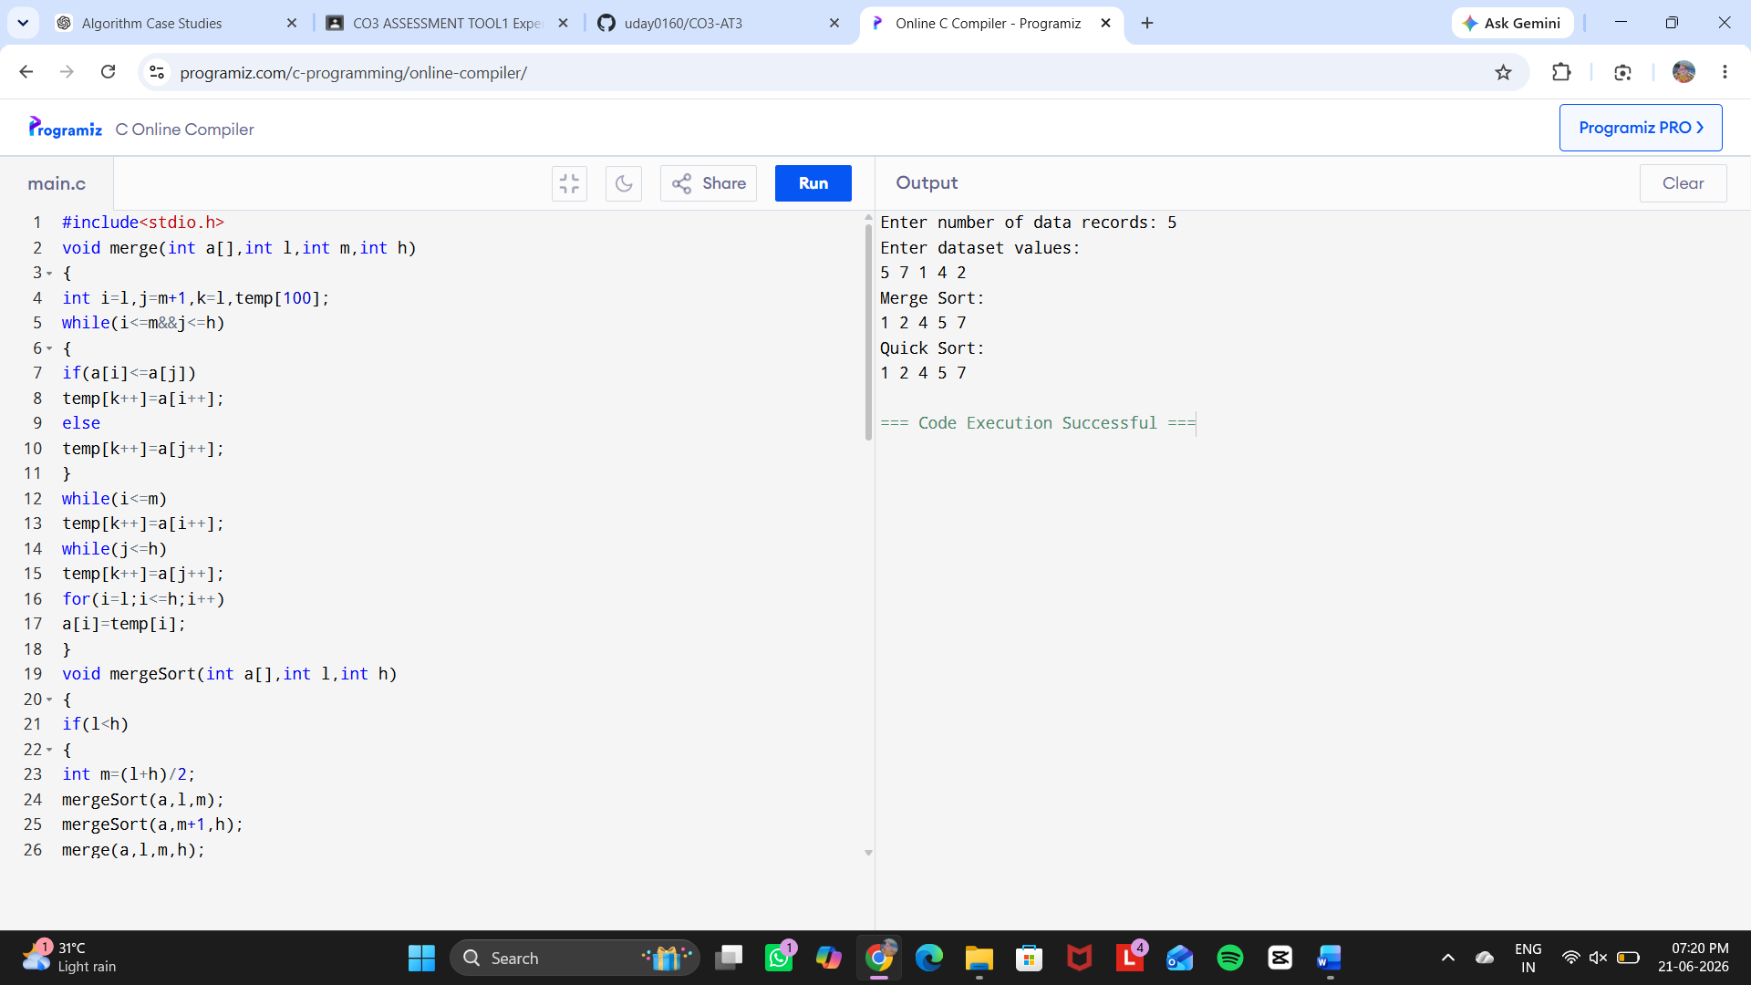

REPORT ANALYSIS:

1. Problem Statement
A government analytics platform processes large datasets containing public information such as population statistics, demographic records, and survey data. Efficient sorting algorithms are required to organize data for analysis and reporting.
This case study compares Merge Sort and Quick Sort using the Divide and Conquer approach.

2. Objective
- To implement Merge Sort and Quick Sort.
- To compare their performance.
- To analyze memory usage, stability, and execution speed.
- To select the most suitable sorting algorithm for large datasets.

3. Problem Understanding
Large government datasets require efficient sorting before generating reports.
Input:
- Number of data records
- Dataset values
Output:
- Sorted data using Merge Sort
- Sorted data using Quick Sort

4. Algorithms Used

Merge Sort
Merge Sort divides the dataset into smaller parts until single elements remain. Then it merges the elements in sorted order.

Steps:
- Divide the array into two halves.
- Sort each half recursively.
- Merge the sorted halves.
- Produce the final sorted dataset.

Quick Sort
Quick Sort selects a pivot element and divides data around the pivot.

Steps:
- Select pivot element.
- Place smaller elements before pivot.
- Place larger elements after pivot.
- Apply the same process recursively.

5. Comparison Between Merge Sort and Quick Sort
Feature | Merge Sort | Quick Sort
Technique | Divide and Conquer | Divide and Conquer
Best Case | O(n log n) | O(n log n)
Average Case | O(n log n) | O(n log n)
Worst Case | O(n log n) | O(n²)
Memory Usage | More memory required | Less memory required
Stability | Stable | Not stable
Speed | Consistent performance | Faster in practice

6. Performance Analysis

Merge Sort
Advantages:
- Guaranteed O(n log n) performance.
- Suitable for very large datasets.
- Maintains original order of equal elements.
Disadvantage:
- Requires additional memory.

Quick Sort
Advantages:
- Requires less memory.
- Faster for smaller datasets.
- Efficient for practical applications.
Disadvantage:
- Worst-case performance can become O(n²).

7. Suitable Solution
For government analytics systems with large-scale data processing, Merge Sort is recommended because:
- It provides consistent performance.
- It handles large datasets efficiently.
- It maintains data stability during sorting.
Quick Sort can be selected when memory efficiency and faster average execution are more important.

8. Conclusion
Both algorithms use the Divide and Conquer method. Binary Search provides efficient searching in railway reservation systems, while Merge Sort and Quick Sort help organize large government datasets. The selection of an algorithm depends on requirements such as speed, memory usage, and data size.

