MLA0105-ARTIFICIAL INTELLIGENCE AND EXPERT SYSTEMS

NAME: D. Uday Kiran (192425161)

1.SLIDING PUZZLE:
import heapq
# Define the goal state
goal_state = [[1, 2, 3],
[4, 5, 6],
[7, 8, 0]]

# Heuristic function: Manhattan distance
def heuristic(state):
d = 0
for i in range(3):
for j in range(3):
value = state[i][j]
if value != 0:
x, y = divmod(value-1, 3)
d += abs(x-i) + abs(y-j)
return d

# Find the position of the empty tile (0)
def find_zero(state):
for i in range(3):
for j in range(3):
if state[i][j] == 0:
return i, j

# Move the empty tile in valid directions
def get_neighbors(state):
zero_x, zero_y = find_zero(state)
neighbors = []
directions = [(-1,0),(1,0),(0,-1),(0,1)]
for dx, dy in directions:
x, y = zero_x + dx, zero_y + dy
if 0 <= x < 3 and 0 <= y < 3:
new_state = [row[:] for row in state]
new_state[zero_x][zero_y], new_state[x][y] = new_state[x][y], new_state[zero_x][zero_y]
neighbors.append(new_state)
return neighbors

# A* algorithm
def solve(start_state):
start_tuple = tuple(tuple(row) for row in start_state)
goal_tuple = tuple(tuple(row) for row in goal_state)

pq = [(heuristic(start_state), 0, start_state, [])]
visited = set()

while pq:
est, cost, state, path = heapq.heappop(pq)
state_tuple = tuple(tuple(row) for row in state)

if state_tuple in visited:
continue
visited.add(state_tuple)

if state_tuple == goal_tuple:
return path + [state]

for neighbor in get_neighbors(state):
heapq.heappush(pq, (cost + 1 + heuristic(neighbor), cost + 1, neighbor, path + [state]))

return None

# Example scrambled state from the image:
start_state = [[1, 6, 5],
[7, 3, 8],
[0, 4, 2]]

solution = solve(start_state)
if solution:
for step in solution:
for row in step:
print(row)
print("-----")
else:
print("No solution found.")

OUTPUT:
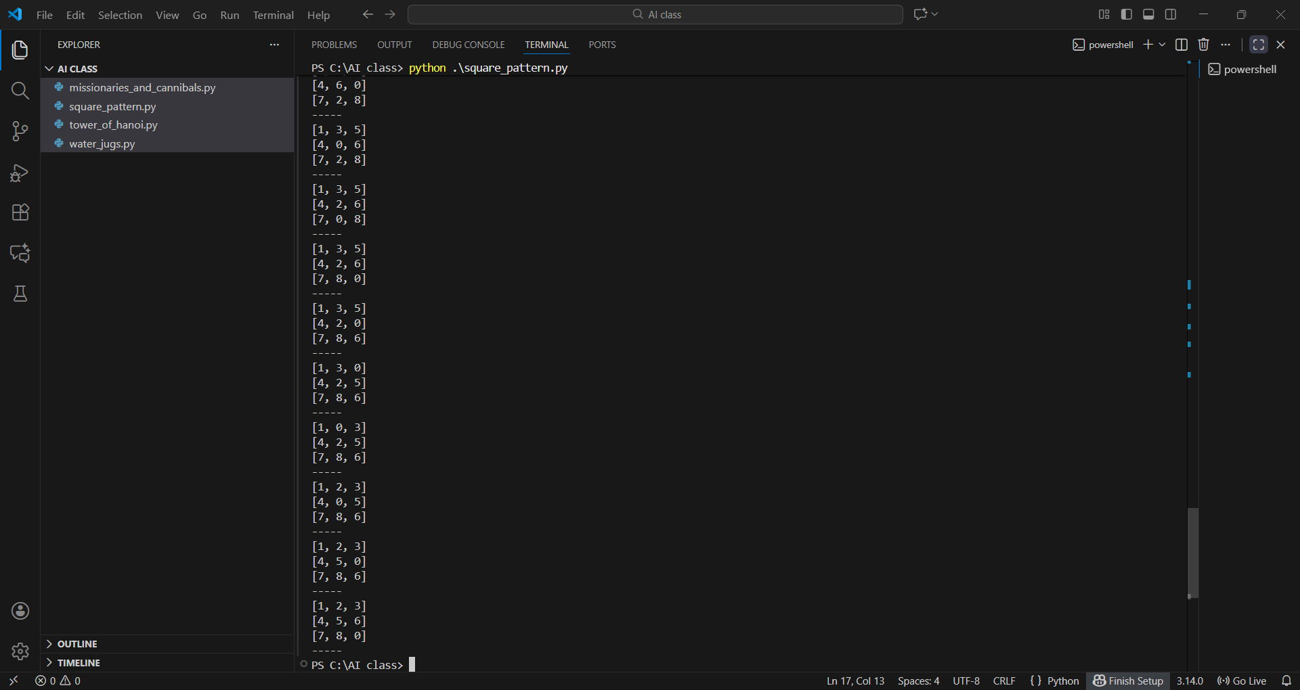

2. The Towers of Hanoi:
def towers_of_hanoi(n, source, auxiliary, target):
if n == 1:
print(f"Move disk 1 from {source} to {target}")
return
towers_of_hanoi(n - 1, source, target, auxiliary)
print(f"Move disk {n} from {source} to {target}")
towers_of_hanoi(n - 1, auxiliary, source, target)

# Example usage:
n = 3 # Number of disks, you can change this value
towers_of_hanoi(n, 'A', 'B', 'C')
print(towers_of_hanoi)
OUTPUT:

