ITA0541-Computer Vision For Electrical Vehicals Lab Programs
D.UDAYKIRAN/192425161
EXPEIMENT 1-10
EXPERIMENT-1
CODE:
import cv2
from google.colab.patches import cv2_imshow
img = cv2.imread('/content/Screenshot 2026-05-06 061946.png')
gray = cv2.cvtColor(img, cv2.COLOR_BGR2GRAY)
cv2_imshow(gray)
cv2.waitKey(0)
cv2.destroyAllWindows()
output:
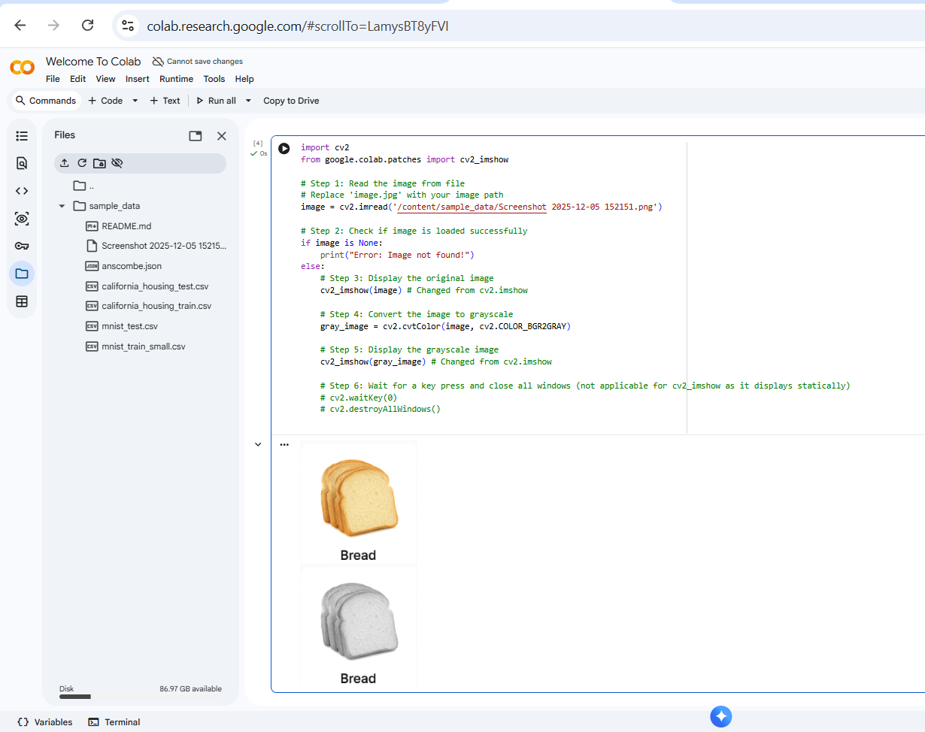

EXPERIMENT-2
CODE
import cv2
from google.colab.patches import cv2_imshow
img = cv2.imread('/content/Screenshot 2026-05-06 061946.png')
blur = cv2.GaussianBlur(img, (5,5), 0)
cv2_imshow(blur)
cv2.waitKey(0)
cv2.destroyAllWindows()
OUTPUT
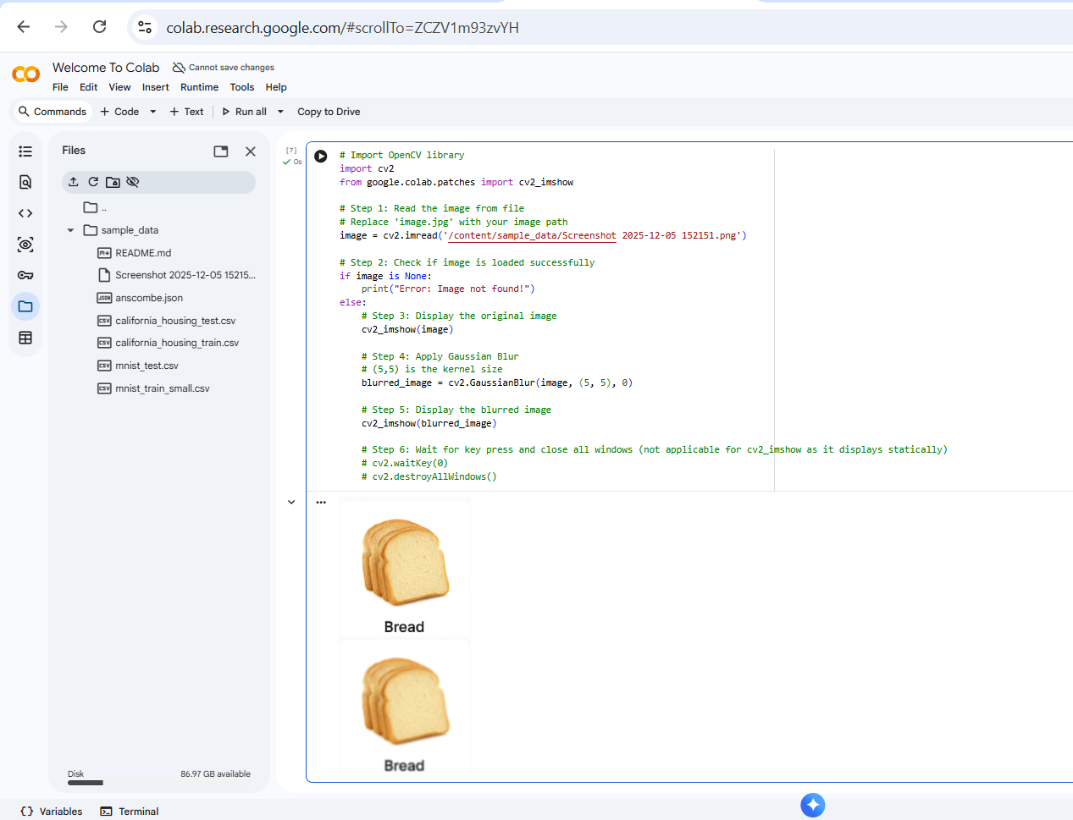
EXPERIMENT-3
CODE
import cv2
import matplotlib.pyplot as plt
img = cv2.imread('/content/Screenshot 2025-12-05 152151.png')
gray = cv2.cvtColor(img, cv2.COLOR_BGR2GRAY)
edges = cv2.Canny(gray, 100, 200)
plt.subplot(1,2,1)
plt.imshow(cv2.cvtColor(img, cv2.COLOR_BGR2RGB))
plt.title("Original Image")
plt.subplot(1,2,2)
plt.imshow(edges, cmap='gray')
plt.title("Canny Edge Image")
plt.show()
OUTPUT
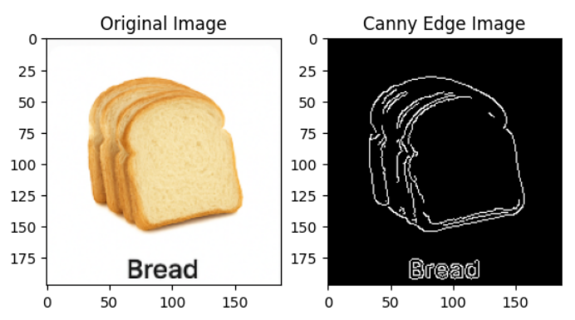
EXPERIMENT-4
CODE
import cv2
from google.colab.patches import cv2_imshow
img = cv2.imread('/content/Screenshot 2026-04-24 213806.png', 0)
equalized = cv2.equalizeHist(img)
cv2_imshow(img)
cv2_imshow(equalized)
OUTPUT
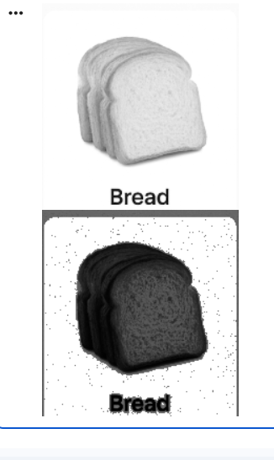
EXPERIMENT-5
CODE
import cv2
import matplotlib.pyplot as plt
img = cv2.imread('/content/Screenshot 2025-12-05 152151.png')
colors = ('b', 'g', 'r')
for i, col in enumerate(colors):
hist = cv2.calcHist([img], [i], None, [256], [0,256])
plt.plot(hist, color=col)
plt.title("Color Histogram")
plt.xlabel("Pixel Value")
plt.ylabel("Frequency")
plt.show()
OUTPUT
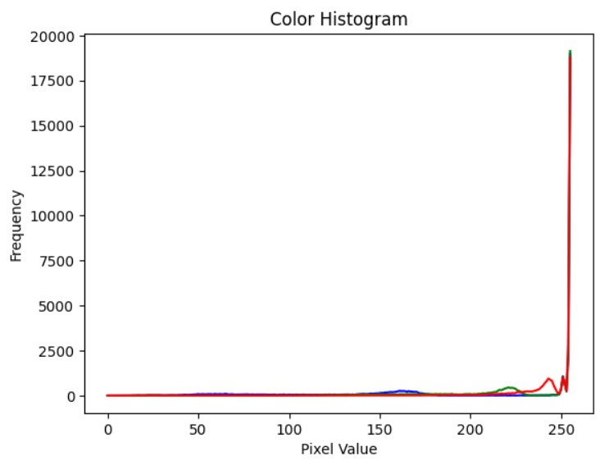
EXPERIMENT-6
CODE
import cv2
import numpy as np
from google.colab.patches import cv2_imshow
img = cv2.imread('/content/Mahadev ❤️.jpg')
kernel = np.ones((5,5), np.uint8)
erode = cv2.erode(img, kernel, iterations=1)
cv2_imshow(erode)
OUTPUT
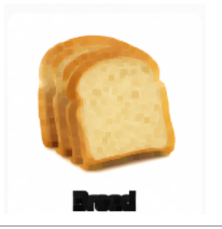
EXPERIMENT-7
CODE
import cv2
from google.colab.patches import cv2_imshow
cap = cv2.VideoCapture('/content/IHEARTGOT.gif')
while cap.isOpened():
ret, frame = cap.read()
if not ret:
break
cv2_imshow(frame)
cap.release()
OUTPUT
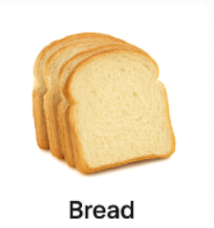
EXPERIMENT-8
CODE
import cv2
import numpy as np
from google.colab.patches import cv2_imshow
img = cv2.imread('/content/Mahadev ❤️.jpg')
kernel = np.ones((5,5), np.uint8)
dilate = cv2.dilate(img, kernel, iterations=1)
cv2_imshow(dilate)
OUTPUT
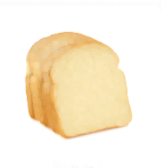
EXPERIMENT-9
CODE
import cv2
from google.colab.patches import cv2_imshow
img = cv2.imread('/content/Screenshot 2026-04-24 213806.png')
big = cv2.resize(img, None, fx=2, fy=2)
small = cv2.resize(img, None, fx=0.5, fy=0.5)
cv2_imshow(img)
cv2_imshow(big)
cv2_imshow(small)
OUTPUT
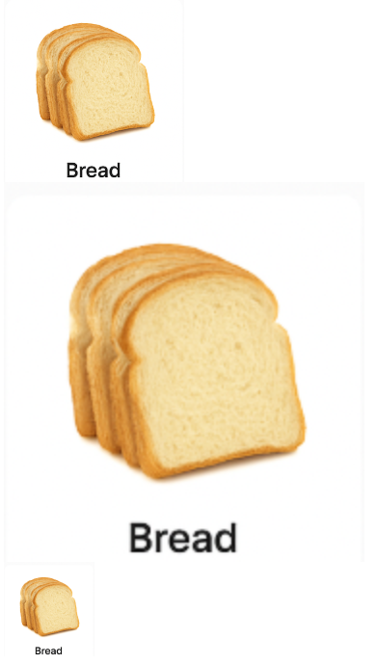
EXPERIMENT-10
CODE
import cv2
from google.colab.patches import cv2_imshow
img = cv2.imread('/content/Screenshot 2026-04-24 213806.png')
rotate = cv2.rotate(img, cv2.ROTATE_90_CLOCKWISE)
cv2_imshow(rotate)
OUTPUT
