ITA0541-Computer Vision For Electrical Vehicals Lab Programs
D.UDAYKIRAN/192425161
EXPEIMENT 21-30

Experiment 21:
import cv2
import numpy as np
from google.colab.patches import cv2_imshow
img = cv2.imread('/content/Screenshot 2025-12-05 152151.png',0)
kernel = np.ones((5,5),np.uint8)
opening = cv2.morphologyEx(img, cv2.MORPH_OPEN, kernel)
cv2_imshow(img)
cv2_imshow(opening)
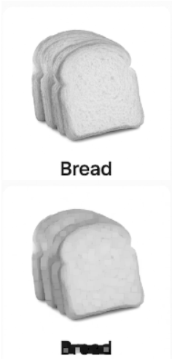

Experiment 22:
import cv2
import numpy as np
from google.colab.patches import cv2_imshow
img = cv2.imread('/content/Screenshot 2025-12-05 152151.png',0)
kernel = np.ones((5,5),np.uint8)
closing = cv2.morphologyEx(img, cv2.MORPH_CLOSE, kernel)
cv2_imshow(img)
cv2_imshow(closing)
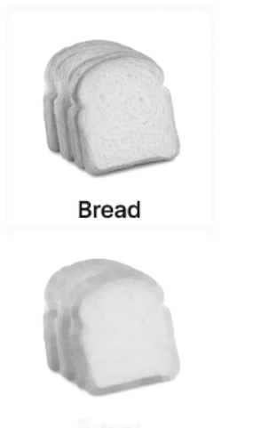

Experiment 23:
import cv2
import numpy as np
from google.colab.patches import cv2_imshow
img = cv2.imread('/content/Screenshot 2025-12-05 152151.png',0)
kernel = np.ones((5,5),np.uint8)
tophat = cv2.morphologyEx(img, cv2.MORPH_TOPHAT, kernel)
cv2_imshow(img)
cv2_imshow(tophat)
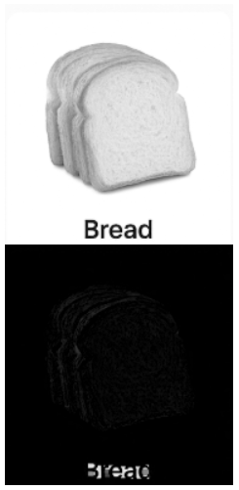

Experiment 24:
import cv2
import numpy as np
from google.colab.patches import cv2_imshow
img = cv2.imread('/content/Screenshot 2025-12-05 152151.png',0)
kernel = np.ones((5,5),np.uint8)
blackhat = cv2.morphologyEx(img, cv2.MORPH_BLACKHAT, kernel)
cv2_imshow(img)
cv2_imshow(blackhat)
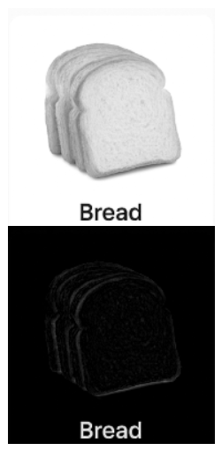

Experiment 25:
import cv2
from google.colab.patches import cv2_imshow
img = cv2.imread('/content/Screenshot 2025-12-05 152151.png')
gray = cv2.cvtColor(img, cv2.COLOR_BGR2GRAY)
cv2.putText(img,'Watch Detected',(50,50),
cv2.FONT_HERSHEY_SIMPLEX,1,(0,255,0),2)
cv2_imshow(img)
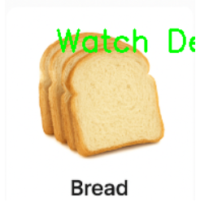

Experiment 26:
import cv2

cap = cv2.VideoCapture('/content/video.mp4')

frames = []

while True:
ret, frame = cap.read()
if not ret:
break
frames.append(frame)

cap.release()

height, width, layers = frames[0].shape

out = cv2.VideoWriter('reverse.mp4',
cv2.VideoWriter_fourcc(*'mp4v'),
20,(width,height))

for frame in reversed(frames):
out.write(frame)

out.release()

print("Reverse video saved")



Experiment 27:
import cv2
from google.colab.patches import cv2_imshow

face_cascade = cv2.CascadeClassifier(
cv2.data.haarcascades+'haarcascade_frontalface_default.xml')

img = cv2.imread('/content/Screenshot 2025-12-05 152151.png')

gray = cv2.cvtColor(img, cv2.COLOR_BGR2GRAY)

faces = face_cascade.detectMultiScale(gray,1.3,5)

for(x,y,w,h) in faces:
cv2.rectangle(img,(x,y),(x+w,y+h),(255,0,0),2)

cv2_imshow(img)
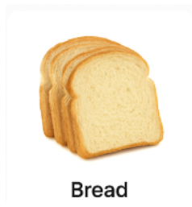

Experiment 28:

import cv2

from google.colab.patches import cv2_imshow

img = cv2.imread('/content/Screenshot 2026-05-14 180131.png')

gray = cv2.cvtColor(img, cv2.COLOR_BGR2GRAY)

face = cv2.CascadeClassifier(cv2.data.haarcascades +

'haarcascade_frontalface_default.xml')

for (x,y,w,h) in face.detectMultiScale(gray,1.3,5):

cv2.rectangle(img,(x,y),(x+w,y+h),(0,255,0),2)

cv2_imshow(img)

cv2.waitKey(0)

cv2.destroyAllWindows()

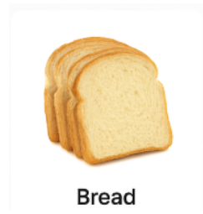

Experiment 29:
import cv2
from google.colab.patches import cv2_imshow
eye_cascade = cv2.CascadeClassifier(
cv2.data.haarcascades+'haarcascade_eye.xml')
img = cv2.imread('/content/Screenshot 2025-12-05 152151.png')
gray = cv2.cvtColor(img,cv2.COLOR_BGR2GRAY)
eyes = eye_cascade.detectMultiScale(gray)
for(x,y,w,h) in eyes:
cv2.rectangle(img,(x,y),(x+w,y+h),(0,255,0),2)
cv2_imshow(img)
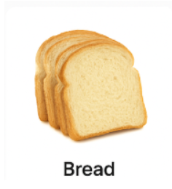

Experiment 30:
import cv2
from google.colab.patches import cv2_imshow
smile_cascade = cv2.CascadeClassifier(
cv2.data.haarcascades+'haarcascade_smile.xml')
img = cv2.imread('/content/Screenshot 2025-12-05 152151.png')
gray = cv2.cvtColor(img,cv2.COLOR_BGR2GRAY)
smiles = smile_cascade.detectMultiScale(gray,1.8,20)
for(x,y,w,h) in smiles:
cv2.rectangle(img,(x,y),(x+w,y+h),(255,0,0),2)
cv2_imshow(img)
