ITA0541-Computer Vision For Electrical Vehicals Lab Programs
D.UDAYKIRAN/192425161
EXPEIMENT 11-20
EXPERIMENT-11
CODE
import cv2
from google.colab.patches import cv2_imshow
img = cv2.imread('/content/Screenshot 2026-04-24 213806.png')
rotate = cv2.rotate(img, cv2.ROTATE_180)
cv2_imshow(rotate)
OUTPUT
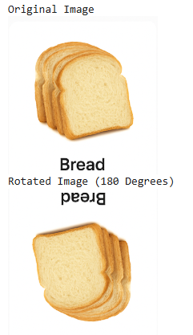
EXPERIMENT-12
CODE
import cv2
from google.colab.patches import cv2_imshow
img = cv2.imread('/content/WhatsApp Image 2026-02-04 at 9.38.21 AM.jpeg')
rotate = cv2.rotate(img, cv2.ROTATE_90_COUNTERCLOCKWISE)
cv2_imshow(rotate)
OUTPUT
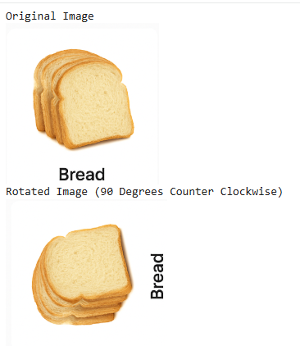
EXPERIMENT-13
CODE
import cv2
import numpy as np
from google.colab.patches import cv2_imshow
img = cv2.imread('/content/WhatsApp Image 2026-02-04 at 9.38.21 AM.jpeg')
rows, cols = img.shape[:2]
pts1 = np.float32([[50,50], [200,50], [50,200]])
pts2 = np.float32([[10,100], [200,50], [100,250]])
matrix = cv2.getAffineTransform(pts1, pts2)
output = cv2.warpAffine(img, matrix, (cols, rows))
cv2_imshow(img)
cv2_imshow(output)
OUTPUT
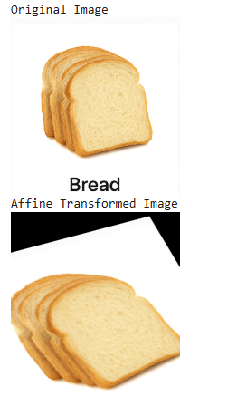
EXPERIMENT-14
CODE
import cv2
import numpy as np
from google.colab.patches import cv2_imshow
img = cv2.imread('/content/WhatsApp Image 2026-02-04 at 9.38.21 AM.jpeg')
rows, cols = img.shape[:2]
pts1 = np.float32([[50,50], [200,50], [50,200], [200,200]])
pts2 = np.float32([[10,100], [200,50], [100,250], [220,220]])
matrix = cv2.getPerspectiveTransform(pts1, pts2)
output = cv2.warpPerspective(img, matrix, (cols, rows))
cv2_imshow(img)
cv2_imshow(output)
OUTPUT
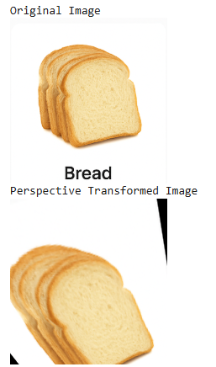
EXPERIMENT-15
CODE
import cv2
import numpy as np
from google.colab.patches import cv2_imshow
img = cv2.imread('/content/WhatsApp Image 2026-02-04 at 9.38.21 AM.jpeg')
gray = cv2.cvtColor(img, cv2.COLOR_BGR2GRAY)
gray = np.float32(gray)
corners = cv2.cornerHarris(gray, 2, 3, 0.04)
img[corners > 0.01 * corners.max()] = [0, 0, 255]
cv2_imshow(img)
OUTPUT
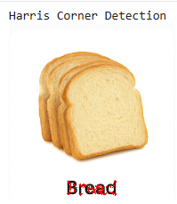
EXPERIMENT-16
CODE
import cv2
from google.colab.patches import cv2_imshow
img = cv2.imread('/content/WhatsApp Image 2026-02-04 at 9.38.21 AM.jpeg',
0)
sobel = cv2.Sobel(img, cv2.CV_64F, 1, 1, ksize=5)
cv2_imshow(sobel)
OUTPUT
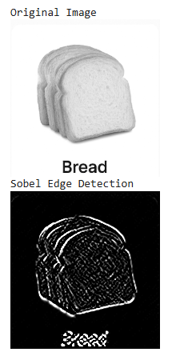
EXPERIMENT-17
CODE
import cv2
from google.colab.patches import cv2_imshow
img = cv2.imread('/content/WhatsApp Image 2026-02-04 at 9.38.21 AM.jpeg')
watermark = img.copy()
cv2.putText(watermark, 'WATERMARK', (50, 50),
cv2.FONT_HERSHEY_SIMPLEX, 1,
(255, 255, 255), 2)
cv2_imshow(watermark)
Output
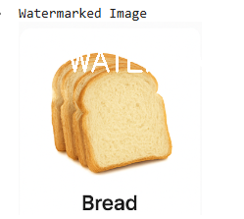
EXPERIMENT-18
CODE
import cv2
from google.colab.patches import cv2_imshow
img = cv2.imread('/content/WhatsApp Image 2026-02-04 at 9.38.21 AM.jpeg')
roi = img[50:200, 50:200]
img[250:400, 250:400] = roi
cv2_imshow(img)
OUTPUT
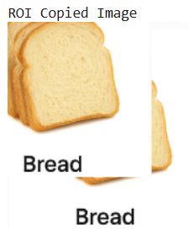

EXPERIMENT-19
CODE
import cv2
import numpy as np
from google.colab.patches import cv2_imshow
img = cv2.imread('/content/WhatsApp Image 2026-02-04 at 9.38.21 AM.jpeg',
0)
kernel = np.ones((5,5), np.uint8)
eroded = cv2.erode(img, kernel, iterations=1)
cv2_imshow(img)
cv2_imshow(eroded)
OUTPUT
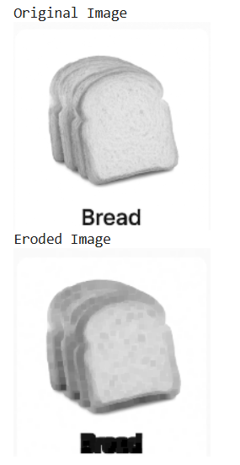
EXPERIMENT-20
CODE
import cv2
import numpy as np
from google.colab.patches import cv2_imshow
img = cv2.imread('/content/WhatsApp Image 2026-02-04 at 9.38.21 AM.jpeg',
0)
kernel = np.ones((5,5), np.uint8)
dilated = cv2.dilate(img, kernel, iterations=1)
cv2_imshow(img)
cv2_imshow(dilated)
OUTPUT
